Rainfall and Flood Severity Model Comparison
XGBoost training and chronological evaluation

1 Scope and main finding
We trained two new XGBoost classifiers using real INDOFLOODS labels. The static version was selected using validation results. The rainfall version achieved higher recall and average precision on the final held-out events, but also more false severe classifications. Overall performance is modest and does not justify operational warning claims or replacing the website’s current model.
Requested route | What the available files support
Exact original task | The old flood/no-flood target cannot be reproduced. All supplied INDOFLOODS rows are flood events, and the original model’s runoff curve-number input is absent.
Permitted scope adjustment | We predict Severe Flood versus Flood, conditional on an observed flood event. Flood means a less severe flood, not no flood.
Fair model comparison | Version A uses static catchment/climate inputs and seasonal context. Version B adds rainfall from the 1–10 days before event onset. Both use identical partitions and natural class distributions.

Data used
The public INDOFLOODS files contain 4,548 events from 155 gauges: 2,919 Flood and 1,629 Severe Flood. Each event joins to its rainfall record and to gauge/catchment attributes. Metadata describe 214 gauges, including 59 restricted gauges without public event rows. Those missing event records are not negative examples. Maharashtra contributes 817 events across 29 gauges; it was not selected as a separate training scope.
The additional India Flood Inventory contains 6,876 reported-event rows. District flooded-area and impact tables contain 732 rows each; DFSI contains 744 rows. These describe district impacts or reported events rather than the same gauge-event targets. They are retained as historical context and are not silently merged into predictors.

2 Methodology and frozen selection
Partition | Events | Flood | Severe | Period
Train | 3250 | 2167 | 1083 | 1965–2009
Validation | 613 | 386 | 227 | 2010–2014
Final test | 625 | 332 | 293 | 2015–2019

The documented EM-Earth precipitation source ends in 2019. All 55 events starting in 2020 were excluded before fitting; 54 have zero ten-day rainfall. Five earlier events extend across partition cutoffs and are also excluded, because their severity labels would not be fully observed by the cutoff. The test sample and exclusions were fixed before model selection.
Version | Inputs | Selected XGBoost settings
A Static | 25 raw inputs: 19 numeric catchment/climate/location fields, 4 categorical fields and 2 seasonal features. | 450 trees, depth 2, learning rate 0.04, minimum child weight 8, L2 regularisation 10.
B With rainfall | The same 25 inputs plus T1d–T10d and four derived rainfall indicators: maximum, standard deviation, rainy-day count and recent three-day share. Total 39 raw inputs. | 450 trees, depth 4, learning rate 0.04, minimum child weight 8, L2 regularisation 10.

Both families used the same 16 prespecified hyperparameter/weight candidates. Numeric medians and categorical vocabularies were fitted on training rows only. Candidate class weights were 1 and the training class ratio; both selected models use weight 1. Validation and test events were not resampled. Random seed: 20261024.
We selected each family by validation average precision (PR-AUC/AP), then F1. Its decision threshold maximises validation F1, with F2 as a tie-breaker. The static model won selection before the final test. Thresholds were frozen at 0.300 for static and 0.125 for rainfall.
Event peaks, duration, recession, flood volume and post-onset dates are excluded from predictors. IDs, warning/danger thresholds and whole-period district impacts/DFSI are also excluded. Modern static climate and 2015 land-cover attributes remain retrospective proxies; this is not a reconstruction of all covariates available in each historical year.

3 Actual chronological results
Severe Flood is the positive class. Precision and recall concern severe events among already recorded floods. PR-AUC below is average precision, not trapezoidal integration. All results use the frozen validation-selected thresholds.
Model | Precision | Recall | F1 | F2 | PR-AUC | ROC-AUC
A Static XGB | 0.543 | 0.648 | 0.591 | 0.624 | 0.553 | 0.601
B Rainfall XGB | 0.504 | 0.802 | 0.619 | 0.717 | 0.612 | 0.624
Rainfall logistic | 0.484 | 0.846 | 0.616 | 0.736 | 0.522 | 0.567
Always severe | 0.469 | 1.000 | 0.638 | 0.815 | 0.469 | 0.500
Training prior | 0.000 | 0.000 | 0.000 | 0.000 | 0.469 | 0.500

Validation model | F1 | PR-AUC | Threshold
A Static XGBoost | 0.673 | 0.687 | 0.300
B Rainfall XGBoost | 0.620 | 0.659 | 0.125

Interpretation
Adding rainfall raises test recall from 64.8% to 80.2% and F1 from 0.591 to 0.619. Precision falls from 54.3% to 50.4%. False severe classifications rise from 160 to 231 among 332 other flood events. These are not false flood-occurrence alarms: every row already represents a flood.
Both XGBoost F1 scores are below the always-severe baseline of 0.638. Their average precision is above the constant-score reference of 0.469, but this modest ranking skill does not establish a useful operating point. The training-prior baseline has slightly lower Brier error than either XGBoost version, so calibrated probability claims are unsupported.
The observed rainfall-minus-static improvement is uncertain. Paired gauge-cluster bootstrap 95% intervals are −0.029 to 0.121 for average precision and −0.028 to 0.087 for F1. Both include zero. The static validation winner remains the frozen selection; it is not replaced using test results.

4 Visual comparison on held out events
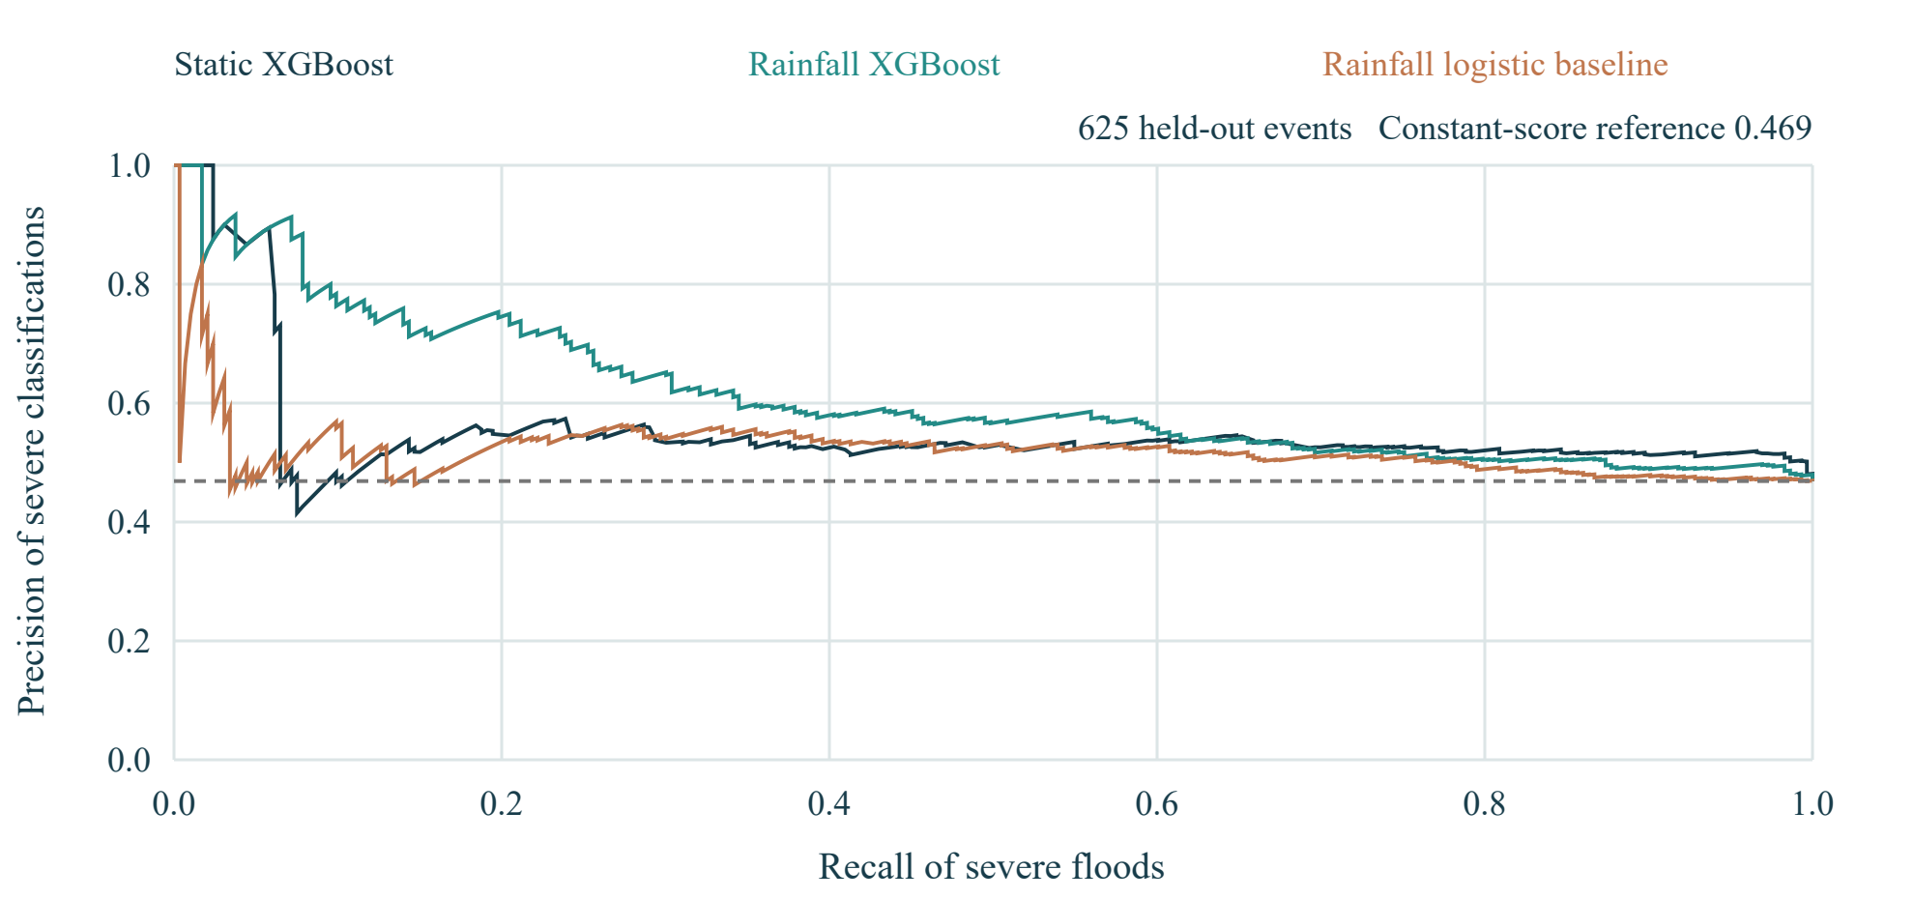
Figure 1 Precision and recall across model score thresholds
The dashed line is the severe-event share in the final test. A useful ranking should maintain precision above this reference while recovering severe events. The curves describe the same 625 events and do not authorise retuning thresholds on the test.
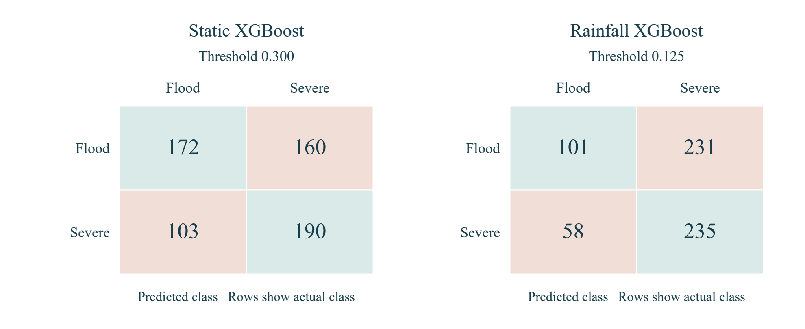
Figure 2 Predictions at the frozen decision thresholds
Static XGBoost misses 103 severe events and classifies 160 other floods as severe. Rainfall XGBoost misses 58 severe events and classifies 231 other floods as severe. Improved recall therefore comes with substantially more false severe classifications.

5 Evaluation and next steps
Neither experiment establishes flood/no-flood prediction or next-week rainfall forecasting. The target is conditional event severity, and the rainfall windows are aligned to a known flood onset. A production occurrence model would need monitored non-event periods and an explicit prediction horizon. An absence from either event inventory is not sufficient evidence of no flood.
Transfer to new gauges is weak. The validation-selected static model has ROC-AUC 0.741 for 318 test events at training gauges and 0.423 for 307 events at new gauges. We report the complete test population rather than removing difficult gauges or narrowing geography after seeing results. Repeated events within gauges and modern static covariates limit generalisation claims.
We preserve both trained pipelines, their preprocessing, selected parameters, raw feature lists, native XGBoost models and final predictions. The current website retains its original classifier because its target and inputs differ. The new results cannot be compared numerically with the old model’s unverified accuracy claims.

Reproducibility
Experiment folder: experiments/indofloods_severity_v1/. Read COMPARISON_REPORT.md, protocol.json, selection.json and final_results.json. Fitted pipelines and native UBJ models are in models/. The merged event dataset, exclusions and frozen split manifest are in data/. No new dataset was obtained beyond the user-supplied files.
From the RiskRadar folder, use the project Python environment with scripts/compare_indofloods_xgboost.py. Run prepare with --source C:/Users/Dell/Downloads, then select, then evaluate. This completed run refuses to overwrite a frozen selection or repeat final evaluation. A new experiment version and an independent future test period are required for further selection.

Sources
Kuntla and Saharia (2025). INDOFLOODS. Dataset: https://zenodo.org/records/14584655. Article: https://doi.org/10.1175/BAMS-D-24-0008.1.
Supplied variables_description_indofloods.pdf, pages 5 and 12: flood-type definition and pre-event precipitation windows. The tabulated severe class uses an inclusive danger-level boundary; source labels are preserved.
Tang, Clark and Papalexiou (2022). EM-Earth, 1950–2019. https://doi.org/10.1175/BAMS-D-21-0106.1.
India Flood Inventory Impacts: https://zenodo.org/records/16994648. Its historical district summaries are not pre-event predictors in this experiment.

