Rainfall and Flood Risk Analysis Using Historical Weather Data
Applied Data Science Final Mini Project Report
Student details | Information
Project title | Rainfall and Flood Risk Analysis Using Historical Weather Data
Student name / Roll number
Semester | VII(A)
Course / Subject | Applied Data Science
Faculty name | Dakshayani R
Submission date

Report checklist
Checked items have supporting evidence in the sections cited. N/A identifies a task outside the study scope, with its reason.
Done | Checklist item | Brief evidence / notes
☑ | Title, abstract, introduction, problem statement, objectives and scope are included. | Sections 1 and 2 define historical analysis and the separate rainfall-category indicator.
☑ | Dataset source, access date, features, dimensions and data limitations are documented. | Section 4.2 documents source files, coverage and genuine event labels.
☑ | Data quality issues and preparation steps are explained. | Section 4.3 explains preparation and source-coverage exclusions.
☑ | Exploratory Data Analysis (EDA) includes descriptive statistics and relevant visualisations. | Section 4.4 and Figures 1 to 4 contain measured statistics and graphs.
☑ | Analysis/model choice is justified and the evaluation method is documented. | Sections 4.5 to 4.7 record chronological model selection and baselines.
☑ | Results include metrics, graphs/tables and interpretations—not screenshots alone. | Section 5 contains severity metrics and eight interpreted data figures; Section 4.7 reports rainfall results.
☑ | Class imbalance is checked for classification tasks and addressed if needed. | Training-only weighting retains natural validation and test distributions.
N/A | For regression, suitable regression methods and error metrics are considered. | N/A: both current predictive outputs are categorical; no continuous regressor is claimed.
☑ | Time-series data is checked; forecasting is attempted where suitable and feasible. | Section 4.6 documents causal three-day rainfall-category forecasting and chronology.
☑ | Conclusion, limitations and possible future improvements are included. | Sections 6 and 7 explain conclusions and unresolved limitations.

1 Abstract
This project analyses historical rainfall and recorded flood severity and demonstrates an experimental rainfall-based risk indicator. We match 4,493 INDOFLOODS events at 155 gauges in 15 covered states and territories to pre-event rainfall and catchment attributes. A separate inventory contains 6,876 reported events; a saved ERA5 series provides 9,497 daily rainfall estimates near Mumbai during 2000–2025. The dashboard provides rainfall trends, monsoon comparisons, anomalies, a historical gauge-severity map and a visible Prediction page. Flood severity uses genuine Severe Flood versus Flood labels, conditional on an already recorded flood. Validation selects catchment XGBoost; its later-event F1 is 0.5910, below the always-severe baseline of 0.6383. For the separate rainfall task, 14 past daily observations generate causal features to classify the next three-day rainfall total using training-derived percentile bands. Logistic Regression, Extra Trees and HistGradientBoosting are compared chronologically against persistence and seasonal baselines. Persistence wins validation macro F1 at 0.4794; the best ML candidate, Extra Trees, scores 0.4719. On 2020–2025 origins, Extra Trees has macro F1 0.4743, High-category precision 31.82% and recall 33.33%. The system supports exploratory risk analysis and manual scenarios, while weak predictive performance, one-point weather coverage and absent non-flood labels prevent dependable flood-warning claims.

2 Introduction

2 1 Background and context
Heavy rainfall can increase runoff, but the same rainfall depth can have different consequences in catchments with different drainage, storage, terrain and antecedent conditions. Historical observations can show how rainfall and flood severity vary together. They cannot establish flood occurrence simply from a high rainfall value.
A useful system for this problem must connect dated rainfall to genuine flood observations and keep the observational unit clear. We use recorded gauge events for rainfall–flood analysis, a separate reported-event inventory for historical context, and a daily rainfall archive for seasonality and trend exploration.

2 2 Problem statement
Rainfall and Flood Risk Analysis Using Historical Weather Data.
The practical question is how historical rainfall patterns and antecedent catchment rainfall relate to recorded floods and their severity, and whether those observations support a defensible ML estimate of severity. The project must distinguish an observed relationship from a calibrated probability that a flood will occur.

2 3 Objectives
1. Prepare one traceable event dataset by joining flood, rainfall, metadata and catchment files without duplicating observations.
2. Analyse rainfall variability and seasonality and compare antecedent rainfall across genuine Flood and Severe Flood events.
3. Use outcome-free inputs to compare catchment-only and rainfall-enhanced severity models against simple baselines.
4. Retain chronological model selection and evaluate precision, recall, F1, F2, average precision, ROC-AUC and calibration error.
5. Provide an understandable interactive dashboard and report where the evidence supports risk analysis and where it does not support operational prediction.

2 4 Scope and intended use
The matched study covers 155 public INDOFLOODS gauges in 15 states and territories with rainfall-supported event dates through 2019. This is coverage of the supplied archive rather than every Indian district or catchment. Maharashtra is available as a filter, not the sole study area. The separate IFI inventory covers reported events during 1967–2023.
The system supports historical rainfall and observed flood-severity analysis. A separate experimental model predicts a category for the next three-day rainfall total at the existing near-Mumbai ERA5 point, with a manual scenario mode. It does not establish flood occurrence, district inundation or live emergency warnings. Restricted gauges, missing rainfall and unrecorded days are not fabricated as normal observations.

3 Hardware and Software Requirements
Category | Specification / tool | Purpose / version (if relevant)
Hardware | 64-bit personal computer | Local files and CPU-based model inference; no GPU is required.
Operating system | Windows with PowerShell | Local dashboard launcher and Python environment.
Programming language | Python 3.12 | Preparation, EDA, fitted pipelines and interface logic.
Libraries and packages | pandas 3.0.6; NumPy 2.5.4; scikit-learn 1.6.1; XGBoost 3.2.0 | Data joins, numerical summaries, preprocessing, logistic regression and gradient-boosted classification.
IDE or platform | Local project; Streamlit 1.66.1; Plotly 6.9.0 | Interactive charts, filters, recorded-event explorer and downloads.
Other tools | joblib 1.6.0; requests 2.34.2; source manifests | Saved models, public historical archive retrieval and reproducible data provenance.

4 Methodology and Data Science Life Cycle
The lifecycle distinguishes historical flood-severity analysis from the separate daily rainfall-category experiment. Neither output establishes a validated probability that flooding will occur.

4 1 Business and Problem Understanding
Done | Checklist item | Brief evidence / notes
☑ | Defined the real-world problem and the stakeholder/user. | Users need to inspect rainfall patterns and the conditions preceding observed floods.
☑ | Identified the target outcome or question and success criteria. | Success includes sound event matching, interpretable analysis and honest baseline comparison.
☑ | Defined assumptions, constraints and potential impact. | Event-only sampling, archive coverage and limited model transfer constrain prediction claims.
Target and success criteria
The descriptive target is the relationship between pre-event rainfall and recorded flood severity. The supervised target is Severe Flood = 1 and Flood = 0, using the publisher labels. Both classes contain actual floods. No monitored non-flood sample set exists in these files, so a genuine flood-occurrence classifier cannot be evaluated.
Predictive success would require better discrimination and useful operating-point performance than simple baselines on later events, with manageable false severe estimates. The models show some ranking information but do not meet a dependable warning-use standard. This negative result is part of the evaluation, not a reason to change test labels or omit weak cases.

4 2 Data Understanding and Collection
Done | Checklist item | Brief evidence / notes
☑ | Identified the dataset source and documented how it was obtained. | INDOFLOODS and IFI source files are supplied public data; raw files and checksums are preserved.
☑ | Checked data meaning, units, data types and collection period. | Dates, rainfall depth in mm, river levels in m and event-based sampling are documented.
☑ | Checked the number of rows/records and columns/features. | The merged table has 4,493 rows and 166 columns; raw predictor counts are 25 or 39.
☑ | Identified the target variable (if supervised learning is used). | Publisher Flood and Severe Flood labels are retained; no non-flood class is invented.
☑ | Considered data privacy, consent, licence and possible bias. | Public data are attributed; restricted gauges are excluded and geographic/reporting bias is discussed.

Dataset details | Your response
Dataset names and sources | INDOFLOODS flood events, precipitation, metadata and catchment attributes [1,2]. IFI-Impacts [3,4]. ERA5 rainfall through Open-Meteo [5].
Access date and collection period | Verified on 24 October 2026. Matched rainfall-supported events: 21 July 1965 to 28 December 2019. IFI reported events: 1967–2023. Cached ERA5 rainfall: 2000–2025.
Number of records | Raw INDOFLOODS: 4,548 events. Rainfall-supported descriptive table: 4,493. Model partitions: 4,488 after five additional cross-boundary exclusions. IFI: 6,876 reports. Cached rainfall: 9,497 daily values.
Columns and model dimensions | Merged analytical table: 166 columns, including IDs, metadata, outcomes, splits, engineered features and 10 reconstructed daily rainfall values. Catchment model: 25 raw inputs, 41 encoded. Rainfall model: 39 raw inputs, 55 encoded.
Feature types | Event/gauge identifiers; onset/end dates; state and categorical catchment descriptors; numeric rainfall, climate and terrain measures; publisher severity labels.
Target and type | Binary severity among recorded events: Severe Flood = 1, Flood = 0. The label is not flood versus no flood. Recorded peak relative to danger is an outcome descriptor, not an input.
File size and complexity | Matched CSV: 7,247,655 bytes. Multiple events share gauge attributes; event rows are dependent within a gauge. The 155 catchment boundaries are context, not extra independent samples.
Known limitations | Uneven gauge coverage; event-only sampling; post-2019 rainfall source mismatch; static modern catchment/climate proxies; changing historical monitoring and potential reporting bias. IFI rows and INDOFLOODS gauge events are not interchangeable samples.
Feature inventory and role separation
Feature / column | Meaning / unit | Data type | Role (input / target / ID / date) | Notes
EventID and GaugeID | Unique event and gauge keys | Text | Join and audit | Not model predictors.
Start Date and End Date | Recorded flood onset and end | Date | Time and outcome | Onset defines alignment; end is excluded from inputs.
T1d to T10d | Cumulative rainfall in the 1 to 10 days before onset, mm | Numeric | Rainfall inputs | All windows end before the flood begins.
Ten daily rainfall depths | Differences of cumulative rainfall windows, mm | Numeric | Analysis | Used in the event rainfall chart; sums reconstruct the source windows.
Drainage and catchment geometry | 12 numeric fields including area, relief, stream order, density, texture and geometry | Numeric | Static inputs | Same common inputs in both XGBoost families.
Climate summaries and coordinates | Annual mean temperature, seasonality, annual/wettest-month precipitation, latitude/longitude | Numeric | Static inputs | Modern retrospective proxies; not historical daily weather measurements.
Climate land soil lithology | Four published categorical descriptors | Category | Static inputs | Training vocabulary and unknown-category handling.
Month sine and cosine | Seasonality of the day before onset | Numeric | Input | Two cyclic features common to both models.
Rainfall indicators | Daily maximum/std, rainy-day count, recent three-day share | Numeric | Engineered input | Four derived variables add to ten cumulative rainfall inputs.
Flood Type and target | Publisher Flood or Severe Flood; binary mapping | Category and integer | Target | Neither label represents a verified non-flood day.
Peak level discharge and duration | Observed event magnitude and development | Numeric | Outcome and EDA | Excluded from all predictive features.
Warning and danger levels | Station-specific official threshold references, m | Numeric | Outcome context | Not used as severity predictors; prevent direct label leakage.
State station river and split | Location descriptions and chronology partition | Text | Filter and audit | Identifiers and partitions are not fitted predictors.
IFI impacts and DFSI | Reported events and aggregate impact/severity summaries | Mixed | Separate context | Not merged into pre-event predictors.
ERA5 date and rain_mm | Daily rainfall estimate near the selected location | Date and numeric | Historical analysis | Separate archive, not substituted for catchment event rainfall.

4 3 Data Preparation
Done | Checklist item | Brief evidence / notes
☑ | Checked missing values and explained the treatment (drop, impute, retain, etc.). | Incomplete source coverage is excluded; train-fitted median imputation handles remaining numeric input gaps.
☑ | Checked duplicate records and handled them where appropriate. | Event IDs are unique; rainfall joins one-to-one and gauge/catchment joins many-to-one.
☑ | Checked invalid values, inconsistent formats, units and data types. | Cumulative rainfall is finite, nonnegative and nondecreasing; dates and labels retain source meaning.
☑ | Investigated outliers/anomalies and justified retaining, correcting, capping or removing them. | Heavy-rainfall tails are retained; source coverage anomalies in 2020 are excluded by date, not by model score.
☑ | Encoded categorical features and scaled/normalised features if required. | Category vocabulary, imputation and logistic scaling fit training only; test distribution is unchanged.
☑ | Recorded any feature engineering, feature selection or transformations. | A fixed outcome-free whitelist defines 25/39 inputs; cumulative differences reconstruct daily rainfall.

Issue / abnormality found | How it was detected | Action taken and reason | Records/features affected
Missingness and coverage | The documented antecedent rainfall product ends in 2019; 54 of 55 source 2020 events have T10d = 0. | Exclude all 55 events starting in 2020 before fitting or analysis; do not treat absent rainfall as dry conditions. | 4,548 raw events become 4,493 rainfall-supported events.
Join duplication | Unique EventID/GaugeID checks and validated merge cardinality. | Join rainfall by EventID; metadata/catchments by GaugeID. Retain distinct genuine repeated events at a gauge. | No event multiplication in the merged table.
Extreme rainfall and labels | Inspect rainfall distributions and verify publisher severity against recorded peak relative to danger. | Retain valid extremes. Keep inclusive source Severe Flood labels, including equality at displayed danger level. | Twenty source severe events equal the rounded danger level.
Encoding and transformation | Separate numeric, categorical and cyclic variables. | Fit median/category preprocessing on training. Logistic baseline uses train-fitted scaling; trees need no standardisation. | 25 or 39 raw predictors; 41 or 55 encoded XGBoost inputs.
Temporal leakage | Review feature roles and event end dates at split cutoffs. | Exclude peak, duration, volume, recession, end date, thresholds and aggregate impacts from predictors; purge crossing events. | Five additional events excluded from supervised partitions; model sample total 4,488.
Final prepared event dataset: 4,493 rows and 166 analytical columns. Supervised subsets contain 3,250 training, 613 validation and 625 test events; five otherwise rainfall-supported events cross partition boundaries. The rainfall model uses 39 raw predictors, not all 166 columns.

4 4 Exploratory Data Analysis
Done | Checklist item | Brief evidence / notes
☑ | Computed relevant descriptive statistics (e.g., mean, median, mode, min/max, range, standard deviation, quartiles). | Rainfall count, spread, quartiles and severity-group medians are calculated.
☑ | Examined distributions and class/target frequencies where applicable. | Event severity counts and the rainfall tail are examined; 2020 gaps are not recoded as zeros.
☑ | Explored relationships/correlations among relevant variables. | Pearson and within-gauge centred relationships expose aggregation and catchment effects.
☑ | Created suitable visualisations and wrote an interpretation for each. | Eight source-derived graphs with captions and interpretations appear in Section 5.3.

Statistic / EDA check | Variables examined | Main finding / implication
Count missingness and uniqueness | Matched events, gauges, states and identifiers | 4,493 unique matched events at 155 gauges across 15 states/territories; complete supported cumulative rainfall windows.
Location and spread | T3d and T10d rainfall | T3d mean 95.6 mm, median 65.8 mm; maximum 809.3 mm. Rainfall is right-skewed.
Quartiles and extremes | T3d rainfall | Overall quartiles 29.0/65.8/131.0 mm. Extreme values remain meaningful observations.
Correlation and relationships | T3d versus severe label | Pooled Pearson r = -0.041; within-gauge centred r = 0.127. Both are weak and descriptive; rainfall alone does not identify severity.
Target distribution | Publisher classes | 2,887 Flood and 1,606 Severe Flood in the rainfall-supported table. Model training has 1,083 severe versus 2,167 other flood events.
Seasonality and historical rainfall | Flood onset month; separate ERA5 archive | 80.2% of supported events begin June–September. At the cached near-Mumbai site, 92.5% of rainfall falls in those months. The two spatial units are not automatically merged.
Visualisation register for measured analysis and model evaluation
Figure no. and graph type | Variables / question | Important observation | What it means for the problem
Figures 1 and 2 seasonal bars | Rainfall climatology and flood onset month | Seasonal concentration in two distinct observational sources. | Shows when rain and recorded floods concentrate without claiming day-level causation.
Figure 3 percentile boxes | Three-day rainfall and event severity | Overlapping rainfall distributions. | A rainfall amount alone is an insufficient severity rule.
Figure 4 conditional shares | Training-derived rainfall groups and severity | Severe shares depend on the event sample and gauge composition. | Percentages are conditional on recorded floods, not occurrence probabilities.
Figures 5 and 6 model diagnostics | Precision, recall, F1, AP and confusion matrix | Baseline limitations and false severe/missed severe counts. | Prevents headline accuracy from hiding weak utility.
Figure 7 event rainfall bars | Ten daily rainfall values before one onset | The rainfall windows are correctly dated and reconstructable. | Explains the event-level input used in the matched analysis.
Figure 8 rainfall forecast matrix | Recorded versus forecast Low/Medium/High rainfall categories | Only 21 of 63 High origins are detected by the ML prototype. | Category evaluation exposes missed heavy-rain periods without claiming flood occurrence.

4 5 Model Selection and Validation
Done | Checklist item | Brief evidence / notes
☑ | Selected an analysis technique/model suited to the problem and explained why. | Gradient boosting suits mixed nonlinear catchment/rainfall inputs; logistic regression is a simpler comparison.
☑ | Specified input features and target variable, if applicable. | The 25/39 input lists and binary conditional-severity target are documented.
☑ | Documented train/test split or other validation design. | Train before 2010; validation 2010–2014; test 2015–2019; crossing windows purged.
☑ | Used cross-validation or explained why a hold-out approach was suitable. | Chronological holdout is suitable for later-event evaluation; random k-fold mixing is avoided.

Design choice | What was used | Reason / details
Analysis task | Descriptive and diagnostic rainfall/flood analysis; conditional severity classification | No continuous prediction or clustering task is substituted for the problem statement.
Technique and models | Catchment XGBoost; rainfall-enhanced XGBoost; rainfall logistic regression | Each XGBoost family compares 16 prespecified configurations, 32 fits total; logistic is a simpler rainfall baseline.
Inputs and target | 25 common features; rainfall version adds 10 windows and 4 indicators | Severe Flood = 1 versus Flood = 0, conditional on a known event.
Baselines | Training-prevalence constant; always severe; rainfall logistic regression | Assess ranking, calibration and operating-point utility rather than accuracy alone.
Chronological split | Train 3,250; validation 613; test 625 | About 72.42%, 13.66% and 13.93% of 4,488 supervised events; years and counts define the split, not a random ratio.
Validation design | Forward chronological holdout; no random k-fold or test resampling | Highest validation average precision selects the family/configuration; validation F1 selects its operating threshold with F2 tie-break.
Evaluation measures | Precision, recall, F1, F2, AP, ROC-AUC, Brier score and confusion counts | MAE/RMSE/R² do not evaluate a categorical severity target. Accuracy is supplementary only.
The selected catchment model has 450 trees, depth 2, learning rate 0.04, minimum child weight 8, L2 penalty 10 and positive-class weight 1. The rainfall-enhanced family winner has 450 trees, depth 4 and the same learning rate/minimum-child/L2/weight values. Both use train-fitted preprocessing and a fixed random seed.
Validation average precision is 0.6873 for the catchment model, 0.6588 for the rainfall model and 0.4785 for logistic regression. Frozen class thresholds are 0.300, 0.125 and 0.250 respectively. The catchment model therefore remains the validation-selected winner even though the rainfall model has higher test recall. This release packages the previously trained pipelines for comparison; it does not claim a newly independent test or change selection after inspecting results.
The working architecture is source flood/rainfall tables → validated event/gauge joins → dated antecedent features → descriptive analysis and frozen severity pipelines → interactive rainfall/flood views. The separate ERA5 rainfall history and category experiment and IFI inventory retain their own observational units. No district impact aggregates, post-onset levels or future rain are inserted into model inputs.

4 6 Task Specific Checks
Classification
Done | Checklist item | Brief evidence / notes
☑ | Checked class counts / class imbalance. | Training: 1,083 severe / 2,167 other floods; validation: 227 / 386; test: 293 / 332.
☑ | If imbalanced, considered class weights, resampling or other suitable methods and explained the choice. | Compare weight 1 with the training negative/positive ratio only; natural validation/test samples retained. No synthetic negatives or test oversampling.
☑ | Used suitable metrics such as precision, recall, F1-score, confusion matrix and/or ROC-AUC, not accuracy alone where misleading. | Precision, recall, F1/F2, AP, ROC-AUC, Brier score and full confusion counts are reported.
The training severe fraction is 33.32%, compared with 37.03% in validation and 46.88% in test. This shift and gauge turnover can weaken calibration. Class-weight tuning uses training counts only; the selected models use weight 1. Additional sampling is not presented as a cure for missing non-flood labels or poor location transfer.
Regression
Done | Checklist item | Brief evidence / notes
N/A | Identified the continuous target and candidate predictors. | N/A: the final target is event severity, not a continuous rainfall or water-level amount.
N/A | Checked relevant assumptions/diagnostics where appropriate (linearity, residual patterns, multicollinearity, influential points). | N/A: linear-regression residual and multicollinearity diagnostics are not the selected task.
N/A | Reported suitable metrics such as MAE, MSE/RMSE and R². | N/A: classification metrics are appropriate; regression error metrics are not substituted.
N/A | Compared actual vs predicted values or examined residuals. | N/A: predicted categories and confusion counts replace numeric actual-versus-predicted residuals.
No regressor is part of the final main application. The preceding river-level experiment is archived and is not evidence for rainfall-linked flood severity.
Clustering and Unsupervised Analysis
Done | Checklist item | Brief evidence / notes
N/A | Explained the similarity/distance measure and key settings. | N/A: no clustering or distance-based grouping is claimed.
N/A | Explained how the number of clusters or structure was chosen. | N/A: no cluster number is selected.
N/A | Interpreted the resulting groups and checked whether they were meaningful. | N/A: descriptive rainfall bins are training quartiles, not learned clusters.
Time Series Analysis and Rainfall Category Forecasting
Done | Checklist item | Brief evidence / notes
☑ | Checked whether a meaningful time/date variable and sequential observations exist. | The saved ERA5 archive provides 9,497 daily observations at one near-Mumbai point.
☑ | Checked frequency, missing periods, trend, seasonality and unusual events where relevant. | Features use 14 complete preceding daily observations; missing values are not replaced with dry days.
☑ | Used a chronological train/test split (not a random split) for forecasting evaluation. | Train 2000–2015; validation 2016–2019; test 2020–2025. Crossing label windows are purged.
☑ | Tried at least one taught forecasting method or suitable ML-based method when data and time permit. | Next three-day rainfall totals are categorised using training positive-window 90th/95th percentiles.
☑ | Compared forecasts against a simple baseline (e.g., last value or seasonal-naive) where possible. | Persistence, calendar-month class rates and always-Low baselines are compared with three ML families.
☑ | Plotted actual vs forecast and reported suitable error metrics. | Figure 8 plots recorded versus forecast categories; category metrics and confusion counts are reported.

Time-series item | Your response
Observation and target | Daily ERA5 rain_sum in mm at the existing near-Mumbai point. Target is the sum on issue day +1, +2 and +3, excluding the issue day.
Predictors | 30 causal features from 14 daily rainfall readings: lags, 3/5/7/14-day sums, rolling maximum/std, wet-day counts, wet spell, change and cyclic month/day seasonality.
Training and validation | 5,828 training origins during 2000–2015; 1,458 validation origins during 2016–2019. All feature/threshold preparation and candidate selection precede test evaluation.
Final retrospective test | 2,189 origins during 2020–2025: 2,069 Low, 57 Medium and 63 High. Three-day windows do not cross partition boundaries. Adjacent targets overlap and are not independent storms.
Category thresholds | Training nonzero three-day totals: Low below 70.40 mm; Medium from 70.40 to below 103.15 mm; High at least 103.15 mm. Dry windows remain Low.
Fitting and selection | Six configurations across Logistic Regression, Extra Trees and HistGradientBoosting. Imbalance weights fit training only. Validation macro F1 selects the candidate and class cutoffs, with High F2 as tie-break.
Scope and interpretation | This is a rainfall-category forecast, not a flood/no-flood label. The existing weather archive was previously inspected; this is a retrospective chronological holdout, not independent prospective confirmation.

4 7 Rainfall Indicator Models and Results
The best ML candidate by validation is Extra Trees with 200 trees, maximum depth 12, minimum leaf size 10 and training-balanced class weights. Its High cutoff is 0.50 and Medium cutoff 0.40. We compare it in the interface with the overall validation winner, persistence, which categorises the previous observed three-day rainfall total. No test result changes that selection.
Persistence has validation macro F1 0.4794, compared with 0.4719 for Extra Trees. Thus the new ML experiment does not establish improvement over the simple baseline on the selection period. Both are frozen before the final retrospective comparison below.
Candidate | Validation macro F1 | Test macro F1 | High precision | High recall
Persistence baseline | 0.4794 | 0.4341 | 0.2698 | 0.2698
Extra Trees 10 | 0.4719 | 0.4743 | 0.3182 | 0.3333
Always Low | 0.3238 | 0.3239 | 0.0000 | 0.0000

Extra Trees High-category F1 is 0.3256, F2 0.3302, average precision 0.2171 and ROC-AUC 0.9022. Of 63 High origins, it identifies 21 and misses 42; 45 non-High origins are flagged High. Its three-class confusion matrix, in Low/Medium/High row and column order, is [1862, 169, 38]; [28, 22, 7]; [16, 26, 21].
Persistence identifies 17 High origins, misses 46 and has 46 false High outputs; High average precision is 0.0938. Extra Trees is better on these test summaries, but this does not reverse the validation winner. Always Low attains 94.52% accuracy while identifying no High origins, demonstrating why headline accuracy would be misleading.
The Prediction page accepts a saved observation date or exactly 14 user-entered daily rainfall values. It shows both category estimates, the next three-day period, input rainfall totals, a rainfall chart, a CSV download and optional recorded outcomes for retrospective replay. Sensitivity examples halve recent rain and recompute features; they demonstrate model response, not causal attribution or a real flood warning.

5 Results and Discussion
The findings below answer the rainfall and flood-risk analysis question using observed records, with supervised severity results presented alongside their baselines and limitations.

5 1 Key Results
The prepared rainfall-supported event table contains 2,887 Flood and 1,606 Severe Flood records. Of these events, 80.2% begin in June–September. Antecedent rainfall distributions overlap substantially between the two labels, so a single pooled rainfall cutoff cannot reliably determine severity.
The pooled correlation between three-day rain and the severe label is -0.041; after within-gauge centring it is 0.127. The changed sign illustrates gauge-composition effects, while both small magnitudes show limited rainfall-only separation. This is association in an event-selected sample, not a causal estimate.
The national inventory remains a separate 6,876-row reported-event view. Multi-state events count once in a national view, and missing reports are not filled as non-flood days. This avoids creating false outcome labels by joining incompatible spatial or temporal units.

5 2 Model Performance and Comparison
Model or baseline | Precision | Recall | F1 | Average precision
Catchment XGBoost | 0.5429 | 0.6485 | 0.5910 | 0.5528
Rainfall XGBoost | 0.5043 | 0.8020 | 0.6192 | 0.6118
Rainfall logistic | 0.4844 | 0.8464 | 0.6161 | 0.5225
Training prevalence | 0.0000 | 0.0000 | 0.0000 | 0.4688
Always severe | 0.4688 | 1.0000 | 0.6383 | 0.4688
All metrics above use the same 625 later recorded flood events, including 293 severe events. The frozen catchment winner gives F2 0.6242, ROC-AUC 0.6013 and Brier error 0.2682. The rainfall model gives F2 0.7173, ROC-AUC 0.6241 and Brier error 0.2763. Higher Brier error is worse; neither model has established useful calibrated occurrence probabilities.
Catchment XGBoost correctly identifies 190 severe events, misses 103 and labels 160 other recorded floods severe. Adding rainfall identifies 235 severe events and misses 58, but labels 231 other floods severe. These errors concern severity within genuine floods, not false flood-occurrence alerts.
Both XGBoost models have F1 below the always-severe baseline of 0.6383. Their average precision exceeds the test severe prevalence of 0.4688, indicating some ranking information, but the operating-point and calibration results remain weak. The rainfall-minus-static gauge-cluster bootstrap intervals cross zero for both F1 and average precision; a reliable overall improvement is not established.
The selected model has ROC-AUC 0.7412 at 318 test events from training-known gauges, versus 0.4229 at 307 events from new gauges. This exposes poor transfer and is not used to drop gauges, alter months or select a replacement using test outcomes.

5 3 Graphs and Interpretation
Figures use the measured event table, the saved ERA5 archive and frozen model results. The rainfall archive in Figure 1 is spatially distinct from catchment event rainfall in Figures 2 to 4 and 7.
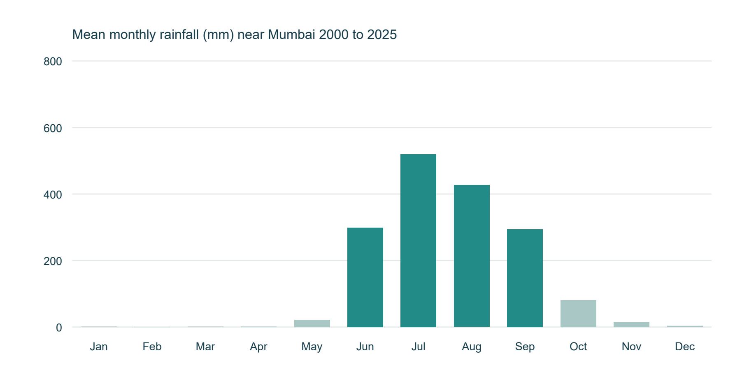
Figure 1 Mean monthly rainfall near Mumbai from 2000 to 2025
The cached ERA5 location has average yearly rainfall of 1,663.5 mm, with 92.5% falling in June–September. This establishes strong seasonality at this example location; it is not a catchment-wide rainfall series for every flood event.
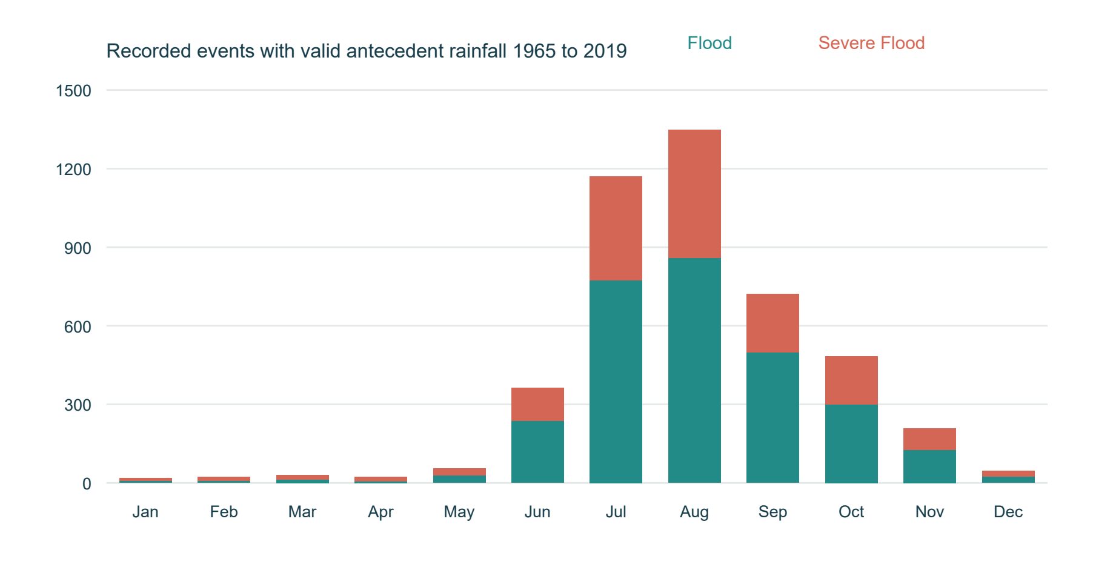
Figure 2 Recorded flood events by onset month from 1965 to 2019
80.2% of the 4,493 supported gauge events begin June–September. Teal and coral distinguish the published Flood and Severe Flood classes. Uneven monitoring and event selection mean counts should not be interpreted as complete national flood probabilities.
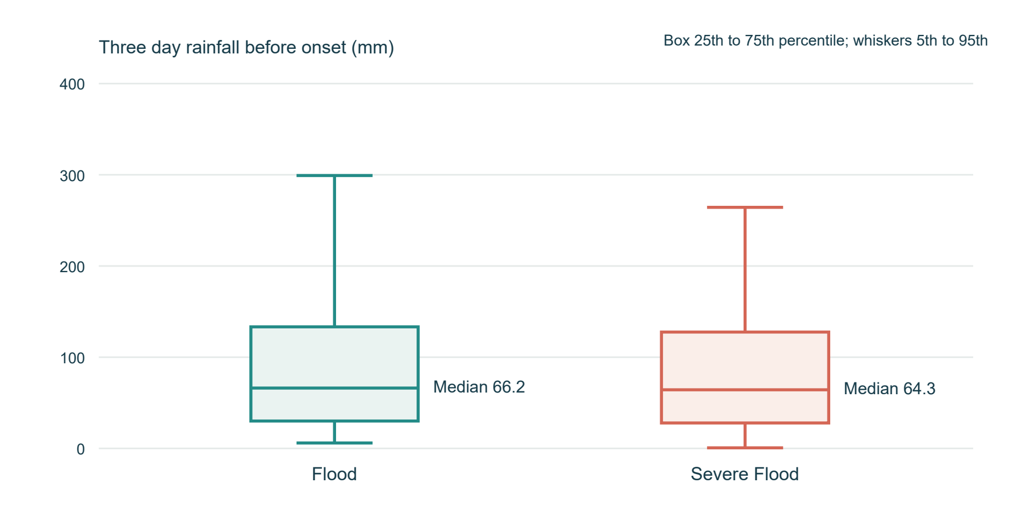
Figure 3 Antecedent three day rainfall by recorded severity
Median rainfall is 66.2 mm for Flood and 64.3 mm for Severe Flood. Boxes span the middle 50% and whiskers the 5th–95th percentiles. Large overlap shows why rain alone cannot identify severity.
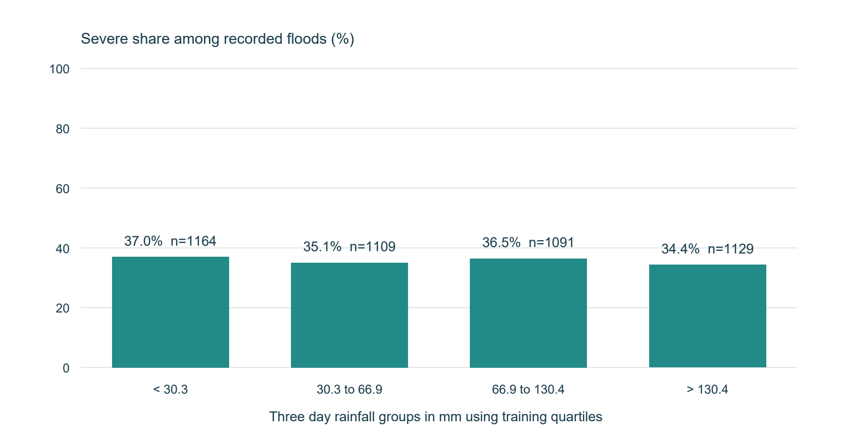
Figure 4 Severe share within training defined rainfall groups
Each bar divides severe recorded events by all recorded floods in that rainfall group; n gives its sample size. These are conditional historical proportions. Gauge composition, drainage and thresholds differ between groups, so the pattern must not be read as a causal rainfall effect or a daily flood probability.
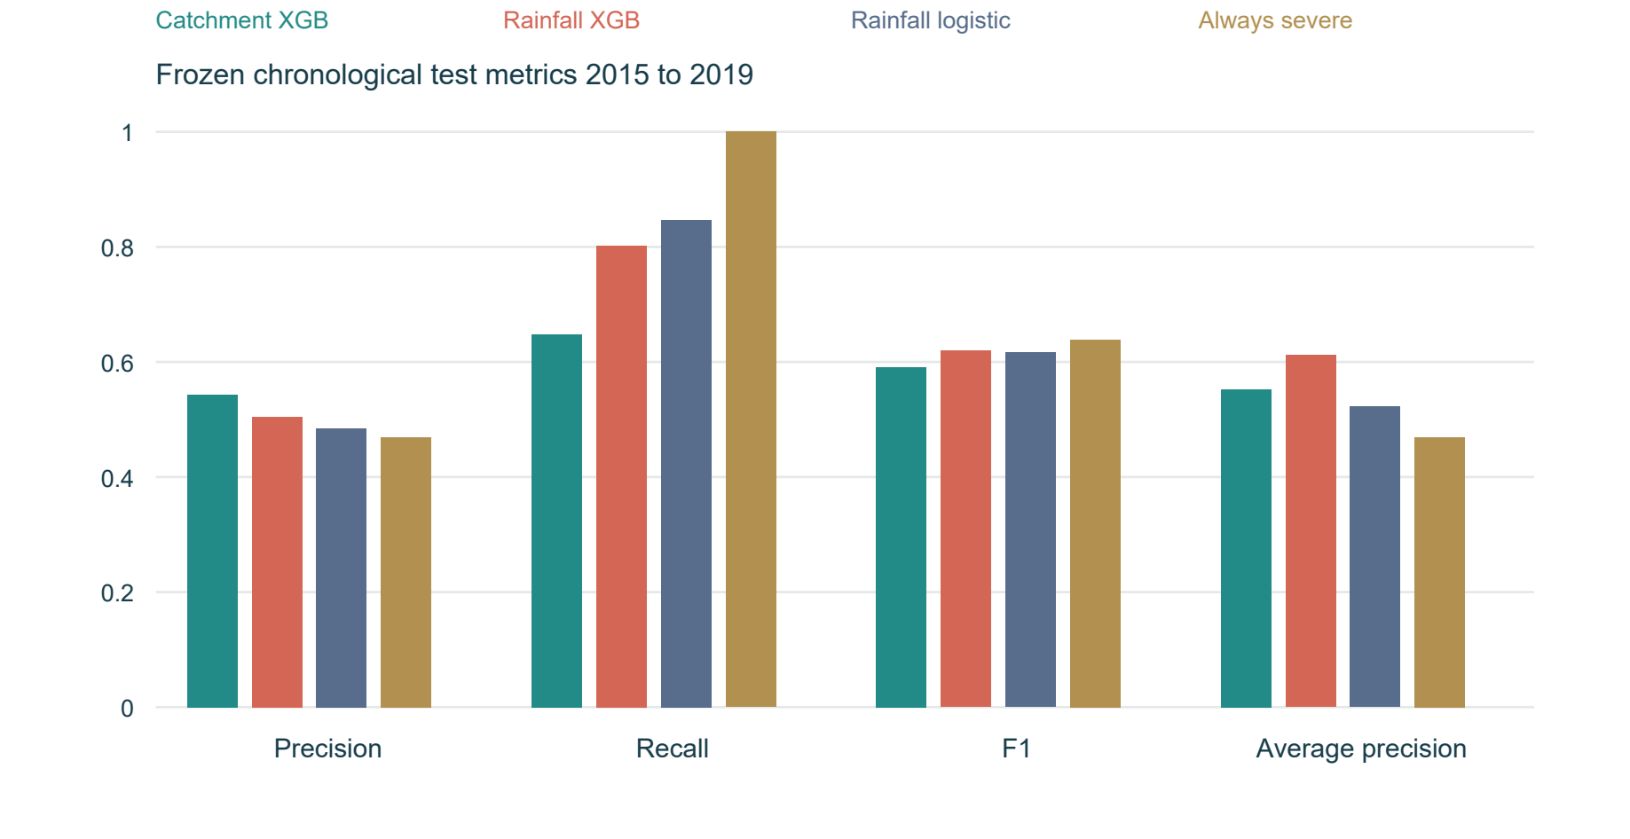
Figure 5 Frozen chronological test metrics and baseline comparison
Rainfall-enhanced XGBoost improves recall and average precision relative to the catchment model in this test, but its precision remains close to one half. Both models fall below always-severe F1. The chart shows the trade-off instead of selecting a winner from the test.
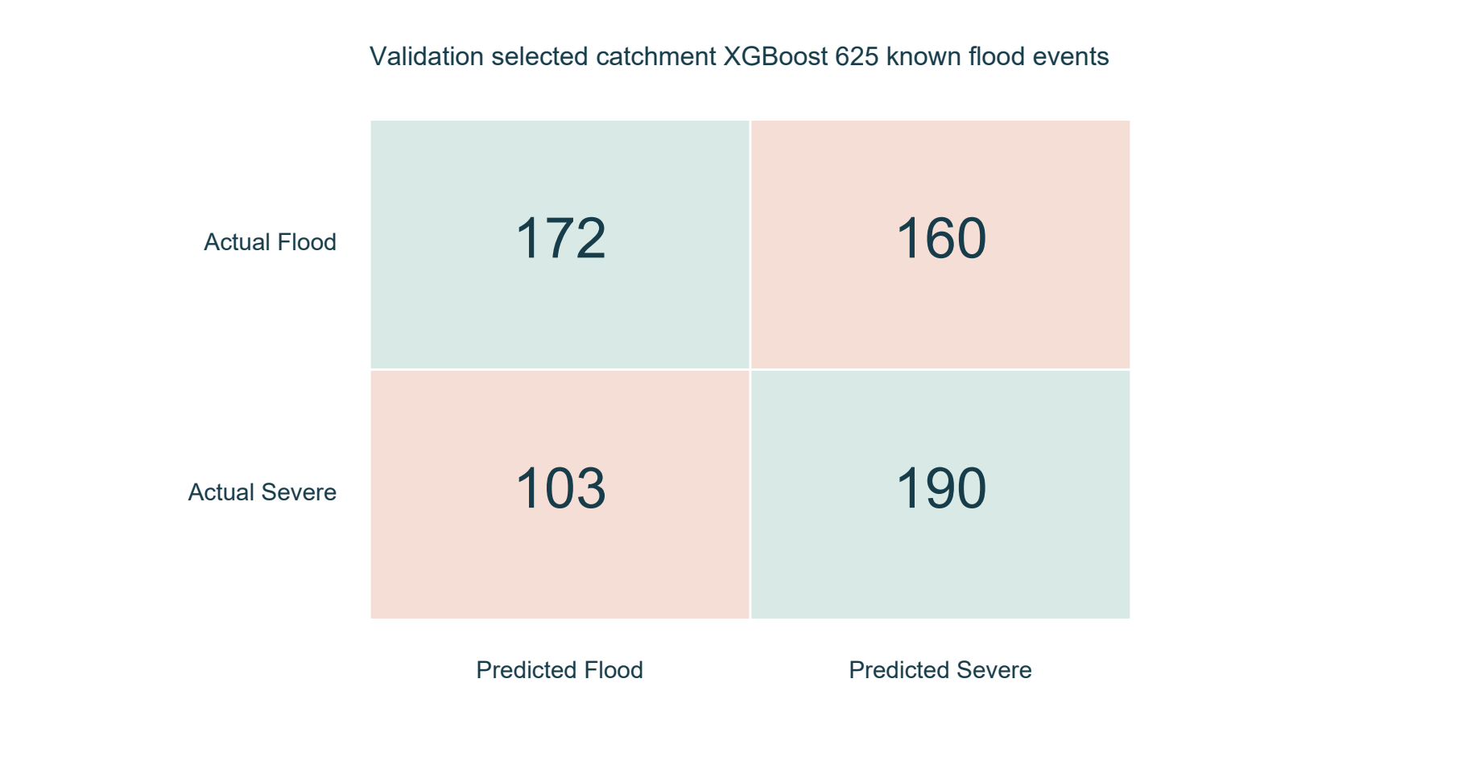
Figure 6 Confusion matrix for the validation selected severity model
Rows show observed labels and columns show estimated labels. The selected model has 172 correctly classified other floods, 160 false severe classifications, 103 missed severe floods and 190 correctly identified severe floods. Class Flood is an actual flood, not a no-flood observation.
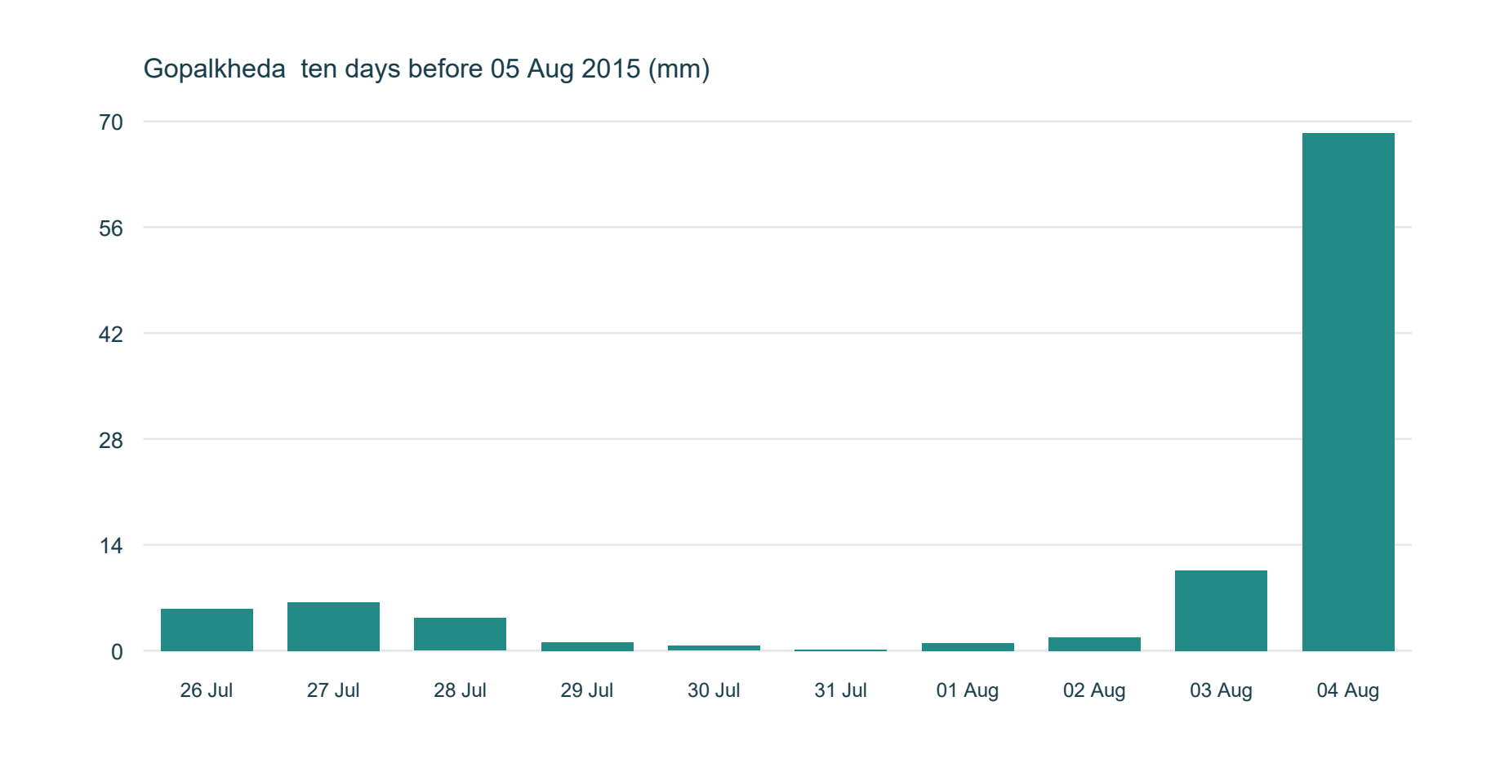
Figure 7 Daily rainfall before a held out Maharashtra event
This example is Gopalkheda, onset 2015-08-05, selected as the first chronological Maharashtra test event without inspecting model success. The last three days sum to 80.8 mm and ten days to 100.0 mm. Every plotted day precedes onset; the recorded label is Flood.
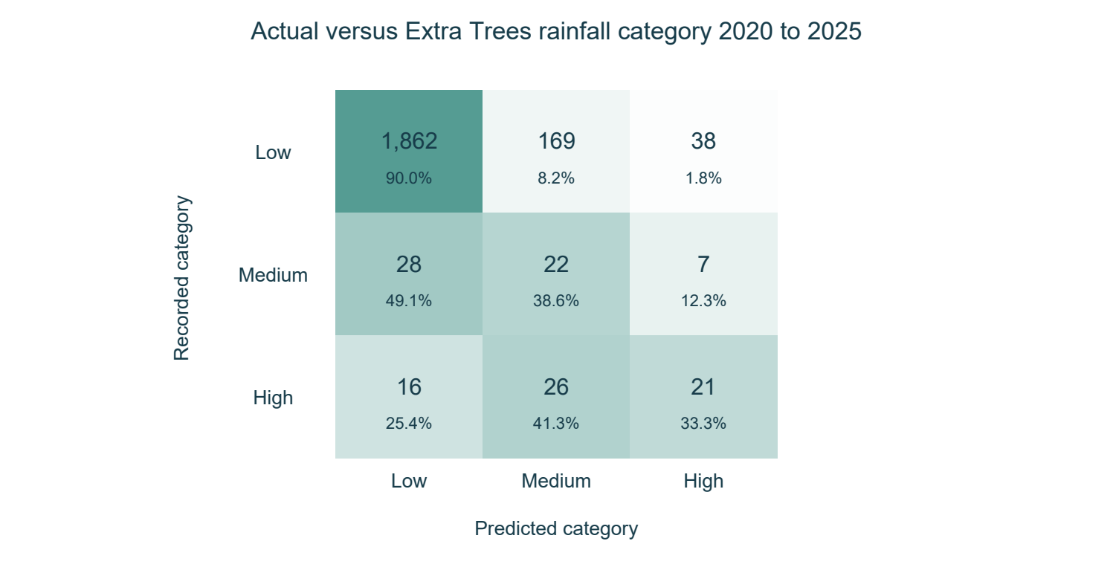
Figure 8 Actual versus forecast three day rainfall categories
The separately frozen Extra Trees rainfall prototype is evaluated on 2,189 daily origins during 2020–2025. Each row is a recorded category and each column is a forecast category; percentages are within the recorded class. Only 21 of 63 High origins are identified, while 45 non-High origins are flagged High. The mostly Low distribution explains why high overall accuracy would conceal poor detection. These categories describe rainfall totals, not flood occurrence.

5 4 Discussion and Application
The interface has four top navigation pages: Rainfall & floods, Prediction, Rainfall history and Flood records. The map colours actual gauges by relative historical severe share among recorded floods, using training-gauge terciles; fewer than ten selected events are gray. Selecting a marker opens that gauge for event exploration. It is not a map of future flood probabilities or district-wide weather predictions.
Rainfall history includes daily, monthly and yearly charts, June–September monsoon comparisons, daily heavy-rain flags from the fixed 2000–2015 wet-day 95th percentile, and monthly departures from fixed calendar-month averages. Months two baseline standard deviations above average are flagged. Incomplete periods remain unknown. These rainfall anomalies are not confirmed flood events.
The main problem statement is supported by direct rainfall–flood analysis rather than an unrelated river-level regression output. The dashboard opens on matched rainfall and recorded flood severity, offers state/year and rainfall-window filters, and lets users inspect the ten days before an actual event. Separate pages preserve yearly/monthly/daily rainfall history and reported flood records. CSV exports retain the underlying evidence.
The optional ML comparison is shown only for held-out 2015–2019 events. It displays estimated severity from catchment and rainfall feature sets alongside the observed label, with its conditional meaning stated. It does not turn a model score into a chance of a future flood. The map uses measured gauge coordinates and does not imply district coverage.
The data preparation and analytical objectives are achieved. The target-specific ML lifecycle is demonstrated, including an important negative finding: adding rainfall does not by itself produce a dependable flood warning model. Future occurrence prediction requires independently observed non-event periods as well as floods and richer causal hydrological inputs.

6 Conclusion
We implemented historical rainfall and recorded flood-severity analysis with a visible rainfall-based Prediction module. The matched records establish strong seasonality but broad overlap in rainfall before different flood severities. The conditional severity model fails to exceed always-severe F1. The separate three-day rainfall experiment compares three ML families against simple baselines; persistence wins validation, while the Extra Trees prototype detects only one third of High test origins. The dashboard therefore supports transparent exploration and manual scenarios, with coverage and weak forecasting performance stated clearly. Missing reports are never relabelled as non-flood days.

7 Limitations and Future Work
The principal limitation is event-only sampling: genuine non-flood monitoring periods are absent. Therefore the model estimates severity conditional on an event and cannot estimate population flood occurrence. The analysis also has uneven gauge coverage, within-gauge dependence, historical monitoring changes, uncertain real-time availability and a documented rainfall coverage cutoff. Static catchment/climate summaries may use more recent vintages than the recorded event. Rainfall alone omits upstream inflow, reservoir operation, soil moisture and local flood defences.
The added daily rainfall indicator is restricted to one existing near-Mumbai ERA5 grid point. It cannot be extrapolated across the 155 event gauges or all districts. The supplied archive has no dynamic humidity, temperature, soil moisture or river observations for this new task. No live readings are fetched. Consecutive three-day outcomes overlap, and the years were already present in the historical application; prospective evidence is still needed.
The High-category precision and recall remain low, and ML does not beat persistence on validation. A Low rainfall category does not mean a location is safe from flooding: upstream flow, drainage and antecedent hydrological conditions are not fully observed. No weather risk band is represented as a calibrated flood probability.
Model limitations include substantial false severe classifications, missed severe events, poor new-gauge discrimination and calibration weaker than simple constant baselines. The observed rainfall-model improvement intervals include zero, and previously inspected test periods are not a fresh prospective evaluation. No filter, event label or decision threshold is changed to improve those results.
Next steps should prioritise verified continuous flood/non-flood observations with consistent spatial units, appropriate historical weather and hydrological inputs, gauge-aware temporal validation and independent probability calibration. A future prespecified study should reserve genuinely new years and locations, compare simple baselines and quantify event-cluster uncertainty before operational use. District impact modelling would require reliable event-to-district linkage, not whole-period aggregate impacts as predictors.

8 References and Appendix
References
[1] Kuntla S K and Saharia M. 2025. INDOFLOODS A comprehensive database for flood events in India enhanced with catchment attributes. Bulletin of the American Meteorological Society 106 E333–E343. https://doi.org/10.1175/BAMS-D-24-0008.1
[2] Kuntla S K and Saharia M. 2025. INDOFLOODS public dataset and variable descriptions. Zenodo record 14584655. https://zenodo.org/records/14584655. Accessed 24 October 2026. Public open-gauge data used with attribution; restricted gauges excluded.
[3] Saharia M and collaborators. India Flood Inventory Impacts 1967–2023 version 4. Zenodo record 16994648. https://zenodo.org/records/16994648. Accessed 24 October 2026.
[4] Saharia M and collaborators. 2021. India flood inventory creation of a multi-source national geospatial database to facilitate comprehensive flood research. Natural Hazards. https://doi.org/10.1007/s11069-021-04698-6
[5] Open-Meteo. Historical Weather API documentation. ERA5 daily rain_sum. https://open-meteo.com/en/docs/historical-weather-api. Accessed 24 October 2026. The cached location is an ERA5 point estimate, not catchment event rainfall.
[6] Tang G and collaborators. EM-Earth precipitation product cited in the INDOFLOODS rainfall study. https://doi.org/10.1175/BAMS-D-21-0106.1. Version 1 rainfall coverage ends in 2019; source study documentation controls this exclusion.
[7] scikit-learn developers. Model evaluation and scoring documentation. https://scikit-learn.org/stable/modules/model_evaluation.html. XGBoost developers. Python API reference. https://xgboost.readthedocs.io/en/stable/python/python_api.html. Accessed 24 October 2026.
[8] Original RiskRadar codebase provenance. https://github.com/nitinc264/Flood-prediction-Model. The final analysis modules and event-severity experiments are maintained in the local project; the inherited annual classifier and subsequent river-level study are preserved in history and are not the main application.

Reproducibility Appendix
The project root contains rainfall_flood.py for matching semantics and model inference, rainfall_flood_page.py for the primary dashboard, historical_page.py for existing rainfall history and scripts/prepare_rainfall_flood_release.py for release preparation. data/rainfall_flood/matched_events.csv is the 4,493-row matched analysis table; manifest.json records source hashes, coverage and training-derived rainfall groups.
experiments/indofloods_severity_v1 preserves the original chronological protocol, 32 XGBoost candidate fits, selected pipelines, validation/test predictions and frozen metrics. experiments/rainfall_flood_release_v1 packages the same fitted models for historical UI comparison without retuning or claiming a new independent test.
Run from the RiskRadar folder: .\.venv\Scripts\python.exe -m streamlit run app.py --server.address=127.0.0.1 --server.port=8501. Open http://127.0.0.1:8501/. Existing datasets and bundles load locally; uncached rainfall-history locations need their historical archive download.
The 25 common model inputs are 19 numeric climate/terrain/location fields, four categories and two cyclic month features. The rainfall model adds T1d–T10d, rain_max_10d, rain_std_10d, rainy_days_10d and recent_3d_share. Complete feature names, preprocessing, seed, thresholds and file checksums are recorded in the frozen protocol and model bundle. Outcome columns are retained for analysis but never passed as predictors.
Appendix checklist:
Done | Checklist item | Brief evidence / notes
☑ | Dataset source and citation included. | References 1 to 6 identify the event, rainfall and inventory sources and their roles.
☑ | Important code/notebook or repository link provided, if required. | Reference 8 and the appendix identify code provenance, modules and exact run command.
☑ | Additional graphs, tables or diagnostic outputs attached where useful. | Eight measured figures, descriptive statistics and model diagnostics are included.
☑ | No confidential, personal or restricted data disclosed. | Only public environmental records are included; identity/contribution/signature fields are reserved for the team.

Rainfall Reproducibility Evidence
rainfall_risk.py defines causal rainfall features, category bands and inference. prediction_page.py renders the Prediction page and anomaly views. scripts/train_rainfall_risk.py preserves the predeclared split and candidate comparison; experiments/rainfall_risk_v1 holds its protocol, split files, six ML pipelines, frozen validation selection and final retrospective predictions. These files are distinct from the conditional INDOFLOODS severity experiment.
The rainfall bundle preserves persistence as the overall validation winner. The separately loaded Extra Trees comparison is selected from ML candidates by validation only. Saved-date inference uses past observations; scenario inference uses the user-provided 14 days. Source values after the issue date never enter features.

9 Team Members and Individual Contributions
Record each member’s actual work and deliverables. Contribution percentages, if used, should total 100%.
S. No. | Member name / Roll No. | Tasks / Life-cycle stages handled | Specific contribution / deliverable | Approx. contribution (%)
1
2
3
4
Contribution areas include problem definition, data collection, matching and preparation, EDA, modelling, evaluation, interface development, interpretation, report writing and presentation.
Member name / Roll No. | Confirmation of contribution | Signature (if required)
Team declaration: We confirm that the contribution details above accurately represent the work completed by each team member.
Team leader name and roll number __________________________ Date ______________

