4D Coronary LCA Tree Generator
  - Final Technical, Validation, and User Deliverable Report
____________________________________________
Final release outcome
52/52 population trees accepted; all 50 real-versus-generated comparisons passed; four controlled healthy/disease 4D cases passed engineering and major-vessel LCA anatomical audits.

Field | Value
Release | 4D Coronary LCA Generator 1.0.0
Model scope | population-derived major-vessel LCA: LMCA, LAD, LCX
Repository branch | latestt_branchh
Report date | 22 August 2026
Software status | PASS
Clinical status | Not clinically validated; research/engineering prototype

Prepared as the master submission document; Section 13 provides a verified handoff for later presentation authoring.

Document map
- 1. Executive summary and submission claim
- 2. Scope, objectives, and non-claims
- 3. Repository and system architecture
- 4. Source data, anatomical assignment, and coordinate systems
- 5. Statistical shape model and training population
- 6. Synthetic anatomy generation and acceptance
- 7. Radius taper, disease, motion, and pulsatility
- 8. Output contract, visualization, and operating workflow
- 9. Verification and quantitative results
- 10. Curated case-by-case deliverables
- 11. Installation, CLI, Python API, and reproducibility
- 12. Limitations, risk boundaries, and future work
- 13. Presentation handoff
- 14. Primary literature context
- Appendices: metrics, artifact map, acceptance checklist, and commands
How to read this report
Software correctness, anatomical plausibility, and clinical validation are deliberately separated. A PASS means the implemented engineering contract passed; it never means clinical certification.

1. Executive summary and submission claim
The project is a reproducible generator for a major-vessel left coronary artery scaffold consisting of LMCA, LAD, and LCX. It combines an anatomy-gated population model with radius taper, controlled stenosis, cardiac motion, local lesion compliance, cyclic pulsatility, portable numerical output, ParaView export, interactive visualization, and independent validation.
What is ready
A usable Python API and CLI; a frozen 52-case LCA statistical package; a 52-tree population cohort; 520 motion snapshots; fixed-size XYZ-radius arrays; four controlled disease demonstrations; dashboards, GIFs, interactive HTML, VTK time series, machine-readable audits, and this final report.

Release gate | Final evidence | Status
Source audit | 191 protected LCA records; 181 resolved daughter assignments | PASS
PCA eligibility | 52 cases; unresolved assignments excluded | PASS
Statistical model | 52 x 81 matrix; 13 modes; 95.55% variance | PASS
Population generation | 52/52 accepted in 64 attempts; every baseline represented | PASS
Distribution validation | 50/50 comparisons; zero warnings | PASS
4D population motion | 52 trees x 10 phases; exact junction and clearance | PASS
Submission cases | 4/4 manifests, VTK readbacks, audits and visual packs | PASS
Regression | 103 staged/audit/focused/integrated checks; zero failures | PASS

Submission claim: this is a validated engineering prototype for population-derived major-vessel LCA generation and controlled 4D disease visualization. It is not a complete coronary tree, a hemodynamic simulator, a diagnostic system, a patient-specific model, or a clinically validated medical device.

2. Scope, objectives, and non-claims

2.1 Implemented objectives
- Use the approximately 200-label source collection rather than the early eight-patient prototype.
- Resolve LAD/LCX daughter identity from multiple anatomical signals in a consistent NIfTI RAS frame.
- Represent anatomy in a common LMCA-based cardiac frame and model the LMCA-LAD-LCX tree jointly.
- Generate smooth anatomical scaffolds without altering protected source centerlines or reproducing segmentation noise point-for-point.
- Support focal, diffuse, and tandem stenosis as explicit radius-only modifications.
- Generate a phase-corresponded 4D cycle with deformation, pulsatility, and reduced lesion compliance.
- Export fixed-size arrays, checksummed manifests, VTK/ParaView time series, and presentation-ready visualizations.
- Quantitatively validate topology, anatomy, disease, motion, pulsatility, file integrity, and reproducibility.

2.2 Explicit non-claims
- No population-derived RCA is claimed because the available disconnected RCA candidates are not resolved ground truth.
- No diagonal, septal, obtuse marginal, PDA, PL, or microvascular side branches are generated in the release contract.
- No flow, pressure, CFD, vessel-wall mechanics, myocardium, perfusion, plaque biology, or clinical outcome prediction is implemented.
- Radii, taper, motion, pulsatility, and compliance are auditable prototype parameters rather than learned patient distributions.
- Engineering and anatomical plausibility gates do not establish clinical validity or suitability for patient care.

3. Repository and system architecture
The active system has two layers: the statistical LCA pipeline that produces frozen population artifacts, and the public integrated generator that consumes those artifacts for disease-aware 4D export. Older LCA and RCA utilities remain for traceability and compatibility but are outside the final statistical contract.
Path | Responsibility
pca_ssm_vessel_tree_generator/ | Extraction, frame alignment, surface projection, fixed representation, PCA, static generation, motion, validation, and population export.
vessel_tree_generator/ | Public API/CLI, disease configurations, pulsatility, integrated 4D validation, portable export, audit, visualization, and verification.
lca_vessel_tree_generator/ | Earlier LCA topology, radius, disease, tortuosity, and mesh utilities retained for compatibility.
rca_vessel_tree_generator/ | Separate primitive RCA utilities; excluded from the population-derived release.
tests/ | Staged Batch 2-7 tests and integrated submission contract tests.
outputs/lca_ssm/ | Frozen statistics, compact population evidence, motion summary, and standardized export summary.
submission_release/ | Portable four-case demonstration, visual tools, quantitative audits, reports, and release summary.
examples/ | Ready-to-run focal, diffuse, and tandem JSON disease configurations.

3.1 End-to-end data flow
1. NIfTI label volumes and protected centerlines enter source audit and graph extraction.
2. Multi-signal daughter assignment identifies LAD and LCX and rejects low-confidence cases.
3. A common cardiac frame and ellipsoid support surface make cases comparable.
4. Fixed branch samples form an 81-dimensional joint surface-deviation vector and a 13-mode PCA model.
5. Generation bootstraps a matched empirical baseline and adds small, joint PCA innovation.
6. Static acceptance enforces topology, anatomy, range, progression, collision, and scaffold checks.
7. Radius, disease, motion, and pulsatility produce the phase-corresponded 4D representation.
8. Export writes arrays, metadata, graphs, VTK, previews, hashes, visual packs, and independent audits.

4. Source data, anatomical assignment, and coordinate systems

4.1 Source-data funnel
Stage | Count | Interpretation
Locally available source label volumes | 200 | Original dataset scale; not all become usable LCA records.
Protected LCA centerline records | 191 | Immutable source geometry preserved.
Resolved daughter assignments | 181 | Multi-signal confidence gate passed.
Source + scaffold core-anatomy pass | 65 | Both independent course checks pass after confident assignment.
Ellipsoid-quality exclusions | 13 | Long-tailed/underconstrained support geometry excluded without lowering gates.
PCA/statistics eligible | 52 | All assignment, frame, ellipsoid, integrity, representation, and anatomy gates passed.
Unresolved assignments used | 0 | Excluded from statistics and generation.

4.2 LAD/LCX assignment logic
Daughter identity is not selected from root radius or a single direction vector. Candidate assignments are scored using branch length, negative RAS-Z inferior/apical displacement, displacement-to-length ratios, initial direction, descending-segment fraction, horizontal/circumferential course, terminal lateral reach, and crown-plane behavior. Low score or small assignment margin causes exclusion/manual review.
Expected LAD behavior | Expected LCX behavior
Dominant inferior/apex-directed displacement | Greater lateral/circumferential displacement
Sustained longitudinal descent | Horizontal crown-like course
Typically longer major daughter | Less inferior displacement than LAD
Initial direction contains inferior component | Initial direction contains strong horizontal component

4.3 Coordinate frames and surfaces
Source anatomy is interpreted in NIfTI RAS orientation and mapped into a common right-handed cardiac frame anchored to LMCA and the LCA bifurcation. The fixed front view uses cardiac X-Z with negative Z toward the apex. Surface-relative coordinates store ellipsoid parameters (u, v, normal offset) plus a local tangent-u, tangent-v, and normal deviation basis. Separate LAD and LCX anatomical planes remain descriptive evidence; the generator does not force every centerline point onto an ellipse or plane. The stored surface mapping is an angular/radial parameterization with exact local-basis reconstruction; it is not claimed to be a Euclidean nearest-point-on-ellipsoid solution.

4.4 Original PPT two-plane/two-ellipse contract
The original measurement model remains a first-class deliverable rather than being replaced by the later ellipsoid/PCA architecture. For each successful case, source XYZ is fitted by two independent SVD/least-squares planes. Points are expressed in each measured plane and passed to a separate actual ellipse estimator for a, b, tilt, landmark theta, angular extent, and residual calculation. The two measured planes are not forced orthogonal; only the separately derived common cardiac frame is orthonormal.
Original requirement | Verified evidence
NIfTI discovery | 200 labels
Centerlines / landmarks / two planes / two ellipses | 191 cases
Per-point ellipse deviations | 77,337 records
Source-coordinate change | 0 mm
Segment-length change | 0 mm
Population outputs | Ellipse a/b/tilt, circular landmark theta/extents, plane angle, fit and residual statistics

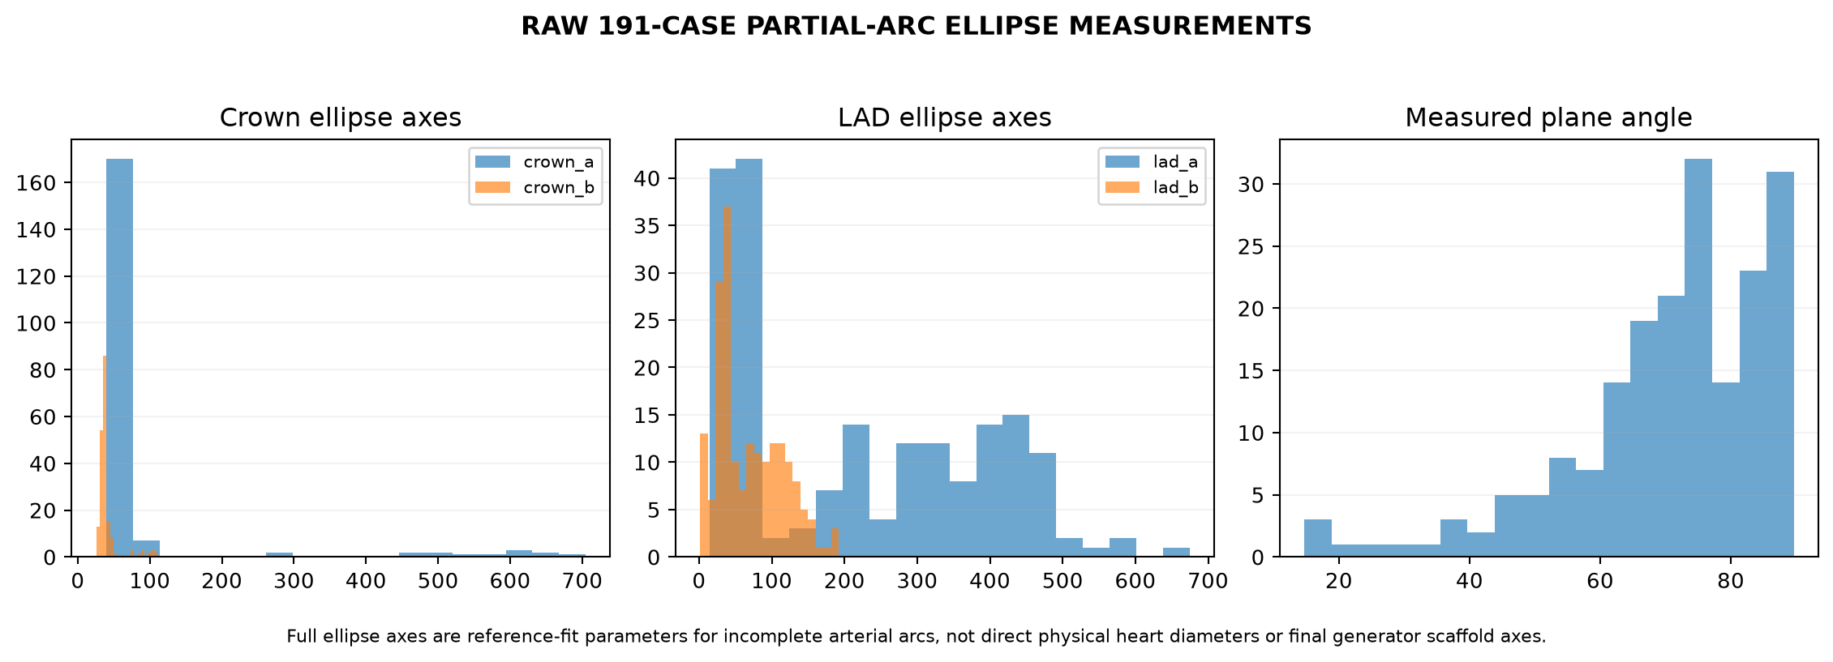
RAW 191-case partial-arc ellipse measurements. Full fitted ellipse axes describe incomplete-arc reference fits; they are not direct physical heart diameters or final generator scaffold axes.

4.5 Technical Design Specification Alignment
The final architecture was traced against the primary technical design. The two measured ellipses provide the triaxial heart-scaffold dimensions: the coronary ellipse supplies a and b, while the cardiac-Z-aligned axis of the interventricular/LAD ellipse supplies c, with explicit quality handling for underconstrained partial arcs. These ellipses are scaffold measurements, not LAD or LCX path molds. Arteries retain their measured or generated surface-relative trajectories and are never snapped onto planar ellipse arcs.
Design component | Alignment | Evidence / limitation
Two anatomical planes | EQUIVALENT | Measured coronary and LAD references retained; the measured LAD plane differs materially from the simplified cross-product example and is the validated downstream reference.
Two ellipses -> ellipsoid | EXACT | Per-case a,b,c provenance is machine-traced for all eligible cases.
u, v, offset representation | EQUIVALENT | 24,657 eligible source points; maximum round-trip error 3.64e-14 mm.
Joint deviation PCA | EXACT | 81 surface-relative features: LMCA 5 + LAD 12 + LCX 10, each with tangent-u, tangent-v and normal coefficients; not raw XYZ PCA.
B-spline chart | PARTIAL | Protected shape-preserving XYZ spline is re-parameterized into the ellipsoid basis. A literal u/v candidate was evaluated but not promoted: 26/52 LAD controls touch a polar singularity and P95 maximum path difference is 5.37 mm.
Motion | EQUIVALENT | Radial contraction, longitudinal shortening and torsion deform the ellipsoid-associated points; nine independent positions plus a closure frame are preserved.
RCA | DELIBERATE DATASET DEVIATION | Disconnected candidates are not sufficiently reliable annotated RCA identity for population training.
Side branches | NOT IMPLEMENTED | No population-derived identities were sufficiently validated; random branches are not fabricated.

The real 52-case surface evidence gives LAD net v progression 1.111 +/- 0.553 rad and LCX total circumferential u travel 1.147 +/- 0.376 rad. The accepted generated cohort has 40/52 cases satisfying the deliberately strict combined surface-role descriptor; the other 12 retain verified eligible real-baseline variation. No PCA, frame, spline/reconstruction, or validator drift was found, so the frozen cohort was not regenerated.
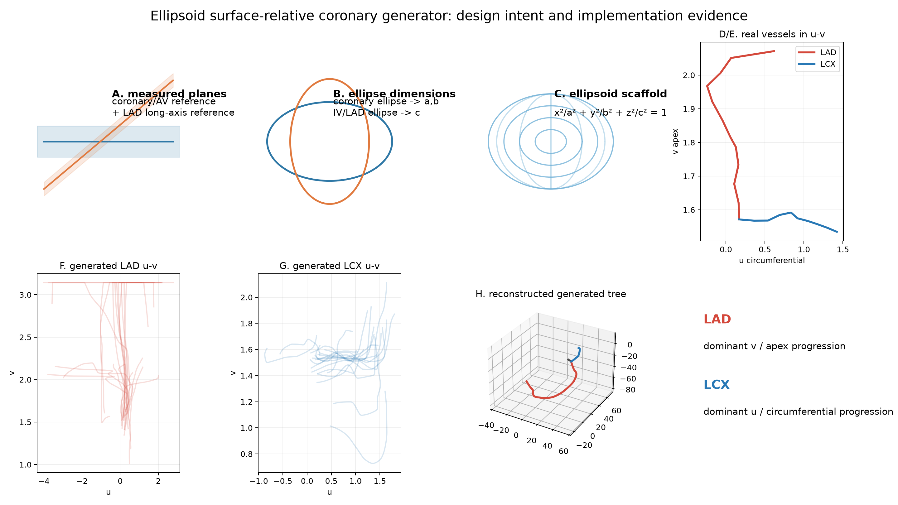
Technical design alignment: measured planes and ellipse dimensions define the ellipsoid scaffold; LAD and LCX are then represented and assessed by their surface-relative u-v trajectories before 3D reconstruction.

5. Statistical shape model and training population
The primary 81-dimensional PCA is not raw cardiac XYZ. It is the specification-faithful LCA-only joint surface-deviation model: 27 fixed points, each represented by tangent-u, tangent-v, and normal coefficients relative to its case-specific ellipsoid. This retains within-vessel and cross-vessel covariance while the ellipsoid and named u-v-offset landmarks define the global scaffold and endpoints.
Model item | Final value
Branch order | LMCA, LAD, LCX
Fixed samples | LMCA 5; LAD 12; LCX 10
Feature dimension | 27 points x 3 = 81
Training cases | 52
Retained modes | 13
Variance cutoff | 95.0%
Actual retained variance | 95.55%
Maximum mathematical rank | 51 for 52 centered observations

Mode | Variance | Cumulative | Coefficient SD
1 | 42.470% | 42.470% | 48.216
2 | 16.567% | 59.037% | 30.114
3 | 9.395% | 68.432% | 22.678
4 | 7.813% | 76.244% | 20.680
5 | 5.981% | 82.225% | 18.094
6 | 4.022% | 86.248% | 14.839
7 | 2.443% | 88.691% | 11.565
8 | 1.849% | 90.540% | 10.061
9 | 1.419% | 91.959% | 8.812
10 | 1.207% | 93.165% | 8.127
11 | 0.905% | 94.071% | 7.039
12 | 0.777% | 94.848% | 6.521
13 | 0.699% | 95.547% | 6.187

PCA scores are centered at approximately zero. Coefficient standard deviations are the square roots of the learned eigenvalues. Generation does not sample an unconstrained point cloud: it starts from a complete case-matched empirical score and adds a clipped standard-normal innovation multiplied by the mode SD and the validated scale 0.04. This preserves coordinated population structure and avoids independent point noise.
Training metric | Mean +/- SD | Central 95% | Observed/definition
LMCA length (mm) | 17.177 +/- 15.062 | 5.281 to 54.223 | 4.472 to 72.780
LAD length (mm) | 120.685 +/- 28.333 | 71.832 to 168.784 | 58.508 to 187.545
LCX length (mm) | 77.092 +/- 23.520 | 42.565 to 121.792 | 40.072 to 129.452
LAD-LCX angle (deg) | 90.807 +/- 24.699 | 57.729 to 151.506 | 49.496 to 173.795
LMCA tortuosity | 1.055 +/- 0.070 | 1.006 to 1.239 | arc/chord distance metric
LAD tortuosity | 1.373 +/- 0.207 | 1.114 to 1.812 | arc/chord distance metric
LCX tortuosity | 1.264 +/- 0.142 | 1.047 to 1.532 | arc/chord distance metric

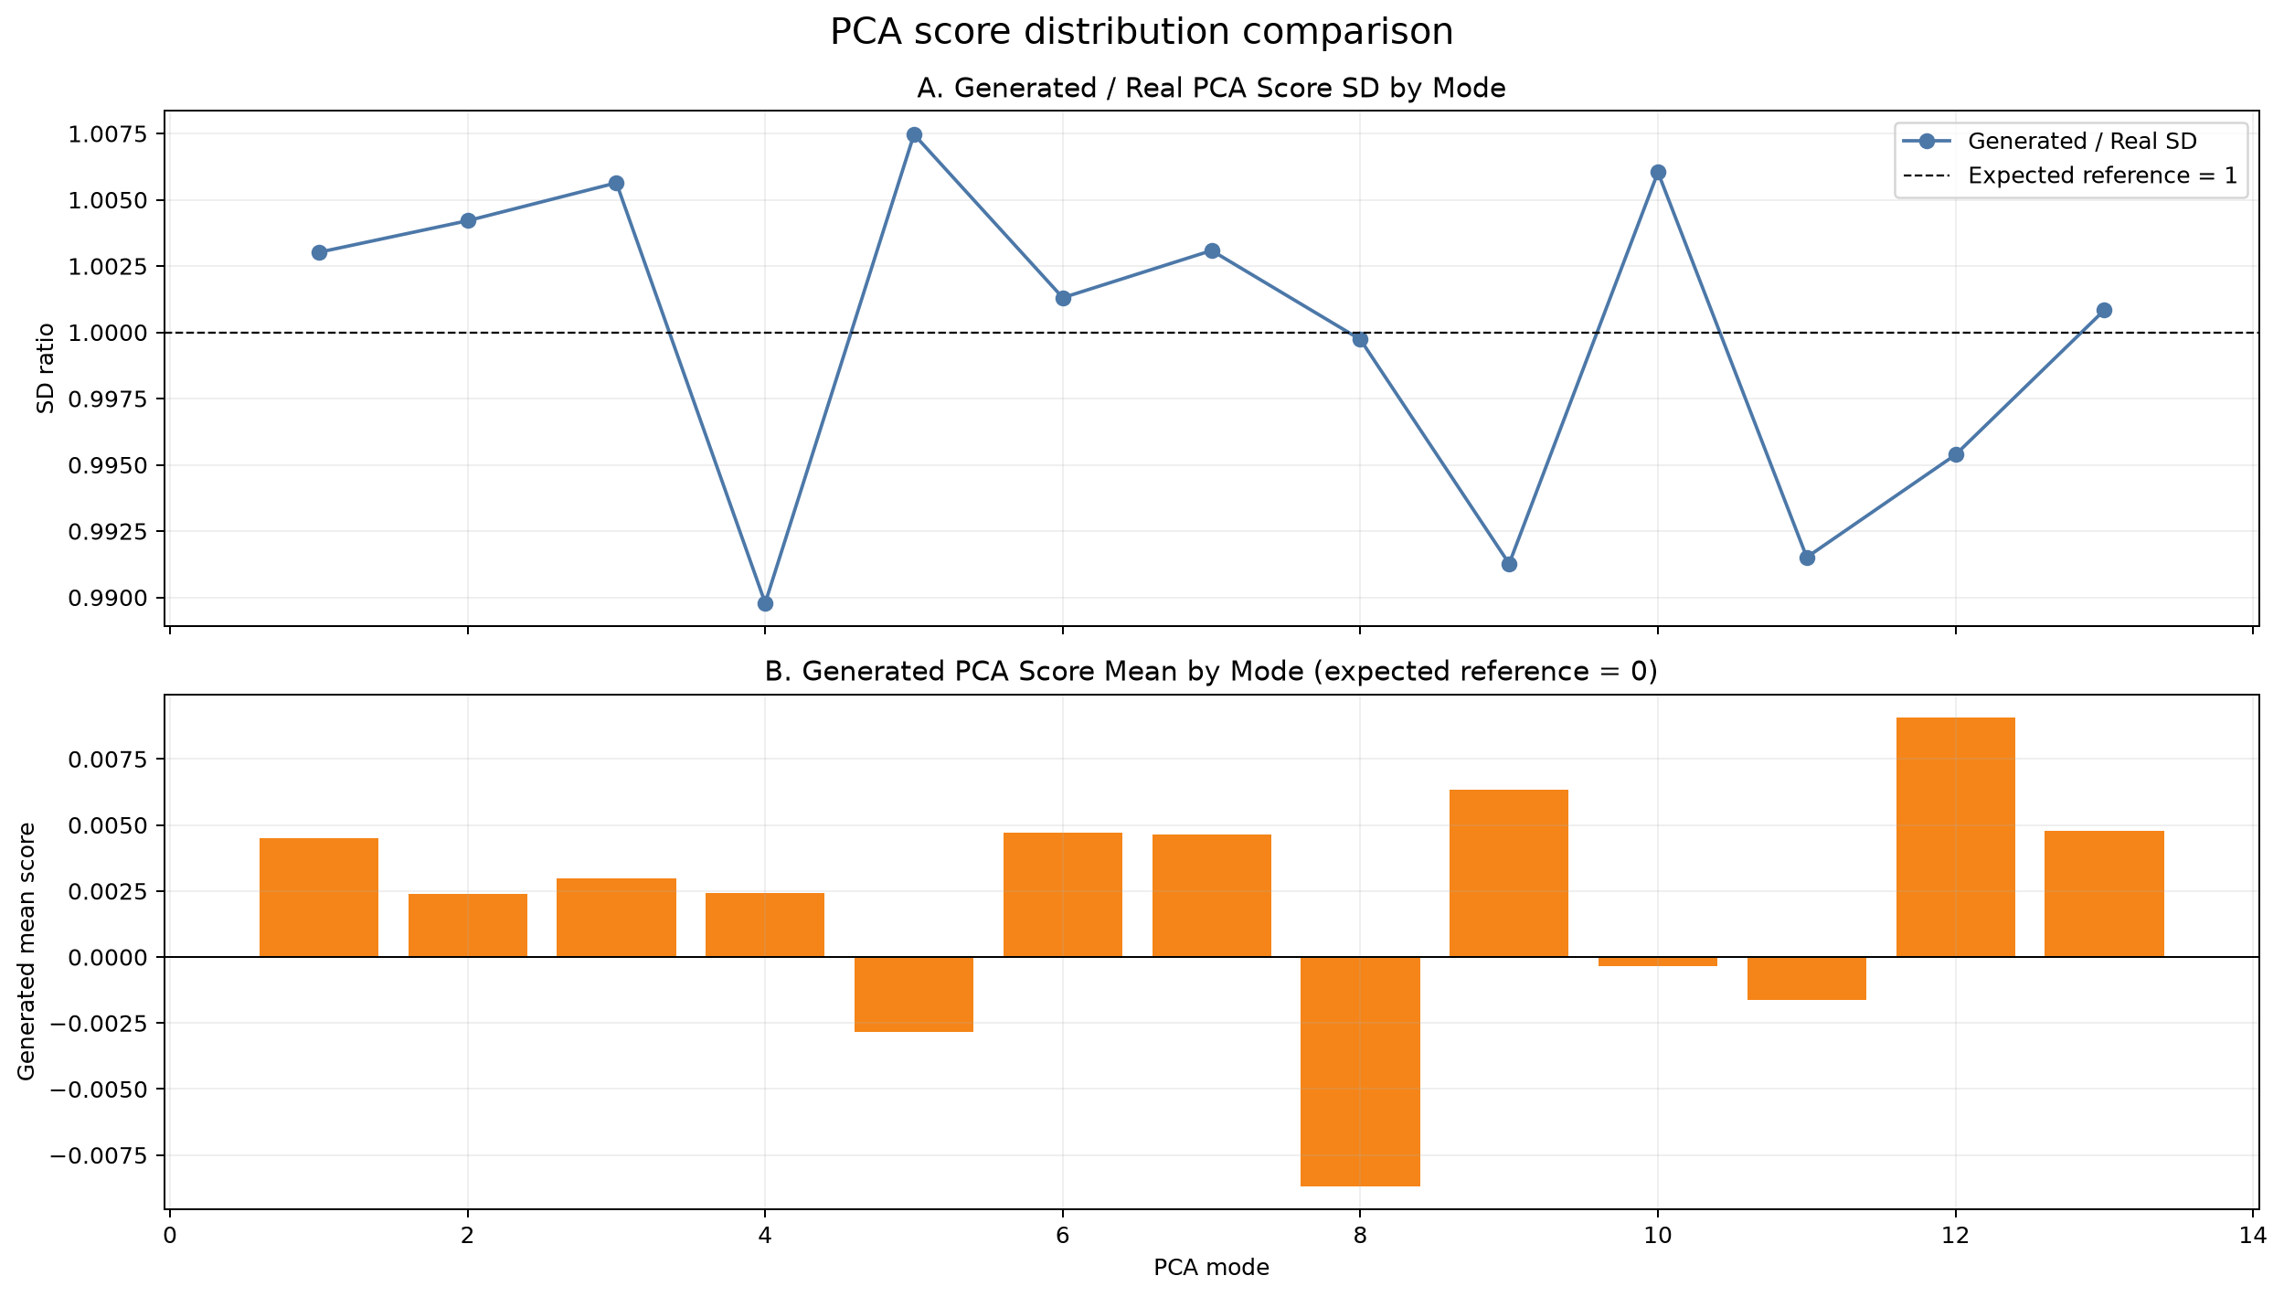
Figure 1. Retained PCA-score comparison between eligible real references and the final generated cohort.

6. Synthetic anatomy generation and acceptance
Each synthetic tree uses a joint empirical bootstrap of ellipsoid and named landmarks, the exact matched trajectory/local-basis representation for the scheduled source case, and centered joint PCA innovation. Endpoint innovation trends are removed so the ostium, shared bifurcation, and terminals remain exact. Unlearned pointwise noise and a second hand-tuned tortuosity perturbation are disabled. The advanced generator generalizes the original two-ellipse scaffold: it does not literally resample two planar ellipse arcs, and this distinction is deliberate and documented.
Generation control | Final policy
Canonical cohort size | 52, one per eligible empirical baseline before any baseline repeats
PCA innovation | 0.04 scale; normal scores clipped to +/-3 SD
Attempts | Up to 250 per requested accepted tree
Topology | LMCA[-1] == LAD[0] == LCX[0] exactly
Endpoints | Empirical ostium, bifurcation, LAD terminal, and LCX terminal preserved
Noise | No independent point-by-point random noise
RCA | Excluded from final statistical model and generation
Dense curve | Normalized-arc shape-preserving cubic B-spline; explicit SciPy BSpline evaluation

6.1 Static acceptance hierarchy
1. Valid finite Nx3 arrays and all mandatory branches present.
2. Exact LMCA-LAD-LCX junction equality and separated daughter terminals.
3. LMCA shorter than both major daughters.
4. Relative daughter-role gate: LAD is at least 10 mm more inferior than LCX; LCX remains comparatively horizontal and more lateral. Absolute apex-reach checks are descriptive warnings, not hard acceptance.
5. No nonlocal self-intersection and no unintended inter-branch collision below the configured clearance.
6. Ellipsoid axes and branch lengths inside observed real hard limits; central 95% departures remain warnings.
7. Tortuosity, obliquity, backward progress, terminal progress, and maximum local turn inside learned observed extrema.
8. VTK files reopen with complete named blocks and point arrays.

6.2 B-spline construction
The final empirical controls are the fixed 5/12/10 normalized-arc samples. Stable PCHIP Hermite derivatives are converted interval-by-interval to cubic Bezier controls, assembled as a clamped cubic B-spline with repeated interior knots, and evaluated through SciPy BSpline at 60/180/160 dense LMCA/LAD/LCX samples. The first and last points are overwritten with exact controls and the daughter starts are snapped to the LMCA terminal. This is a real B-spline basis representation, not a polyline. Unconstrained global cubic trials were rejected because they introduced hooks and violated learned progression/tortuosity limits. The accepted implementation reproduces the prior stable path to numerical precision while making the spline basis explicit. The protected spline interpolates the fixed controls in cardiac XYZ; every dense sample is then re-parameterized and reconstructed in u, v, offset and the ellipsoid local basis. It is therefore surface-relative, but only partially aligned with a literal global u-v spline because the current LAD chart reaches a polar singularity in 26 of 52 eligible baselines.
Final limitation fixed
The earlier 25-tree cohort had one LMCA local-turn distribution warning. The 0.04 innovation calibration and learned branch-course hard bounds produced 52/52 accepted trees with 50/50 distribution checks passing.

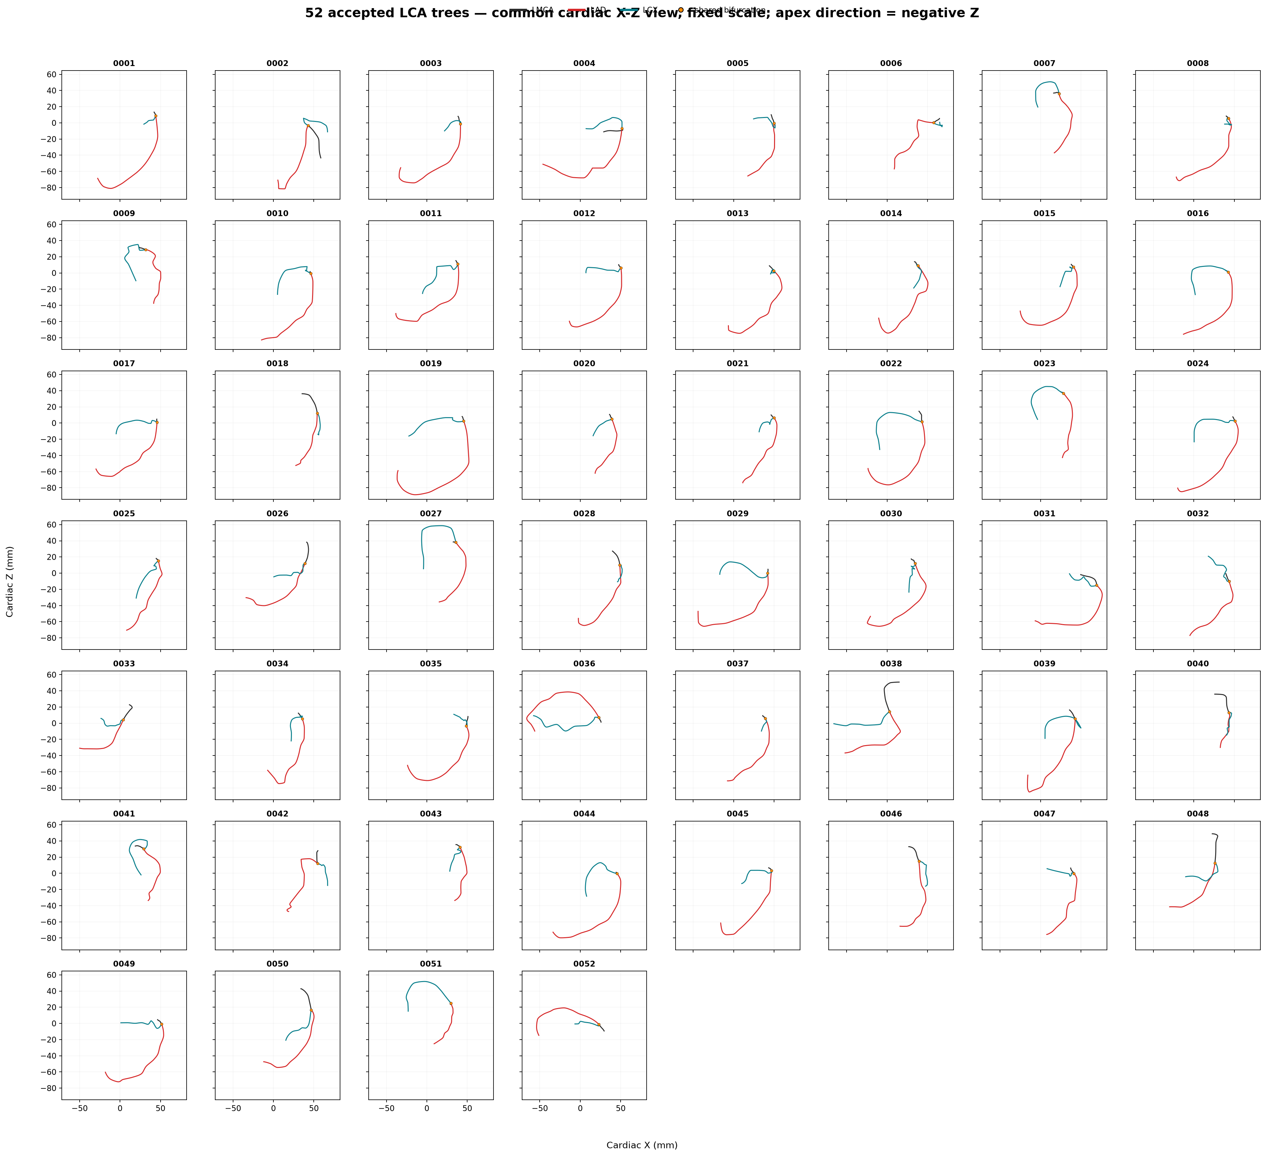
Figure 2. All 52 accepted trees in a common fixed-scale cardiac X-Z view. Colors are machine-checked: LMCA dark gray, LAD red, LCX teal; negative Z points toward the apex.
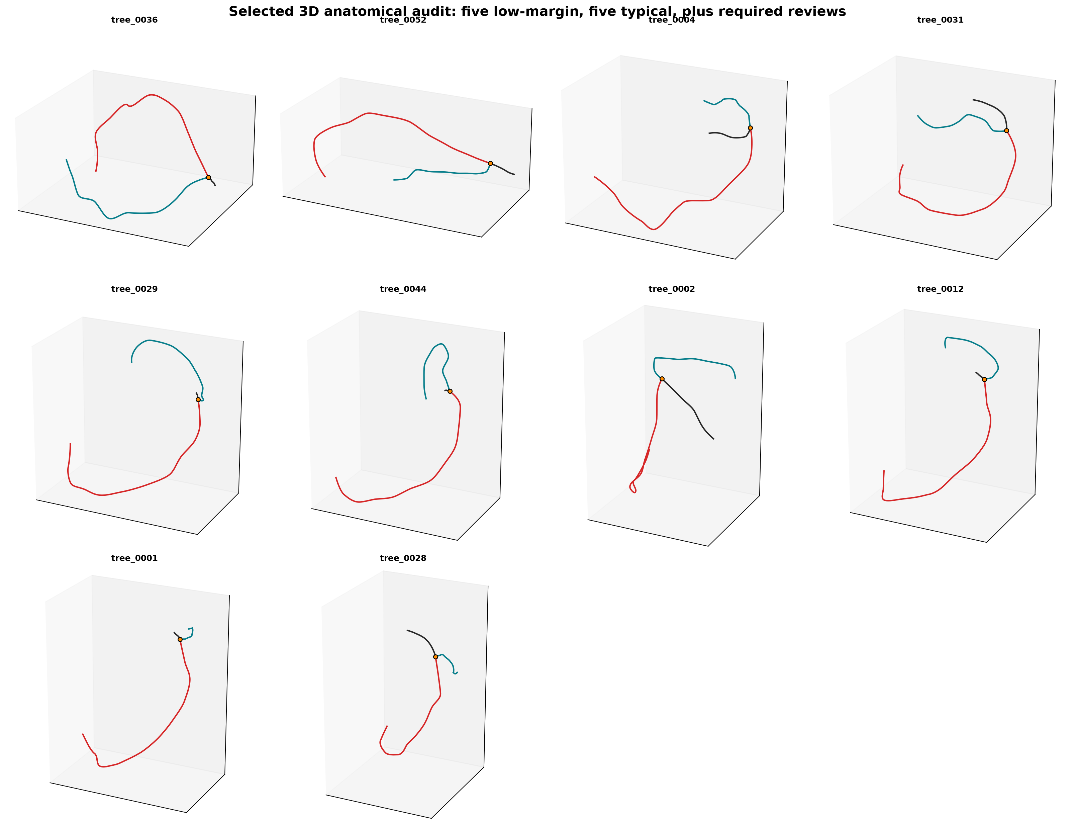
Selected 3D audit views include low-margin, typical, and specifically requested trees 0036 and 0052; apparent 2D crossings are assessed with 3D clearance metrics.
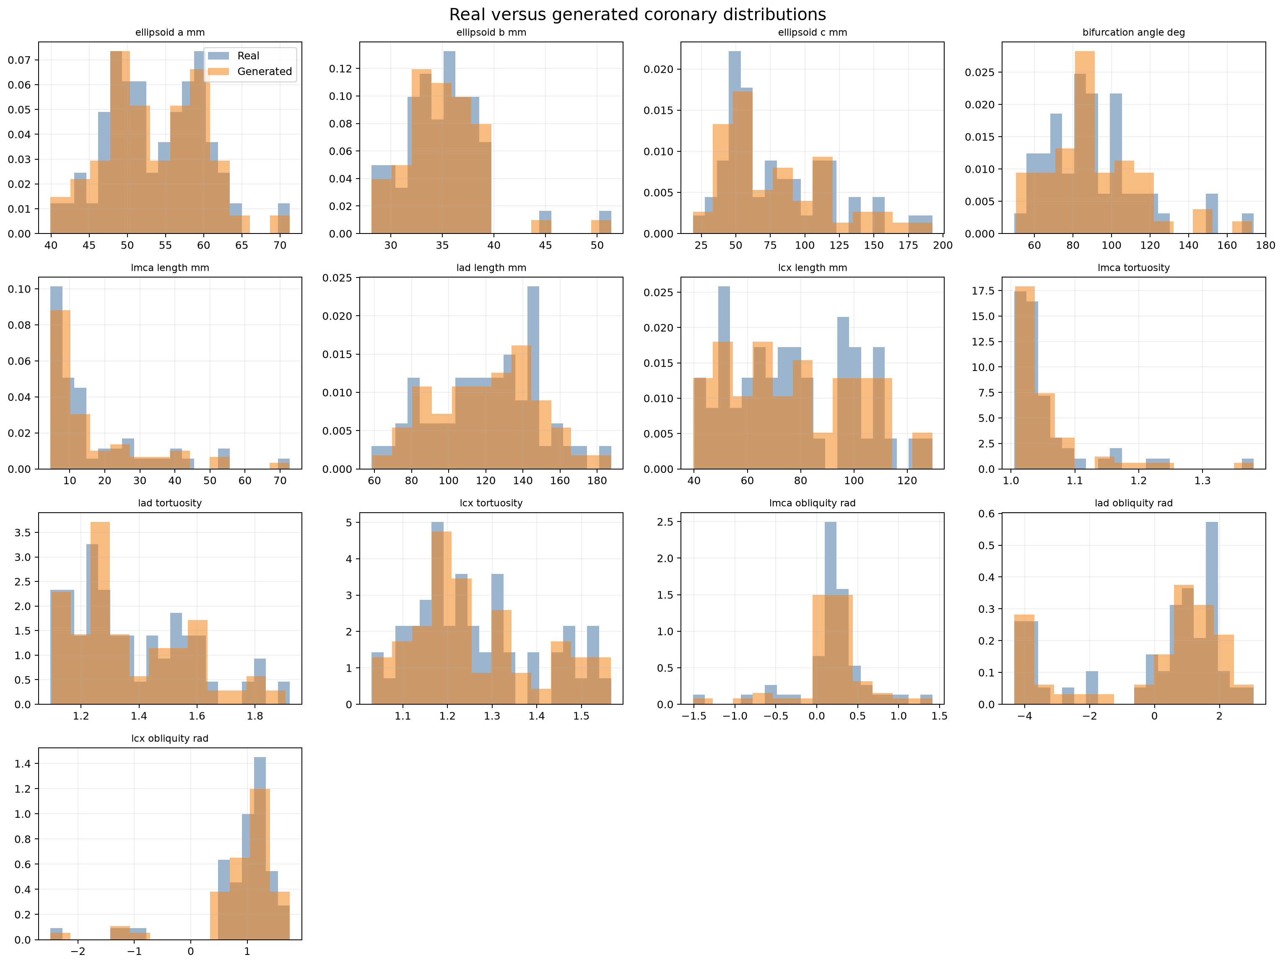
Figure 3. Real-versus-generated length, angle, tortuosity, landmark, and scaffold distributions.

7. Radius taper, disease, motion, and pulsatility

7.1 Static radius model
Branch | Proximal radius | Taper | Representative proximal diameter
LMCA | 2.0 mm | Cube-law distal target with distance-shaped transition | 4.0 mm
LAD | 1.3 mm | exp(-0.0035 x distance_mm) | 2.6 mm
LCX | 1.2 mm | exp(-0.0035 x distance_mm) | 2.4 mm

The LMCA distal radius is computed from LAD and LCX proximal radii using the cube law. Radii must remain positive, finite, monotonic non-increasing, free of large adjacent jumps, and compatible with the cube-law relative tolerance. Radius values are not part of the 81-dimensional PCA.

7.2 Disease model
Mode | Input semantics | Profile behavior
Focal | branch, center, normalized length, severity | Smooth compact radius-reduction profile
Diffuse | branch, start/end derived from center and normalized length | Smooth plateau with transitions
Tandem | multiple focal centers and sub-lesion lengths | Composed focal lesions; overlap handled numerically

Severity is fractional radius reduction, not percentage area stenosis. Equivalent circular area reduction is 1 - (1 - radius_reduction)^2. Disease changes only the radius column and leaves all centerline XYZ coordinates identical to the healthy reference. Configurations are normalized by branch arc length and validated before and after application.

7.3 Cardiac motion
Parameter | Final default | Role
Phases | 10 including phase 0 and repeated phase 1 | Exactly closed animation cycle
Radial contraction | 14% | Ellipsoid a/b contraction; calibrated to keep representative maximum below 8 mm
Longitudinal shortening | 10% | Ellipsoid c shortening
Base-to-apex torsion | 10 degrees | Phase-conditioned longitudinal torsion gradient
Peak phase | 0.35 | Peak systolic contraction response
Heart rate | 60 bpm | Maps normalized phase to a 1-second period

Every reference point is projected to the ellipsoid/local basis and reconstructed on the deformed surface. The shared bifurcation is re-snapped at every phase. Temporal correspondence is exact: the same branch and point indices describe the same modeled material locations throughout the cycle.

7.4 Pulsatility and local compliance
The diseased reference radius is treated as end-diastolic. Geometric motion peaks at phase 0.35, while the separate coronary pulse response peaks in early diastole at phase 0.60. Healthy epicardial lumen radius expands by up to 3% at that modeled pulse peak. At the maximum lesion, pulsatility amplitude is multiplied by 0.35 and blended continuously using the local lesion-reduction profile. This is a scalar compliance approximation; it does not represent anisodiametric wall motion or coupled pressure mechanics.
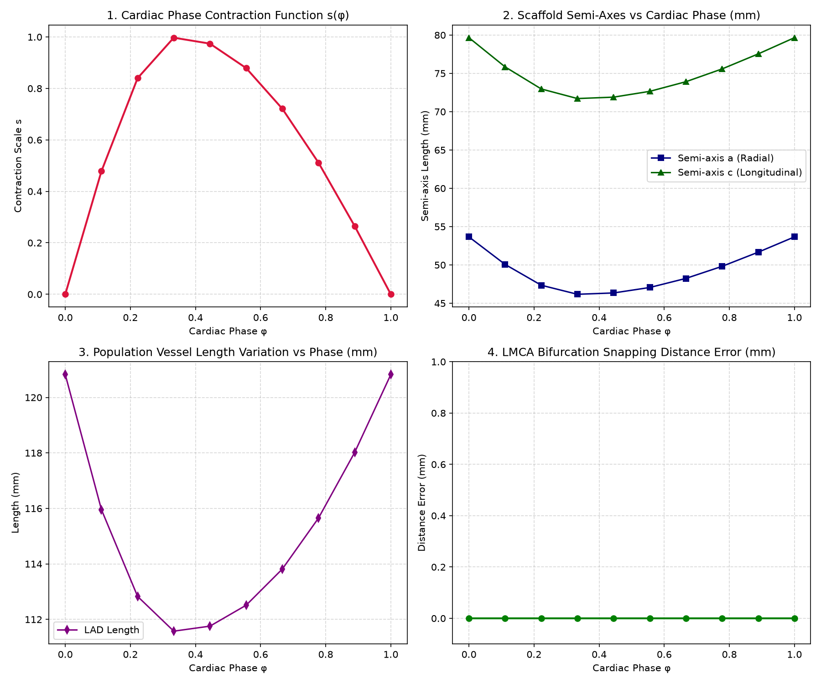
Figure 4. Population motion QC: contraction function, scaffold axes, LAD length variation, and exact junction error.

8. Output contract, visualization, and operating workflow
Artifact | Shape or purpose
geometry_cine.npy | (phase, branch, point, 4) float array ordered x_mm, y_mm, z_mm, radius_mm
geometry_static.npy | Reference/phase-zero fixed-size (branch, point, 4) array
coronary_tree_4d.npz | Compressed tensor plus phase, time, branch, and coordinate labels
geometry_healthy_reference.npy | Healthy radius reference used to quantify disease
disease_reduction.npy | Pointwise fractional radius-reduction array
metadata.json | Configuration, provenance, model, disease, motion, pulsatility, and validation
graph.json | Directed LMCA-to-LAD/LCX hierarchy and branch attributes
manifest.json | Shapes, SHA-256 checksums, validation status, and VTK readback evidence
vtk/cine.pvd | ParaView time-series entry point with one VTM per phase
preview.png | Fixed-front/radius/motion/pulsatility release preview
visualizations/ | Dashboard, tortuosity plot, cardiac GIF, interactive HTML, quantitative plot, metrics

Final branch order is [LMCA, LAD, LCX]. Fixed export uses 50 points per branch. VTK point data include radius and disease-reduction values suitable for coloring in ParaView. The focal LAD interactive viewer is self-contained for offline use; the remaining small HTML files load Plotly from its CDN.

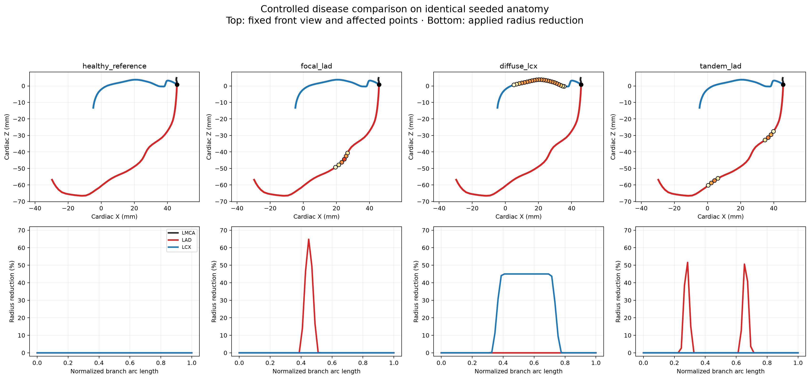
Figure 5. Healthy, focal LAD, diffuse LCX, and tandem LAD cases on identical seeded anatomy.

9. Verification and quantitative results

9.1 Final population results
Metric | Real mean +/- SD | Generated mean +/- SD | Result
LMCA length (mm) | 17.177 +/- 15.062 | 17.175 +/- 15.047 | PASS
LAD length (mm) | 120.685 +/- 28.333 | 120.824 +/- 28.315 | PASS
LCX length (mm) | 77.092 +/- 23.520 | 77.107 +/- 23.522 | PASS
LMCA tortuosity | 1.055 +/- 0.070 | 1.055 +/- 0.069 | PASS
LAD tortuosity | 1.373 +/- 0.207 | 1.374 +/- 0.205 | PASS
LCX tortuosity | 1.264 +/- 0.142 | 1.264 +/- 0.142 | PASS
LAD-LCX angle (deg) | 90.807 +/- 24.699 | 90.697 +/- 24.730 | PASS
LMCA max turn (deg) | 4.811 +/- 3.490 | 5.350 +/- 3.224 | PASS

Cohort result | Value
Accepted/requested | 52/52
Sampling attempts | 64
Unique eligible baselines represented | 52/52
PCA innovation scale | 0.04
Exact LCA topology in every tree | True
Compared metrics | 50
Distribution passes/warnings | 50/0

9.2 4D and export results
Check | Evidence | Status
Population motion | 52 trees x 10 phases | PASS
Motion junction | Exact LMCA-LAD/LCX snap at every phase | PASS
Motion clearance | No rejected self-intersection at 0.75 mm policy | PASS
Fixed-size export | 52 trees; 50 points/branch | PASS
Static identity | geometry_static == geometry_cine[0]; max error 0 | PASS
Curated case audits | 4/4 with no warnings | PASS
Checksums and VTK readback | All four exported case manifests independently verified | PASS

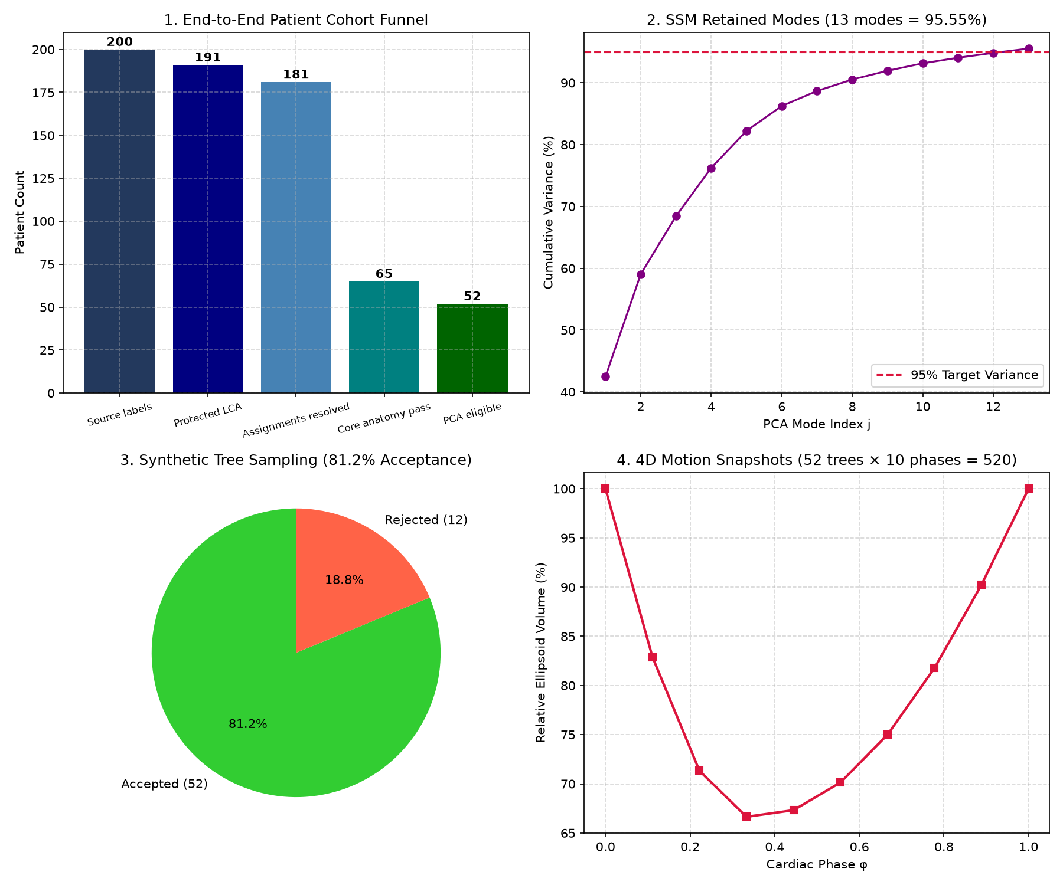
Figure 6. Standardized export QC and identity evidence for the 52-tree population.

9.3 Regression and repository QA
Suite | Passed | Failed
Staged Batch 2-7 tests | 61 | 0
Final independent-audit contract tests | 5 | 0
Focused Person-2 generation tests | 19 | 0
Integrated public-generator tests | 5 | 0
Total | 103 | 0

Additional release gates passed: Python compileall, dependency consistency (pip check), JSON parsing, four independent export verification runs, VTK first/last-phase readback, SHA-256 integrity, and final Git diff checks.

9.4 Generative novelty and internal holdout
Audit result | Verified value | Interpretation
Canonical exact duplicates | 0 | No generated fixed representation is numerically identical to training
Near duplicates (<0.1 mm RMS coordinate) | 0 | No effective duplicates at the declared threshold
Mean displacement from scheduled baseline | 0.934 mm RMS point | Small but non-trivial conservative innovation
Median nearest-training distance | 0.437 mm RMS coordinate | Bootstrap derivatives remain close to learned support
Five-baseline variant audit | 23/25 direct variants accepted | Five variants each; rejection remains explicit
Internal holdout | 5 folds; train 41-42; holdout 10-11 | Source-grouped; not external validation
Holdout first-draw anatomy acceptance | 78.8% | No threshold tuning; rejected draws remain visible
Leakage | 0 source / 0 baseline | All derivatives grouped by source_case_id

A controlled strategy comparison retained empirical bootstrap plus 0.04 PCA innovation. Pure bounded PCA-score sampling accepted only 4/52 direct candidates and showed large local turns; a 0.10 moderate innovation was more diverse but lacked the canonical strategy's demonstrated 50/50 population-comparison result. The selection balances anatomical validity, population fidelity, and measurable non-identity rather than maximizing acceptance alone.
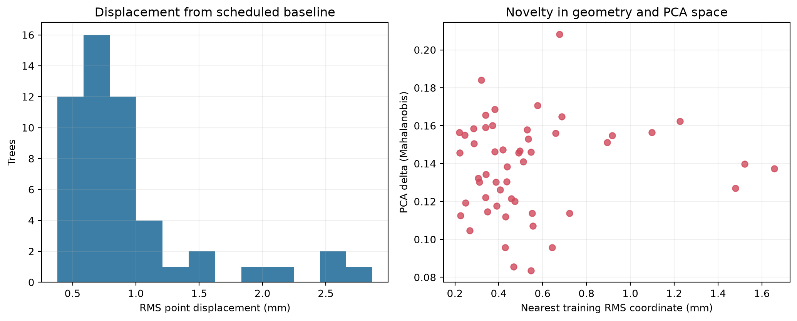
Canonical geometry/PCA novelty audit.
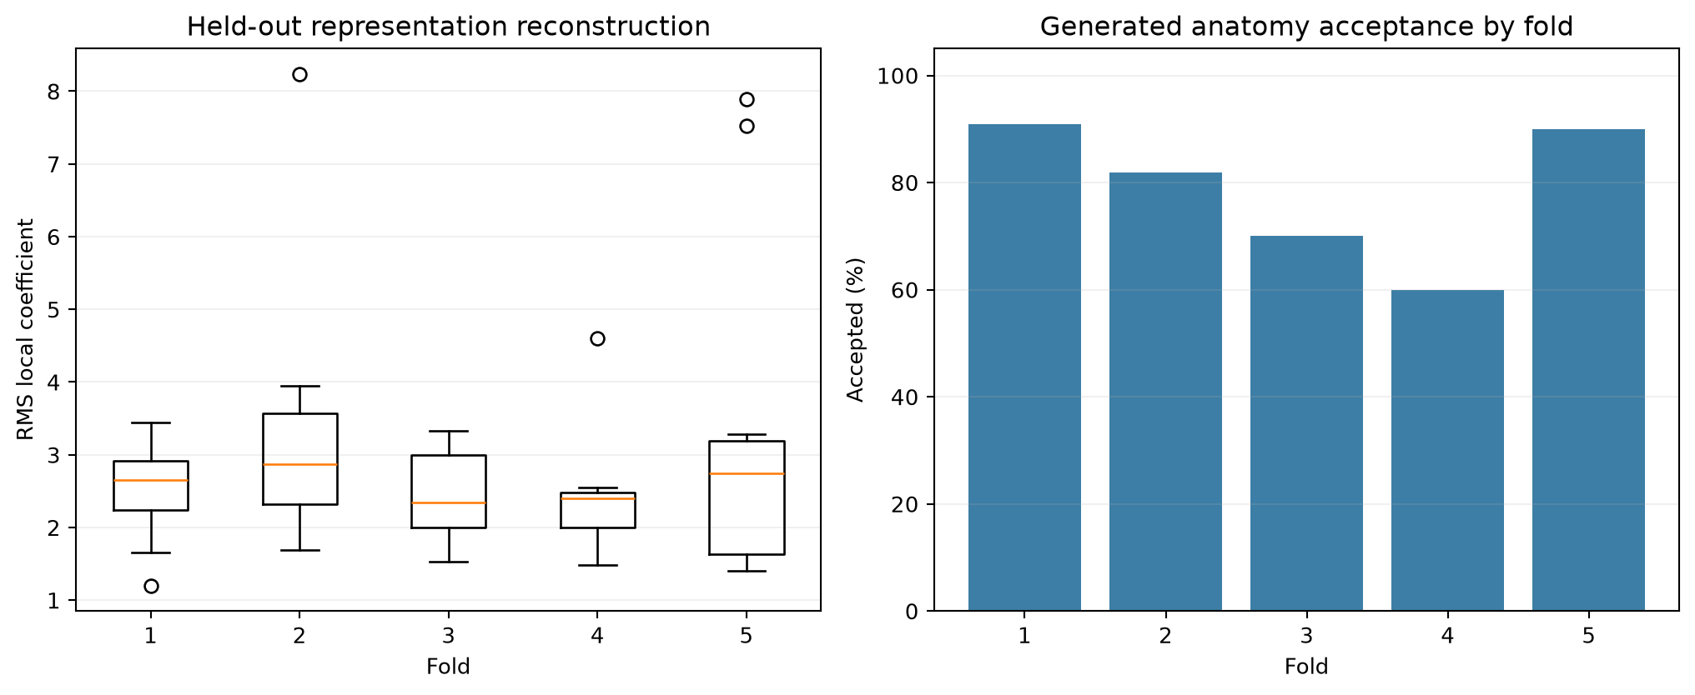
Source-grouped five-fold internal holdout evidence.

10. Curated case-by-case deliverables
All four cases use source case 63.label, seed 20260822, PCA scale 0.04, and identical XYZ centerlines. Their differences therefore isolate disease and local compliance rather than anatomy. Each case contains 10 frames, three branches, and 50 exported points per branch.
Case | Disease result | Maximum motion | Audit
healthy | No lesion; healthy taper reference | 7.810 mm | PASS
focal_lad | LAD: 64.8% radius, 87.6% area; minimum lumen diameter 0.756 mm | 7.810 mm | PASS
diffuse_lcx | LCX: 45.0% radius, 69.8% area; minimum lumen diameter 1.082 mm | 7.810 mm | PASS
tandem_lad | LAD: 51.6% radius, 76.6% area; minimum lumen diameter 0.974 mm | 7.810 mm | PASS

10.1 Shared representative anatomy
Branch | Length | Arc/chord | Proximal diameter | Inferior displacement
LMCA | 6.672 mm | 1.034 | 4.000 mm | 3.960 mm
LAD | 121.064 mm | 1.274 | 2.600 mm | 57.701 mm
LCX | 81.639 mm | 1.229 | 2.400 mm | 14.106 mm

The LAD-LCX angle is 97.864 degrees and the acute LAD/LCX plane-normal angle is 47.838 degrees. Maximum displacement is 7.810 mm, mean displacement at the sampled peak is 6.062 mm, the cycle-closing error is 0.0e+00 mm, and healthy maximum pulsatility is 2.980%.
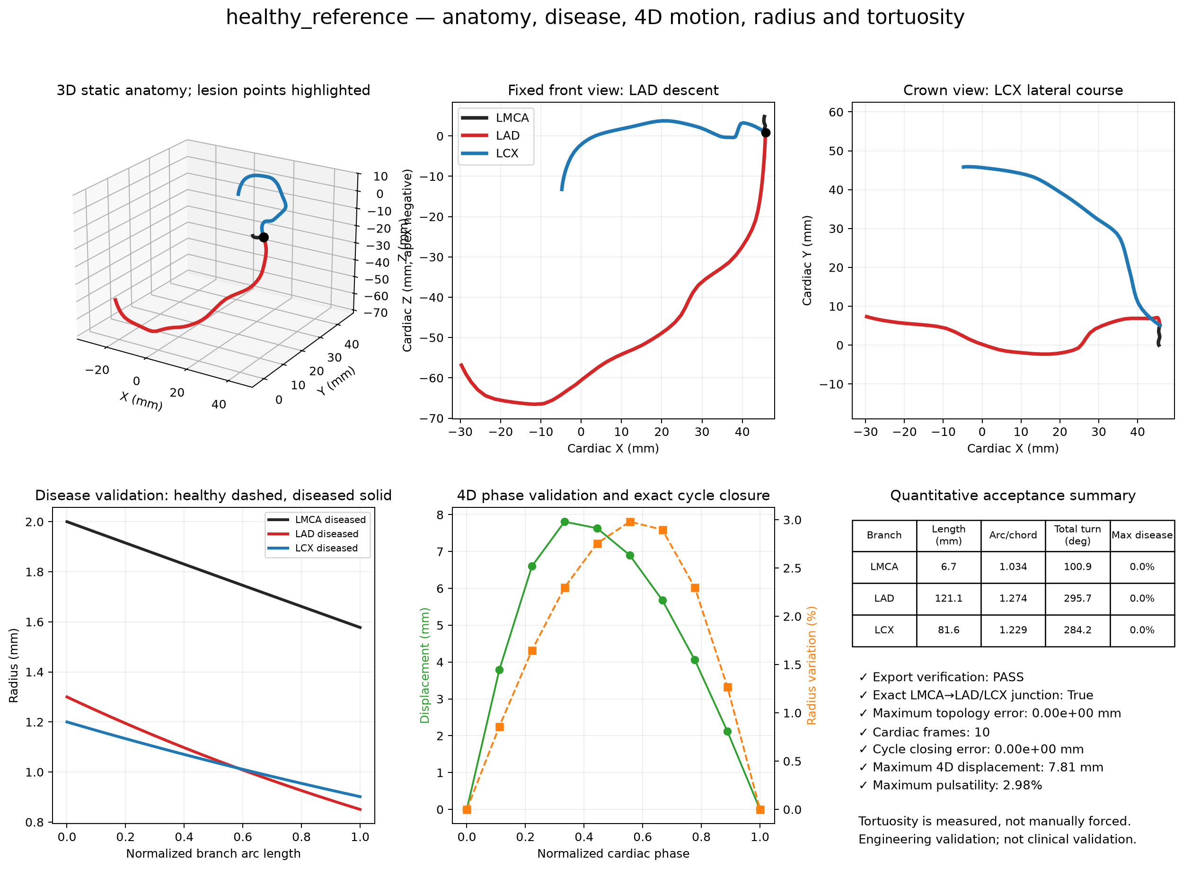
Figure 7. Healthy representative anatomy, topology, radii, motion, pulsatility, and tortuosity dashboard.
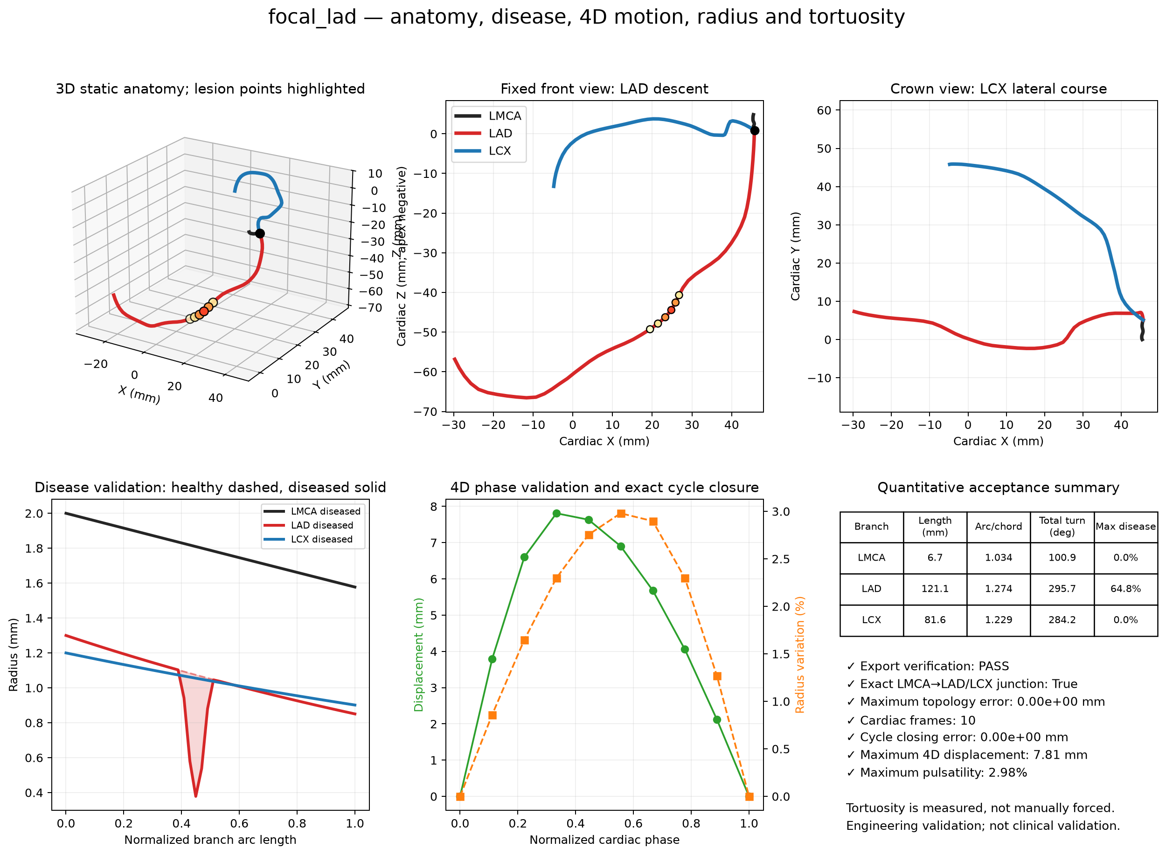
Figure 8. Focal LAD validation dashboard showing localized radius loss with unchanged centerline geometry.

10.2 Local and global pulsatility
Case | Global maximum | Maximum-lesion response | Peak sign
healthy | 2.980% | N/A | expansion
focal_lad | 2.980% | LAD: 1.044% (0.350x healthy) | expansion
diffuse_lcx | 2.980% | LCX: 1.043% (0.350x healthy) | expansion
tandem_lad | 2.980% | LAD: 1.166% (0.391x healthy) | expansion

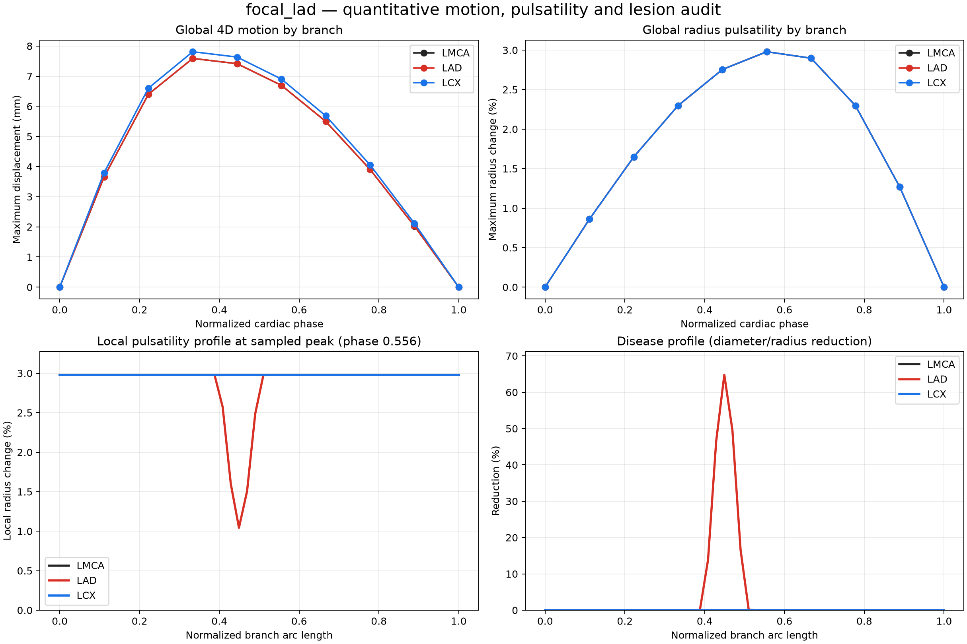
Figure 9. Quantitative focal-LAD motion and pulsatility audit, including reduced lesion response.

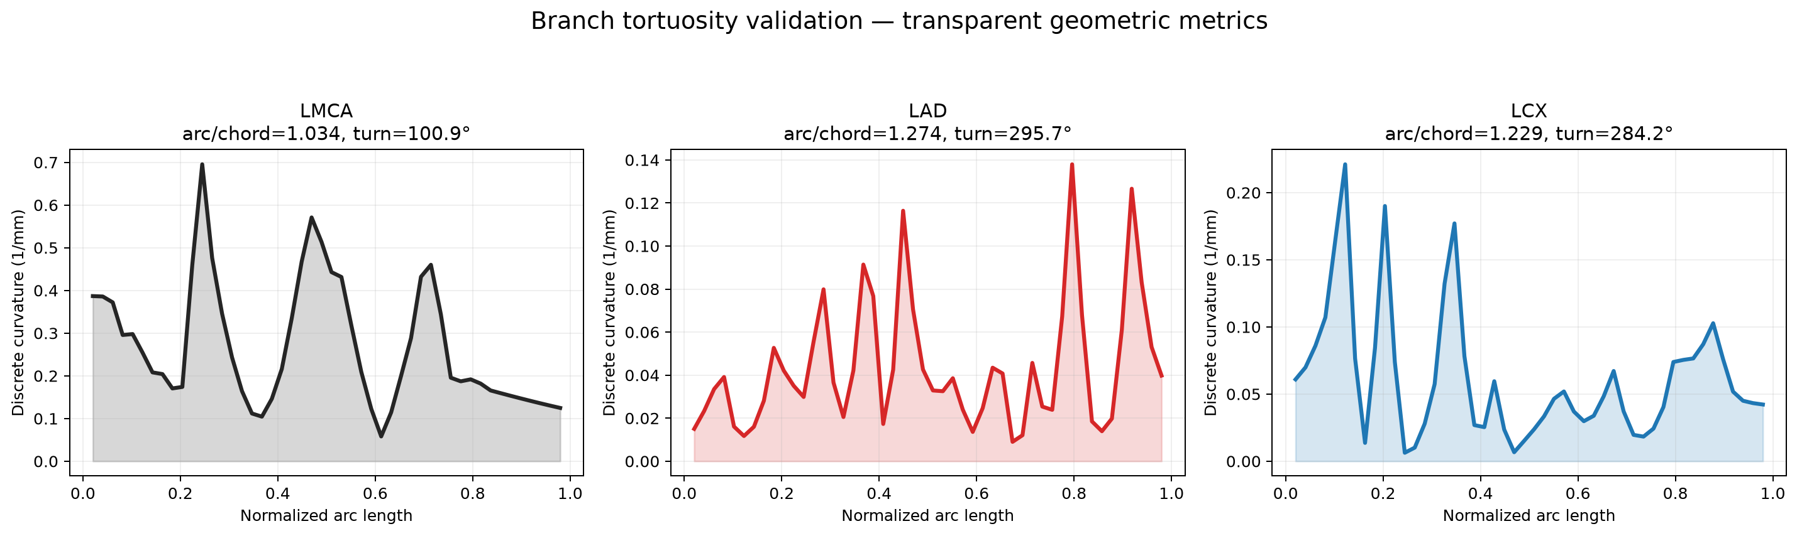
Figure 10. Branch-specific curvature and distance-metric tortuosity for the shared representative anatomy.

11. Installation, CLI, Python API, and reproducibility

11.1 Environment
- Python 3.10 or newer is required.
- Create a virtual environment and install requirements.txt, or install the project editable with pip install -e .
- Core dependencies are NumPy, SciPy, Matplotlib, PyVista, Plotly, Pillow, and python-docx.
- The frozen generator statistics package must remain under outputs/lca_ssm/lca_population_model/generator_statistics unless an alternate path is supplied.

11.2 Primary commands
Task | PowerShell command
Generate four demo cases | .\.venv\Scripts\python.exe -m vessel_tree_generator demo --output-dir submission_release\demo_cases --clean
Generate one focal LAD case | .\.venv\Scripts\python.exe -m vessel_tree_generator generate --output-dir my_case --preset focal --branch LAD --position 0.45 --length 0.12 --severity 0.65 --clean
Verify one export | .\.venv\Scripts\python.exe -m vessel_tree_generator verify --input-dir my_case
Create visual pack | .\.venv\Scripts\python.exe -m vessel_tree_generator visualize --input-dir my_case --clean --standalone-html
Audit full release | .\.venv\Scripts\python.exe -m vessel_tree_generator audit --input-dir submission_release\demo_cases --release
Rebuild population cohort | .\.venv\Scripts\python.exe pipeline.py generate --count 52 --pca-scale 0.04 --clean
Validate population | .\.venv\Scripts\python.exe pipeline.py validate --clean
Validate novelty | .\.venv\Scripts\python.exe pipeline.py novelty-validate
Run internal holdout | .\.venv\Scripts\python.exe pipeline.py holdout-validate
Run complete final audit | .\.venv\Scripts\python.exe pipeline.py audit-final

11.3 Python API pattern
Instantiate CoronaryTreeGenerator, create a stenosis_config, and call generate_case. For controlled disease comparisons, call sample_reference once and reuse the returned reference for every disease configuration. GenerationConfig controls seed, source case, PCA scale, attempts, and heart rate; MotionConfig controls phases and deformation; PulsatilityConfig independently controls radius amplitude, pulse peak phase, and lesion compliance.

11.4 Reproducibility and leakage control
- Seeds and source_case_id are recorded in metadata and manifests.
- Generated trees are synthetic derivatives, not new independent patients.
- For machine-learning splits, group every generated derivative, disease state, and phase by source_case_id to prevent train/validation/test leakage.
- The canonical scheduler covers 52 source baselines before repeating one; counts above 52 add variations, not new subjects.
- Checksums detect post-export changes, and verify reopens VTK plus checks array shape, radii, topology, and hashes.
- Protected source geometry is never edited; outputs and bulk runs are regenerated from frozen statistics and tracked code.

12. Limitations, risk boundaries, and future work

12.1 Limitations that remain
Limitation | Consequence
Small effective sample | Only 52 independent eligible anatomies support an 81-feature, 13-mode model. Synthetic derivatives do not increase clinical sample size.
Selection bias | Strict gating excludes 129 resolved cases and may favor clean/common anatomies.
No external cohort | A source-grouped five-fold internal holdout is provided, but no independent institution or clinical cohort was available.
LCA-only anatomy | RCA and side branches are absent from the final population contract.
Linear PCA | A linear Gaussian-mode approximation may miss multimodal dominance patterns, rare variants, or nonlinear shape manifolds.
Parametric radius | Taper and proximal radii are defaults, not learned distributions or patient measurements.
Parametric physiology | Motion, pulsatility, and compliance are explicit mechanisms, not subject-specific measurements or FSI.
Simplified disease | Stenosis is a smooth axisymmetric radius profile; eccentric plaque, calcification, remodeling, and wall morphology are absent.
No hemodynamics | The project does not calculate pressure, flow, FFR, WSS, perfusion, or ischemia.
Clinical status | No clinical outcomes, expert-reader study, regulatory process, or prospective validation has been performed.

12.2 What was safely improved in the final pass
- Canonical population size increased from 25 to 52 so every eligible baseline is represented once.
- PCA innovation reduced from 0.08 to 0.04 based on controlled distribution evidence, eliminating the LMCA turn mismatch without collapsing LAD/LCX spread.
- Learned hard extrema were added for branch tortuosity, obliquity, backward progress, terminal progress, and local turn.
- Radial-motion default reduced from 15% to 14%, moving representative maximum displacement from 8.22 mm to 7.81 mm.
- Single-case CLI audit status handling was fixed and verified.
- The empirical dense-curve stage was converted from a misleading PCHIP-named helper into an explicit, behavior-preserving cubic B-spline basis.
- Generation novelty, three sampling strategies, exact PCA recomputation, and source-grouped five-fold internal holdout were added without weakening gates.
- Population and demo phase conventions were unified to nine independent geometric positions plus one repeated closure frame.
- All population, motion, export, release, visualization, and documentation artifacts were regenerated from the final settings.

12.3 Recommended next work
1. Acquire expert-reviewed RCA and side-branch topology and build a separate confidence-resolved extension.
2. Recover more of the 181 resolved cases by diagnosing frame/ellipsoid/representation failures without weakening anatomy gates.
3. Add an external source-grouped cohort and reader-based anatomical scoring.
4. Learn diameter, taper, motion, and compliance distributions from patient data with metadata and acquisition definitions.
5. Evaluate nonlinear or conditional shape models only after the real cohort is substantially expanded.
6. Add eccentric plaque surfaces, vessel wall representation, and optional CFD/FSI as separately validated modules.
7. Generate and maintain the final presentation deck from the verified figures and machine-readable result tables without introducing new claims.

13. Presentation handoff

13.1 Recommended demonstration order
1. Start with submission_release/demo_cases/disease_mode_comparison.png to establish controlled same-anatomy disease comparison.
2. Open focal_lad/visualizations/validation_dashboard.png to explain anatomy, radius, motion, topology, pulsatility, and tortuosity together.
3. Open focal_lad/visualizations/interactive_tree.html for rotation, zoom, phase slider, playback, hover values, and disease coloring.
4. Open focal_lad/vtk/cine.pvd in ParaView, color by radius_mm or disease_reduction_fraction, and play the sequence.
5. Use the population montage and real-versus-generated plot to explain the 52-case SSM evidence.
6. End with limitations: major-vessel LCA research scaffold, not a complete or clinically validated coronary model.

13.2 Suggested PPT slide structure
Slide | Message | Recommended visual
1 | Problem and deliverable | Title plus compact pipeline statement
2 | Data and anatomy gate | 200 -> 191 -> 181 -> 65 -> 52 funnel
3 | Common frame and SSM | 27-point representation and PCA modes
4 | Population validity | 52-tree montage and distribution comparison
5 | Disease model | Four-case comparison
6 | 4D motion and pulsatility | Quantitative motion/pulsatility plot
7 | Interactive/ParaView workflow | Dashboard and cine screenshot
8 | Verification | 103 tests, 50/50 comparisons, zero warnings
9 | Limitations and future work | Honest scope boundary

14. External anatomical sanity checks
These comparisons are descriptive engineering sanity checks, not clinical acceptance limits. The repository-defined LMCA begins at a graph endpoint selected by local mask radius and ends at the selected major-daughter junction; it is not guaranteed to match a manually annotated clinical ostium-to-first-bifurcation segment. Diameter defaults and motion amplitude are parametric prototype settings, not distributions learned from the 52-case anatomical cohort.
Metric | Project | Literature | Interpretation
LMCA/proximal-LCA path | mean 17.175; SD 15.047; range 4.489–72.655 | 9.13 mm; 3.23 mm; range 2–19.5 mm (PMID 37829965) | definition differs
LAD length | mean 120.824; SD 28.315; range 58.852–187.380 | 109.46 mm; 14.49 mm; range 72.46–144.78 mm (PMID 37829965) | broadly consistent
LCX length | mean 77.107; SD 23.522; range 39.571–129.387 | 66.27 mm; 11.56 mm; range 40.7–107.66 mm (PMID 37829965) | broader project range; endpoint/segmentation definition differs
LAD-LCX angle | mean 90.697; SD 24.730; range 50.416–172.914 | 89.0 degrees; range 74.5–93 degrees; cadaver definition (PMID 36944018) | definition differs
LMCA proximal diameter | parametric default = 4.0 mm; not a learned distribution | 4.38 mm; 0.58 mm (PMID 37829965) | default is descriptively consistent
LAD proximal diameter | parametric default = 2.6 mm; not a learned distribution | 2.62 mm; 0.50 mm (PMID 37829965) | default is descriptively consistent
LCX proximal diameter | parametric default = 2.4 mm; not a learned distribution | 2.41 mm; 0.43 mm (PMID 37829965) | default is descriptively consistent
Representative generated LCA maximum displacement | 7.810 mm maximum for the validated representative case; not cohort-derived | 2.8–6.6 mm by axis; substructure/landmark dependent (PMID 24098082) | within broadly consistent literature-scale motion

Independent post-export coordinate audit: 52/52 pass the production coordinate role/topology/clearance gate with zero validator mismatch. 35/52 also pass every stricter absolute/descriptive apex-reach check. The latter are reported transparently and are not the production acceptance predicate.
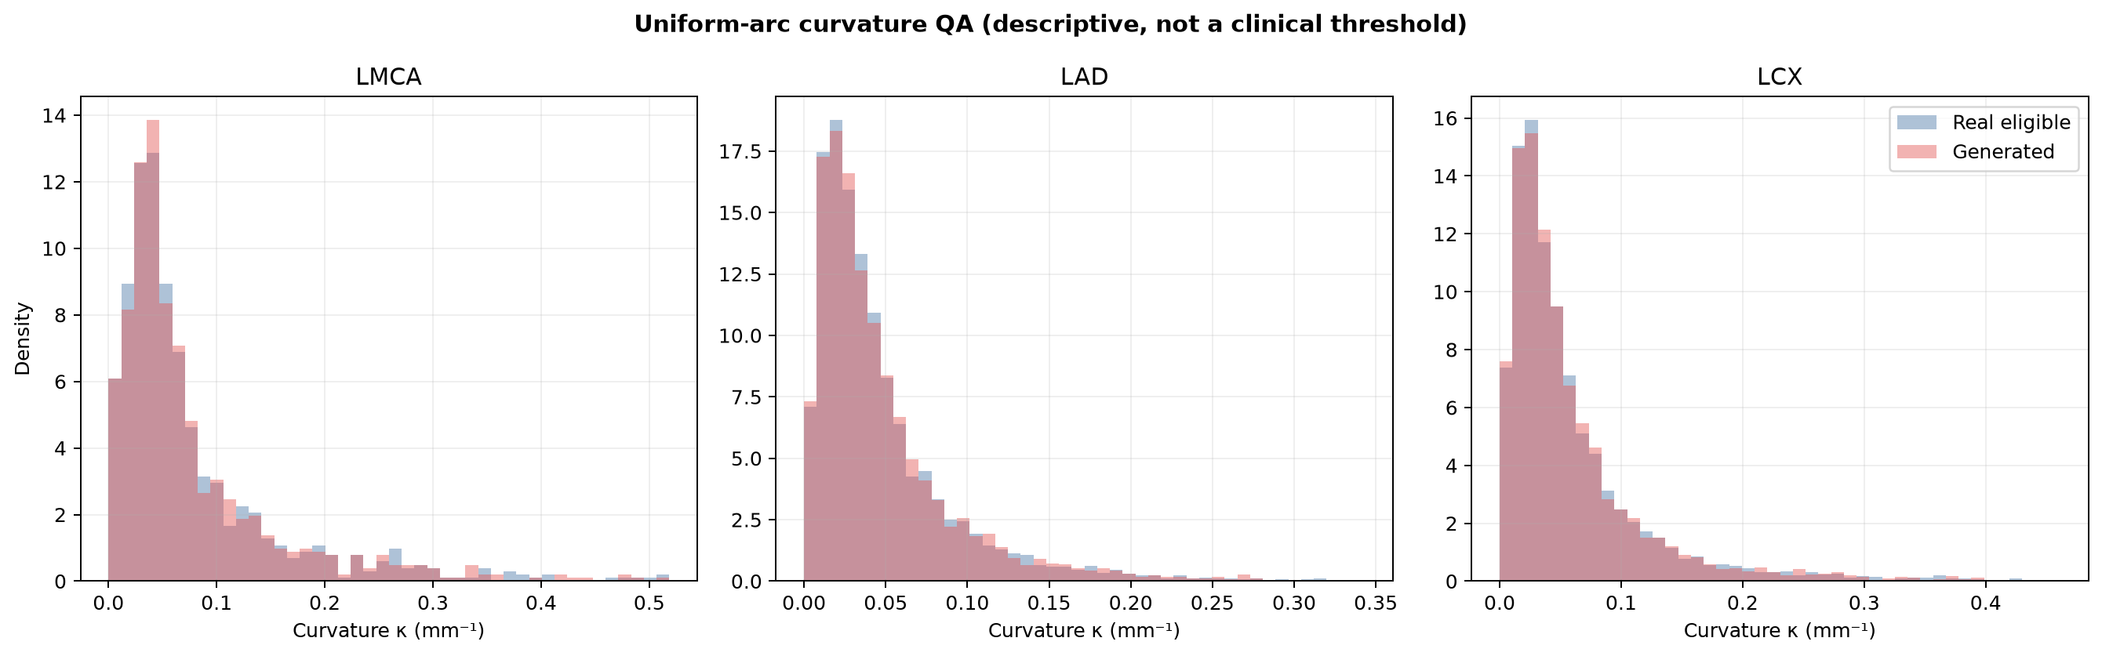
Uniform 1 mm arc-length curvature comparison. P95/P99 are descriptive cohort evidence; no arbitrary clinical curvature limit is imposed.

15. Primary literature context
Literature values are descriptive external sanity checks. Differences in modality, population, vessel endpoint definition, phase, and measurement method prevent treating them as interchangeable clinical limits.
1. Manpoong et al., Detailed Morphometric Analysis on Left Coronary Artery in the Population of North-East India, 2023. PubMed record PMID 37829965 Topic: human LCA length and diameter morphometry.
2. Lujinovic et al., Morphometric analysis of clinically significant parameters of the main trunk of the left coronary artery, 2023. PubMed record PMID 36944018 Topic: left-main bifurcation anatomy.
3. Pflederer et al., Measurement of coronary artery bifurcation angles by multidetector computed tomography, 2006. PubMed record PMID 17035869 Topic: 3D coronary bifurcation angles.
4. Paul et al., A milestone in prediction of the coronary artery dimensions, 2019. PubMed record PMID 31779861 Topic: normal coronary diameters.
5. Tan et al., Estimation of the displacement of cardiac substructures and the motion of the coronary arteries using ECG gating, 2013. PubMed record PMID 24098082 Topic: coronary displacement over the cardiac cycle.
6. Ge et al., Intravascular ultrasound imaging of angiographically normal coronary arteries, 1994. PubMed record PMID 8043342 Topic: normal and plaque-segment cyclic lumen-area change.
7. Nakatani et al., Assessment of coronary artery distensibility by intravascular ultrasound, 1995. PubMed record PMID 7796499 Topic: coronary distensibility and plaque.
8. Numao et al., Pulsatile diameter change of coronary artery lumen estimated by IVUS, 1997. PubMed record PMID 9253689 Topic: reduced diameter pulsatility in CAD.

Appendix A. Metric definitions
Metric | Definition and interpretation
Arc length | Sum of Euclidean distances between consecutive centerline samples.
Chord | Euclidean distance between branch endpoints.
Distance-metric tortuosity | Arc length divided by chord; 1 is straight and larger values indicate a longer path relative to endpoint separation.
Total turning angle | Sum of angles between successive unit segment directions; strongly dependent on sampling and smoothing.
Maximum local turn | Maximum direction change after uniform arc-length resampling; used for local sharpness QC.
Inferior displacement | Dominant negative cardiac/RAS-Z displacement from branch start toward terminal.
Terminal lateral fraction | Terminal lateral/circumferential displacement normalized by branch length.
Backward-progress ratio | Accumulated negative projection along the branch chord divided by chord length.
Terminal-progress fraction | Fraction of sampled steps that approach the terminal rather than move away.
Plane residual | Orthogonal distance from centerline points to the least-squares SVD plane; descriptive, not a requirement that the vessel is planar.
Radius reduction | 1 - diseased_radius / healthy_radius at each point.
Equivalent area reduction | 1 - (diseased_radius / healthy_radius)^2 under a circular cross-section approximation.
Pulsatility | Absolute cyclic radius change relative to the diseased reference radius.
Topology error | Euclidean difference between LMCA terminal and daughter start points; required to be effectively zero.

Appendix B. Artifact map
Location | Contents
outputs/lca_ssm/lca_population_model/generator_statistics/ | Frozen ellipsoid, landmark, branch assignment, PCA, surface coordinate, and validation packages.
outputs/lca_ssm/lca_population_cohort/ | 52 accepted static trees locally; tracked compact evidence, tree 0001, montage, metrics, and validation plots.
outputs/lca_ssm/lca_population_motion/ | 52 x 10 phase motion output locally; tracked summary and QC image.
outputs/lca_ssm/lca_population_export/ | Fixed-size population arrays locally; tracked summary and QC report.
submission_release/demo_cases/ | Four complete portable cases with arrays, metadata, VTK, previews, visualizations, and audits.
submission_release/reports/ | Per-tree quantitative DOCX reports retained as supporting evidence.
submission_release/design_spec_alignment/ | Requirement matrix, ellipse-to-ellipsoid provenance, point-level surface trace, real/generated u-v audits, spline-equivalence evaluation, figures, and final alignment report.
submission_release/mentor_visualization_pack/ | Self-contained ParaView pack with all 52 static trees, four 10-frame disease/motion cine series, referenced VTK dependencies, presentation assets, checksums, and a viewing guide.
submission_release/FINAL_PROJECT_REPORT.docx | Master project report and final document.
SUBMISSION_GUIDE.md | Five-minute usage, API, outputs, ParaView, validation, and scope guide.

Appendix C. Acceptance checklist
- PASS - Protected source centerlines remain unmodified.
- PASS - Only confidence-resolved assignments enter statistics.
- PASS - All 52 eligible baselines are represented in the final cohort.
- PASS - All requested trees are accepted and exact topology is preserved.
- PASS - All 50 population comparisons pass with no warning.
- PASS - All 52 exported trees pass the documented relative LAD/LCX role gate; stricter absolute apex-reach checks remain separately descriptive.
- PASS - Learned branch-course extrema are enforced.
- PASS - Motion preserves topology and clearance in all 520 population snapshots.
- PASS - Four release cases preserve exact closed-cycle and phase-zero identity.
- PASS - Disease changes radii only and leaves XYZ unchanged.
- PASS - Local lesion pulsatility is lower than healthy pulsatility by the configured compliance model.
- PASS - All exports pass checksum, shape, radius, topology, and VTK readback verification.
- PASS - All 103 regression checks pass; compileall and dependency checks pass.
- PASS - Five-fold internal holdout has zero source/baseline leakage; it is not external validation.
- PASS - Clinical non-validation and anatomical incompleteness are explicitly documented.
- PASS - The final DOCX was rendered page-by-page and visually inspected before release.
Final conclusion
The repository is ready as a reproducible, disease-aware 4D major-vessel LCA research deliverable. Its engineering contract is validated; its remaining scientific and clinical boundaries are explicit and must be preserved.

