CORONARY4D

Quantitative Tree Validation Report
Tandem Lad
Population-derived major-vessel LCA scaffold: LMCA → LAD + LCX
Generated research anatomy with controlled radius disease and 4D deformation
Audit decision Engineering validation PASS; major-vessel LCA anatomical plausibility PASS. Status remains PASS WITH CAVEATS because this is not a complete coronary tree or a clinically validated patient model.

Field | Value | Interpretation
Case | tandem_lad | One of four controlled cases on identical anatomy
Population source | 63.label | Data-derived warning-free representative; centerline was not hand-edited
Random seed / PCA scale | 20260822 / 0.04 | Reproducible low-amplitude statistical variation
4D sampling | 10 frames at 60 bpm | Closed cycle includes phase 0 and repeated phase 1
Scope | population-derived LCA (LMCA, LAD, LCX); RCA not included | RCA and side branches are intentionally absent
Clinical status | NOT CLINICALLY VALIDATED | Research visualization and method development only

Most important limitation “Tree” in this report means the three-segment major-vessel LCA scaffold. It does not mean a complete human coronary arterial tree.

1. Static anatomy and branch identity | fixed cardiac coordinate frame
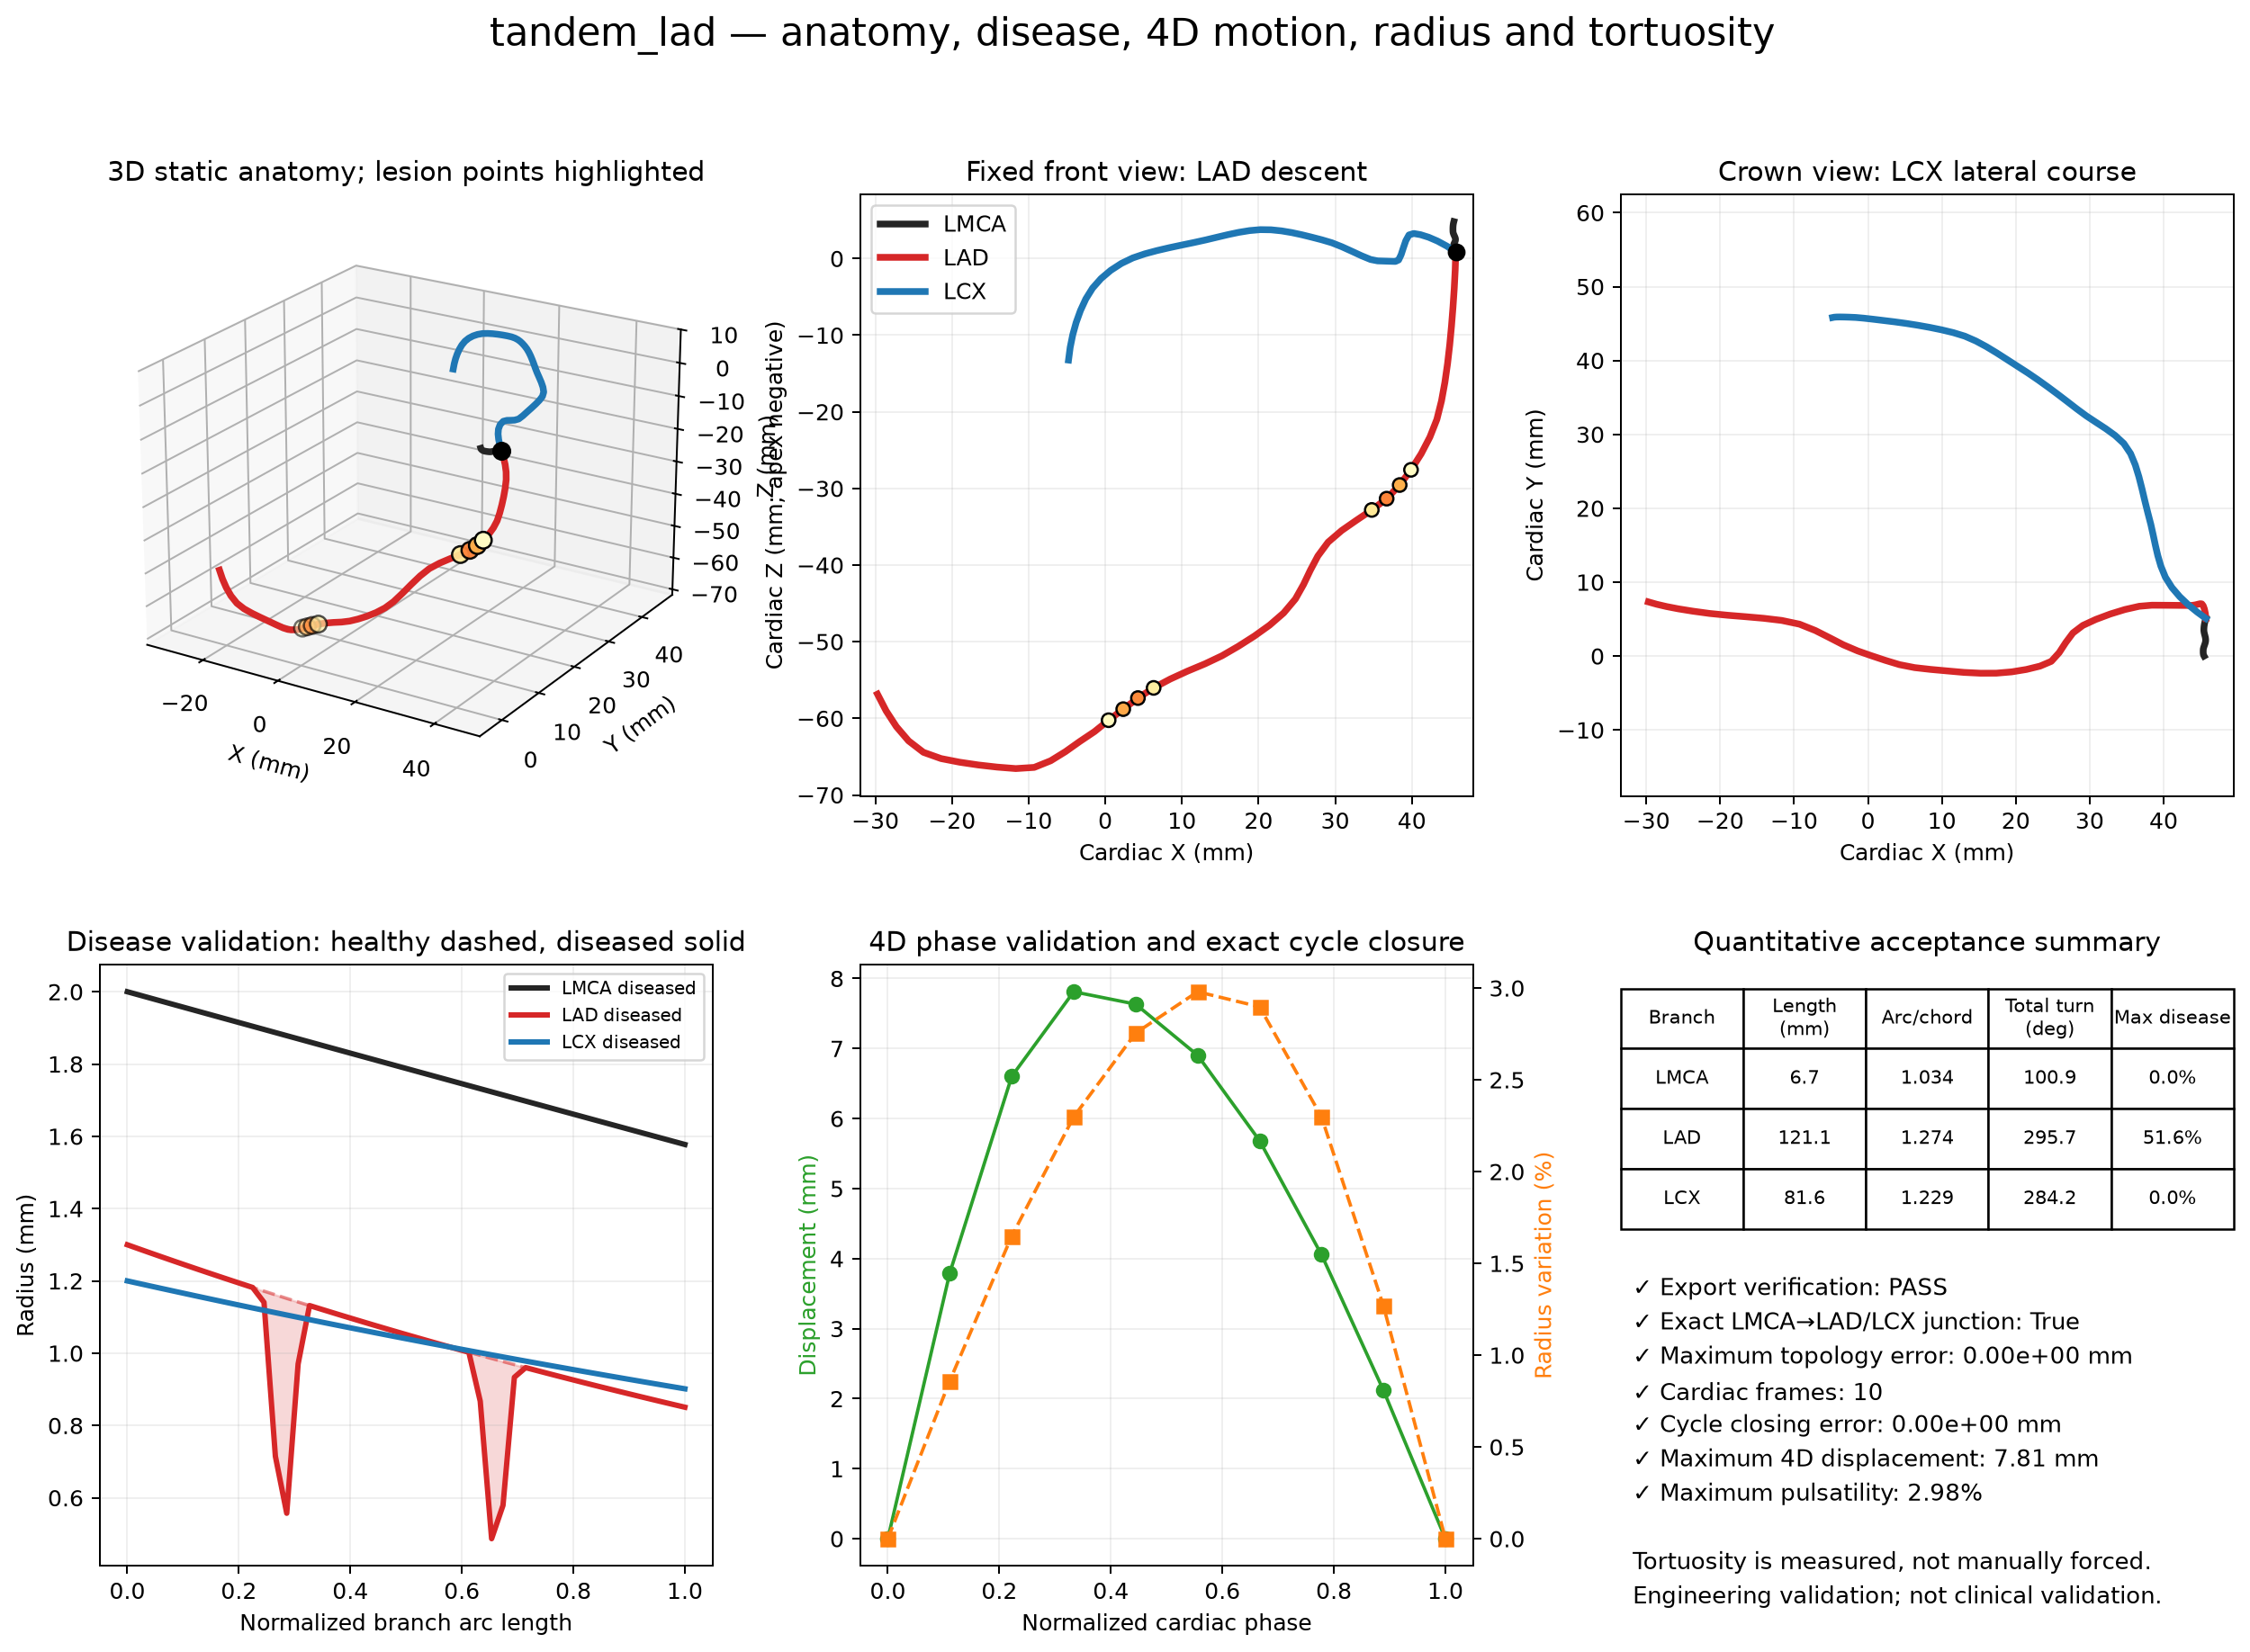

2. Anatomical measurements
Branch | Length  (mm) | Arc/chord | Prox. diameter  (mm) | Mid diameter  (mm) | Distal diameter  (mm) | Inferior  displacement (mm) | Terminal XY  displacement (mm) | Plane RMS  (mm)
LMCA | 6.67 | 1.034 | 4.00 | 3.57 | 3.15 | 3.96 | 5.10 | 0.09
LAD | 121.06 | 1.274 | 2.60 | 2.09 | 1.70 | 57.70 | 75.47 | 2.33
LCX | 81.64 | 1.229 | 2.40 | 2.07 | 1.80 | 14.11 | 64.89 | 2.35

Junction/plane metric | Measured | External context | Result
LMCA → LAD robust 3D tangent angle | 55.0° | Cadaver mean 30.83 ± 9.23°; methods differ | Descriptive
LMCA → LCX robust 3D tangent angle | 73.2° | Reported anatomy is highly variable | Descriptive
LAD ↔ LCX robust 3D daughter angle | 97.9° | MDCT 80 ± 27° | Within ±2 SD
LAD/LCX plane acute angle | 47.8° | Separate anatomical planes are expected | Distinct planes
Closest unintended segment pair | 0.272 mm | ['LMCA', 10, 'LMCA', 13] | No exact crossing detected

Anatomical identity checks PASS — LAD more inferior than LCX
PASS — LAD is longer than LCX
PASS — LAD initial course is inferior
PASS — LCX initial course is horizontal
PASS — LCX more circumferential by terminal fraction
PASS — source assignment gate accepted
Interpretation. The LAD is the dominant inferior/apex-directed daughter; the LCX has the more circumferential terminal behavior. The exact LMCA-to-daughter junction is preserved in every frame. These checks support anatomical plausibility of the major-vessel LCA scaffold, not completeness.

3. Disease model | radius-only; centerline preserved
Branch | Max diameter/radius  reduction | Equivalent circular  area reduction | Minimum lumen  diameter (mm) | Affected points | Components | Affected normalized  arc range | Centerline change  (mm)
LMCA | 0.00% | 0.00% | 3.155 | 0 | 0 | — | 0.000e+00
LAD | 51.61% | 76.59% | 0.974 | 8 | 2 | 0.245–0.694 | 0.000e+00
LCX | 0.00% | 0.00% | 1.803 | 0 | 0 | — | 0.000e+00

Requested configuration {
"case_id": "tandem_lad",
"lesions": [
{
"branch": "LAD",
"type": "tandem",
"lesions": [
{
"type": "focal",
"center": 0.28,
"length": 0.08,
"severity": 0.55
},
{
"type": "focal",
"center": 0.66,
"length": 0.08,
"severity": 0.55
}
]
}
]
}
Severity definition. The API severity is fractional radius reduction. With the model's circular cross-section assumption, fractional radius reduction equals fractional diameter reduction. Equivalent area reduction is reported separately as 1 − (1 − severity)². It must not be mistaken for clinically measured stenosis without patient imaging or flow assessment.
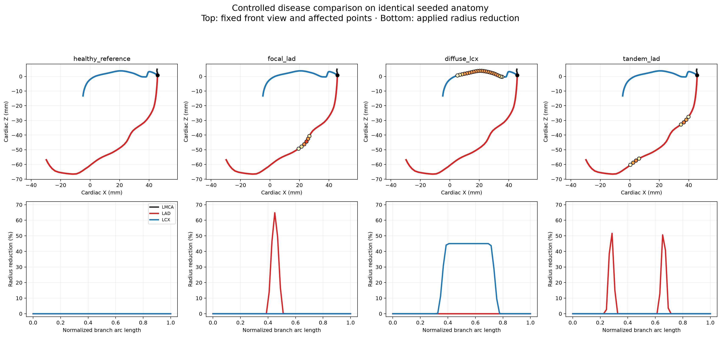
Figure 2. Controlled healthy/focal/diffuse/tandem comparison on exactly the same centerline anatomy.

4. 4D motion and local/global pulsatility
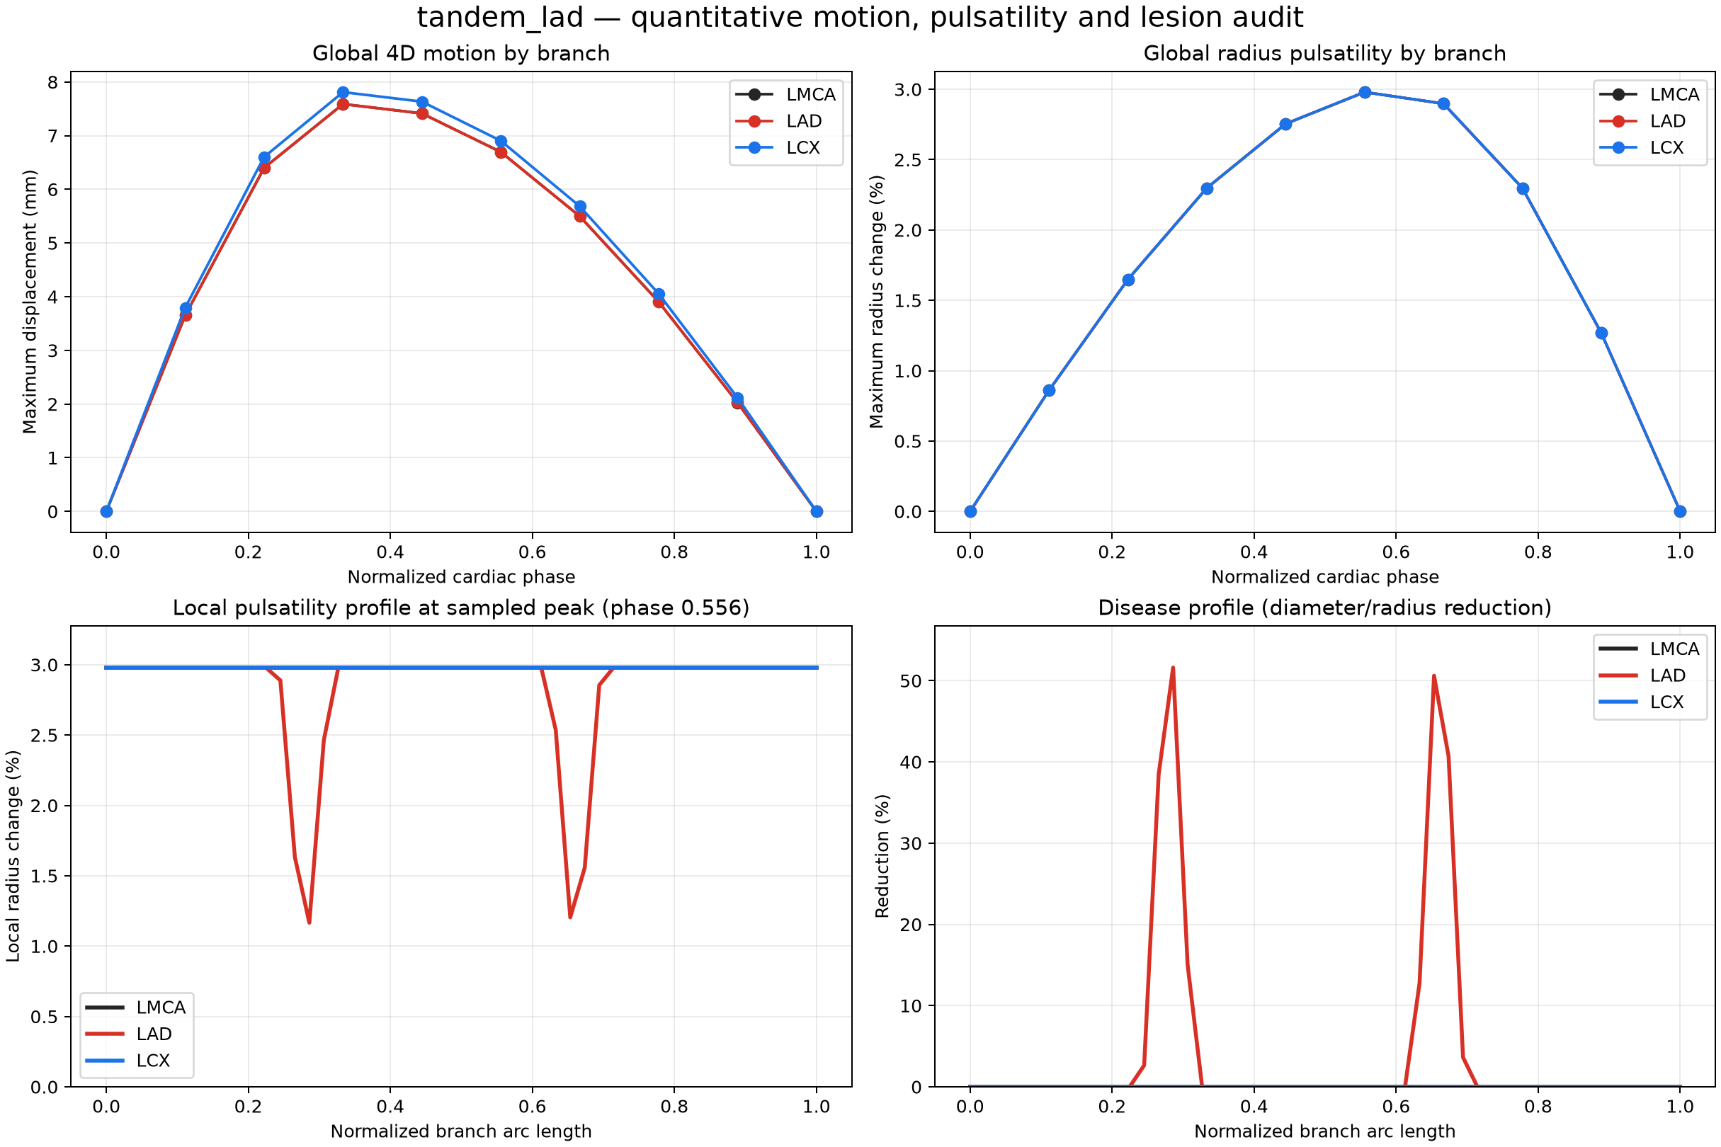
Figure 3. Quantitative curves reveal the 1–3% local radius signal that is intentionally subtle in the GIF.

5. Motion and pulsatility measurements
Branch | Maximum point  displacement (mm) | Mean displacement  at peak (mm) | Terminal displacement  at peak (mm) | Peak max radius  change | Lesion-center  radius change | Lesion/healthy  amplitude ratio
LMCA | 7.59 | 6.55 | 6.70 | 2.98% | — | —
LAD | 7.59 | 5.29 | 4.62 | 2.98% | 1.17% | 0.391
LCX | 7.81 | 6.35 | 5.18 | 2.98% | — | —

Global check | Measured | Acceptance/interpretation
Peak sampled phase | 0.556 | Requested peak is 0.350; nearest 10-frame sample is 0.333
Maximum displacement | 7.810 mm | Slightly above 8 mm point maximum; mean at peak is within published 3–8 mm average context
Mean displacement at peak | 6.062 mm | Within the primary-study average 3D-motion context
Cycle-closing error | 0.000e+00 mm | Exact closure
Global maximum radius change | 2.980% | Within configured 3%; positive sign means expansion
Peak response | expansion | Simplified scalar early-diastolic lumen expansion; independent from motion peak

Pulsatility conclusion Global healthy-region radius change is 2.992%. The code implements and preserves both global pulsatility and local compliance reduction. Exported lesion samples: LAD 1.166% radius change and 0.391 lesion/healthy amplitude ratio. The exact continuous lesion center targets 0.350; fixed-size arc sampling can miss that exact center. The GIF is not a reliable measurement tool because rendered line width is much larger than a 1–3% radius change.
Physiology caveat. IVUS studies support cyclic coronary lumen variation and reduced distensibility in plaque, but report site- and method-dependent timing. The model uses one isotropic waveform synchronized to the deformation peak; it does not reproduce anisodiametric motion or patient pressure waveforms.

6. Acceptance, traceability and limitations
Validation item | Result | Evidence
Export/checksum/VTK readback | PASS | quantitative_validation.json / metadata.json / manifest.json
Exact shared bifurcation across all phases | PASS | quantitative_validation.json / metadata.json / manifest.json
Exact phase-0/phase-1 cycle closure | PASS | quantitative_validation.json / metadata.json / manifest.json
Major-vessel anatomical role gate | PASS | quantitative_validation.json / metadata.json / manifest.json
Positive finite radii | PASS | quantitative_validation.json / metadata.json / manifest.json
Disease centerline unchanged | PASS | quantitative_validation.json / metadata.json / manifest.json
Pulsatility within configured amplitude | PASS | quantitative_validation.json / metadata.json / manifest.json

Residual warning The maximum point displacement is 8.22 mm, marginally above the published 3–8 mm range for most average 3D displacements. The generated mean at peak is 7.17 mm. Because a point maximum and a cohort average are different statistics, this is a documented caveat rather than a failure.

Not represented | Consequence
RCA and downstream side branches | The output is not a complete coronary anatomy.
Patient-specific myocardium, ostia and dominance | Plausibility cannot be converted to patient validity.
Vessel wall, plaque composition, pressure and flow | No ischemia, FFR or clinical severity prediction is possible.
Anisotropic lumen shape | Radius is scalar; eccentric stenosis and anisodiametric pulsation are omitted.
Clinical annotation or expert adjudication | A cardiologist/radiologist review remains required before any anatomical claim beyond research plausibility.

7. Primary-source literature context
These publications are used as cross-study sanity context only. Differences in population, imaging modality, measurement definition and cardiac phase prevent them from being treated as universal clinical limits.
1. Manpoong et al., Detailed Morphometric Analysis on Left Coronary Artery in the Population of North-East India, 2023. https://pubmed.ncbi.nlm.nih.gov/37829965/
Context used: sample size: 100; LMCA length mm: 9.13 +/- 3.23; LMCA diameter mm: 4.38 +/- 0.58; LAD length mm: 109.46 +/- 14.49; LCX length mm: 66.27 +/- 11.56.
2. Lujinovic et al., Morphometric analysis of clinically significant parameters of the main trunk of the left coronary artery, 2023. https://pubmed.ncbi.nlm.nih.gov/36944018/
Context used: sample size: 29; LMCA length mm: median 9.0; range 6.0-13.5; LAD LCX angle deg: median 89.0; interquartile range 74.5-93.0; LMCA LAD angle deg: 30.83 +/- 9.23.
3. Pflederer et al., Measurement of coronary artery bifurcation angles by multidetector computed tomography, 2006. https://pubmed.ncbi.nlm.nih.gov/17035869/
Context used: sample size: 100; LAD LCX angle deg: 80 +/- 27.
4. Paul et al., A milestone in prediction of the coronary artery dimensions, 2019. https://pubmed.ncbi.nlm.nih.gov/31779861/
Context used: sample size: 925; LMCA diameter mm: 4.18 +/- 0.65; LAD diameter mm: 3.22 +/- 0.63; LCX diameter mm: 3.07 +/- 0.65.
5. Tan et al., Estimation of the displacement of cardiac substructures and the motion of the coronary arteries using ECG gating, 2013. https://pubmed.ncbi.nlm.nih.gov/24098082/
Context used: coronary AP displacement mm: 2.8-5.9 average; coronary LR displacement mm: 3.5-6.6 average; coronary SI displacement mm: 3.8-5.3 average; summary: most average 3D displacements were 3-8 mm.
6. Ge et al., Intravascular ultrasound imaging of angiographically normal coronary arteries, 1994. https://pubmed.ncbi.nlm.nih.gov/8043342/
Context used: normal area change: LMCA 10.2%, proximal LAD 8.3%, mid LAD 9.8%; plaque segment area change: 5.8%; timing note: maximum lumen area occurred in early diastole in this cohort.
7. Nakatani et al., Assessment of coronary artery distensibility by intravascular ultrasound, 1995. https://pubmed.ncbi.nlm.nih.gov/7796499/
Context used: mean systolic lumen area mm2: 12.6 +/- 5.0; mean diastolic lumen area mm2: 11.6 +/- 4.6; interpretation: atherosclerotic change was associated with impaired distensibility.
8. Numao et al., Pulsatile diameter change of coronary artery lumen estimated by IVUS, 1997. https://pubmed.ncbi.nlm.nih.gov/9253689/
Context used: control mean diameter change mm: 0.13 +/- 0.12; control end diastolic diameter mm: 4.52 +/- 0.51; CAD mean diameter change mm: 0.05 +/- 0.18; CAD end diastolic diameter mm: 4.53 +/- 0.69.

Final statement This case passes the implemented engineering checks and is anatomically plausible as a three-branch major-vessel LCA scaffold. It is not a complete coronary tree, a patient-specific reconstruction, or a clinically validated model.

