1. Problem Understanding

Description of the Problem

Modern healthcare faces the challenge of moving from reactive treatment to proactive risk management for chronic diseases like diabetes.The primary goal is to develop a reliable classification system to accurately identify "at-risk" individuals using non-invasive patient health attributes.This project compares two computational approaches—Traditional Machine Learning and Neural Networks (Deep Learning)—to determine which architecture better handles data variability and noise in indicators like BMI, age, and blood pressure to provide a binary prediction of diabetes risk.

Importance of Predicting Diabetes Risk

Predicting diabetes risk is a critical necessity for public health and individual well-being. This predictive task is important because it enables:
- Early Intervention: Identifying high-risk individuals allows providers to suggest lifestyle adjustments before the condition becomes chronic.
- Personalized Management and Resource Optimization: Systems can offer actionable, tailored insights and prioritize patients who need urgent clinical attention, reducing the burden on healthcare infrastructure.
- Cost Reduction: Reducing long-term healthcare costs by preventing costly complications (e.g., kidney failure, amputations).
- Quality of Life: Improving quality of life for at-risk patients through preventative measures.
- Public Health Strategy: Facilitating targeted public health screenings and awareness campaigns.

2. Data Exploration Insights

Key Observations from the Dataset
The dataset provides a structured look at 6,000 patients across seven health-related metrics. Initial exploration reveals several critical characteristics:
- Data Integrity: The dataset is exceptionally clean with 0 missing values across all columns. This ensures that the predictive models will have a complete feature set for every patient.
- Class Imbalance: The target variable (diabetes) is significantly imbalanced. Only 9.03% of the patients in this study have diabetes (542 out of 6,000). This indicates that the model will need to be sensitive to the minority class to avoid simply predicting "no diabetes" for everyone.
- Demographic Range: The patient age ranges from 18 to 84 years, with a mean age of approximately 51 years. This provides a broad representation of adult life stages.
- Physical Metrics: The average BMI is 26.0, which falls slightly into the "Overweight" category (25.0–29.9). The average blood pressure is 134.2 mmHg, hovering near the threshold for Hypertension Stage 1.

Analysis of the Distributions
1. The Role of Age in Classification
The "Age Distribution by Diabetes Status" plot shows that while non-diabetic patients are spread relatively evenly across all age groups, the diabetic population is concentrated in the older demographics (roughly 60 – 80 years). This confirms age as a vital feature for the classification task.
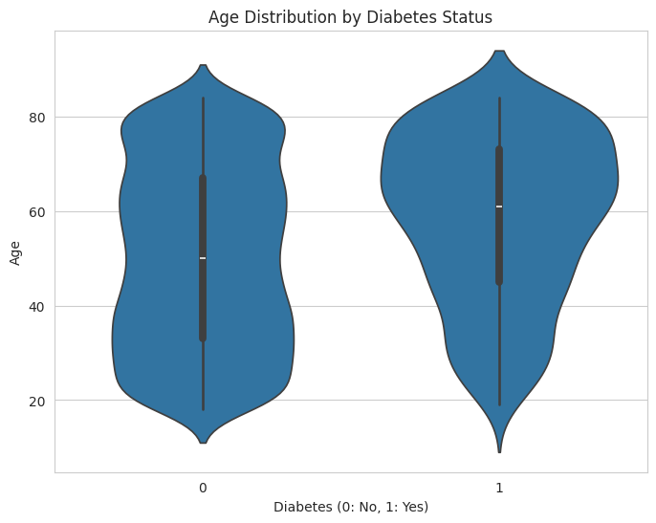
2. BMI Distribution Analysis
The "BMI Distribution" chart illustrates a distinct shift between the two groups. While the "Diabetes: 0" curve (blue) peaks earlier, the "Diabetes: 1" curve (green) shows a later peak. This demonstrates that although many individuals with a BMI of 25 remain non-diabetic, the likelihood of a diabetes diagnosis rises significantly alongside increasing BMI, specifically once it surpasses the 30.0 threshold.
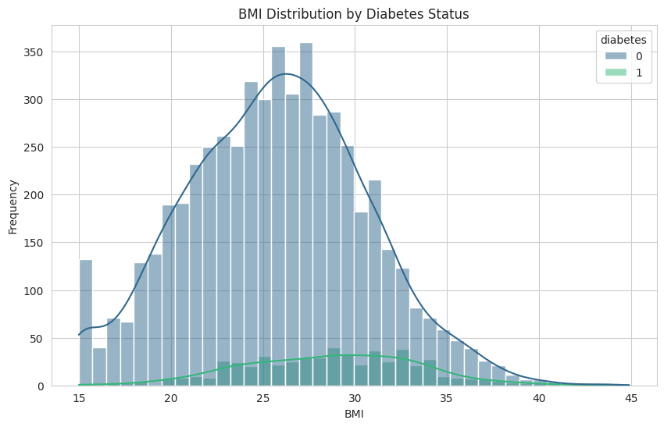
3. Analysis of Physical Activity Levels
The "Exercise Hours per Week Distribution by Diabetes Status" visualization reveals that the distribution for individuals with Diabetes: 1 is notably denser at the lower end of the scale compared to those with Diabetes: 0. This indicates that, on average, patients diagnosed with diabetes tend to report fewer exercise hours per week.
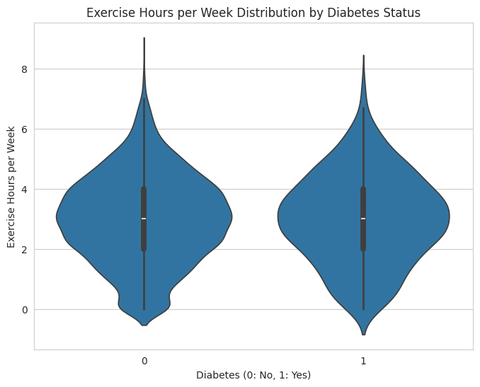

Important Features Influencing Prediction
By analyzing the distribution plots, we can identify which variables show the most significant variance between diabetic and non-diabetic individuals.
- BMI (Body Mass Index): This is the strongest numerical predictor in your dataset with a correlation coefficient of 0.17. The histogram shows that while the non-diabetic population peaks around a BMI of 25, the diabetic population (green curve) is shifted to the right, showing a significantly higher density in the 30.0 to 35.0 range.
- Blood Pressure: With a correlation of 0.15, this is the second most impactful feature. High blood pressure often co-occurs with metabolic issues, and the data reflects this link.
- Age: The violin plot reveals a "top-heavy" distribution for diabetic patients. While the general population is spread across all ages, the median age for diabetic patients is noticeably higher, with the bulk of cases falling between 60 and 80 years old. It carries a correlation of 0.12.

3. Model Implementation

Explanation of the Machine Learning Model
The traditional Machine Learning model used is Logistic Regression. This is a linear classification algorithm used for binary prediction that calculates the probability of the target class based on a weighted sum of input features (patient health attributes). The coefficients derived from training indicate both the strength and direction of a feature's influence on the diabetes prediction.

Explanation of the Neural Network Architecture
The Deep Learning approach uses a Sequential Artificial Neural Network (ANN) designed for binary classification.
- Input Layer: Accepts 5 normalized features: Age, BMI, Blood Pressure, Smoker Status, and Exercise Hours.
- Hidden Layers: Consists of two fully connected (Dense) layers with 16 and 8 neurons respectively. The ReLU activation function is used in both to introduce non-linearity.
- Output Layer: A single neuron with a Sigmoid activation function, which outputs the final probability score between 0 and 1.

4. Model Evaluation

Performance Metrics for Both Models

Traditional ML Model (Logistic Regression)
The model achieved an overall Accuracy of 65%. Given the class imbalance, this accuracy reflects an attempt to prioritize the identification of the minority (diabetic) class.
Feature Importance:
The model's coefficients quantify the influence of each feature on the prediction:
- BMI (0.524): Most significant positive predictor.
- Age (0.337): Second most influential positive predictor.
- Blood Pressure (0.273): Primary physiological marker.
- Smoker (-0.176): Shows a small inverse relationship.
- Exercise Hours (0.033): Least influential feature.

Deep Learning Model (ANN)
The model achieved a high overall Accuracy of 90.5% (0.9050) with a Loss of 0.3473 on the test data. However, the performance on the minority class (Diabetes=1) is critically low.

Visualizations (Confusion Matrix and Classification Report)

Logistic Regression Classification Report

Classification Report for ANN:
precision recall f1-score support

0 0.91 0.99 0.95 1092
1 0.29 0.04 0.07 108

accuracy 0.91 1200
macro avg 0.60 0.51 0.51 1200
weighted avg 0.86 0.91 0.87 1200

Logistic Regression Confusion Matrix

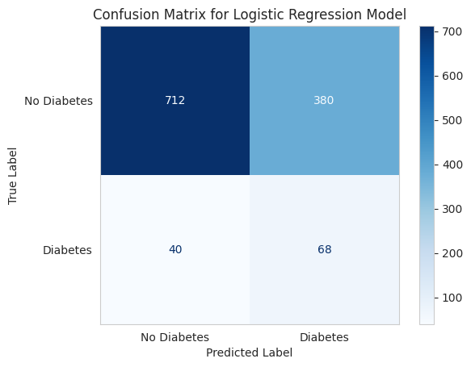

ANN Classification Report

Classification Report for ANN:
precision recall f1-score support

0 0.91 0.99 0.95 1092
1 0.29 0.04 0.07 108

accuracy 0.91 1200
macro avg 0.60 0.51 0.51 1200
weighted avg 0.86 0.91 0.87 1200

ANN Confusion Matrix:

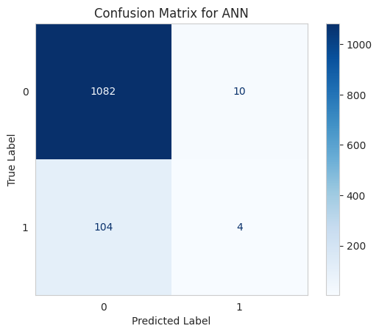

5. Comparative Analysis

Differences Between the Models
The primary distinction lies in the architectural approach and resulting performance profile:
- Overall Performance vs. Specificity: The Deep Learning (ANN) model achieved a significantly higher overall accuracy (90.5%) than the traditional Logistic Regression model (65%). However, this high accuracy for the ANN is misleading, as the Logistic Regression model, being linear, provides superior interpretability through explicit feature coefficients.
- Feature Influence: Logistic Regression clearly ranks the features, identifying BMI (0.524), Age (0.337), and Blood Pressure (0.273) as the strongest positive predictors of risk. The non-linear nature of the ANN (using ReLU activation) makes feature importance opaque.
- Model Complexity: The Logistic Regression is a simple, linear model, while the ANN is a non-linear, multi-layer architecture.

Reasons for Accuracy Differences
The substantial difference in overall accuracy is a direct consequence of the severe class imbalance (90.97% non-diabetic vs. 9.03% diabetic) and the models' response to this imbalance:
- ANN Overfitting to Majority Class: The ANN's impressive overall accuracy (90.5%) is achieved by correctly classifying the vast majority of non-diabetic patients. This is evidenced by the exceptionally high Recall for the non-diabetic class (0.99). Conversely, the model effectively ignores the minority class, resulting in a critically low Recall for diabetic patients (0.04). The model is therefore highly biased towards predicting "No Diabetes."
- Logistic Regression's Balanced Approach: The lower accuracy of the Logistic Regression model (65%) suggests it established a more conservative decision boundary. While its overall performance is inferior, its less aggressive classification strategy may offer a more balanced, though still imperfect, trade-off between False Positives and False Negatives than the highly skewed ANN.

Recommendations for Real-World Use
For a healthcare risk prediction application, the cost of a False Negative (failing to identify an at-risk patient) is far greater than the cost of a False Positive. Therefore, the current models require refinement:
- Current ANN is Clinically Unsuitable: An ANN model with a Recall of 0.04 on the diabetic class means it misses 96% of patients who actually have the condition, rendering it useless for clinical screening.
- Prioritize Recall over Accuracy: Any subsequent model training must focus on optimizing metrics that prioritize the minority class, such as the F1-score or Recall for the positive class (Diabetes=1).
- Recommendation for Deployment: The Logistic Regression model is immediately preferable for its interpretability in a clinical context. However, both models require re-training with robust techniques to address the class imbalance (e.g., using class weights, synthetic oversampling like SMOTE, or adjusting the probability threshold) to achieve an acceptable level of sensitivity (Recall) for the diabetic population.

