IST652-Scripting for Data Analysis. MiniProject1

Sales Analysis of iPhones in India

**Anjana Sowmya Puvvada**

**Suid-6788587001**

***Table of contents***

1. Executive Summary…………………………………………………………………………2
2. Introduction……………………………………………………………………………………..2
3. Data Overview………………………………………………………………………………….3
4. Top 10 Highest-Rated iPhones in India……………………………………………4
   * Methodology
   * Top 5 Highest-Rated iPhones
5. Number of Ratings and Reviews………………………………………………………4
   * Methodology
   * Key Findings
6. Relationship Between Sale Price and Ratings……………………………………6
   * Methodology
   * Key Finding
7. Relationship Between Discount Percentage and Ratings…………………..7
   * Methodology
   * Key Finding
8. Key Takeaways……………………………………………………………………………………8
9. Conclusion………………………………………………………………………………………….9
10. References…………………………………………………………………………………………9

**Executive Summary**

This detailed report presents a comprehensive analysis of iPhone sales in the Indian market. Leveraging Python and the provided dataset ("apple_products.csv"), we delve into various aspects of iPhone sales, such as identifying the top-rated iPhones, examining the number of ratings and reviews, and exploring the relationships between sale price, discount percentage, and number of ratings. The goal is to provide valuable insights for businesses and retailers operating in the Indian iPhone market.

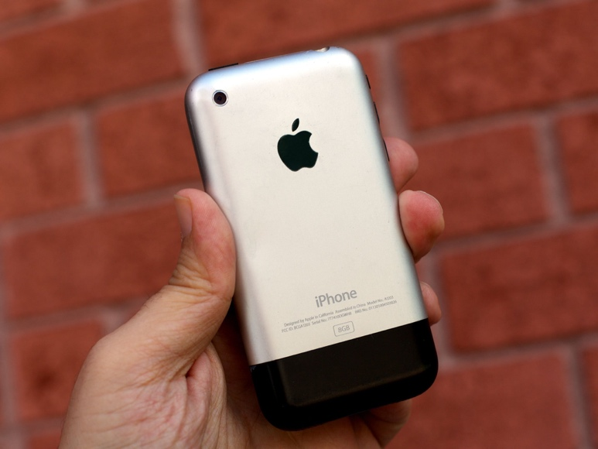

**Introduction**

The Indian smartphone market is a dynamic and fiercely competitive landscape, where consumers are presented with a wide array of choices from various manufacturers. Amid this vibrant market, iPhones, manufactured by Apple Inc., maintain a significant and distinct presence. These iconic devices have garnered a substantial following in India, a country known for its diverse and discerning consumer base.

This report seeks to provide a comprehensive illumination of the iPhones that have resonated most with Indian consumers, and to dissect the factors that underpin their popularity. In a market where consumer preferences can be as diverse as the nation's myriad cultures, understanding what makes certain iPhones stand out is crucial for both Apple and other stakeholders in the industry.

We will embark on a data-driven journey through the world of Indian iPhone sales, relying on a dataset named "apple_products.csv" as our compass. This dataset serves as a treasure trove of information, meticulously curated to offer insights into various aspects of iPhone sales in the Indian context. Our goal is to not only unveil which iPhones are most appreciated but also to explore the factors that shape this appreciation. By employing the tools of data analysis and visualization, we aim to decipher the intricate interplay of factors such as star ratings, number of ratings, pricing, and discounts.

Ultimately, this report is a beacon of knowledge for businesses and retailers operating in the Indian iPhone market. It endeavors to uncover patterns, reveal trends, and present actionable insights that can guide strategic decisions. In a marketplace that is ever evolving, understanding what resonates with consumers and the dynamics of pricing and discounts is indispensable for success.

**Data Overview**

We conducted the analysis using the following libraries:

* Pandas for data manipulation
* NumPy for numerical operations
* Plotly Express for data visualization

**Data Source**

The dataset is collected from Kaggle containing data about the sales of iPhones in India on Flipkart. You can download the dataset from

<https://www.kaggle.com/datasets/komalkhetlani/apple-iphone-data>



The dataset, "apple_products.csv," is free of null values, ensuring the reliability of the analysis.

**Top 10 Highest-Rated iPhones in India**

**Methodology:** To identify the top-rated iPhones, we sorted the dataset by "Star Rating" in descending order and selected the top 10.

**Top 5 Highest-Rated iPhones:**

1. APPLE iPhone 11 Pro Max (Midnight Green, 64 GB)
2. APPLE iPhone 11 Pro Max (Space Grey, 64 GB)
3. APPLE iPhone 11 Pro Max (Midnight Green, 256 GB)
4. APPLE iPhone 11 Pro Max (Gold, 64 GB)
5. APPLE iPhone 11 Pro Max (Gold, 256 GB)

**Number of Ratings and Reviews**

**Methodology:** We examined the number of ratings and reviews for the top-rated iPhones.

**Key Findings:**

1. **"APPLE iPhone 8 Plus (Gold, 64 GB)"** emerged as the top-rated iPhone with the **highest number of ratings** on Flipkart among the top-rated iPhones. This indicates that a substantial number of customers have provided their feedback and ratings for this particular iPhone model, making it a prominent choice among consumers.
2. Additionally, **"APPLE iPhone 8 Plus (Gold, 64 GB)"** also garnered the distinction of having the **highest number of reviews** among the top-rated iPhones in India. Reviews often contain more detailed and qualitative information about a product, and the fact that this iPhone model received the most reviews suggests that it has generated considerable interest and engagement from customers.

**Relationship Between Sale Price and Ratings**

In our analysis, we delved into the relationship between the sale price of iPhones and the number of ratings they received. We used a scatter plot to visualize this relationship, enabling us to identify patterns and trends in the data.

**Key Finding:**

* Our analysis revealed a **negative linear relationship** between the sale price of iPhones and the number of ratings they received. This means that as the sale price of an iPhone decreases, the number of ratings it accumulates tends to increase. In other words, iPhones with lower price tags are more likely to be popular and attract a higher number of ratings in the Indian market.

This finding suggests that cost-consciousness and affordability play a significant role in consumer preferences in India. It indicates that consumers tend to favor iPhones that offer good value for their money, which is often associated with lower sale prices.

**Relationship Between Discount Percentage and Ratings**

In our analysis, we investigated how the discount percentage offered on iPhones relates to the number of ratings those iPhones received. We used a scatter plot to visualize this relationship, allowing us to uncover trends and patterns in the data.

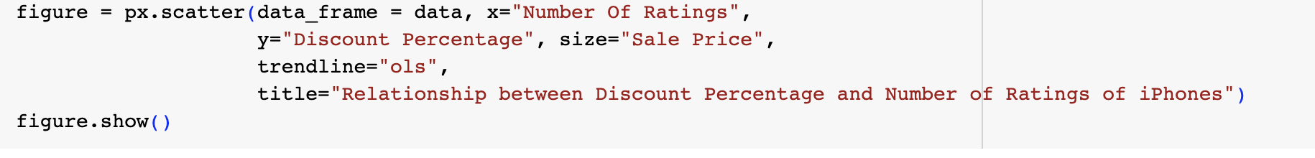

**Key Finding:**

* Our analysis revealed a **linear relationship** between the discount percentage on iPhones and the number of ratings they received. This means that as the discount percentage on an iPhone increases, the number of ratings it accumulates also tends to increase. In simpler terms, iPhones with higher discounts are more appealing to Indian consumers and, as a result, tend to receive a greater number of ratings.

This finding suggests that price incentives in the form of discounts strongly influence consumer behavior in the Indian market. It implies that consumers are more inclined to rate and potentially purchase iPhones when they are offered substantial discounts.

**Key Takeaways**

The analysis of iPhone sales in the Indian market offers several significant insights with important implications for businesses and retailers operating in this competitive landscape.

1. **"APPLE iPhone 8 Plus (Gold, 64 GB)" Leads in Appreciation:**
   * Our analysis reveals that "APPLE iPhone 8 Plus (Gold, 64 GB)" holds a special place among Indian consumers. It not only boasts the highest number of ratings but also garners the most reviews among the top-rated iPhones. This indicates that it has resonated strongly with users and has elicited active engagement and feedback.
2. **Affordability Matters: iPhones with Lower Sale Prices:**
   * The analysis underscores a clear trend that iPhones with lower sale prices tend to receive higher ratings and are more popular in India. This suggests that Indian consumers are price-sensitive and often gravitate toward iPhones that provide good value for their money.
3. **Discounts Drive Engagement: iPhones with Higher Discounts:**

* The analysis also highlights the role of discounts in influencing consumer behavior. iPhones with higher discounts tend to attract more ratings and consumer engagement. This insight suggests that promotional strategies, including discounts and special offers, can significantly impact a product's popularity.

[**Conclusion**](https://amankharwal.medium.com/data-analysis-projects-with-python-a262a6f9e68c)

Understanding consumer preferences and market dynamics is crucial for success in the Indian smartphone market. This analysis offers actionable insights that businesses can leverage to make informed decisions about their product offerings and pricing strategies. As the smartphone market continues to evolve, staying attuned to consumer sentiment and adapting strategies accordingly will be essential for sustained success.

**References**

<https://amankharwal.medium.com/data-analysis-projects-with-python-a262a6f9e68c>

<https://www.kaggle.com/search>