**ShopNest Store Power BI Capstone**

**Anjana k**

1. **Top Categories by Total Price:** Identify and visually represent the top 10 product categories by total sales.

* Health Beauty is the top product category by sales
* Followed by watches and gifts

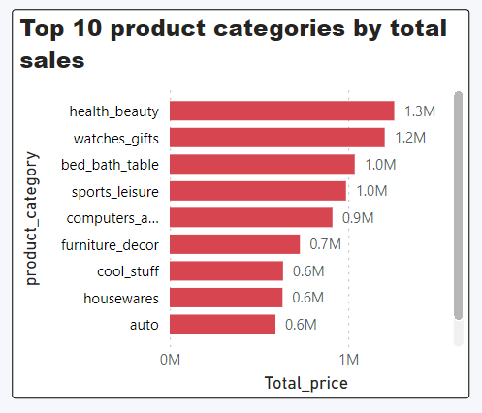

1. **Delayed Orders Analysis:** Determine the number of delayed orders in each category. An order is considered delayed if the actual delivery date is later than the estimated delivery date.

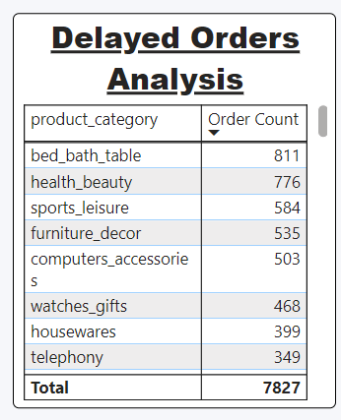

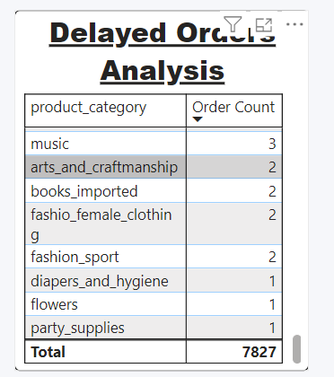

* Total number of delayed orders count is 7827
* Bed_Bath_table category has the most delayed order count.
* Party supplies and flowers are the orders with the lowest number of delayed orders, but these categories also have the lowest total orders.

1. **Monthly Comparison of Delayed and On-Time Orders:** Create a dynamic visual that compares the number of delayed orders to the number of orders received earlier for each month. Utilize the drillthrough cross-report feature to provide a detailed analysis of late and on-time deliveries.

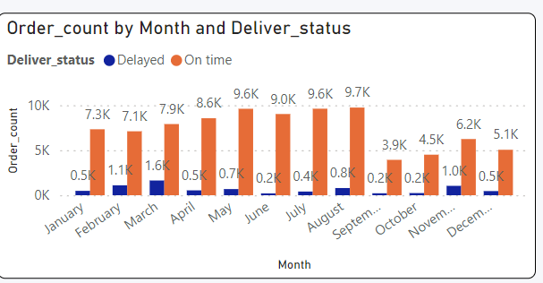

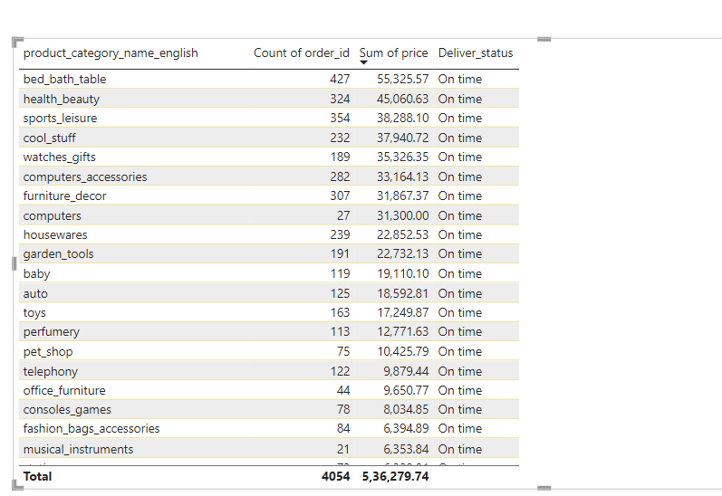

* March has the highest count of delayed deliveries.
* September has the highest count of On time deliveries

1. **Payment Method Analysis:** Analyze the most frequently used payment methods by customers using a visually appealing representation, such as a pie chart or other suitable visuals.

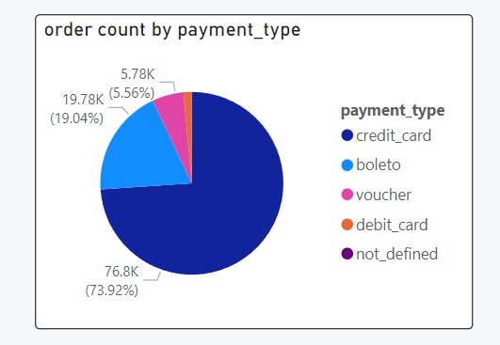

* Most frequently used payment method is credit card & the least used one is debit card

1. **Product Rating Analysis:** Determine the top 10 highest-rated products and the bottom 10 lowest-rated products using a bar or column chart.

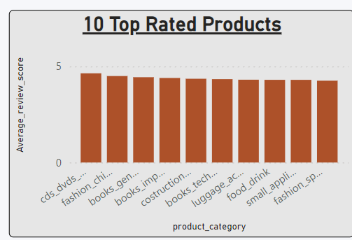

* Highest rate product category is cds_dvds_musicals which has an average rating of 4.64

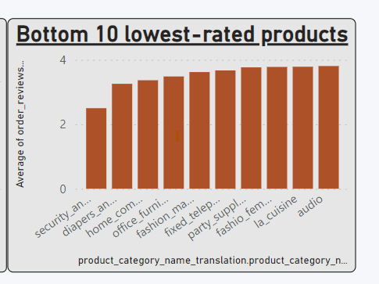

* Lowest rated product category is security and services.

1. **State-wise Sales Analysis:** Identify and visually represent states with high and low sales, providing a clear understanding of regional sales performance.

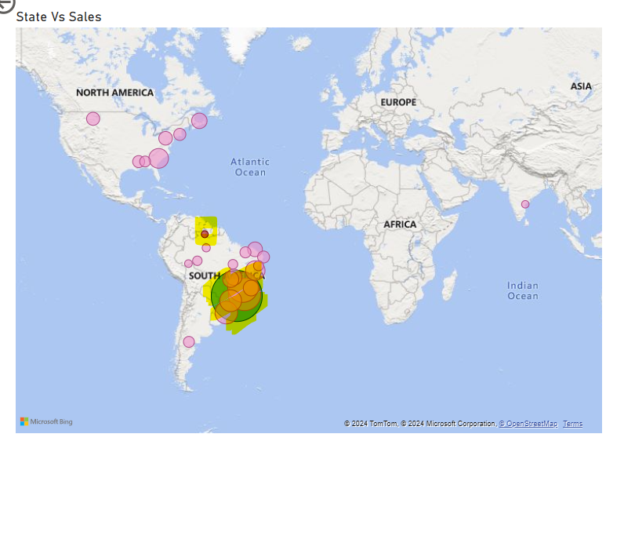

* State SP has the highest Sale highlighted in green bubble in the map and RR has the lowest sales bubbled in red.

**City wise data for state SP (average rating, Total slaes)**

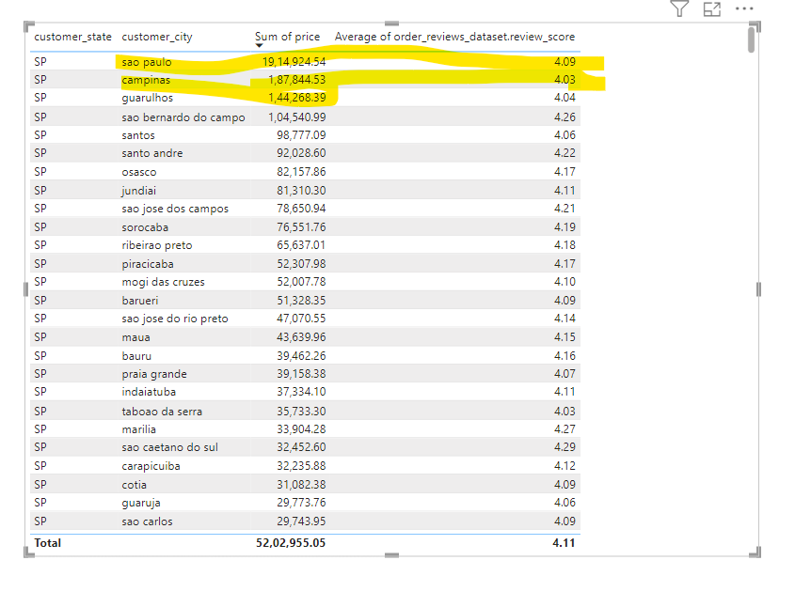

**City wise sale for state RR**

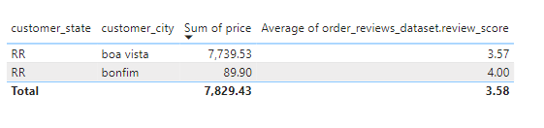

1. **Seasonal Sales Patterns:** Investigate and visualize any seasonal patterns(Quarterly) or trends in sales data over the course of the year.

* Quarter 2 has highest sales, as we can see that order count increases sales increases

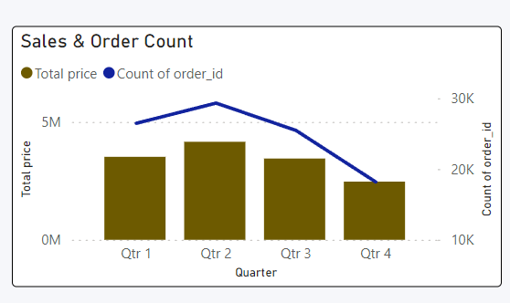

1. **Revenue Analysis:** Determine the total revenue generated by ShopNest Store  and analyze how it changes over time(Yearly). Represent this information through suitable visuals to highlight trends and patterns.

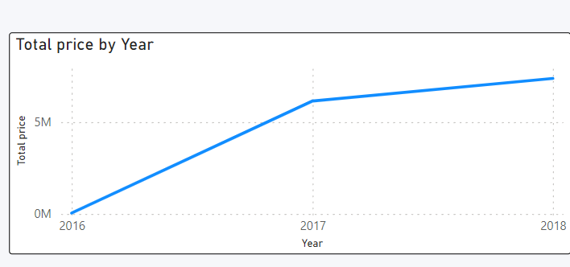

* From 2016 to 2017 the sales increases.
* Below graph show the sales for highest rated product Health Beauty

