Git Experiment – Week 8

Introduction
This lab exercise demonstrates how to set up Git on a local machine, configure the environment, and use Git commands to track and manage files. The activity also includes integrating Notepad++ as the default Git editor and pushing changes to a remote GitLab repository.
By completing this lab, you gain hands-on experience with:
- Git basic commands (git init, git status, git add, git commit, git push, git pull)
- Local to remote repository integration
- File tracking, staging, and committing

Prerequisites
- Git installed on the system
- GitLab account created
- Notepad++ installed
- Stable internet connection

Step-by-Step Execution

1. Git Configuration
1. Open Git Bash and verify Git installation:
git --version
2. Configure username and email:
git config --global user.name "Anjana B"
git config --global user.email “anjana0876@gmail.com"
3. Verify configuration:
git config --list

2. Integrate Notepad++ with Git
1. Ensure notepad++.exe is in the system PATH.
2. Set Notepad++ as the default editor:
git config --global core.editor "notepad++"
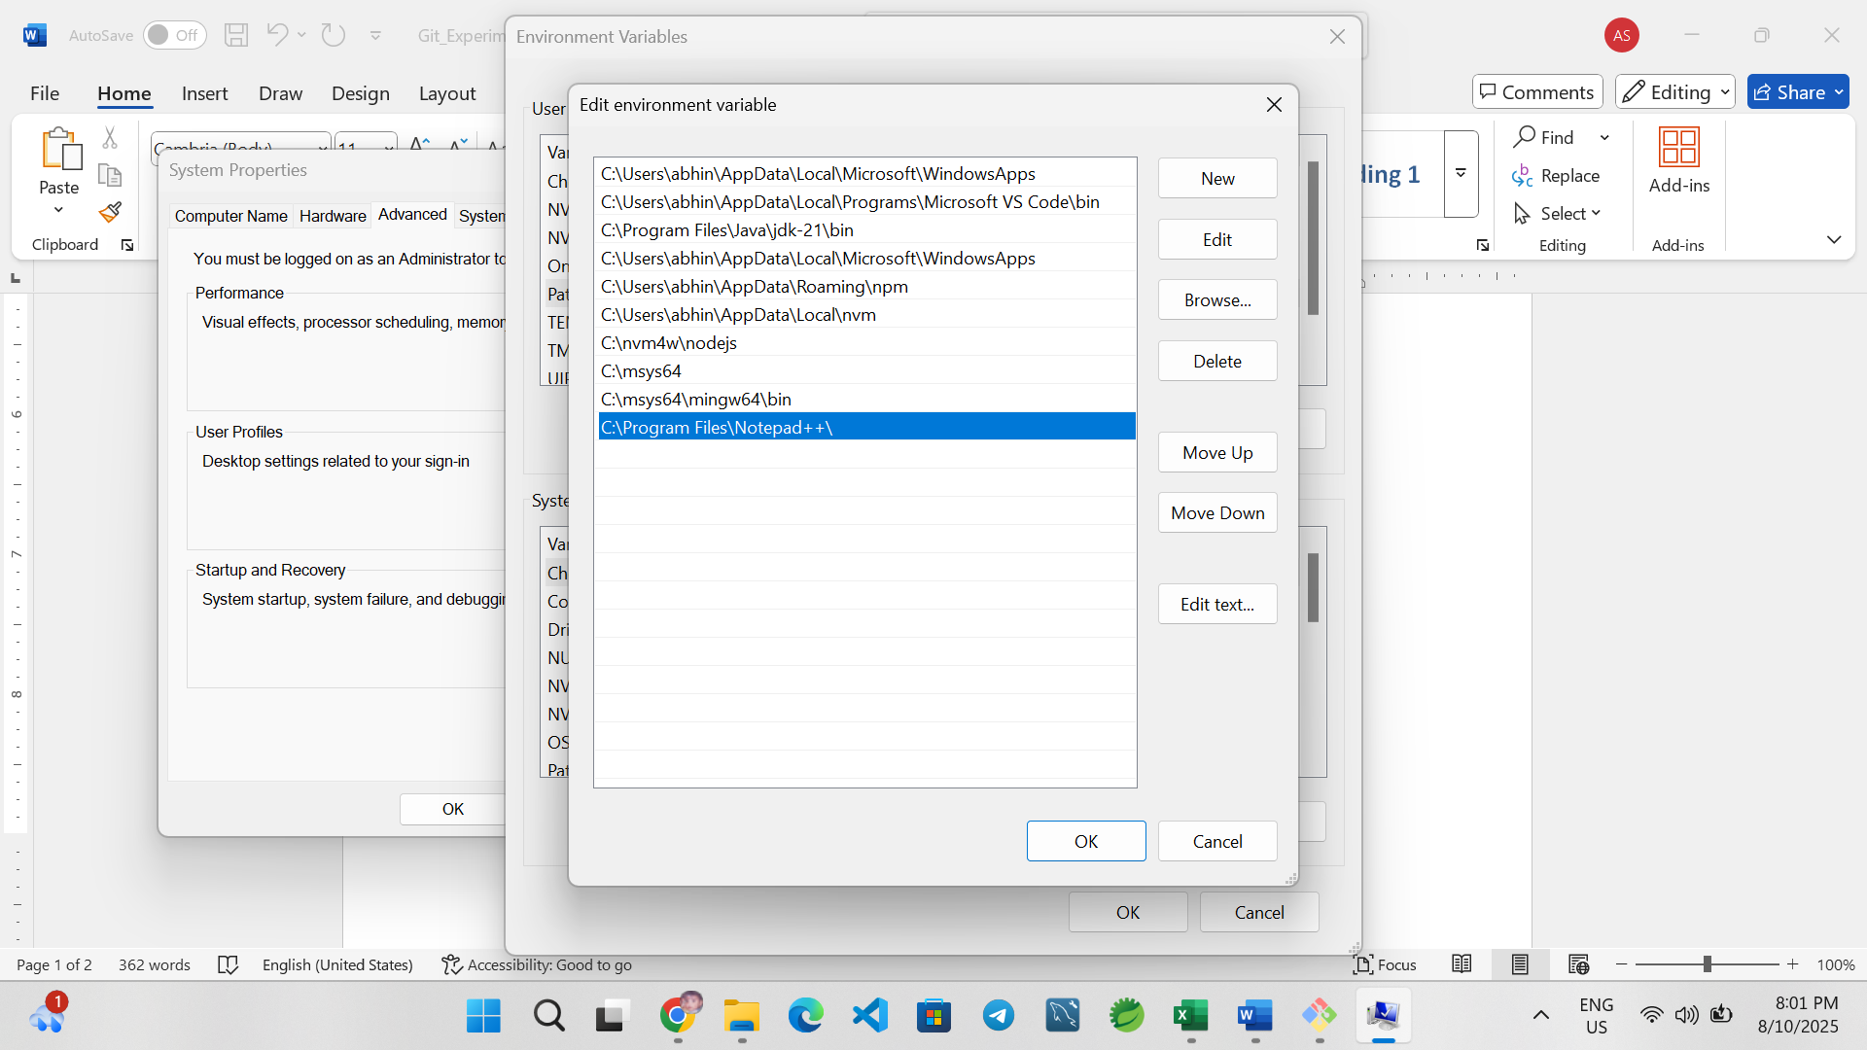
3. Verify:
git config -e --global

3. Create Local Repository
1. Navigate to project folder
2. Initialize Git repository:
git init

4. Add First File
1. Create welcome.txt:
echo "Welcome to Git Demo" > welcome.txt
2. Check status:
git status
3. Stage the file:
git add welcome.txt
4. Commit changes:
git commit -m "Added welcome.txt"

5. Link to GitLab Repository
1. Create an empty GitDemo1 repository in GitLab (no README).
2. Link remote:
git remote add origin <your-gitlab-repo-URL>
3. Rename branch if needed:
git branch -M main
4. Push changes:
git push origin main

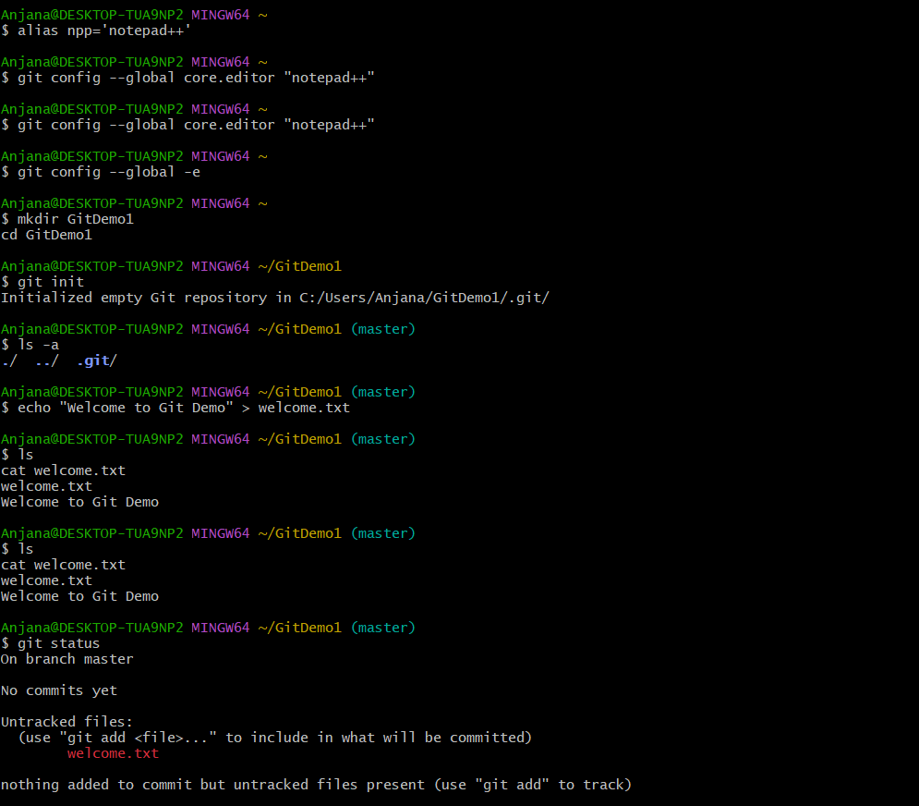
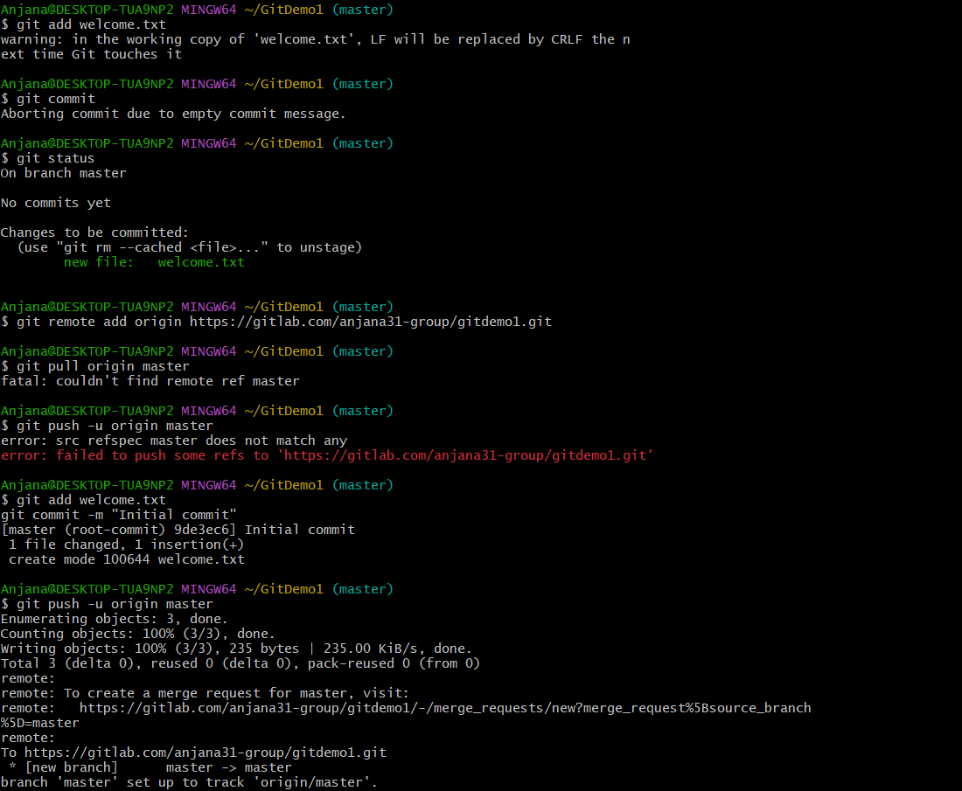

Output:
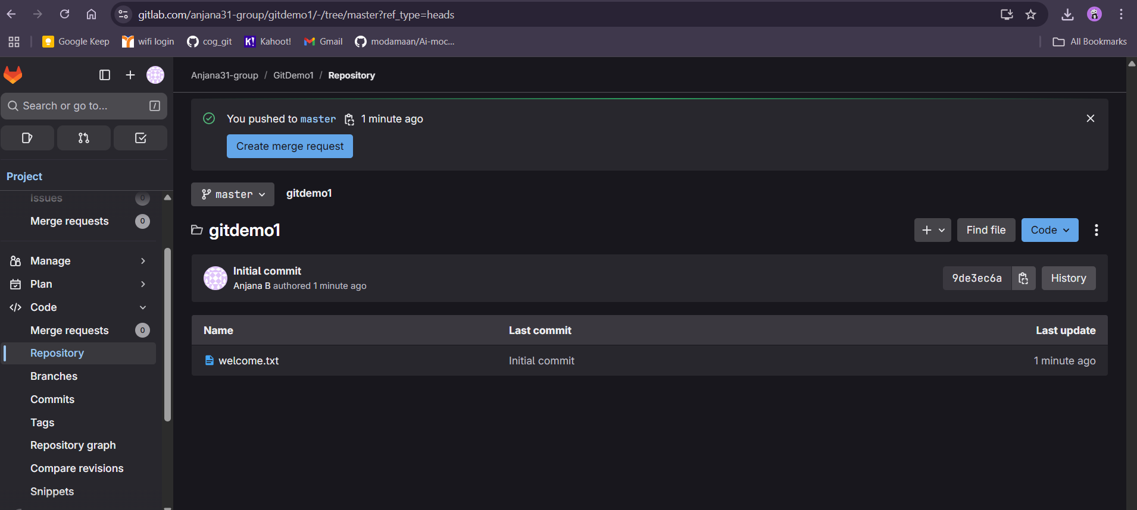

Conclusion
This lab successfully demonstrated the end-to-end process of using Git with GitLab. You learned how to:
- Configure Git and set up Notepad++ as the default editor
- Initialize a repository and track files
- Stage, commit, and push changes to a remote repository
By following these steps, you can now manage version control for any project efficiently.

Git Ignore Experiment - Week 8
Introduction
This experiment demonstrates how to use the .gitignore file in Git to ignore unwanted files and folders. In many projects, certain files are generated locally (e.g., log files, temporary build files) and should not be committed to the repository. The .gitignore file allows developers to specify patterns for files and directories that Git should ignore.
Objectives
• Explain what .gitignore is and how it works.
• Demonstrate how to ignore unwanted files and folders using .gitignore.
Prerequisites
• Git installed and configured on the system.
• Notepad++ integrated as the default Git editor (optional).
• Local Git repository initialized and connected to a remote repository on GitLab.
Steps
1. Navigate to your working directory containing the Git repository:
cd ~/OneDrive/Documents/Cognizant/Week8
2. Create a `.log` file and a `log` folder:
touch test.log
mkdir log
3. Create or edit the `.gitignore` file in the repository root:
notepad++ .gitignore
4. Add the following lines to `.gitignore` to ignore all `.log` files and the `log` folder:
*.log
log/
5. Save and close `.gitignore`.
6. Verify that Git is ignoring the files by running:
git status
Expected: `.log` files and `log/` folder do not appear in untracked files.
7. Add `.gitignore` to the repository and commit the change:
git add .gitignore
git commit -m "Add .gitignore to ignore .log files and log folder"
8. Push the commit to the remote repository:
git push origin main
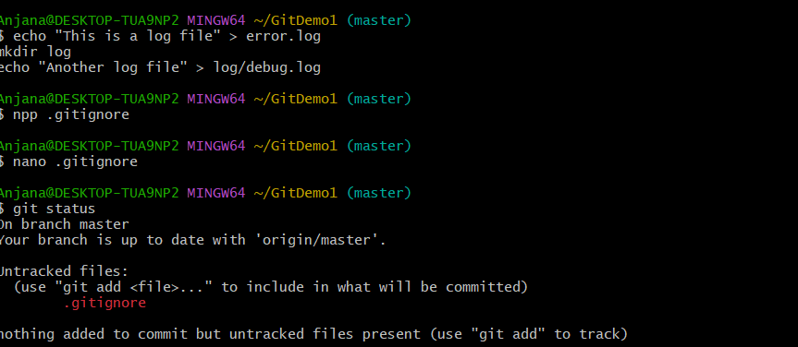
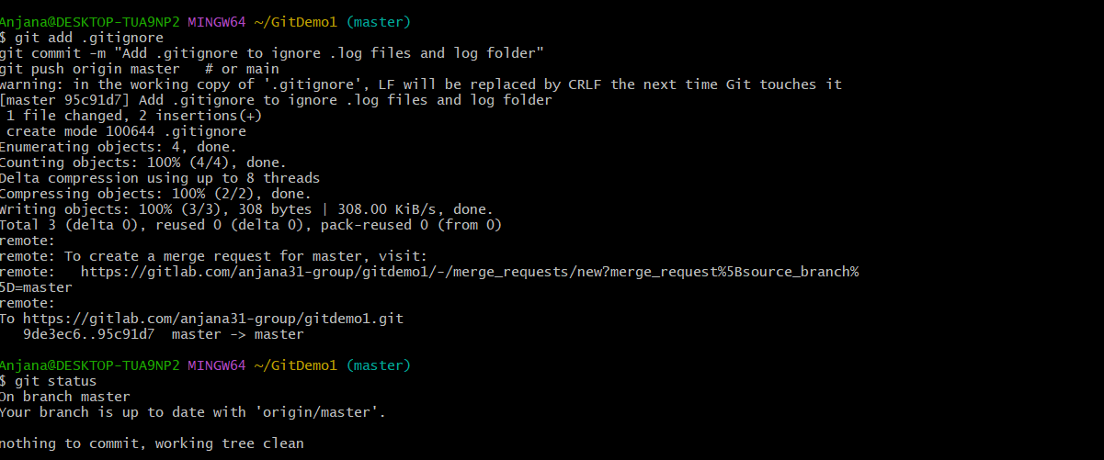

Output
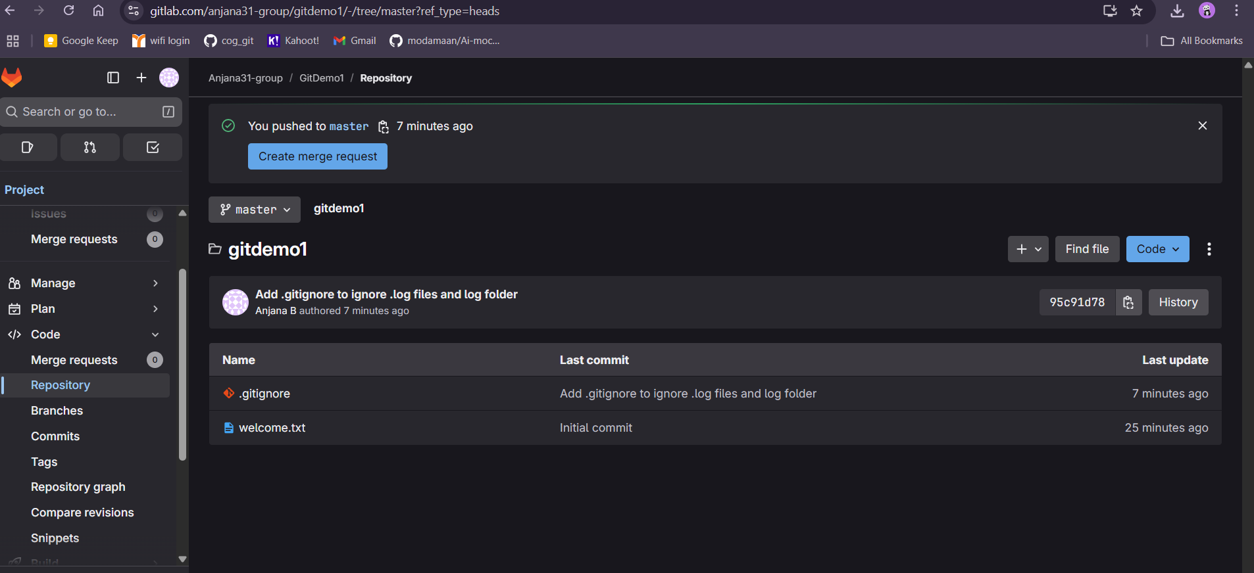
Conclusion
In this experiment, we successfully implemented the `.gitignore` file to prevent Git from tracking unwanted `.log` files and the `log` folder. This helps maintain a clean repository by avoiding the inclusion of temporary or environment-specific files.

3 Git Branching and Merging Hands-on Lab
Introduction
Version control is a vital part of modern software development, enabling teams to manage source code changes efficiently. Git is one of the most popular distributed version control systems, and branching/merging are among its most powerful features.
Branching allows developers to create an independent workspace for new features or bug fixes without affecting the main codebase. Merging brings the changes from different branches back into the main line of development. This hands-on lab demonstrates how to create a branch, make changes, and merge it back to the master branch using both the command line and P4Merge tool for visual comparison.

Objectives
By the end of this lab, you will be able to:
- Explain branching and merging in Git.
- Create a branch request in GitLab.
- Create a merge request in GitLab.
- Construct a branch, make changes, and merge it with the master (or trunk) branch.

Prerequisites
- Git environment set up on your system.
- P4Merge tool installed for visual merging (Windows).
- GitHub account (Do not use Cognizant credentials).
- Basic knowledge of Git commands.

Branching in Git
Theory
Branching in Git lets you diverge from the main line of development to work independently on a task.
- master/main branch → Main codebase.
- feature branch → Isolated environment for development.

Procedure
1. Create a new branch GitNewBranch
bash
CopyEdit
git branch GitNewBranch
2. List all local and remote branches
bash
CopyEdit
git branch -a
- The branch with * indicates the currently checked-out branch.
3. Switch to the new branch
bash
CopyEdit
git checkout GitNewBranch
4. Add files with content
bash
CopyEdit
echo "This is a test file in GitNewBranch" > file1.txt
git add file1.txt
5. Commit the changes
bash
CopyEdit
git commit -m "Added file1.txt in GitNewBranch"
6. Check branch status
bash
CopyEdit
git status

Merging in Git
1. Switch back to master
bash
CopyEdit
git checkout master
2. View differences (command line)
bash
CopyEdit
git diff master GitNewBranch
3. View visual differences (P4Merge)
bash
CopyEdit
git mergetool
(Ensure P4Merge is configured in Git settings beforehand.)
4. Merge branch into master
bash
CopyEdit
git merge GitNewBranch
5. View merge history
bash
CopyEdit
git log --oneline --graph --decorate
6. Delete the branch after merging
bash
CopyEdit
git branch -d GitNewBranch
- Check status:
bash
CopyEdit
git status

Creating a Branch Request in GitLab
- Push your new branch to GitLab:
bash
CopyEdit
git push origin GitNewBranch
- In GitLab, navigate to your repository.
- Go to Repository → Branches.
- Locate your branch and click New merge request.

Creating a Merge Request in GitLab
- In the merge request form:
  - Select Source branch = GitNewBranch
  - Select Target branch = master
- Add a title and description.
- Assign reviewers if required.
- Click Create merge request.
- Once reviewed, click Merge to integrate changes.
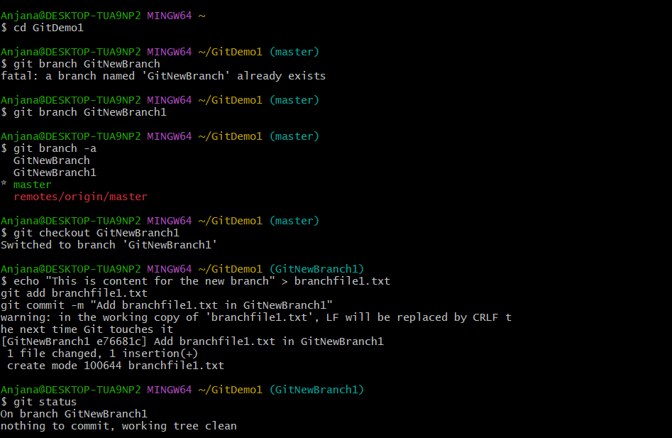

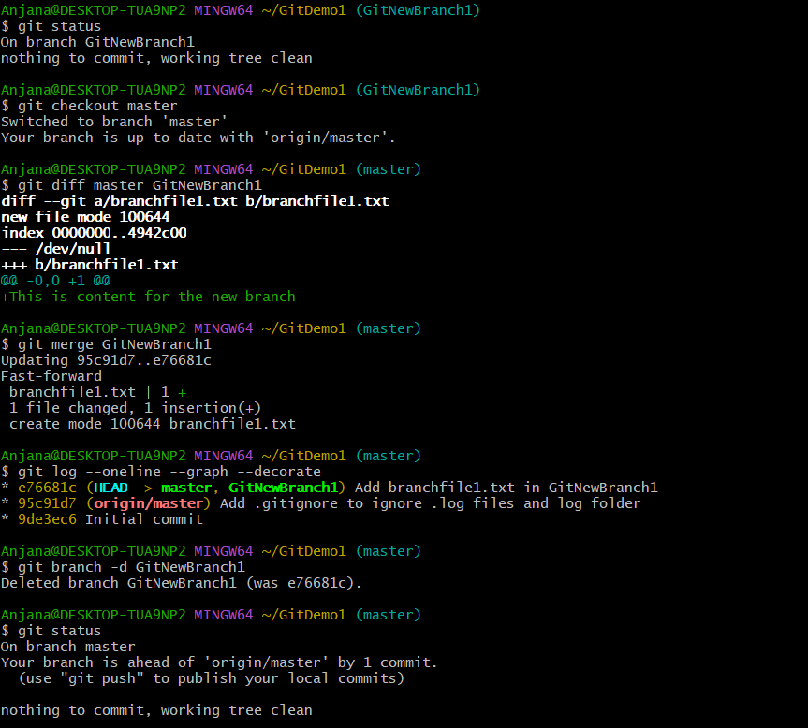

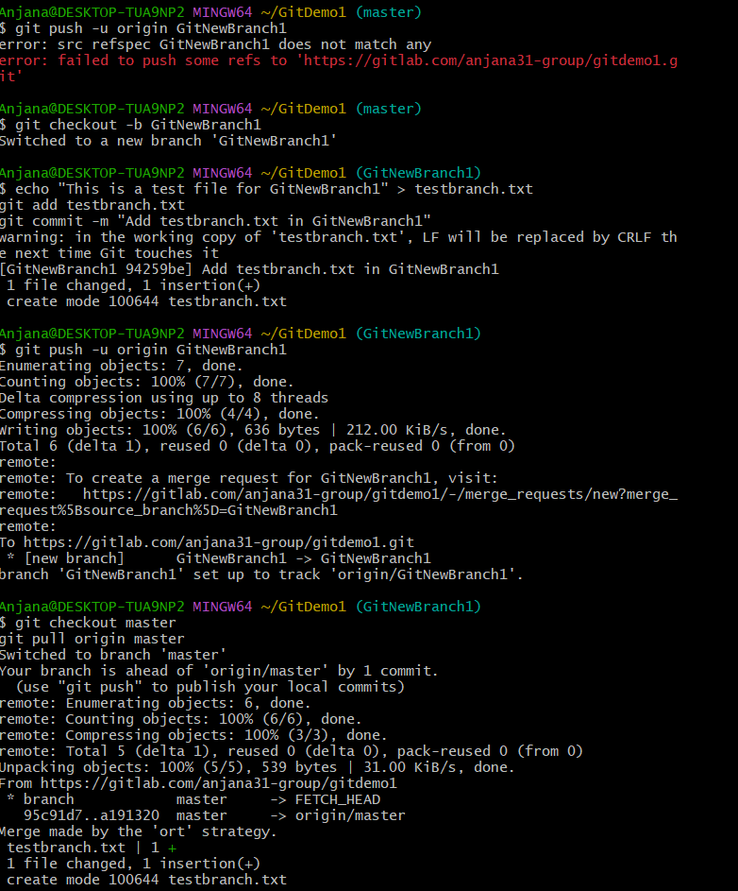
Conclusion
In this lab, you learned how to create a branch, make changes in it, and merge it back into the master branch. You also explored how to identify changes between branches using both the Git CLI and P4Merge tool, and understood how to create branch and merge requests in GitLab. Mastering branching and merging enables parallel development, better collaboration, and safer integration of new features into the main codebase.

4.Git Conflict Resolution Hands-on Lab

Introduction
Git is a powerful version control system that allows multiple developers to work on the same project simultaneously. However, when two branches modify the same part of a file differently, a merge conflict occurs. Resolving these conflicts correctly is essential to maintain code integrity. This lab guides you through creating a conflict and resolving it using Git commands and the P4Merge visual tool.

Objectives
- Explain how to resolve conflicts during a merge.
- Implement conflict resolution when multiple users update the same file in different branches.

Prerequisites
- Git environment installed and configured.
- P4Merge tool installed for visual diff and merge.
- Hands-on ID: Git-T03-HOL_001.
- A Git repository initialized with a default branch (main or master).

Step-by-step Procedure
1. Verify the main branch is clean
bash
CopyEdit
git checkout main
git status
2. Create and switch to a new branch GitWork
bash
CopyEdit
git checkout -b GitWork
3. Add a file hello.xml in GitWork and commit
bash
CopyEdit
echo "<message>From GitWork branch</message>" > hello.xml
git add hello.xml
git commit -m "Add hello.xml in GitWork"
4. Update hello.xml in GitWork and commit
bash
CopyEdit
echo "<message>Updated in GitWork branch</message>" > hello.xml
git add hello.xml
git commit -m "Update hello.xml content in GitWork"
5. Switch back to main branch
bash
CopyEdit
git checkout main
6. Add hello.xml in main with different content and commit
bash
CopyEdit
echo "<message>From main branch</message>" > hello.xml
git add hello.xml
git commit -m "Add hello.xml in main with different content"
7. View commit log to observe divergence
bash
CopyEdit
git log --oneline --graph --decorate --all
8. Check textual differences between branches
bash
CopyEdit
git diff main..GitWork
9. View visual differences with P4Merge
bash
CopyEdit
git difftool main..GitWork
10. Merge GitWork into main (conflict occurs)
bash
CopyEdit
git merge GitWork
11. View conflict markers in hello.xml
bash
CopyEdit
cat hello.xml
12. Resolve the conflict using P4Merge
bash
CopyEdit
git mergetool
- In P4Merge, review BASE, LOCAL (main), and REMOTE (GitWork) versions.
- Choose or combine changes as needed.
- Save and close to mark conflict as resolved.
13. Stage the resolved file and commit the merge
bash
CopyEdit
git add hello.xml
git commit -m "Merge GitWork into main with conflict resolved"
14. Add backup and temporary files to .gitignore
bash
CopyEdit
echo "*.orig" >> .gitignore
echo "*~" >> .gitignore
git add .gitignore
git commit -m "Add backup file patterns to .gitignore"
15. List all branches
bash
CopyEdit
git branch -a
16. Delete the merged branch GitWork
bash
CopyEdit
git branch -d GitWork
17. View final commit log graph
bash
CopyEdit
git log --oneline --graph --decorate

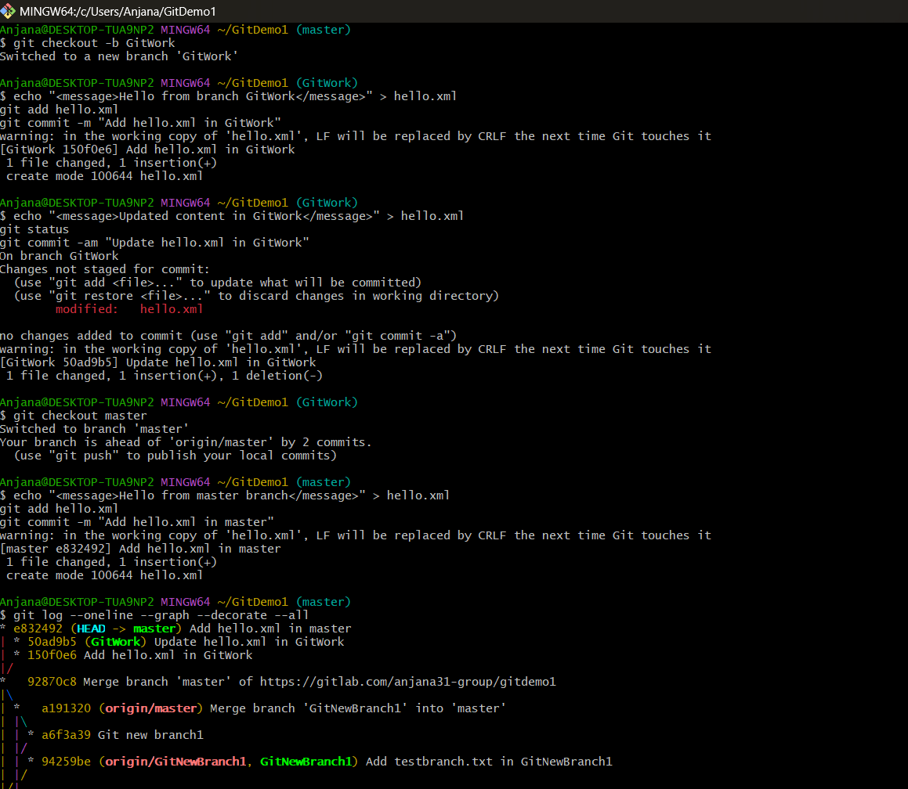
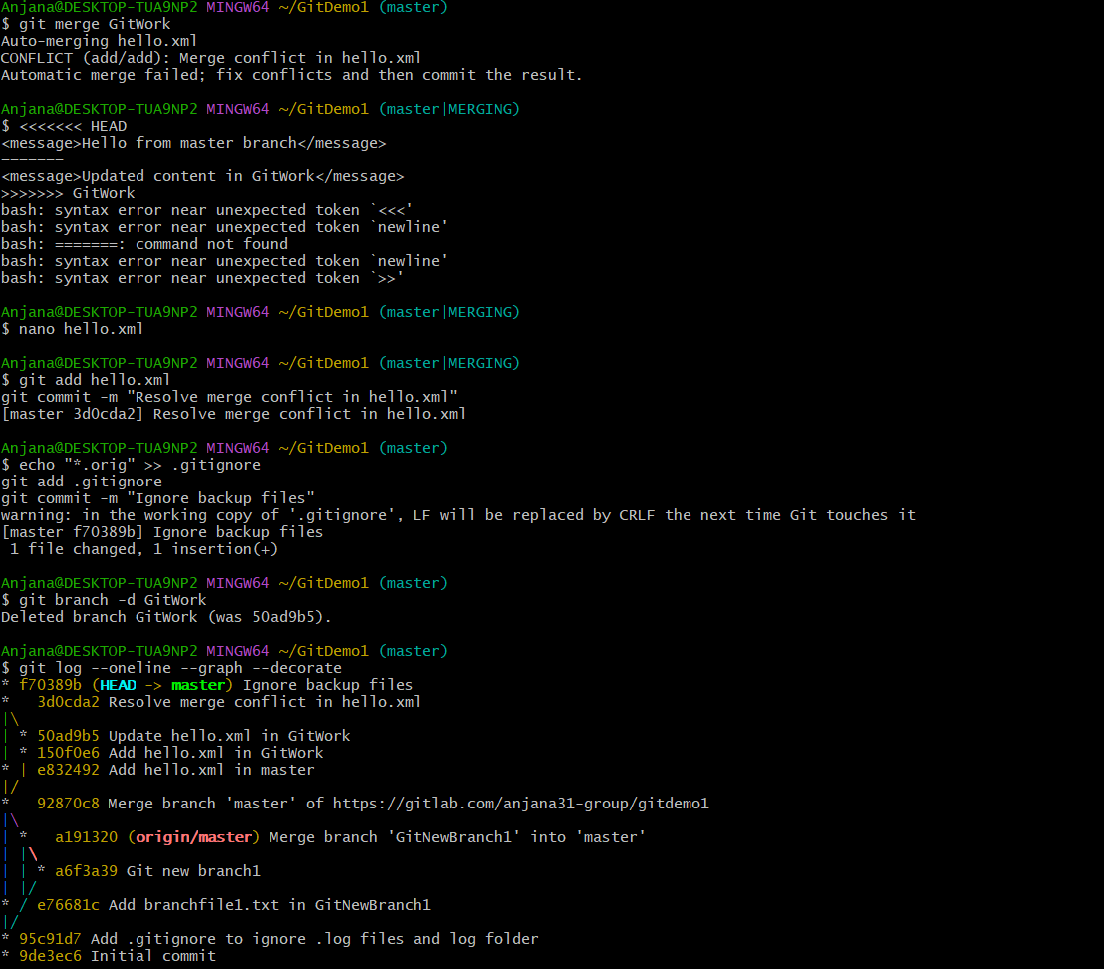

Conclusion
In this lab, you successfully created and resolved a merge conflict between two branches using Git commands and the P4Merge visual tool. Handling merge conflicts confidently is critical for collaborative software development, ensuring code consistency and smooth integration of changes.
5 Git Clean-up and Push Back to Remote Repository

Introduction
In collaborative software development, it is essential to keep your local Git repository clean and synchronized with the remote repository. This lab guides you through verifying your local branch state, pulling changes from the remote, and pushing your local changes back to the remote repository.

Objectives
- Explain how to clean up your local repository state.
- Execute steps to push local changes to the remote Git repository.

Prerequisites
- Git installed and configured on your machine.
- Access to a remote Git repository (e.g., GitLab or GitHub).
- Hands-on ID: Git-T03-HOL_002.
- Local branch named Git-T03-HOL_002 with changes ready to push.

Step-by-step Procedure
Step 1: Verify if the main branch is in a clean state
bash
CopyEdit
git checkout main
git status
Step 2: List all available branches (local and remote)
bash
CopyEdit
git branch -a
Step 3: Pull the latest changes from the remote repository into your local main branch
bash
CopyEdit
git pull origin main
Step 4: Push your local changes from branch Git-T03-HOL_002 to the remote repository
bash
CopyEdit
git checkout Git-T03-HOL_002
git push origin Git-T03-HOL_002
Step 5: Verify that the changes are reflected in the remote repository
- Visit your repository on GitLab/GitHub.
- Check the branch Git-T03-HOL_002 for your recent commits and changes.
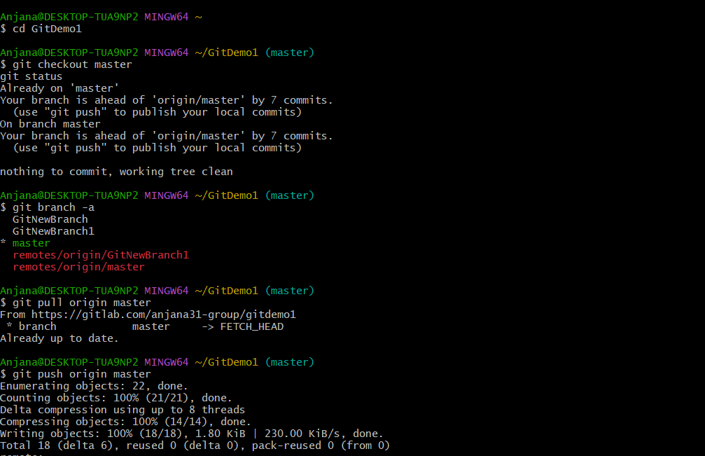

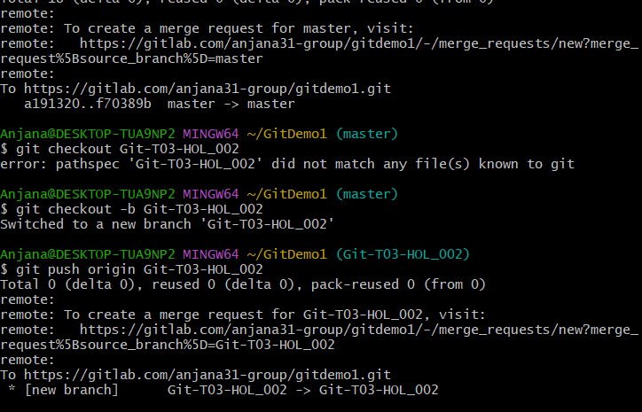
Conclusion
This lab demonstrated the essential Git commands to keep your local repository clean and in sync with the remote. You successfully pulled the latest changes from the remote repository and pushed your local commits, ensuring smooth collaboration and version control.

