# Deep Learning Project Report: Fashion-MNIST Image Classifier (CNN)

## 1. Introduction and Approach

### 1.1 Objective and Rationale

The objective was to develop and evaluate a Convolutional Neural Network (CNN) for the multi-class classification of Fashion-MNIST images. A CNN was chosen for its superior ability to **automatically learn spatial features** (edges, textures, and shapes), crucial for high performance in image tasks.

### 1.2 Data Preprocessing

The dataset of 70,000 images (28×28 grayscale) underwent rigorous preprocessing:

1. **Normalization:** Pixel values (0-255) were scaled to 0.0 **to** 1.0.
2. **Reshaping:** Images were formatted to (N,28,28,1) for Conv2D input.
3. **Splitting:** The training data was split into a **Training Set** and a **Validation Set** to monitor generalization.

## 2. Model Architecture and Training

### 2.1 Advanced CNN Architecture

The model uses a deep architecture incorporating **Batch Normalization** (BN) and **Dropout** for stabilization and regularization.

|  |  |  |  |
| --- | --- | --- | --- |
| Layer Type | Filters/Units | Output Shape | Technique |
| **Conv2D + BN** | 32 | (28,28,32) | ReLU |
| **MaxPooling2D** | N/A | (14,14,32) | Dropout (25%) |
| **Conv2D + BN** | 64 | (14,14,64) | ReLU |
| **MaxPooling2D** | N/A | (7,7,64) | Dropout (25%) |
| **Conv2D + BN** | 128 | (7,7,128) | ReLU |
| **GlobalAveragePooling** | N/A | (128) | N/A |
| **Dense + BN** | 256 | (256) | ReLU, Dropout (50%) |
| **Dense (Output)** | 10 | (10) | Softmax |

### 2.2 Training Strategy

The model was compiled with the **Adam optimizer** and Sparse Categorical Crossentropy loss. Advanced training included:

* **Learning Rate Scheduling (**ReduceLROnPlateau**):** Dynamically adjusted the learning rate, enabling rapid initial convergence and precise final optimization.
* **Early Stopping:** Monitored validation loss and halted training effectively at **Epoch 46**, ensuring the best-performing weights were restored.

## 3. Evaluation and Key Insights

### 3.1 Final Test Performance

The model was evaluated on the independent 10,000-image test set.

|  |  |
| --- | --- |
| Metric | Result |
| **Final Test Accuracy** | **93.50%** |
| Final Test Loss | 0.1817 |

### 3.2 Training History

The history plots confirm excellent generalization; training and validation curves track tightly, validating the effectiveness of Batch Normalization and Dropout in preventing overfitting.

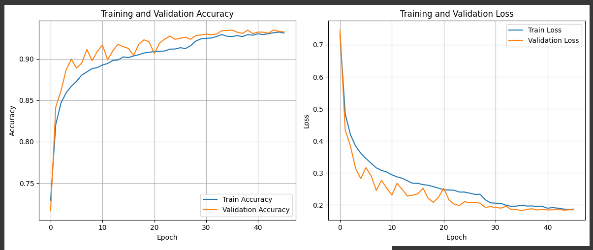

**Figure 1: Training and Validation History**

### 3.3 Confusion Matrix Analysis

The Confusion Matrix highlights class-specific performance, confirming the reliability of the model.

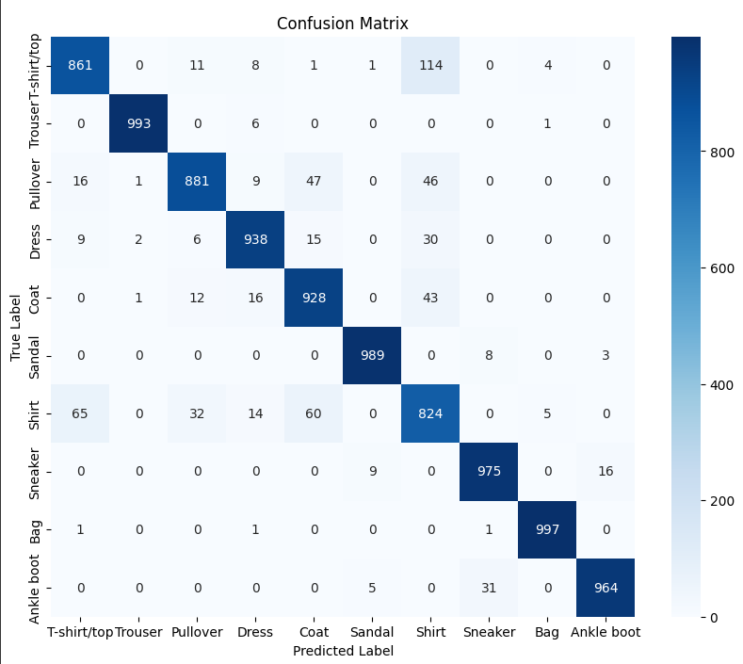

**Key Insights:**

1. **Strengths:** Categories with distinct silhouettes like **Trouser (**0.99 **F1-score)** and **Bag (**0.99 **F1-score)** were classified almost perfectly.
2. **Weaknesses:** The highest confusion is concentrated between subtle top-wear garments. **Shirt (Class 6)** is most frequently misclassified as **T-shirt/top (Class 0)** (114 instances), highlighting the intrinsic challenge of low-resolution grayscale image classification.

**Figure 2: Confusion Matrix**

## 4. Conclusion and Future Work

The CNN successfully completed the task with a high test accuracy of 93.50%. This result, achieved through a robust architecture incorporating Batch Normalization and optimized training, demonstrates mastery of deep learning implementation and evaluation.

**Future Enhancements:**

* **Data Augmentation:** Introduce slight rotations and shifts on the training images to increase the model's invariance to real-world variations.

**Optional: Misclassified Images**

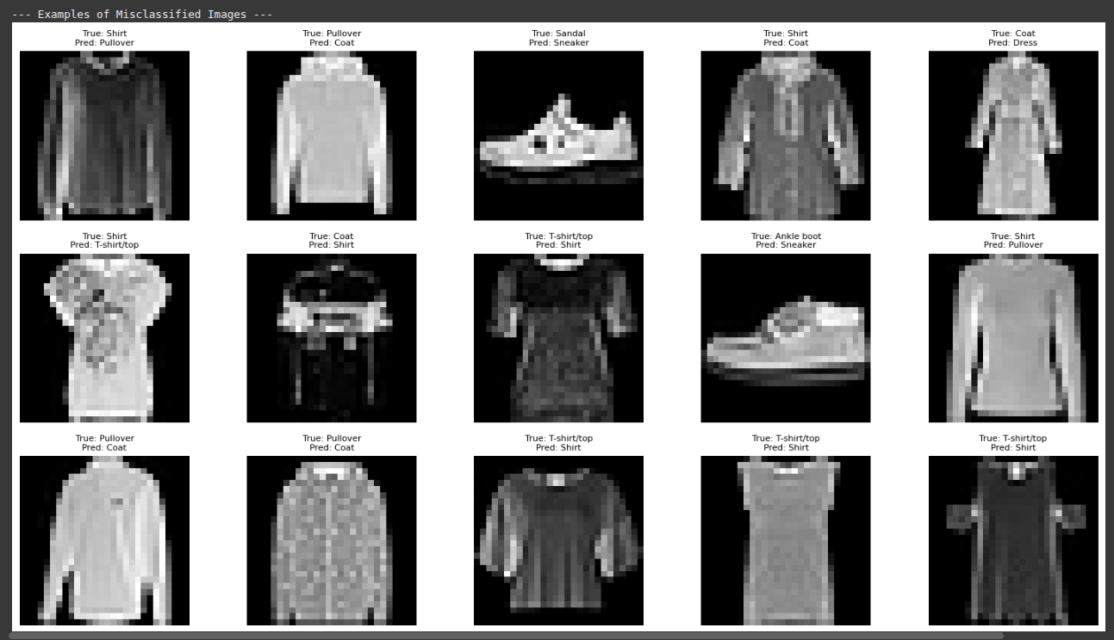

**Figure 3: Examples of Misclassified Images**