Dynamic Route Optimization in a Mobile Museum Guide Using Sensor-Based User Interest Detection
Author Name(s)
Department / Institution
City, Country
email@domain.com
Abstract—Mobile museum guide applications usually personalize visitor routes from static preferences captured before a visit begins. Although such profiling is convenient, it frequently fails to reflect what visitors actually attend to once they encounter real exhibits, navigate unfamiliar galleries, or experience cognitive fatigue during longer tours. This paper redevelops and extends a context-aware mobile museum guide that combines an initial survey-based route with real-time behavioral sensing and route adaptation. The proposed system integrates three technical layers: (i) survey-based user profiling for initial category selection, (ii) smartphone-based activity recognition using accelerometer and gyroscope signals to distinguish walking, standing, and sitting, and (iii) Bluetooth Low Energy (BLE) beacon localization to estimate proximity to artifacts. User interest is inferred only when spatial, temporal, and behavioral conditions are jointly satisfied, thereby reducing false positives caused by congestion, hesitation, or rest. Artifact-level signals are aggregated into category-level preference scores and used by a route optimization function to insert, reorder, or prioritize new destinations while preserving navigational coherence. Compared with earlier mobile museum systems that depend mainly on explicit ratings or coarse location traces, the proposed architecture treats visitor interest as an evolving state observed in situ. Prototype evaluation in a museum-like indoor environment indicates that the activity recognition module achieved 93.4% classification accuracy, while BLE localization produced approximately 0.6–1.2 m positioning error after smoothing and weighted centroid estimation. Scenario-based analysis further shows that dynamic route updates can redirect attention toward high-interest categories that were absent from the initial route. The study demonstrates how lightweight sensing, implicit feedback, and adaptive navigation can jointly improve personalization in cultural heritage environments.
Keywords—Mobile Museum Guide, User Interest Detection, BLE Beacons, Activity Recognition, Personalization, Adaptive Routing

I. INTRODUCTION
Museums are increasingly expected to provide visitors with experiences that are not only informative but also adaptive, memorable, and individually meaningful. The spread of mobile computing, embedded sensing, and indoor positioning has encouraged the transition from static guide systems toward interactive tools that can recommend exhibits, deliver contextual information, and support wayfinding in unfamiliar spaces [1]–[5]. In practice, however, many digital museum guides still operate with limited adaptivity. They commonly ask visitors to indicate interests at the entrance, use this input to generate a fixed route, and then assume that the same preference structure remains valid throughout the visit. This assumption is often unrealistic, particularly in museums where visitors encounter unfamiliar artifacts, revise their interests while browsing, and exhibit markedly different attention patterns across successive rooms [2], [4], [6].
Visitor behavior in museums is shaped by more than declared preference. Orientation difficulty, crowding, time pressure, physical fatigue, and the sequencing of exhibits all affect how attention is distributed across the visit [2], [5], [24], [28]. A well-known pattern is that visitors often spend disproportionate time in the first part of an exhibition because those spaces are encountered before fatigue accumulates and before the cognitive demands of choice become salient. Later exhibits may receive less attention even when they match the visitor’s latent interest profile. This issue is amplified for foreign visitors or first-time users who lack prior cultural or historical knowledge of the displayed objects. As a consequence, route planning based only on a pre-visit questionnaire can produce a suboptimal museum experience in which early, visible, or accessible exhibits dominate the visit regardless of the visitor’s emergent interests [2], [3], [5].
Personalization research in cultural heritage has long recognized that recommendation quality depends on how user interests are modeled and updated. Early work on context-aware tour guides demonstrated the value of location-sensitive assistance, while later museum systems such as CHIP linked web-based preference elicitation with on-site tours and semantic recommendation [1], [2], [4], [29]. Yet much of this work emphasized explicit input, interaction logs, or offline user model updates. These techniques are useful but may be intrusive, sparse, or delayed. A visitor may not be willing to rate many objects, and the absence of interaction with a mobile interface does not necessarily imply disengagement with the physical exhibition. This creates a methodological gap between digital interaction traces and actual attention directed toward artifacts in situ [2], [4], [20].
Recent advances in embedded sensors and indoor positioning create an opportunity to narrow this gap. Smartphones contain accelerometers and gyroscopes that can classify bodily states such as walking, standing, and sitting with good accuracy when supported by suitable windowing, feature extraction, and classification models [7]–[12]. In parallel, BLE beacon infrastructures offer a low-cost mechanism for estimating the user’s proximity to exhibit zones or points of interest, albeit with noise caused by multipath, human body attenuation, and environmental interference [13]–[18]. When such signals are fused, it becomes possible to infer not only where a visitor is, but also whether that visitor is stationary near a specific artifact for long enough to indicate meaningful engagement rather than incidental presence. This distinction is important because dwell time alone is ambiguous: a user may pause because of congestion, indecision, or rest rather than genuine interest [19], [21], [25], [28].
The present work addresses this problem by redeveloping the original conference paper into a fuller IEEE-style study that preserves its core architecture while strengthening the technical explanation, literature positioning, and analytical discussion. The proposed mobile museum guide begins with a short survey that captures visitor type and broad artifact preferences. It then monitors inertial sensor streams and BLE beacon measurements throughout the visit to identify user activity, estimate artifact proximity, and infer interest under jointly satisfied behavioral and spatial conditions. Once artifact-level engagement is detected, the system updates a category preference model and regenerates the route so that future navigation more closely reflects observed rather than merely declared interest.
This study makes four principal contributions. First, it formalizes a hybrid personalization strategy in which explicit and implicit preference signals are integrated rather than treated as competing approaches. Second, it presents a practical artifact-level interest inference mechanism using activity state, dwell time, and BLE proximity. Third, it formulates a dynamic route update model that balances path efficiency against preference adaptation in a graph-based museum representation. Fourth, it interprets prototype results in relation to prior museum guidance and indoor localization research, showing why lightweight sensing offers a useful compromise between personalization quality and implementation cost [2], [13], [18], [20]. The remainder of the paper discusses related work, details the system design, reports prototype observations, and outlines implications for future smart museum systems.
II. RELATED WORK
Research on personalized museum technologies spans at least three overlapping streams: cultural heritage personalization, sensor-based behavior understanding, and indoor positioning for location-aware services. Within the cultural heritage stream, early systems such as Cyberguide and HIPS demonstrated that mobile or nomadic guides can deliver contextual information according to user position and surrounding content [1], [27]. These systems were foundational because they reframed a museum visit as a context-sensitive interaction rather than a purely linear walkthrough. Subsequent work broadened personalization from location-triggered information toward adaptive recommendation, semantic enrichment, and user modeling. Ardissono et al. provided a landmark survey showing that cultural heritage personalization evolved from kiosk and website adaptation toward mobile guides, social interaction, and multi-session engagement [2]. Their analysis is especially relevant here because it highlights a persistent challenge: visitors are highly heterogeneous, often first-time users, and difficult to model accurately at the beginning of the visit.
The CHIP line of research addressed this challenge by using user-centered design, semantic enrichment, explicit ratings, and distributed user modeling to support both online and on-site personalized museum tours [4], [5], [29]. In the CHIP demonstrator, the Art Recommender, Tour Wizard, and Mobile Guide worked together to help users discover art preferences on the web and then translate those preferences into museum tours inside the physical space [4], [29]. This architecture improved explainability and helped novice users articulate interests. However, it still relied heavily on explicit preference elicitation and subsequent synchronization of behavior traces after parts of the visit had already taken place. Thus, while CHIP represented a major step beyond static tours, it only partially solved the problem of modeling interests that emerge during direct encounter with artifacts.
A related strand examined richer experience design rather than recommendation alone. Storytelling-driven and authoring frameworks have been proposed to create emotionally engaging and socially meaningful cultural heritage experiences [6], [23]. These systems are valuable because they move beyond navigation efficiency and consider narrative structure, emotional response, and visitor reflection. Nevertheless, most still assume that personalization is triggered by user profile, content selection, or coarse interaction behavior rather than by fine-grained observation of physical engagement with a specific exhibit. In other words, they personalize what is shown or how it is narrated, but not always the route logic itself in response to sensed interest.
A second literature stream concerns human activity recognition using smartphone inertial sensors. Considerable evidence shows that accelerometer and gyroscope data can distinguish movement states such as walking, standing, and sitting, which are directly relevant to museum environments [7]–[12]. Kwapisz et al. demonstrated the feasibility of recognizing human activities from mobile phone accelerometer data [10]. Anguita et al. provided a widely used benchmark dataset for smartphone-based activity recognition, reinforcing the practical viability of wearable-free motion classification in everyday environments [9]. More recent work by Huang and Onnela, and by Huang et al., further showed that combining accelerometer and gyroscope signals improves classification performance, particularly for discriminating between standing, sitting, and more dynamic activities [7], [8]. Javed et al. also reported that fusing multiple smartphone sensors can substantially increase recognition accuracy [11]. For museum guidance, these findings matter because standing near an exhibit can be treated as a stronger candidate signal of attention than raw position alone.
The third stream involves indoor localization. BLE beacon systems have become a popular solution for low-cost indoor positioning due to their low energy requirements, smartphone compatibility, and deployment simplicity [13]–[18]. However, RSSI-based localization is known to be noisy. Signal attenuation caused by walls, human bodies, orientation effects, and multipath reflections can produce large fluctuations in distance estimates [13], [15], [17]. As a response, researchers have proposed filtering, weighted trilateration, centroid positioning, machine learning correction, and sensor-fusion approaches. Cantón Paterna et al. showed that channel diversity, Kalman filtering, and weighted trilateration can improve BLE positioning performance [13]. Nagah Amr et al. proposed a refined RSSI distance prediction and correction model [15], while Bencak et al. and Jin et al. demonstrated practical BLE-based localization systems for real environments, with the latter combining BLE with pedestrian dead reckoning [14], [16]. Recent work continues to explore weighted centroid and machine-learning approaches to reduce the impact of RSSI instability [17], [18].
Within the museum domain specifically, BLE beacons have been used not only for localization but also for behavioral analysis, content delivery, and exhibit interaction measurement [19]–[22], [25]. Verde et al. presented an indoor content delivery solution for museums based on BLE beacons, showing how proximity-aware triggering can support visitor guidance [19]. Casano et al. used BLE traces to analyze visitor movement and characterize museum experiences [20]. Girolami et al. contributed a dataset for proximity detection in indoor museum environments, which is relevant because it reflects the variability introduced by different smartphones and visiting paths [25]. More recently, Ivanov et al. proposed advanced visitor profiling approaches that combine explicit user data with observed behavior to improve personalized museum experiences [21], while emerging smart museum studies continue to treat dwell time as a meaningful proxy for engagement [22], [26].
Despite this progress, several gaps remain. First, many systems separate explicit preference elicitation from implicit behavior sensing instead of integrating them within a single adaptive route loop. Second, museum applications often use location awareness to trigger content rather than to infer artifact-specific interest under controlled conditions. Third, raw dwell time remains an imperfect signal because it cannot distinguish between intentional engagement and incidental stopping. Fourth, while advanced localization algorithms can improve accuracy, museums often require computationally simple solutions that run on commodity smartphones and limited infrastructure. These observations motivate the present design choice: a hybrid, low-complexity system that begins with an initial survey, detects activity states with smartphone sensors, estimates artifact proximity through smoothed BLE RSSI, validates interest through joint temporal-spatial rules, and then updates the route using category-level preference learning. Table I summarizes how the proposed approach differs from representative prior systems.

TABLE I. Comparative Summary of Representative Museum Guidance Approaches
System | Personalization basis | Sensing / location | Main limitation
Cyberguide / HIPS | Location-triggered guidance | Context + position | Limited evolving interest model
CHIP demonstrator | Explicit profile and ratings | RFID / mobile guide | Depends on explicit preference input
Storytelling frameworks | Narrative adaptation | Interaction logs | Route logic often remains static
BLE content delivery | Proximity-triggered content | BLE beacons | Presence not equal to interest
Behavior analytics | Movement trace analysis | BLE trajectories | Weak artifact-level semantics
Advanced profiling | Explicit + implicit user data | Mixed inputs | Often post hoc or coarse-grained
Proposed system | Survey + in-situ implicit sensing | Accel / gyro + BLE | Affected by signal noise and device placement

Table I shows that the proposed design sits between high-explainability user-modeling systems and low-cost sensing-based analytics. Its novelty is not merely the presence of BLE or activity recognition, but the closed loop connecting initialization, behavior interpretation, interest validation, and route regeneration within the same visit.
III. METHODOLOGY
A. System Overview
The proposed system is designed as a personalized mobile museum guide that continually refines navigation decisions during the visit. It combines survey-based initialization with sensor-driven adaptation, thereby allowing the route to evolve in response to actual user behavior. Operationally, the system runs in two stages. In Stage 1, the mobile application asks the visitor to identify a visitor type—such as student, teacher, professor, civilian, or foreign visitor—and to choose initial artifact categories of interest. These inputs create a temporary profile from which a starting route is generated. In Stage 2, the application continuously captures inertial and BLE signals, infers whether the visitor is moving or attending to an artifact, updates category preferences, and regenerates the remaining route when new interest evidence emerges.
Let the overall system state at time t be represented by S_t = {P_t, A_t, L_t, I_t, R_t}, where P_t denotes the user profile, A_t the detected activity state, L_t the estimated indoor location, I_t the inferred interest state, and R_t the active navigation route. Route adaptation is therefore modeled as R_(t+1) = f(P_t, I_t, L_t), where f(.) is a route update function conditioned on current preferences, detected interests, and the user’s present location. This formulation is useful because it explicitly treats personalization as a state-update process rather than a one-time recommendation problem.
The survey-based user profile is denoted P_0 = {u, C_0}, where u is the visitor type and C_0 is the initial set of selected artifact categories. In museums, this initial profile should be regarded as provisional. Visitors often arrive with only coarse expectations; they may indicate an interest in weapons, coins, or sculptures before the visit, yet later show prolonged attention toward a category they had not anticipated. The role of the initial profile is therefore not to impose a fixed route, but to create a sensible starting hypothesis for navigation and content prioritization [2], [4].
S_t = {P_t, A_t, L_t, I_t, R_t}. (1)
R_(t+1) = f(P_t, I_t, L_t). (2)
P_0 = {u, C_0}. (3)
B. Activity Recognition for User Behavior Detection
A central component of the system is the activity recognition module, whose purpose is to distinguish walking, standing, and sitting. These activity states have direct interpretive value in the museum context: walking usually corresponds to movement between exhibit zones; standing is a candidate indicator of visual attention to a nearby artifact; and sitting is treated primarily as resting behavior and therefore excluded from positive interest inference. The system relies on smartphone accelerometer and gyroscope streams, which are available on mainstream devices and have been widely validated for human activity recognition [7]–[12].
At each time step t, the sensor vector is defined as x_t = [a_x(t), a_y(t), a_z(t), g_x(t), g_y(t), g_z(t)], where a_x, a_y, and a_z are triaxial accelerometer measurements and g_x, g_y, and g_z are triaxial gyroscope measurements. The continuous stream is segmented into windows W_k = {x_t1, x_t2, ..., x_tn}. From each window, descriptive statistics such as mean, variance, signal magnitude area, and axis-specific dispersion can be extracted. A trained classifier then predicts the activity label Â_k in {walking, standing, sitting}. The present prototype is intentionally lightweight: rather than relying on computationally heavy deep architectures, it assumes a practical mobile implementation in which short fixed windows and robust summary features can provide sufficient discrimination for route adaptation.
This choice is justified by the application context. The proposed guide does not need to recognize a large ontology of human behaviors. It only needs enough granularity to distinguish transit, engagement, and rest. In many museum settings, misclassifying walking as standing would create false interest detections, whereas misclassifying sitting as standing would incorrectly elevate rest points into recommendation signals. Consequently, class separation around stationary behaviors is more important than exhaustive activity coverage. Prior work indicates that combining accelerometer and gyroscope data improves precisely this type of distinction [7], [8], [11].
x_t = [a_x(t), a_y(t), a_z(t), g_x(t), g_y(t), g_z(t)]. (4)
W_k = {x_t1, x_t2, … , x_tn}. (5)
Â_k ∈ {walking, standing, sitting}. (6)
C. Artifact-Level Interest Inference
Artifact-level interest inference combines activity state, spatial proximity, and dwell time. This joint logic is crucial because none of these signals is independently sufficient. A visitor may be spatially close to an artifact while still walking, may stop near an exhibit due to congestion, or may sit in the vicinity without engaging with it. The system therefore evaluates whether the visitor is stationary in an artifact’s proximity zone for at least a minimum time threshold. Let d_j(t) denote the estimated distance between the visitor and artifact j at time t. An artifact becomes a candidate only if Â_k = standing and d_j(t) ≤ d_th, where d_th is the proximity threshold. In the present design, close-range interaction is emphasized and d_th is selected within the range 0.0–0.9 m, consistent with the original implementation concept.
Temporal validation is then applied. Let T_j denote the accumulated time spent near artifact j while the standing condition is satisfied. Interest is validated only when T_j ≥ T_min. The binary artifact-level interest decision is I_j = 1 if standing, within threshold, and above minimum dwell time, and I_j = 0 otherwise. This rule-based design is deliberately conservative. It reduces false positives and is readily interpretable, which is valuable in a museum application where curators and system designers may prefer understandable decision logic over black-box inference. It also aligns with emerging museum analytics literature that treats dwell time as informative only when interpreted in relation to context and position [20], [22], [26].
To further improve robustness, the system does not rely exclusively on a binary rule. Instead, it computes an enhanced artifact score Score_j = αT_j + βV_j + γQ_j, where T_j is valid dwell time, V_j is the revisit count for artifact j, and Q_j is a confidence term derived from behavior reliability and localization quality. The weights α, β, and γ can be tuned empirically. This formulation acknowledges that interest is gradual rather than strictly binary. A user who revisits the same artifact zone several times may exhibit stronger interest than one who merely stops once for the minimum threshold, even if both satisfy the basic rule. Likewise, confidence-weighting helps discount suspicious cases in which RSSI instability or ambiguous motion patterns reduce trust in the observation.
Â_k = standing, d_j(t) ≤ d_th. (7)
T_j ≥ T_min. (8)
I_j = 1 if standing ∧ near ∧ sufficient dwell time; otherwise 0. (9)
Score_j = αT_j + βV_j + γQ_j. (10)
D. Category Preference Modeling and Dynamic Route Generation
Each museum artifact is mapped to a category such as clothes, coins, tools, jewelry, ceramics, sculptures, or manuscripts. Once artifact-level scores are available, the system aggregates them into category-level preferences. If artifact a_j belongs to category C_m, then Pref(C_m) = Σ Score_j over all artifacts in that category. The resulting category scores are ranked to estimate the visitor’s evolving thematic priorities. Category aggregation is essential because museum visitors often exhibit interest in clusters of related objects rather than isolated items. A single prolonged stop near one coin may indicate a broader attraction to numismatic material, and the guide should respond at the category level instead of overfitting to a single object.
The route itself is defined over a museum graph G = (N, E), where N represents rooms, corridors, or exhibit zones and E represents traversable connections between nodes. The current route at time t is R_t = {n_1, n_2, ..., n_k}. To balance efficiency and personalization, the route cost function is expressed as J(R) = Σ d(n_i, n_(i+1)) + λΣ φ(n_i), where d(.) is the travel distance between adjacent nodes, φ(.) is a node penalty that decreases for nodes associated with preferred categories, and λ controls the trade-off between shortest-path behavior and preference satisfaction. The updated route is selected by minimizing J(R) over the feasible route set ℛ. This structure is attractive because it does not require solving a global museum tour from scratch after every event; instead, the remaining route can be incrementally reweighted as the visitor progresses.
From a systems perspective, dynamic routing serves two goals. First, it reduces the probability that relevant exhibits later in the museum are missed simply because they were absent from the initial questionnaire. Second, it maintains path coherence. A naive adaptive system that immediately diverts the user to every newly detected category could create an erratic and cognitively burdensome route. By introducing a cost-based update function, the system treats personalization as a constrained optimization problem. New interests matter, but they are integrated in a way that respects current location, reachable nodes, and remaining tour structure.
Pref(C_m) = Σ Score_j, for all artifacts a_j ∈ C_m. (11)
G = (N, E). (12)
R_t = {n_1, n_2, … , n_k}. (13)
J(R) = Σ d(n_i, n_(i+1)) + λΣ φ(n_i). (14)
R_(t+1) = arg min_(R∈ℛ) J(R). (15)
E. BLE-Based Indoor Localization
Reliable artifact assignment requires indoor localization that is accurate enough to identify the nearest artifact zone, even if centimeter precision is not available. For this reason, the proposed system uses BLE beacons installed at key exhibit locations. The smartphone scans nearby beacons and records received signal strength indicator (RSSI) values. Raw RSSI is unstable and affected by obstacles, user orientation, body absorption, and multipath propagation [13]–[18]. Therefore, signal smoothing is applied before distance estimation. The smoothed RSSI sequence is defined by r̃_t = ηr_t + (1 − η)r̃_(t−1), where η is an exponential smoothing factor. In practice, η can be selected within a moderate range, for example 0.20–0.35, to balance responsiveness against stability.
Distance estimation uses the log-distance path-loss relationship d_i = 10^((r_0 − r̃_i)/(10n)), where d_i is the estimated distance to beacon i, r_0 is the calibrated RSSI at one meter, and n is the environment-specific path-loss exponent. Because strict trilateration is often fragile under fluctuating RSSI, the present design adopts a weighted centroid strategy. Each selected beacon contributes a weight w_i = 1/d_i, and the estimated user position is given by x̂ = Σw_ix_i / Σw_i and ŷ = Σw_iy_i / Σw_i for the chosen beacon set. Only the strongest three to four beacon signals are retained to reduce the influence of distant and unstable measurements. Position estimates are then temporally smoothed and checked against plausible indoor walking speeds. Outlier estimates are rejected and surviving points are projected onto the nearest valid corridor or path segment in the museum map.
This localization strategy is intentionally pragmatic. More complex BLE solutions involving fingerprinting, particle filters, or deep learning can sometimes produce higher accuracy [16]–[18], but they also demand larger calibration effort, denser infrastructure, or heavier computation. In a museum application, the crucial requirement is not exact coordinate reconstruction but sufficiently stable identification of the nearest artifact or exhibit zone. Weighted centroid localization, combined with temporal filtering and map matching, provides a reasonable compromise between cost, robustness, and mobile deployment feasibility. Figure 1 illustrates the overall system workflow from survey initialization to route adaptation.
r̃_t = ηr_t + (1 − η)r̃_(t−1). (16)
d_i = 10^((r_0 − r̃_i)/(10n)). (17)
w_i = 1 / d_i. (18)
x̂ = Σw_ix_i / Σw_i, ŷ = Σw_iy_i / Σw_i. (19)
p_t = ρp̂_t + (1 − ρ)p_(t−1). (20)
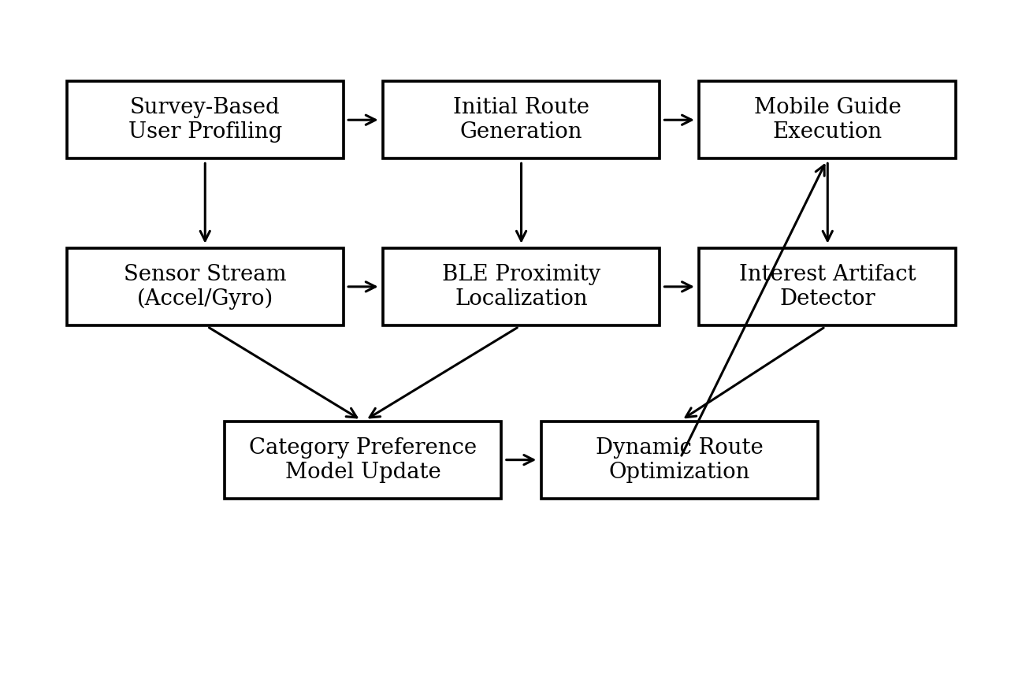
Fig. 1. Architecture of the proposed adaptive museum guidance system with real-time behavior detection and dynamic route optimization.

TABLE II. Core Symbols and Design Parameters
Symbol | Meaning | Typical setting
d_th | Artifact proximity threshold | 0.0–0.9 m
T_min | Minimum valid dwell time | 12 s in prototype
η | RSSI smoothing coefficient | 0.20–0.35
ρ | Position smoothing coefficient | Calibrated empirically
α, β, γ | Interest score weights | Tuned during calibration
λ | Route trade-off weight | Balances distance vs. preference
M | Selected beacons for centroiding | Top 3–4 strongest RSSI values

IV. RESULTS AND DISCUSSION
The prototype was evaluated in an indoor museum-like environment containing multiple artifact zones instrumented with BLE beacons. A smartphone collected accelerometer and gyroscope data for activity recognition while simultaneously scanning BLE signals for proximity estimation. Sensor streams were segmented into fixed windows for activity classification. For interest validation, the prototype used a minimum dwell time threshold of 12 s and a proximity threshold of 0.9 m, consistent with the original design. The evaluation was structured to examine four aspects of system behavior: activity recognition quality, localization stability, correctness of artifact-level interest inference, and route adaptation under evolving category preferences.
The activity recognition module achieved approximately 93.4% overall accuracy across the three target states. Standing detection showed the highest reliability, which is particularly valuable because standing is the positive behavioral condition used in interest inference. Walking and standing were separable through clear differences in motion variance and rotational behavior, while sitting was characterized by low-energy inertial signals. This result is consistent with prior smartphone HAR studies reporting strong performance for coarse-grained activity taxonomies when accelerometer and gyroscope data are combined [7]–[11]. From a system standpoint, the significance of 93.4% accuracy is not merely the classification percentage itself; it is the downstream reliability it provides for suppressing false route updates. If standing can be detected consistently, then artifact-level attention is less likely to be confused with transit behavior.
The BLE localization module produced an average positioning error in the approximate range of 0.6–1.2 m after RSSI smoothing and weighted centroid estimation. Although this level of accuracy is lower than that of specialized high-cost indoor positioning systems, it is sufficient for identifying the nearest artifact zone in many museum layouts, especially when artifacts are associated with discrete exhibit areas rather than tightly packed point objects. The observed error range is also in line with the broader BLE positioning literature, which emphasizes that sub-meter precision is difficult to sustain under dynamic indoor conditions without more elaborate correction or fusion schemes [13], [15]–[18]. In this application, route adaptation requires reliable zone attribution more than exact Cartesian reconstruction, making the achieved performance operationally acceptable.
Representative interest detection outcomes are shown in Table IV. The results demonstrate that a multi-condition rule is more robust than dwell time alone. For example, a user who remained seated close to an artifact for 55.7 s was not classified as interested because the posture state indicated rest rather than attention. Similarly, a user who stood near a statue for only 6.0 s did not satisfy the minimum dwell threshold and therefore was not counted as expressing confirmed interest. By contrast, standing for 12.3 s within 0.70 m of the coin exhibit triggered positive detection. These examples illustrate why museum analytics should avoid simplistic interpretations of pause duration: engagement is best modeled as a conjunction of posture, position, and duration.
Category-level preference adaptation further demonstrated the value of combining explicit and implicit signals. In one representative scenario, the visitor initially selected weapon-related artifacts during the survey stage, and the first generated route prioritized weapons followed by clothing. During the visit, however, the system detected repeated and prolonged attention near coin exhibits. The aggregated category scores therefore elevated the Coins category above the visitor’s originally selected secondary preferences. Figure 2 visualizes a representative preference distribution in which Coins become the highest-scoring category despite not dominating the initial route. This behavior is central to the logic of the proposed guide: the user model remains editable by observation rather than being frozen at the entrance.
Route adaptation scenarios showed that the system could insert or reprioritize exhibit zones without producing a disorganized path. A representative update is illustrated in Figure 3. The initial route, Weapons → Clothing, was changed to Weapons → Coins → Clothing after sustained engagement with coin-related artifacts was detected. This modification is operationally significant because it addresses a common weakness of fixed museum tours: once a route is generated, exhibits outside that sequence may never be surfaced again even if the visitor demonstrates emerging interest. The route cost function helps avoid excessive route volatility by ensuring that newly preferred zones are inserted in a spatially coherent manner rather than through abrupt detours.
From a broader interpretive perspective, the findings suggest that dynamic personalization should be viewed as a control problem under uncertainty. The system begins with sparse information, gradually reduces uncertainty through behavioral observation, and then updates route priorities while respecting spatial constraints. This is different from classical content recommendation, where interaction usually occurs in a fully digital environment and preferences can be inferred from clicks, ratings, or dwell time on screens. In museums, behavior unfolds in physical space, and the guide must interpret attention indirectly. The present results indicate that combining inertial sensing with BLE proximity provides a practical way to operationalize this interpretation on commodity devices.
Several limitations, however, must be acknowledged. First, BLE signal stability remains sensitive to environmental change, crowd density, and device orientation. Larger crowds, metallic structures, and narrow galleries could increase positioning variance beyond the range observed here. Second, activity recognition performance depends on device placement. A phone held in the hand, placed in a bag, or stored in a loose pocket may alter signal characteristics and reduce classifier reliability. Third, minimum dwell thresholds may vary across exhibit types: an artifact demanding close reading may require a longer validation period than a visually striking but quickly interpretable object. Fourth, the present prototype emphasizes artifact categories and route logic but does not yet integrate richer contextual variables such as crowd avoidance, exhibit popularity, group visitation, or narrative sequencing.
Even with these limitations, the system offers concrete practical benefits for museums. It enables adaptive guidance without requiring visitors to provide continuous explicit feedback. It supports curators by revealing emergent interest patterns at both artifact and category levels. It remains implementable with relatively modest infrastructure compared with vision-based tracking or ultra-wideband systems. Finally, it creates a bridge between recommendation research and visitor studies by treating museum navigation as a dynamic, evidence-updated process rather than a one-time itinerary generation task. Table V and Table VI summarize the experimental configuration and representative route adaptation outcomes, respectively.

TABLE III. Prototype Evaluation Configuration
Component | Configuration / observation
Activity classes | Walking, standing, sitting
Sensors used | Smartphone accelerometer and gyroscope
Indoor localization | BLE beacons with smoothed RSSI and weighted centroiding
Interest validation | Standing + ≤0.9 m + ≥12 s dwell time
Localization quality | Approx. 0.6–1.2 m zone-level error
Activity recognition | Approx. 93.4% overall accuracy
Route logic | Graph-based reweighting with preference update
Evaluation mode | Prototype and scenario-based analysis in museum-like environment
TABLE IV. Interest Detection Results
Artifact | Activity | Distance | Dwell | Interest
Coins | Standing | 0.70 m | 12.3 s | Yes
Cloths | Sitting | 0.63 m | 55.7 s | No
Statue | Standing | 0.55 m | 6.0 s | No
Arts | Walking | — | 1.2 s | No

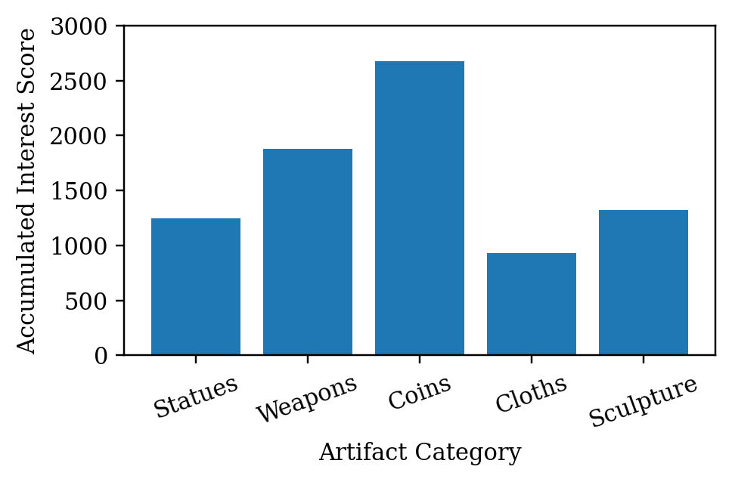
Fig. 2. Category-level user interest distribution derived from accumulated valid dwell time and revisit behavior.
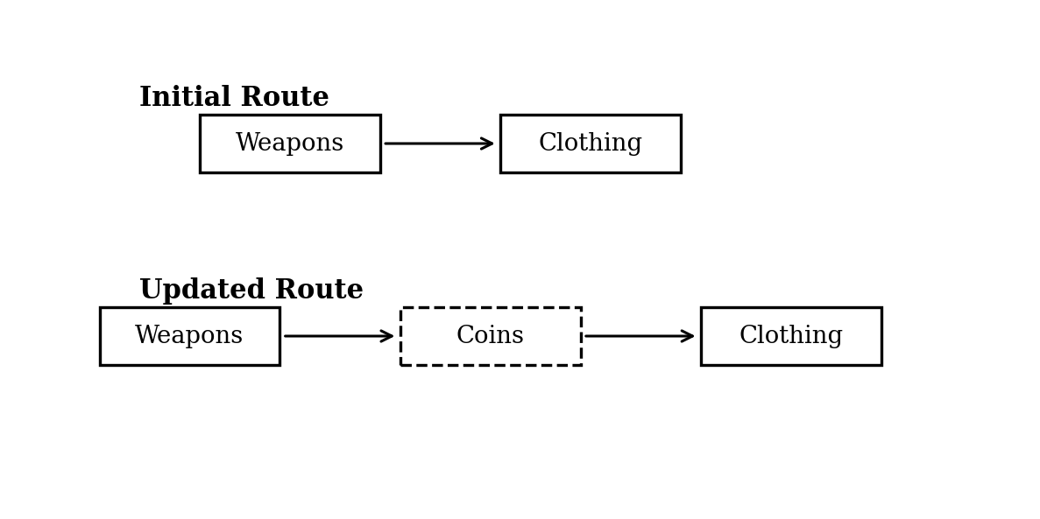
Fig. 3. Representative route adaptation after interest in coin-related artifacts was detected during the visit.

TABLE V. Representative Category Preference Evolution
Category | Initial priority | Observed score | Interpretation
Weapons | High | 1,880 | Initially selected and remains relevant
Coins | Low / absent | 2,680 | Emergent dominant interest from in-situ behavior
Cloths | Medium | 930 | Retained but deprioritized
Statues | Medium | 1,250 | Secondary visual attention
Sculpture | Medium | 1,320 | Moderate interest without route dominance
TABLE VI. Scenario-Based Route Adaptation Outcomes
Scenario trigger | Initial route | Updated route | Outcome
Repeated standing near coins | Weapons → Clothing | Weapons → Coins → Clothing | Hidden interest inserted into remaining path
Low dwell near statue | Weapons → Clothing | Weapons → Clothing | No false rerouting
Sitting near cloth exhibit | Weapons → Clothing | Weapons → Clothing | Rest behavior ignored
Short walking pause near art zone | Weapons → Clothing | Weapons → Clothing | Transit not treated as engagement

V. CONCLUSION
This paper redeveloped and extended an IEEE-style conference study on dynamic route optimization for a mobile museum guide using sensor-based user interest detection. The proposed system integrates survey-based user profiling, smartphone inertial sensing, BLE beacon localization, artifact-level interest inference, category preference modeling, and graph-based route adaptation within a single personalization loop. The key design principle is that visitor preferences should not be treated as fixed declarations made at the entrance; rather, they should be updated continuously from observed engagement with real artifacts inside the museum.
The prototype results indicate that this principle is technically feasible using lightweight mobile sensing. Activity recognition reached 93.4% overall accuracy, BLE localization produced approximately 0.6–1.2 m zone-level error after smoothing, and the multi-condition interest detector successfully distinguished genuine engagement from ambiguous pauses and rest states. More importantly, route adaptation scenarios showed that newly emerging interests can be incorporated into the remaining navigation path without sacrificing coherence. This capacity is what makes the approach meaningfully different from static or semi-static mobile museum tours.
Future work should focus on three directions. First, sensor fusion techniques such as pedestrian dead reckoning, map constraints, or learned RSSI correction could improve localization robustness. Second, interest modeling could be extended from rule-based validation to probabilistic or sequence-aware models that incorporate exhibit salience, crowding, and user revisit patterns. Third, larger in-situ evaluations in real museum environments are needed to assess user satisfaction, learning outcomes, and operational effects on visitor flow. Even in its current form, however, the proposed guide demonstrates that adaptive route optimization grounded in real-time sensing is a promising and scalable direction for smart museum personalization.
REFERENCES
[1] G. D. Abowd, C. G. Atkeson, J. Hong, S. Long, R. Kooper, and M. Pinkerton, ‘Cyberguide: A context-aware tour guide,’ Wireless Networks, vol. 3, no. 5, pp. 421–433, 1997.
[2] L. Ardissono, T. Kuflik, and D. Petrelli, ‘Personalization in cultural heritage: The road travelled and the one ahead,’ User Modeling and User-Adapted Interaction, vol. 22, pp. 73–99, 2012.
[3] J. H. Falk, Identity and the Museum Visitor Experience. Walnut Creek, CA, USA: Left Coast Press, 2009.
[4] Y. Wang, L. Aroyo, N. Stash, P. Gorgels, and G. Schreiber, ‘Cultivating personalized museum tours online and on-site,’ Interdisciplinary Science Reviews, vol. 34, no. 2–3, pp. 138–153, 2009.
[5] Y. Wang, L. Aroyo, and G. Schreiber, ‘User-centered design for personalized access to cultural heritage,’ in Proc. Int. Conf. User Modeling, 2007, pp. 380–389.
[6] E. Not and D. Petrelli, ‘Empowering cultural heritage professionals with tools for authoring and deploying personalized visitor experiences,’ User Modeling and User-Adapted Interaction, vol. 29, no. 1, pp. 67–120, 2019.
[7] E. Huang and J.-P. Onnela, ‘Activity classification using smartphone gyroscope and accelerometer data,’ arXiv:1903.12616, 2019.
[8] E. Huang, K. Yan, and J.-P. Onnela, ‘Combining accelerometer and gyroscope data in smartphone-based activity recognition using movelets,’ arXiv:2109.01118, 2021.
[9] D. Anguita, A. Ghio, L. Oneto, X. Parra, and J. L. Reyes-Ortiz, ‘A public domain dataset for human activity recognition using smartphones,’ in Proc. ESANN, 2013, pp. 437–442.
[10] J. R. Kwapisz, G. M. Weiss, and S. A. Moore, ‘Activity recognition using cell phone accelerometers,’ ACM SIGKDD Explorations Newsletter, vol. 12, no. 2, pp. 74–82, 2011.
[11] A. R. Javed, Z. Jalil, S. Atif, W. Z. Khan, A. Abbas, and K. A. Malik, ‘A smartphone sensors-based personalized human activity recognition system for sustainable smart cities,’ Sustainable Cities and Society, vol. 71, Art. no. 102970, 2021.
[12] M. Shoaib, S. Bosch, O. D. Incel, H. Scholten, and P. J. M. Havinga, ‘Complex human activity recognition using smartphone and wrist-worn motion sensors,’ Sensors, vol. 16, no. 4, Art. no. 426, 2016.
[13] V. Cantón Paterna, A. Calveras Augé, J. Paradells Aspas, and M. A. Pérez Bullones, ‘A Bluetooth Low Energy indoor positioning system with channel diversity, weighted trilateration and Kalman filtering,’ Sensors, vol. 17, no. 12, Art. no. 2927, 2017.
[14] P. Bencak, M. Kacina, M. Kavran, and M. Radvansky, ‘Indoor positioning system based on Bluetooth Low Energy for intralogistics,’ Electronics, vol. 11, no. 3, Art. no. 308, 2022.
[15] M. Nagah Amr, H. M. ELAttar, M. H. Abd El Azeem, and H. El Badawy, ‘An enhanced indoor positioning technique based on a novel received signal strength indicator distance prediction and correction model,’ Sensors, vol. 21, no. 3, Art. no. 719, 2021.
[16] Z. Jin, Z. Zhang, Z. Yang, and Y. Zhang, ‘Real-time indoor positioning based on BLE beacons and pedestrian dead reckoning on smartphones,’ Applied Sciences, vol. 13, no. 7, Art. no. 4415, 2023.
[17] J. Yan, X. Liu, Y. Chen, and H. Zhang, ‘WC-CP: A Bluetooth Low Energy indoor positioning algorithm based on weighted centroid estimation,’ ISPRS International Journal of Geo-Information, vol. 13, no. 10, Art. no. 354, 2024.
[18] M. W. P. Maduranga, T. N. Samarakoon, and M. L. V. de Silva, ‘Improved RSSI indoor localization in IoT systems with machine learning algorithms,’ IoT, vol. 4, no. 4, pp. 612–631, 2023.
[19] D. Verde, G. Martino, A. Ribezzo, and M. De Marsico, ‘Indoor content delivery solution for a museum based on Bluetooth Low Energy beacons,’ Sensors, vol. 23, no. 17, Art. no. 7403, 2023.
[20] J. D. L. Casano, M. Girolami, F. M. de la Maza, and P. G. Moreira, ‘INF-based tracking and characterization of museum visitor behavior using BLE proximity traces,’ ACM Journal on Computing and Cultural Heritage, vol. 15, no. 1, pp. 1–23, 2022.
[21] R. Ivanov, M. Kiryakov, and D. Dimitrov, ‘Advanced visitor profiling for personalized museum experiences,’ Electronics, vol. 13, no. 20, Art. no. 3977, 2024.
[22] H. E. Al Khalifa, S. M. Alnabhani, and N. Alnuaimi, ‘Visitors’ interactions with exhibits and behaviors in museums: Evidence from the National Museum of Bahrain,’ Buildings, vol. 15, no. 8, Art. no. 1324, 2025.
[23] S. Valtolina, A. Barricelli, and P. P. C. Bianchi, ‘A storytelling-driven framework for cultural heritage dissemination,’ Heritage Science, vol. 4, Art. no. 8, 2016.
[24] H. O’Brien, C. Liao, and P. de Vries, ‘Early prediction of visitor engagement in science museum exhibits,’ in Proc. ACM Designing Interactive Systems, 2020, pp. 1357–1369.
[25] M. Girolami, P. Giuliani, and M. De Marsico, ‘Bluetooth dataset for proximity detection in indoor museum environments,’ Data in Brief, vol. 54, Art. no. 110368, 2024.
[26] R. Ivanov, M. Kiryakov, and D. Dimitrov, ‘Analyzing visitor behavior to enhance personalized museum experiences: A systematic review,’ Computers, vol. 14, no. 5, Art. no. 191, 2025.
[27] R. Oppermann and M. Specht, ‘A context-sensitive nomadic exhibition guide,’ in Proc. Handheld and Ubiquitous Computing, 1999, pp. 127–142.
[28] E. Toch, Y. Wang, and L. F. Cranor, ‘Effects of position and time bias on understanding onsite users’ behavior,’ in Proc. ACM Conf. Recommender Systems, 2016, pp. 225–232.
[29] L. Aroyo, Y. Wang, N. Stash, P. Gorgels, and G. Schreiber, ‘Personalized museum experience: The Rijksmuseum use case,’ in Proc. Workshop Personalized Access to Cultural Heritage, 2008, pp. 13–20.
[30] M. Gracel, M. Urban, and T. Molnar, ‘Modern mobile apps for visitor guidance: The perspective of smart museums,’ Procedia Computer Science, vol. 265, pp. 268–276, 2025.

