HOMEWORK 01 – CE 650 C

Submitted By

Anjana AVR

The id used for performing this homework is, user5 (10.29.19.6)

PART 01

* Create a **new repository** on **GitHub** (make it public and initiate it with the **README.md**)

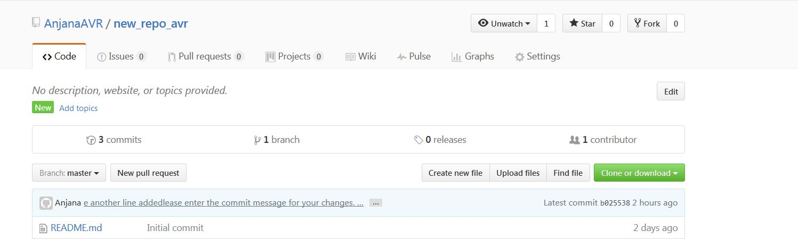

* **Clone** the repository (on the machine that was assigned to you)

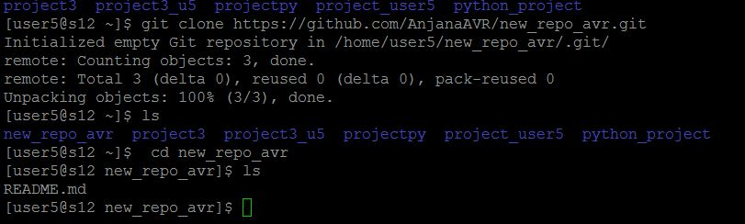

* **Add** a new **file** to this repository using the "vi editor"

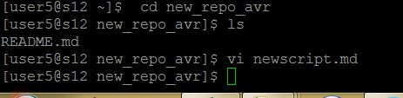

* Add the file to **tracking**

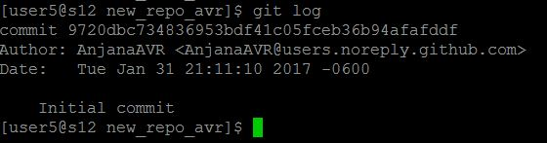

* Do a **commit**



* Do a **push** to your GitHub account

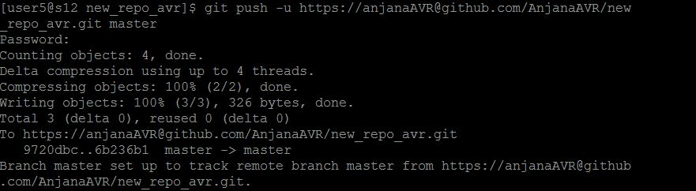

* Create a **fix** (add some lines) to some file in your local repository and do a **git merge** operation

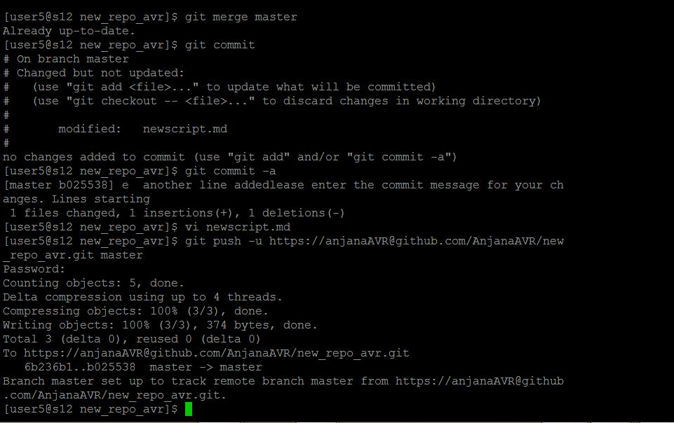

PART 02 and PART 03



The files for questions 2 and 3 are being attached in the folder along with this report.