ANJANA C

--1.1

CREATE TABLE UNITS(

UNITID INT PRIMARY KEY,

UNIT INT)

INSERT INTO UNITS VALUES(1,1),(2,28);

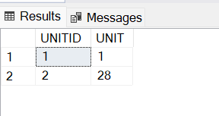

CREATE TABLE ITEM(

ITEMID INT PRIMARY KEY,

ITEM VARCHAR(20))

INSERT INTO ITEM VALUES(1,'Bar One'),(2,'Kit Kat'),(3,'Milky Bar'),(4,'Munch');

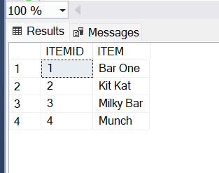

CREATE TABLE SHOP(

SHOPID INT PRIMARY KEY,

SHOPNAME VARCHAR(20))

INSERT INTO SHOP VALUES (1,'Amal stores'),(2,'Jyothi stores'),(3,'Indira Stores');

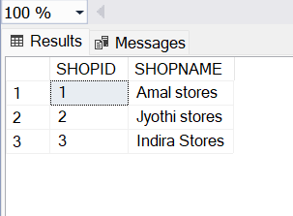

CREATE TABLE SALEDATES(

SALEDATEID INT PRIMARY KEY,

SALEDATE DATE)

INSERT INTO SALEDATES VALUES (1,'2018-10-05'),(2,'2018-10-10'),(3,'2018-09-15');

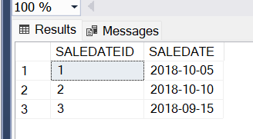

CREATE TABLE SALES(

SALEID INT PRIMARY KEY,

SHOPID INT,

ITEMID INT,

SALEDATEID INT,

QUANTITY INT,

UNITPRICE DECIMAL(10,2),

FOREIGN KEY(SALEDATEID) REFERENCES SALEDATES(SALEDATEID),

FOREIGN KEY(SHOPID) REFERENCES SHOP(SHOPID),

FOREIGN KEY(ITEMID) REFERENCES ITEM(ITEMID)

);

INSERT INTO SALES VALUES (1,1,1,1,100,10.00);

INSERT INTO SALES VALUES (2,1,2,1,200,15.00);

INSERT INTO SALES VALUES (3,1,3,1,50,5.00);

INSERT INTO SALES VALUES (4,1,4,1,150,10.00);

INSERT INTO SALES VALUES (5,2,1,2,10\*28,280.00);

INSERT INTO SALES VALUES (6,2,2,2,30\*28,420.00);

INSERT INTO SALES VALUES (7,2,3,2,40\*28,140.00);

INSERT INTO SALES VALUES (8,2,4,2,20\*28,280.00);

INSERT INTO SALES VALUES (9,3,1,3,50\*28,280.00);

INSERT INTO SALES VALUES (10,3,2,3,70\*28,420.00);

INSERT INTO SALES VALUES (11,3,3,3,30\*28,140.00);

INSERT INTO SALES VALUES (12,3,1,1,150,10.00);

INSERT INTO SALES VALUES (13,3,2,1,250,15.00);

INSERT INTO SALES VALUES (14,3,4,1,200,10.00);

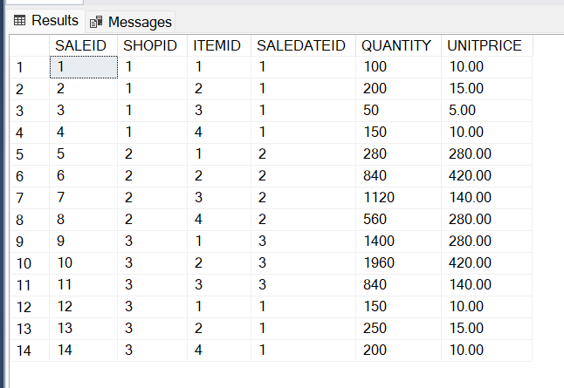

--1.2

SELECT TOP 1 i.ITEM, SUM(s.QUANTITY\*s.UNITPRICE) AS REVENUE

FROM

SALES s

JOIN

SALEDATES sd ON

s.SALEDATEID=sd.SALEDATEID

JOIN

ITEM i ON s.ITEMID=i.ITEMID

WHERE

MONTH(sd.SALEDATE)=10

GROUP BY

i.ITEM

ORDER BY

REVENUE DESC;

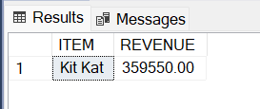

--1.3

SELECT TOP 1 i.ITEM, SUM(s.QUANTITY) AS TOTALQUANTITY

FROM

SALES s

JOIN SALEDATES sd ON

s.SALEDATEID=sd.SALEDATEID

JOIN ITEM i ON s.ITEMID=i.ITEMID

JOIN

SHOP sh ON s.SHOPID=sh.SHOPID

WHERE

MONTH(sd.SALEDATE)=10

AND sh.SHOPNAME='AMAL STORES'

GROUP BY

i.ITEM

ORDER BY

TOTALQUANTITY DESC;

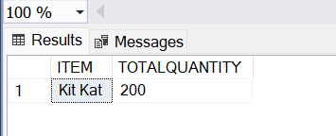

--1.4

SELECT i.ITEM, SUM(s.QUANTITY\*s.UNITPRICE) AS REVENUE

FROM

SALES s

JOIN SALEDATES sd ON

s.SALEDATEID=sd.SALEDATEID

JOIN ITEM i ON s.ITEMID=i.ITEMID

WHERE

MONTH(sd.SALEDATE)=10

GROUP BY

i.ITEM

HAVING

SUM(s.QUANTITY\*s.UNITPRICE)>10000

ORDER BY

REVENUE DESC

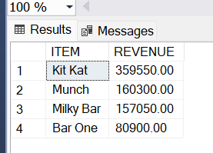

--1.5

SELECT TOP 1 sh.SHOPNAME,

SUM(s.QUANTITY\*s.UNITPRICE)

AS REVENUE

FROM

SALES s

JOIN SALEDATES sd ON

s.SALEDATEID=sd.SALEDATEID

JOIN

SHOP sh ON s.SHOPID=sh.SHOPID

WHERE

MONTH(sd.SALEDATE)=10

GROUP BY SHOPNAME

ORDER BY REVENUE DESC;

