ANJANA

PL2119

CREATE TABLE Manufacturer (

MfName VARCHAR(50) PRIMARY KEY,

city VARCHAR(50),

state VARCHAR(50)

);

INSERT INTO Manufacturer (MfName, city, state)

VALUES

('Manufacturer1', 'south dakota', 'africa'),

('Manufacturer2', 'palakkad', 'india'),

('Manufacturer3', 'kannur', 'kerala');

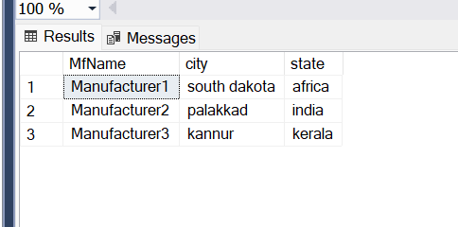

CREATE TABLE Computer (

SerialNumber INT PRIMARY KEY,

Model VARCHAR(50),

weight DECIMAL(10, 2),

EmployeeId INT,

MfName VARCHAR(50),

FOREIGN KEY (EmployeeId) REFERENCES Employee(EmployeeId),

FOREIGN KEY (MfName) REFERENCES Manufacturer(MfName)

);

INSERT INTO Computer (SerialNumber, Model, weight, EmployeeId, MfName)

VALUES

(101, 'ComputerModel1', 5.5, 1, 'Manufacturer1'),

(102, 'ComputerModel2', 9.2, 2, 'Manufacturer2'),

(103, 'ComputerModel3', 10.4, 3, 'Manufacturer1');

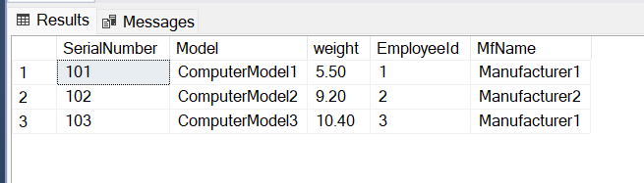

CREATE TABLE Employee (

EmployeeId INT PRIMARY KEY,

EmployeeName VARCHAR(100),

area_code VARCHAR(10),

phone VARCHAR(20),

email VARCHAR(100)

);

INSERT INTO Employee (EmployeeId, EmployeeName, area_code, phone, email)

VALUES

(1, 'Anjana C', '123', '9987675423', 'anj@gmail.com'),

(2, 'RAHUL B', '345', '9876456342', 'rahul@gmail.com'),

(3, 'Mariya james', '567', '7864536789', 'mariya@gmail.com');

INSERT INTO EMPLOYEE VALUES (4, 'Diya james', '267', '9964536789', 'diya@gmail.com');

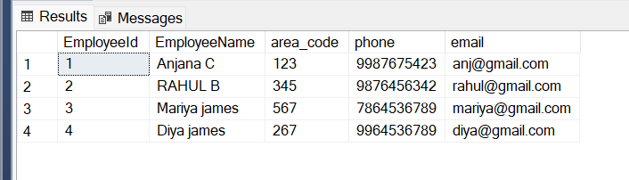

--1

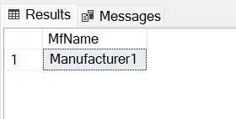

--2

SELECT AVG(Weight)AS 'average weight' FROM COMPUTER;

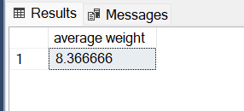

--3

SELECT EmployeeName FROM EMPLOYEE WHERE Area_Code LIKE '2%'

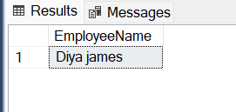

--4

SELECT SerialNumber

FROM Computer

WHERE weight < (SELECT AVG(weight) FROM Computer);

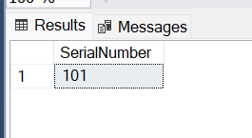

--5

SELECT MfName FROM MANUFACTURER WHERE MfName NOT IN (SELECT MfName FROM COMPUTER);

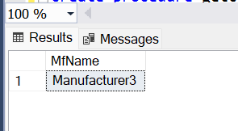

--6

SELECT E.EmployeeName, C.SerialNumber, M.City FROM EMPLOYEE E

JOIN COMPUTER C ON E.EmployeeID = C.EmployeeID

JOIN MANUFACTURER M ON C.MfName = M.MfName

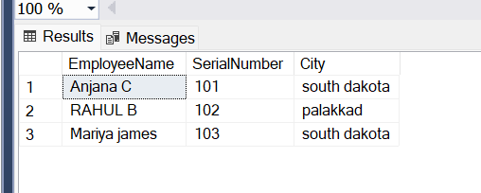

--7

CREATE PROCEDURE getcomp

@EmployeeId int

AS

BEGIN

SELECT Computer.SerialNumber, Manufacturer.mfname, Model, weight

FROM computer

JOIN employee on Computer.EmployeeId = Employee.EmployeeId

JOIN manufacturer on Computer.MfName = Manufacturer.MfName

WHERE Employee.EmployeeId =@EmployeeId;

END;

