**HW # 1**

**Team name:** The Original

**Github Link :** <https://github.com/Tejas945/cmpe207/tree/master/Assignments/HW_1>

**Team Members:**

1. Tejas Madappa (Student ID:012462372)
2. Chandra Mohan (Student ID: 013734227)
3. Vedant Bhoj (Student ID: 013554593)
4. Ketan Rudrurkar (Student ID: 013708773)
5. Hao Ran Chen(Student ID:012494781)

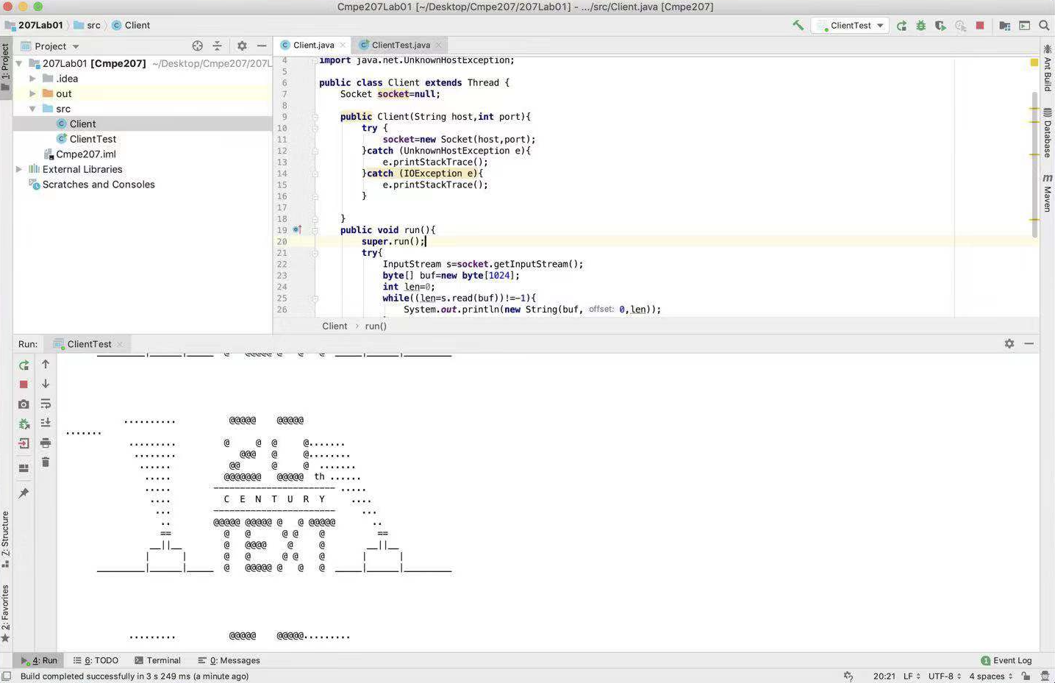

Fig. 1. Code written in Java executing below connected to Port 23

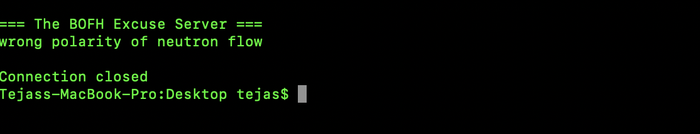

Fig. 2. Connection to Port 666 will produce a random excuse is generated by the Server.

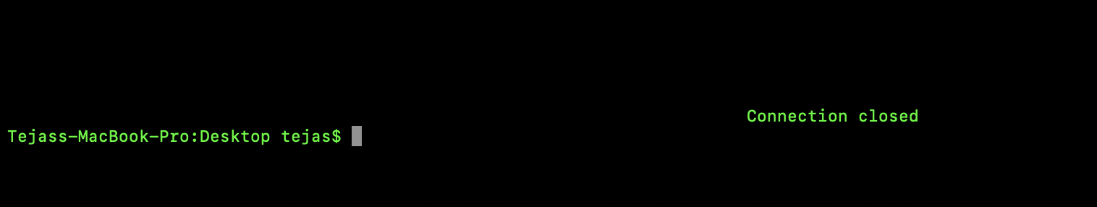

Fig. 3. Connection closed message after all text has been sent by server

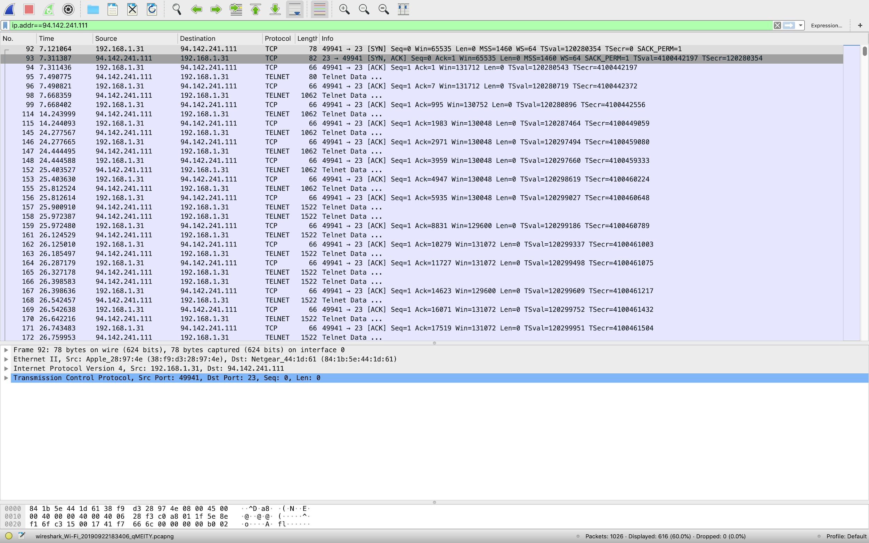

Fig. 4. Wireshark capture for connection to server