**DynamoDB table:** (Initially Empty)

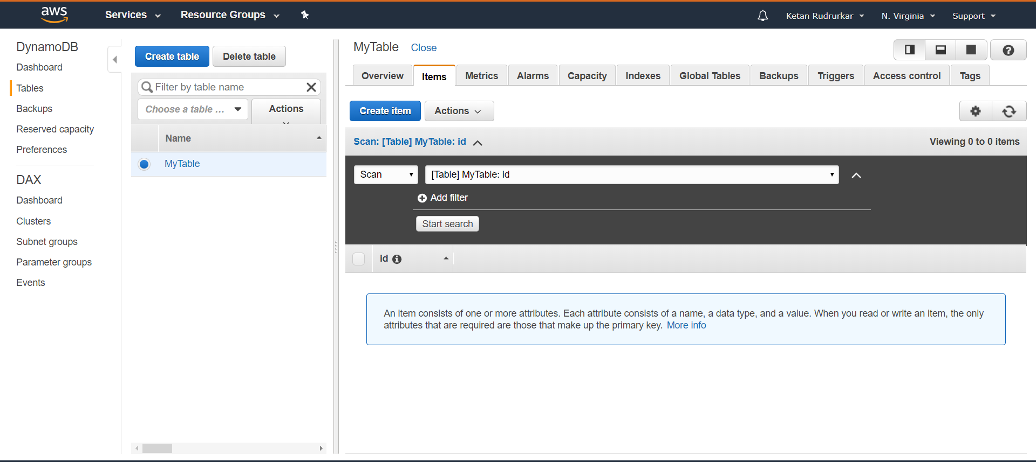

**Execution results for GET:** (Empty body since initially table is empty with no items)

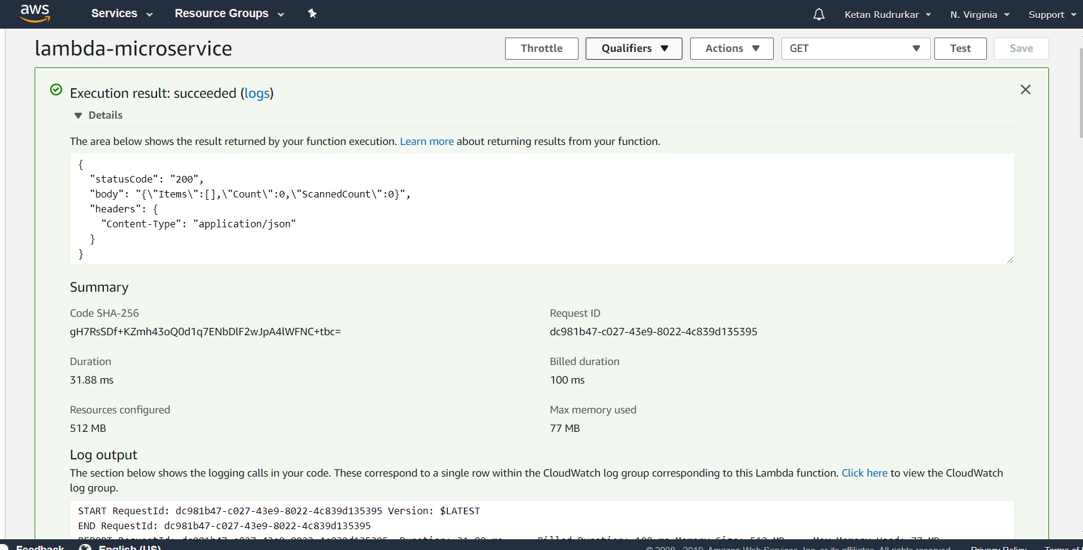

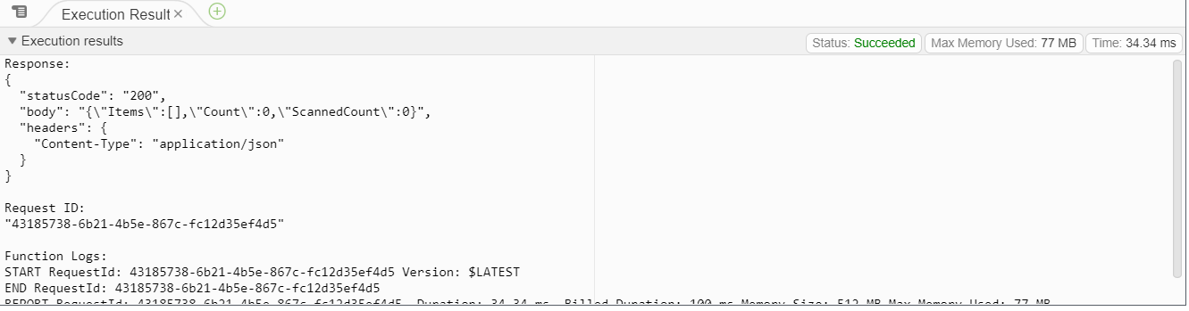

**POST: (After posting ID:1)**

**POST Function worked status code: 200 – (code specifies 200 if executed and 400 for error)**

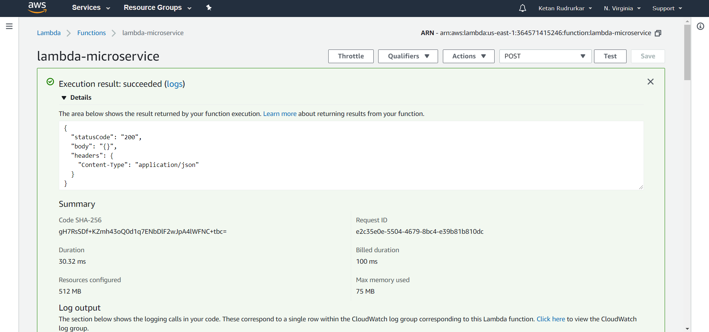

**DynamoDB table after POST ID:1 – (Creates an item with id:1)**

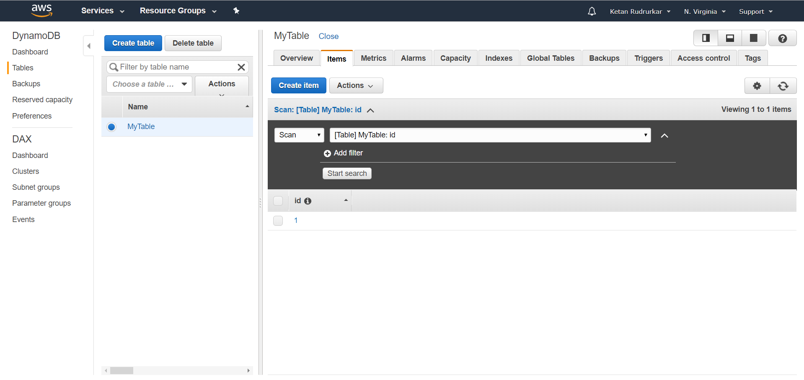

**Calling GET to verify the POST function worked: (Scans the database table and returns - body id:1)**

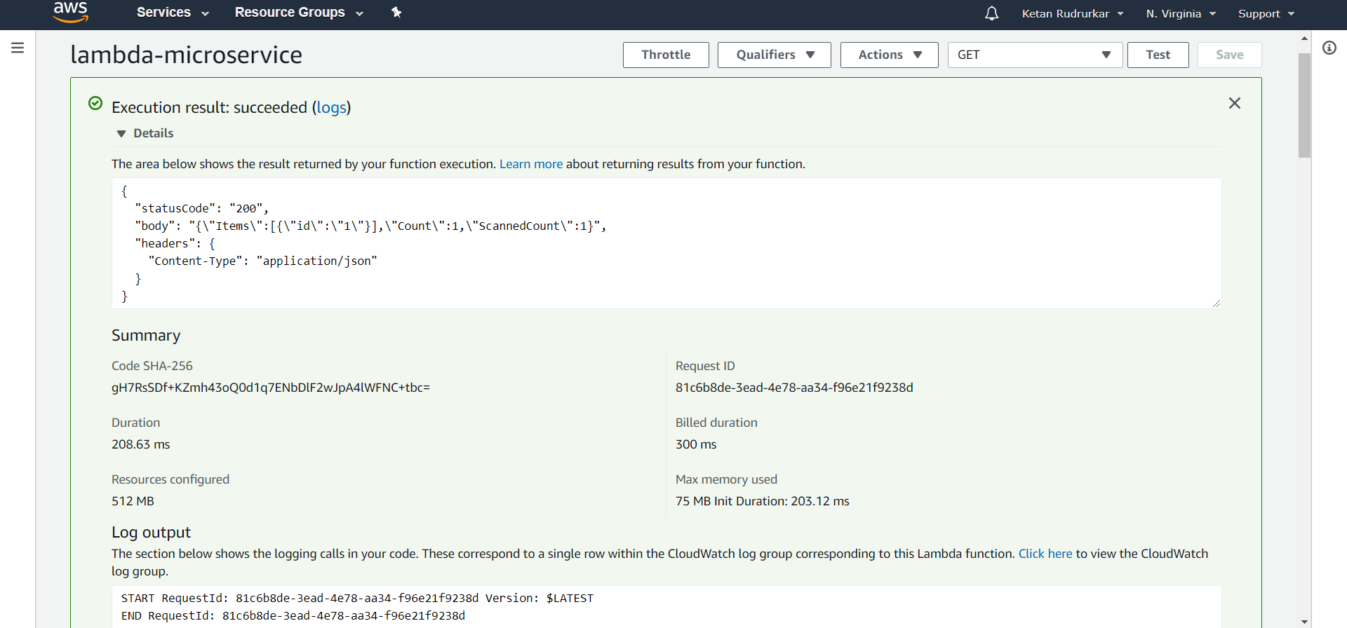

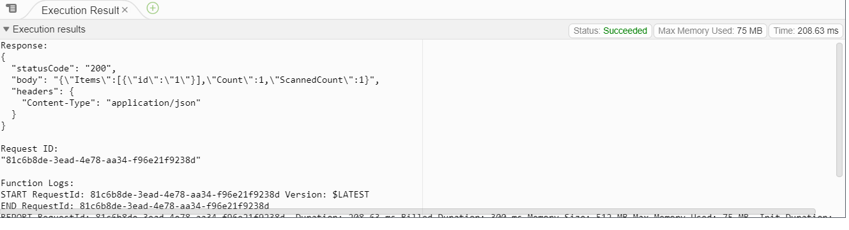

**PUT: (Id:4) (Updates table with id:4)**

**PUT worked status code :200 (code specifies 200 if executed and 400 for error)**

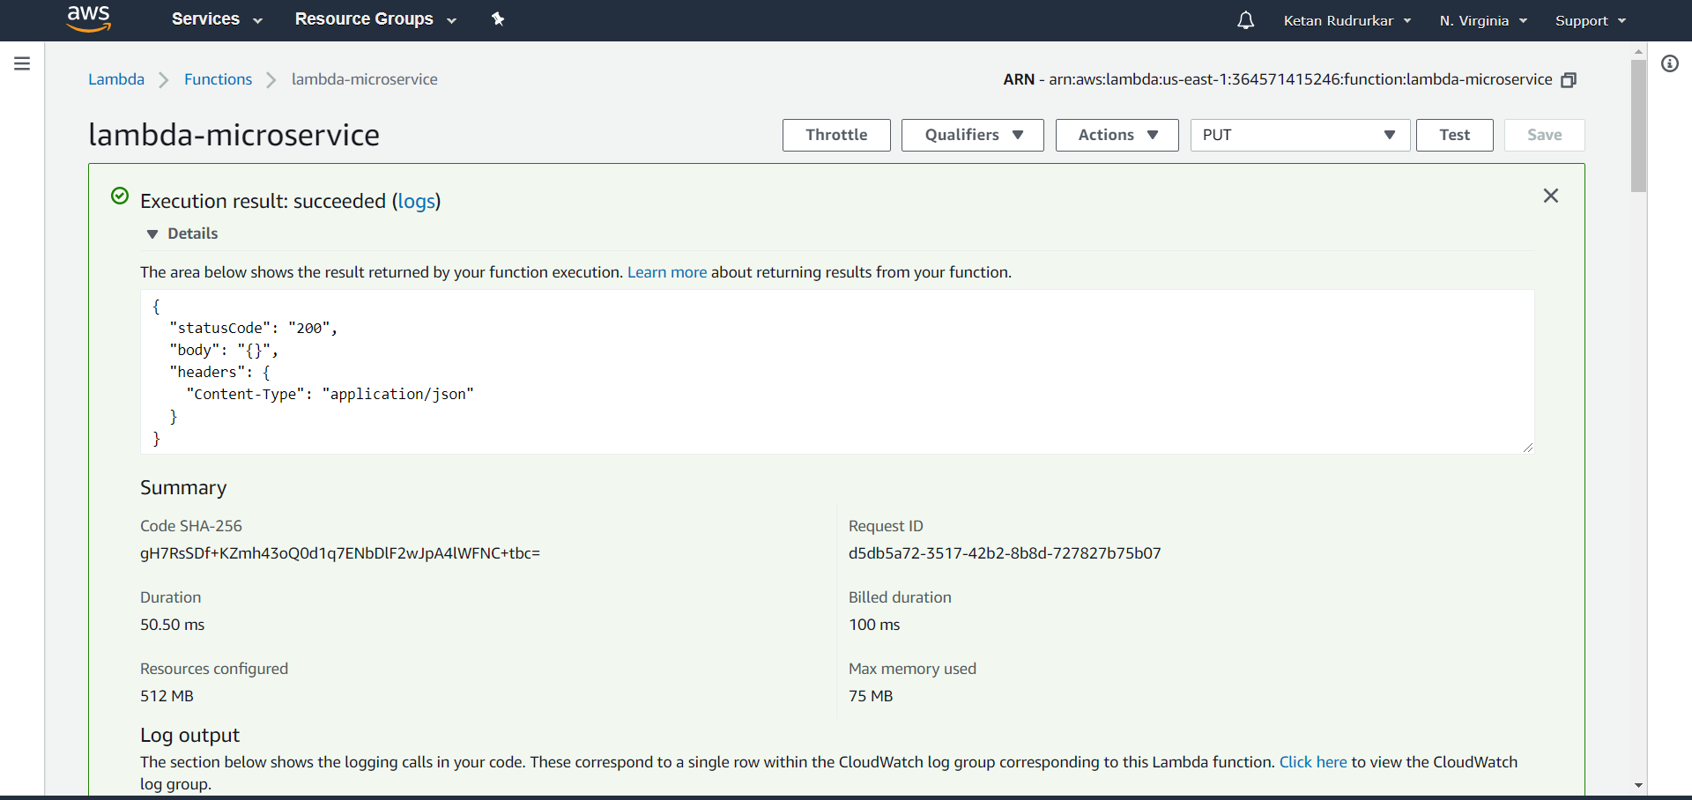

**DynamoDB Table: (After PUT ID: 4)**

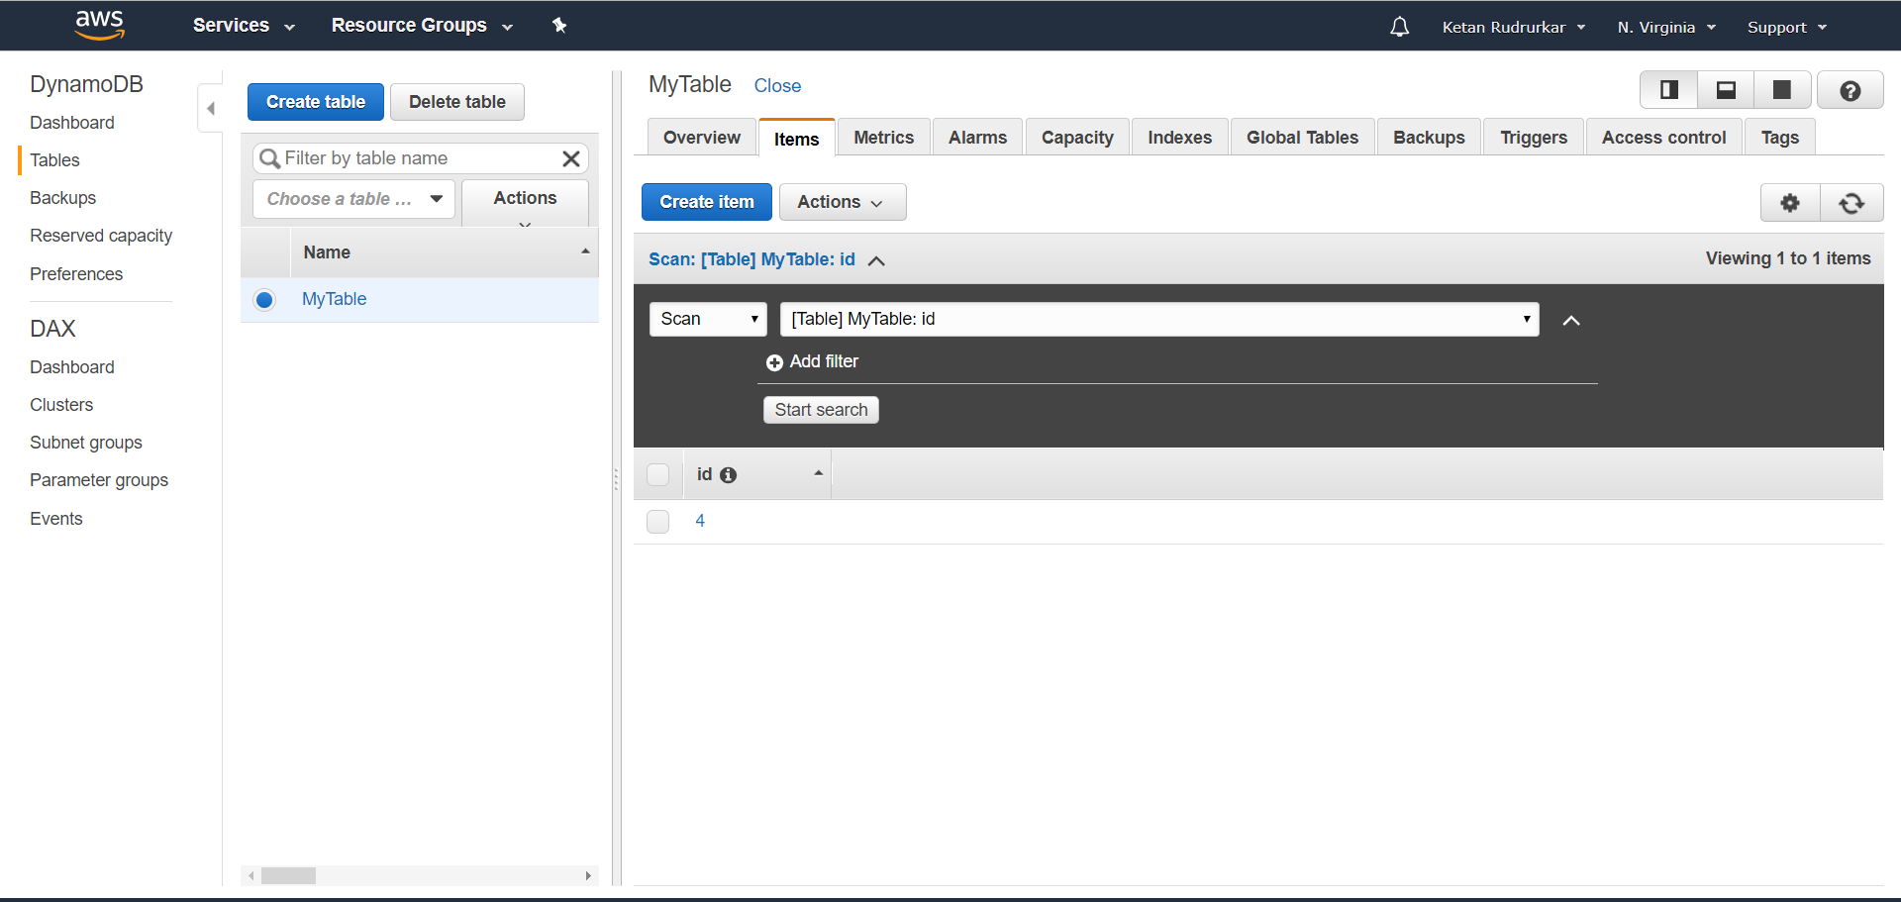

**Calling GET to verify PUT function worked: (Scans the table and returns - body shows id : 4)**

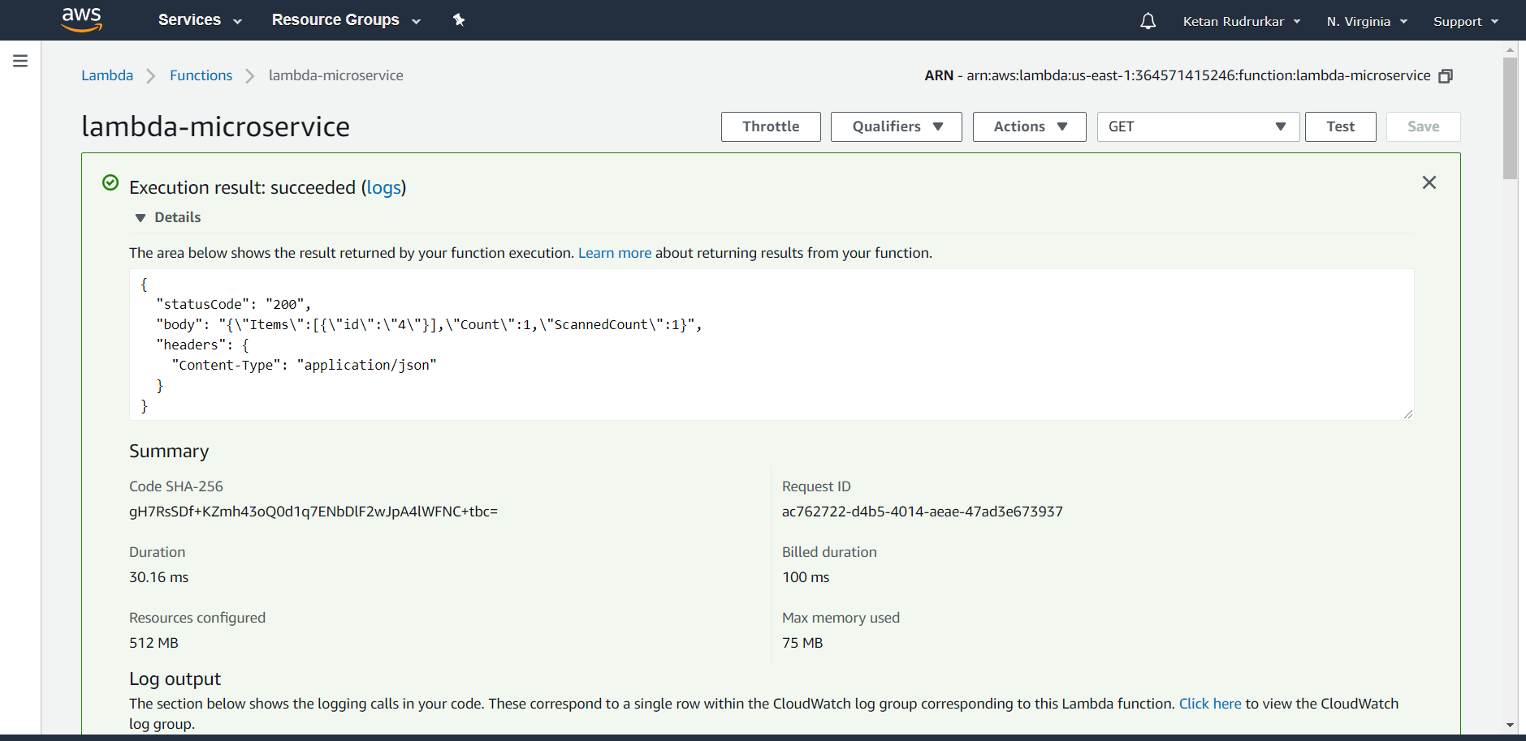

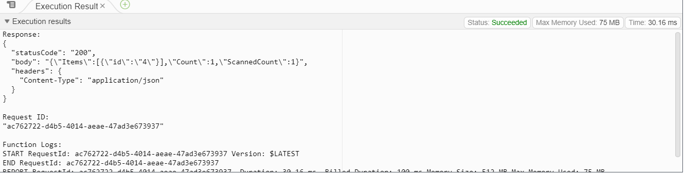

**DELETE:**

**DELETE worked with status code: 200 - (code specifies 200 if executed and 400 for error)**

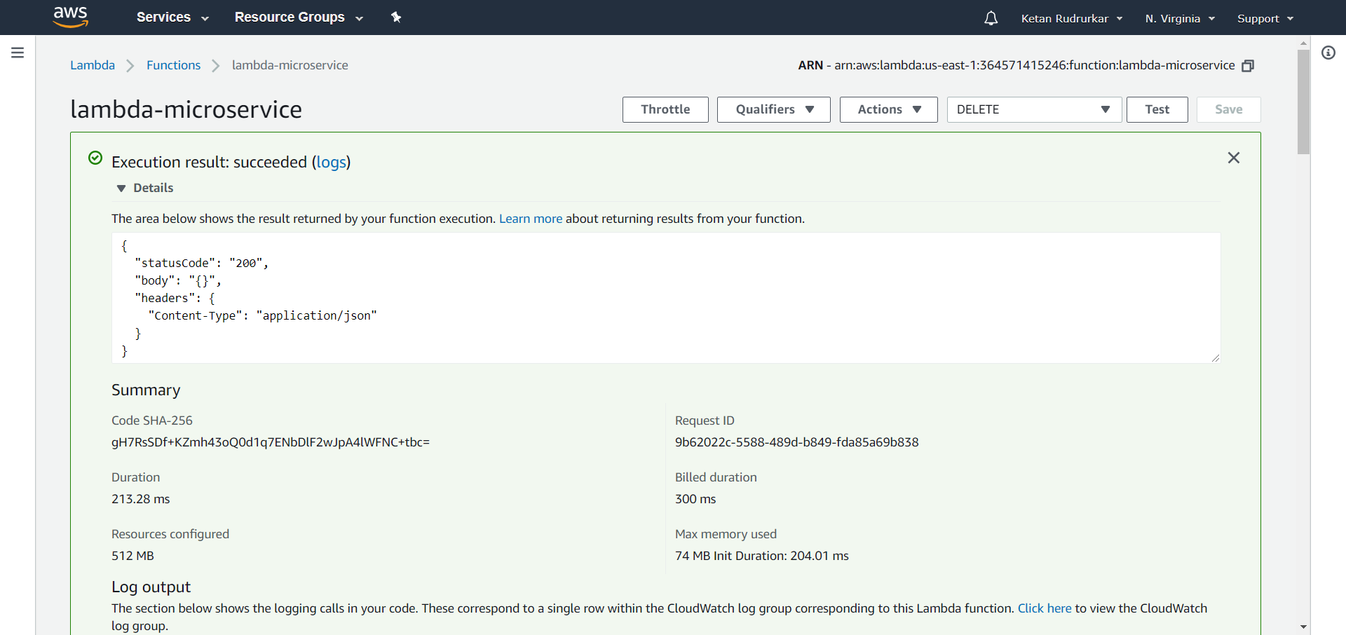

**DynamoDB table after DELETE function deleting id:4 –**

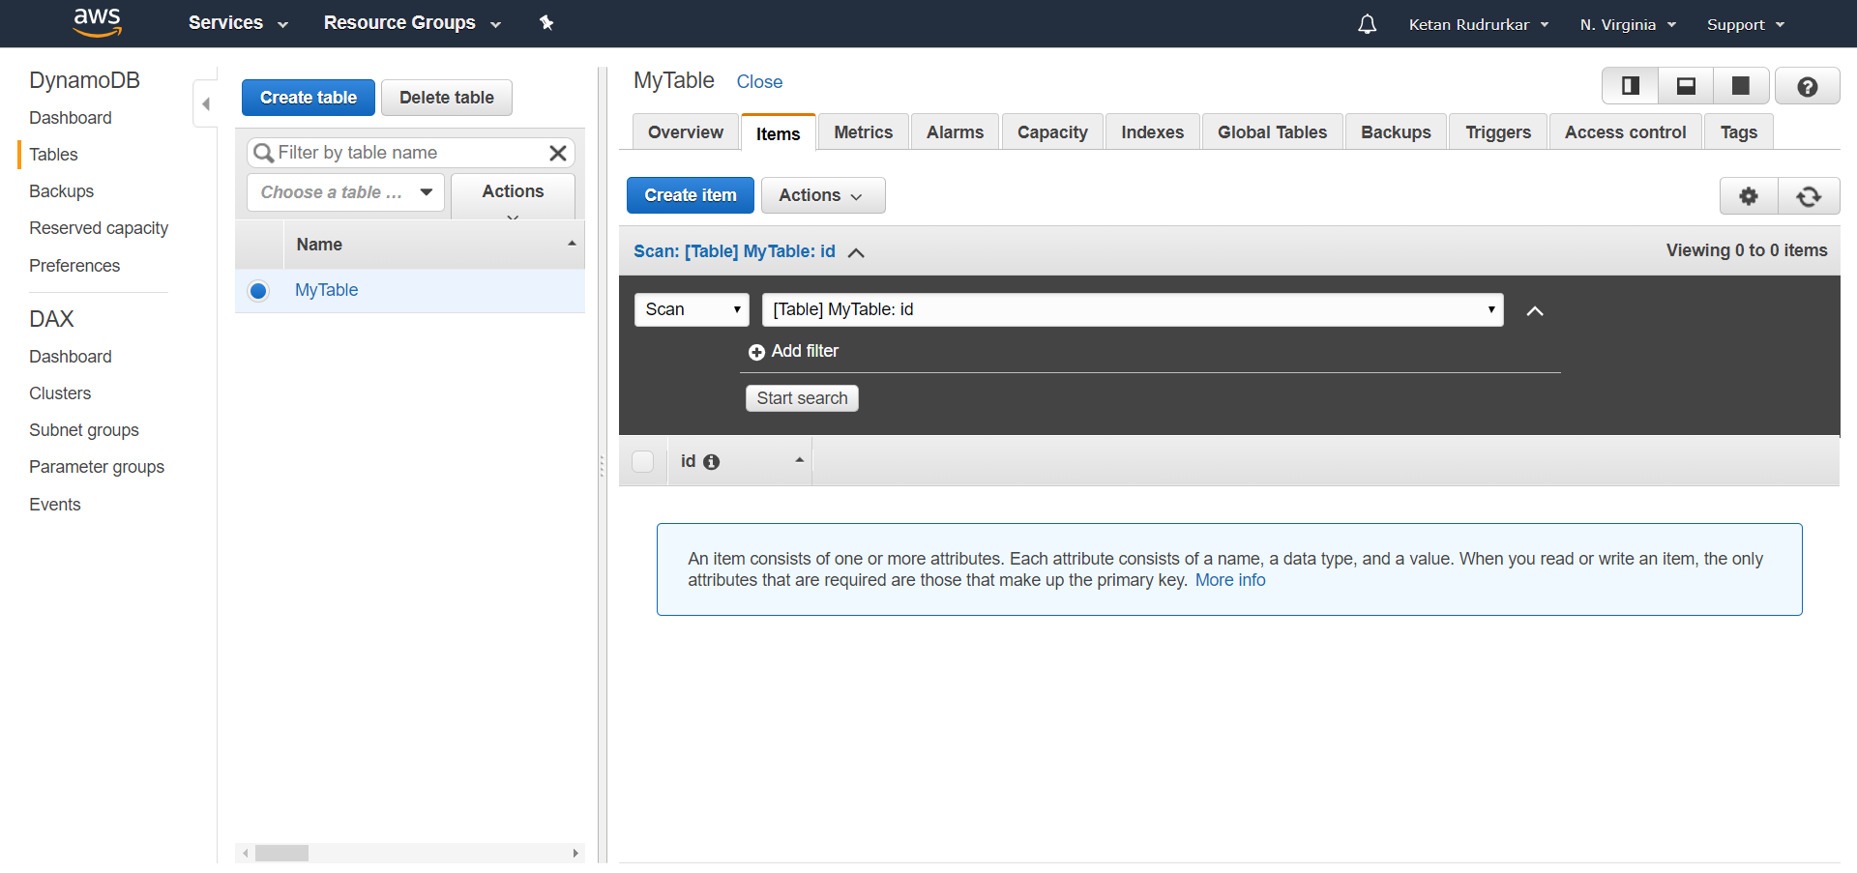

**Calling GET to verify DELETE worked: (Scans table and returns empty body as items are deleted)**

