**HW #6 Introduction to AWS VPC**

Team name: The Original

Team Members: Tejas Madappa

Chandra Mohan

Vedant Bhoj

Ketan Rudrurkar

Hao Ran Chen

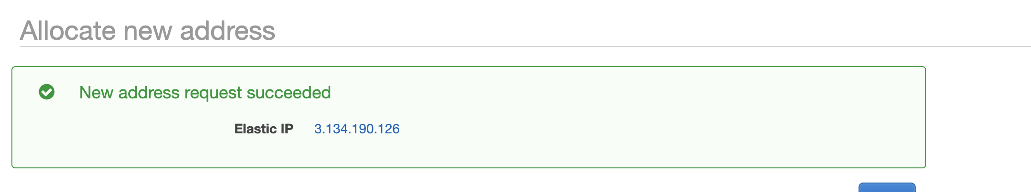

Fig.1 Creating Elastic IP

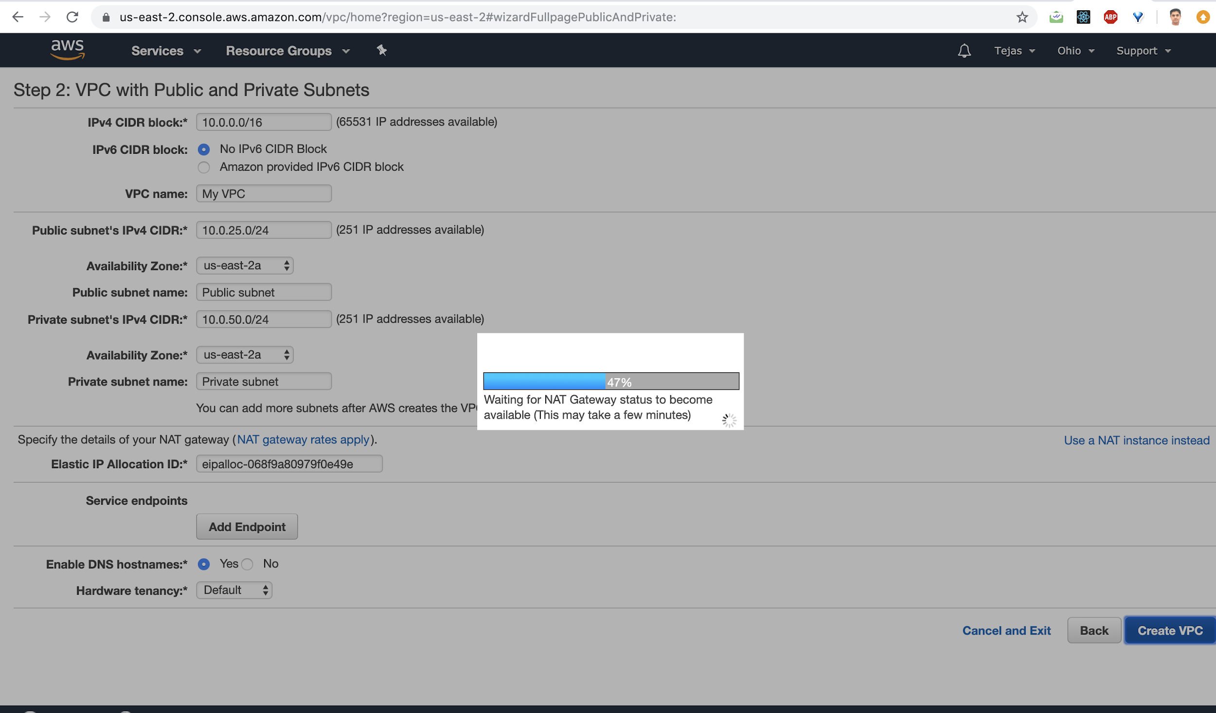

Fig.2 Configuring VPC and Assigning Public and Private Subnets.

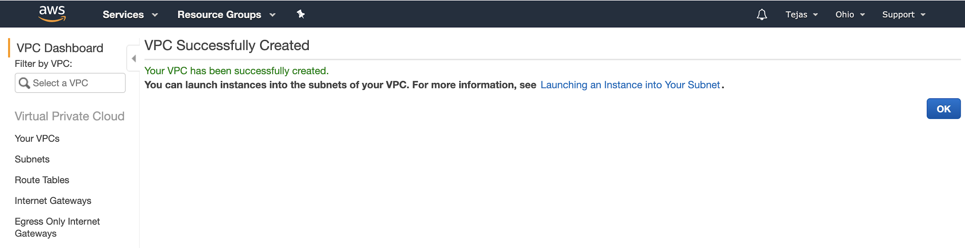

Fig.3 Created VPC using VPC Wizard

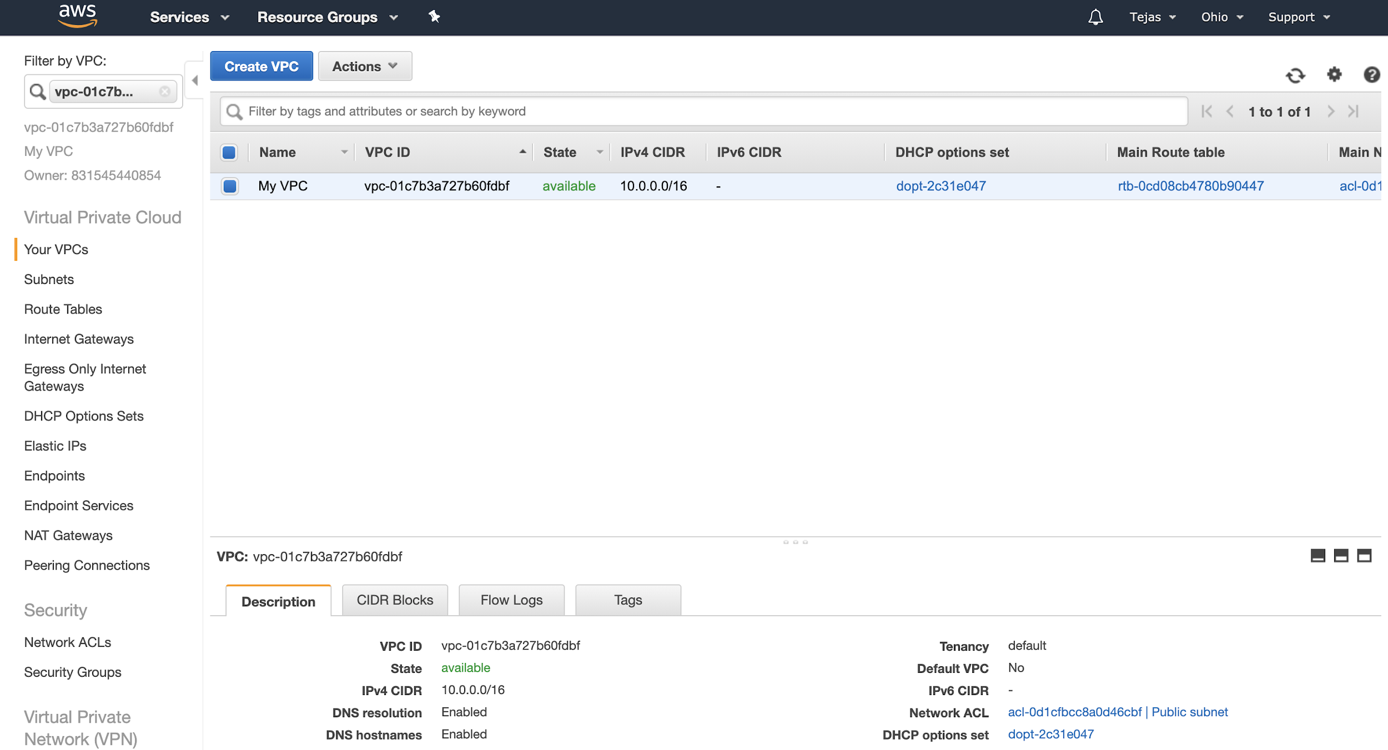

Fig.4 Displaying created VPC on Console

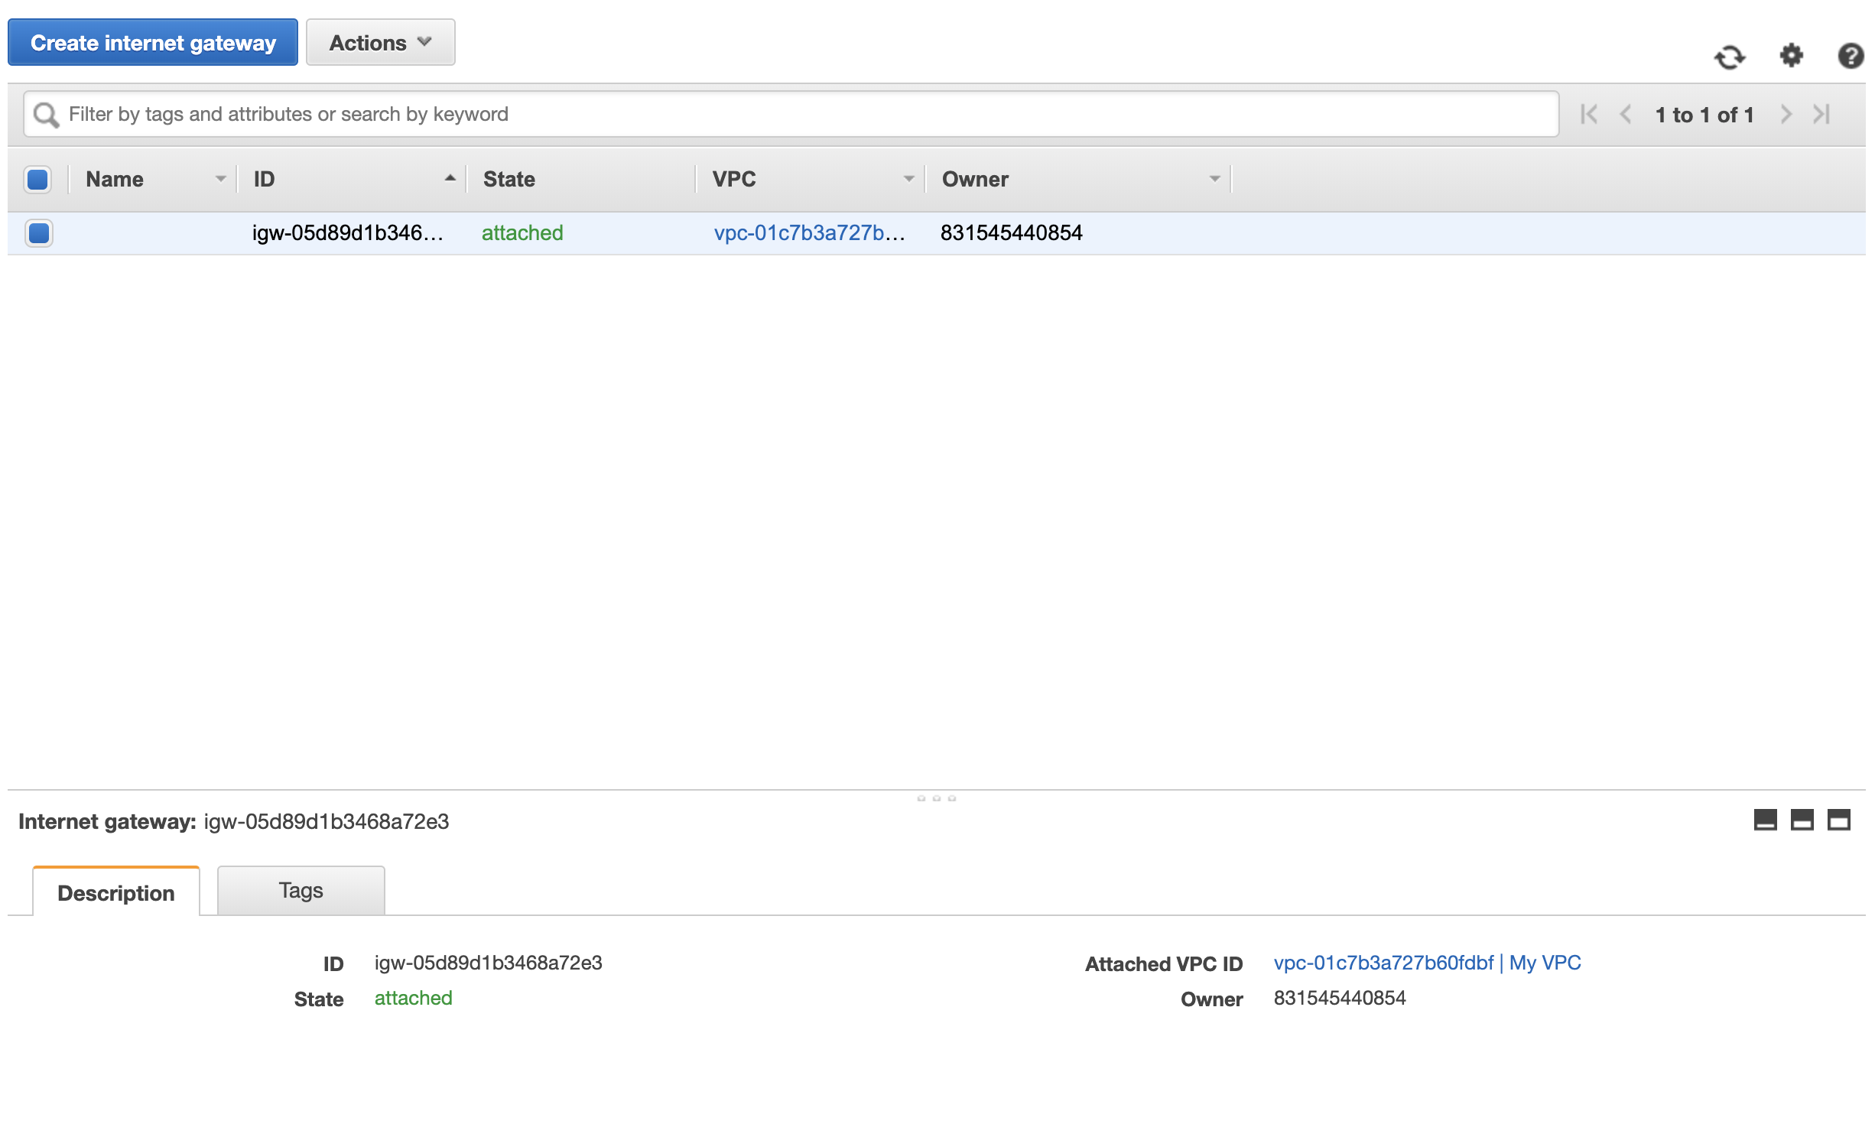

Fig.5 The Internet Gateway for the VPC is displayed.

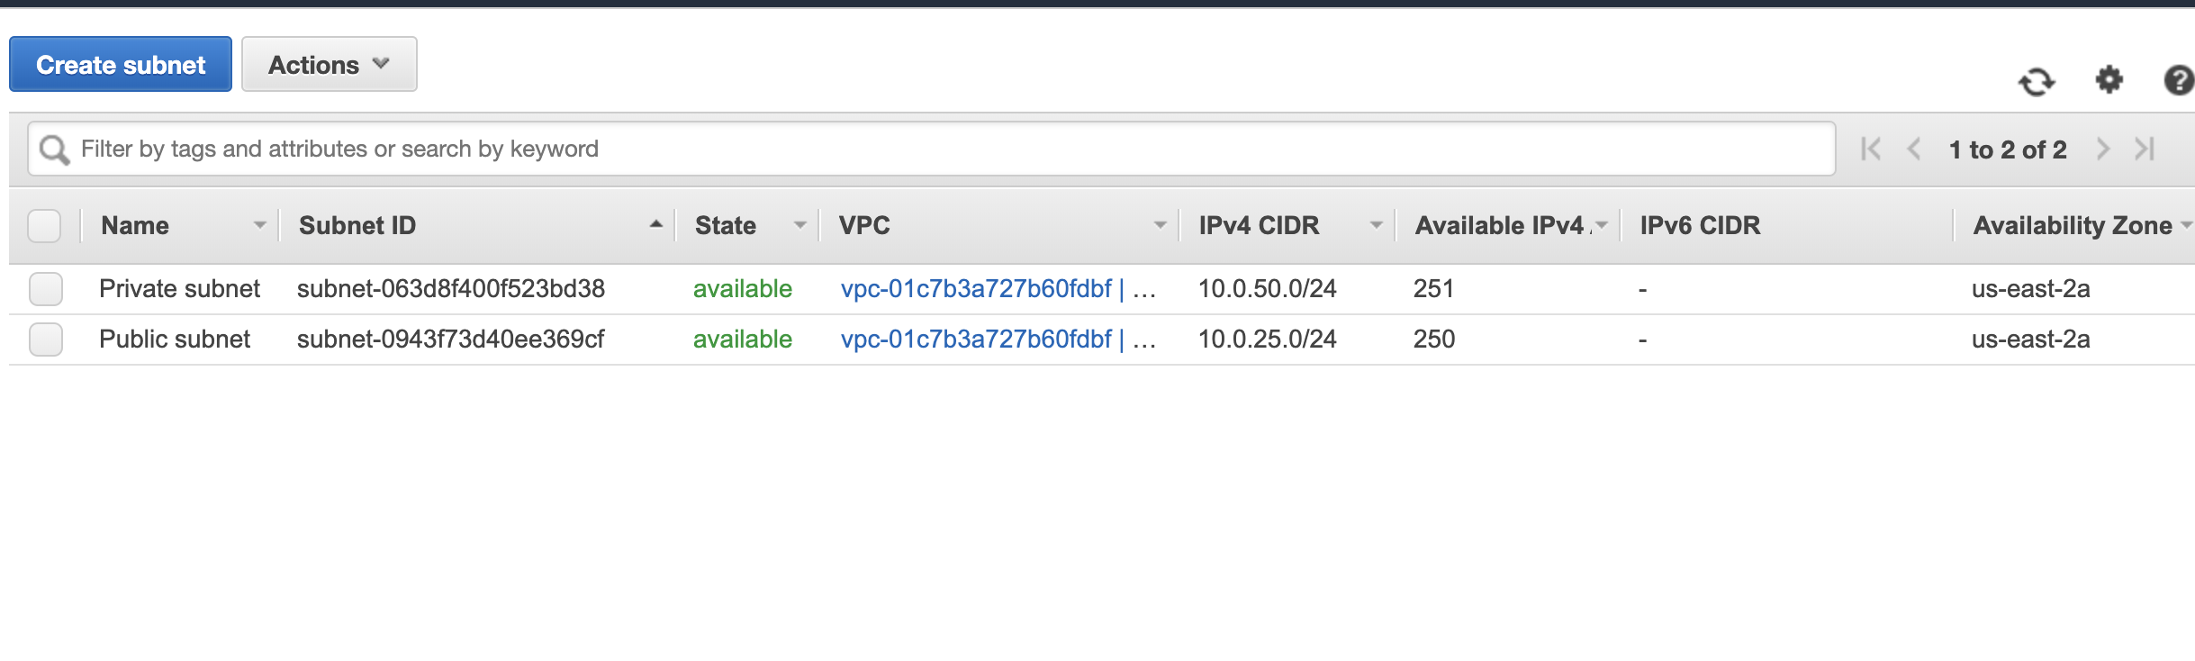

Fig.6 The Public Subnet and Private Subnet of the VPC are displayed.

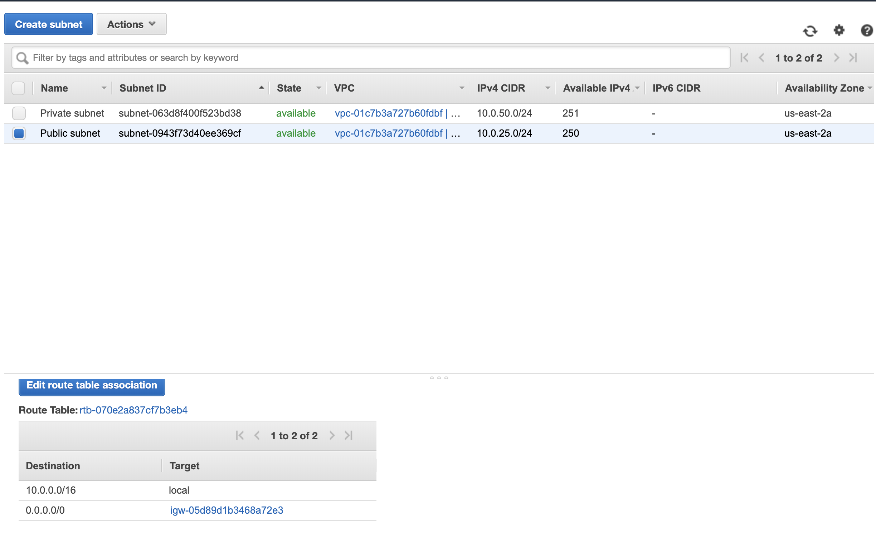

Fig.7 Route Table for Public Subnet

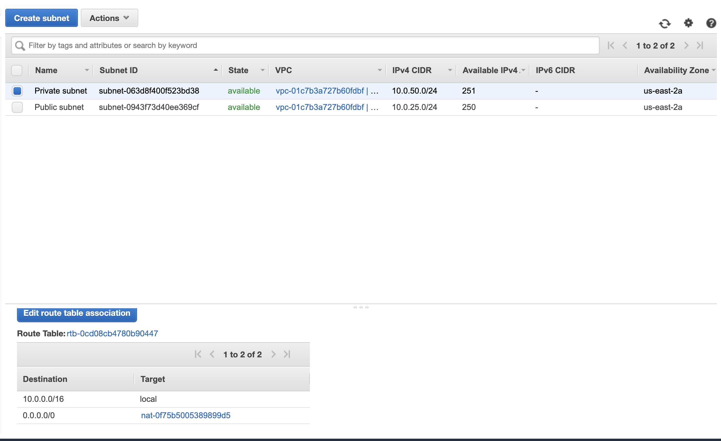

Fig.8 Route Table for Private Subnet

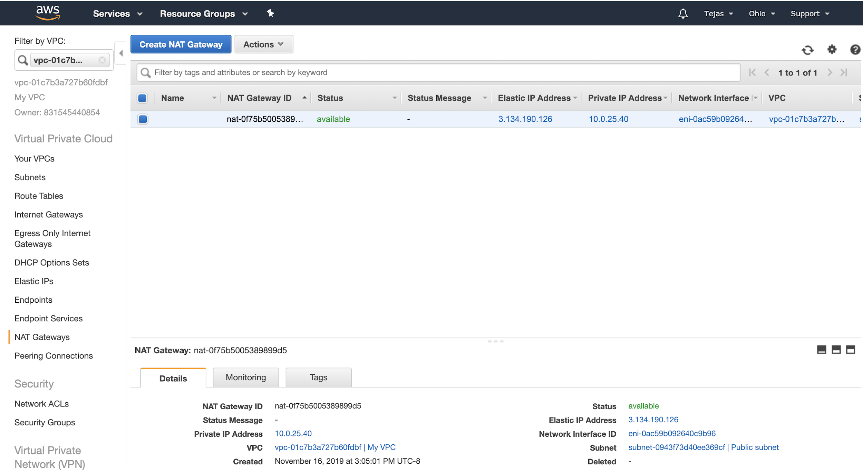

Fig.9 NAT Gateway