1. Create a keystore file to store server’s private key and self-signed certificate by executing the following command, and specify a password value of "changeit".

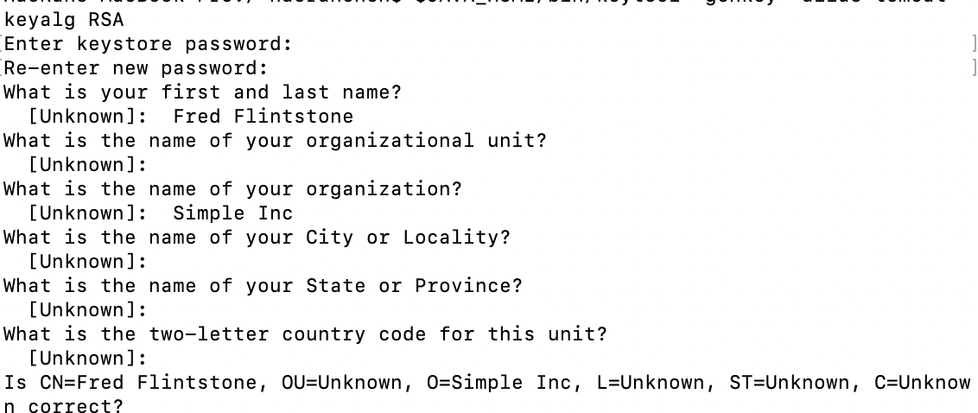

1. Configuration

Prepar the certificate Keystore

Create p12 file

Get self signed certificate that could use for server

1. Edit the server.xml

Change certificate path

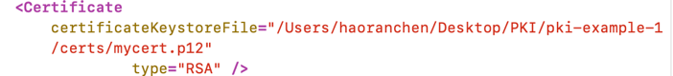

1. Set configuration at Intelij ide https at 8443

1. Try to connect after using TLS

So before set certificate for client， it works because you cannot connect without

Certificate.