**Exp:4**

**Aim:Analyse CSS by applying the different style using inline, external & internal CSS in html file.**

**Source code:**

**Inline css:**

<html>

<body style="background-color:pink;">

<center><h1 style="color:blue;font-size:20px;text-align:justify;margin-left:20px;margin-right=20px;">College of Engineering Vatakara(CEV)<h1></center>

<fieldset><p><b>college of engineering vatakara</b> began in the year 1999 using the Maniyoor High School building as a temporary campus.

The college was later shifted to the present day campus which is its own. The campus is situated in Kurunthodi near maniyoor, 10 km from Vadakara railway station. Stretched over 10 hectares of land,

<i>The campus is one of the greenest campuses in the state</i>.

The campus consists of an Administrative block and five academic blocks designated to different departments along with laboratories, workshops, hostels, canteens and courts/grounds. Its one of the ten colleges run by the Co-operative Academy of Professional Education (CAPE) under Govt. of Kerala.

Its one of the few <i>ISO</i> and <i>NAAC</i> certified technical institutions in the state.

</p>

College of Engineering Vadakara (CEV) formerly known as Co-operative Institute of Technology, Vadakara,

is the first engineering college under Co-operative Academy of Professional Education (CAPE) established by Govt. of Kerala in the year 1999.

This was started with a broad vision of assisting the Government to impart quality education to the meritorious and economically backward students in the State without much financial burden.

</p></fieldset>

</html>

**Output:**

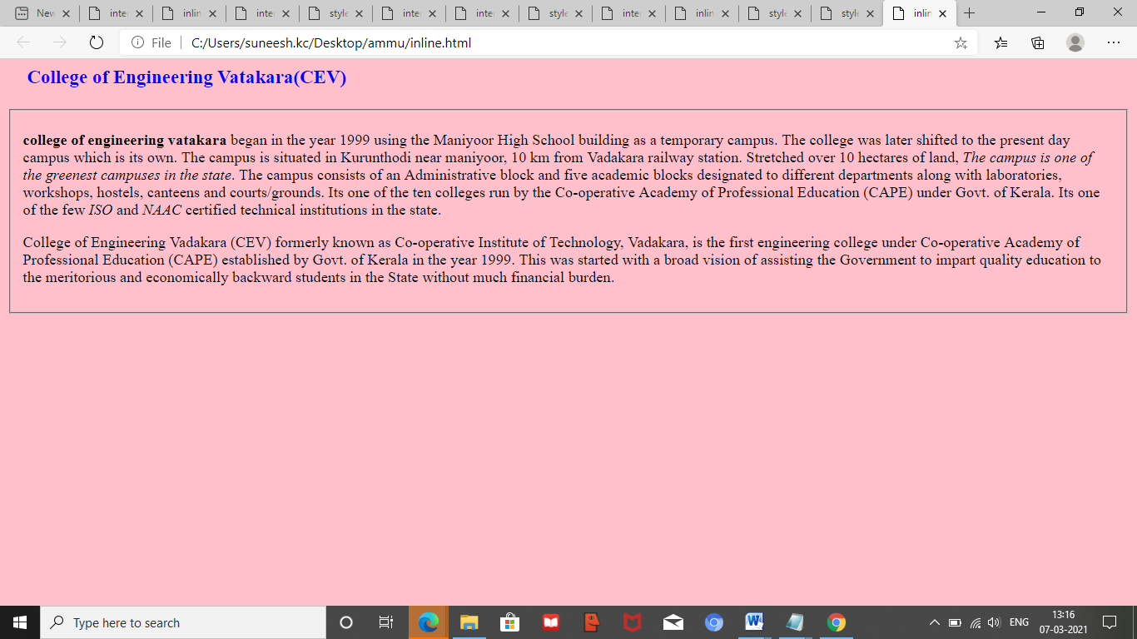

**Internal CSS**

<html>

<style>

body{background-color:pink;}

h1{

color:#5d8 aa8;

padding:10 px;

textalign:center;

}

p{

color:#873260;

font-size:20px;

text-align:justify;

margin-left:20px;

margin-right:20px;

}

</style>

<body>

<center><h1 style="color:blue;">College of Engineering Vatakara(CEV)<h1></center>

<fieldset>

<p><b>college of engineering vatakara</b> began in the year 1999 using the Maniyoor High School building as a temporary campus.

The college was later shifted to the present day campus which is its own. The campus is situated in Kurunthodi near maniyoor, 10 km from Vadakara railway station. Stretched over 10 hectares of land,

<i>The campus is one of the greenest campuses in the state</i>.

The campus consists of an Administrative block and five academic blocks designated to different departments along with laboratories, workshops, hostels, canteens and courts/grounds.

Its one of the ten colleges run by the Co-operative Academy of Professional Education (CAPE) under Govt. of Kerala.

Its one of the few <i>ISO</i> and <i>NAAC</i> certified technical institutions in the state.

</p>

<p>

College of Engineering Vadakara (CEV) formerly known as Co-operative Institute of Technology, Vadakara, is the first engineering college under Co-operative Academy of Professional Education (CAPE) established by Govt. of Kerala in the year 1999.

This was started with a broad vision of assisting the Government to impart quality education to the meritorious and economically backward students in the State without much financial burden.

</p>

</fieldset>

</html>

**Output:**

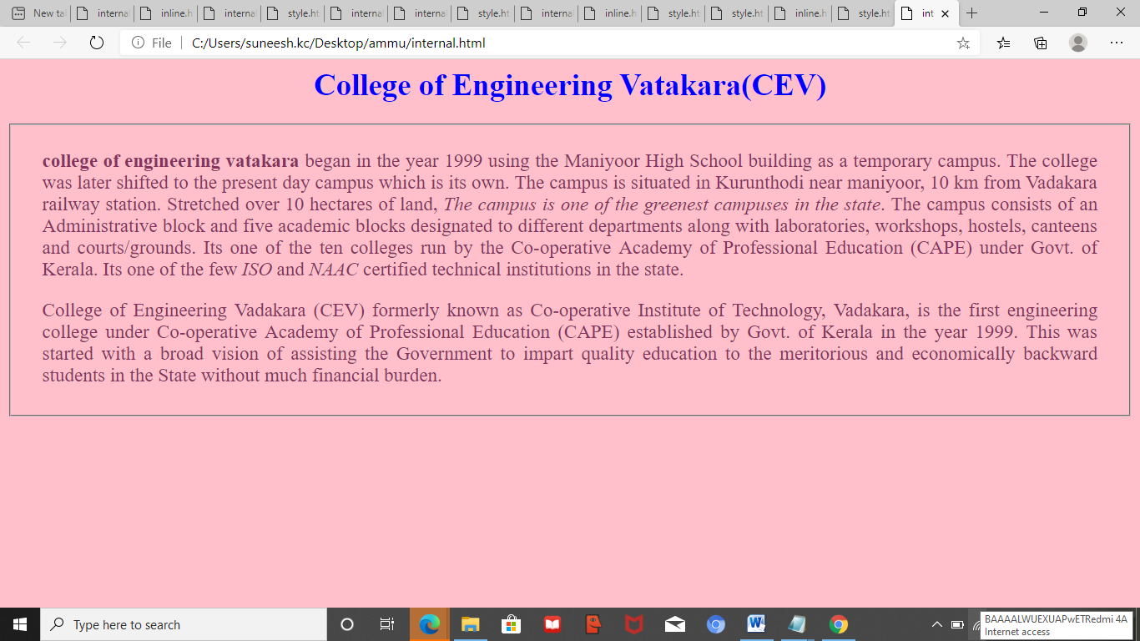

**External CSS**

**Style.html**

<html>

<head>

<link rel="style" href="scss.css">

</head>

<body>

<center><h1 style="color:blue;">College of Engineering Vatakara(CEV)<h1></center>

<fieldset><p><b>college of engineering vatakara</b> began in the year 1999 using the Maniyoor High School building as a temporary campus.

The college was later shifted to the present day campus which is its own. The campus is situated in Kurunthodi near maniyoor, 10 km from Vadakara railway station. Stretched over 10 hectares of land,

<i>The campus is one of the greenest campuses in the state</i>.

The campus consists of an Administrative block and five academic blocks designated to different departments along with laboratories, workshops, hostels, canteens and courts/grounds. Its one ofthe ten colleges run by the Co-operative Academy of Professional Education (CAPE) under Govt. of Kerala.

Its one of the few <i>ISO</i> and <i>NAAC</i> certified technical institutions in the state.

</p>

<p>

College of Engineering Vadakara (CEV) formerly known as Co-operative Institute of Technology, Vadakara, is the first engineering college under Co-operative Academy of Professional Education (CAPE)

established by Govt. of Kerala in the year 1999.

This was started with a broad vision of assisting the Government to impart quality education to the meritorious and economically backward students in the State without much financial burden.

</fieldset></p>

</body>

</html>

**SCSS.html**

h1{

color:blue;

padding:20px;

text-align:center;

}

p{

color:#ff8760;

fontsize:20px;

text-align:justify;

margin-left:20px;

margin-right:20px;

}

**OUTPUT:**

