**09.08.2024 JAVA PROGRAMMING**

**1.ADD A SERIES OF NUMBER USING RECURSION**

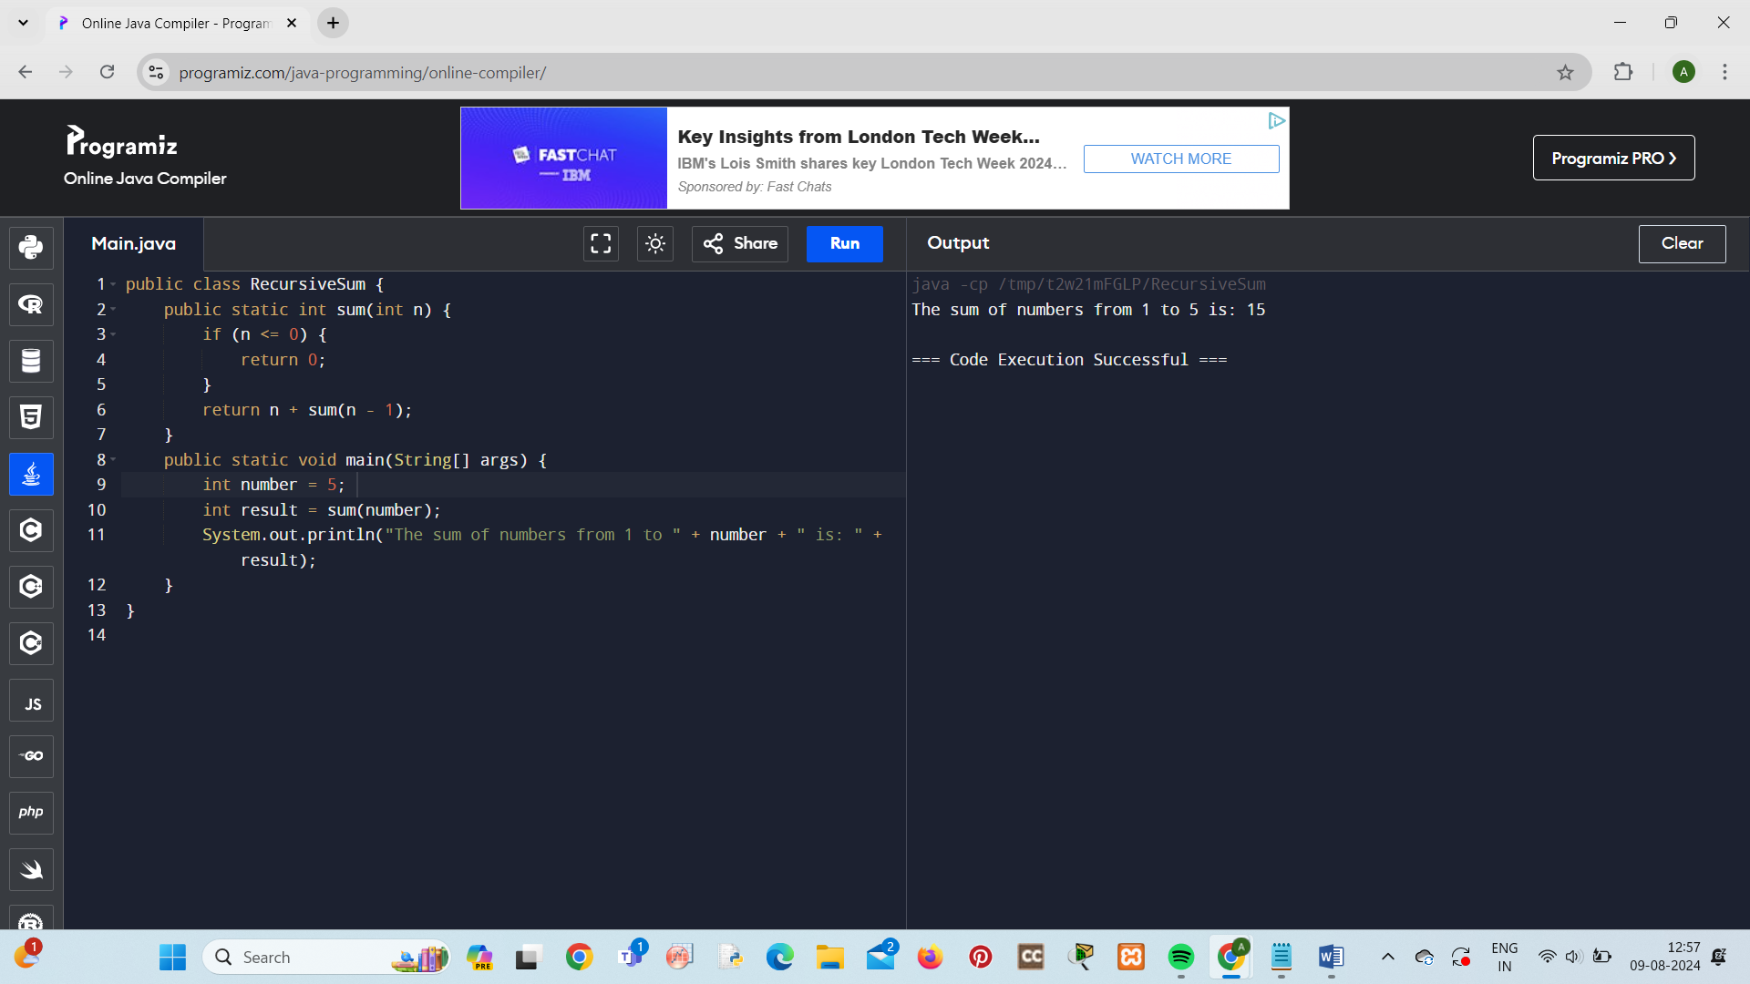

**2.FACTORIAL RECURSION**

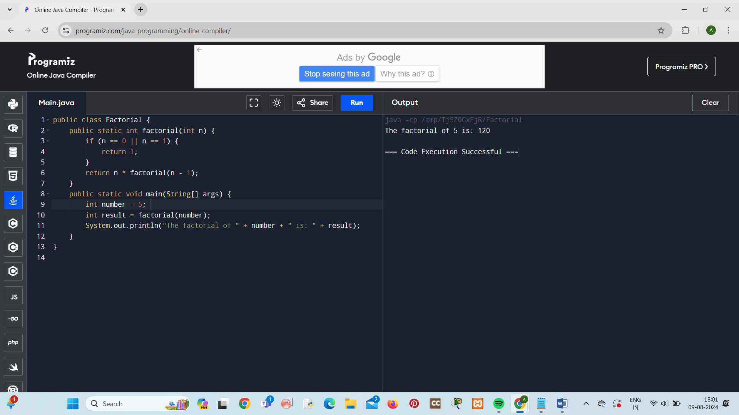

**3.FIBONOACCI SERIES USING RECURSION**

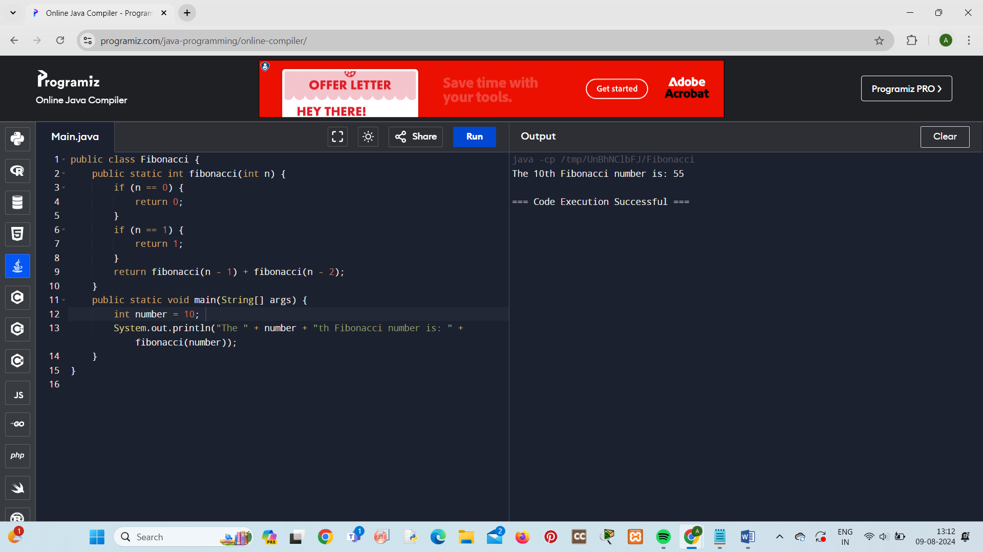

**4.CHECK PALINDROME OR NOT USING RECURSION**

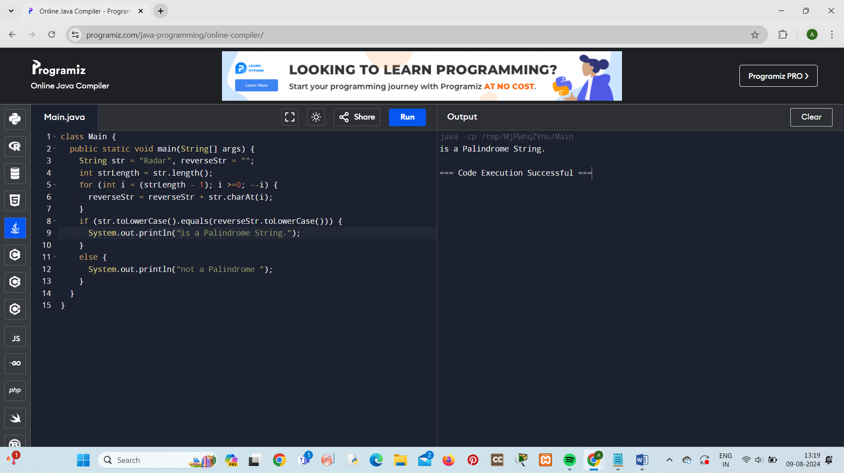

**5.PRINT A SERIES OF NUMBER USING RECURSION IN REVERSE ORDER**

