1. **RECTANGLE**

// Java Program to create a rectangle and add it to the scene

package application;

import javafx.application.Application;

import static javafx.application.Application.launch;

import javafx.scene.Group;

import javafx.scene.Scene;

import javafx.scene.paint.Color;

import javafx.scene.shape.Rectangle;

import javafx.stage.Stage;

public class Shape_Example extends Application{

@Override

public void start(Stage primaryStage) throws Exception {

primaryStage.setTitle("Rectangle Example");

Group group = new Group();

Rectangle rect=new Rectangle();

rect.setX(20);

rect.setY(20);

rect.setWidth(100);

rect.setHeight(100); // setting the height of rectangle

group.getChildren().addAll(rect); //adding rectangle to the //group

Scene scene = new Scene(group,200,300,Color.BLUE);

primaryStage.setScene(scene);

primaryStage.show();

}

public static void main(String[] args) {

launch(args);

}

}

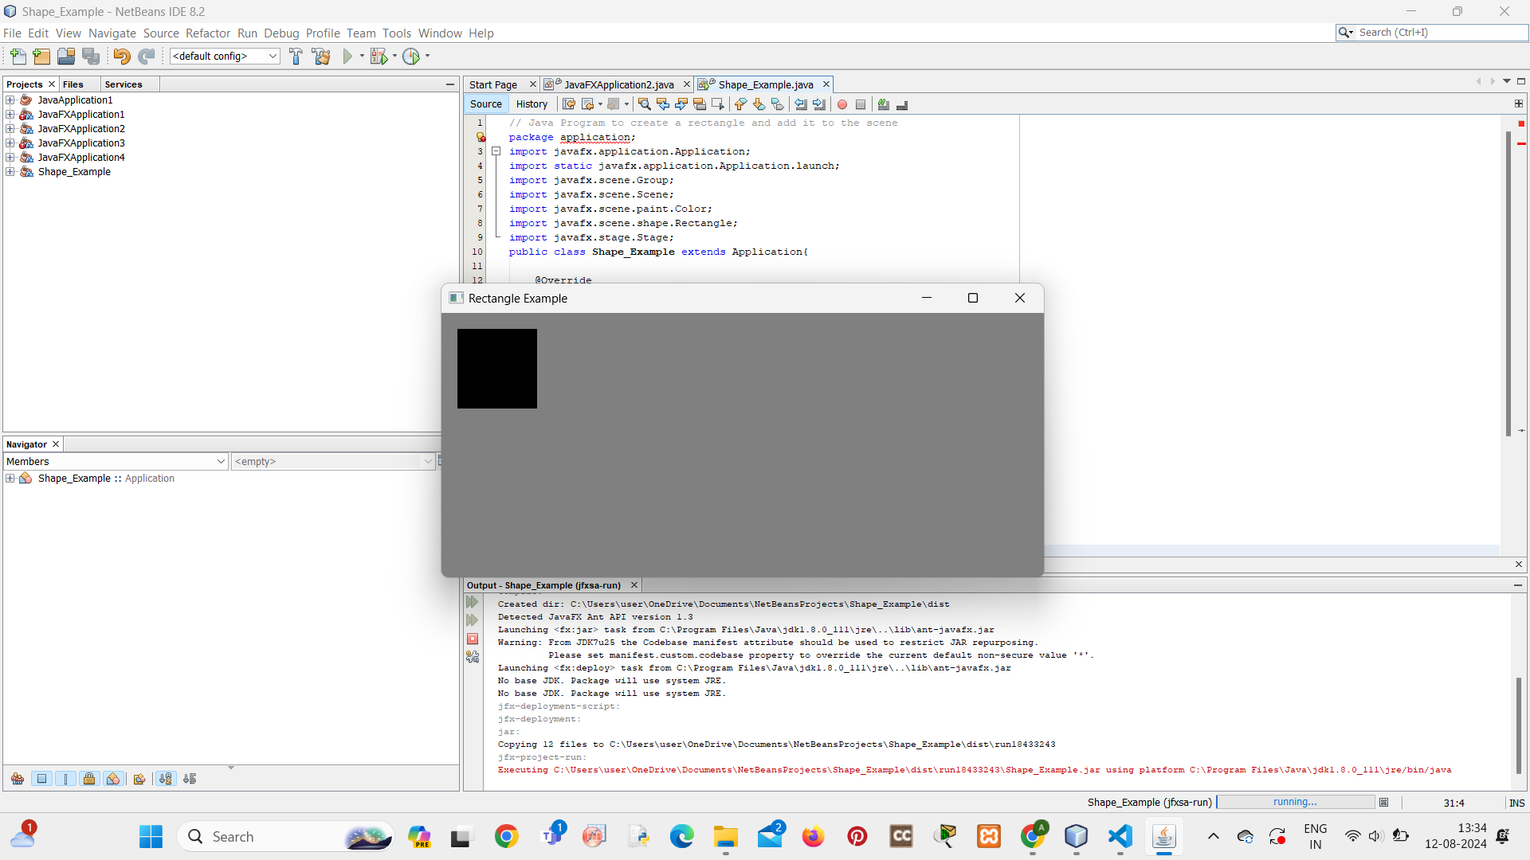

1. **CIRCLE**

package application;

import javafx.application.Application;

import static javafx.application.Application.launch;

import javafx.scene.Group;

import javafx.scene.Scene;

import javafx.scene.paint.Color;

import javafx.scene.shape.Circle;

import javafx.stage.Stage;

public class Circle1 extends Application{

@Override

public void start(Stage primaryStage) throws Exception {

// TODO Auto-generated method stub

primaryStage.setTitle("Circle Example");

Group group = new Group();

Circle circle = new Circle();

circle.setCenterX(200);

circle.setCenterY(200);

circle.setRadius(100);

circle.setFill(Color.RED);

group.getChildren().addAll(circle);

Scene scene = new Scene(group,400,500,Color.GRAY);

primaryStage.setScene(scene);

primaryStage.show();

}

public static void main(String[] args) {

launch(args);

}

}

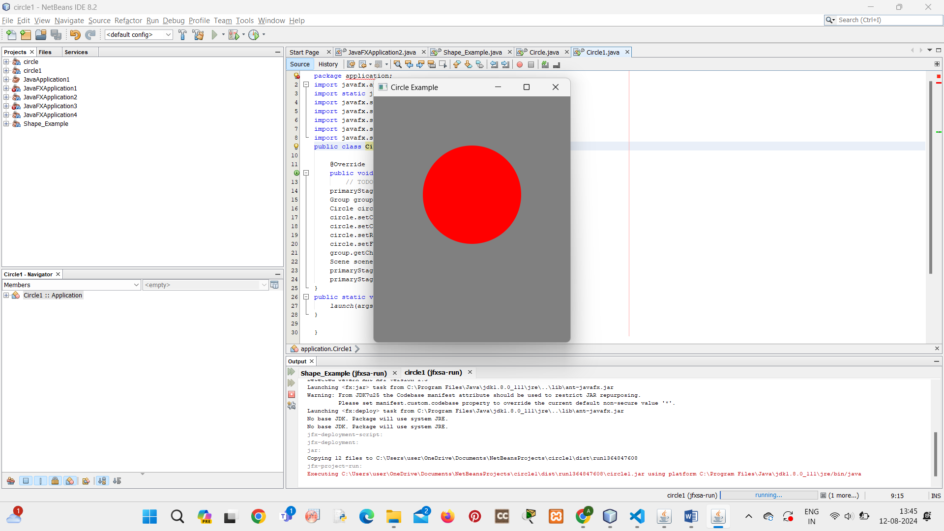

1. **POLYGON**

package application;

import javafx.application.Application;

import javafx.scene.Group;

import javafx.scene.Scene;

import javafx.scene.shape.Polygon;

import javafx.stage.Stage;

public class Shape1 extends Application {

@Override

public void start(Stage primarystage) {

Group root = new Group();

primarystage.setTitle("Pollygon Example");

Polygon polygon = new Polygon();

polygon.getPoints().addAll(new Double[]{

0.0, 0.0,

100.0, 200.0,

200.0, 100.0 });

root.getChildren().add(polygon);

Scene scene = new Scene(root,300,400);

primarystage.setScene(scene);

primarystage.show();

}

public static void main(String[] args) {

launch(args);

}

}

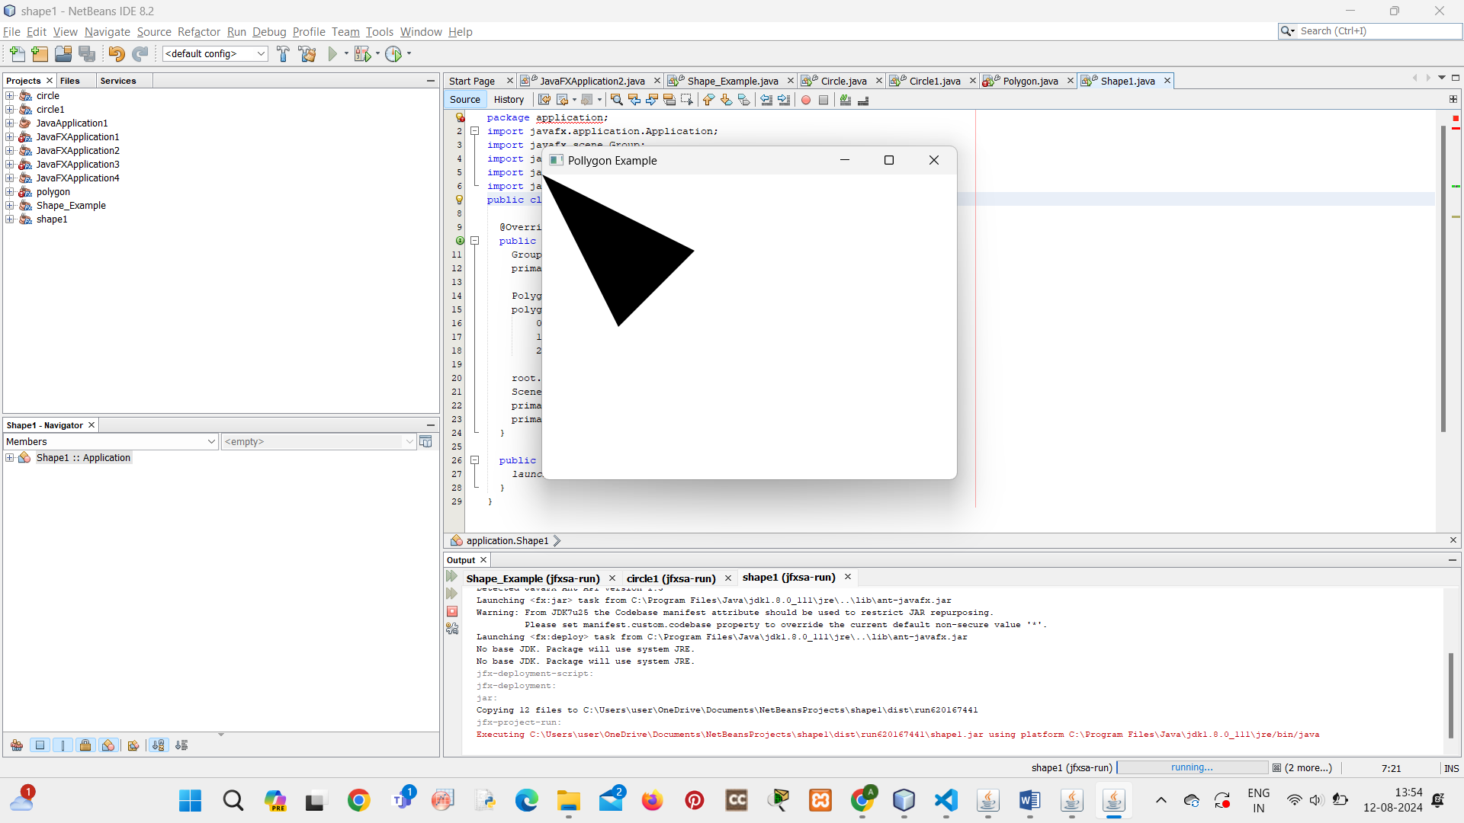

1. **COLOR FILL**

package application;

import javafx.application.Application;

import javafx.scene.Group;

import javafx.scene.Scene;

import javafx.scene.effect.DropShadow;

import javafx.scene.effect.Shadow;

import javafx.scene.paint.Color;

import javafx.scene.shape.Rectangle;

import javafx.stage.Stage;

public class Shape_color1 extends Application {

@Override

public void start(Stage primarystage) {

Group root = new Group();

primarystage.setTitle("Color Example");

Rectangle rect = new Rectangle();

rect.setX(50);

rect.setY(20);

rect.setWidth(100);

rect.setHeight(150);

int red=20;

int green=125;

int blue=10;

rect.setFill(Color.rgb(red, green, blue,0.63));

root.getChildren().add(rect);

Scene scene = new Scene(root,200,200);

primarystage.setScene(scene);

primarystage.show();

}

public static void main(String[] args) {

launch(args);

}

}

