**21.08.2024 JAVA PROGRAMMING**

**SERIALIZATION AND DESERIALIZTION**

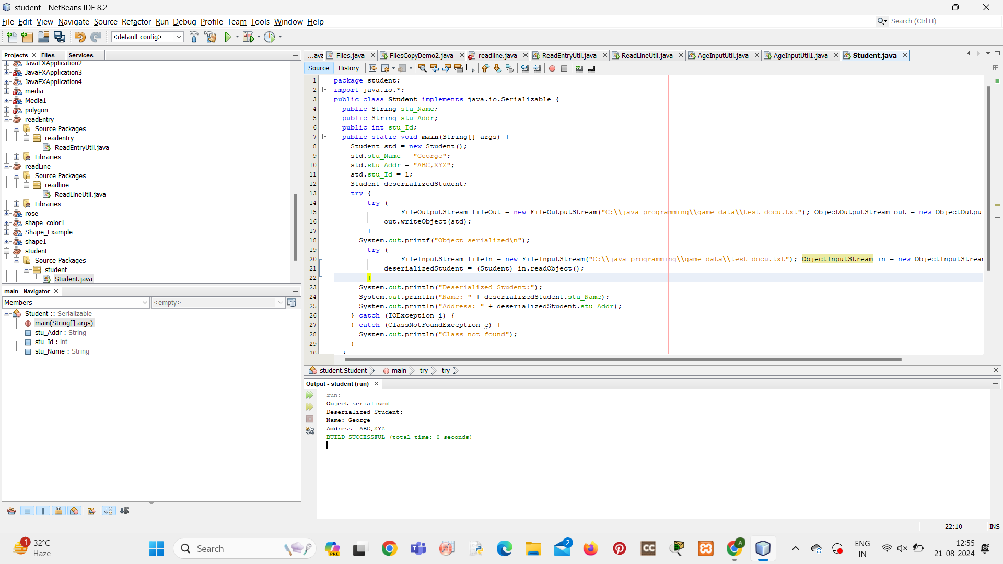

**PRINT WRITER**

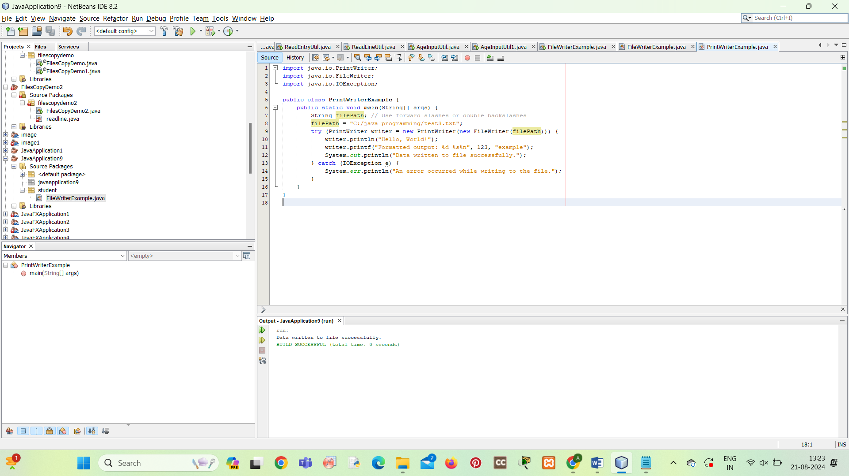

**FILE WRITER**

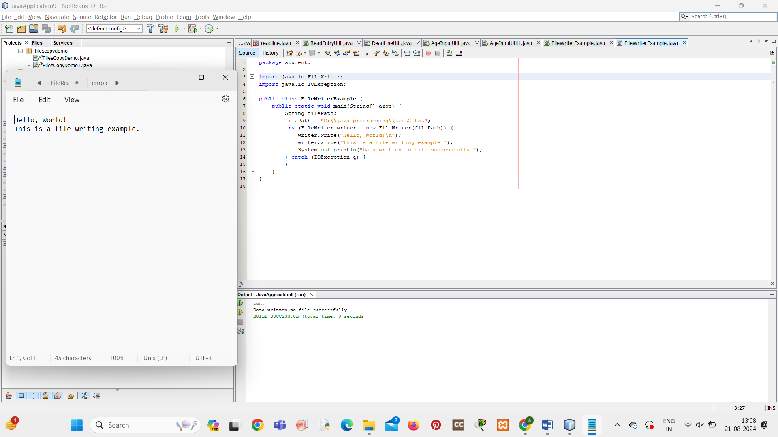

**WRITER**

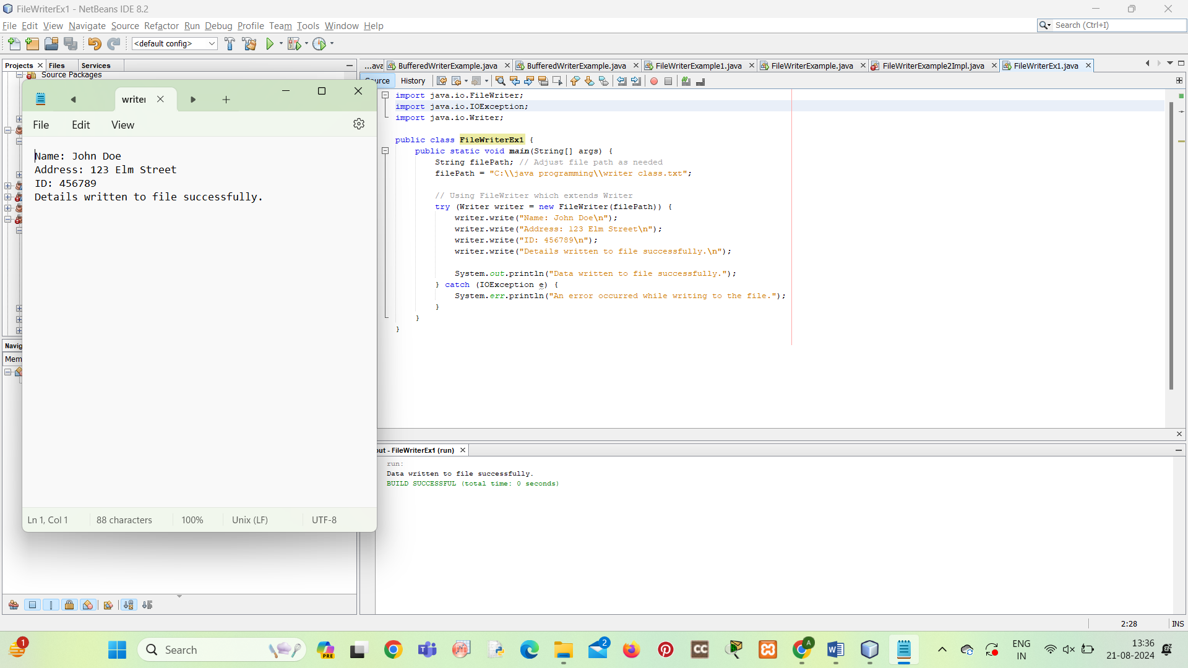

**BUFFER WRITER**

