LAB ASSIGNMENT -6
SWE4009
LINUX PROGRAMMING
DATE: 18/02/2020
ANJANA P
17MIS1028

1.) SYSTEM CALLS(FILE OPEN ,READ ,WRITE)

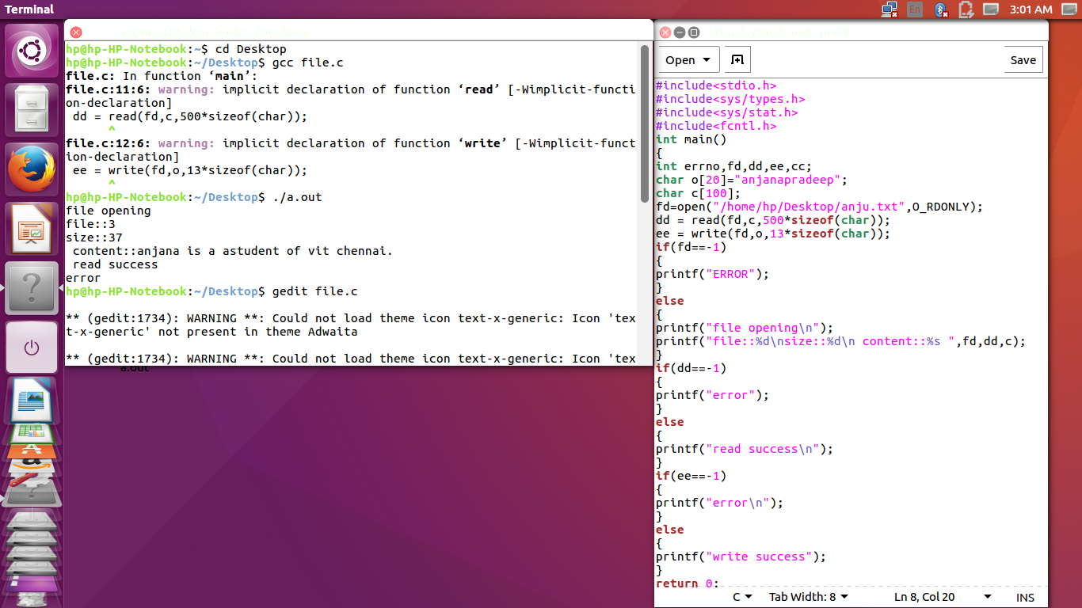

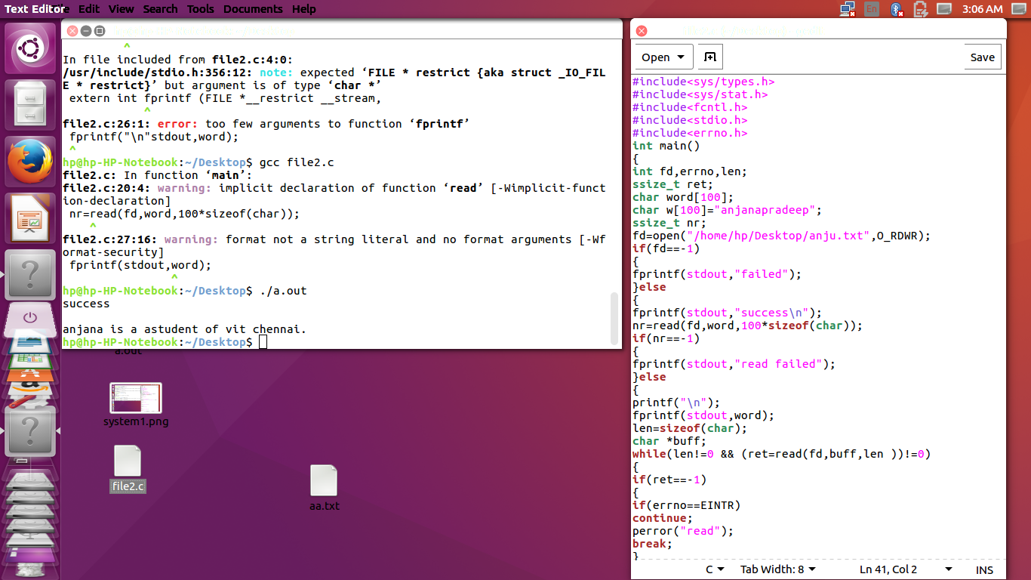

2.) FILE PERMISSIONS USING ACL COMMANDS:

