SWE4009 – LINUX PROGRAMMING

VIRTUAL ASSIGNMENT

20/02/2020

ANJANA P

17MIS1028

1.)SCREENSHOT:

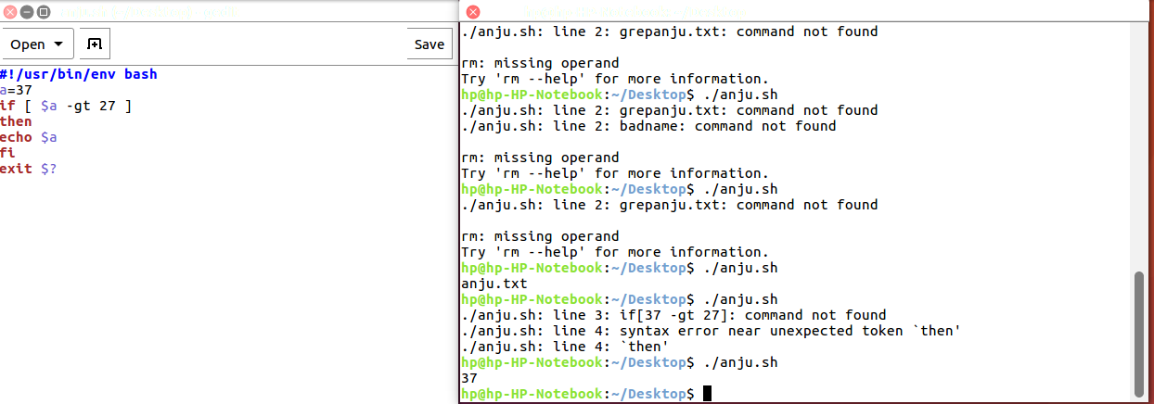

2.) SCREENSHOT:

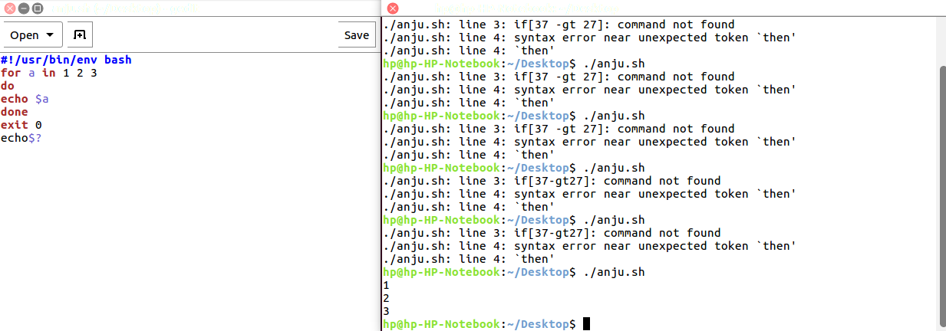

3.)SCREENSHOT:

