User Manual
Pharmacy Management System with AI
Version 1.0

1. Introduction
This manual explains how to install, run, and use the Pharmacy Management System — a local, Docker-based application for managing medicines, stock, prescriptions, billing, suppliers, and expiry/low-stock alerts. It is written for pharmacy staff, managers, and administrators using the system day to day, not for developers (see the README and SRS document for technical details).

2. Getting Started

2.1 Prerequisites
- Docker Desktop installed and running on your computer
- A modern web browser (Chrome, Edge, or Firefox)

2.2 Starting the Application
- Open a terminal in the project folder.
- Run: docker-compose up --build — wait until you see "Uvicorn running on http://0.0.0.0:8000".
- The first time only, load demo data: docker exec -it pharmacy_backend python -m app.seed
- Open frontend/index.html in your browser (or serve the frontend folder with a local web server).

2.3 Logging In
Use one of the accounts below. Passwords should be changed for any real deployment; these are demo credentials only.
Username | Password | Role
admin | admin123 | Admin — full access
manager | manager123 | Manager — most operations
staff | staff123 | Staff — day-to-day counter work

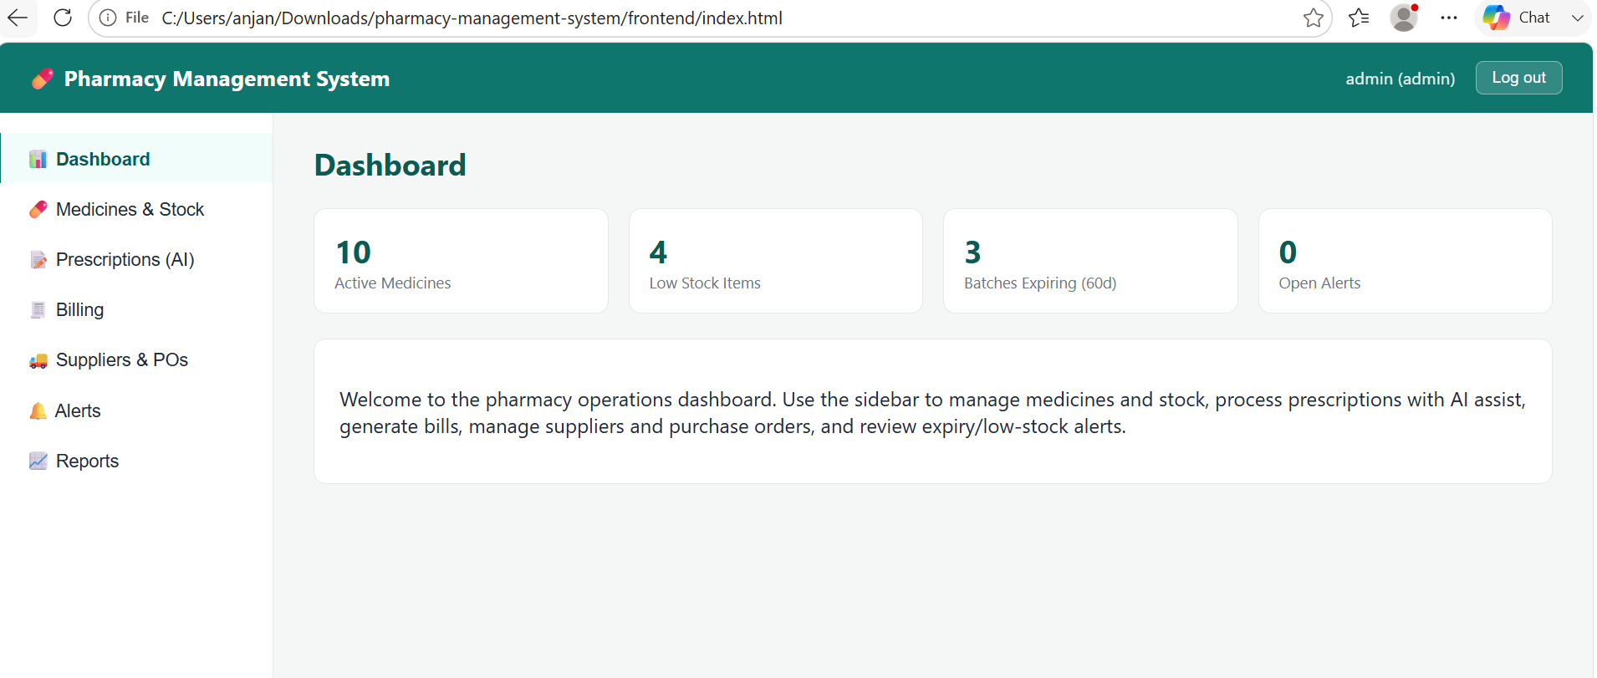
Figure 1 — Dashboard after logging in as admin, showing live stock and alert counts.

3. Dashboard
The Dashboard is the landing screen after login. It shows four live counters: Active Medicines, Low Stock Items, Batches Expiring within 60 days, and Open Alerts. Use it as a quick daily health check of the pharmacy's stock position before diving into a specific module.

4. Medicines & Stock

4.1 Adding a Medicine
Go to Medicines & Stock in the sidebar. Fill in the Add Medicine form — Name and Unit Price are required; Generic Name, Category, Dosage Form, Manufacturer, and Reorder Level are optional but recommended (Reorder Level drives the low-stock alert). Click Add Medicine.

4.2 Adding a Stock Batch
Click the Batches button next to any medicine in the Catalog table. Enter a batch number, quantity, expiry date, and cost price, then click Add Batch. Stock is tracked per batch, not just per medicine, so expiry dates and reorder alerts are always accurate to the specific lot.

4.3 Reading the Catalog
The Catalog table shows current total stock (summed across all batches) for each medicine. A medicine at or below its reorder level is marked with a yellow "low" badge.
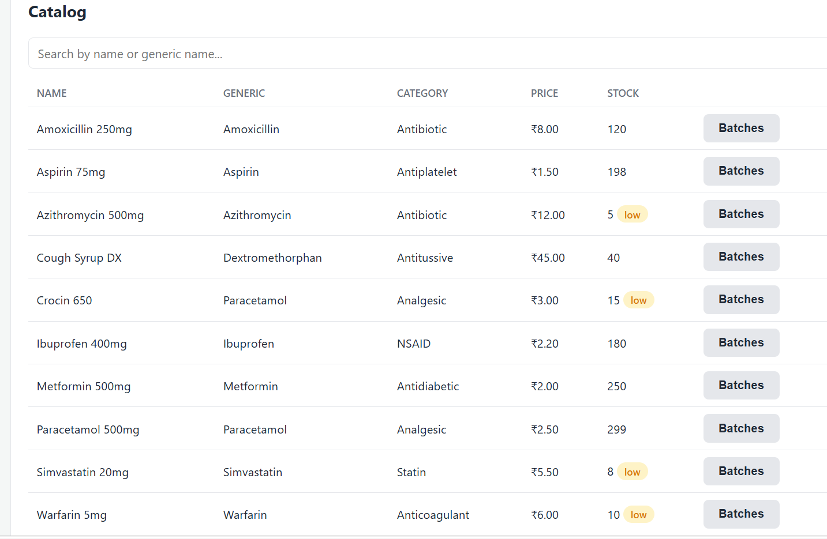
Figure 2 — Medicine catalog. Note the "low" badges on items at or below reorder level.

5. Prescriptions — AI Assist
This screen automates reading a prescription. Type or paste the prescription text into the box — one medicine per line, e.g. "Paracetamol 500mg 1-0-1" — and click Process with AI Assist.
The system will, for each line:
- Extract the medicine name, dosage, and dosing frequency
- Attempt to match the name against your medicine catalog
- Check the whole prescription for known drug-drug interactions and attach a warning badge where one is found
Review the extracted items in the Recent Prescriptions table before dispensing. In a full clinical deployment this text would come from an OCR pass over an uploaded prescription image — see the SRS document, Section 8, for that and other planned enhancements.
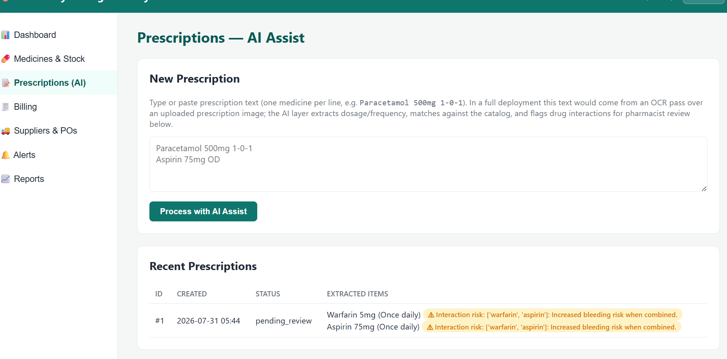
Figure 3 — AI-extracted prescription items with an automatically flagged drug interaction (Warfarin + Aspirin).

6. Billing
Go to Billing to create an invoice. Click + Add Item, choose a medicine, choose a specific batch (batches with available stock and their expiry dates are listed), and enter a quantity. Add as many line items as needed, optionally enter a discount, then click Generate Invoice.
The system automatically calculates GST per line based on each medicine's configured rate, deducts the billed quantity from the selected batch, and logs a stock-out movement. If any line item requests more than the batch has available, the entire invoice is rejected and no stock is deducted.
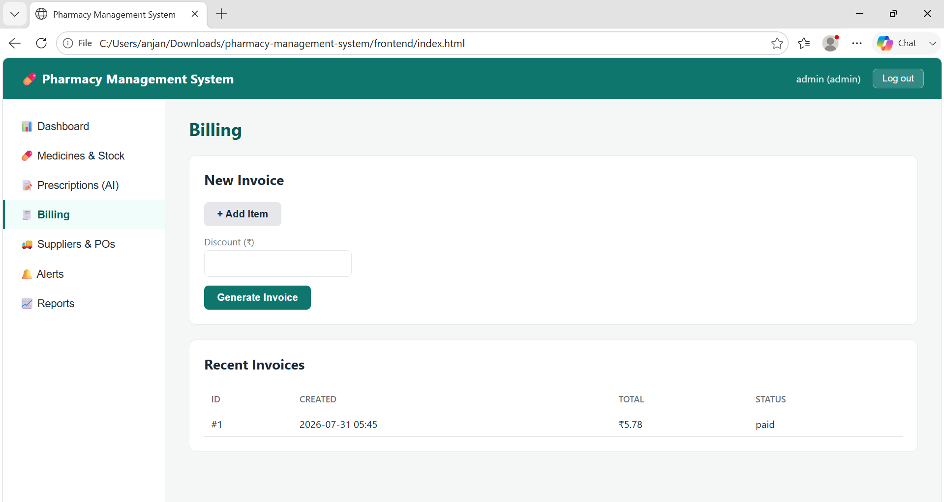
Figure 4 — A generated invoice, showing the calculated total including GST.
To process a return, use the return endpoint via the API docs (/docs) referencing the invoice item — a dedicated return button in the dashboard UI is a suggested future enhancement.

7. Suppliers & Purchase Orders

7.1 Adding a Supplier
Go to Suppliers & POs and fill in the Add Supplier form with name, contact person, phone, email, and lead time in days.

7.2 Creating a Purchase Order
Select a supplier, click + Add Item for each medicine you want to order, specify quantity and unit cost, then click Create Purchase Order. Once stock physically arrives, mark the PO as Received and add the corresponding batch(es) under Medicines & Stock with the actual batch number and expiry date supplied by the vendor.

8. Alerts
Go to Alerts and click Scan Now to run the expiry and low-stock rule engine. It checks every batch's days-to-expiry and every medicine's total stock against its reorder level, and creates an alert for anything that needs attention that isn't already flagged.
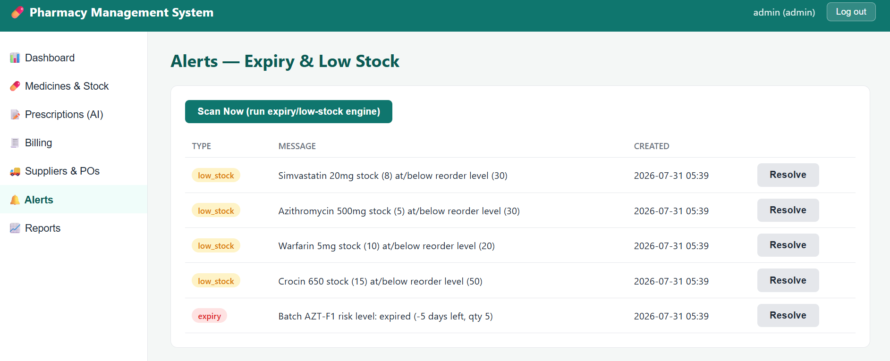
Figure 5 — Open alerts after a scan: low-stock warnings and one expired batch.
Once you have taken action on an alert (reordered stock, disposed of expired product, etc.), click Resolve to remove it from the open list.

9. Reports
Go to Reports and use the tabs to view: Fast-Moving medicines (highest sales volume in the last 30 days), Dead Stock (medicines with stock that hasn't sold recently), Expiry Loss (estimated monetary loss from already-expired stock), Daily Sales (today's invoice count and total), and Reorder Needs (medicines at/below reorder level with a simple projected 30-day demand figure).

10. Roles & Permissions Summary
Action | Admin | Manager | Staff
Add / edit medicines | ✔ | ✔ | —
Deactivate a medicine | ✔ | — | —
Add stock batches | ✔ | ✔ | ✔
Create suppliers / purchase orders | ✔ | ✔ | —
Process prescriptions | ✔ | ✔ | ✔
Generate invoices | ✔ | ✔ | ✔
Resolve alerts | ✔ | ✔ | ✔
List all system users | ✔ | — | —

11. Troubleshooting

"Authentication failed" / login doesn't work
Confirm the backend is running (docker-compose up) and that you ran the seed script at least once. If you registered custom users before seeding, the seed script may have skipped — see Section 11.3.

Frontend loads but shows connection errors
Check that the backend is reachable at http://localhost:8000/docs in your browser. If you changed the backend port, update API_BASE in frontend/js/api.js to match.

Seed script says "Database already seeded. Skipping."
This means the users table already has at least one row — often because a user was registered via /docs before seeding. To start clean: run docker-compose down -v (this deletes all data), then docker-compose up --build, then run the seed script again before creating any other users.

bcrypt / password hashing error on seed
This was a known version mismatch between the passlib and bcrypt Python packages, fixed by pinning bcrypt==4.0.1 in backend/requirements.txt. If you see this error, confirm your requirements.txt has that pin and rebuild with docker-compose up --build.

— End of Document —

