Supplement for: Longer heatwaves disrupt bacterial communities by decoupling resistance from recovery.
Authors: Ana-Hermina Ghenu, Anjaney J. Pandey, Zachary M. Bailey, David R. Johnson, and Madhav P. Thakur

Materials & Methods
Table S1: List of bacterial strains used in the experiment.
ID | Strain identification | Isolated from… | Fluorescence | Lab of Origin &  Strain ID in their Collection | Ref.
BSC001 | Pseudomonas putida F1 | creek | sYFP | Jan van der Meer (UniL, CH)  7609 | --
BSC002 | Pseudomonas putida KT2440 | ? | mScarlet | Jan van der Meer (UniL, CH)  7598 | --
BSC003 | Pseudomonas putida uwc 2 | soil | mTagBFP2 | Jan van der Meer (UniL, CH)  7597 | --
BSC004 | Pseudomonas veronii | ? | mTagBFP2 | Jan van der Meer (UniL, CH)  7591 | --
BSC005 | Pseudomonas veronii | ? | mScarlet | Jan van der Meer (UniL, CH)  7592 | --
BSC006 | Pseudomonas veronii | ? | mCherry | Jan van der Meer (UniL, CH)  3434 | --
BSC007 | Pseudomonas knackmussii B13 | soil | mCherry | Jan van der Meer (UniL, CH)  2586 | --
BSC008 | Pseudomonas knackmussii B14 | sewage | eGFP | Jan van der Meer (UniL, CH)  1369 | --
BSC009 | Pseudomonas plecoglossicida | soil | N/A | Antonis Chatzinotas (UFZ, DE)  B405 | [30]
BSC010 | Pseudomonas putida mt-2 KT2440 | soil | N/A | Antonis Chatzinotas (UFZ, DE)  B410 | --
BSC015 | Pseudomonas putida KT2440 | ? | GFP | Pilar Junier (UniNe, CH) | --
BSC019 | Pseudomonas grimontii | soil | N/A | Jan van der Meer (UniL, CH)  906 (SV16) | [31]
CK101 | Pseudomonas protegens Pf5 | soil | mTourquoise2 | Christof Keel (UniL, CH)  Pf5-mtou | [32]
CK102 | Pseudomonas protegens Pf5 | soil | mCherry | Christof Keel (UniL, CH)  Pf5-mche | [33]
CK103 | Pseudomonas protegens CHAO | soil | sGFP2 | Christof Keel (UniL, CH)  CHA0-gfp2 | [34]
CK104 | Pseudomonas protegens CHAO | soil | mCherry | Christof Keel (UniL, CH)  CHA0-mche | [34]
BSC028 | Pseudomonas grimontii | (see above) | sGFP2 | BSC019 | This.

Experiment I: Estimating thermal performance traits
The time-to-detection protocol was modified for high throughput by snap freezing the inocula into single-use ‘shots’, either at the stationary or early exponential phase. Bacteria were streaked, incubated overnight at 28℃, and inoculated into liquid media at 225 rpm. For stationary phase inocula, 3.0 mL was incubated for 24 hrs (OD₆₀₀ >3) then resuspended to OD₆₀₀=0.25 into their own filter-sterilized spent media with 10% glycerol. For early exponential phase inocula, 55 mL was incubated to OD₆₀₀ ~ 0.01–0.05 (~ 4–7 hrs) then resuspended into fresh media with 10% glycerol. 100 µL inocula in PCR strip-tubes were snap-frozen on dry ice. These single-use inoculum shots were stored at -79℃ and used within 2 months. Thawed inocula were diluted into liquid media to create a six-step, 10-fold dilution series (10⁻¹–10⁻⁶) for CFUs and growth curves.
CFUs were incubated at three temperatures (28℃, 35℃, and 40℃) using the 6x6 drop plate method (n=3 for both inocula culture phases). Plates were incubated until colonies could be counted by eye (at least overnight) or failed to show discernible growth (at most 7 days).
Growth curves were measured at four temperatures (25℃, 30℃, 35℃, and 40℃) using
200 µL cultures in 96-well microplates covered with a Breathe-Easy sealing membrane and incubated in microplate readers with continuous double-orbital shaking at 807 cpm (1 mm) and a vertical heat gradient of 1℃. OD₆₀₀ was measured every 10 min \cite{growth_rates_made_easy} until cultures reached carrying capacity (≥42 hrs) or failed to show discernible growth (≤60 hrs). Replicate dilution series (n=3) were done on different days for each culture phase, randomizing the incubator and microplate well location.
Experiment II: Assaying diffusible species interactions using supernatant experiments
The four focal species were grown in co-cultures with P. protegens in 25 mL flasks for 24 hrs at 220 rpm and 30℃. Cultures were centrifuged at 10 000 g for 5 min, the supernatant was removed, filtered twice using a 0.22 $\mu$m PES filter, and plated on agar plates to verify the absence of live bacteria. This supernatant was mixed with fresh media and aliquoted to 96-well microplates so that each focal species could be subjected to 90%, 80%, 70%, 60%, 50%, 40%, 30%, 20%, 10%, 5%, and 0% of each supernatant. Microplates were incubated in the plate reader for 12 hrs and the final versus initial OD₆₀₀ values were compared to determine the effect of diffusible secondary metabolites produced by P. protegens on focal species' growth. The inhibitory concentration that reduces the population size by 50% (IC₅₀) was estimated for each focal species by nonlinear least squares fitting using the nlsLM function (minpack.lm) initialized in R with a Hill curve function.
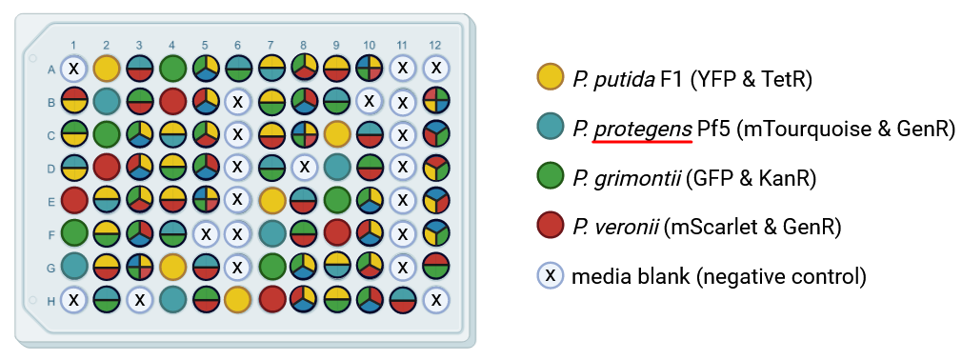Figure S1. The arrangement of the 15 communities (n=5) on the 96-well microplates during Experiment II. Communities are arranged in five blocks across the microplate such that two of the blocks are all edge wells and the other three blocks are all non-edge wells. Coloured circles represent communities inoculated with the species indicated in the legend. Media blanks are shown with crosses. Figure created with BioRender.

Figure S2. Flow cytometry gating strategy to identify individual species. All events in the cells gate (panel A) are either assigned to species level, using a set of three nested polygon gates to identify events with single fluorophore expression (panels B-E), or excluded from further analyses. For panels B-E), representative screenshots are taken from the FCS Express analysis for a positive sample (top plots) with all four species present and a negative sample (bottom plots) with the three other species present.
A)
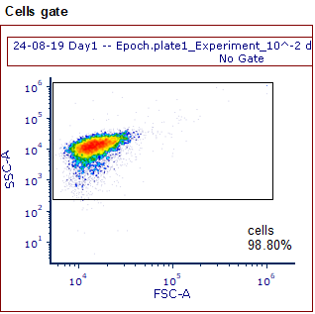
Figure S2 Panel A) A rectangular gate (black) in the forward scatter area (FSC-A) and side scatter area (SSC-A) was used to identify cells and exclude small particles, which are most likely debris.

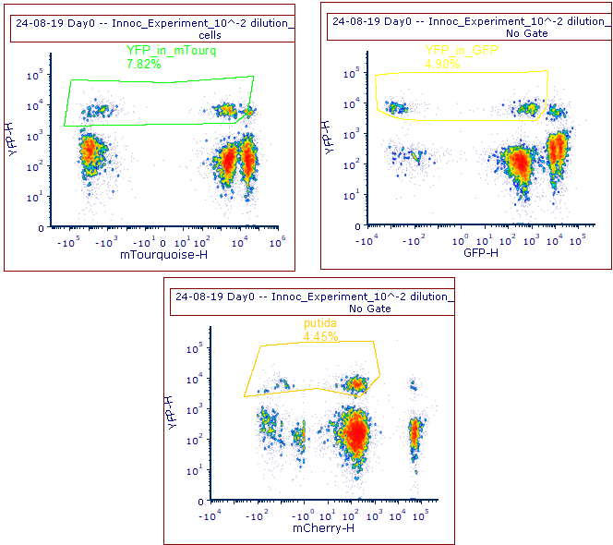
The same strategy for a sample without P. putida (YFP-negative):
B)
Gating strategy to identify the YFP-positive cell population (P. putida):
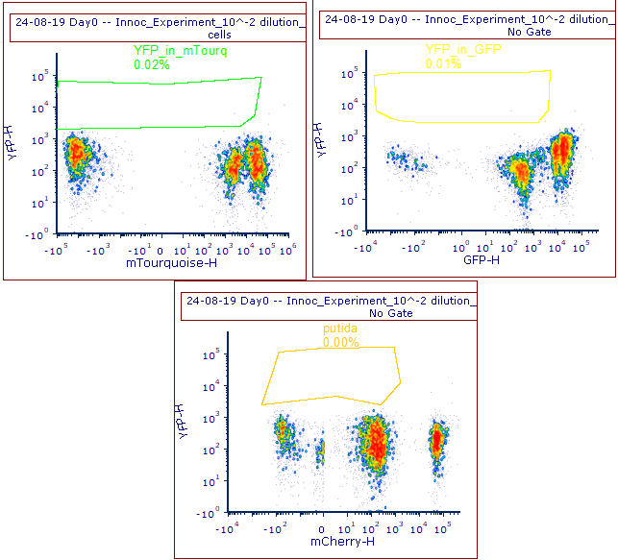
Figure S2 Panel B) Events from the cells gate are assigned to P. putida species because they express only YFP, as measured in YFP height (YFP-H, y-axis of all plots). First, mTourquoise events are excluded using a polygon gate in mTourquoise height (mTourquoise-H), then GFP events are excluded using a polygon gate in GFP height (GFP-H), and finally mCherry events are excluded using a polygon gate in mCherry height (mCherry-H).
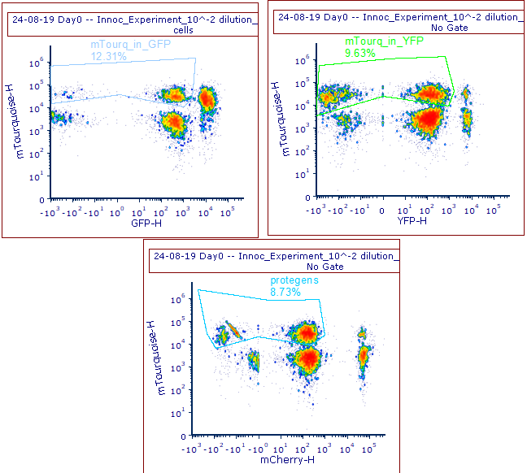
C)
Gating strategy to identify the mTourquoise-positive cell population (P. protegens):
The same strategy for a sample without P. protegens (mTourquoise-negative):
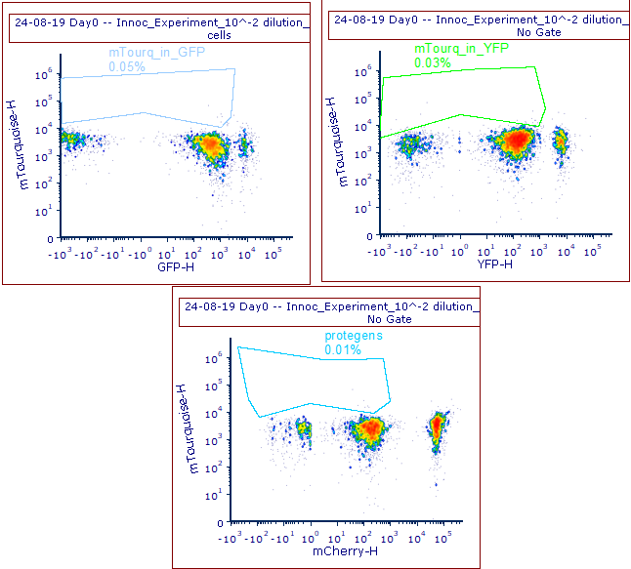
Figure S2 Panel C) Events from the cells gate are assigned to P. protegens species because they express only mTourquoise, as measured in mTourquoise height (mTourquoise-H, y-axis of all plots). First, GFP events are excluded using a polygon gate in GFP height (GFP-H), then YFP events are excluded using a polygon gate in YFP height (YFP-H), and finally mCherry events are excluded using a polygon gate in mCherry height (mCherry-H).
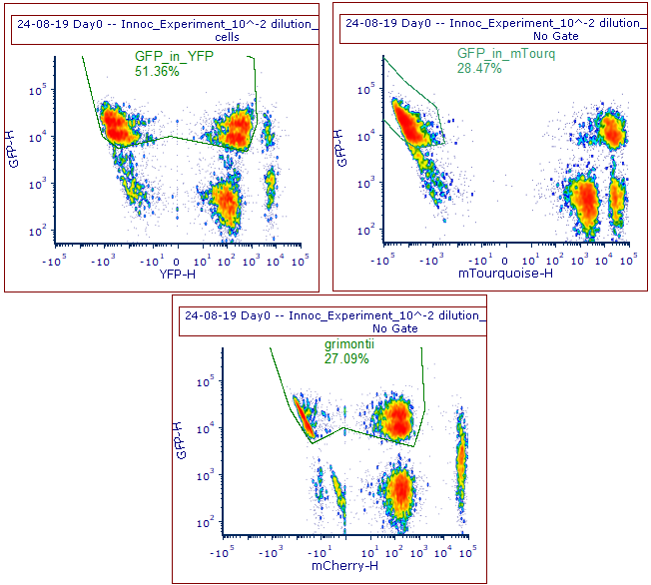
The same strategy for a sample without P. grimontii (GFP-negative):
D)
Gating strategy to identify the GFP-positive cell population (P. grimontii):
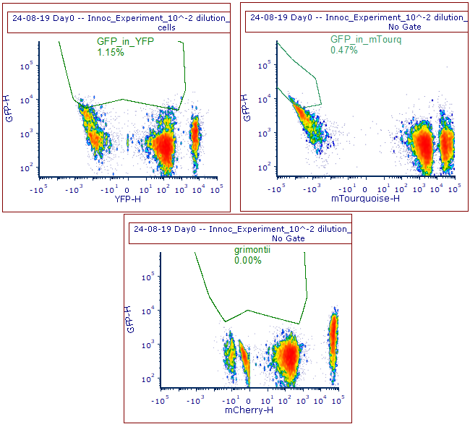
Figure S2 Panel D) Events from the cells gate are assigned to P. grimontii species because they express only GFP, as measured in GFP height (GFP-H, y-axis of all plots). First, YFP events are excluded using a polygon gate in YFP height (YFP-H), then mTourquoise events are excluded using a polygon gate in mTourquoise height (mTourquoise-H), and finally mCherry events are excluded using a polygon gate in mCherry height (mCherry-H).
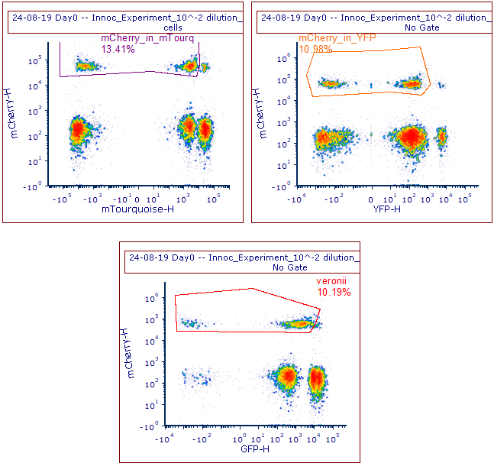
The same strategy for a sample without P. veronii (mCherry-negative):
E)
Gating strategy to identify the mCherry-positive cell population (P. veronii):
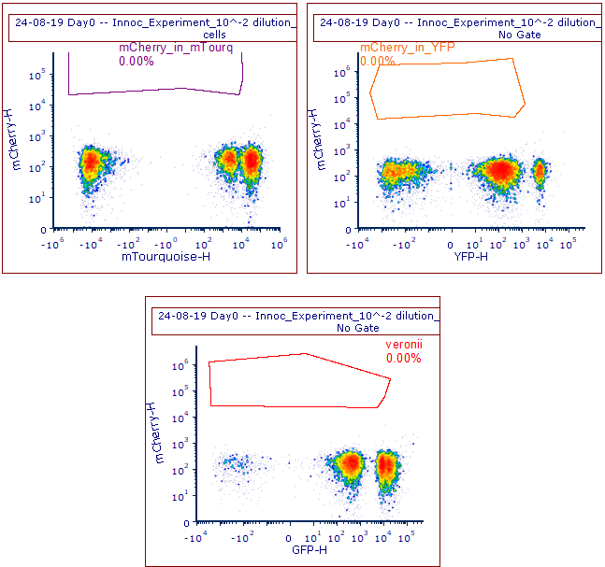
Figure S2 Panel E) Events from the cells gate are assigned to P. veronii species because they express only mCherry, as measured in mCherry height (mCherry-H, y-axis of all plots). First, mTourquoise events are excluded using a polygon gate in mTourquoise height (mTourquoise-H), then YFP events are excluded using a polygon gate in YFP height (YFP-H), and finally GFP events are excluded using a polygon gate in GFP height (GFP-H).
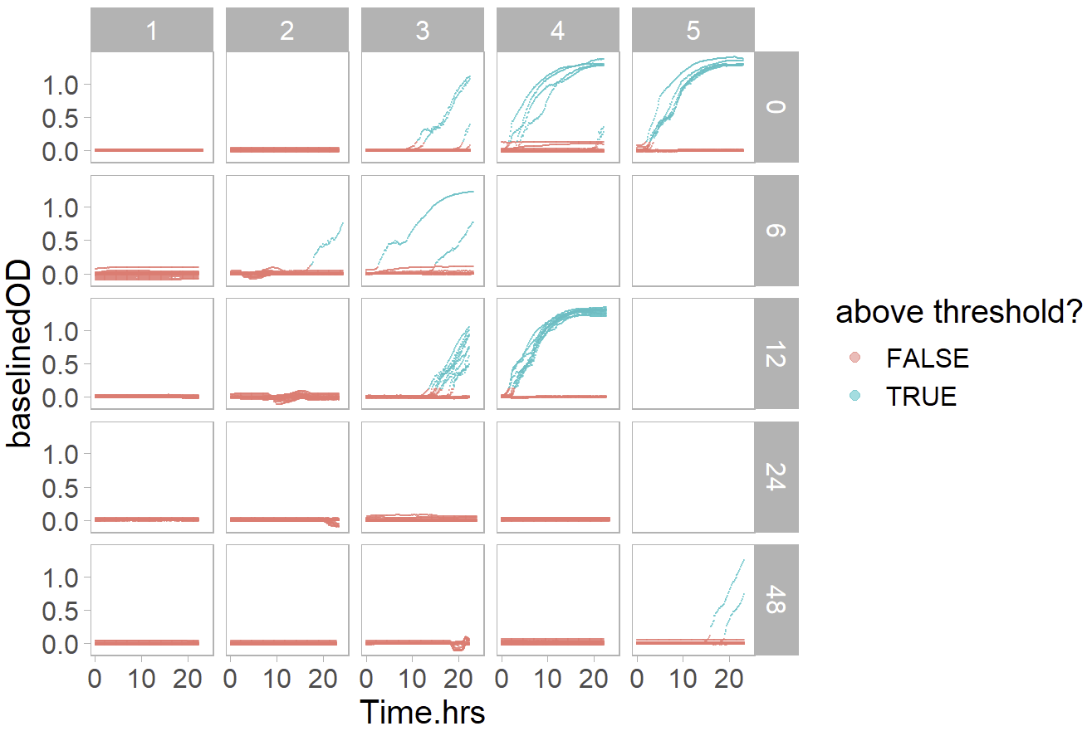
A)
B)
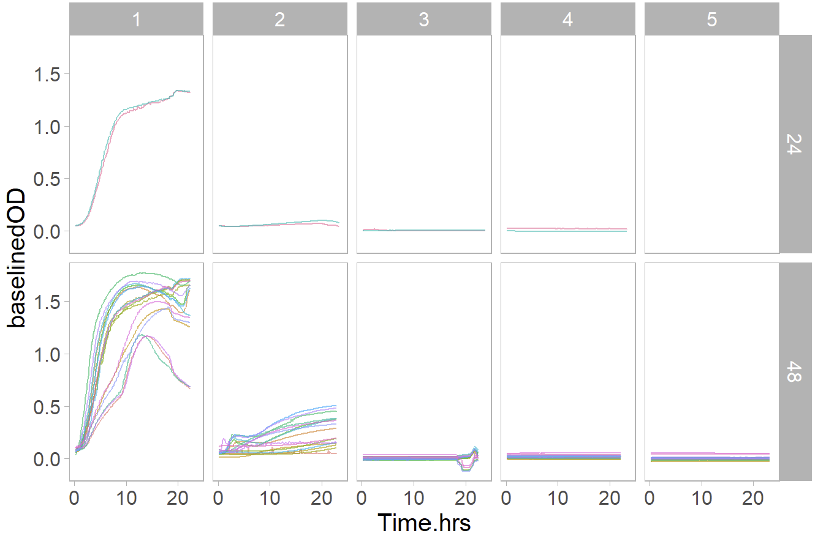
Figure S3. The same threshold was used for identifying contaminated well blanks (A) and wells that experienced community extinction (B). Different columns indicate the day of growth (Day 1 to 5) and different rows indicate the duration of the heat pulse treatment (0 indicates no heat control, 6 hrs heat, 12 hrs heat, 24 hrs heat, or 48 hrs heat) as illustrated in Figure 1 of the main text. There is no data for Days 4-5 of 6 hrs heat and Day 5 for 12 & 24 hrs heat (see main text). A) Shows the baseline-subtracted OD for all well blanks, including contaminated well blanks. Datapoints that are above the threshold are shown in blue and indicate contaminated blank wells. B) Shows the baseline-subtracted OD only for non-blank communities that went extinct. Datapoints are coloured by unique replicates.

Results for Experiment I
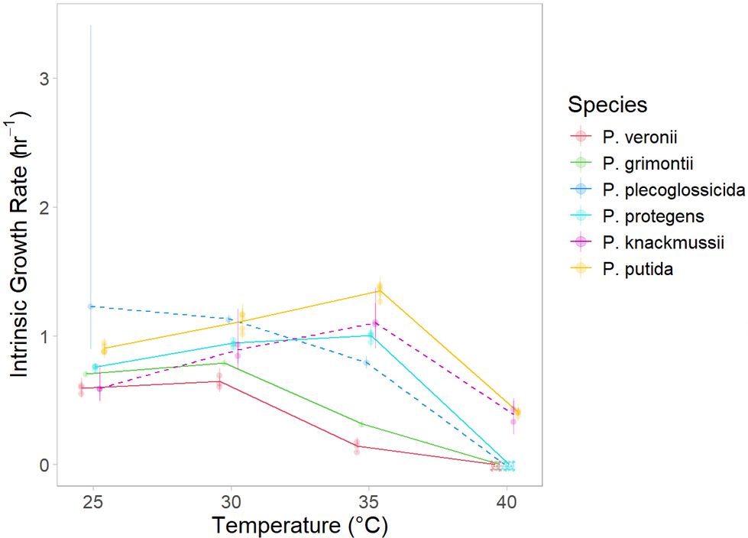
Figure S4. Net growth rate of stationary phase cultures as a function of temperature for 6 bacterial species in liquid media. Batch-culture intrinsic net growth rates (points) ± bootstrapped 95% confidence intervals (error bars) are shown for each strain inoculated from stationary phase. Temperatures without consistent growth after 48hrs are shown as skulls. Lines connect species averages, with solid lines indicating species with consistent rank across temperatures (used in Experiment II) and dashed lines indicating species that change rank across temperatures.
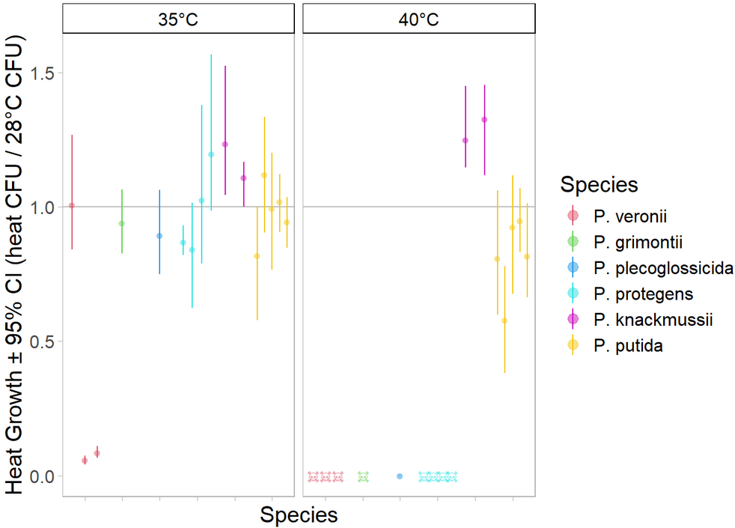
Figure S5. Relative growth of stationary phase cultures as a function of temperature for 6 bacterial species in solid media. CFUs at stress temperature as a fraction of CFUs at 28°C (dots) ± bootstrapped 95% confidence intervals (error bars) are shown for each strain inoculated from early exponential phase. Temperatures without any growth after 7 days are shown as skulls.

a)
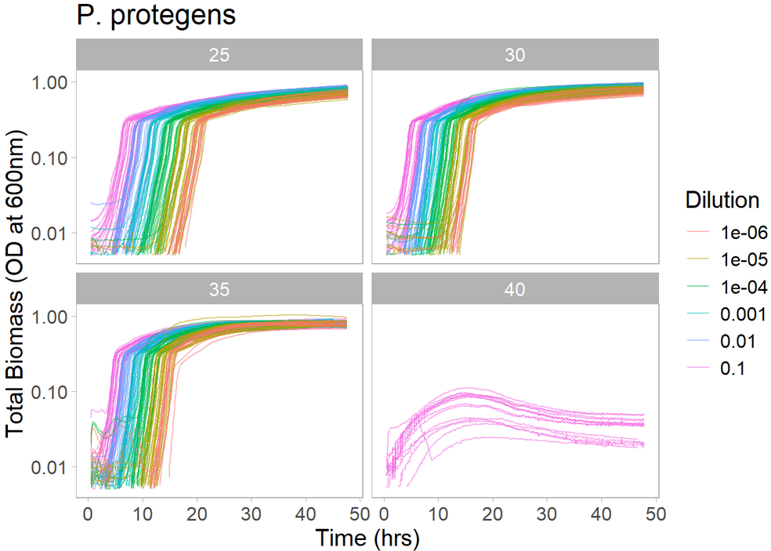
b)  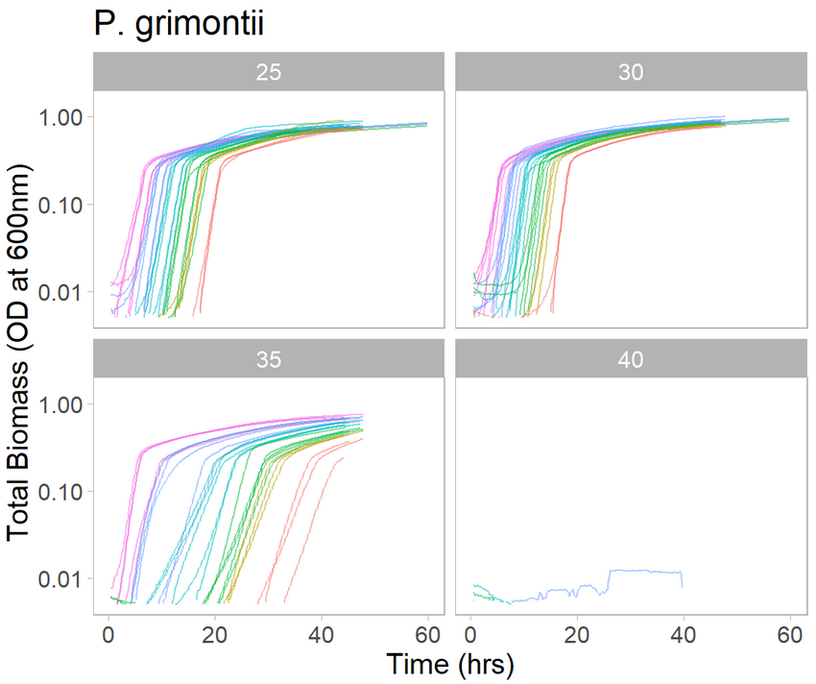 | c)  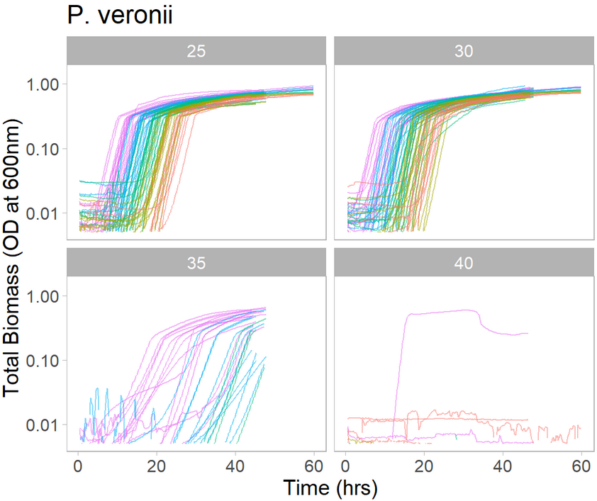

Figure S6. P. protegens (a) exhibits density-dependence during growth at extreme heat, but other species that are also sensitive to extreme heat, P. grimontii (b) and P. veronii (c), do not show density-dependent growth. Each panel shows the log of the OD (y-axis) over time (x-axis) for batch cultures inoculated, from both early exponential and stationary phase, at different starting dilutions (colours) that were incubated at different temperatures (facets). The most concentrated P. protegens cultures grew at about the same rate in the first five hours of growth at 40°C as when those was incubated at lower temperatures. However, there was a complete absence of growth at 40°C for all other starting concentrations.

a)  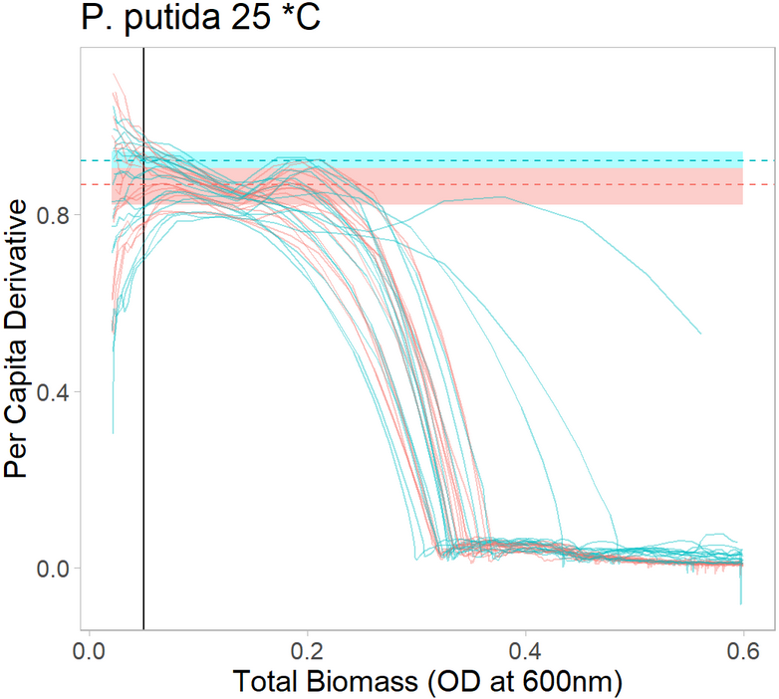 | b)  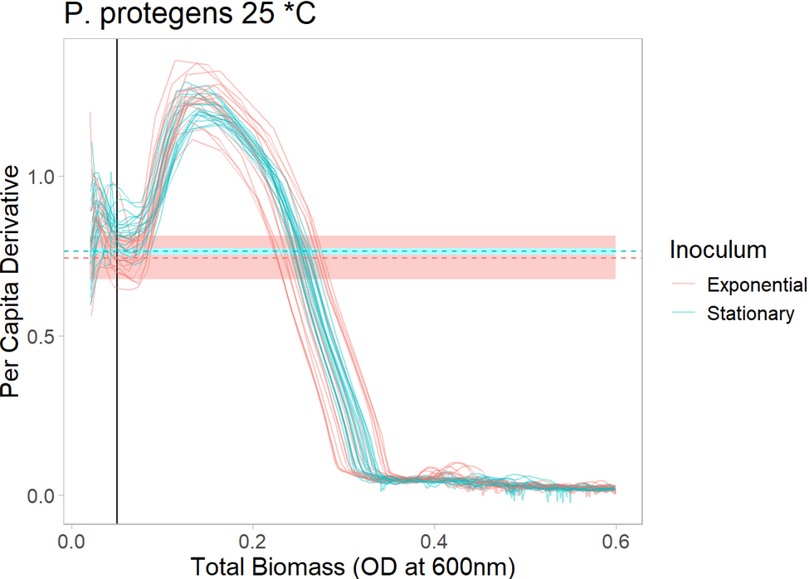
c)  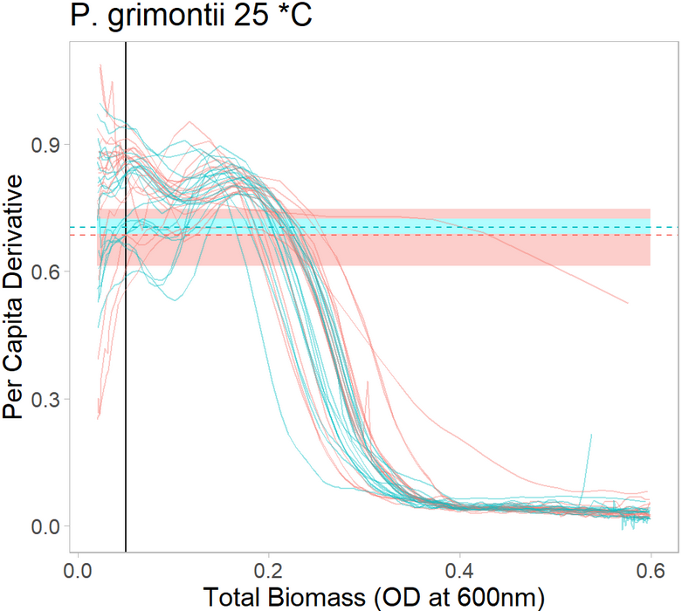 | d)  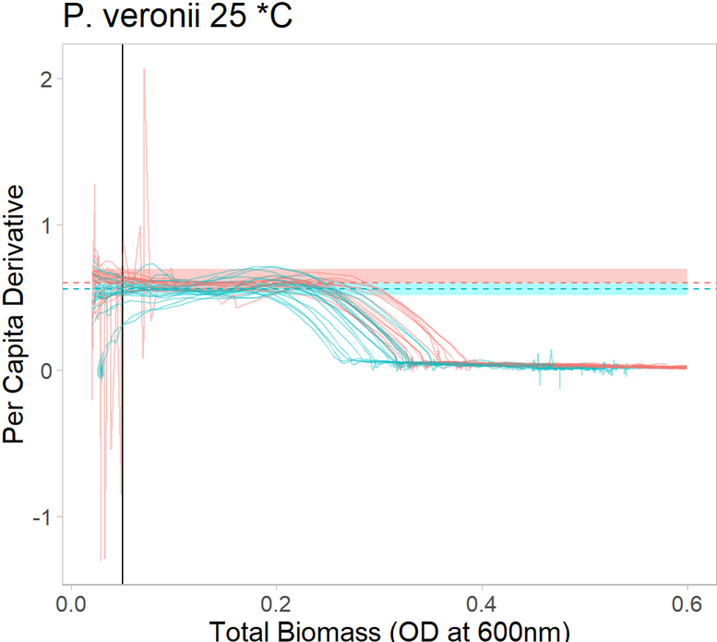
Figure S7. P. protegens (b) exhibits a consistent and strong density-dependence of growth rate at 25°C, as compared to other species (a, c, d). Each panel shows the per capita derivative of OD (y-axis) as a function of OD (x-axis) at 25°C for batch cultures inoculated at different starting dilutions from either early exponential (red) or stationary (blue) phase. The horizontal dashed lines show the mean of the intrinsic growth rate, coloured by exponential or stationary phase estimate, and the ribbons show the corresponding 95% confidence intervals. The black vertical line shows the threshold of detection that was used to estimate the intrinsic growth rate. By convention, the intrinsic growth rate (µ) is defined as the growth rate in the absence of density-dependent effects. For all species, the intrinsic growth rate estimates are in good agreement with the per capita derivatives at low density (i.e., near the black line). b) P. protegens cultures show a consistent ~50% increase in the per capita derivative of OD at intermediate OD (~0.15) as compared to low OD. This could suggest that P. protegens cells can facilitate each other’s growth more than other species.

Table S2. Non-parametric tests of whether intrinsic growth rate rank at ambient temperatures is correlated with that at extreme heat (Spearman’s rank correlation).
Correlation of species rank at 25°C with that at 40°C
rho = -0.34 | S = 46.8 | p-value = 0.51
Correlation of species rank at 30°C with that at 40°C
rho = 0.30 | S = 24.4 | p-value = 0.56

Table S3. Parametric tests of whether intrinsic growth rate at ambient temperatures is correlated with that at extreme heat (linear mixed effects model).
lm( intrinsic growth rate at 40°C ~ intrinsic growth rate at 25°C + (1 | Species) )
Efron R² = 0.962
 | Estimate | SE | p-value
Fixed effects
Intercept | 0.084 | 0.13 | 0.52 (NS)
Growth at 25°C | 0.068 | 0.14 | 0.63 (NS)
Random effect
Species (intercept) | 0.037 | 0.19
lm( intrinsic growth rate at 40°C ~ intrinsic growth rate at 30°C + (1 | Species) )
Efron R² = 0.962
 | Estimate | SE | p-value
Fixed effects
Intercept | 0.21 | 0.20 | 0.28 (NS)
Growth at 30°C | -0.086 | 0.20 | 0.67 (NS)
Random effect
Species (intercept) | 0.038 | 0.19

Table S4. Parametric test of whether intrinsic growth rate at ambient temperatures is correlated with the relative growth by CFU (linear mixed effects model).
Bonferroni-corrected ɑ = 0.025
lm( relative growth by CFU at 40°C ~ intrinsic growth rate at 25°C + (1 | Species) )
Efron R² = 0.81
 | Estimate | SE | p-value
Fixed effects
Intercept | 0.26 | 0.49 | 0.59 (NS)
Growth at 25°C | 0.034 | 0.60 | 0.96 (NS)
Random effect
Species (intercept) | 0.15 | 0.38
lm( relative growth by CFU at 40°C ~ intrinsic growth rate at 30°C + (1 | Species) )
Efron R² = 0.83
 | Estimate | SE | p-value
Fixed effects
Intercept | -0.98 | 0.66 | 0.14 (NS)
Growth at 30°C | 1.4 | 0.70 | 0.048 (NS)
Random effect
Species (intercept) | 0.13 | 0.36

Results for Experiment II
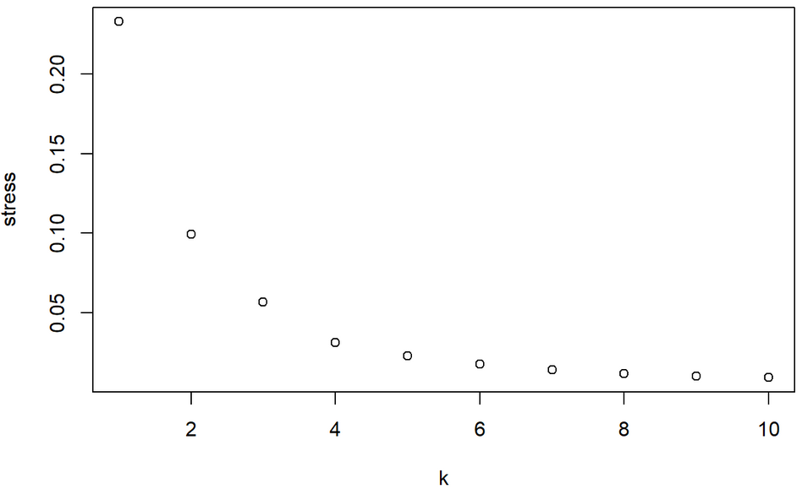
Figure S8. Scree plot of NMDS ordination for all communities over time on the resistance, early recovery, and late recovery days. Three dimensions were used for the analysis as the this is dimensionality is readily interpretable and the decrease in stress plateaus off around k=3.

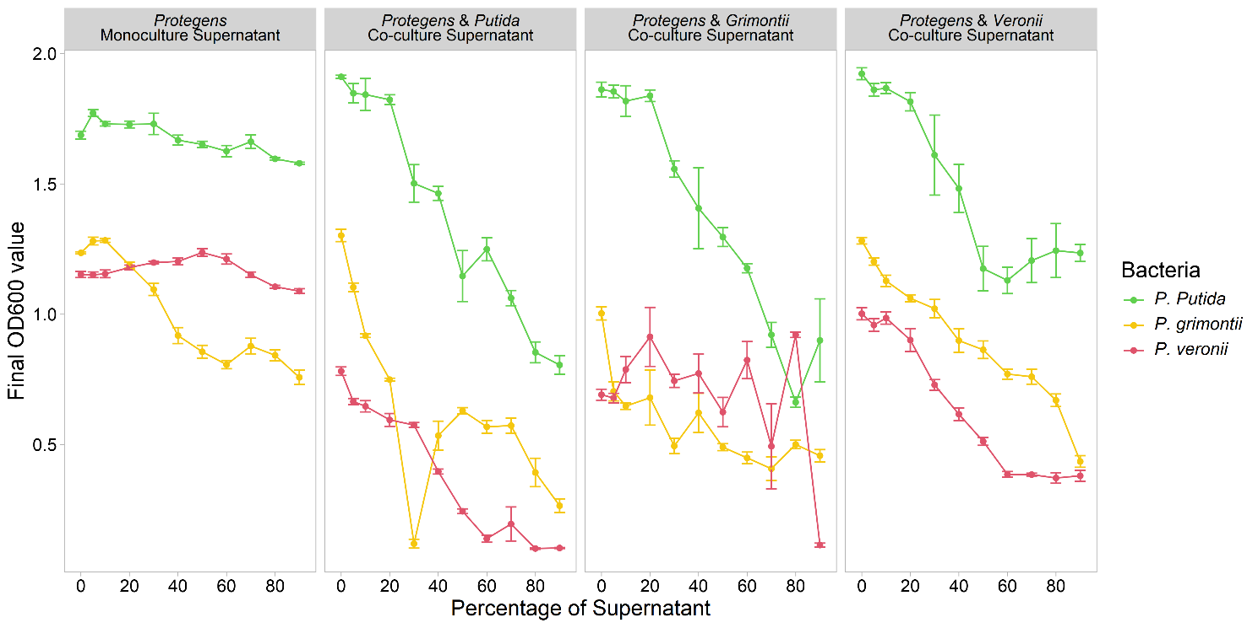
Figure S9. Average OD values for three of the focal species after 12 hours of growth versus percentage of media that is supernatant (compared to fresh 50% LB). This figure is the same style and is part of the motivation for Figure 3C. Here we compare the growth of these bacterial species when subjected to P. protegens supernatant when P. protegens is grown alone versus when P. protegens is grown with another species.
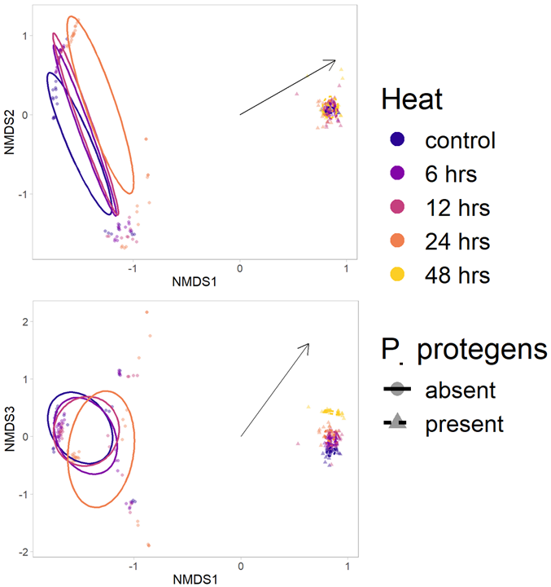
Figure S10. NMDS ordination for the data excluding the communities without P. protegens that were exposed to 48h heat pulse duration. The figure style is the same as Figure 3A from the main text except for the thin black arrows. The arrows show the direction of the environmental gradient of heat pulse duration (which is statistically significant, p<0.001).

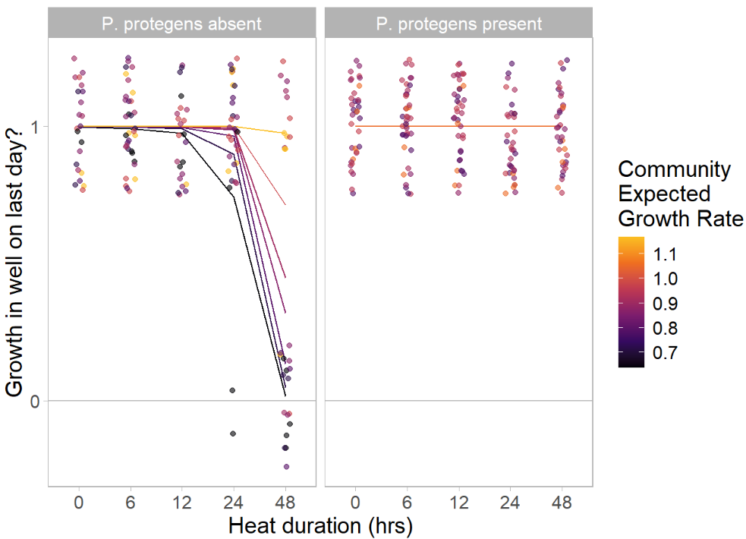
Figure S11. Logistic regression found three risk factors for community extinction: the duration of the heat pulse, the absence of P. protegens from the community, and slow community expected growth rate. Points show the observed data and lines show the logistic model predictions. Heat duration was treated as a numeric variable in the model although it is shown here on the x-axis as a categorical variable. The y-axis is binary and indicates whether growth was observed in the well two days after the end of the heat pulse (i.e., the final day of the experiment). Colours show the community expected growth rates, and the facets show communities without (left) and with (right) P. protegens. Multiple identical model predictions are stacked on top of one another in the right facet.

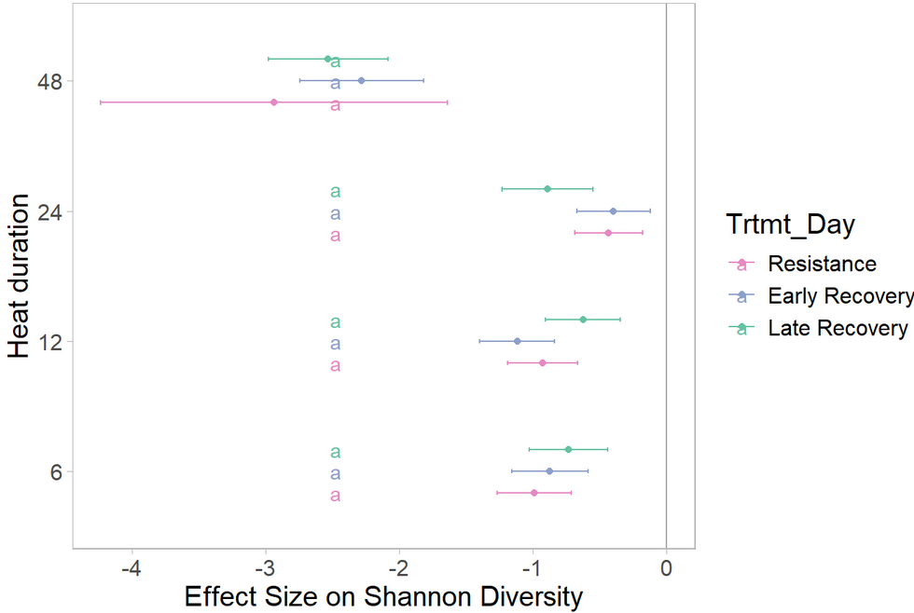
Figure S12. Forest plot of the effect sizes on Shannon diversity for the complete data (i.e., including communities that went extinct). The figure style is the same as Figure 4A from the main text. The colours indicate different treatment days and the letters indicate treatment days within the same heat pulse duration that are statistically indistinguishable.

Table S5. Pairwise t-tests between heat pulse durations on the effect sizes of Shannon diversity for the complete data (i.e., including communities that went extinct).
Bonferroni-corrected ɑ = 0.001
Treatment  Day | 1st Heat Pulse Duration | Compared to 2nd Heat Pulse Duration | t-statistic | df | p-value | Adjusted  p-value
Resistance | 6 hrs | 12 hrs | -1.17 | 24.2 | 0.253 |  | 1.00 | NS
 |  | 24 hrs | -10.3 | 23.2 | p < ${10}^{-9}$ |  | p < ${10}^{-6}$ | *
 |  | 48 hrs | 9.79 | 11.3 | p < ${10}^{-6}$ |  | p < ${10}^{-4}$ | *
 | 12 hrs | 24 hrs | -9.25 | 22.5 | p < ${10}^{-6}$ |  | p < ${10}^{-6}$ | *
 |  | 48 hrs | 10.1 | 11.3 | p < ${10}^{-6}$ |  | p < ${10}^{-4}$ | *
 | 24 hrs | 48 hrs | 12.6 | 11.3 | p < ${10}^{-6}$ |  | p < ${10}^{-6}$ | *
Early Recovery | 6 hrs | 12 hrs | 4.32 | 24.2 | p < ${10}^{-3}$ |  | 0.00418 | NS
 |  | 24 hrs | -8.38 | 23.0 | p < ${10}^{-6}$ |  | p < ${10}^{-6}$ | *
 |  | 48 hrs | 17.5 | 16.8 | p < ${10}^{-9}$ |  | p < ${10}^{-9}$ | *
 | 12 hrs | 24 hrs | -12.6 | 22.4 | p < ${10}^{-9}$ |  | p < ${10}^{-9}$ | *
 |  | 48 hrs | 14.5 | 16.9 | p < ${10}^{-9}$ |  | p < ${10}^{-6}$ | *
 | 24 hrs | 48 hrs | 23.3 | 17.0 | p < ${10}^{-12}$ |  | p < ${10}^{-12}$ | *
Late Recovery | 6 hrs | 12 hrs | -1.93 | 24.2 | 0.0655 |  | 1.00 | NS
 |  | 24 hrs | 2.37 | 21.5 | 0.0274 |  | 0.493 | NS
 |  | 48 hrs | 22.8 | 17.7 | p < ${10}^{-12}$ |  | p < ${10}^{-12}$ | *
 | 12 hrs | 24 hrs | 4.10 | 20.9 | p < ${10}^{-3}$ |  | 0.00932 | NS
 |  | 48 hrs | 24.4 | 17.3 | p < ${10}^{-12}$ |  | p < ${10}^{-12}$ | *
 | 24 hrs | 48 hrs | 19.5 | 19.6 | p < ${10}^{-12}$ |  | p < ${10}^{-12}$ | *

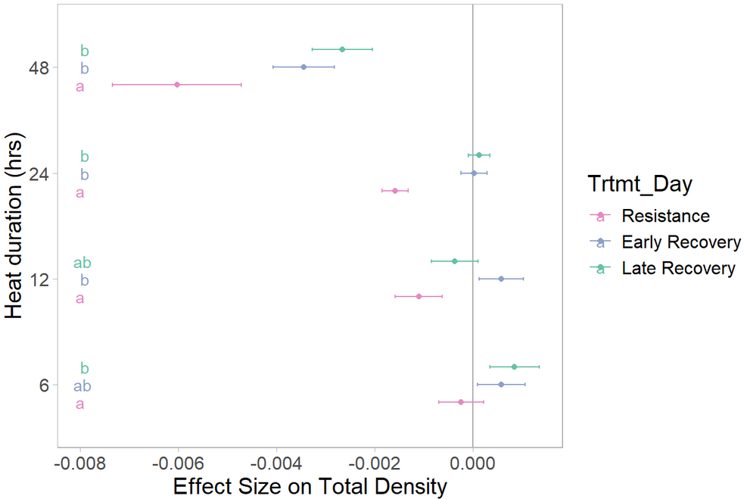
Figure S13. Forest plot of the effect sizes on productivity for the complete data (i.e., including communities that were never able to recover because they went extinct). The figure style is the same as Figure 4B from the main text. The colours indicate different treatment days and the letters indicate groups of treatment days within the same heat pulse duration that are statistically indistinguishable.

Table S6. Pairwise t-tests between heat pulse durations on the effect sizes of total productivity for the complete data (i.e., including communities that went extinct).
Bonferroni-corrected ɑ = 0.001
Treatment  Day | 1st Heat Pulse Duration | Compared to 2nd Heat Pulse Duration | t-statistic | df | p-value | Adjusted  p-value
Resistance | 6 hrs | 12 hrs | 10.5 | 30.8 | p < ${10}^{-9}$ |  | p < ${10}^{-9}$ | *
 |  | 24 hrs | 21.2 | 28.5 | p < ${10}^{-18}$ |  | p < ${10}^{-15}$ | *
 |  | 48 hrs | 32.9 | 18.1 | p < ${10}^{-15}$ |  | p < ${10}^{-15}$ | *
 | 12 hrs | 24 hrs | 6.86 | 22.6 | p < ${10}^{-6}$ |  | p < ${10}^{-4}$ | *
 |  | 48 hrs | 27.6 | 19.0 | p < ${10}^{-15}$ |  | p < ${10}^{-12}$ | *
 | 24 hrs | 48 hrs | 26.1 | 16.2 | p < ${10}^{-12}$ |  | p < ${10}^{-12}$ | *
Early Recovery | 6 hrs | 12 hrs | -0.0725 | 32.0 | 0.943 |  | 1.00 | NS
 |  | 24 hrs | 8.27 | 27.6 | p < ${10}^{-6}$ |  | p < ${10}^{-6}$ | *
 |  | 48 hrs | 40.9 | 28.9 | p < ${10}^{-18}$ |  | p < ${10}^{-18}$ | *
 | 12 hrs | 24 hrs | 8.34 | 23.6 | p < ${10}^{-6}$ |  | p < ${10}^{-6}$ | *
 |  | 48 hrs | 40.9 | 27.3 | p < ${10}^{-18}$ |  | p < ${10}^{-18}$ | *
 | 24 hrs | 48 hrs | 40.3 | 20.1 | p < ${10}^{-18}$ |  | p < ${10}^{-18}$ | *
Late Recovery | 6 hrs | 12 hrs | 14.2 | 31.9 | p < ${10}^{-12}$ |  | p < ${10}^{-12}$ | *
 |  | 24 hrs | 10.9 | 24.2 | p < ${10}^{-9}$ |  | p < ${10}^{-6}$ | *
 |  | 48 hrs | 35.6 | 29.3 | p < ${10}^{-18}$ |  | p < ${10}^{-18}$ | *
 | 12 hrs | 24 hrs | -7.44 | 20.3 | p < ${10}^{-6}$ |  | p < ${10}^{-4}$ | *
 |  | 48 hrs | 23.0 | 28.3 | p < ${10}^{-18}$ |  | p < ${10}^{-18}$ | *
 | 24 hrs | 48 hrs | 33.8 | 18.6 | p < ${10}^{-15}$ |  | p < ${10}^{-15}$ | *

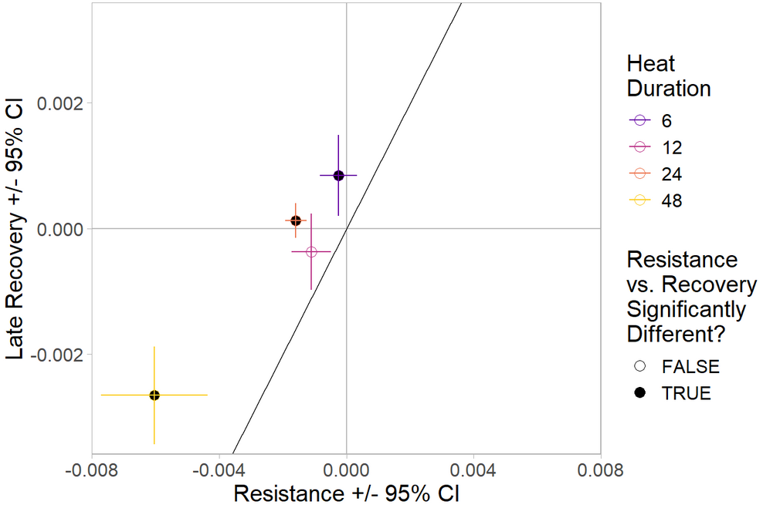
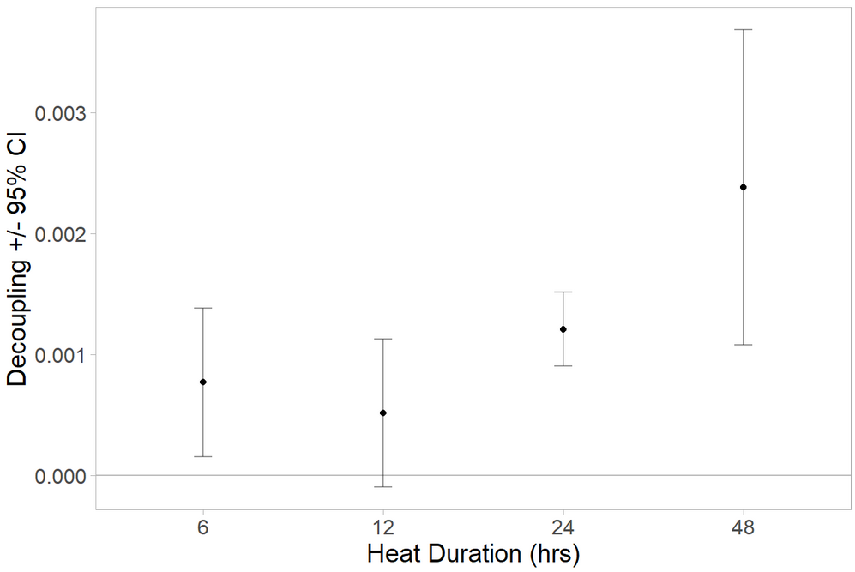
Figure S14. Decoupling plot of the effect sizes on productivity for the completely data (i.e., including communities that went extinct). The figure style is the same as Figure 5 from the main text.

