**Title (max. 150 characters):** Long exposure to extreme heat magnifies the decoupling between bacterial resistance and recovery

**Abstract (max. 200 words)**

Climate change is expected to prolong the duration of extreme heat events. It is unknown how these longer events will affect the stability of communities, and whether the findings from shorter events can predict the impacts of longer events. We used a resistance-recovery experimental framework to understand how the duration of a heat event alters the dynamics of microbial communities. By screening species’ thermal performance curves, we selected four *Pseudomonas* species with different growth rates that retain the same rank order during heat. The communities were inoculated in all 15 possible species combinations, exposed to a single heat pulse of variable duration (0.25, 0.5, one, or two days), then allowed to recover for a fixed two-day duration. We hypothesized that the fastest growing species (*P. putida*) would dominate the communities exposed to the longer heat pulses, as it is also the most heat-resistant. Surprisingly, an intermediate grower (*P. protegens*) outcompeted the other species, regardless of heat, because it is the most effective killer. Across all communities we observed a threshold effect of heat pulse duration: species diversity significantly decreased during and after the 0.25, 0.5, and one- day durations, but these metrics, as well as total abundance, declined precipitously for the longest heat duration.

This effect is explained by an increased risk of species extinction during the two-day heat pulse. Even among communities that managed to survive, the two-day pulse showed a precipitous decoupling between the effect size of total abundance during resistance as compared to recovery. Our research shows that, while short and intermediate heat pulses predictably shape communities, long heat pulses lead to less predictable outcomes.

**Introduction (total article length, including title page, abstract, figures, legends, tables, references, etc. is 10 000 words)**

Climate change is increasing the frequency, intensity, and duration of heat events (Tripathy et al., 2023). Prolonged heat events are likely to exterminate species, destabilize communities, and undermine ecosystem services. To reduce the impacts on human society, we need a better understanding of how the duration of a heat event alters community dynamics. Which species will thrive under longer duration heat events (Pacifici et al., 2015), and which communities are most vulnerable?

* The short timescale and high throughput of microbial systems make them great for testing general ecological principles. Like plant literature (refs?), previous microbial studies suggest that growth rate is a key trait for predicting individual species resistances to extreme environments (Gilbert et al. 1990). Growth rate can also predict microbial community dynamics at warmer temperatures (Gore lab). There are basically no studies that look at effect of extreme heat duration.
* Introduce resistance-recovery experimental framework from Thakur et al. 2022. It can be used to look at community stability to environmental perturbation.
* Introduce the concept of decoupling. Reductionist approach might expect that if we have a stable system, the rate of response during a perturbation could somehow tell us something about whether & how fast the system will return to equilibrium after the perturbation is over. Decoupling is troubling result for this way of thinking because it means that systems are more complex and we cannot predict stuff. (cite refs)
* Brief summary of methods and results.

**Methods**

**Bacterial strains & species identification**

**Thermal performance traits**

**Communities’ resistance and recovery from extreme heat**

* Inoculated all 15 possible communities of the 4 species in a serial-transfer batch culture system starting from equal frequencies and initial inoculum size sufficient that the communities would reach their carrying capacity on the first day. Transferred 5% of the culture daily and used the remaining culture to get cell counts for each species using flow cytometry.

**Figure 1**

**Species abundance estimates by flow cytometry**

**Assaying diffusible species interactions**

**Statistical analyses**

**Results**

**Growth rate at warm temperatures does not predict(?) extreme heat resistance**

* We screened the growth rate of 6 soil *Pseudomonas* species (in total 16 genotypes) at 4 temperatures in order to test whether slow growers would be more heat resistant. We found that species change in their rank order across different temperatures; i.e, it’s not possible to classify them as fast or slow growers. We found little correlation between growth rate at warm temperatures and species survival at extreme temperatures.

**Figure 2**

* We selected 4 species to use in our experiment. The species were selected such that they do not change in their rank order between temperatures. We wahypothesized that the fastest grower, *P. putida*, would dominate all communities where it was inoculated, especially during longer heat pulses.

***P. protegens* is an effective killer that dominates the communities where it was inoculated**

* *P. protegens* was found to dominate all the communities where it was inoculated, regardless of heat. This is clear from the NMDS ordination (a) of all communities on last day of heat, first day of recovery, and second day of recovery: no overlap between communities where *P. protegens* was present versus those where it was absent.
  + NMDS clusters show significant interaction between presence of P. protegens and heat pulse duration by PERMANOVA (F=44.6, p < 0.001). Unfortunately, the PERMANOVA results may not be trustworthy as there is significant heterogeneity in group variances (beta dispersion test,  
    p < 0.001). Non-parametric test ANOSIM showed significant effect of P. protegens presence and heat pulse duration (R=0.621, p < 0.001).
* The trend of *P. protegens* dominating the communities is also clear from data of community richness over time (b).
* This strong competitive effect led to loss of replicates when contamination events led to community invasion by P. protegens.
* C) Follow-up colony experiments show that *P. protegens* expresses diffusible metabolites at 30*C that completely inhibit growth of *P. putida* and *P. grimontii*, and slightly inhibit growth of the slowest grower, *P. veronii*.

**Figure 3**

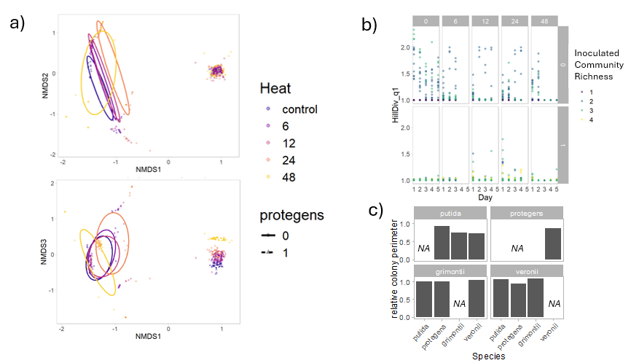

**Long duration heat pulse magnifies the decoupling between resistance and recovery**

* From the NMDS we can also see that there is a continuous trend of heat duration pushing the clusters upwards, except there is a discontinuous effect for the longest heat duration. (maybe I can report the non-significant gradient effect?)
* The threshold effect that we can see on the NMDS also shows up in other metrics like the effect size on biodiversity (a) and the effect size on total abundance (b)

**Figure 4**

* This effect is *in part* due to extinction. There is a significant effect of heat duration on the probability of extinction (effect size of heat duration= -0.1445, SE=0.0310, p<0.00001).
* However, this effect is *not entirely* due to extinction because we can still see the discontinuous effect when we run the NMDS, diversity, and total abundance models again this time removing the extinct replicates (figures in supplement):

* Finally, we can see the threshold effect quite clearly when we compare the effect size of total abundance during resistance to that during recovery. Shorter heat events show similar responses during resistance as recovery, with a slight decoupling for intermediate heat duration. Long heat duration shows a very marked decoupling.

**Figure 5**

**Discussion**

How do we interpret this threshold effect?

