Supplement for: Long exposure to extreme heat magnifies the decoupling between bacterial resistance and recovery

Authors: Ana-Hermina Ghenu, Anjaney J. Pandey, Zachary M. Bailey, David R. Johnson, and Madhav P. Thakur

# Materials & Methods

**Table S1: List of bacterial strains used in the experiment.**

|  |  |  |  |  |  |
| --- | --- | --- | --- | --- | --- |
| ID | Strain identification | Isolated from… | Fluorescence | Lab of Origin & Strain ID in their Collection | Ref. |
| BSC001 | *Pseudomonas putida F1* | creek | sYFP | Jan van der Meer (UniL, CH) 7609 |  |
| BSC002 | *Pseudomonas putida KT2440* | ? | mScarlet | Jan van der Meer (UniL, CH) 7598 |  |
| BSC003 | *Pseudomonas putida uwc 2* | soil | mTagBFP2 | Jan van der Meer (UniL, CH) 7597 |  |
| BSC004 | *Pseudomonas veronii* | ? | mTagBFP2 | Jan van der Meer (UniL, CH) 7591 |  |
| BSC005 | *Pseudomonas veronii* | ? | mScarlet | Jan van der Meer (UniL, CH) 7592 |  |
| BSC006 | *Pseudomonas veronii* | ? | mCherry | Jan van der Meer (UniL, CH) 3434 |  |
| BSC007 | *Pseudomonas knackmussii B13* | soil | mCherry | Jan van der Meer (UniL, CH) 2586 |  |
| BSC008 | *Pseudomonas knackmussii B14* | sewage | eGFP | Jan van der Meer (UniL, CH) 1369 |  |
| BSC009 | *Pseudomonas plecoglossicida* | soil | *<NA>* | Antonis Chatzinotas (UFZ, DE) B405 |  |
| BSC010 | *Pseudomonas putida mt-2 KT2440* | soil | *<NA>* | Antonis Chatzinotas (UFZ, DE) B410 |  |
| BSC015 | *Pseudomonas putida KT2440* | ? | GFP | Pilar Junier (UniNe, CH) |  |
| BSC019 | *Pseudomonas grimontii* | soil | <*NA>* | Jan van der Meer (UniL, CH) 906 (SV16) |  |
| CK101 | *Pseudomonas protegens Pf5* | soil | mTourquoise2 | Christof Keel (UniL, CH) Pf5-*mtou* |  |
| CK102 | *Pseudomonas protegens Pf5* | soil | mCherry | Christof Keel (UniL, CH) Pf5-*mche* |  |
| CK103 | *Pseudomonas protegens CHAO* | soil | sGFP2 | Christof Keel (UniL, CH) CHA0-*gfp2* |  |
| CK104 | *Pseudomonas protegens CHAO* | soil | mCherry | Christof Keel (UniL, CH) CHA0-*mche* |  |
| BSC028 | *Pseudomonas grimontii* | *(see above)* | sGFP2 | **BSC019** |  |

**Figure S1. The arrangement of the 15 communities (n=5) on the 96-well microplates during Experiment II.** Communities are arranged in five blocks across the microplate such that two of the blocks are all edge wells and the other three blocks are all non-edge wells. Coloured circles represent communities inoculated with the species indicated in the legend. Media blanks are shown with crosses. Figure created with BioRender.

# Results for Experiment I

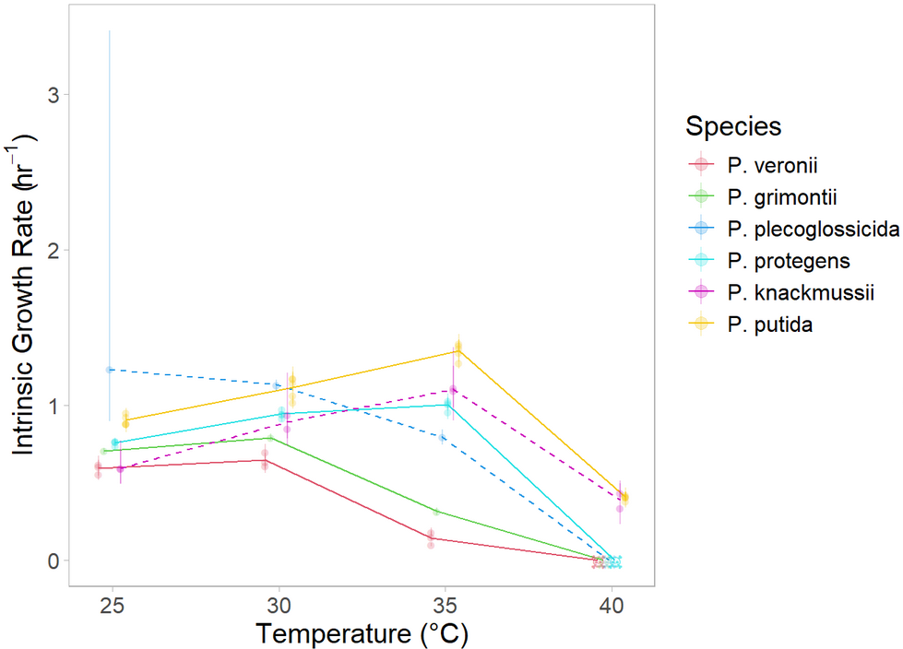

**Figure S2. Net growth rate of stationary phase cultures as a function of temperature for 6 bacterial species in liquid media.** Batch-culture intrinsic net growth rates (points) ± bootstrapped 95% confidence intervals (error bars) are shown for each strain inoculated from stationary phase. Temperatures without consistent growth after 48hrs are shown as skulls. Lines connect species averages, with solid lines indicating species with consistent rank across temperatures (used in Experiment II) and dashed lines indicating species that change rank across temperatures.

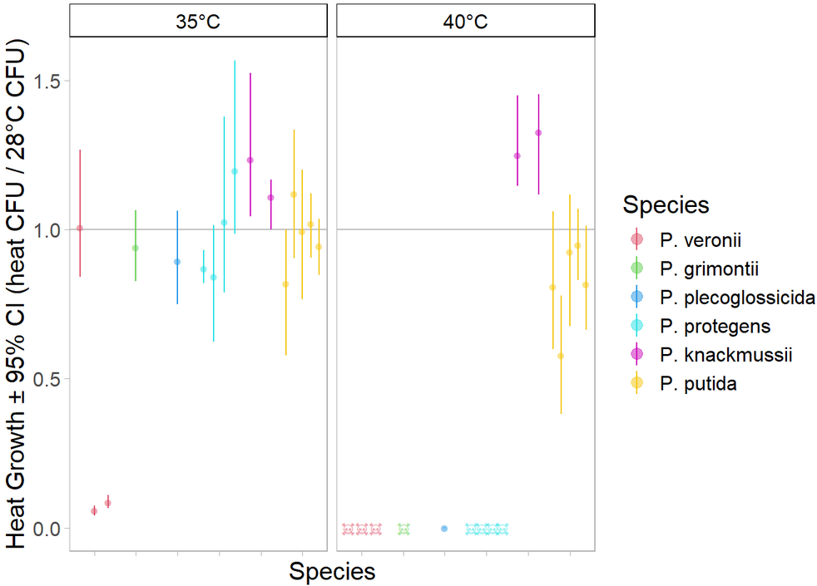

**Figure S3. Relative growth of stationary phase cultures as a function of temperature for 6 bacterial species in solid media.** CFUs at stress temperature as a fraction of CFUs at 28°C (dots) ± bootstrapped 95% confidence intervals (error bars) are shown for each strain inoculated from early exponential phase. Temperatures without any growth after 7 days are shown as skulls.

a)

|  |  |
| --- | --- |
| b) | c) |

**Figure S4. *P. protegens* (a) exhibits density-dependence during growth at extreme heat, but other species that are also sensitive to extreme heat, *P. grimontii* (b) and *P. veronii* (c), do not show density-dependent growth.** Each panel shows the log of the OD (y-axis) over time (x-axis) for batch cultures inoculated, from both early exponential and stationary phase, at different starting dilutions (colours) that were incubated at different temperatures (facets). The most concentrated *P. protegens* cultures grew at about the same rate in the first five hours of growth at 40°C as when those was incubated at lower temperatures. However, there was a complete absence of growth at 40°C for all other starting concentrations.

|  |  |
| --- | --- |
| a) | b) |
| c) | d) |

**Figure S5. *P. protegens* (b) exhibits a consistent and strong density-dependence of growth rate at 25°C, as compared to other species (a, c, d).** Each panel shows the per capita derivative of OD (y-axis) as a function of OD (x-axis) at 25°C for batch cultures inoculated at different starting dilutions from either early exponential (red) or stationary (blue) phase. The horizontal dashed lines show the mean of the intrinsic growth rate, coloured by exponential or stationary phase estimate, and the ribbons show the corresponding 95% confidence intervals. The black vertical line shows the threshold of detection that was used to estimate the intrinsic growth rate. By convention, the intrinsic growth rate (µ) is defined as the growth rate in the absence of density-dependent effects. For all species, the intrinsic growth rate estimates are in good agreement with the per capita derivatives at low density (i.e., near the black line). **b)** *P. protegens* cultures show a consistent ~50% increase in the per capita derivative of OD at intermediate OD (~0.15) as compared to low OD. This could suggest that *P. protegens* cells can facilitate each other’s growth more than other species.

**Table S2. Non-parametric tests of whether intrinsic growth rate rank at ambient temperatures is correlated with that at extreme heat (Spearman’s rank correlation).**

|  |  |  |
| --- | --- | --- |
| Correlation of species rank at 25°C with that at 40°C | | |
| rho = -0.34 | S = 46.8 | p-value = 0.51 |
| Correlation of species rank at 30°C with that at 40°C | | |
| rho = 0.30 | S = 24.4 | p-value = 0.56 |

**Table S3. Parametric tests of whether intrinsic growth rate at ambient temperatures is correlated with that at extreme heat (linear mixed effects model).**

|  |  |  |  |
| --- | --- | --- | --- |
| lm( intrinsic growth rate at 40°C ~ intrinsic growth rate at 25°C + (1 | Species) ) | | | |
| Efron R2 = 0.962 | | | |
|  | Estimate | SE | p-value |
| Fixed effects |  |  |  |
| Intercept | 0.084 | 0.13 | 0.52 (NS) |
| Growth at 25°C | 0.068 | 0.14 | 0.63 (NS) |
| Random effect |  |  |  |
| Species (intercept) | 0.037 | 0.19 |  |
|  |  |  |  |
| lm( intrinsic growth rate at 40°C ~ intrinsic growth rate at 30°C + (1 | Species) ) | | | |
| Efron R2 = 0.962 |  |  |  |
|  | Estimate | SE | p-value |
| Fixed effects |  |  |  |
| Intercept | 0.21 | 0.20 | 0.28 (NS) |
| Growth at 30°C | -0.086 | 0.20 | 0.67 (NS) |
| Random effect |  |  |  |
| Species (intercept) | 0.038 | 0.19 |  |

**Table S4. Parametric test of whether intrinsic growth rate at ambient temperatures is correlated with the relative growth by CFU (linear mixed effects model).**Bonferroni-corrected ɑ = 0.025

|  |  |  |  |
| --- | --- | --- | --- |
| lm( relative growth by CFU at 40°C ~ intrinsic growth rate at 25°C + (1 | Species) ) | | | |
| Efron R2 = 0.81 | | | |
|  | Estimate | SE | p-value |
| Fixed effects |  |  |  |
| Intercept | 0.26 | 0.49 | 0.59 (NS) |
| Growth at 25°C | 0.034 | 0.60 | 0.96 (NS) |
| Random effect |  |  |  |
| Species (intercept) | 0.15 | 0.38 |  |
|  |  |  |  |
| lm( relative growth by CFU at 40°C ~ intrinsic growth rate at 30°C + (1 | Species) ) | | | |
| Efron R2 = 0.83 |  |  |  |
|  | Estimate | SE | p-value |
| Fixed effects |  |  |  |
| Intercept | -0.98 | 0.66 | 0.14 (NS) |
| Growth at 30°C | 1.4 | 0.70 | 0.048 (NS) |
| Random effect |  |  |  |
| Species (intercept) | 0.13 | 0.36 |  |

# Results for Experiment II

**Figure S6. Scree plot of NMDS ordination for all communities over time on the resistance, early recovery, and late recovery days.** Three dimensions were used for the analysis as the this is dimensionality is readily interpretable and the decrease in stress plateaus off around k=3.