Experiment:6
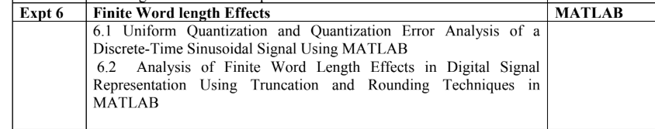
%% Expt 6: Finite Word Length Effects
fs = 1000;
t = 0:1/fs:1;
x = sin(2*pi*50*t);

% --- 6.1 Uniform Quantization and Error ---
L = 16;
xmax = max(abs(x));
q_step = (2*xmax)/L;

xq = q_step * round(x/q_step);
error = x - xq;

figure;
subplot(3,1,1); plot(t,x); title('6.1 Original Signal');
subplot(3,1,2); plot(t,xq); title('6.1 Quantized Signal');
subplot(3,1,3); plot(t,error); title('6.1 Quantization Error');

% --- 6.2 Truncation vs Rounding ---
x_rand = rand(1,20)*10;
x_trunc = fix(x_rand);
x_round = round(x_rand);

disp('--- Expt 6.2 Finite Word Length Effects ---');
disp('Original values:'), disp(x_rand);
disp('Truncated values:'), disp(x_trunc);
disp('Rounded values:'), disp(x_round);
output:
