**Prerequisites**

Install either Python or the Anacondas distribution of Python.

Install the Django with below commands:

* pip install django

For the Anacondas Python distribution, use the below commands:

* conda install django
* **Step 1:**

Navigate to any folder you want in order to create the django project, open the command prompt there and enter the following command:

django-admin startproject SampleProject

* **Step2:**

Navigate to the project folder and create a web app using the below command:

python manage.py startapp MyApp

* **Step 3:**

Open the settings.py file and add the below lines of code in the INSTALLED_APPS section:

'templateApp',

**Step 4:**

Open urls.py file and add the below lines of code:

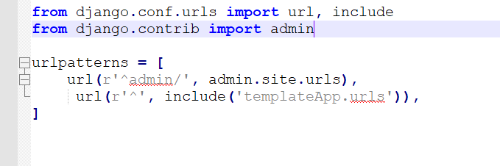

Note that we have added an import for include from django.conf.urls and added a url pattern for an empty route. When accessing the homepage, Django will look for more url definitions in the  app, so create a file called urls.py in app folder .

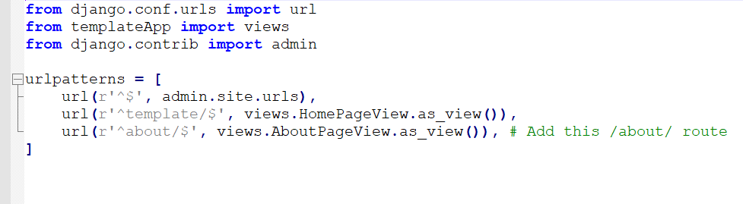

This code imports the views from the app and expects a view called HomePageView to be defined. Since we don't have one, open the views.py file in the app and write this code.

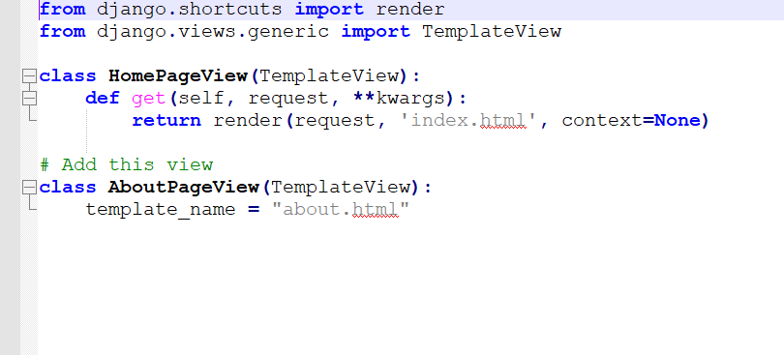

Now create a template folder and write the two html files inside that.

* about.html
* index.html

**Step5:**We can start the api with below commands in command prompt:

* python manage.py runserver