RoadSafe Delhi
Explainable Road Risk Mapping and Safety Intervention Prioritization Using Machine Learning
Pre-Submission Project Evaluation Report
Project Information | Details
Study Area | Delhi / National Capital Territory of Delhi
Course | CSE20232 — Machine Learning
Academic Level | B.Tech CSE, Semester 5
Project Stage | Pre-submission
Current Phase | Data audit, preprocessing, exploratory data analysis and spatial data preparation completed; classification modelling planned as the next stage.
Group No.- | 4
Student / Team | ANJANI KUMAR (240382);  Nakshtr Gupta (240545);  Kaavish Babbar (240499);  AMIT (240376);  ANUSHREE AGRAWAL (240392)
Faculty / Guide | Prof. Shraddha Arora
Submission Date | 29th September 2026

1. Problem Statement
Core Problem Formulation: Urban road traffic accidents are one of the biggest public safety and public health emergencies in metropolitan Delhi. However, traditional modelling attempts are usually based on predicting the exact point in time that a particular accident will occur. The individual collision events are mathematically rare occurrences, and they are extremely sparse in time, so predicting them at a point is a scientifically ill-posed problem and is of little value in transport planning practice.
Research Paradigm: RoadSafe Delhi does NOT do point occurrence prediction. This research, on the other hand, proposes a machine learning approach to a road-segment relative risk estimation and safety intervention prioritisation problem. The project main question is:
"Can machine learning integrate historical road-crash patterns with road-network, spatial, temporal, and environmental characteristics to identify high-risk road locations in Delhi and support prioritization for preventive road-safety assessment?"
Practical Utility: The analysis unit used is the Road Segment / Road Link. The models will estimate the risk of occurrence at the segment level and prioritize the level of risk into actionable corridors, directly supporting municipal engineers and traffic enforcement agencies to deploy preventive interventions (speed management, geometric realignment, lighting, and targeted enforcement) before future crashes.

2. Datasets and Multi-Source Architecture
Multi-Source Integration: To characterize road hazards comprehensively, the project integrates multi-source geospatial, infrastructure, meteorological, and incident data. All raw datasets are permanently maintained in an unedited, pristine state inside the Datasets/ directory.
Dataset Source | Format / Scale | Verified Volume | Role in Pipeline
Meteostat Ground Observations | Hourly CSV (.gz)  Station 42182 (Safdarjung) | 35,064 records  (2022–2025) | Primary ground-truth weather for temperature, humidity, precipitation, and fog identification.
NASA POWER Reanalysis | Hourly CSV  MERRA-2 Satellite Grid | 35,064 records  (2022–2025) | Secondary reanalysis source utilized for meteorological cross-validation and redundancy verification.
OpenStreetMap (OSM) Delhi | Vector Shapefile (.shp.zip)  Cartesian EPSG:32643 | 215,373 raw features  191,199 vehicular links | Primary road-network infrastructure defining road geometry, hierarchy, road attributes such as one-way/bridge/maxspeed where available, and segment lengths
ESA WorldCover 10m (2021) | GeoTIFF Raster (10m)  Tile N27E075 | 10m resolution  NCT Delhi coverage | High-resolution land-cover classification distinguishing urban fabric, tree canopy, cropland, and water.
SRTM Digital Elevation Model | HGT Elevation Tiles  N28E076 & N28E077 | 30m resolution  195m–315m MSL | Topographic elevation gradients and terrain slope computations across the study area.
Crash Data Provenance & Scope: A critical distinction is maintained regarding crash data provenance. Official Delhi government road accident data (represented by five aggregate UUID CSV files) provides macro-level totals (~7,000–8,000 crashes per year, ~2,000 annual fatalities) but lacks spatial coordinates. To develop the spatial matching and feature-engineering pipeline, a candidate third-party accident dataset (2,433 records in Delhi) was ingested as a supplementary benchmark. It is treated strictly as a candidate proof-of-concept pipeline dataset, fully subject to replacement when official FIR crash-level logs are released.

3. Data Audit and Integrity Checks
Audit Objectives: The data audit phase programmatically inspected every raw asset to determine true internal structure rather than trusting file naming conventions. Three crucial findings emerged from this audit:
- Resolution of Meteostat Multi-Year Records: The files 42182.csv.gz through 42182 (3).csv.gz were initially suspected to be redundant duplicate downloads. Detailed row-level inspection proved they are four distinct, consecutive single-year records covering 2022, 2023, 2024, and 2025. They were successfully concatenated into a contiguous 35,064-hour series.
- Proactive Data Leakage Quarantine: The candidate crash dataset contains an attribute named 'risk_score'. Detailed correlation analysis revealed a strong association with crash outcomes and casualties (r = 0.704), indicating it was derived post-hoc. Retaining it would introduce fatal data leakage; it was permanently quarantined.
- Cross-Validation of Weather Sources: Station observations from Safdarjung (WMO 42182) were cross-validated against MERRA-2 gridded satellite reanalysis, confirming high agreement while exposing localized surface-level fog capture.
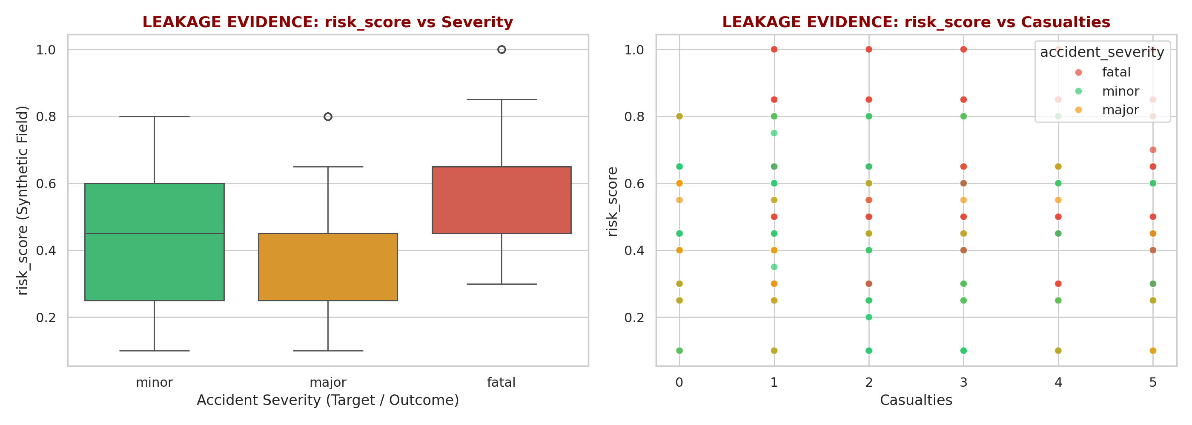
Figure 1: Empirical Evidence of Target Leakage in the Candidate 'risk_score' Feature
Observation: Boxplots and scatter plots show that risk_score is strongly associated with casualty counts and differs across minor, major, and fatal injury classes (r = 0.704)
Interpretation: The strong association suggests that risk_score may contain information derived from accident outcomes. It was therefore quarantined as a potential target-leakage variable.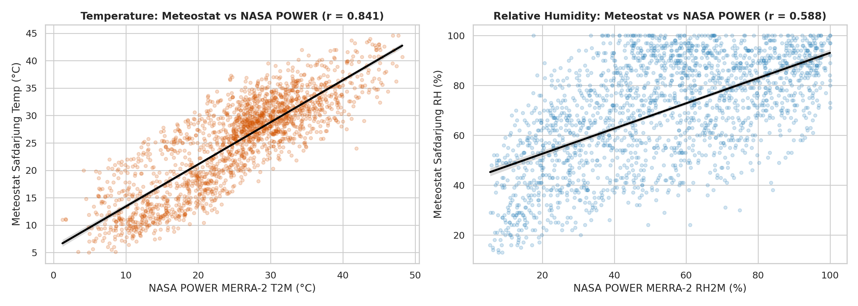
Figure 2: Meteorological Cross-Validation: Meteostat Ground Observations vs. NASA POWER Reanalysis
Observation: Scatter plots and linear regressions show strong temperature correlation (r = 0.841) and moderate relative humidity correlation (r = 0.588) between Safdarjung ground sensors and MERRA-2 satellite grid cells.
Interpretation: Ground-station observations accurately capture micro-scale surface cooling and localized winter fog that gridded satellite reanalysis smooths out, validating Meteostat as the primary weather record.

4. Data Preprocessing and Spatial Matching Methodology
Methodological Foundation: Data preprocessing established geometric rigor and physical consistency across disparate spatial layers:
- Cartesian Reprojection: Unprojected geographic coordinates (WGS84 / EPSG:4326) produce distorted distance measurements when calculating segment lengths or buffer radiuses. All vector geometries (OSM road links and crash coordinates) were reprojected into EPSG:32643 (UTM Zone 43N), ensuring all spatial computations are performed in true Cartesian meters.
- Vehicular Filtering: The 215,373 raw OSM features were filtered to remove pedestrian pathways, footways, and cycle tracks, retaining 191,199 vehicular road segments. From these, 16,630 major arterial segments were designated for primary spatial collision assignment.
- Spatial Assignment Diagnostics: Crash coordinates were mapped to road links using nearest-neighbor spatial joins in UTM coordinates. Distance sensitivity was evaluated across 25m, 50m, 100m, 200m, and 500m thresholds.
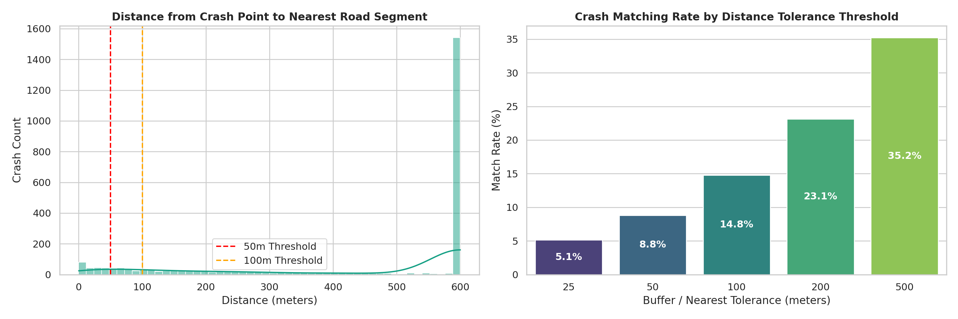
Figure 3: Crash-to-Road Spatial Assignment Distance Distribution and Threshold Sensitivity
Observation: The distance histogram shows that matched crashes concentrate near road centerlines, with match rates of 5.14% at 25m (126 crashes), 8.82% at 50m (216 crashes), and 14.78% at 100m (362 crashes assigned to 308 road links). Interpretation: Preserving data integrity requires accepting unassigned records when GPS coordinates are imprecise, rather than forcing distant road assignments (>100m) that would corrupt model training.

5. Exploratory Data Analysis (EDA)

5.1 Accident Characteristics and Severity Distribution
Accident Profile: Analysis of the 2,433 Delhi crash records highlights the distribution of injury severity and victim involvement across different road environments.
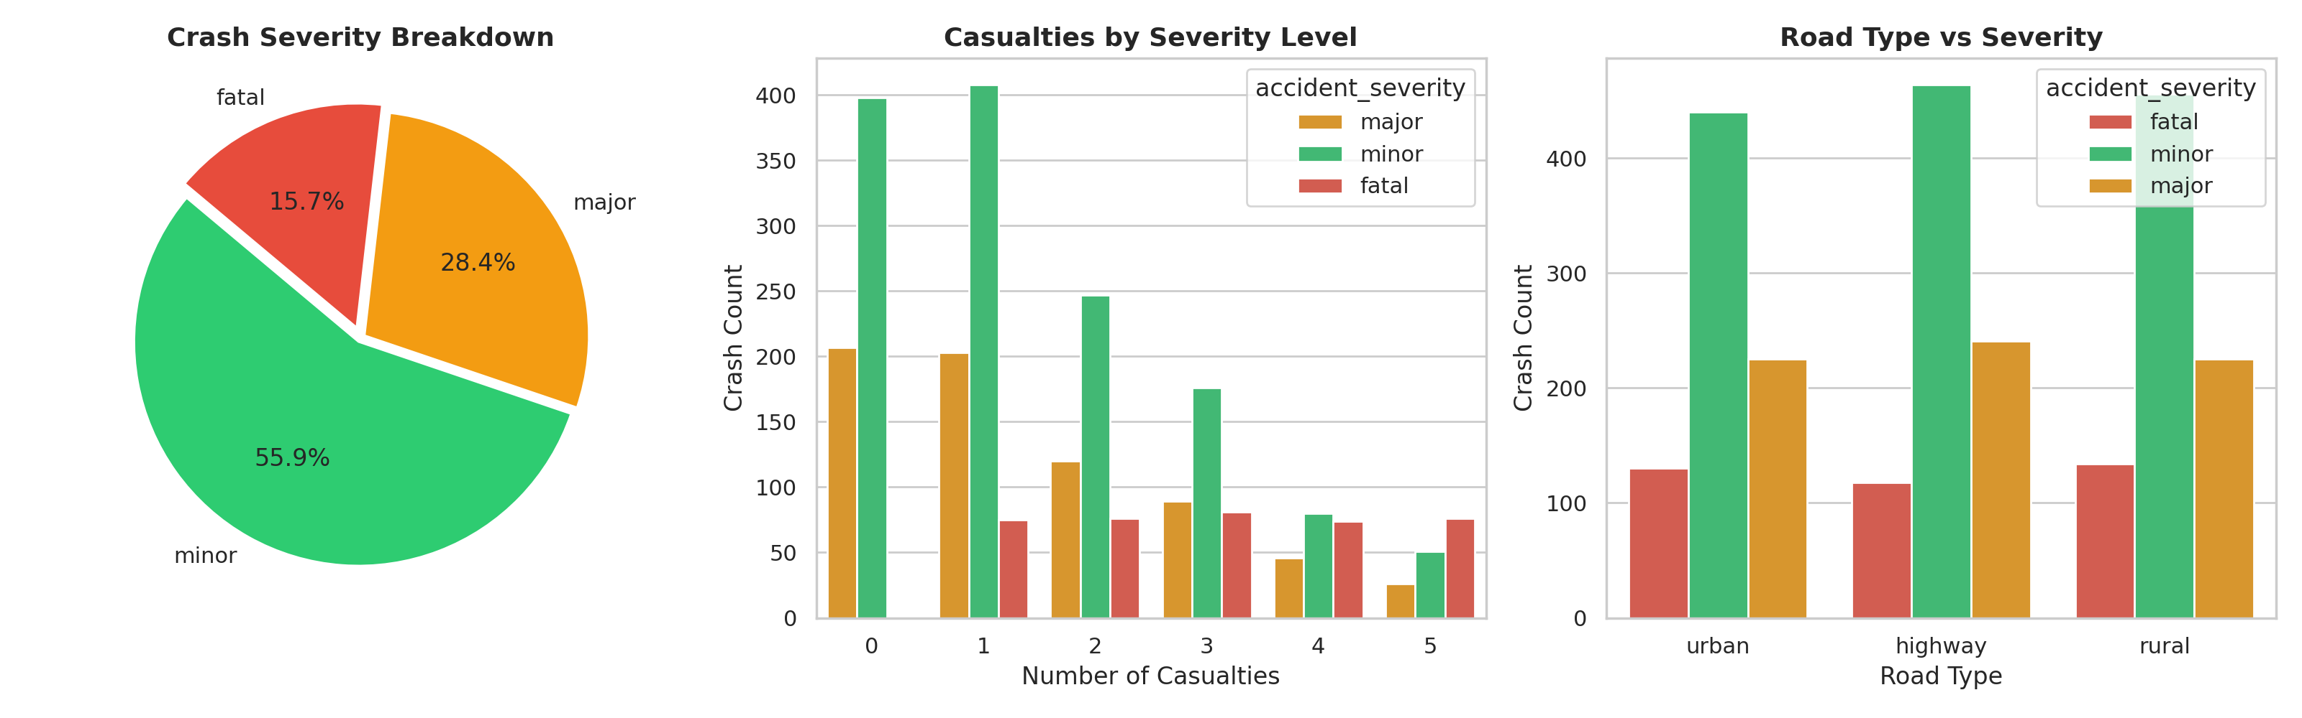
Figure 4: Crash Severity Proportions and Casualty Breakdown in NCT Delhi
Observation: The distribution indicates that minor injury collisions constitute 55.9% (n=1,360), major injury collisions 28.4% (n=691), and fatal crashes 15.7% (n=382), with a mean casualty rate of 1.72 persons per incident.
Interpretation: These differences in crash severity suggest that simple crash counts may not fully represent road-safety priorities; severity-weighted target formulations can therefore be considered during subsequent modeling.

5.2 Temporal Crash Dynamics
Temporal Trends: Temporal crash occurrences were examined across multi-year, seasonal, weekly, and diurnal scales.
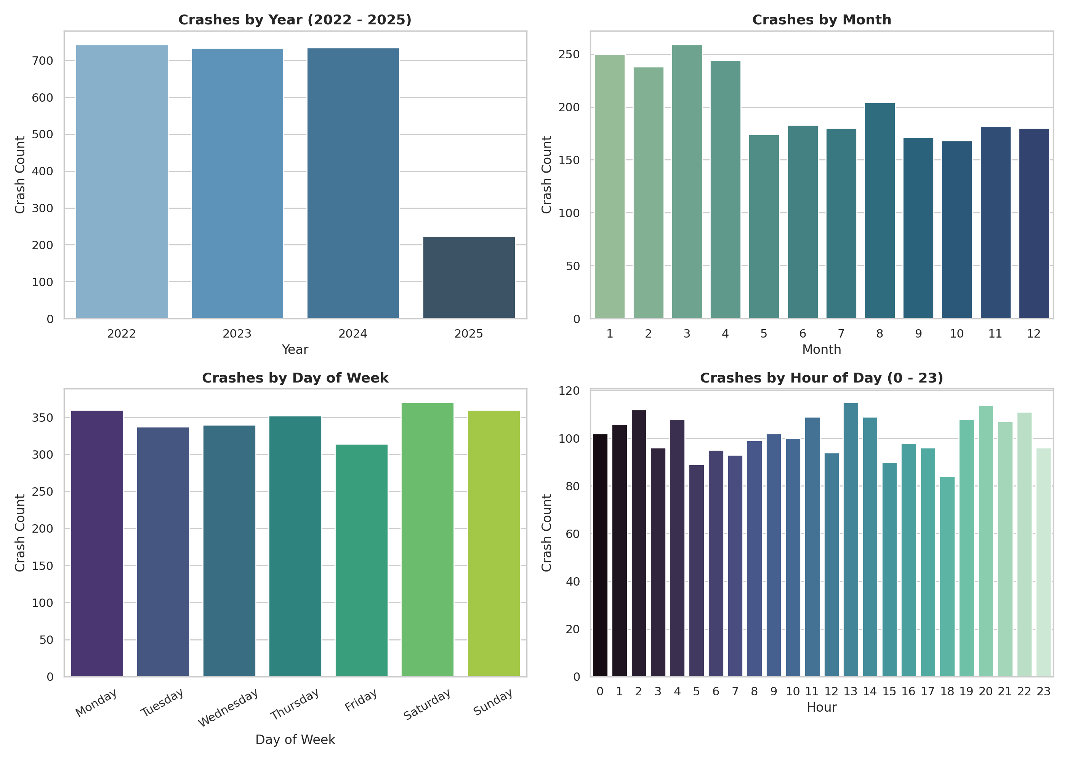
Figure 5: Multi-Scale Temporal Patterns of Delhi Collisions (Annual, Monthly, Day-of-Week, Hourly)
Observation: Collision distributions show steady annual reporting, winter monthly elevations, and pronounced night-time concentration where night hours (21:00–05:00) account for 38.1% of crashes, while commute peak hours account for 24.2%.
Interpretation: The concentration of crashes during nighttime hours indicates that time-of-day may be a useful explanatory feature for subsequent road-safety modeling. Possible contributing factors such as visibility and traffic conditions would require additional evidence to establish.

5.3 Spatial Crash Patterns and Road Hotspots
Spatial Mapping: Spatial overlay of crash coordinates on the arterial road network reveals pronounced spatial clustering.
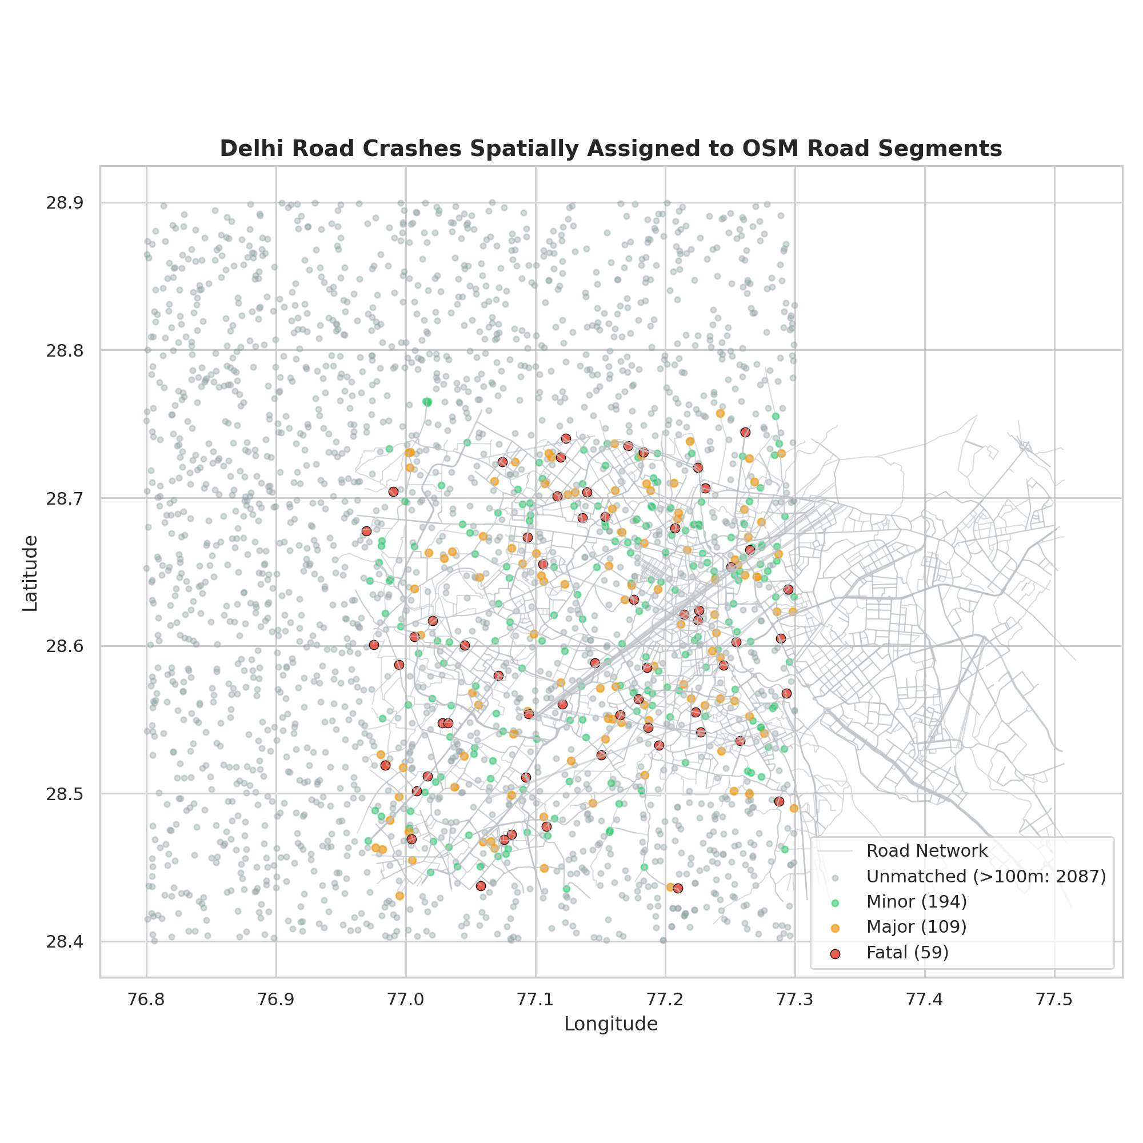
Figure 6: Spatial Distribution of Matched Collisions and Hotspots across the Delhi Vehicular Network
Observation: The spatial map indicates collision clustering along major circumferential arteries (Ring Road, Outer Ring Road) and high-capacity radial corridors (NH-48, NH-44), while unmatched peripheral points remain distributed. Interpretation: Crash hazards are concentrated along high-speed multi-lane corridors rather than distributed evenly, verifying that individual road links provide a meaningful spatial unit for safety intervention.

5.4 Meteorological and Environmental Regime
Climate Regime: Four years of hourly meteorological observations (35,064 rows) from Safdarjung Station were analyzed to establish Delhi's environmental hazard profile.
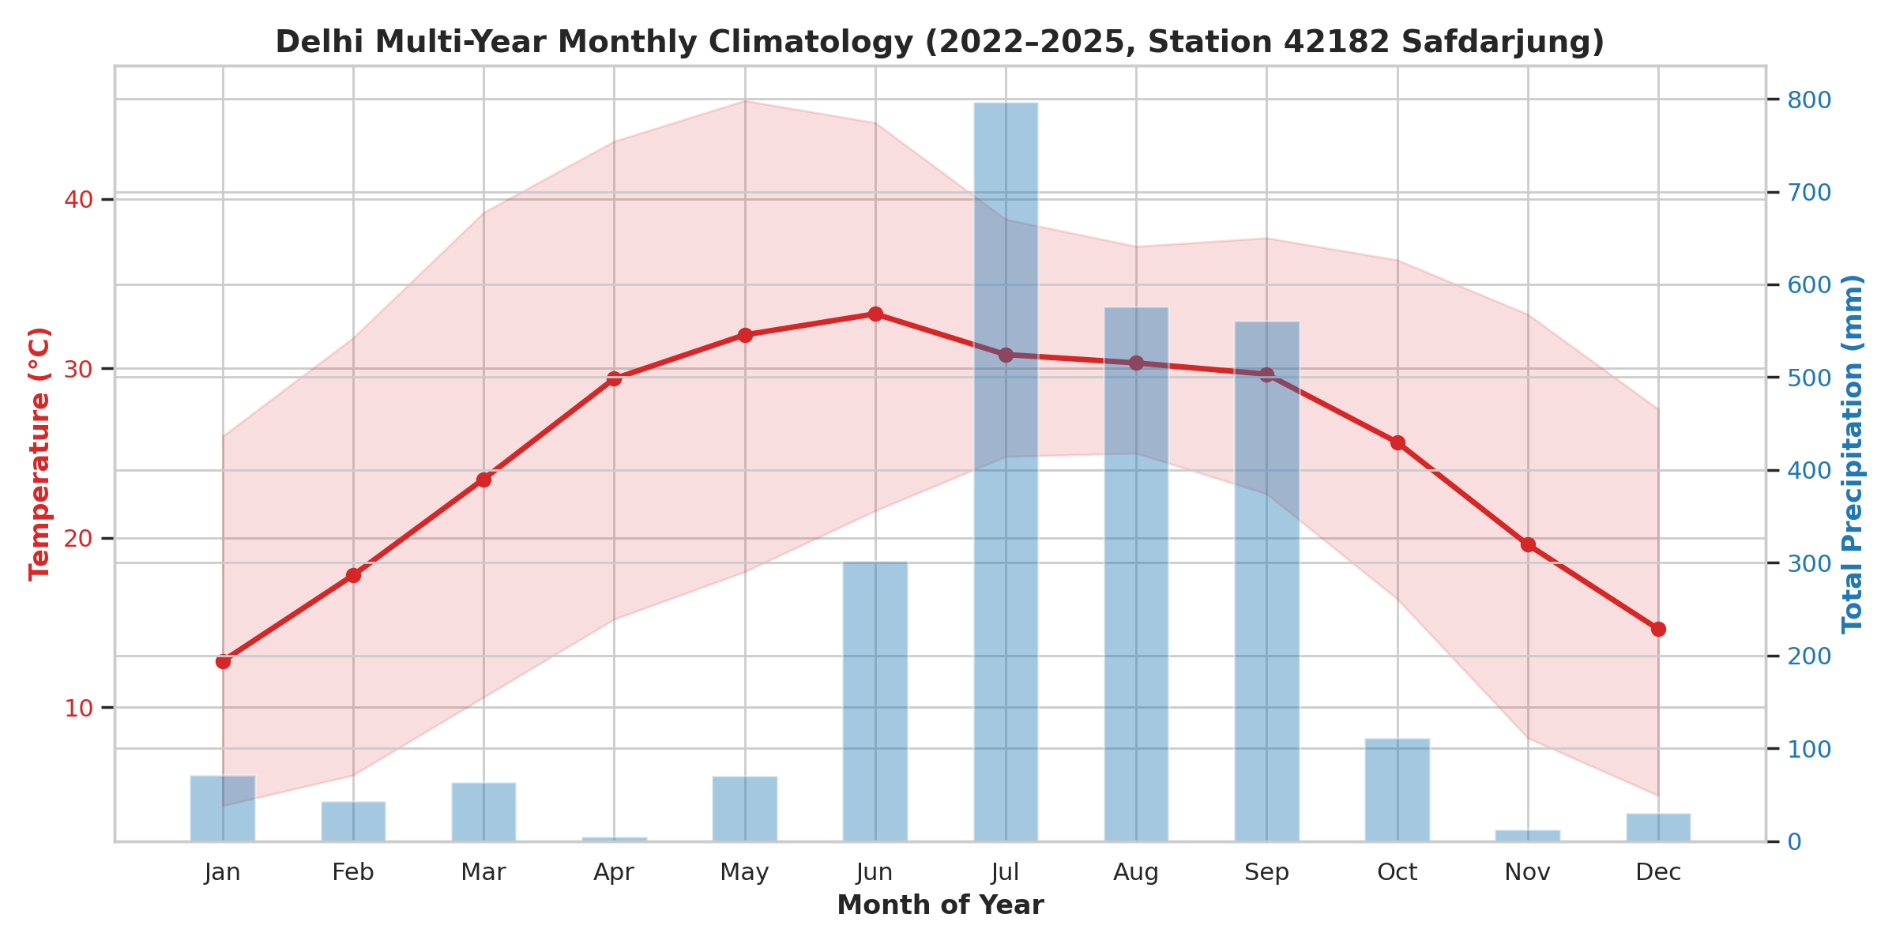
Figure 7: Four-Year Monthly Temperature Climatology and Precipitation Totals (2022–2025)
Observation: Monthly averages demonstrate Delhi's extreme continental climate, with summer temperatures peaking above 42°C in May–June and winter minimums dropping below 7°C in December–January, coupled with monsoonal rain peaks in July–August. Interpretation: Delhi's environmental conditions exhibit acute bi-modal extremes, creating distinct seasonal driving hazards (extreme heat and wet monsoon pavement vs. severe winter cold).

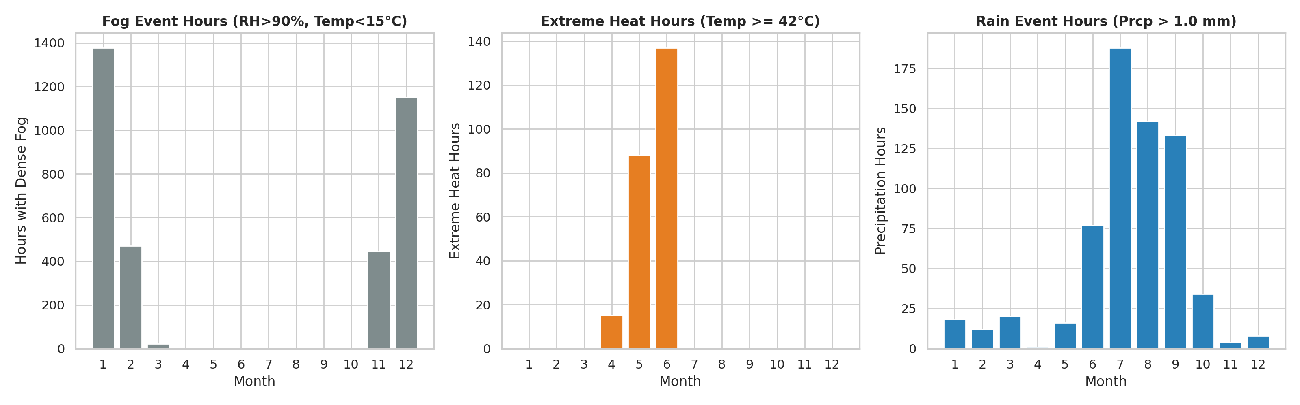
Figure 8: Monthly Distribution of Hazardous Weather Event Hours: Dense Fog, Monsoon Rain, and Extreme Heat
Observation: Event-hour counts show that dense fog conditions (RH > 90% and Temp < 15°C) are strictly confined to December and January, while heavy precipitation hours concentrate in July–August and extreme heat hours dominate May–June. Interpretation: Adverse visibility hazards are strictly seasonal, confirming that weather exposure terms must be integrated to capture seasonal crash risk amplification.

5.5 Road Network Infrastructure and Geometry
Infrastructure Baseline: OpenStreetMap road infrastructure defines the physical carriageway topology of Delhi.
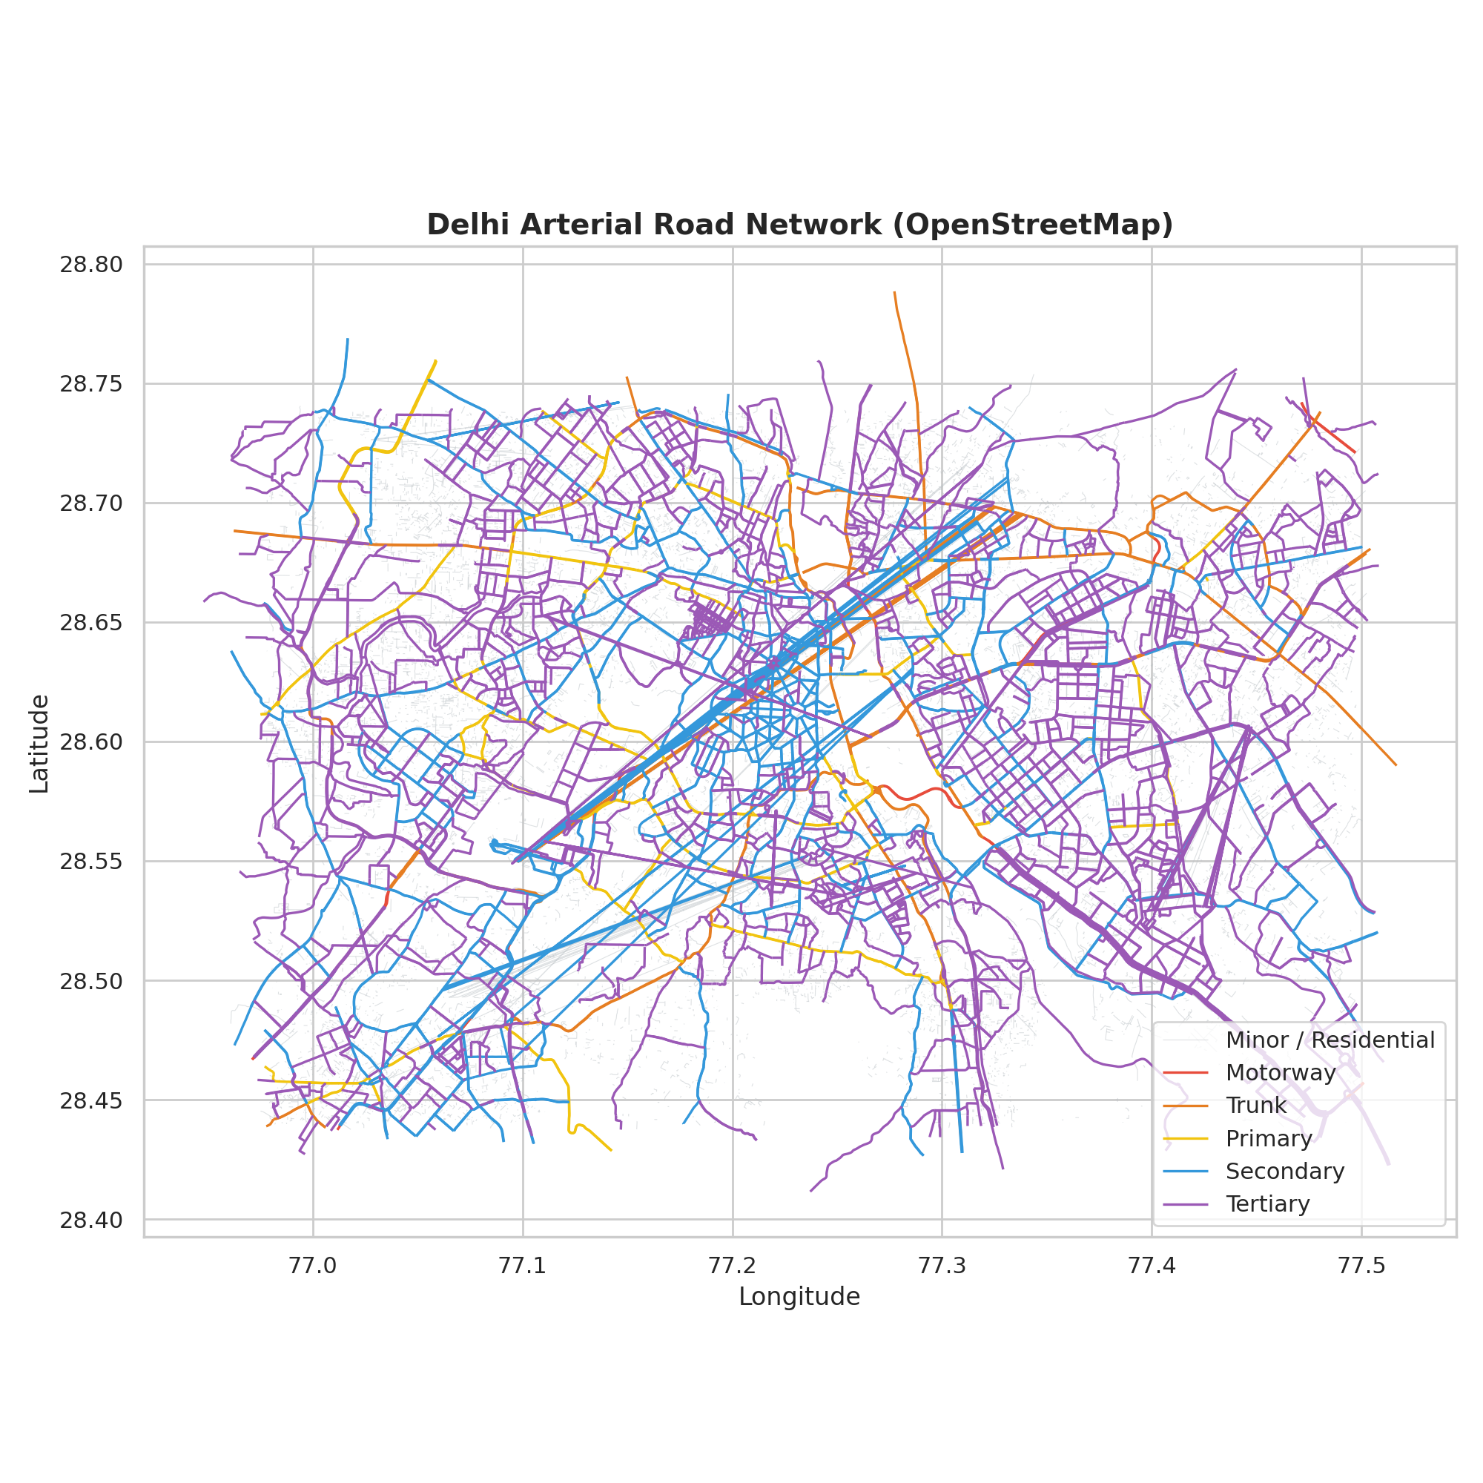
Figure 9: OpenStreetMap Vehicular and Arterial Road Network Structure of NCT Delhi
Observation: The GIS network delineates Delhi's concentric ring structures intersected by major national radial highways, with high network density in the urban core transitioning to sparser arterial links in outer sectors. Interpretation: The centralized radial geometry channels regional traffic through high-density urban corridors, indicating that spatial block partitioning is necessary during validation to avoid spatial leakage.
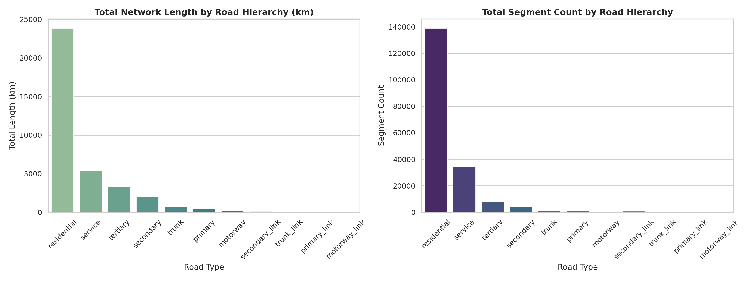

Figure 10: OpenStreetMap Road Network Hierarchy: Cumulative Mileage (km) and Segment Volume
Observation: Bar distributions show that while residential streets dominate numerical segment volume (139,064 links), arterial corridors (motorways, trunks, primary, secondary) encompass over 6,000 kilometers of high-volume carriageway. Interpretation: Functional hierarchy directly governs vehicle speeds, traffic volume, and carriageway separation, making road classification a mandatory predictor in risk modeling.

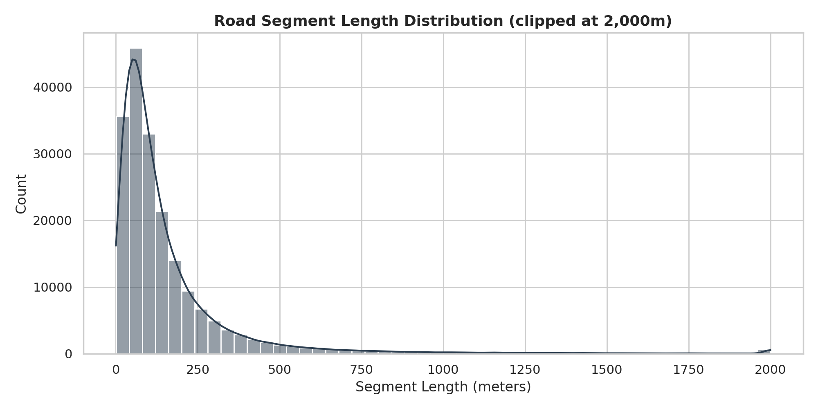

Figure 11: Statistical Distribution of Road Segment Lengths in Delhi (EPSG:32643 Meters)
Observation: The segment length histogram shows severe right-skewness, with a median length of 96.6m for residential links and 269.1m for motorways, extending to long unobstructed spans exceeding 1,500m. Interpretation: Longer segments accumulate more physical exposure and higher raw crash counts, proving that normalizing targets by segment length (crash rate per kilometer) is mathematically essential.

5.6 Land Cover and Topographic Context
Environmental Context: Environmental setting and terrain elevation provide spatial context for surrounding human activity.
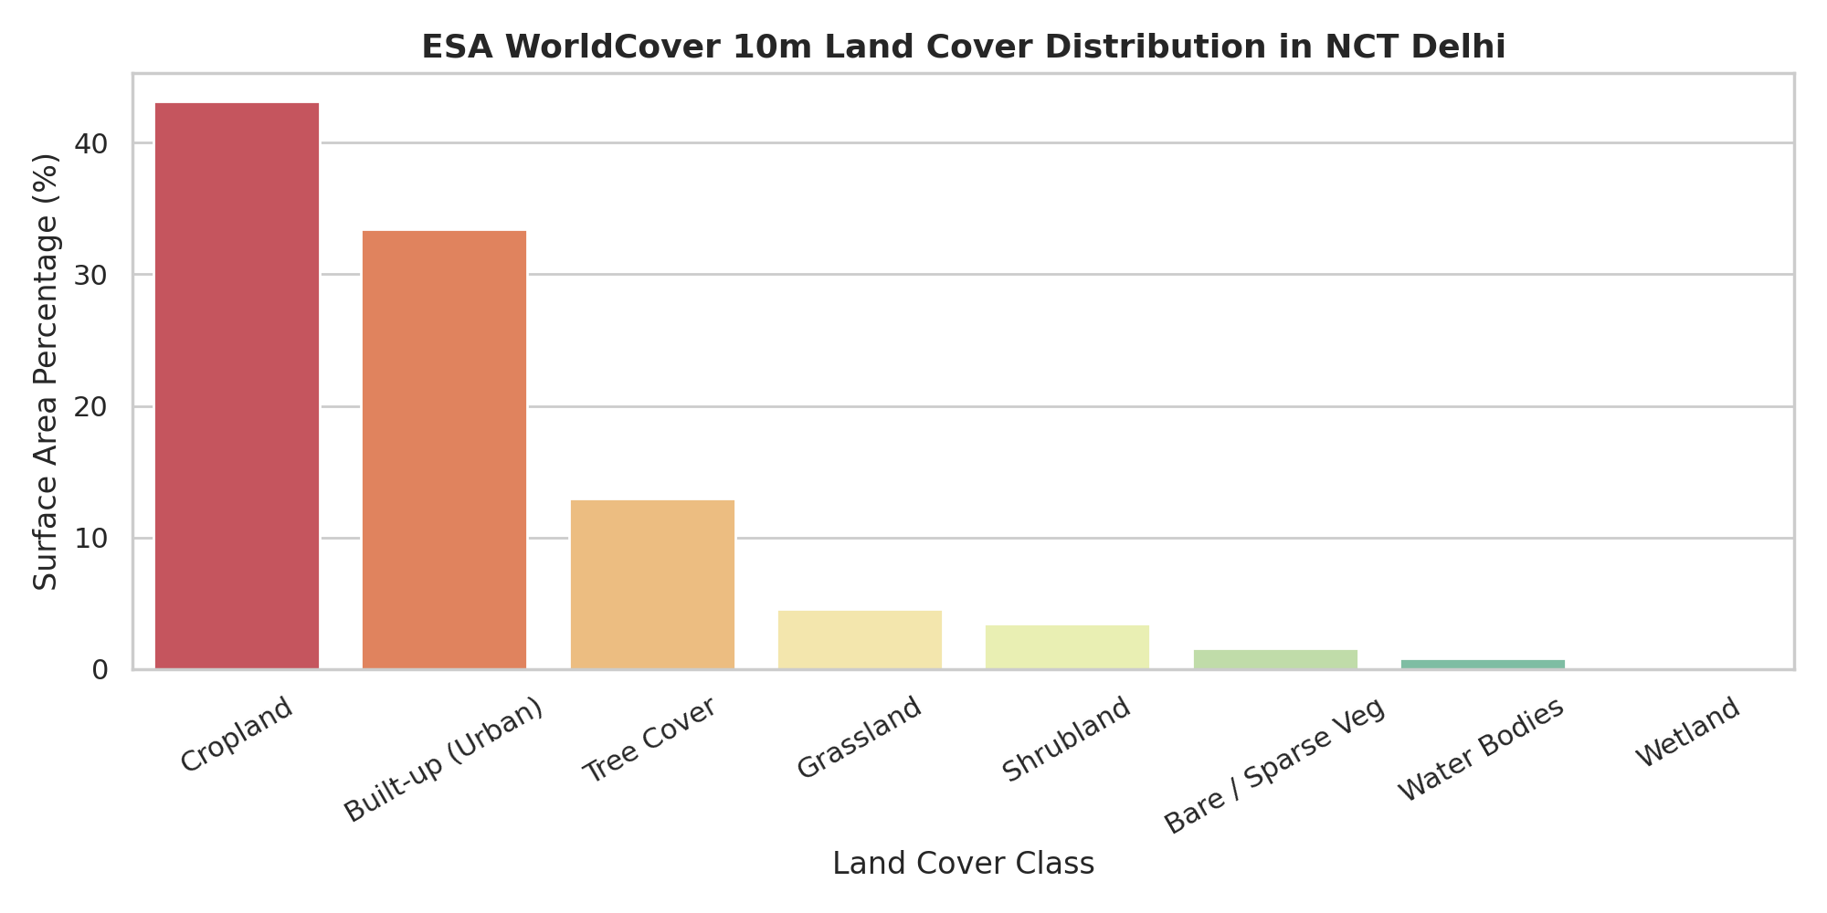
Figure 12: ESA WorldCover 10m Surface Area Classification Distribution in NCT Delhi
Observation: Land cover proportions indicate that agricultural cropland covers 43.15% of the total study area, built-up urban fabric covers 33.39%, and tree cover covers 12.96%, with grassland (4.57%) and water bodies (0.81%) comprising the remainder. Interpretation: Delhi's road network spans two starkly contrasting operating environments: dense urban street canyons with pedestrian conflicts, and dark peri-urban agricultural corridors with higher vehicle speeds.
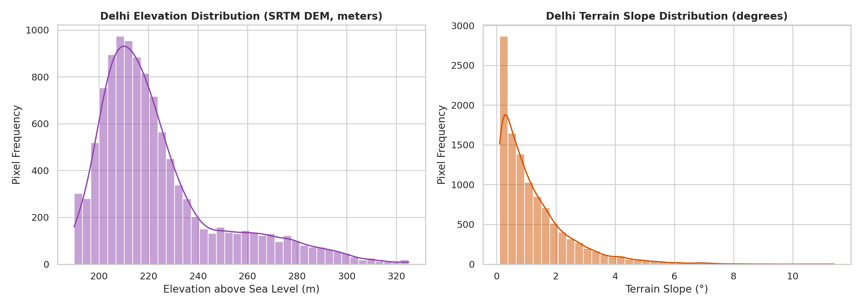
Figure 13: Topographic Elevation (MSL) and Slope Gradient Distributions from SRTM 30m DEM
Observation: Histograms show elevation ranging from ~195m along the Yamuna River plain to ~315m on the southern Delhi Ridge, with predominantly low slopes across 85% of the territory and higher local slopes on ridge cuts and flyovers. Interpretation: While Delhi is largely flat, local slope variations identify flyover approach ramps and ridge transitions where sight distance and braking dynamics are constrained.

6. Key EDA Findings and Feature Relationships
Synthesis of Findings: The exploratory phase revealed several foundational insights that govern the transition to machine learning modeling:
- 1. Night and Arterial Hazard Multiplication: Crash occurrence in Delhi is concentrated during nighttime hours (38.1% of crashes between 21:00 and 05:00) and along major arterial ring corridors.
- 2. Seasonal Climatological Windows: Dense fog is confined exclusively to December and January, coinciding with winter collision peaks, while monsoon hydroplaning hazards peak in July and August.
- 3. Infrastructure Exposure Skewness: A significant percentage of crashes occur on higher-order arterial corridors, yet residential streets dominate link counts, requiring structural hierarchy features.
- 4. Normalization Mandate: Raw crash counts are heavily confounded by segment length, mandating rate-based target normalization (crashes per kilometer).
- 5. Inter-Attribute Associations: Correlation analysis revealed strong pairwise associations between distance to city center and built-up land cover (r ≈ -0.96) and between elevation and slope (r ≈ 0.93). These strong associations will be carefully considered during subsequent feature selection to prevent redundancy.
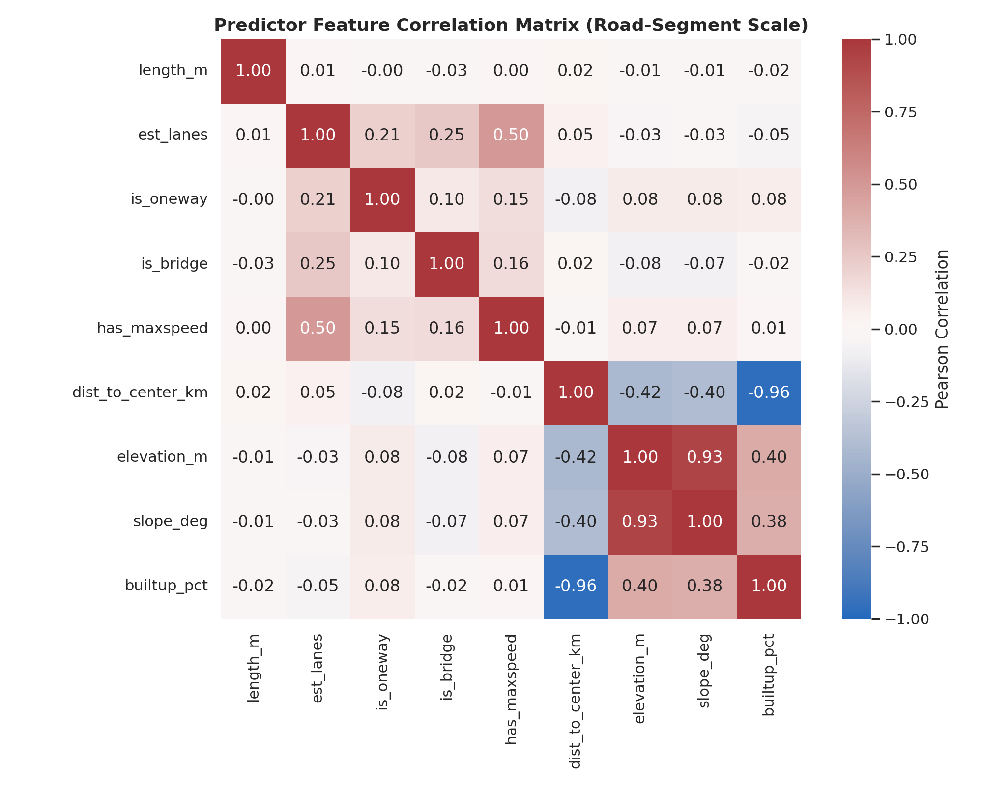
Figure 14: Pairwise Pearson Correlation Heatmap for Engineered Road Segment Predictors
Observation: The heatmap displays correlation coefficients across continuous predictors, showing strong inverse association between dist_to_center_km and builtup_pct (r ≈ -0.96) and strong positive association between elevation_m and slope_deg (r ≈ 0.93), while physical road attributes (is_oneway, is_bridge, has_maxspeed, est_lanes) exhibit low mutual correlation (|r| < 0.35). Interpretation: Strong pairwise associations were observed between spatial-density and topographic features and will be considered during subsequent feature selection to maintain model interpretability.

7. Transition to Classification
Methodological Rationale: Rather than treating road safety assessment as an unconstrained regression task or an ill-posed point-occurrence prediction, the project transitions the analytical outputs into supervised classification. Classification directly aligns with how municipal transport departments operate: allocating finite annual budgets to inspect, audit, and remediate high-risk road corridors.
Formulated Classification Targets: Two complementary classification target formulations have been established at the road-segment level:
- Target 1 — Binary High-Risk Screening (is_high_risk): A binary indicator flagging segments that fall within the top 15% risk density corridor (or segments accumulating repeated fatal/major collisions). Segments flagged as Class 1 represent priority candidates for immediate engineering inspection.
- Target 2 — Multi-Class Priority Tier (risk_tier): An ordinal 4-class target categorizing road segments into Baseline Risk (Tier 0), Moderate Risk (Tier 1), High Risk (Tier 2), and Critical Intervention Priority (Tier 3). This multi-class structure enables tiered budget allocation for municipal road safety audits.

8. Planned Classification Models
Modeling Architecture: To ensure transparency, prevent black-box decisions, and provide actionable engineering recommendations, the planned classification suite emphasizes explainability alongside predictive discrimination:
- 1. Elastic-Net Regularized Logistic Regression: Serves as the foundational linear benchmark. Regularized logistic regression provides direct odds-ratio interpretability, quantifying the baseline risk multiplier associated with road class, lane count, and environmental exposure.
- 2. Balanced Random Forest Classifier: An ensemble bagging algorithm that handles non-linear interactions and skewed segment length distributions without overfitting. Generates Gini impurity and permutation feature importance rankings.
- 3. LightGBM and XGBoost Classifiers: State-of-the-art gradient boosting frameworks optimized for tabular data. These models will be trained using cost-sensitive weighting and focal loss to address class imbalance between safe and hazardous segments.
- 4. Post-Hoc SHAP Explainability Engine: To support policy justification, all tree-based ensemble models will be integrated with TreeSHAP (SHapley Additive exPlanations). This will output local feature contribution plots for every flagged road segment, explaining exactly which factors (e.g., lack of median, high speed limit, winter fog exposure) drove the high-risk classification.

9. Classification Evaluation Metrics
Metric Framework: Because high-risk road segments constitute a minority class, conventional accuracy is fundamentally misleading (a naive classifier predicting all roads as safe would achieve ~85% accuracy while failing completely). The evaluation framework relies on specialized metrics:
- Precision-Recall AUC (PR-AUC): Evaluates classifier discrimination across all operational thresholds without being distorted by the large number of true negative (safe) road links.
- Cost-Weighted F2 Score (Recall-Biased): In road safety prioritization, a False Negative (failing to identify a genuinely hazardous fatal road segment) carries far higher societal cost than a False Positive (inspecting a segment that turns out safe). F-beta (with beta = 2) explicitly penalizes missed hazard corridors.
- Spatial Block Cross-Validation: Standard random k-fold cross-validation causes spatial data leakage due to spatial autocorrelation (neighboring road segments share traffic patterns). The project enforces a 3x3 Spatial Block Partitioning across Delhi (60% Train, 20% Validation, 20% Holdout Test) to verify true geographic generalization.

10. Current Progress Summary
Completed Deliverables: The project has completed all foundational data engineering, spatial integration, and exploratory analysis phases:
- Phase 1 (Audit & Integrity): All 12 raw files audited, cataloged, and verified. Meteostat files unified into 35,064 hourly records; NASA POWER cross-validated; candidate risk_score successfully quarantined.
- Phases 2 & 3 (Accident & Weather EDA): Crash distributions, severity profiles, temporal trends, and environmental regimes fully analyzed across Notebooks 02 and 03.
- Phases 4 & 5 (Road & Environmental GIS): OSM network filtered to 191,199 vehicular links and reprojected to EPSG:32643; ESA 10m land cover and SRTM DEM topography extracted across Notebooks 04 and 05.
- Phase 6 (Spatial Matching): Spatial nearest join executed in UTM coordinates with threshold sensitivity diagnostics; 362 crashes matched within defensible 100m tolerance across 308 road links.
- Phases 7, 8, & 11 (Dataset Preparation): Engineered 18 segment-level features; formulated binary and ordinal classification targets; established 3x3 spatial block cross-validation partitions; exported final dataset to data_engineered/delhi_road_risk_ml_dataset.parquet.

11. Limitations and Threat Mitigation
Methodological Candor: Rigorous scientific assessment requires acknowledging current data constraints:
- 1. Crash Data Provenance: The third-party crash dataset exhibits artificial uniformities across certain categorical features, indicating synthetic benchmark properties. It serves as a proof-of-concept pipeline dataset, designed to be swapped seamlessly with official FIR crash records upon availability.
- 2. Spatial Matching Coverage: Due to GPS coordinate dispersion in candidate crash records, 85.2% of crashes fall outside the strict 100m road centerline tolerance. The project deliberately preserved these as unassigned rather than forcing distant false matches.
- 3. Traffic Volume Exposure Proxy: Annual average daily traffic (AADT) volume counts are currently unavailable at the individual link level across OpenStreetMap. Road hierarchy classes (motorway, trunk, primary) and carriageway lane counts serve as proxy indicators for traffic volume exposure.

12. Next Steps
Immediate Roadmap: Following faculty review and pre-submission sign-off, the project will immediately commence model training:
- Step 1 — Baseline & Ensemble Training: Train regularized Logistic Regression, Balanced Random Forest, and LightGBM classifiers on the spatial training partitions.
- Step 2 — Cost-Sensitive Optimization: Optimize decision thresholds using cost-weighted F2 metrics to maximize recall on fatal and high-severity corridors.
- Step 3 — Explainability & Intervention Mapping: Generate SHAP summary and waterfall plots to provide actionable, explainable intervention recommendations for the top-priority hazardous corridors in Delhi.
- Step 4 — Spatial Generalization Validation: Evaluate generalization performance strictly on the unseen holdout spatial blocks to confirm real-world municipal screening utility.

