

Tribhuvan University
Faculty of Humanities and Social Sciences

TITLE OF PROJECT REPORT

A PROJECT REPORT

Submitted to
Department of Computer Application
Ratna Rajyalaxmi Campus
In partial fulfillment of the requirements for the Bachelors in Computer Application

Submitted by

Name: Kapil Malla Thakuri Roll No:- 24
Reg no: 6-2-40-718-2024
Name: Abhishek Ale Roll no:- 04
Reg no: 6-2-40-700-2024

Month and Year

Under the Supervision of
Supervisor Name

(A typical Specimen of Certificate)

Tribhuvan University
Faculty of Humanities and Social Sciences
Kathmandu College of Technology

Supervisor’s Recommendation

I hereby recommend that this project prepared under my supervision by Kapil Malla Thakuri and Abhishek Ale entitled “Futsal Matchmaking System(Khelmandu)” in partial fulfillment of the requirements for the degree of Bachelor of Computer Application is recommended for the final evaluation.

Signature of the Supervisor

SIGNATURE

Name

SUPERVISOR

Academic Designation

Department

Full address of the Dept & College

Tribhuvan University
Faculty of Humanities and Social Sciences
College Name

LETTER OF APPROVAL

This is to certify that this project prepared by Kapil Malla Thakuri and Abhishek Ale entitled “Futsal Matchmaking System.(Khelmandu)” in partial fulfillment of the requirements for the degree of Bachelor in Computer Application has been evaluated. In our opinion it is satisfactory in the scope and quality as a project for the required degree.

SIGNATURE of Supervisor  Name and Academic designation  Ratna Rajyalaxmi campus  Pradarshani Marg, Kathmandu | SIGNATURE of HOD/ Coordinator  Name and Academic Designation  Ratna Rajyalaxmi campus  Pradarshani Marg, Kathmandu
SIGNATURE of Internal Examiner  Internal Examiner | SIGNATURE of External Examiner  External Examiner

Ratna Rajyalaxmi Campus
Ref No:
Date:

Subject: Approval of Project Proposal
The project entitled “Khelmandu” proposed by Mr.Kapil Malla thakuri and Mr.Abhishek Ale for the partial fulfillment of the requirement for Bachelor in Computer Application (BCA), fourth semester has been approved for further development.
Proposal Evaluation Committee

- _______________________

- _______________________

- _______________________

- _______________________

Mr.
Campus Chief (.)

Contents

Chapter 1 Introduction 6
1.1 Introduction of Proposed project 6
1.2 Problem Statement 6
1.3 Objectives 6
1.4 Scope and limitation 6
Chapter 2 Literature Review 6-7
Chapter 3 Methodology 7
3.1 System Analysis 7-8
3.2 System Design 9
3.3 Gantt Diagram 9
3.4 Admin and User flowchart………………………………………………………………………………………………………..10
3.4.1User Flowchart………………………………………………………………………………………………..10
3.4.2Admin Flowchart…………………………………………………………………………………………….10
3.5 Database Design……………………………………………………………………………………………………………………...11
Chapter 4 Conclusion 11
4.1 Expected Outcome 11

Chapter 1: Introduction

1.1 Introduction of Proposed Project
Futsal is one of the most popular sports among youths in Nepal. However, players often face difficulties in finding opponents, and organizing matches. Most arrangements are made through social media groups or personal contacts, which can be time-consuming and inefficient.
The Futsal Matchmaking System is a web-based platform designed to connect futsal players, teams, and futsal venues in one place. The system allows teams players to create profiles, join teams, schedule matches, find opponents with similar skill levels, and book futsal grounds online and find opponents.
The main purpose of this system is to simplify the process of organizing futsal matches and create a convenient environment for futsal enthusiasts.

1.2 Problem Statement
In the context of Nepal, futsal players and teams face several challenges:
- Difficulty finding available teams.
- Lack of a centralized platform for arranging matches.
- Time-consuming communication through social media.
- Limited information about futsal grounds and booking availability.

1.3 Objectives
The main objective of this project is to provide an efficient platform for futsal players and teams.
- Allow teams to register and create team profiles (Citizenship/school id card).
- Match teams with opponents.
- Allow online booking of futsal venues.
- Maintain match schedules.

1.4 Scope and Limitation

Scope
- Easy registration and profile management.
- Team management.
- Booking facility.
- Accessible from anywhere with internet access.

Limitation
- Requires internet connectivity.
- Online payment integration may not be available initially.
- Limited to registered users only.
- Real-time location tracking is not included.
- All player can login to the team account which creates confusion.

Chapter 2: Literature Review
Various sports management and team-finding applications are available worldwide. Applications such as sports booking platforms and team management systems help users organize games and events efficiently.
The Futsal Matchmaking System aims to address these limitations by combining team management, match scheduling, and matchmaking within a single platform.

Chapter 3: Methodology
The project will follow the Waterfall Model for software development.
The Waterfall Model consists of the following phases:
- Analysis
- Designing
- Coding
- Testing
- Implementation
- Maintenance
The model is suitable because the project requirements are clearly defined and can be developed in a sequential manner.
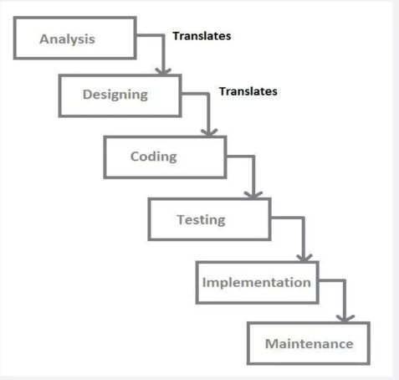

Fig : Waterfall method

3.1 System Analysis
System analysis involves studying the requirements of teams, and administrators.

Requirements Identification
The system needs to fulfill the following requirements:

Functional Requirements
- Teams can register and log in.
- Teams can send and receive match requests.
- Administrators can manage teams.

Non-Functional Requirements

1. Availability
The system will be available online 24/7.

2. Security
Team/User information and account details will be protected through secure authentication.

3. Performance
The system should provide fast responses and smooth navigation.

4. Reliability
The platform should maintain accurate and booking records.

Feasibility Study

a. Technical Feasibility
The project uses widely available technologies such as HTML, CSS, JavaScript, PHP, and MySQL.

b. Economic Feasibility
The project uses open-source technologies, minimizing development costs.

c. Operational Feasibility
The system is easy to use and requires minimal technical knowledge.

Tools

Front-End
- HTML
- CSS
- JavaScript

Back-End
- PHP

Database
- MySQL

3.2 System Design

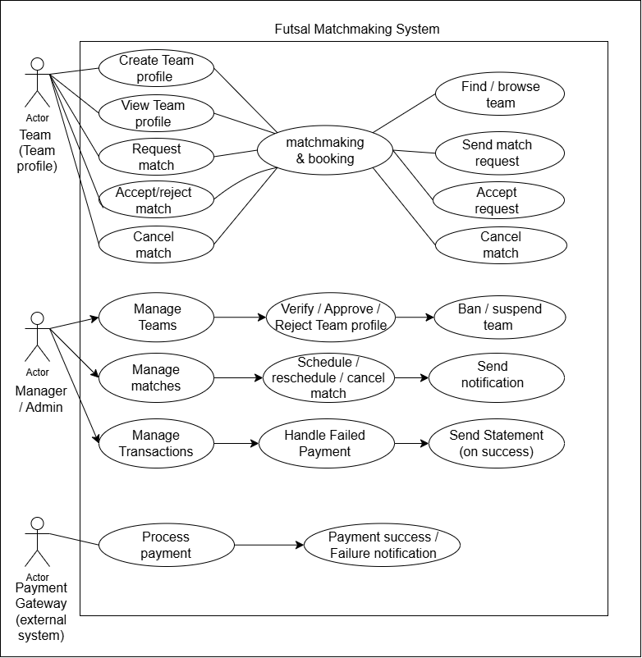

Fig: Case diagram of Futsal Matchmaking System (Khelmandu)

3.3 Gantt Diagram
Activity | Week 1 | Week 2 | Week 3 | Week 4 | Week 5 | Week 6
Requirement Analysis | ✓
System Design |  | ✓
Database Design |  | ✓ | ✓
Development |  |  | ✓ | ✓
Testing |  |  |  | ✓ | ✓
Documentation |  |  |  |  | ✓ | ✓
Deployment |  |  |  |  |  | ✓

3.4 Admin and user flowchart

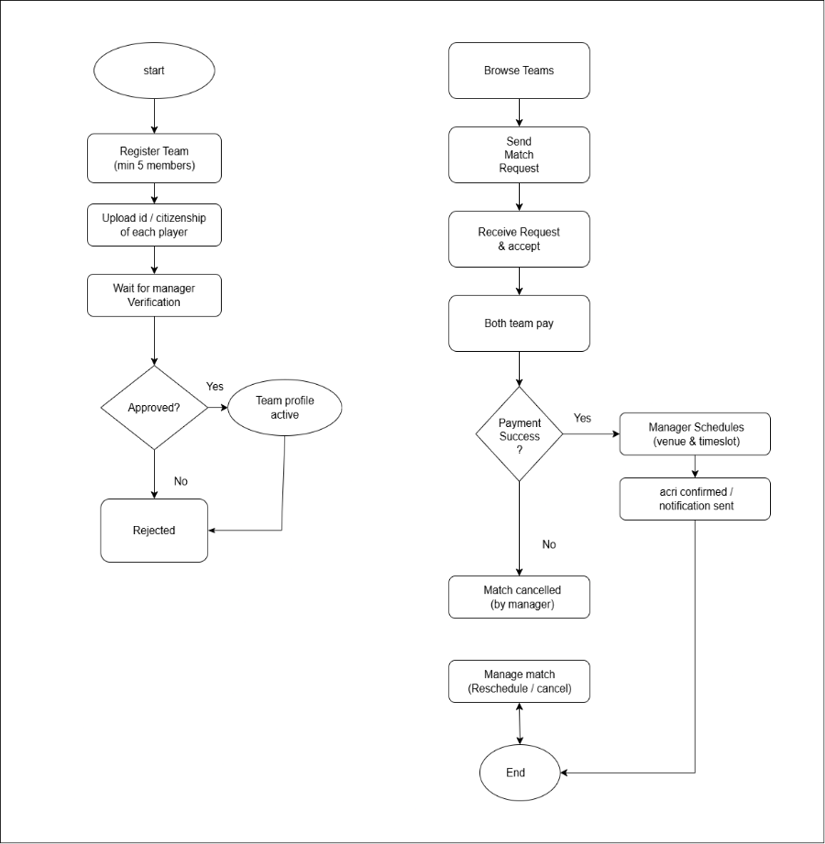
3.4.1 User flowchart
Matchmaking & booking

Fig: user flowchart

3.4.2 Admin flowchart
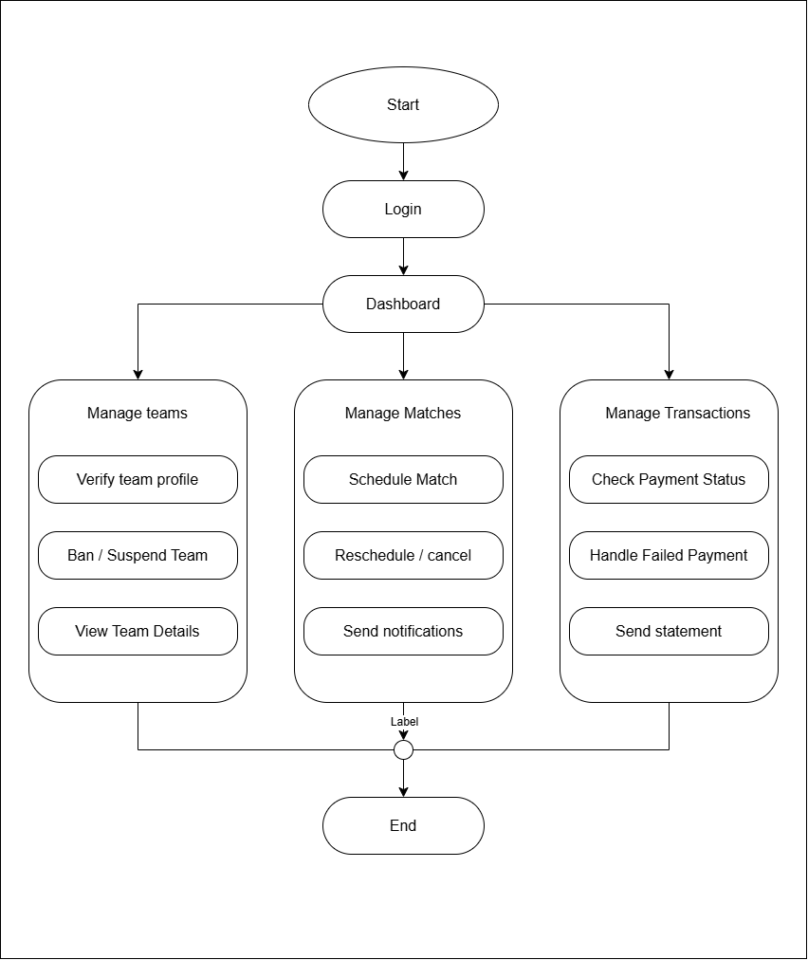

Fig: Admin Flowchart

3.5 Database design
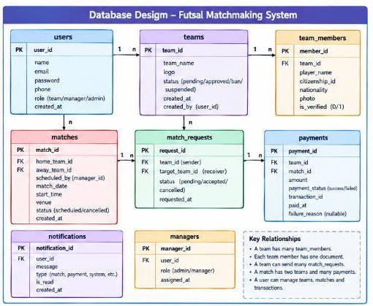

Fig: Database design

Chapter 4: Conclusion
The Futsal Matchmaking System will provide a centralized platform for futsal, teams. It will simplify the process of match scheduling match making and booking.

4.1 Expected Outcome
After completion of the project:
- Teams will be able to register and create profiles.
- Teams will be able to organize matches efficiently.
- Teams will be able to find opponents easily.
- Futsal ground can be booked online.
- The overall futsal community will benefit from better coordination and organization.

