# <http://www.javatpoint.com/>

# Java Tutorial

1. [Java - What, Where and Why?](http://www.javatpoint.com/java-tutorial)
2. [What is Java](http://www.javatpoint.com/java-tutorial)
3. [Where Java is used](http://www.javatpoint.com/java-tutorial)
4. [Java Applications](http://www.javatpoint.com/java-tutorial)

Java technology is widely used currently. Let's start learning of java from basic questions like what is java, where it is used, what type of applications are created in java and why use java?

## What is Java?

Java is a **programming language** and a **platform**.

**Platform** Any hardware or software environment in which a program runs, known as a platform. Since Java has its own Runtime Environment (JRE) and API, it is called platform.

## Where it is used?

According to Sun, 3 billion devices run java. There are many devices where java is currently used. Some of them are as follows:

1. Desktop Applications such as acrobat reader, media player, antivirus etc.
2. Web Applications such as irctc.co.in, javatpoint.com etc.
3. Enterprise Applications such as banking applications.
4. Mobile
5. Embedded System
6. Smart Card
7. Robotics
8. Games etc.

Types of Java Applications

There are mainly 4 type of applications that can be created using java:

**1) Standalone Application**

It is also known as desktop application or window-based application. An application that we need to install on every machine such as media player, antivirus etc. AWT and Swing are used in java for creating standalone applications.

**2) Web Application**

An application that runs on the server side and creates dynamic page, is called web application. Currently, servlet, jsp, struts, jsf etc. technologies are used for creating web applications in java.

**3) Enterprise Application**

An application that is distributed in nature, such as banking applications etc. It has the advantage of high level security, load balancing and clustering. In java, EJB is used for creating enterprise applications.

**4) Mobile Application**

An application that is created for mobile devices. Currently Android and Java ME are used for creating mobile applications.

### Java Version History

There are many java versions that has been released.

1. JDK Alpha and Beta (1995)
2. JDK 1.0 (23rd Jan, 1996)
3. JDK 1.1 (19th Feb, 1997)
4. J2SE 1.2 (8th Dec, 1998)
5. J2SE 1.3 (8th May, 2000)
6. J2SE 1.4 (6th Feb, 2002)
7. J2SE 5.0 (30th Sep, 2004)
8. Java SE 6 (11th Dec, 2006)
9. Java SE 7 (28th July, 2011)

# Features of Java

1. [Features of Java](http://www.javatpoint.com/features-of-java#features)
   1. [Simple](http://www.javatpoint.com/features-of-java#featuressimple)
   2. [Object-Oriented](http://www.javatpoint.com/features-of-java#featuresobject)
   3. [Platform Independent](http://www.javatpoint.com/features-of-java#featuresplateform)
   4. [secured](http://www.javatpoint.com/features-of-java#featuressecured)
   5. [Robust](http://www.javatpoint.com/features-of-java#featuresrobust)
   6. [Architecture Neutral](http://www.javatpoint.com/features-of-java#featuresarchitecture)
   7. [Portable](http://www.javatpoint.com/features-of-java#featuresportable)
   8. [High Performance](http://www.javatpoint.com/features-of-java#featureshigh)
   9. [Distributed](http://www.javatpoint.com/features-of-java#featuresdistributed)
   10. [Multi-threaded](http://www.javatpoint.com/features-of-java#featuresmulti)

There is given many features of java. They are also known as java buzzwords.

1. Simple
2. Object-Oriented
3. Platform independent
4. Secured
5. Robust
6. Architecture neutral
7. Portable
8. Dynamic
9. Interpreted
10. High Performance
11. Multithreaded
12. Distributed

### Simple

|  |
| --- |
| According to Sun, Java language is simple because: |
| syntax is based on C++ (so easier for programmers to learn it after C++). |
| Removed many confusing and/or rarely-used features e.g., explicit pointers, operator overloading etc. |
| No need to remove unreferenced objects because there is Automatic Garbage Collection in java. |

### Object-oriented

|  |
| --- |
| Object-oriented means we organize our software as a combination of different types of objects that incorporates both data and behaviour. |
| Object-oriented programming(OOPs) is a methodology that simplify software development and maintenance by providing some rules. |
| Basic concepts of OOPs are: |
| 1. Object 2. Class 3. Inheritance 4. Polymorphism 5. Abstraction 6. Encapsulation |

### Platform Independent

|  |
| --- |
| A platform is the hardware or software environment in which a program runs. There are two types of platforms software-based and hardware-based. Java provides software-based platform. The Java platform differs from most other platforms in the sense that it's a software-based platform that runs on top of other hardware-based platforms. It has two components:   1. Runtime Environment 2. API(Application Programming Interface) |

|  |
| --- |
| java is platform independent  Java code can be run on multiple platforms e.g. Windows, Linux, Sun Solaris, Mac/OS etc. Java code is compiled by the compiler and converted into bytecode. This bytecode is a platform independent code because it can be run on multiple platforms i.e. Write Once and Run Anywhere(WORA). |

### Secured

|  |
| --- |
| Java is secured because: |
| * No explicit pointer * Programs run inside virtual machine sandbox. |

|  |  |
| --- | --- |
| how java is secured | how java is secured |

|  |
| --- |
| * **Classloader-** adds security by separating the package for the classes of the local file system from those that are imported from network sources. * **Bytecode Verifier-** checks the code fragments for illegal code that can violate access right to objects. * **Security Manager-** determines what resources a class can access such as reading and writing to the local disk. |
| These security are provided by java language. Some security can also be provided by application developer through SSL,JAAS,cryptography etc. |

### Robust

|  |
| --- |
| Robust simply means strong. Java uses strong memory management. There are lack of pointers that avoids security problem. There is automatic garbage collection in java. There is exception handling and type checking mechanism in java. All these points make java robust. |

### Architecture-neutral

|  |
| --- |
| There is no implementation dependent feature e.g. size of primitive types is set. |

### Portable

|  |
| --- |
| We may carry the java bytecode to any platform. |

### High-performance

|  |
| --- |
| Java is faster than traditional interpretation since byte code is "close" to native code still somewhat slower than a compiled language (e.g., C++) |

### Distributed

|  |
| --- |
| We can create distributed applications in java. RMI and EJB are used for creating distributed applications. We may access files by calling the methods from any machine on the internet. |

### Multi-threaded

A thread is like a separate program, executing concurrently. We can write Java programs that deal with many tasks at once by defining multiple threads. The main advantage of multi-threading is that it shares the same memory. Threads are important for multi-media, Web applications etc.

### Creating hello java example

|  |
| --- |
| Let's create the hello java program: |

1. **class** Simple{
2. **public** **static** **void** main(String args[]){
3. System.out.println("Hello Java");
4. }
5. }

|  |
| --- |
| save this file as Simple.java |

|  |  |
| --- | --- |
| **To compile:** | javac Simple.java |
| **To execute:** | java Simple |

**Output:**Hello Java

### Understanding first java program

Let's see what is the meaning of class, public, static, void, main, String[], System.out.println().

* **class** keyword is used to declare a class in java.
* **public** keyword is an access modifier which represents visibility, it means it is visible to all.
* ***static****is a keyword, if we declare any method as static, it is known as static method. The core advantage of static method is that there is no need to create object to invoke the static method. The main method is executed by the JVM, so it doesn't require to create object to invoke the main method. So it saves memory.*
* **void** is the return type of the method, it means it doesn't return any value.
* **main** represents startup of the program.
* **String[] args** is used for command line argument. We will learn it later.
* **System.out.println()** is used print statement. We will learn about the internal working of System.out.println statement later.

# Internal Details of Hello Java Program

1. [Internal Details of Hello Java](http://www.javatpoint.com/internal-details-of-hello-java-program)

In the previous page, we have learned about the first program, how to compile and how to run the first java program. Here, we are going to learn, what happens while compiling and running the java program. Moreover, we will see some question based on the first program.

### What happens at compile time?

|  |
| --- |
| At compile time, java file is compiled by Java Compiler (It does not interact with OS) and converts the java code into bytecode. |
| compilation of simple java program |

### What happens at runtime?

|  |
| --- |
| At runtime, following steps are performed: |
| what happens at runtime when simple java program runs |

|  |
| --- |
| **Classloader:**is the subsystem of JVM that is used to load class files. |
| **Bytecode Verifier:**checks the code fragments for illegal code that can violate access right to objects. |
| **Interpreter:**read bytecode stream then execute the instructions. |

### Q)Can you save a java source file by other name than the class name?

|  |
| --- |
| Yes, like the figure given below illustrates: |
| how to save simple java program by another name |

|  |  |
| --- | --- |
| **To compile:** | javac Hard.java |
| **To execute:** | java Simple |

### Q)Can you have multiple classes in a java source file?

|  |
| --- |
| Yes, like the figure given below illustrates: |
| how to contain multiple class in simple java program |

|  |
| --- |
| Difference between JDK, JRE and JVM  1. [Brief summary of JVM](http://www.javatpoint.com/difference-between-jdk-jre-and-jvm) 2. [Java Runtime Environment (JRE)](http://www.javatpoint.com/difference-between-jdk-jre-and-jvm#jre) 3. [Java Development Kit (JDK)](http://www.javatpoint.com/difference-between-jdk-jre-and-jvm#jdk)   Understanding the difference between JDK, JRE and JVM is important in Java. We are having brief overview of JVM here.  If you want to get the detailed knowledge of Java Virtural Machine, move to the next page. Firstly, let's see the basic differences between the JDK, JRE and JVM. |
| JVM  |  | | --- | | JVM (Java Virtual Machine) is an abstract machine. It is a specification that provides runtime environment in which java bytecode can be executed. | | JVMs are available for many hardware and software platforms. JVM, JRE and JDK are platform dependent because configuration of each OS differs. But, Java is platform independent. | | The JVM performs following main tasks:   * Loads code * Verifies code * Executes code * Provides runtime environment | |  |  JRE  |  | | --- | | JRE is an acronym for Java Runtime Environment.It is used to provide runtime environment.It is the implementation of JVM.It physically exists.It contains set of libraries + other files that JVM uses at runtime. | | Implementation of JVMs are also actively released by other companies besides Sun Micro Systems. | | jre |  JDK  |  | | --- | | JDK is an acronym for Java Development Kit. It physically exists. It contains JRE + development tools. | | jdk | |

# JVM (Java Virtual Machine)

1. [Java Virtual Machine](http://www.javatpoint.com/internal-details-of-jvm)
2. [Internal Architecture of JVM](http://www.javatpoint.com/internal-details-of-jvm#jvminternalarch)

JVM (Java Virtual Machine) is an abstract machine. It is a specification that provides runtime environment in which java bytecode can be executed.

JVMs are available for many hardware and software platforms (i.e.JVM is plateform dependent).

### What is JVM?

It is:

1. **A specification** where working of Java Virtual Machine is specified. But implementation provider is independent to choose the algorithm. Its implementation has been provided by Sun and other companies.
2. **An implementation** Its implementation is known as JRE (Java Runtime Environment).
3. **Runtime Instance** Whenever you write java command on the command prompt to run the java class, and instance of JVM is created.

### What it does?

The JVM performs following operation:

* Loads code
* Verifies code
* Executes code
* Provides runtime environment

JVM provides definitions for the:

* Memory area
* Class file format
* Register set
* Garbage-collected heap
* Fatal error reporting etc.

### Internal Architecture of JVM

|  |
| --- |
| Let's understand the internal architecture of JVM. It contains classloader, memory area, execution engine etc. |

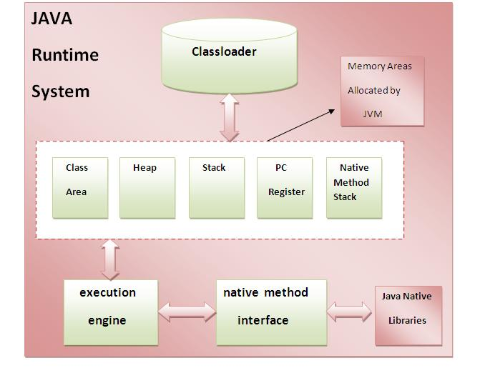 

### 1) Classloader:

Classloader is a subsystem of JVM that is used to load class files.

### 2) Class(Method) Area:

Class(Method) Area stores per-class structures such as the runtime constant pool, field and method data, the code for methods.

### 3) Heap:

It is the runtime data area in which objects are allocated.

### 4) Stack:

|  |
| --- |
| Java Stack stores frames.It holds local variables and partial results, and plays a part in method invocation and return. |
| Each thread has a private JVM stack, created at the same time as thread. |
| A new frame is created each time a method is invoked. A frame is destroyed when its method invocation completes. |

### 5) Program Counter Regiser:

PC (program counter) register. It contains the address of the Java virtual machine instruction currently being executed.

### 6) Native Method Stack:

It contains all the native methods used in the application.

### 7) Execution Engine:

|  |
| --- |
| It contains: |
| **1) A virtual processor** |
| **2) Interpreter:** Read bytecode stream then execute the instructions. |
| **3) Just-In-Time (JIT) compiler:** It is used to improve the performance. JIT compiles parts of the byte code that have similar functionality at the same time, and hence reduces the amount of time needed for compilation. Here the term compiler refers to a translator from the instruction set of a Java virtual machine (JVM) to the instruction set of a specific CPU. |

# Variable and Datatype in Java

1. [Variable](http://www.javatpoint.com/variable-datatype#variable)
2. [Types of Variable](http://www.javatpoint.com/variable-datatype#typesofvariable)
3. [Data Types in Java](http://www.javatpoint.com/variable-datatype#datatype)

|  |
| --- |
| In this page, we will learn about the variable and java data types. Variable is a name of memory location. There are three types of variables: local, instance and static. There are two types of data types in java, primitive and non-primitive. |

### Variable

|  |
| --- |
| Variable is name of reserved area allocated in memory. |
| variable in java |

int data=50;//Here data is variable

### Types of Variable

|  |
| --- |
| There are three types of variables in java   * local variable * instance variable * static variable * types of variable |

#### Local Variable

|  |
| --- |
| A variable that is declared inside the method is called local variable. |

#### Instance Variable

|  |
| --- |
| A variable that is declared inside the class but outside the method is called instance variable. It is not declared as static. |

#### Static variable

|  |
| --- |
| A variable that is declared as static is called static variable. It cannot be local. |

|  |
| --- |
| We will have detailed learning of these variables in next chapters. |

#### Example to understand the types of variables

class A{

int data=50;//instance variable

static int m=100;//static variable

void method(){

int n=90;//local variable

}

}//end of class

### Data Types in Java

|  |
| --- |
| In java, there are two types of data types   * primitive data types * non-primitive data types |

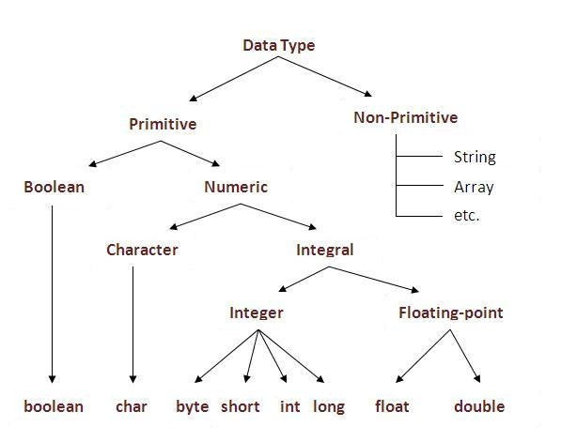

|  |  |  |
| --- | --- | --- |
| **Data Type** | **Default Value** | **Default size** |
| boolean | false | 1 bit |
| char | '\u0000' | 2 byte |
| byte | 0 | 1 byte |
| short | 0 | 2 byte |
| int | 0 | 4 byte |
| long | 0L | 8 byte |
| float | 0.0f | 4 byte |
| double | 0.0d | 8 byte |

### Why char uses 2 byte in java and what is \u0000 ?

|  |
| --- |
| because java uses Unicode system rather than ASCII code system. \u0000 is the lowest range of unicode system.To get detail about Unicode see below. |

# Unicode System

|  |
| --- |
| Unicode is a universal international standard character encoding that is capable of representing most of the world's written languages. |

### Why java uses Unicode System?

|  |
| --- |
| Before Unicode, there were many language standards: |
| * **ASCII** (American Standard Code for Information Interchange) for the United States. * **ISO 8859-1** for Western European Language. * **KOI-8** for Russian. * **GB18030 and BIG-5** for chinese, and so on. |

|  |
| --- |
| **This caused two problems:**   1. A particular code value corresponds to different letters in the various language standards. 2. The encodings for languages with large character sets have variable length.Some common characters are encoded as single bytes, other require two or more byte. |
| To solve these problems, a new language standard was developed i.e. Unicode System. |
| In unicode, character holds 2 byte, so java also uses 2 byte for characters. |
| **lowest value:**\u0000 |
| **highest value:**\uFFFF |

# Operators in java

**Operator** is a special symbol that is used to perform operations. There are many types of operators in java such as unary operator, arithmetic operator, relational operator, shift operator, bitwise operator, ternary operator and assignment operator.

|  |  |
| --- | --- |
| **Precedence of Operators** | |
| Operators | Precedence |
| postfix | expr++ expr-- |
| unary | ++expr --expr +expr -expr ~ ! |
| multiplicative | * / % |
| additive | + - |
| shift | << >> >>> |
| relational | < > <= >= instanceof |
| equality | == != |
| bitwise AND | & |
| bitwise exclusive OR | ^ |
| bitwise inclusive OR | | |
| logical AND | && |
| logical OR | || |
| Ternary | ? : |
| assignment | = += -= *= /= %= &= ^= |= <<= >>= >>>= |

### Useful Programs:

|  |
| --- |
| There is given some useful programs such as factorial number, prime number, fibonacci series etc. |

#### It is better for the fresher’s to skip this topic and come to it after OOPs concepts.

### 1) Program of factorial number.

class Operation{

static int fact(int number){

int f=1;

for(int i=1;i<=number;i++){

f=f*i;

}

return f;

}

public static void main(String args[]){

int result=fact(5);

System.out.println("Factorial of 5="+result);

}

}

### 2) Program of fibonacci series.

class Fabnoci{

public static void main(String...args)

{

int n=10,i,f0=1,f1=1,f2=0;

for(i=1;i<=n;i++)

{

f2=f0+f1;

f0=f1;

f1=f2;

f2=f0;

System.out.println(f2);

}

}

}

### 3) Program of armstrong number.

class ArmStrong{

public static void main(String...args)

{

int n=153,c=0,a,d;

d=n;

while(n>0)

{

a=n%10;

n=n/10;

c=c+(a*a*a);

}

if(d==c)

System.out.println("armstrong number");

else

System.out.println("it is not an armstrong number");

}

}

### 4) Program of checking palindrome number.

class Palindrome

{

public static void main( String...args)

{

int a=242;

int n=a,b=a,rev=0;

while(n>0)

{

a=n%10;

rev=rev*10+a;

n=n/10;

}

if(rev==b)

System.out.println("it is Palindrome");

else

System.out.println("it is not palinedrome");

}

}

### 5) Program of swapping two numbers without using third variable.

class SwapTwoNumbers{

public static void main(String args[]){

int a=40,b=5;

a=a*b;

b=a/b;

a=a/b;

System.out.println("a= "+a);

System.out.println("b= "+b);

}

}

### 6) Program of factorial number by recursion

class FactRecursion{

static int fact(int n){

if(n==1)

return 1;

return n*=fact(n-1);

}

public static void main(String args[]){

int f=fact(5);

System.out.println(f);

}

}

# Java OOPs Concepts

1. [Object Oriented Programming](http://www.javatpoint.com/java-oops-concepts#oops)
2. [Advantage of OOPs over Procedure-oriented programming language](http://www.javatpoint.com/java-oops-concepts#oopsadvantage)
3. [Difference between Objcet-oriented and Objcet-based programming language.](http://www.javatpoint.com/java-oops-concepts#oopsdifference)

In this page, we will learn about basics of OOPs. Object Oriented Programming is a paradigm that provides many concepts such as **inheritance**, **data binding**, **polymorphism** etc.

**Simula** is considered as the first object-oriented programming language. The programming paradigm where everything is represented as an object is known as truly object-oriented programming language.

**Smalltalk** is considered as the first truly object-oriented programming language.

## OOPs (Object Oriented Programming System)

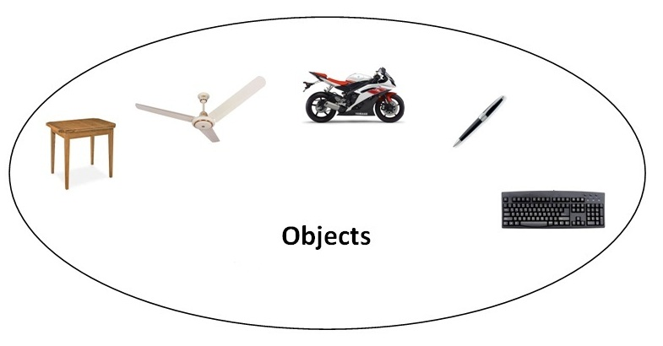**Object** means a real word entity such as pen, chair, table etc. **Object-Oriented Programming** is a methodology or paradigm to design a program using classes and objects. It simplifies the software development and maintenance by providing some concepts:

* Object
* Class
* Inheritance
* Polymorphism
* Abstraction
* Encapsulation

#### Object

Any entity that has state and behavior is known as an object. For example: chair, pen, table, keyboard, bike etc. It can be physical and logical.

#### Class

**Collection of objects** is called class. It is a logical entity.

#### Inheritance

**When one object acquires all the properties and behaviors of parent object** i.e. known as inheritance. It provides code reusability. It is used to achieve runtime polymorphism.

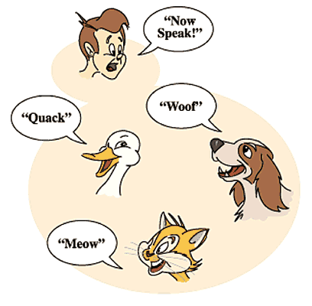

#### Polymorphism

When **one task is performed by different ways** i.e. known as polymorphism. For example: to convense the customer differently, to draw something e.g. shape or rectangle etc.

In java, we use method overloading and method overriding to achieve polymorphism.

Another example can be to speak something e.g. cat speaks meaw, dog barks woof etc.

#### Abstraction

**Hiding internal details and showing functionality** is known as abstraction. For example: phone call, we don't know the internal processing.

In java, we use abstract class and interface to achieve abstraction.



#### Encapsulation

**Binding (or wrapping) code and data together into a single unit is known as encapsulation**. For example: capsule, it is wrapped with different medicines.

A java class is the example of encapsulation. Java bean is the fully encapsulated class because all the data members are private here.

### Advantage of OOPs over Procedure-oriented programming language

|  |
| --- |
| 1)OOPs makes development and maintenance easier where as in Procedure-oriented programming language it is not easy to manage if code grows as project size grows. |
| 2)OOPs provides data hiding whereas in Procedure-oriented prgramming language a global data can be accessed from anywhere. |
| 3)OOPs provides ability to simulate real-world event much more effectively. We can provide the solution of real word problem if we are using the Object-Oriented Programming language. |

|  |  |
| --- | --- |
| Global Data | Object Data |

### What is difference between object-oriented programming language and object-based programming language?

|  |
| --- |
| Object based programming language follows all the features of OOPs except Inheritance. JavaScript and VBScript are examples of object based programming languages. |

Do You Know ?

|  |
| --- |
| * Can we overload main method ? * Constructor returns a value but, what ? * Can we create a program without main method ? * What are the 6 ways to use this keyword ? * Why multiple inheritance is not supported in java ? * Why use aggregation ? * Can we override the static method ? * What is covariant return type ? * What are the three usage of super keyword? * Why use instance initializer block? * What is the usage of blank final variable ? * What is marker or tagged interface ? * What is runtime polymorphism or dynamic method dispatch ? * What is the difference between static and dynamic binding ? * How downcasting is possible in java ? * What is the purpose of private constructor? * What is object cloning ? |

What we will learn in OOPs Concepts ?

|  |
| --- |
| * Advantage of OOPs * Naming Convention * Object and class * Method overloading * Constructor * static keyword * this keyword with 6 usage * Inheritance * Aggregation * Method Overriding * Covariant Return Type * super keyword * Instance Initializer block * final keyword * Abstract class * Interface * Runtime Polymorphism * Static and Dynamic Binding * Downcasting with instanceof operator * Package * Access Modifiers * Encapsulation * Object Cloning |

# Java Naming conventions

A **naming convention** is a rule to follow as you decide what to name your identifiers e.g. class, package, variable, constant, method etc.

But, it is not forced to follow. So, it is known as convention not rule.

#### Advantage of naming conventions in java

By using standard Java naming conventions, you make your code easier to read for yourself and for other programmers. Readability of Java program is very important. It indicates that **less time** is spent to figure out what the code does.

|  |  |
| --- | --- |
| Name | **Convention** |
| class name | should start with uppercase letter and be a noun e.g. String, Color, Button, System, Thread etc. |
| interface name | should start with uppercase letter and be an adjective e.g. Runnable, Remote, ActionListener etc. |
| method name | should start with lowercase letter and be a verb e.g. actionPerformed(), main(), print(), println() etc. |
| variable name | should start with lowercase letter e.g. firstName, orderNumber etc. |
| package name | should be in lowercase letter e.g. java, lang, sql, util etc. |
| constants name | should be in uppercase letter. e.g. RED, YELLOW, MAX_PRIORITY etc. |

#### Understanding CamelCase in java naming conventions

Java follows camelcase syntax for naming the class, interface, method and variable.

If name is combined with two words, second word will start with uppercase letter always e.g. actionPerformed(), firstName, ActionEvent, ActionListener etc.

# Object and Class in Java

1. [Object in Java](http://www.javatpoint.com/object-and-class-in-java#object)
2. [Class in Java](http://www.javatpoint.com/object-and-class-in-java#class)
3. [Instace Variable in Java](http://www.javatpoint.com/object-and-class-in-java#objectinstancevariable)
4. [Method in Java](http://www.javatpoint.com/object-and-class-in-java#objectmethod)
5. [Example of Object and class that maintains the records of student](http://www.javatpoint.com/object-and-class-in-java#objectex2)
6. [Annonymous Object](http://www.javatpoint.com/object-and-class-in-java#objectannonymous)

In this page, we will learn about java objects and classes. In object-oriented programming technique, we design a program using objects and classes.

Object is the physical as well as logical entity whereas class is the logical entity only.

### Object in Java



An entity that has state and behavior is known as an object e.g. chair, bike, marker, pen, table, car etc. It can be physical or logical (tengible and intengible). The example of integible object is banking system.

An object has three characteristics:

* **state:** represents data (value) of an object.
* **behavior:** represents the behavior (functionality) of an object such as deposit, withdraw etc.
* **identity:** Object identity is typically implemented via a unique ID. The value of the ID is not visible to the external user. But,it is used internally by the JVM to identify each object uniquely.

|  |
| --- |
| For Example: Pen is an object. Its name is Reynolds, color is white etc. known as its state. It is used to write, so writing is its behavior. |

|  |
| --- |
| **Object is an instance of a class.** Class is a template or blueprint from which objects are created. So object is the instance(result) of a class. |

### Class in Java

|  |
| --- |
| A class is a group of objects that has common properties. It is a template or blueprint from which objects are created. |

A class in java can contain:

* **data member**
* **method**
* **constructor**
* **block**
* **class and interface**

### Syntax to declare a class:

**class** <class_name>{

     data member;

     method;

}

### Simple Example of Object and Class

In this example, we have created a Student class that have two data members id and name. We are creating the object of the Student class by new keyword and printing the objects value.

**class** Student{

**int** id;//data member (also instance variable)

  String name;//data member(also instance variable)

**public** **static** **void** main(String args[]){

   Student s1=**new** Student();//creating an object of Student

   System.out.println(s1.id+" "+s1.name);

    }

}

Output: 0 null

### Instance variable in Java

|  |
| --- |
| A variable that is created inside the class but outside the method, is known as instance variable. Instance variable doesn't get memory at compile time.It gets memory at runtime when object(instance) is created.That is why, it is known as instance variable. |

### Method in Java

|  |
| --- |
| In java, a method is like function i.e. used to expose behaviour of an object. |

#### Advantage of Method

* Code Reusability
* Code Optimization

### new keyword

|  |
| --- |
| The new keyword is used to allocate memory at runtime. |

### Example of Object and class that maintains the records of students

|  |
| --- |
| In this example, we are creating the two objects of Student class and initializing the value to these objects by invoking the insertRecord method on it. Here, we are displaying the state (data) of the objects by invoking the displayInformation method. |

**class** Student{

**int** rollno;

  String name;

**void** insertRecord(**int** r, String n){  //method

   rollno=r;

   name=n;

  }

**void** displayInformation(){System.out.println(rollno+" "+name);}//method

**public** **static** **void** main(String args[]){

   Student s1=**new** Student();

   Student s2=**new** Student();

   s1.insertRecord(111,"Karan");

   s2.insertRecord(222,"Aryan");

   s1.displayInformation();

   s2.displayInformation();

  }

}

Output:111 Karan

222 Aryan

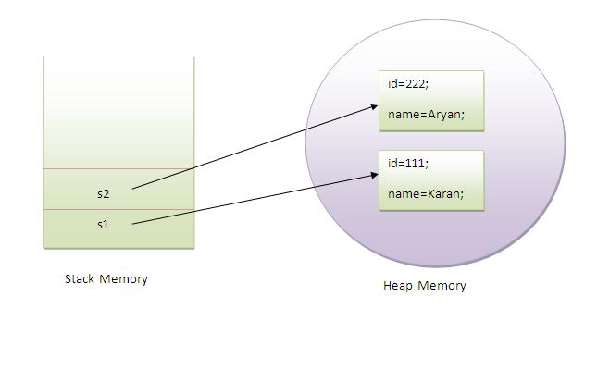

|  |
| --- |
| As you see in the above figure, object gets the memory in Heap area and reference variable refers to the object allocated in the Heap memory area. Here, s1 and s2 both are reference variables that refer to the objects allocated in memory. |

### Another Example of Object and Class

|  |
| --- |
| There is given another example that maintains the records of Rectangle class. Its exaplanation is same as in the above Student class example. |

**class** Rectangle{

**int** length;

**int** width;

**void** insert(**int** l,**int** w){

  length=l;

  width=w;

 }

**void** calculateArea(){System.out.println(length*width);}

**public** **static** **void** main(String args[]){

  Rectangle r1=**new** Rectangle();

  Rectangle r2=**new** Rectangle();

  r1.insert(11,5);

  r2.insert(3,15);

  r1.calculateArea();

  r2.calculateArea();

}

}

Output:55

45

### What are the different ways to create an object in Java?

|  |
| --- |
| There are many ways to create an object in java. They are:   * By new keyword * By newInstance() method * By clone() method * By factory method etc.   We will learn, these ways to create the object later. |

### Annonymous object

|  |
| --- |
| Annonymous simply means nameless.An object that have no reference is known as annonymous object. |
| If you have to use an object only once, annonymous object is a good approach. |

**class** Calculation{

**void** fact(**int**  n){

**int** fact=1;

**for**(**int** i=1;i<=n;i++){

   fact=fact*i;

  }

 System.out.println("factorial is "+fact);

}

**public** **static** **void** main(String args[]){

**new** Calculation().fact(5);//calling method with annonymous object

}

}

Output:Factorial is 120

### Creating multiple objects by one type only

|  |
| --- |
| We can create multiple objects by one type only as we do in case of primitives. |

1. Rectangle r1=**new** Rectangle(),r2=**new** Rectangle();//creating two objects

|  |
| --- |
| Let's see the example: |

**class** Rectangle{

**int** length;

**int** width;

**void** insert(**int** l,**int** w){

  length=l;

  width=w;

 }

**void** calculateArea(){System.out.println(length*width);}

**public** **static** **void** main(String args[]){

  Rectangle r1=**new** Rectangle(),r2=**new** Rectangle();//creating two objects

  r1.insert(11,5);

  r2.insert(3,15);

  r1.calculateArea();

  r2.calculateArea();

}

}

Output:55

45

http://www.javatpoint.com/object-and-class-in-java