Q) What are different oops concept in java?
Ans) OOPs stands for Object Oriented Programming. The concepts in oops are similar to any other programming languages. Basically, it is program agnostic.
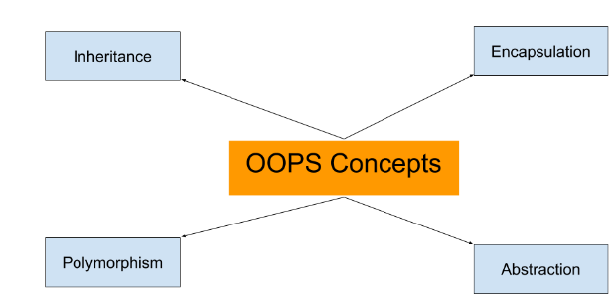
In this page, we will learn about basics of OOPs. Object Oriented Programming is a paradigm that provides many concepts such as inheritance, data binding, polymorphism etc.
Simula is considered as the first object-oriented programming language. The programming paradigm where everything is represented as an object, is known as truly object-oriented programming language.
Smalltalk is considered as the first truly object-oriented programming language.

OOPs (Object Oriented Programming System)
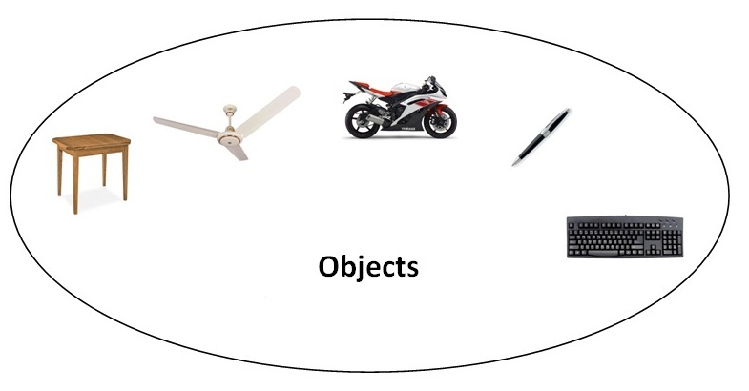Object means a real word entity such as pen, chair, table etc.Object-Oriented Programming is a methodology or paradigm to design a program using classes and objects. It simplifies the software development and maintenance by providing some concepts:
- Object
- Class
- Inheritance
- Polymorphism
- Abstraction
- Encapsulation

Object
Any entity that has state and behavior is known as an object. For example: chair, pen, table, keyboard, bike etc. It can be physical and logical.

Class
Collection of objects is called class. It is a logical entity.

Inheritance
When one object acquires all the properties and behaviours of parent object i.e. known as inheritance. It provides code reusability. It is used to achieve runtime polymorphism.
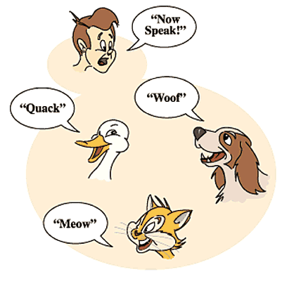

Polymorphism
When one task is performed by different ways i.e. known as polymorphism. For example: to convince the customer differently, to draw something e.g. shape or rectangle etc.
In java, we use method overloading and method overriding to achieve polymorphism.
Another example can be to speak something e.g. cat speaks meaw, dog barks woof etc.

Abstraction
Hiding internal details and showing functionality is known as abstraction. For example: phone call, we don't know the internal processing.
In java, we use abstract class and interface to achieve abstraction.


Encapsulation
Binding (or wrapping) code and data together into a single unit is known as encapsulation. For example: capsule, it is wrapped with different medicines.
A java class is the example of encapsulation. Java bean is the fully encapsulated class because all the data members are private here

What are the different ways to create an object in Java?
There are many ways to create an object in java. They are:
- By new keyword
- By newInstance() method
- By clone() method
- By factory method etc.
We will learn, these ways to create the object later.

Annonymous object
Annonymous simply means nameless.An object that have no reference is known as annonymous object.
If you have to use an object only once, annonymous object is a good approach.
- class Calculation{

- void fact(int n){
- int fact=1;
- for(int i=1;i<=n;i++){
- fact=fact*i;
- }
- System.out.println("factorial is "+fact);
- }

- public static void main(String args[]){
- new Calculation().fact(5);//calling method with annonymous object
- }
- }
Output:Factorial is 120
.

Method Overloading in Java
- Different ways to overload the method
- By changing the no. of arguments
- By changing the datatype
- Why method overloading is not possible by changing the return type
- Can we overload the main method
- method overloading with Type Promotion
If a class have multiple methods by same name but different parameters, it is known as Method Overloading.
If we have to perform only one operation, having same name of the methods increases the readability of the program.
Suppose you have to perform addition of the given numbers but there can be any number of arguments, if you write the method such as a(int,int) for two parameters, and b (int,int,int) for three parameters then it may be difficult for you as well as other programmers to understand the behavior of the method because its name differs. So, we perform method overloading to figure out the program quickly.


Advantage of method overloading?
Method overloading increases the readability of the program.

Different ways to overload the method
There are two ways to overload the method in java
- By changing number of arguments
- By changing the data type

) Example of Method Overloading by changing the no. of arguments
In this example, we have created two overloaded methods, first sum method performs addition of two numbers and second sum method performs addition of three numbers.
- class Calculation{
- void sum(int a,int b){System.out.println(a+b);}
- void sum(int a,int b,int c){System.out.println(a+b+c);}

- public static void main(String args[]){
- Calculation obj=new Calculation();
- obj.sum(10,10,10);
- obj.sum(20,20);

- }
- }
Test it Now
Output:30
40

2) Example of Method Overloading by changing data type of argument
In this example, we have created two overloaded methods that differs in data type. The first sum method receives two integer arguments and second sum method receives two double arguments.
- class Calculation2{
- void sum(int a,int b){System.out.println(a+b);}
- void sum(double a,double b){System.out.println(a+b);}

- public static void main(String args[]){
- Calculation2 obj=new Calculation2();
- obj.sum(10.5,10.5);
- obj.sum(20,20);

- }
- }
Test it Now
Output:21.0
40

Que) Why Method Overloaing is not possible by changing the return type of method?
In java, method overloading is not possible by changing the return type of the method because there may occur ambiguity. Let's see how ambiguity may occur:
because there was problem:
- class Calculation3{
- int sum(int a,int b){System.out.println(a+b);}
- double sum(int a,int b){System.out.println(a+b);}

- public static void main(String args[]){
- Calculation3 obj=new Calculation3();
- int result=obj.sum(20,20); //Compile Time Error

- }
- }
Test it Now
int result=obj.sum(20,20); //Here how can java determine which sum() method should be called

Can we overload main() method?
Yes, by method overloading. You can have any number of main methods in a class by method overloading. Let's see the simple example:
- class Overloading1{
- public static void main(int a){
- System.out.println(a);
- }

- public static void main(String args[]){
- System.out.println("main() method invoked");
- main(10);
- }
- }
Test it Now
Output:main() method invoked
10

Method Overloading and Type Promotion
One type is promoted to another implicitly if no matching datatype is found. Let's understand the concept by the figure given below:
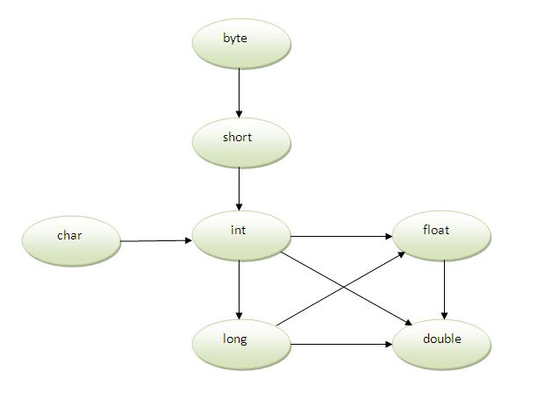
As displayed in the above diagram, byte can be promoted to short, int, long, float or double. The short datatype can be promoted to int,long,float or double. The char datatype can be promoted to int,long,float or double and so on.

Example of Method Overloading with TypePromotion
- class OverloadingCalculation1{
- void sum(int a,long b){System.out.println(a+b);}
- void sum(int a,int b,int c){System.out.println(a+b+c);}

- public static void main(String args[]){
- OverloadingCalculation1 obj=new OverloadingCalculation1();
- obj.sum(20,20);//now second int literal will be promoted to long
- obj.sum(20,20,20);

- }
- }
Test it Now
Output:40
60

Example of Method Overloading with Type Promotion if matching found
If there are matching type arguments in the method, type promotion is not performed.
- class OverloadingCalculation2{
- void sum(int a,int b){System.out.println("int arg method invoked");}
- void sum(long a,long b){System.out.println("long arg method invoked");}

- public static void main(String args[]){
- OverloadingCalculation2 obj=new OverloadingCalculation2();
- obj.sum(20,20);//now int arg sum() method gets invoked
- }
- }
Test it Now
Output:int arg method invoked

Example of Method Overloading with Type Promotion in case of ambiguity
If there are no matching type arguments in the method, and each method promotes similar number of arguments, there will be ambiguity.
- class OverloadingCalculation3{
- void sum(int a,long b){System.out.println("a method invoked");}
- void sum(long a,int b){System.out.println("b method invoked");}

- public static void main(String args[]){
- OverloadingCalculation3 obj=new OverloadingCalculation3();
- obj.sum(20,20);//now ambiguity
- }
- }
Test it Now
Output:Compile Time Error

Java Copy Constructor
There is no copy constructor in java. But, we can copy the values of one object to another like copy constructor in C++.
There are many ways to copy the values of one object into another in java. They are:
- By constructor
- By assigning the values of one object into another
- By clone() method of Object class
In this example, we are going to copy the values of one object into another using java constructor.
- class Student6{
- int id;
- String name;
- Student6(int i,String n){
- id = i;
- name = n;
- }

- Student6(Student6 s){
- id = s.id;
- name =s.name;
- }
- void display(){System.out.println(id+" "+name);}

- public static void main(String args[]){
- Student6 s1 = new Student6(111,"Karan");
- Student6 s2 = new Student6(s1);
- s1.display();
- s2.display();
- }
- }
Test it Now
Output:
111 Karan
111 Karan

Copying values without constructor
We can copy the values of one object into another by assigning the objects values to another object. In this case, there is no need to create the constructor.
- class Student7{
- int id;
- String name;
- Student7(int i,String n){
- id = i;
- name = n;
- }
- Student7(){}
- void display(){System.out.println(id+" "+name);}

- public static void main(String args[]){
- Student7 s1 = new Student7(111,"Karan");
- Student7 s2 = new Student7();
- s2.id=s1.id;
- s2.name=s1.name;
- s1.display();
- s2.display();
- }
- }
Test it Now
Output:
111 Karan
111 Karan

Q) Does constructor return any value?
Ans:yes, that is current class instance (You cannot use return type yet it returns a value).

Can constructor perform other tasks instead of initialization?
Yes, like object creation, starting a thread, calling method etc. You can perform any operation in the constructor as you perform in the method.

Java static keyword
- Static variable
- Program of counter without static variable
- Program of counter with static variable
- Static method
- Restrictions for static method
- Why main method is static ?
- Static block
- Can we execute a program without main method ?
The static keyword in java is used for memory management mainly. We can apply java static keyword with variables, methods, blocks and nested class. The static keyword belongs to the class than instance of the class.
The static can be:
- variable (also known as class variable)
- method (also known as class method)
- block
- nested class

1) Java static variable
If you declare any variable as static, it is known static variable.
- The static variable can be used to refer the common property of all objects (that is not unique for each object) e.g. company name of employees,college name of students etc.
- The static variable gets memory only once in class area at the time of class loading.

Advantage of static variable
It makes your program memory efficient (i.e it saves memory).

Program of counter without static variable
In this example, we have created an instance variable named count which is incremented in the constructor. Since instance variable gets the memory at the time of object creation, each object will have the copy of the instance variable, if it is incremented, it won't reflect to other objects. So each objects will have the value 1 in the count variable.
- class Counter{
- int count=0;//will get memory when instance is created

- Counter(){
- count++;
- System.out.println(count);
- }

- public static void main(String args[]){

- Counter c1=new Counter();
- Counter c2=new Counter();
- Counter c3=new Counter();

- }
- }
Test it Now
Output:1
1
1

Program of counter by static variable
As we have mentioned above, static variable will get the memory only once, if any object changes the value of the static variable, it will retain its value.
- class Counter2{
- static int count=0;//will get memory only once and retain its value

- Counter2(){
- count++;
- System.out.println(count);
- }

- public static void main(String args[]){

- Counter2 c1=new Counter2();
- Counter2 c2=new Counter2();
- Counter2 c3=new Counter2();

- }
- }
Test it Now
Output:1
2
3

Restrictions for static method
There are two main restrictions for the static method. They are:

- The static method can not use non static data member or call non-static method directly.
- this and super cannot be used in static context.

Q) why java main method is static?
Ans) because object is not required to call static method if it were non-static method, jvm create object first then call main() method that will lead the problem of extra memory allocation.

Java static block
- Is used to initialize the static data member.
- It is executed before main method at the time of classloading.

Example of static block
- class A2{
- static{System.out.println("static block is invoked");}
- public static void main(String args[]){
- System.out.println("Hello main");
- }
- }
Test it Now
Output:static block is invoked
Hello main

Q) Can we execute a program without main() method?
Ans) Yes, one of the way is static block but in previous version of JDK not in JDK 1.7.
- class A3{
- static{
- System.out.println("static block is invoked");
- System.exit(0);
- }
- }
Test it Now
Output:static block is invoked (if not JDK7)
In JDK7 and above, output will be:
Output:Error: Main method not found in class A3, please define the main method as:
public static void main(String[] args)

There can be a lot of usage of java this keyword. In java, this is a reference variable that refers to the current object.

Usage of java this keyword
Here is given the 6 usage of java this keyword.
- this keyword can be used to refer current class instance variable.
- this() can be used to invoke current class constructor.
- this keyword can be used to invoke current class method (implicitly)
- this can be passed as an argument in the method call.
- this can be passed as argument in the constructor call.
- this keyword can also be used to return the current class instance.
Suggestion: If you are beginner to java, lookup only two usage of this keyword.

Rule: Call to this() must be the first statement in constructor.
- class Student15{
- int id;
- String name;
- Student15(){System.out.println("default constructor is invoked");}

- Student15(int id,String name){
- id = id;
- name = name;
- this ();//must be the first statement
- }
- void display(){System.out.println(id+" "+name);}

- public static void main(String args[]){
- Student15 e1 = new Student15(111,"karan");
- Student15 e2 = new Student15(222,"Aryan");
- e1.display();
- e2.display();
- }
- }
Test it Now
Output:Compile Time Error

The this keyword can be used to invoke current class method (implicitly).

4) this keyword can be passed as an argument in the method.
The this keyword can also be passed as an argument in the method. It is mainly used in the event handling. Let's see the example:
- class S2{
- void m(S2 obj){
- System.out.println("method is invoked");
- }
- void p(){
- m(this);
- }

- public static void main(String args[]){
- S2 s1 = new S2();
- s1.p();
- }
- }

5) The this keyword can be passed as argument in the constructor call.
We can pass the this keyword in the constructor also. It is useful if we have to use one object in multiple classes. Let's see the example:
- class B{
- A4 obj;
- B(A4 obj){
- this.obj=obj;
- }
- void display(){
- System.out.println(obj.data);//using data member of A4 class
- }
- }

- class A4{
- int data=10;
- A4(){
- B b=new B(this);
- b.display();
- }
- public static void main(String args[]){
- A4 a=new A4();
- }
- }
Test it Now
Output:10

6) The this keyword can be used to return current class instance.
We can return the this keyword as an statement from the method. In such case, return type of the method must be the class type (non-primitive). Let's see the example:

Syntax of this that can be returned as a statement
- return_type method_name(){
- return this;
- }

Example of this keyword that you return as a statement from the method
- class A{
- A getA(){
- return this;
- }
- void msg(){System.out.println("Hello java");}
- }

- class Test1{
- public static void main(String args[]){
- new A().getA().msg();
- }
- }
Test it Now
Output:Hello java

Proving this keyword
Let's prove that this keyword refers to the current class instance variable. In this program, we are printing the reference variable and this, output of both variables are same.
- class A5{
- void m(){
- System.out.println(this);//prints same reference ID
- }

- public static void main(String args[]){
- A5 obj=new A5();
- System.out.println(obj);//prints the reference ID

- obj.m();
- }
- }
Test it Now
Output:A5@22b3ea59
A5@22b3ea59

Fibonacci series in Java
In fibonacci series, next number is the sum of previous two numbers for example 0, 1, 1, 2, 3, 5, 8, 13, 21, 34, 55 etc. The first two numbers of fibonacci series are 0 and 1.
There are two ways to write the fibonacci series program in java:
- Fibonacci Series without using recursion
- Fibonacci Series using recursion

Fibonacci Series in Java without using recursion
Let's see the fibonacci series program in java without using recursion.
- class FibonacciExample1{
- public static void main(String args[])
- {
- int n1=0,n2=1,n3,i,count=10;
- System.out.print(n1+" "+n2);//printing 0 and 1

- for(i=2;i<count;++i)//loop starts from 2 because 0 and 1 are already printed
- {
- n3=n1+n2;
- System.out.print(" "+n3);
- n1=n2;
- n2=n3;
- }

- }}
Output:
0 1 1 2 3 5 8 13 21 34

Fibonacci Series using recursion in java
Let's see the fibonacci series program in java using recursion.
- class FibonacciExample2{
- static int n1=0,n2=1,n3=0;
- static void printFibonacci(int count){
- if(count>0){
- n3 = n1 + n2;
- n1 = n2;
- n2 = n3;
- System.out.print(" "+n3);
- printFibonacci(count-1);
- }
- }
- public static void main(String args[]){
- int count=10;
- System.out.print(n1+" "+n2);//printing 0 and 1
- printFibonacci(count-2);//n-2 because 2 numbers are already printed
- }
- }
Output:
0 1 1 2 3 5 8 13 21 34

Prime Number Program in Java
Prime number in Java: Prime number is a number that is greater than 1 and divided by 1 or itself. In other words, prime numbers can't be divided by other numbers than itself or 1. For example 2, 3, 5, 7, 11, 13, 17.... are the prime numbers.

Note: 0 and 1 are not prime numbers. The 2 is the only even prime number because all the other even numbers can be divided by 2.
Let's see the prime number program in java. In this java program, we will take a number variable and check whether the number is prime or not.
- class PrimeExample{
- public static void main(String args[]){
- int i,m=0,flag=0;
- int n=17;//it is the number to be checked
- m=n/2;
- for(i=2;i<=m;i++){
- if(n%i==0){
- System.out.println("Number is not prime");
- flag=1;
- break;
- }
- }
- if(flag==0)
- System.out.println("Number is prime");
- }
- }
Output:
Number is prime

Palindrome Program in Java
Palindrome number in java: A palindrome number is a number that is same after reverse. For example 545, 151, 34543, 343, 171, 48984 are the palindrome numbers.

Palindrome number algorithm
- Get the number to check for palindrome
- Hold the number in temporary variable
- Reverse the number
- Compare the temporary number with reversed number
- If both numbers are same, print "palindrome number"
- Else print "not palindrome number"
Let's see the palindrome program in java. In this java program, we will get a number variable and check whether number is palindrome or not.
- class PalindromeExample{
- public static void main(String args[]){
- int r,sum=0,temp;
- int n=454;//It is the number variable to be checked for palindrome

- temp=n;
- while(n>0){
- r=n%10; //getting remainder
- sum=(sum*10)+r;
- n=n/10;
- }
- if(temp==sum)
- System.out.println("palindrome number ");
- else
- System.out.println("not palindrome");
- }
- }
Output:
palindrome number

Factorial Program in Java
Factorial Program in Java: Factorial of n is the product of all positive descending integers. Factorial of n is denoted by n!. For example:
- 4! = 4*3*2*1 = 24
- 5! = 5*4*3*2*1 = 120
Here, 4! is pronounced as "4 factorial", it is also called "4 bang" or "4 shriek".
The factorial is normally used in Combinations and Permutations (mathematics).
There are many ways to write the factorial program in java language. Let's see the 2 ways to write the factorial program in java.
- Factorial Program using loop
- Factorial Program using recursion

Factorial Program using loop in java
Let's see the factorial Program using loop in java.
- class FactorialExample{
- public static void main(String args[]){
- int i,fact=1;
- int number=5;//It is the number to calculate factorial
- for(i=1;i<=number;i++){
- fact=fact*i;
- }
- System.out.println("Factorial of "+number+" is: "+fact);
- }
- }
Output:
Factorial of 5 is: 120

Factorial Program using recursion in java
Let's see the factorial program in java using recursion.
- class FactorialExample2{
- static int factorial(int n){
- if (n == 0)
- return 1;
- else
- return(n * factorial(n-1));
- }
- public static void main(String args[]){
- int i,fact=1;
- int number=4;//It is the number to calculate factorial
- fact = factorial(number);
- System.out.println("Factorial of "+number+" is: "+fact);
- }
- }

Armstrong Number in Java
Armstrong Number in Java: Armstrong number is a number that is equal to the sum of cubes of its digits for example 0, 1, 153, 370, 371, 407 etc.
Let's try to understand why 153 is an Armstrong number.
- 153 = (1*1*1)+(5*5*5)+(3*3*3)
- where:
- (1*1*1)=1
- (5*5*5)=125
- (3*3*3)=27
- So:
- 1+125+27=153
Let's try to understand why 371 is an Armstrong number.
- 371 = (3*3*3)+(7*7*7)+(1*1*1)
- where:
- (3*3*3)=27
- (7*7*7)=343
- (1*1*1)=1
- So:
- 27+343+1=371
Let's see the java program to check Armstrong Number.
- class ArmstrongExample{
- public static void main(String[] args) {
- int c=0,a,temp;
- int n=153;//It is the number to check armstrong
- temp=n;
- while(n>0)
- {
- a=n%10;
- n=n/10;
- c=c+(a*a*a);
- }
- if(temp==c)
- System.out.println("armstrong number");
- else
- System.out.println("Not armstrong number");
- }
- }
Output:
armstrong number

Inheritance in Java
- Inheritance
- Types of Inheritance
- Why multiple inheritance is not possible in java in case of class?
Inheritance in java is a mechanism in which one object acquires all the properties and behaviors of parent object.
The idea behind inheritance in java is that you can create new classes that are built upon existing classes. When you inherit from an existing class, you can reuse methods and fields of parent class, and you can add new methods and fields also.
Inheritance represents the IS-A relationship, also known as parent-child relationship.

Why use inheritance in java
- For Method Overriding (so runtime polymorphism can be achieved).
- For Code Reusability.

Syntax of Java Inheritance
- class Subclass-name extends Superclass-name
- {
- //methods and fields
- }
The extends keyword indicates that you are making a new class that derives from an existing class.
In the terminology of Java, a class that is inherited is called a super class. The new class is called a subclass.

Understanding the simple example of inheritance
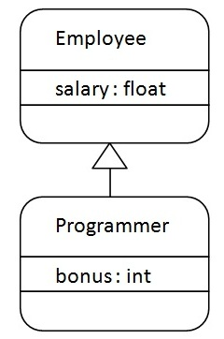
As displayed in the above figure, Programmer is the subclass and Employee is the superclass. Relationship between two classes is Programmer IS-A Employee.It means that Programmer is a type of Employee.
- class Employee{
- float salary=40000;
- }
- class Programmer extends Employee{
- int bonus=10000;
- public static void main(String args[]){
- Programmer p=new Programmer();
- System.out.println("Programmer salary is:"+p.salary);
- System.out.println("Bonus of Programmer is:"+p.bonus);
- }
- }
Test it Now
Programmer salary is:40000.0
Bonus of programmer is:10000

Types of inheritance in java
On the basis of class, there can be three types of inheritance in java: single, multilevel and hierarchical.
In java programming, multiple and hybrid inheritance is supported through interface only. We will learn about interfaces later.
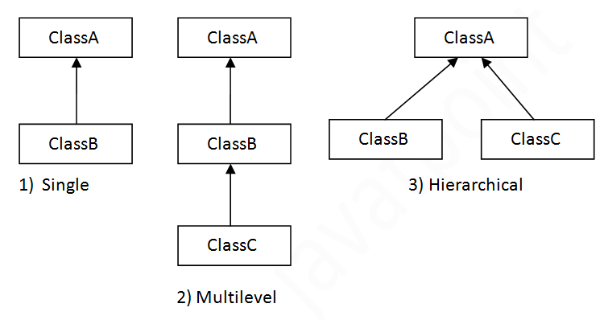

Note: Multiple inheritance is not supported in java through class.
When a class extends multiple classes i.e. known as multiple inheritance. For Example:
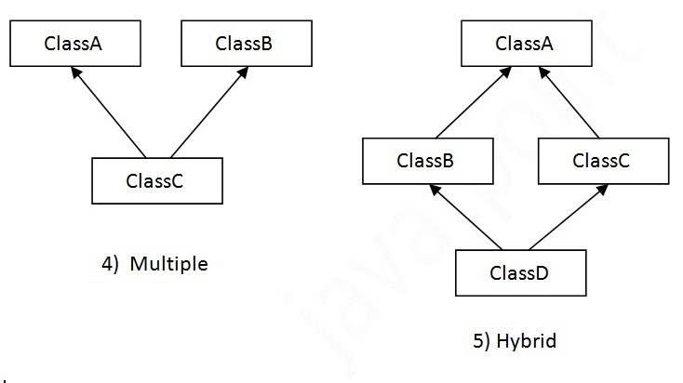

Why multiple inheritance is not supported in java?
To reduce the complexity and simplify the language, multiple inheritance is not supported in java.
Consider a scenario where A, B and C are three classes. The C class inherits A and B classes. If A and B classes have same method and you call it from child class object, there will be ambiguity to call method of A or B class.
Since compile time errors are better than runtime errors, java renders compile time error if you inherit 2 classes. So whether you have same method or different, there will be compile time error now.
- class A{
- void msg(){System.out.println("Hello");}
- }
- class B{
- void msg(){System.out.println("Welcome");}
- }
- class C extends A,B{//suppose if it were

- Public Static void main(String args[]){
- C obj=new C();
- obj.msg();//Now which msg() method would be invoked?
- }
- }
Test it Now
Compile Time Error

Aggregation in Java
If a class have an entity reference, it is known as Aggregation. Aggregation represents HAS-A relationship.
Consider a situation, Employee object contains many informations such as id, name, emailId etc. It contains one more object named address, which contains its own informations such as city, state, country, zipcode etc. as given below.
- class Employee{
- int id;
- String name;
- Address address;//Address is a class
- ...
- }
In such case, Employee has an entity reference address, so relationship is Employee HAS-A address.

Why use Aggregation?
- For Code Reusability.

When use Aggregation?
- Code reuse is also best achieved by aggregation when there is no is-a relationship.
- Inheritance should be used only if the relationship is-a is maintained throughout the lifetime of the objects involved; otherwise, aggregation is the best choice.

Method Overriding in Java
- Understanding problem without method overriding
- Can we override the static method
- method overloading vs method overriding
If subclass (child class) has the same method as declared in the parent class, it is known as method overriding in java.
In other words, If subclass provides the specific implementation of the method that has been provided by one of its parent class, it is known as method overriding.

Usage of Java Method Overriding
- Method overriding is used to provide specific implementation of a method that is already provided by its super class.
- Method overriding is used for runtime polymorphism

Rules for Java Method Overriding
- method must have same name as in the parent class
- method must have same parameter as in the parent class.
- must be IS-A relationship (inheritance).

Understanding the problem without method overriding
Let's understand the problem that we may face in the program if we don't use method overriding.
- class Vehicle{
- void run(){System.out.println("Vehicle is running");}
- }
- class Bike extends Vehicle{

- public static void main(String args[]){
- Bike obj = new Bike();
- obj.run();
- }
- }
Test it Now
Output:Vehicle is running
Problem is that I have to provide a specific implementation of run() method in subclass that is why we use method overriding.

Example of method overriding
In this example, we have defined the run method in the subclass as defined in the parent class but it has some specific implementation. The name and parameter of the method is same and there is IS-A relationship between the classes, so there is method overriding.
- class Vehicle{
- void run(){System.out.println("Vehicle is running");}
- }
- class Bike2 extends Vehicle{
- void run(){System.out.println("Bike is running safely");}

- public static void main(String args[]){
- Bike2 obj = new Bike2();
- obj.run();
- }
Test it Now
Output:Bike is running safely

Real example of Java Method Overriding
Consider a scenario, Bank is a class that provides functionality to get rate of interest. But, rate of interest varies according to banks. For example, SBI, ICICI and AXIS banks could provide 8%, 7% and 9% rate of interest.
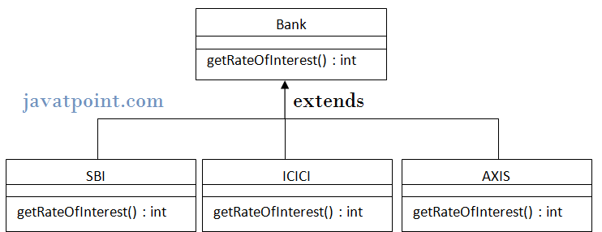
- class Bank{
- int getRateOfInterest(){return 0;}
- }

- class SBI extends Bank{
- int getRateOfInterest(){return 8;}
- }

- class ICICI extends Bank{
- int getRateOfInterest(){return 7;}
- }
- class AXIS extends Bank{
- int getRateOfInterest(){return 9;}
- }

- class Test2{
- public static void main(String args[]){
- SBI s=new SBI();
- ICICI i=new ICICI();
- AXIS a=new AXIS();
- System.out.println("SBI Rate of Interest: "+s.getRateOfInterest());
- System.out.println("ICICI Rate of Interest: "+i.getRateOfInterest());
- System.out.println("AXIS Rate of Interest: "+a.getRateOfInterest());
- }
- }
Test it Now
Output:
SBI Rate of Interest: 8
ICICI Rate of Interest: 7
AXIS Rate of Interest: 9

Can we override static method?
No, static method cannot be overridden. It can be proved by runtime polymorphism, so we will learn it later.

Why we cannot override static method?
because static method is bound with class whereas instance method is bound with object. Static belongs to class area and instance belongs to heap area.

Can we override java main method?
No, because main is a static method.

Difference between method overloading and method overriding in java
There are many differences between method overloading and method overriding in java. A list of differences between method overloading and method overriding are given below:
No. | Method Overloading | Method Overriding
1) | Method overloading is used to increase the readability of the program. | Method overriding is used to provide the specific implementation of the method that is already provided by its super class.
2) | Method overloading is performed within class. | Method overriding occurs in two classes that have IS-A (inheritance) relationship.
3) | In case of method overloading, parameter must be different. | In case of method overriding, parameter must be same.
4) | Method overloading is the example of compile time polymorphism. | Method overriding is the example of run time polymorphism.
5) | In java, method overloading can't be performed by changing return type of the method only. Return type can be same or different in method overloading. But you must have to change the parameter. | Return type must be same or covariant in method overriding.

Access Modifiers in java
- private access modifier
- Role of private constructor
- default access modifier
- protected access modifier
- public access modifier
- Applying access modifier with method overriding
There are two types of modifiers in java: access modifiers and non-access modifiers.
The access modifiers in java specifies accessibility (scope) of a data member, method, constructor or class.
There are 4 types of java access modifiers:
- private
- default
- protected
- public
There are many non-access modifiers such as static, abstract, synchronized, native, volatile, transient etc. Here, we will learn access modifiers.

1) private access modifier
The private access modifier is accessible only within class.

Simple example of private access modifier
In this example, we have created two classes A and Simple. A class contains private data member and private method. We are accessing these private members from outside the class, so there is compile time error.
- class A{
- private int data=40;
- private void msg(){System.out.println("Hello java");}
- }

- public class Simple{
- public static void main(String args[]){
- A obj=new A();
- System.out.println(obj.data);//Compile Time Error
- obj.msg();//Compile Time Error
- }
- }

Role of Private Constructor
If you make any class constructor private, you cannot create the instance of that class from outside the class. For example:
- class A{
- private A(){}//private constructor
- void msg(){System.out.println("Hello java");}
- }
- public class Simple{
- public static void main(String args[]){
- A obj=new A();//Compile Time Error
- }
- }

2) default access modifier
If you don't use any modifier, it is treated as default bydefault. The default modifier is accessible only within package.

Example of default access modifier
In this example, we have created two packages pack and mypack. We are accessing the A class from outside its package, since A class is not public, so it cannot be accessed from outside the package.
- //save by A.java
- package pack;
- class A{
- void msg(){System.out.println("Hello");}
- }
- //save by B.java
- package mypack;
- import pack.*;
- class B{
- public static void main(String args[]){
- A obj = new A();//Compile Time Error
- obj.msg();//Compile Time Error
- }
- }
In the above example, the scope of class A and its method msg() is default so it cannot be accessed from outside the package.

3) protected access modifier
The protected access modifier is accessible within package and outside the package but through inheritance only.
The protected access modifier can be applied on the data member, method and constructor. It can't be applied on the class.

Example of protected access modifier
In this example, we have created the two packages pack and mypack. The A class of pack package is public, so can be accessed from outside the package. But msg method of this package is declared as protected, so it can be accessed from outside the class only through inheritance.
- //save by A.java
- package pack;
- public class A{
- protected void msg(){System.out.println("Hello");}
- }
- //save by B.java
- package mypack;
- import pack.*;

- class B extends A{
- public static void main(String args[]){
- B obj = new B();
- obj.msg();
- }
- }
Output:Hello

Understanding all java access modifiers
Let's understand the access modifiers by a simple table.
Access Modifier | within class | within package | outside package by subclass only | outside package
Private | Y | N | N | N
Default | Y | Y | N | N
Protected | Y | Y | Y | N
Public | Y | Y | Y | Y

Java access modifiers with method overriding
If you are overriding any method, overridden method (i.e. declared in subclass) must not be more restrictive.
- class A{
- protected void msg(){System.out.println("Hello java");}
- }

- public class Simple extends A{
- void msg(){System.out.println("Hello java");}//C.T.Error
- public static void main(String args[]){
- Simple obj=new Simple();
- obj.msg();
- }
- }
The default modifier is more restrictive than protected. That is why there is compile time error.

ExceptionHandling with MethodOverriding in Java
There are many rules if we talk about methodoverriding with exception handling. The Rules are as follows:
- If the superclass method does not declare an exception
  - If the superclass method does not declare an exception, subclass overridden method cannot declare the checked exception but it can declare unchecked exception.
- If the superclass method declares an exception
  - If the superclass method declares an exception, subclass overridden method can declare same, subclass exception or no exception but cannot declare parent exception.

If the superclass method does not declare an exception

1) Rule: If the superclass method does not declare an exception, subclass overridden method cannot declare the checked exception.
- import java.io.*;
- class Parent{
- void msg(){System.out.println("parent");}
- }

- class TestExceptionChild extends Parent{
- void msg()throws IOException{
- System.out.println("TestExceptionChild");
- }
- public static void main(String args[]){
- Parent p=new TestExceptionChild();
- p.msg();
- }
- }
Test it Now
Output:Compile Time Error

2) Rule: If the superclass method does not declare an exception, subclass overridden method cannot declare the checked exception but can declare unchecked exception.
- import java.io.*;
- class Parent{
- void msg(){System.out.println("parent");}
- }

- class TestExceptionChild1 extends Parent{
- void msg()throws ArithmeticException{
- System.out.println("child");
- }
- public static void main(String args[]){
- Parent p=new TestExceptionChild1();
- p.msg();
- }
- }
Test it Now
Output:child

If the superclass method declares an exception

1) Rule: If the superclass method declares an exception, subclass overridden method can declare same, subclass exception or no exception but cannot declare parent exception.

Example in case subclass overridden method declares parent exception
- import java.io.*;
- class Parent{
- void msg()throws ArithmeticException{System.out.println("parent");}
- }

- class TestExceptionChild2 extends Parent{
- void msg()throws Exception{System.out.println("child");}

- public static void main(String args[]){
- Parent p=new TestExceptionChild2();
- try{
- p.msg();
- }catch(Exception e){}
- }
- }
Test it Now
Output:Compile Time Error

Example in case subclass overridden method declares same exception
- import java.io.*;
- class Parent{
- void msg()throws Exception{System.out.println("parent");}
- }

- class TestExceptionChild3 extends Parent{
- void msg()throws Exception{System.out.println("child");}

- public static void main(String args[]){
- Parent p=new TestExceptionChild3();
- try{
- p.msg();
- }catch(Exception e){}
- }
- }
Test it Now
Output:child

Example in case subclass overridden method declares subclass exception
- import java.io.*;
- class Parent{
- void msg()throws Exception{System.out.println("parent");}
- }

- class TestExceptionChild4 extends Parent{
- void msg()throws ArithmeticException{System.out.println("child");}

- public static void main(String args[]){
- Parent p=new TestExceptionChild4();
- try{
- p.msg();
- }catch(Exception e){}
- }
- }
Test it Now
Output:child

Example in case subclass overridden method declares no exception
- import java.io.*;
- class Parent{
- void msg()throws Exception{System.out.println("parent");}
- }

- class TestExceptionChild5 extends Parent{
- void msg(){System.out.println("child");}

- public static void main(String args[]){
- Parent p=new TestExceptionChild5();
- try{
- p.msg();
- }catch(Exception e){}
- }
- }
Test it Now
Output:child

Covariant Return Type
The covariant return type specifies that the return type may vary in the same direction as the subclass.
Before Java5, it was not possible to override any method by changing the return type. But now, since Java5, it is possible to override method by changing the return type if subclass overrides any method whose return type is Non-Primitive but it changes its return type to subclass type. Let's take a simple example:

Note: If you are beginner to java, skip this topic and return to it after OOPs concepts.

Simple example of Covariant Return Type
- class A{
- A get(){return this;}
- }

- class B1 extends A{
- B1 get(){return this;}
- void message(){System.out.println("welcome to covariant return type");}

- public static void main(String args[]){
- new B1().get().message();
- }
- }
Test it Now
Output:welcome to covariant return type
As you can see in the above example, the return type of the get() method of A class is A but the return type of the get() method of B class is B. Both methods have different return type but it is method overriding. This is known as covariant return type.

super keyword in java
The super keyword in java is a reference variable that is used to refer immediate parent class object.
Whenever you create the instance of subclass, an instance of parent class is created implicitly i.e. referred by super reference variable.

Usage of java super Keyword
- super is used to refer immediate parent class instance variable.
- super() is used to invoke immediate parent class constructor.
- super is used to invoke immediate parent class method.

1) super is used to refer immediate parent class instance variable.
Problem without super keyword
- class Vehicle{
- int speed=50;
- }
- class Bike3 extends Vehicle{
- int speed=100;
- void display(){
- System.out.println(speed);//will print speed of Bike
- }
- public static void main(String args[]){
- Bike3 b=new Bike3();
- b.display();
- }
- }
Test it Now
Output:100
In the above example Vehicle and Bike both class have a common property speed. Instance variable of current class is refered by instance bydefault, but I have to refer parent class instance variable that is why we use super keyword to distinguish between parent class instance variable and current class instance variable.
Solution by super keyword
- //example of super keyword

- class Vehicle{
- int speed=50;
- }

- class Bike4 extends Vehicle{
- int speed=100;

- void display(){
- System.out.println(super.speed);//will print speed of Vehicle now
- }
- public static void main(String args[]){
- Bike4 b=new Bike4();
- b.display();

- }
- }
Test it Now
Output:50

2) super is used to invoke parent class constructor.
The super keyword can also be used to invoke the parent class constructor as given below:
- class Vehicle{
- Vehicle(){System.out.println("Vehicle is created");}
- }

- class Bike5 extends Vehicle{
- Bike5(){
- super();//will invoke parent class constructor
- System.out.println("Bike is created");
- }
- public static void main(String args[]){
- Bike5 b=new Bike5();

- }
- }
Test it Now
Output:Vehicle is created
Bike is created

Note: super() is added in each class constructor automatically by compiler.
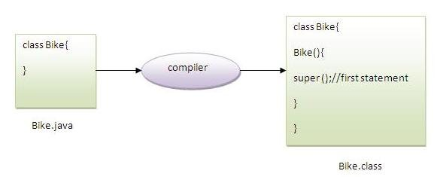
As we know well that default constructor is provided by compiler automatically but it also adds super() for the first statement.If you are creating your own constructor and you don't have either this() or super() as the first statement, compiler will provide super() as the first statement of the constructor.

Another example of super keyword where super() is provided by the compiler implicitly.
- class Vehicle{
- Vehicle(){System.out.println("Vehicle is created");}
- }

- class Bike6 extends Vehicle{
- int speed;
- Bike6(int speed){
- this.speed=speed;
- System.out.println(speed);
- }
- public static void main(String args[]){
- Bike6 b=new Bike6(10);
- }
- }
Test it Now
Output:Vehicle is created
10

3) super can be used to invoke parent class method
The super keyword can also be used to invoke parent class method. It should be used in case subclass contains the same method as parent class as in the example given below:
- class Person{
- void message(){System.out.println("welcome");}
- }

- class Student16 extends Person{
- void message(){System.out.println("welcome to java");}

- void display(){
- message();//will invoke current class message() method
- super.message();//will invoke parent class message() method
- }

- public static void main(String args[]){
- Student16 s=new Student16();
- s.display();
- }
- }
Test it Now
Output:welcome to java
welcome
In the above example Student and Person both classes have message() method if we call message() method from Student class, it will call the message() method of Student class not of Person class because priority is given to local.

In case there is no method in subclass as parent, there is no need to use super. In the example given below message() method is invoked from Student class but Student class does not have message() method, so you can directly call message() method.

Program in case super is not required
- class Person{
- void message(){System.out.println("welcome");}
- }

- class Student17 extends Person{

- void display(){
- message();//will invoke parent class message() method
- }

- public static void main(String args[]){
- Student17 s=new Student17();
- s.display();
- }
- }
Test it Now
Output:welcome

Instance initializer block
- Instance initializer block
- Example of Instance initializer block
- What is invoked firstly instance initializer block or constructor?
- Rules for instance initializer block
- Program of instance initializer block that is invoked after super()
Instance Initializer block is used to initialize the instance data member. It run each time when object of the class is created.
The initialization of the instance variable can be directly but there can be performed extra operations while initializing the instance variable in the instance initializer block.

Que) What is the use of instance initializer block while we can directly assign a value in instance data member? For example:
- class Bike{
- int speed=100;
- }

Why use instance initializer block?
Suppose I have to perform some operations while assigning value to instance data member e.g. a for loop to fill a complex array or error handling etc.

Example of instance initializer block
Let's see the simple example of instance initializer block the performs initialization.
- class Bike7{
- int speed;

- Bike7(){System.out.println("speed is "+speed);}

- {speed=100;}

- public static void main(String args[]){
- Bike7 b1=new Bike7();
- Bike7 b2=new Bike7();
- }
- }
Test it Now
Output:speed is 100
speed is 100

There are three places in java where you can perform operations:
- method
- constructor
- block

What is invoked first, instance initializer block or constructor?
- class Bike8{
- int speed;

- Bike8(){System.out.println("constructor is invoked");}

- {System.out.println("instance initializer block invoked");}

- public static void main(String args[]){
- Bike8 b1=new Bike8();
- Bike8 b2=new Bike8();
- }
- }
Test it Now
Output:instance initializer block invoked
constructor is invoked
instance initializer block invoked
constructor is invoked
In the above example, it seems that instance initializer block is firstly invoked but NO. Instance intializer block is invoked at the time of object creation. The java compiler copies the instance initializer block in the constructor after the first statement super(). So firstly, constructor is invoked. Let's understand it by the figure given below:

Note: The java compiler copies the code of instance initializer block in every constructor.
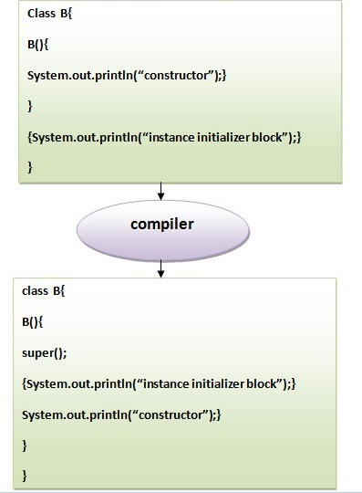

Rules for instance initializer block :
There are mainly three rules for the instance initializer block. They are as follows:
- The instance initializer block is created when instance of the class is created.
- The instance initializer block is invoked after the parent class constructor is invoked (i.e. after super() constructor call).
- The instance initializer block comes in the order in which they appear.

Program of instance initializer block that is invoked after super()
- class A{
- A(){
- System.out.println("parent class constructor invoked");
- }
- }
- class B2 extends A{
- B2(){
- super();
- System.out.println("child class constructor invoked");
- }

- {System.out.println("instance initializer block is invoked");}

- public static void main(String args[]){
- B2 b=new B2();
- }
- }
Test it Now
Output:parent class constructor invoked
instance initializer block is invoked
child class constructor invoked

Another example of instance block
- class A{
- A(){
- System.out.println("parent class constructor invoked");
- }
- }

- class B3 extends A{
- B3(){
- super();
- System.out.println("child class constructor invoked");
- }

- B3(int a){
- super();
- System.out.println("child class constructor invoked "+a);
- }

- {System.out.println("instance initializer block is invoked");}

- public static void main(String args[]){
- B3 b1=new B3();
- B3 b2=new B3(10);
- }
- }
Test it Now
Output:parent class constructor invoked
instance initializer block is invoked
child class constructor invoked
parent class constructor invoked
instance initializer block is invoked
child class constructor invoked 10

Final Keyword In Java
- Final variable
- Final method
- Final class
- Is final method inherited ?
- Blank final variable
- Static blank final variable
- Final parameter
- Can you declare a final constructor
The final keyword in java is used to restrict the user. The java final keyword can be used in many context. Final can be:
- variable
- method
- class
The final keyword can be applied with the variables, a final variable that have no value it is called blank final variable or uninitialized final variable. It can be initialized in the constructor only. The blank final variable can be static also which will be initialized in the static block only. We will have detailed learning of these. Let's first learn the basics of final keyword.
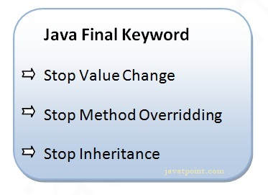

1) Java final variable
If you make any variable as final, you cannot change the value of final variable(It will be constant).

Example of final variable
There is a final variable speedlimit, we are going to change the value of this variable, but It can't be changed because final variable once assigned a value can never be changed.
- class Bike9{
- final int speedlimit=90;//final variable
- void run(){
- speedlimit=400;
- }
- public static void main(String args[]){
- Bike9 obj=new Bike9();
- obj.run();
- }
- }//end of class
Test it Now
Output:Compile Time Error

2) Java final method
If you make any method as final, you cannot override it.

Example of final method
- class Bike{
- final void run(){System.out.println("running");}
- }

- class Honda extends Bike{
- void run(){System.out.println("running safely with 100kmph");}

- public static void main(String args[]){
- Honda honda= new Honda();
- honda.run();
- }
- }
Test it Now
Output:Compile Time Error

3) Java final class
If you make any class as final, you cannot extend it.

Example of final class
- final class Bike{}

- class Honda1 extends Bike{
- void run(){System.out.println("running safely with 100kmph");}

- public static void main(String args[]){
- Honda1 honda= new Honda();
- honda.run();
- }
- }
Test it Now
Output:Compile Time Error

Q) Is final method inherited?
Ans) Yes, final method is inherited but you cannot override it. For Example:
- class Bike{
- final void run(){System.out.println("running...");}
- }
- class Honda2 extends Bike{
- public static void main(String args[]){
- new Honda2().run();
- }
- }
Test it Now
Output:running...

Q) What is blank or uninitialized final variable?
A final variable that is not initialized at the time of declaration is known as blank final variable.
If you want to create a variable that is initialized at the time of creating object and once initialized may not be changed, it is useful. For example PAN CARD number of an employee.
It can be initialized only in constructor.

Example of blank final variable
- class Student{
- int id;
- String name;
- final String PAN_CARD_NUMBER;
- ...
- }

Que) Can we initialize blank final variable?
Yes, but only in constructor. For example:
- class Bike10{
- final int speedlimit;//blank final variable

- Bike10(){
- speedlimit=70;
- System.out.println(speedlimit);
- }

- public static void main(String args[]){
- new Bike10();
- }
- }
Test it Now
Output:70

static blank final variable
A static final variable that is not initialized at the time of declaration is known as static blank final variable. It can be initialized only in static block.

Example of static blank final variable
- class A{
- static final int data;//static blank final variable
- static{ data=50;}
- public static void main(String args[]){
- System.out.println(A.data);
- }
- }

Q) What is final parameter?
If you declare any parameter as final, you cannot change the value of it.
- class Bike11{
- int cube(final int n){
- n=n+2;//can't be changed as n is final
- n*n*n;
- }
- public static void main(String args[]){
- Bike11 b=new Bike11();
- b.cube(5);
- }
- }
Test it Now
Output:Compile Time Error

Q) Can we declare a constructor final?
No, because constructor is never inherited.

Polymorphism in Java
Polymorphism in java is a concept by which we can perform a single action by different ways. Polymorphism is derived from 2 greek words: poly and morphs. The word "poly" means many and "morphs" means forms. So polymorphism means many forms.
There are two types of polymorphism in java: compile time polymorphism and runtime polymorphism. We can perform polymorphism in java by method overloading and method overriding.
If you overload static method in java, it is the example of compile time polymorphism. Here, we will focus on runtime polymorphism in java.

Runtime Polymorphism in Java
Runtime polymorphism or Dynamic Method Dispatch is a process in which a call to an overridden method is resolved at runtime rather than compile-time.
In this process, an overridden method is called through the reference variable of a superclass. The determination of the method to be called is based on the object being referred to by the reference variable.
Let's first understand the upcasting before Runtime Polymorphism.

Upcasting
When reference variable of Parent class refers to the object of Child class, it is known as upcasting. For example:
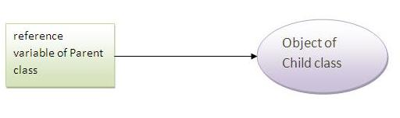
- class A{}
- class B extends A{}
- A a=new B();//upcasting

Example of Java Runtime Polymorphism
In this example, we are creating two classes Bike and Splendar. Splendar class extends Bike class and overrides its run() method. We are calling the run method by the reference variable of Parent class. Since it refers to the subclass object and subclass method overrides the Parent class method, subclass method is invoked at runtime.
Since method invocation is determined by the JVM not compiler, it is known as runtime polymorphism.
- class Bike{
- void run(){System.out.println("running");}
- }
- class Splender extends Bike{
- void run(){System.out.println("running safely with 60km");}

- public static void main(String args[]){
- Bike b = new Splender();//upcasting
- b.run();
- }
- }
Test it Now
Output:running safely with 60km.

Real example of Java Runtime Polymorphism
Consider a scenario, Bank is a class that provides method to get the rate of interest. But, rate of interest may differ according to banks. For example, SBI, ICICI and AXIS banks could provide 8%, 7% and 9% rate of interest.
Note: It is also given in method overriding but there was no upcasting.
- class Bank{
- int getRateOfInterest(){return 0;}
- }

- class SBI extends Bank{
- int getRateOfInterest(){return 8;}
- }

- class ICICI extends Bank{
- int getRateOfInterest(){return 7;}
- }
- class AXIS extends Bank{
- int getRateOfInterest(){return 9;}
- }

- class Test3{
- public static void main(String args[]){
- Bank b1=new SBI();
- Bank b2=new ICICI();
- Bank b3=new AXIS();
- System.out.println("SBI Rate of Interest: "+b1.getRateOfInterest());
- System.out.println("ICICI Rate of Interest: "+b2.getRateOfInterest());
- System.out.println("AXIS Rate of Interest: "+b3.getRateOfInterest());
- }
- }
Test it Now
Output:
SBI Rate of Interest: 8
ICICI Rate of Interest: 7
AXIS Rate of Interest: 9

Java Runtime Polymorphism with data member
Method is overridden not the datamembers, so runtime polymorphism can't be achieved by data members.
In the example given below, both the classes have a datamember speedlimit, we are accessing the datamember by the reference variable of Parent class which refers to the subclass object. Since we are accessing the datamember which is not overridden, hence it will access the datamember of Parent class always.

Rule: Runtime polymorphism can't be achieved by data members.
- class Bike{
- int speedlimit=90;
- }
- class Honda3 extends Bike{
- int speedlimit=150;

- public static void main(String args[]){
- Bike obj=new Honda3();
- System.out.println(obj.speedlimit);//90
- }
Test it Now
Output:90

Try for Output
- class Animal{
- void eat(){System.out.println("animal is eating...");}
- }

- class Dog extends Animal{
- void eat(){System.out.println("dog is eating...");}
- }

- class BabyDog1 extends Dog{
- public static void main(String args[]){
- Animal a=new BabyDog1();
- a.eat();
- }}
Test it Now
Output: Dog is eating
Since, BabyDog is not overriding the eat() method, so eat() method of Dog class is invoked.

Static Binding and Dynamic Binding

Connecting a method call to the method body is known as binding.
There are two types of binding
- static binding (also known as early binding).
- dynamic binding (also known as late binding).

Understanding Type
Let's understand the type of instance.

1) variables have a type
Each variable has a type, it may be primitive and non-primitive.
- int data=30;
Here data variable is a type of int.

2) References have a type
- class Dog{
- public static void main(String args[]){
- Dog d1;//Here d1 is a type of Dog
- }
- }

3) Objects have a type
An object is an instance of particular java class,but it is also an instance of its superclass.
- class Animal{}

- class Dog extends Animal{
- public static void main(String args[]){
- Dog d1=new Dog();
- }
- }
Here d1 is an instance of Dog class, but it is also an instance of Animal.

static binding
When type of the object is determined at compiled time(by the compiler), it is known as static binding.
If there is any private, final or static method in a class, there is static binding.

Example of static binding
- class Dog{
- private void eat(){System.out.println("dog is eating...");}

- public static void main(String args[]){
- Dog d1=new Dog();
- d1.eat();
- }
- }

Dynamic binding
When type of the object is determined at run-time, it is known as dynamic binding.

Example of dynamic binding
- class Animal{
- void eat(){System.out.println("animal is eating...");}
- }

- class Dog extends Animal{
- void eat(){System.out.println("dog is eating...");}

- public static void main(String args[]){
- Animal a=new Dog();
- a.eat();
- }
- }
Test it Now
Output:dog is eating...
In the above example object type cannot be determined by the compiler, because the instance of Dog is also an instance of Animal.So compiler doesn't know its type, only its base type.
N

Java instanceof
- java instanceof
- Example of instanceof operator
- Applying the instanceof operator with a variable the have null value
- Downcasting with instanceof operator
- Downcasting without instanceof operator
The java instanceof operator is used to test whether the object is an instance of the specified type (class or subclass or interface).
The instanceof in java is also known as type comparison operator because it compares the instance with type. It returns either true or false. If we apply the instanceof operator with any variable that has null value, it returns false.

Simple example of java instanceof
Let's see the simple example of instance operator where it tests the current class.
- class Simple1{
- public static void main(String args[]){
- Simple1 s=new Simple1();
- System.out.println(s instanceof Simple1);//true
- }
- }
Test it Now
Output:true

An object of subclass type is also a type of parent class. For example, if Dog extends Animal then object of Dog can be referred by either Dog or Animal class.

Another example of java instanceof operator
- class Animal{}
- class Dog1 extends Animal{//Dog inherits Animal

- public static void main(String args[]){
- Dog1 d=new Dog1();
- System.out.println(d instanceof Animal);//true
- }
- }
Test it Now
Output:true

instanceof in java with a variable that have null value
If we apply instanceof operator with a variable that have null value, it returns false. Let's see the example given below where we apply instanceof operator with the variable that have null value.
- class Dog2{
- public static void main(String args[]){
- Dog2 d=null;
- System.out.println(d instanceof Dog2);//false
- }
- }
Test it Now
Output:false

instanceof in java with a variable that have null value
If we apply instanceof operator with a variable that have null value, it returns false. Let's see the example given below where we apply instanceof operator with the variable that have null value.
- class Dog2{
- public static void main(String args[]){
- Dog2 d=null;
- System.out.println(d instanceof Dog2);//false
- }
- }
Test it Now
Output:false

Downcasting with java instanceof operator
When Subclass type refers to the object of Parent class, it is known as downcasting. If we perform it directly, compiler gives Compilation error. If you perform it by typecasting, ClassCastException is thrown at runtime. But if we use instanceof operator, downcasting is possible.
- Dog d=new Animal();//Compilation error
If we perform downcasting by typecasting, ClassCastException is thrown at runtime.
- Dog d=(Dog)new Animal();
- //Compiles successfully but ClassCastException is thrown at runtime

Possibility of downcasting with instanceof
Let's see the example, where downcasting is possible by instanceof operator.
- class Animal { }

- class Dog3 extends Animal {
- static void method(Animal a) {
- if(a instanceof Dog3){
- Dog3 d=(Dog3)a;//downcasting
- System.out.println("ok downcasting performed");
- }
- }

- public static void main (String [] args) {
- Animal a=new Dog3();
- Dog3.method(a);
- }

- }
Test it Now
Output:ok downcasting performed

Downcasting without the use of java instanceof
Downcasting can also be performed without the use of instanceof operator as displayed in the following example:
- class Animal { }
- class Dog4 extends Animal {
- static void method(Animal a) {
- Dog4 d=(Dog4)a;//downcasting
- System.out.println("ok downcasting performed");
- }
- public static void main (String [] args) {
- Animal a=new Dog4();
- Dog4.method(a);
- }
- }
Test it Now
Output:ok downcasting performed
Let's take closer look at this, actual object that is referred by a, is an object of Dog class. So if we downcast it, it is fine. But what will happen if we write:
- Animal a=new Animal();
- Dog.method(a);
- //Now ClassCastException but not in case of instanceof operator

Abstract class in Java
A class that is declared with abstract keyword, is known as abstract class in java. It can have abstract and non-abstract methods (method with body).
Before learning java abstract class, let's understand the abstraction in java first.

Abstraction in Java
Abstraction is a process of hiding the implementation details and showing only functionality to the user.
Another way, it shows only important things to the user and hides the internal details for example sending sms, you just type the text and send the message. You don't know the internal processing about the message delivery.
Abstraction lets you focus on what the object does instead of how it does it.

Ways to achieve Abstaction
There are two ways to achieve abstraction in java
- Abstract class (0 to 100%)
- Interface (100%)

Abstract class in Java
A class that is declared as abstract is known as abstract class. It needs to be extended and its method implemented. It cannot be instantiated.

Example abstract class
- abstract class A{}

abstract method
A method that is declared as abstract and does not have implementation is known as abstract method.

Example abstract method
- abstract void printStatus();//no body and abstract

Example of abstract class that has abstract method
In this example, Bike the abstract class that contains only one abstract method run. It implementation is provided by the Honda class.
- abstract class Bike{
- abstract void run();
- }
- class Honda4 extends Bike{
- void run(){System.out.println("running safely..");}
- public static void main(String args[]){
- Bike obj = new Honda4();
- obj.run();
- }
- }
Test it Now
running safely..

Another example of abstract class in java
File: TestBank.java
- abstract class Bank{
- abstract int getRateOfInterest();
- }
- class SBI extends Bank{
- int getRateOfInterest(){return 7;}
- }
- class PNB extends Bank{
- int getRateOfInterest(){return 8;}
- }

- class TestBank{
- public static void main(String args[]){
- Bank b;
- b=new SBI();
- System.out.println("Rate of Interest is: "+b.getRateOfInterest()+" %");
- b=new PNB();
- System.out.println("Rate of Interest is: "+b.getRateOfInterest()+" %");
- }}
Test it Now
Rate of Interest is: 7 %
Rate of Interest is: 8 %

Abstract class having constructor, data member, methods etc.
An abstract class can have data member, abstract method, method body, constructor and even main() method.
File: TestAbstraction2.java
- //example of abstract class that have method body
- abstract class Bike{
- Bike(){System.out.println("bike is created");}
- abstract void run();
- void changeGear(){System.out.println("gear changed");}
- }

- class Honda extends Bike{
- void run(){System.out.println("running safely..");}
- }
- class TestAbstraction2{
- public static void main(String args[]){
- Bike obj = new Honda();
- obj.run();
- obj.changeGear();
- }
- }
Test it Now
bike is created
running safely..
gear changed

Rule: If there is any abstract method in a class, that class must be abstract.
- class Bike12{
- abstract void run();
- }
Test it Now
compile time error

Rule: If you are extending any abstract class that have abstract method, you must either provide the implementation of the method or make this class abstract.

Another real scenario of abstract class
The abstract class can also be used to provide some implementation of the interface. In such case, the end user may not be forced to override all the methods of the interface.

Note: If you are beginner to java, learn interface first and skip this example.
- interface A{
- void a();
- void b();
- void c();
- void d();
- }

- abstract class B implements A{
- public void c(){System.out.println("I am C");}
- }

- class M extends B{
- public void a(){System.out.println("I am a");}
- public void b(){System.out.println("I am b");}
- public void d(){System.out.println("I am d");}
- }

- class Test5{
- public static void main(String args[]){
- A a=new M();
- a.a();
- a.b();
- a.c();
- a.d();
- }}
Test it Now
Output:I am a
I am b
I am c
I am d

Wrapper class in Java
Wrapper class in java provides the mechanism to convert primitive into object and object into primitive.
Since J2SE 5.0, autoboxing and unboxing feature converts primitive into object and object into primitive automatically. The automatic conversion of primitive into object is known as autoboxing and vice-versa unboxing.
The eight classes of java.lang package are known as wrapper classes in java. The list of eight wrapper classes are given below:
Primitive Type | Wrapper class
boolean | Boolean
char | Character
byte | Byte
short | Short
int | Integer
long | Long
float | Float
double | Double

Wrapper class Example: Primitive to Wrapper
- public class WrapperExample1{
- public static void main(String args[]){
- //Converting int into Integer
- int a=20;
- Integer i=Integer.valueOf(a);//converting int into Integer
- Integer j=a;//autoboxing, now compiler will write Integer.valueOf(a) internally

- System.out.println(a+" "+i+" "+j);
- }}
Output:
20 20 20

Wrapper class Example: Wrapper to Primitive
- public class WrapperExample2{
- public static void main(String args[]){
- //Converting Integer to int
- Integer a=new Integer(3);
- int i=a.intValue();//converting Integer to int
- int j=a;//unboxing, now compiler will write a.intValue() internally

- System.out.println(a+" "+i+" "+j);
- }}
Output:
3 3 3

Recursion in Java
Recursion in java is a process in which a method calls itself continuously. A method in java that calls itself is called recursive method.
It makes the code compact but complex to understand.
Syntax:
- returntype methodname(){
- //code to be executed
- methodname();//calling same method
- }

Java Recursion Example 1: Infinite times
- public class RecursionExample1 {
- static void p(){
- System.out.println("hello");
- p();
- }

- public static void main(String[] args) {
- p();
- }
- }
Output:
hello
hello
...
java.lang.StackOverflowError

Java Recursion Example 2: Finite times
- public class RecursionExample2 {
- static int count=0;
- static void p(){
- count++;
- if(count<=5){
- System.out.println("hello "+count);
- p();
- }
- }
- public static void main(String[] args) {
- p();
- }
- }
Output:
hello 1
hello 2
hello 3
hello 4
hello 5

Call by Value and Call by Reference in Java
There is only call by value in java, not call by reference. If we call a method passing a value, it is known as call by value. The changes being done in the called method, is not affected in the calling method.

Example of call by value in java
In case of call by value original value is not changed. Let's take a simple example:
- class Operation{
- int data=50;

- void change(int data){
- data=data+100;//changes will be in the local variable only
- }

- public static void main(String args[]){
- Operation op=new Operation();

- System.out.println("before change "+op.data);
- op.change(500);
- System.out.println("after change "+op.data);

- }
- }

Output:before change 50
after change 50

Another Example of call by value in java
In case of call by reference original value is changed if we made changes in the called method. If we pass object in place of any primitive value, original value will be changed. In this example we are passing object as a value. Let's take a simple example:
- class Operation2{
- int data=50;

- void change(Operation2 op){
- op.data=op.data+100;//changes will be in the instance variable
- }

- public static void main(String args[]){
- Operation2 op=new Operation2();

- System.out.println("before change "+op.data);
- op.change(op);//passing object
- System.out.println("after change "+op.data);

- }
- }

Output:before change 50
after change 150

Difference between object and class
There are many differences between object and class. A list of differences between object and class are given below:
No. | Object | Class
1) | Object is an instance of a class. | Class is a blueprint or template from which objects are created.
2) | Object is a real world entity such as pen, laptop, mobile, bed, keyboard, mouse, chair etc. | Class is a group of similar objects.
3) | Object is a physical entity. | Class is a logical entity.
4) | Object is created through new keyword mainly e.g.  Student s1=new Student(); | Class is declared using class keyword e.g.  class Student{}
5) | Object is created many times as per requirement. | Class is declared once.
6) | Object allocates memory when it is created. | Class doesn't allocated memory when it is created.
7) | There are many ways to create object in java such as new keyword, newInstance() method, clone() method, factory method and deserialization. | There is only one way to define class in java using class keyword.

