Maven :

1.what is Maven :
Project Management tool , Build tool
Compile, Run tests ,Package jars ,package wars , deploy in servepr

Project structure will be . as follow

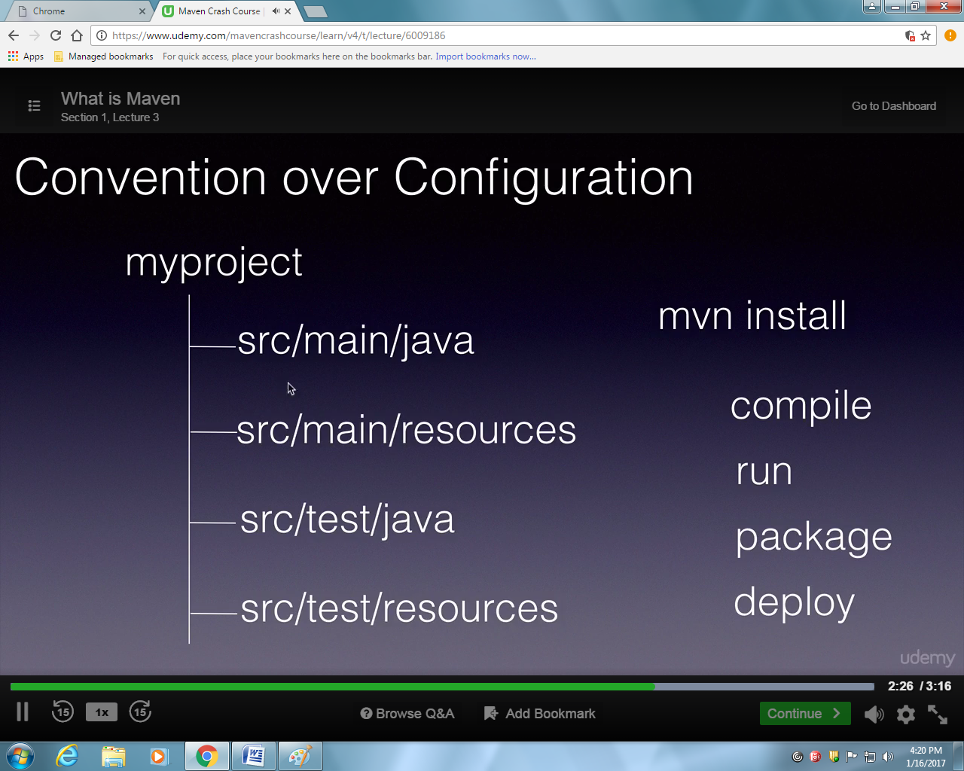

Why we use maven

Common interface for developer , easy to build , it manage dependencies,

