<!DOCTYPE html>

<html lang="en">

<head>

    <meta charset="UTF-8">

    <meta name="viewport" content="width=device-width, initial-scale=1.0">

    <title>MY PHONE VIDEOS</title>

    <center><h1>funnyvideo</h1></center>

</head>

<body>

    <details>

    <summary>funnyvideo</summary>

    <details>

    <summary>chinna tiffin box ee</summary>

    <>

    <video controls src="./40r/funnyvideo.mp4 " height="300" width="400">

        </video>

    </details>

</body>

</html>

**Step1**

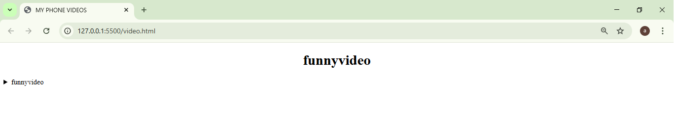

**Step2**

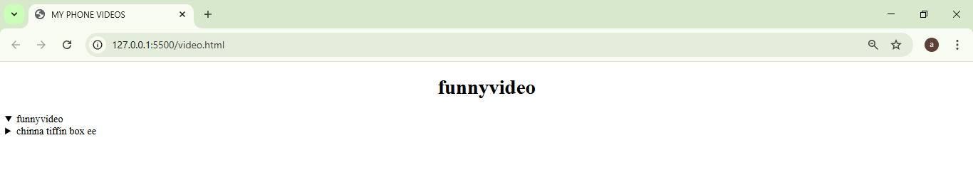

**Step3**

