KIET Group of Institutions, Ghaziabad
Department of Computer Science & Engineering
LAB ASSESSMENT 2 (LAB-2)
Use Case Diagram, Actors and Use Case Specification
Secure File Sharing System
Name | Anjil Tripathi
Roll Number | 202401100200053
Section | A
Program | B.Tech Computer Science & Engineering (2024–2028)
Project / SRS | Secure File Sharing System, Version 1.0

1. Aim
To draw the use case diagram for the Secure File Sharing System described in the SRS, identify the role of each actor, and state the function, precondition and postcondition of every use case.

2. System Overview
The Secure File Sharing System is a web-based application that allows authenticated users to upload, store, share, download and manage files securely. It protects files from unauthorised access through authentication, authorisation, controlled sharing, secure communication and audit logging. Four user classes are identified in the SRS: Unauthenticated Visitor, Registered User, File Owner and Administrator.

3. Use Case Diagram
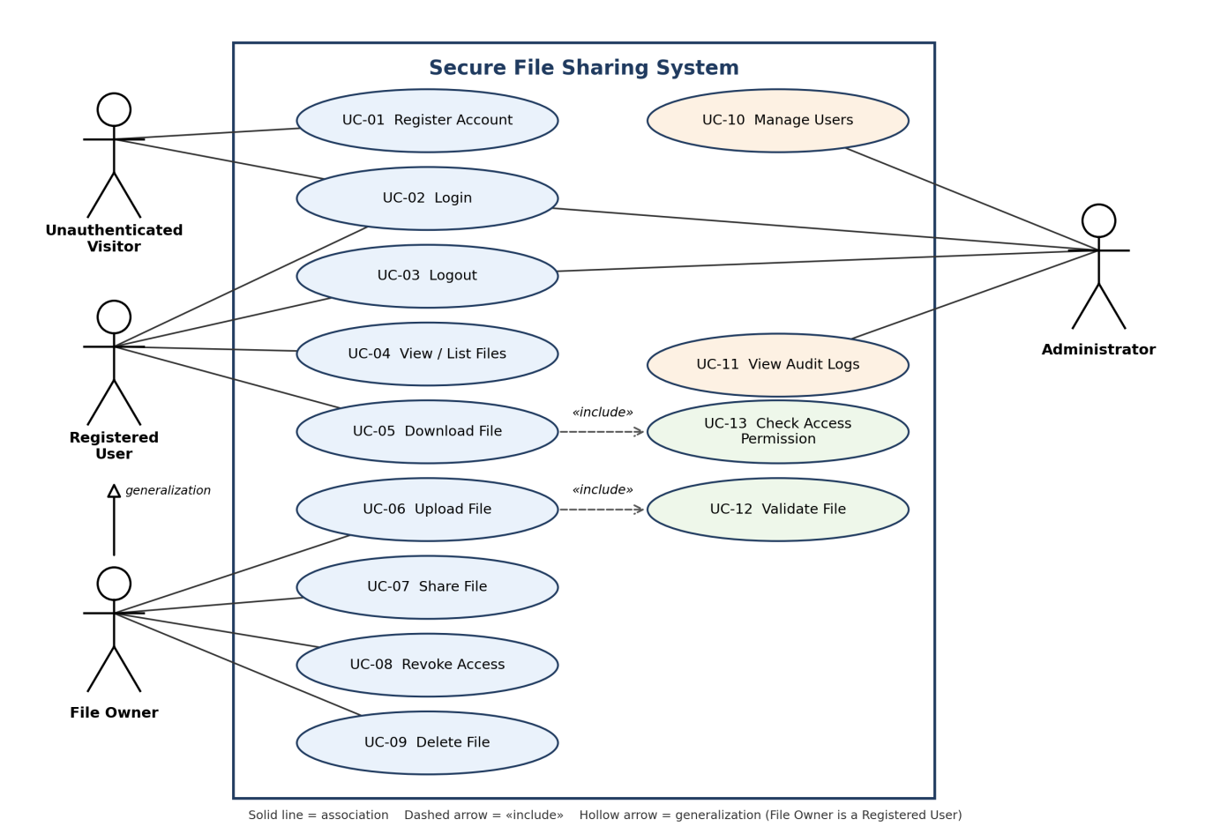
Figure 1: Use case diagram of the Secure File Sharing System

Relationships in the diagram
- Association: a solid line connects an actor to each use case it takes part in.
- Generalization: File Owner is a specialised Registered User, so it inherits all Registered User use cases (login, logout, view, download).
- Include: Upload File includes Validate File, and Download File includes Check Access Permission. These steps always run as part of the base use case.
- Audit logging: every security-sensitive use case (register, login, upload, share, revoke, download, delete, admin actions) records an audit entry, which the Administrator reads through View Audit Logs.

4. Actors and Their Roles
Actor | Role / Responsibility | Use Cases
Unauthenticated Visitor | A person who has not logged in. Can only reach the public pages (registration and login). Has no access to any protected file or user data. | Register Account, Login
Registered User | A normal authenticated user. Can log in and out, see files they own or that are shared with them, and download files for which an active permission exists. | Login, Logout, View / List Files, Download File
File Owner | A Registered User in the context of a file he/she uploaded (specialisation of Registered User). Controls who can access the file, and can manage or delete it. Inherits everything a Registered User can do. | Upload File, Share File, Revoke Access, Delete File (plus all Registered User use cases)
Administrator | Optional privileged role that manages user accounts and monitors system activity. Admin privileges are kept separate from normal users and do not automatically expose file contents. | Login, Logout, Manage Users, View Audit Logs

5. Use Case Specifications
Each use case below lists the actor(s), its function, the precondition that must hold before it starts, and the postcondition that holds after it completes.
UC-01: Register Account
Actor(s) | Unauthenticated Visitor
Function | Lets a new user create an account by submitting the required details. The system validates the input, rejects missing, invalid or duplicate details, and stores the password only in hashed form.
Precondition | User is not logged in.  Registration page is reachable over HTTPS.
Postcondition | A new user account is created with a hashed password.  On failure, no account is created and a suitable error is shown.  Registration event is recorded.

UC-02: Login
Actor(s) | Unauthenticated Visitor, Registered User, Administrator
Function | Authenticates the user with credentials and creates an authenticated session/token. Invalid credentials are denied without revealing which one was wrong.
Precondition | User has a registered account.  User is currently unauthenticated.
Postcondition | A valid session/token is created and the user can access protected functions.  On failure, access is denied and the session is not created.  Login attempt is logged.

UC-03: Logout
Actor(s) | Registered User, Administrator
Function | Ends the user's current session by invalidating the active session/token and returns the user to the unauthenticated state.
Precondition | User is logged in with a valid session.
Postcondition | Session/token is invalidated.  Protected pages and files can no longer be accessed until the user logs in again.

UC-04: View / List Files
Actor(s) | Registered User (and File Owner)
Function | Displays the files owned by the user and the files shared with the user, along with metadata such as name, size, owner, upload date and available actions.
Precondition | User is logged in.
Postcondition | Only files the user owns or has active permission for are listed.  No data of other users is exposed.

UC-05: Download File
Actor(s) | Registered User (and File Owner)
Function | Lets an authorised user download a file. The system authenticates the user, checks that the file exists and that permission is active (UC-13), and then returns the file securely.
Precondition | User is logged in.  File exists.  User is the owner or holds an active share permission.
Postcondition | The file is delivered to the user over HTTPS.  If permission is invalid or the file is missing, access is denied with an appropriate response.  Download (or denied attempt) is logged with timestamp and user identity.

UC-06: Upload File
Actor(s) | File Owner
Function | Allows a user to upload a file. The file name, size and type are validated (UC-12), the file is stored, and its metadata (ID, name, storage reference, size, owner, timestamp, status) is saved with the uploader as owner.
Precondition | User is logged in.  File satisfies the configured size and type limits.
Postcondition | File object and its metadata are stored and the user becomes its owner.  A failed upload leaves no misleading metadata.  Upload event is logged.

UC-07: Share File
Actor(s) | File Owner
Function | Lets the owner select a registered recipient and a permission (e.g. view/download) for a file they own. The system records the sharing permission as Active.
Precondition | User is logged in and is the owner of the file.  Recipient is a registered user.
Postcondition | A sharing record (file, recipient, permission, timestamp) is stored in Active state.  The recipient can now access the file according to that permission.  Share event is logged.

UC-08: Revoke Access
Actor(s) | File Owner
Function | Lets the owner remove or disable a recipient's existing permission on a file so that all subsequent access requests by that recipient are denied.
Precondition | User is logged in and is the owner of the file.  An active share permission exists for the recipient.
Postcondition | The permission state changes from Active to Revoked.  Recipient's later requests for the file are denied.  Revoke event is logged.

UC-09: Delete File
Actor(s) | File Owner
Function | Allows the owner to delete a file under the system's deletion rules. The file is identified by its ID, never by an arbitrary server path, to prevent path-traversal.
Precondition | User is logged in and is the owner of the file.  File exists.
Postcondition | File object, its metadata and its sharing permissions are removed or marked deleted.  Nobody can access the file afterwards.  Delete event is logged.

UC-10: Manage Users
Actor(s) | Administrator
Function | Lets the administrator manage user accounts (e.g. view, disable or remove users) and handle administrative operations, without gaining access to file contents.
Precondition | Administrator is logged in with the admin role.
Postcondition | The selected account change is applied.  File contents remain inaccessible to the admin unless explicitly authorised by policy.  Administrative action is logged.

UC-11: View Audit Logs
Actor(s) | Administrator
Function | Shows the recorded security-relevant events (upload, share, revoke, download, delete, login etc.) with timestamp and user identity so the admin can monitor system activity.
Precondition | Administrator is logged in with the admin role.  Audit records exist.
Postcondition | Audit records are displayed to the administrator.  Logs contain no passwords or unnecessary sensitive content, and are not modified by viewing.

UC-12: Validate File (included in UC-06)
Actor(s) | System (included use case)
Function | Checks the file name, size and type against configured limits and sanitises the name to prevent injection and path-traversal.
Precondition | A file has been submitted for upload.
Postcondition | A valid file is accepted for storage; an invalid file is rejected with a clear message.

UC-13: Check Access Permission (included in UC-05)
Actor(s) | System (included use case)
Function | Verifies the identity of the requester and whether they are the owner or hold an active (not revoked) permission for the requested file.
Precondition | A protected file request has been received from an authenticated user.
Postcondition | Access is allowed if permission is active, otherwise denied; no file content is exposed on denial.

6. Conclusion
The use case model covers the four user classes and all major functions given in the SRS: account management, secure upload, controlled sharing and revocation, authorised download, deletion, and audit-based monitoring. Authorisation checks and file validation are modelled as included use cases to show that security is applied on every protected operation.

