SOFTWARE ENGINEERING LAB
LAB 3
UML Class Diagram Design
Project: Secure File Sharing System
Name : Anjil Tripathi
Roll Number : 202401100200053
Class / Section : BTECH ‘CSE’
Date of Submission : 28 October 2026
Submitted To : Navdesh Sir

1. Aim
To identify the classes, their attributes, methods and the relationships between them for the Secure File Sharing System, and to draw the UML Class Diagram for it.

2. Objectives
- Write down the requirements of the project clearly before jumping into the diagram.
- Pick out the candidate classes from the requirements (mostly the nouns) and filter the ones that actually matter.
- Decide the attributes and operations for each class along with their visibility.
- Show association, aggregation, composition, inheritance and dependency with the correct multiplicity.
- Draw the final class diagram using a UML tool and explain the design decisions.

3. Introduction
A class diagram is the static view of a system. It does not tell us what happens step by step, it tells us what "things" exist in the software, what data each one holds and how they are connected. Since this is the diagram that later turns into actual classes and database tables, getting it right early saves a lot of rework.
Our project is a Secure File Sharing System, which is basically a small Google Drive / WeTransfer type of application but with a stronger focus on security. A user can upload files, the files are encrypted before they are stored, and the user can share them with others through links that have permissions, an expiry date and optionally a password. The owner can revoke a link any time and every important action is written to an audit log.

4. Problem Statement
Students and small teams usually share files over WhatsApp, e-mail attachments or public drive links. Once a link is out, there is no control over who opens it, for how long it works, or whether the file was changed on the way. We want a system where files stay encrypted at rest, sharing is controlled (view only, download, edit), links expire on their own, and the owner can see and cancel access whenever needed.

5. Software Requirements Specification (Summary)

5.1 Functional Requirements
ID | Requirement
FR1 | A new user can register using name, e-mail and password. The e-mail must be verified before first login.
FR2 | Users log in with e-mail and password, followed by a one-time password (MFA) from an authenticator app.
FR3 | Account gets locked for 15 minutes after 5 wrong login attempts.
FR4 | A user can create folders and upload files into them, within their storage quota.
FR5 | Every uploaded file is encrypted (AES-256) before being stored; a checksum is stored to detect tampering.
FR6 | Re-uploading a file with the same name creates a new version instead of overwriting the old one.
FR7 | The owner can generate a share link with permission (View / Download / Edit), expiry date, download limit and optional password.
FR8 | A recipient can open a valid link and view or download the file according to its permission.
FR9 | The owner can revoke any share link at any time.
FR10 | Owner is notified when a shared file is downloaded.
FR11 | Admin can view audit logs, suspend users and set system-wide sharing policies.

5.2 Non-Functional Requirements
Category | Requirement
Security | Passwords stored as bcrypt hashes; TLS for all traffic; files encrypted at rest with per-file keys.
Performance | Upload / download of a 100 MB file should start within 2 seconds on a normal connection.
Availability | Target 99.5% uptime.
Scalability | Should support at least 10,000 users without redesign (files kept in object storage).
Usability | Sharing a file should take no more than 3 clicks.
Auditability | Logins, uploads, shares, downloads and revokes are logged with time and IP address.

6. Tools Used
- PlantUML 1.2024.7 (text based UML tool, runs on Java) for drawing the diagram.
- VS Code with the PlantUML extension for writing and previewing the source.
- MS Word for preparing this report.
We chose PlantUML over drag-and-drop tools like StarUML because the diagram is plain text. It was easy to edit as a group and every change could be tracked. Draw.io or StarUML would also work fine for the same diagram.

7. Procedure
- Read through the requirements above and underlined all the nouns (user, file, folder, link, key, log, session, etc.). These became the candidate classes.
- Removed the nouns that were just attributes of some other class (for example "e-mail", "expiry date", "checksum") and the ones that were too vague ("system", "data").
- Merged duplicates. "Owner", "recipient" and "member" are really the same kind of user playing different roles, so they became one class, Member.
- Since both Member and Admin need login, profile and password reset, a common abstract parent User was created (generalisation).
- For each class we listed the attributes (data it must remember) and operations (what it is responsible for). Attributes were kept private (-) and operations public (+).
- Identified relationships and asked "can the part exist without the whole?" to decide between aggregation and composition. Multiplicity was decided from the requirements.
- Wrote the PlantUML code, rendered it, and adjusted the layout until the lines were readable.

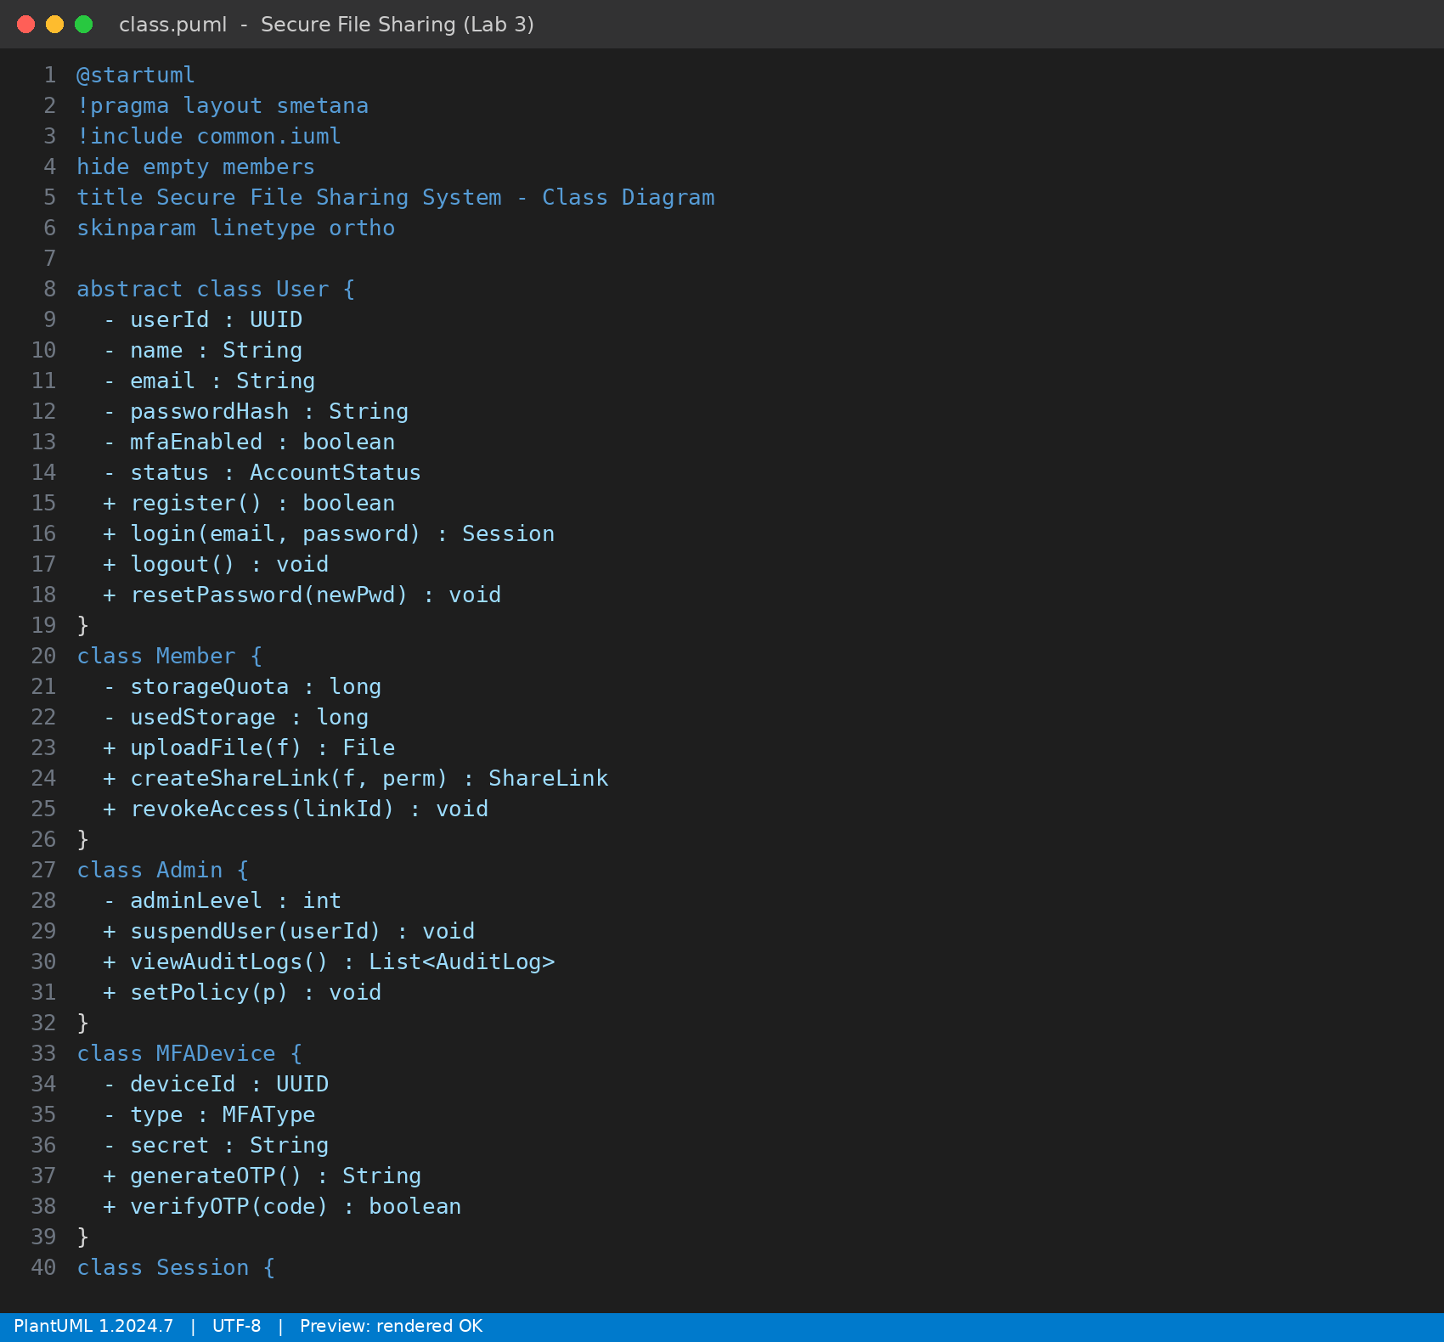
Figure 1: Screenshot: PlantUML source of the class diagram in VS Code (class definitions)
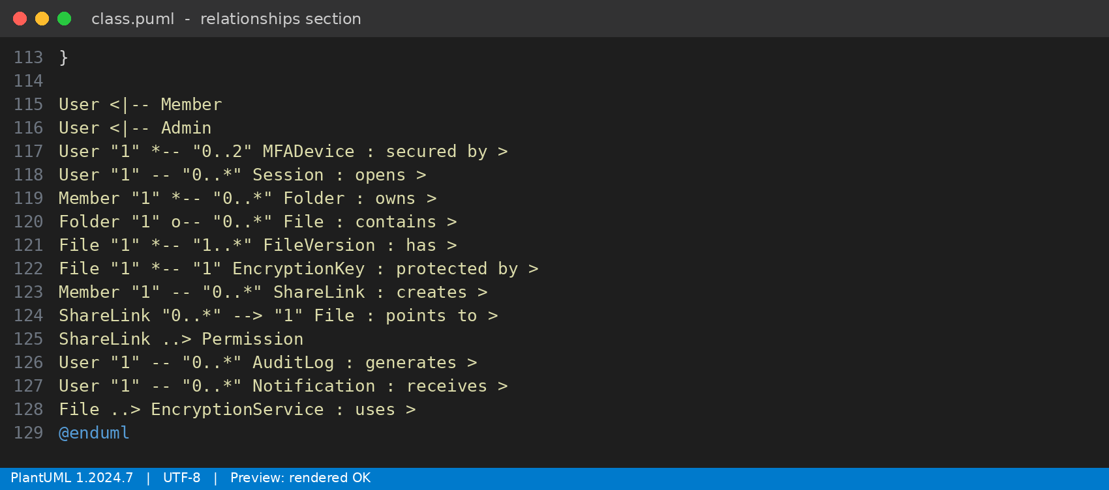
Figure 2: Screenshot: relationship section of the same file, showing multiplicities

8. Identified Classes
Class | Key Attributes | Key Methods | Responsibility
User (abstract) | userId, name, email, passwordHash, mfaEnabled, status | register(), login(), logout(), resetPassword() | Common identity and authentication data for everyone
Member | storageQuota, usedStorage | uploadFile(), createShareLink(), revokeAccess() | Normal user who owns and shares files
Admin | adminLevel | suspendUser(), viewAuditLogs(), setPolicy() | Manages users and system policies
MFADevice | deviceId, type, secret | generateOTP(), verifyOTP() | Second factor for login
Session | sessionId, token, ipAddress, expiresAt | isValid(), invalidate() | Represents one logged-in session
Folder | folderId, name, createdAt | addFile(), removeFile(), listFiles() | Groups files for a member
File | fileId, fileName, size, mimeType, checksum | encrypt(), decrypt(), verifyIntegrity(), delete() | The uploaded document itself
FileVersion | versionNo, storagePath, createdAt | restore() | Older copies of a file
EncryptionKey | keyId, algorithm, wrappedKey | rotate() | Per-file AES key, stored wrapped by a master key
ShareLink | linkId, url, permission, expiresAt, maxDownloads, downloadCount, passwordHash | isExpired(), validate(), revoke() | Controlled access to one file
Permission (enum) | VIEW, DOWNLOAD, EDIT | - | Level of access a link gives
AuditLog | logId, action, timestamp, ipAddress | record() | Trace of every sensitive action
Notification | message, sentAt | send() | E-mail / in-app alerts
EncryptionService | - | generateKey(), encrypt(), decrypt() | Helper service doing the actual crypto

9. UML Class Diagram
The final class diagram is shown below. Abstract class names are in italics, the "A" icon marks the abstract class, "C" a concrete class and "E" an enumeration.
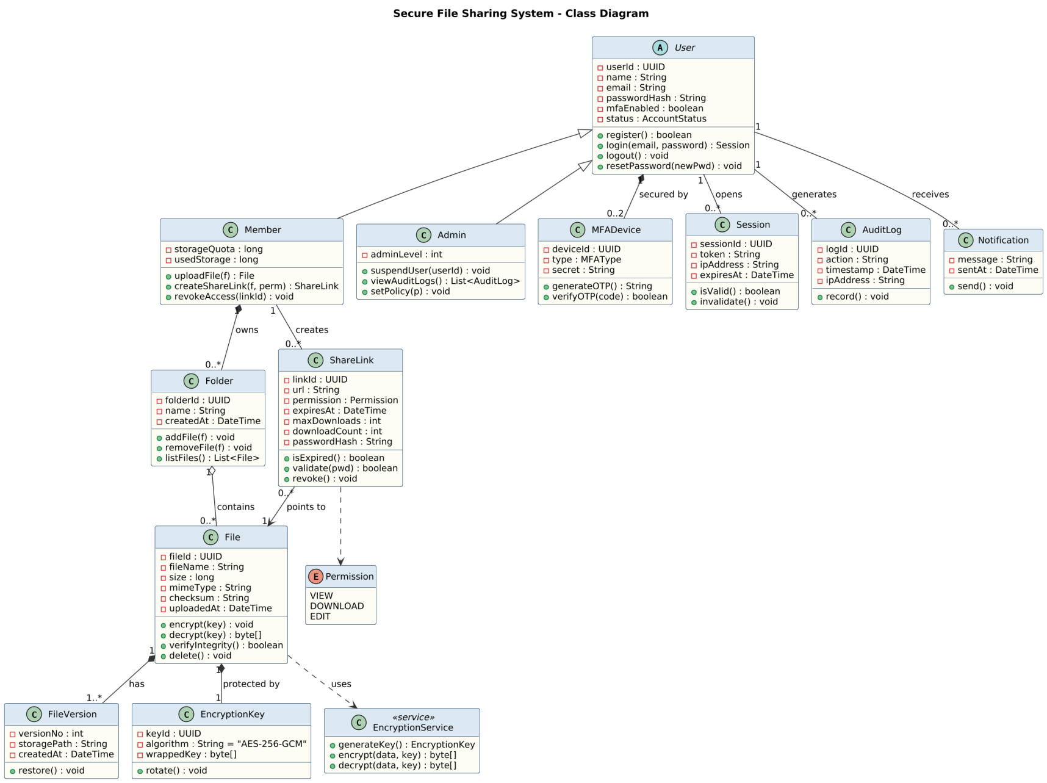
Figure 3: UML Class Diagram of the Secure File Sharing System

10. Relationships Explained
Relationship | Between | Type | Multiplicity | Reason
Inheritance | Member, Admin → User | Generalisation | - | Both are users and share login/profile behaviour
Composition | User → MFADevice | Strong "has-a" | 1 to 0..2 | An MFA device means nothing without its user; deleted with the account
Composition | Member → Folder | Strong "has-a" | 1 to 0..* | Folders are private to the member and removed with the account
Aggregation | Folder → File | Weak "has-a" | 1 to 0..* | A file can be moved to another folder and still exist
Composition | File → FileVersion | Strong "has-a" | 1 to 1..* | Versions are parts of the file; at least version 1 always exists
Composition | File → EncryptionKey | Strong "has-a" | 1 to 1 | Each file has exactly one key, useless once the file is gone
Association | Member – ShareLink | Creates | 1 to 0..* | A member can create many links
Directed association | ShareLink → File | Points to | 0..* to 1 | Many links can point to the same file; file does not need to know its links
Association | User – Session / AuditLog / Notification | Plain | 1 to 0..* | A user can have many sessions, log entries and alerts
Dependency | File → EncryptionService | Uses | - | File only calls the service temporarily while encrypting/decrypting

The part that took us the most discussion was aggregation versus composition. Our rule was simple: if deleting the "whole" should automatically delete the "part", it is composition. Deleting a file must also destroy its key and versions, otherwise we would have orphan keys lying around, which is a security issue. A folder on the other hand is just a container, so files are only aggregated in it.

11. Observations
- Most of the security features (MFA, encryption, expiry, audit) became separate classes instead of extra fields in User or File. This keeps each class small and focused.
- Making User abstract avoided repeating the login and password logic in two places.
- Keeping the encryption key wrapped (encrypted by a master key) means even if the database leaks, files cannot be decrypted directly.
- ShareLink holds the permission, expiry and download count, so revoking or expiring access never touches the file itself.
- Layout matters a lot in a diagram with 14 classes. Placing the User family on top and the file-related classes below it kept most of the lines from crossing.

12. Result and Conclusion
The classes, attributes, methods and relationships of the Secure File Sharing System were identified from the requirements, and the UML class diagram was drawn successfully using PlantUML. The design shows inheritance, association, aggregation, composition and dependency with proper multiplicities.
Doing the requirements first really helped, because almost every class could be traced back to at least one requirement (for example ShareLink to FR7 to FR9 and AuditLog to FR11). This diagram will be used as the base for the sequence and activity diagrams in the next lab.

