SOFTWARE ENGINEERING LAB
LAB 4
UML Sequence and Activity Diagram Modeling
Project: Secure File Sharing System
Name : Anjil Tripathi
Roll Number : 202401100200053
Class / Section : CSE ‘A’
Date of Submission :28 October 2026
Submitted To : Navdesh sir

1. Aim
To model the major scenarios of the Secure File Sharing System using UML Activity Diagrams for workflow representation, and Sequence Diagrams to show how objects interact over time.

2. Objectives
- Identify the main scenarios (use cases) of the system that are worth modelling.
- Draw activity diagrams with swimlanes, decisions, forks/joins, and start/end nodes for each workflow.
- Draw sequence diagrams for the key scenarios, using the classes from the Lab 3 class diagram.
- Show alternate and error paths (wrong OTP, expired link, unauthorised revoke) and not just the happy path.

3. Theory

3.1 Activity Diagram
An activity diagram is like an improved flowchart. It shows the flow of work from one activity to the next. We used these notations:
Symbol | Meaning
Filled black circle | Initial node (start of the flow)
Circle with a dot inside | Final node (end of the flow)
Rounded rectangle | Action / activity
Diamond | Decision (branch) or merge, guards written as [yes] / [no]
Thick bar | Fork / join for activities running in parallel
Vertical partitions | Swimlanes showing who performs each action (User, System, Storage)

3.2 Sequence Diagram
A sequence diagram shows the objects taking part in one scenario and the messages passed between them in time order, from top to bottom. Solid arrows are calls, dashed arrows are return messages, and the boxes marked alt are alternative fragments (like an if/else). Each object has a dashed lifeline running down from it.
Activity diagrams answer "what are the steps and decisions?", while sequence diagrams answer "which object talks to which, and in what order?". Using both for the same scenario gave us a much clearer picture than either one alone.

4. Scenarios Selected
# | Scenario | Actors | Diagrams
1 | User registration and login with MFA | User, System | Activity 1, Sequence 1
2 | Uploading a file with encryption | Member, System, Storage | Activity 2, Sequence 2
3 | Sharing a file through a secure link | Owner, System | Activity 3, Sequence 3
4 | Downloading a shared file | Recipient, System | Activity 4, Sequence 3
5 | Revoking access | Owner / Admin, System | Activity 5, Sequence 4

5. Tools Used
- PlantUML 1.2024.7 for both activity (new beta syntax with swimlanes) and sequence diagrams.
- VS Code with the PlantUML extension for live preview.
- MS Word for the report.

6. Procedure
- Listed the use cases from the requirements in Lab 3 and picked the five that cover the core of the system: login, upload, share, download and revoke.
- For each scenario, wrote the normal flow as plain steps first, then wrote down what can go wrong at every step (invalid input, expired link, wrong password and so on).
- Decided the swimlanes by asking "who does this step?" (the person using the app, the server, or the storage layer).
- Converted the steps into PlantUML activity syntax using if/else for decisions and fork for parallel steps (virus scan and checksum run at the same time during upload).
- For sequence diagrams, picked the objects from the class diagram and added controller/service objects that would exist in the real implementation (AuthController, FileService, etc.).
- Added alt fragments for success and failure paths and turned on autonumber so the messages can be referred to by number.
- Rendered all diagrams to PNG and checked that each flow has a proper start and end and no dangling branch.

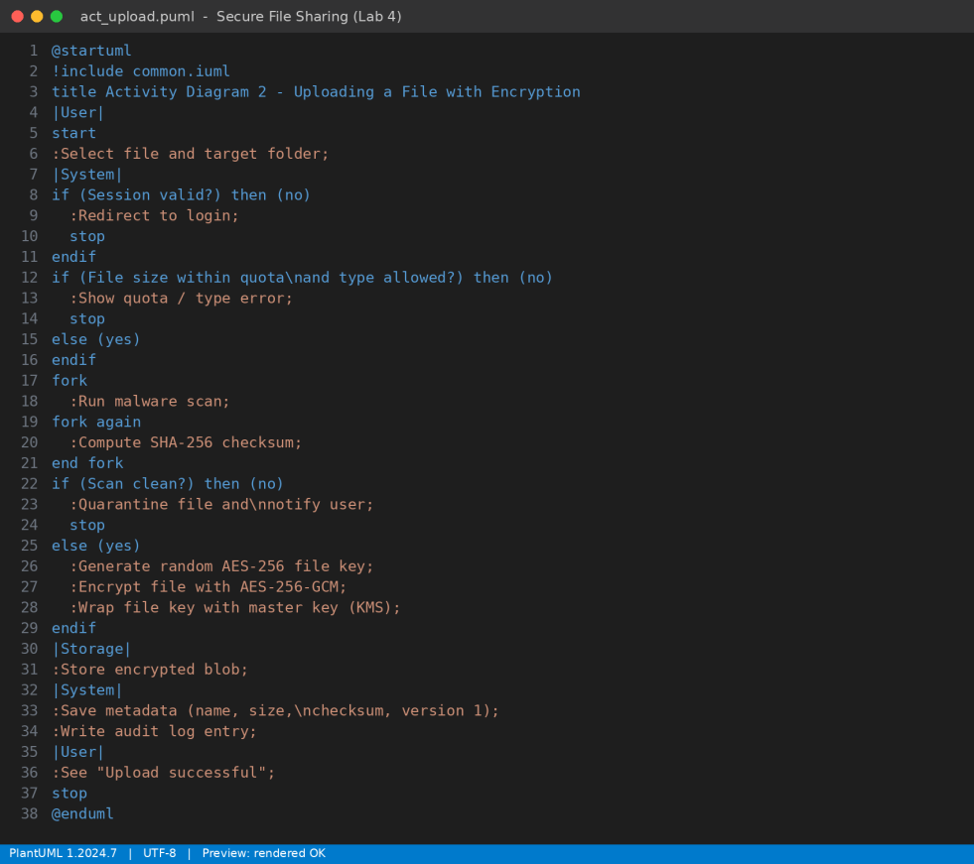
Figure 1: Screenshot: PlantUML source of the upload activity diagram
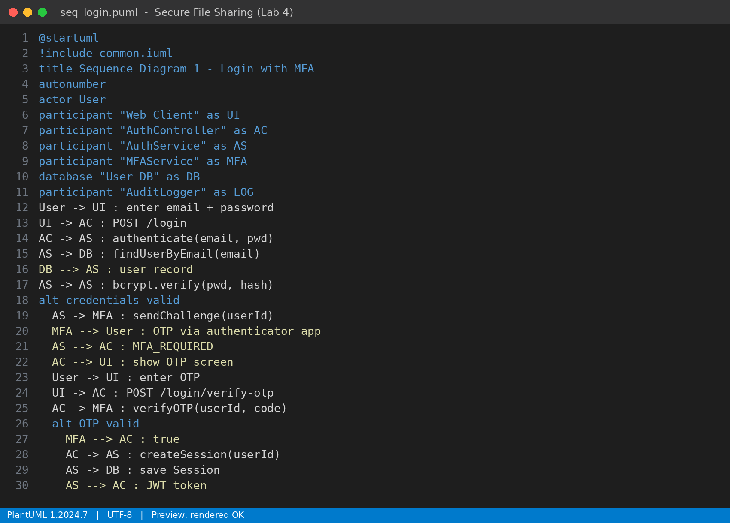
Figure 2: Screenshot: PlantUML source of the login sequence diagram

7. Activity Diagrams

7.1 Registration and Login with MFA
A new user registers first, gets a verification mail, and then goes through the normal login. After the password is verified, the system asks for an OTP. Five wrong passwords lock the account for 15 minutes, which protects against brute force attacks.
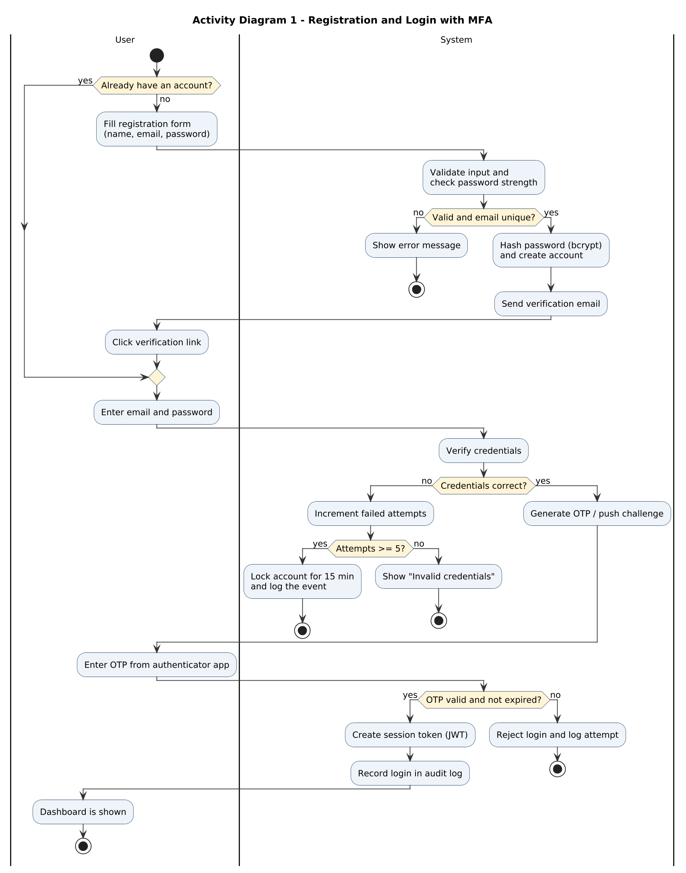
Figure 3: Activity diagram for registration and login with MFA

7.2 Uploading a File with Encryption
The quota and file-type check happens before anything heavy is done. The malware scan and checksum calculation run in parallel (fork and join). Only after the scan is clean is a fresh AES-256 key generated, the file encrypted, and the key wrapped by the master key before saving.
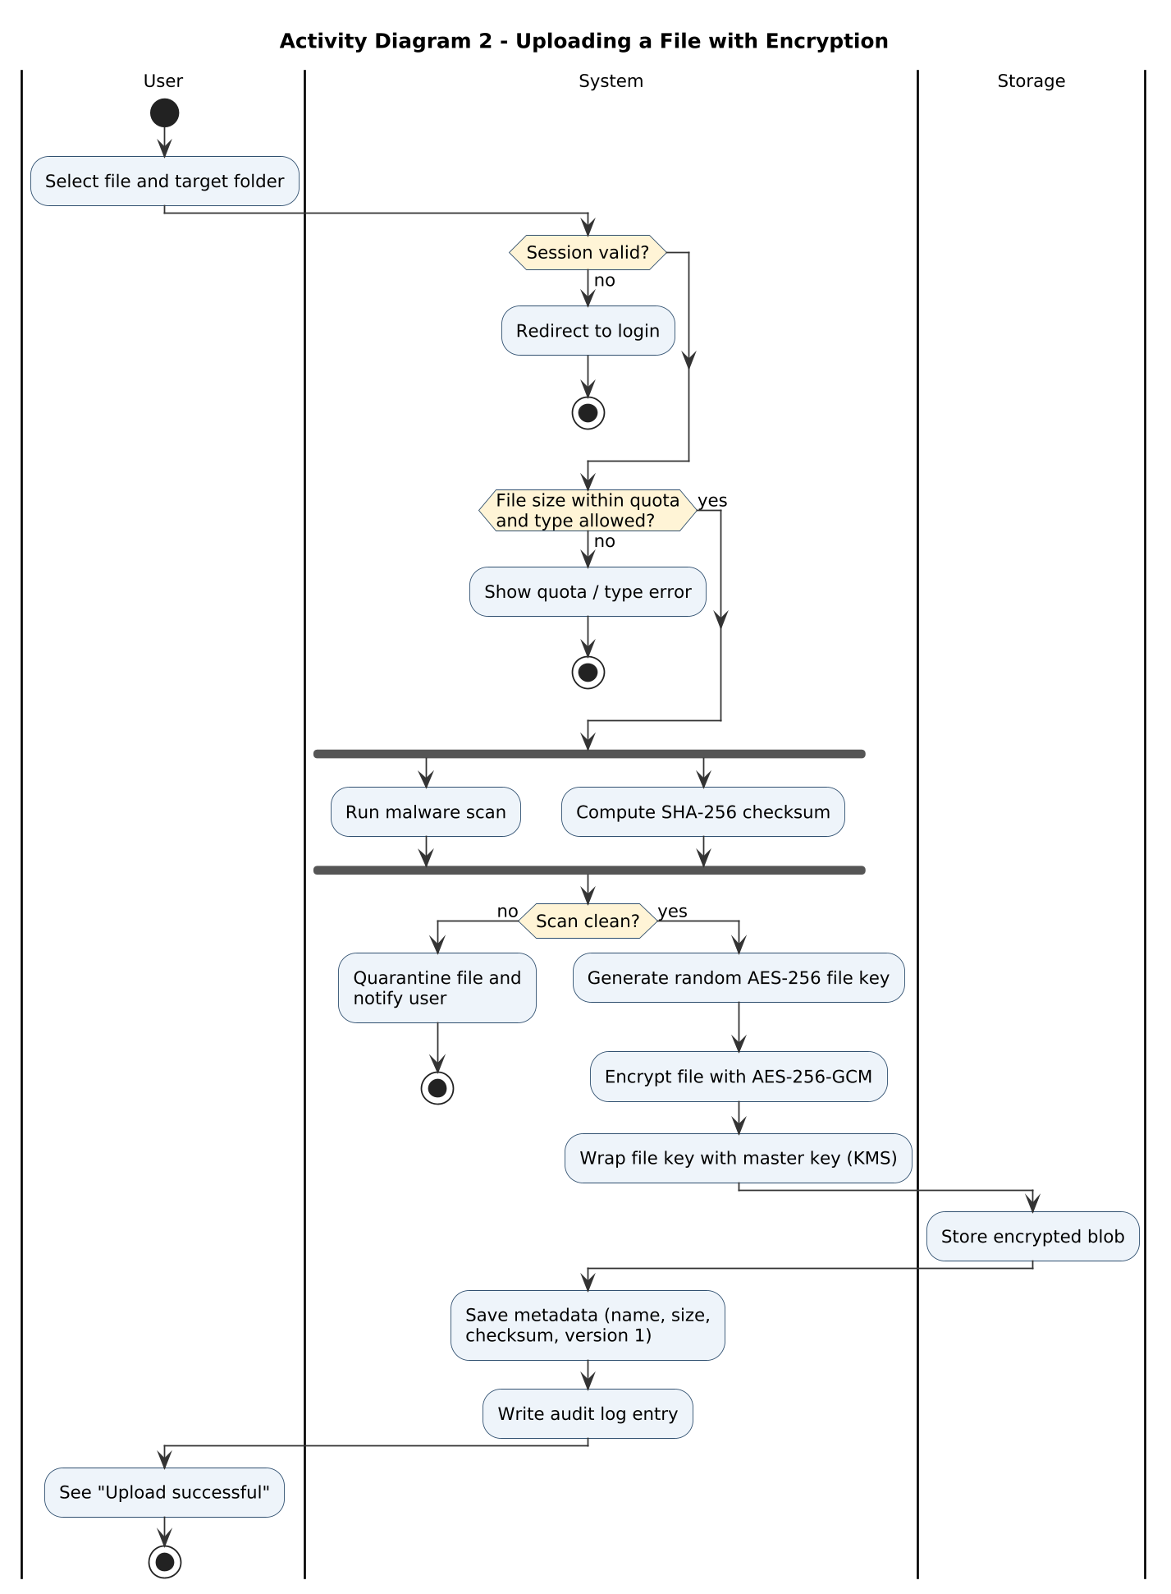
Figure 4: Activity diagram for uploading a file with encryption

7.3 Sharing a File via Secure Link
The owner chooses whether to share with a registered user or create a public link, then sets permission, expiry and an optional password. The system generates a random 128-bit token so links cannot be guessed.
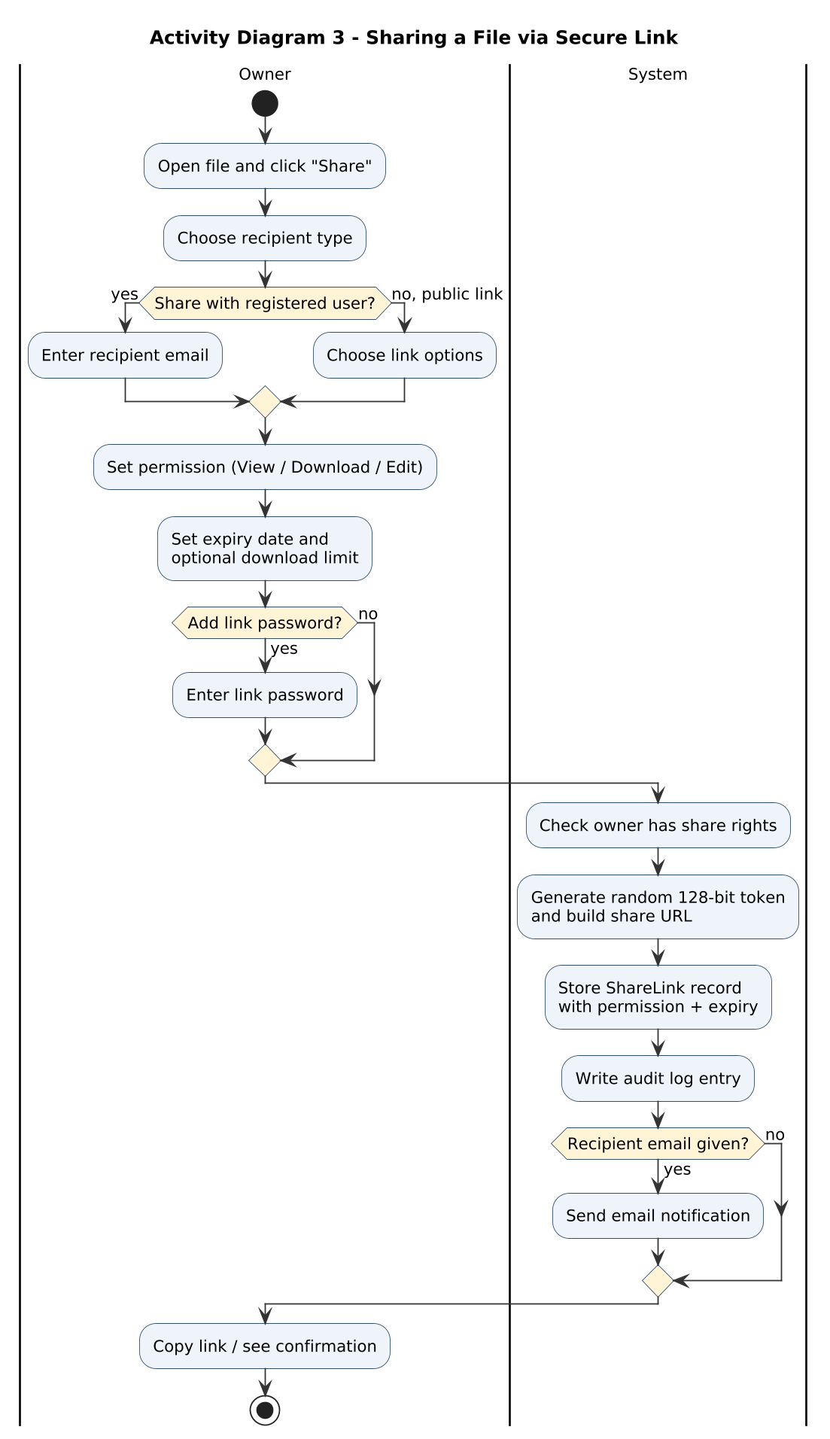
Figure 5: Activity diagram for creating a share link

7.4 Downloading a Shared File
This flow has the most checks: link existence, revocation, expiry, download limit, password, and permission. A link with only VIEW permission opens a preview instead of downloading.
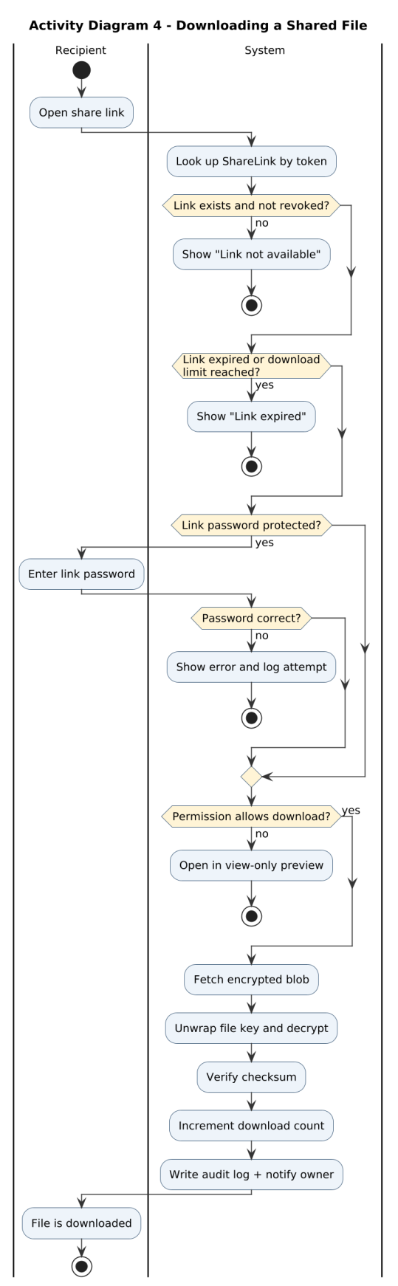
Figure 6: Activity diagram for downloading a shared file

7.5 Revoking Access
Only the owner or an admin can revoke. Revoking marks the link as revoked and clears any cached access. Optionally the file key can be rotated, which is useful if the owner thinks the file was already leaked.
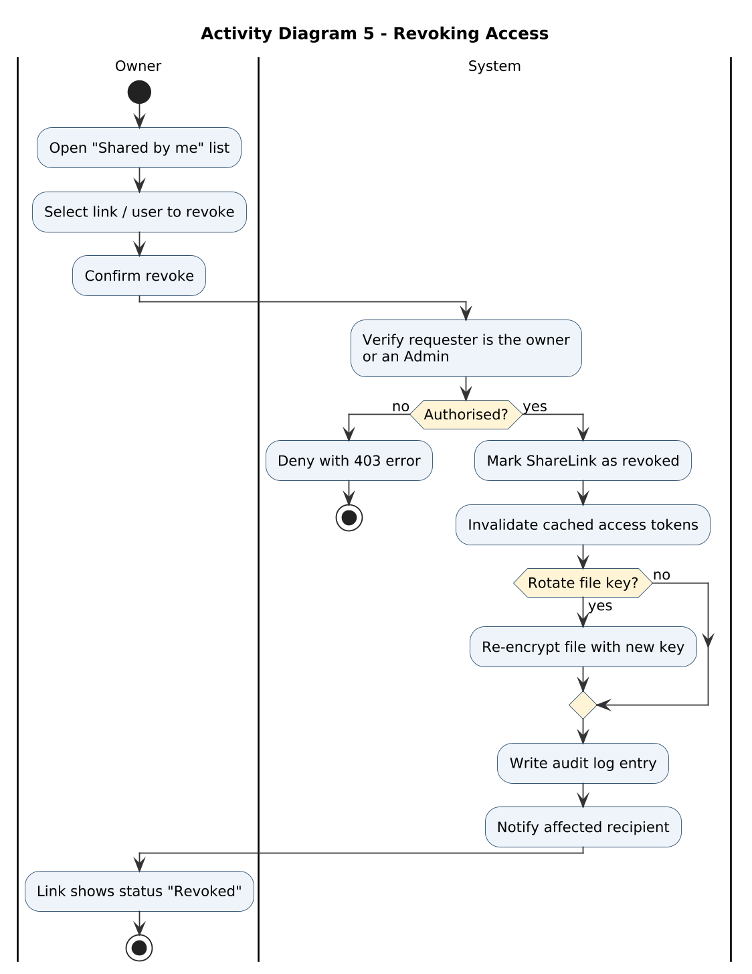
Figure 7: Activity diagram for revoking access

8. Sequence Diagrams

8.1 Login with MFA
The AuthService checks the password hash and, only if it matches, asks MFAService to send a challenge. The session (JWT) is created after the OTP is verified, not before. Every success and failure is passed to the AuditLogger.
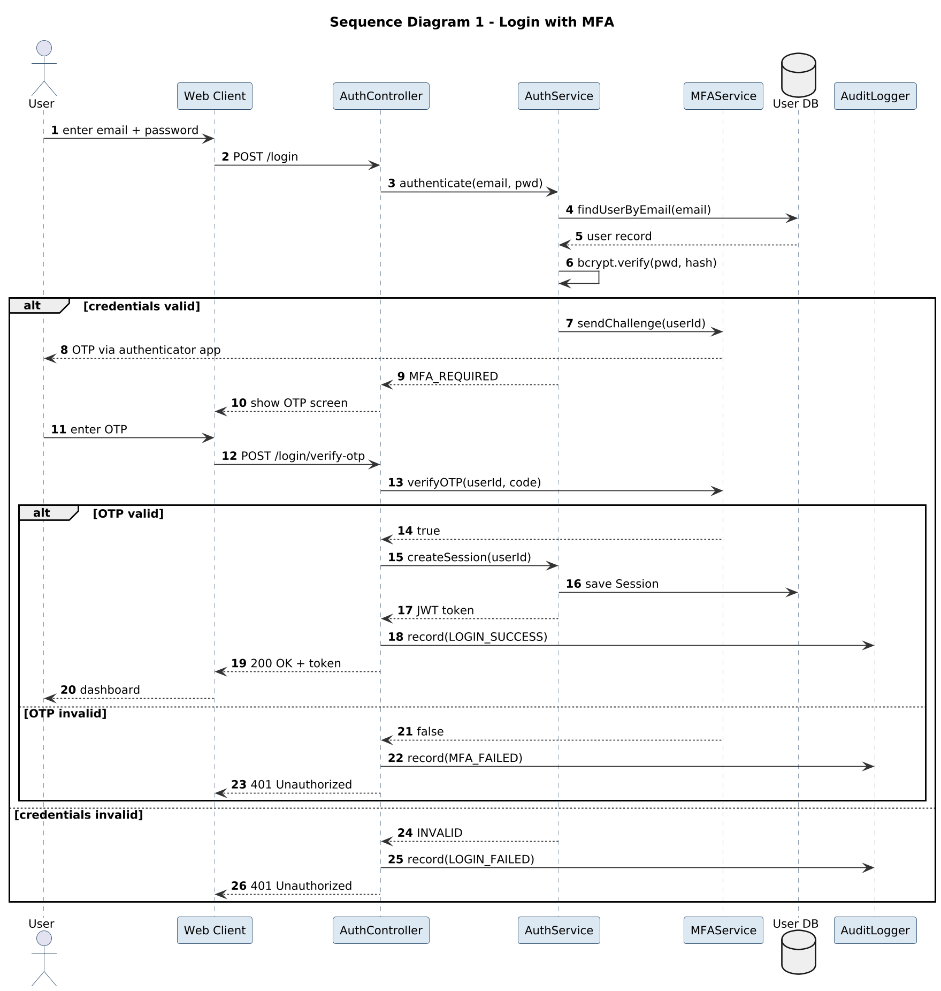
Figure 8: Sequence diagram for login with MFA

8.2 Encrypted File Upload
Notice that the plain file key never leaves the server. FileService asks the KMS to wrap it and only the wrapped key is stored in the database, next to the file metadata.
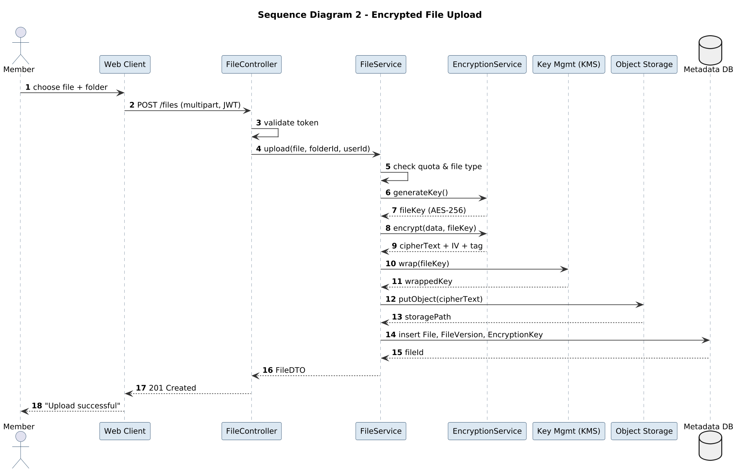
Figure 9: Sequence diagram for encrypted file upload

8.3 Create Share Link and Download
This diagram is split into two parts using dividers: first the owner creates the link, then the recipient uses it. The alt fragment shows the response for a revoked or expired link (HTTP 410) versus a valid one.
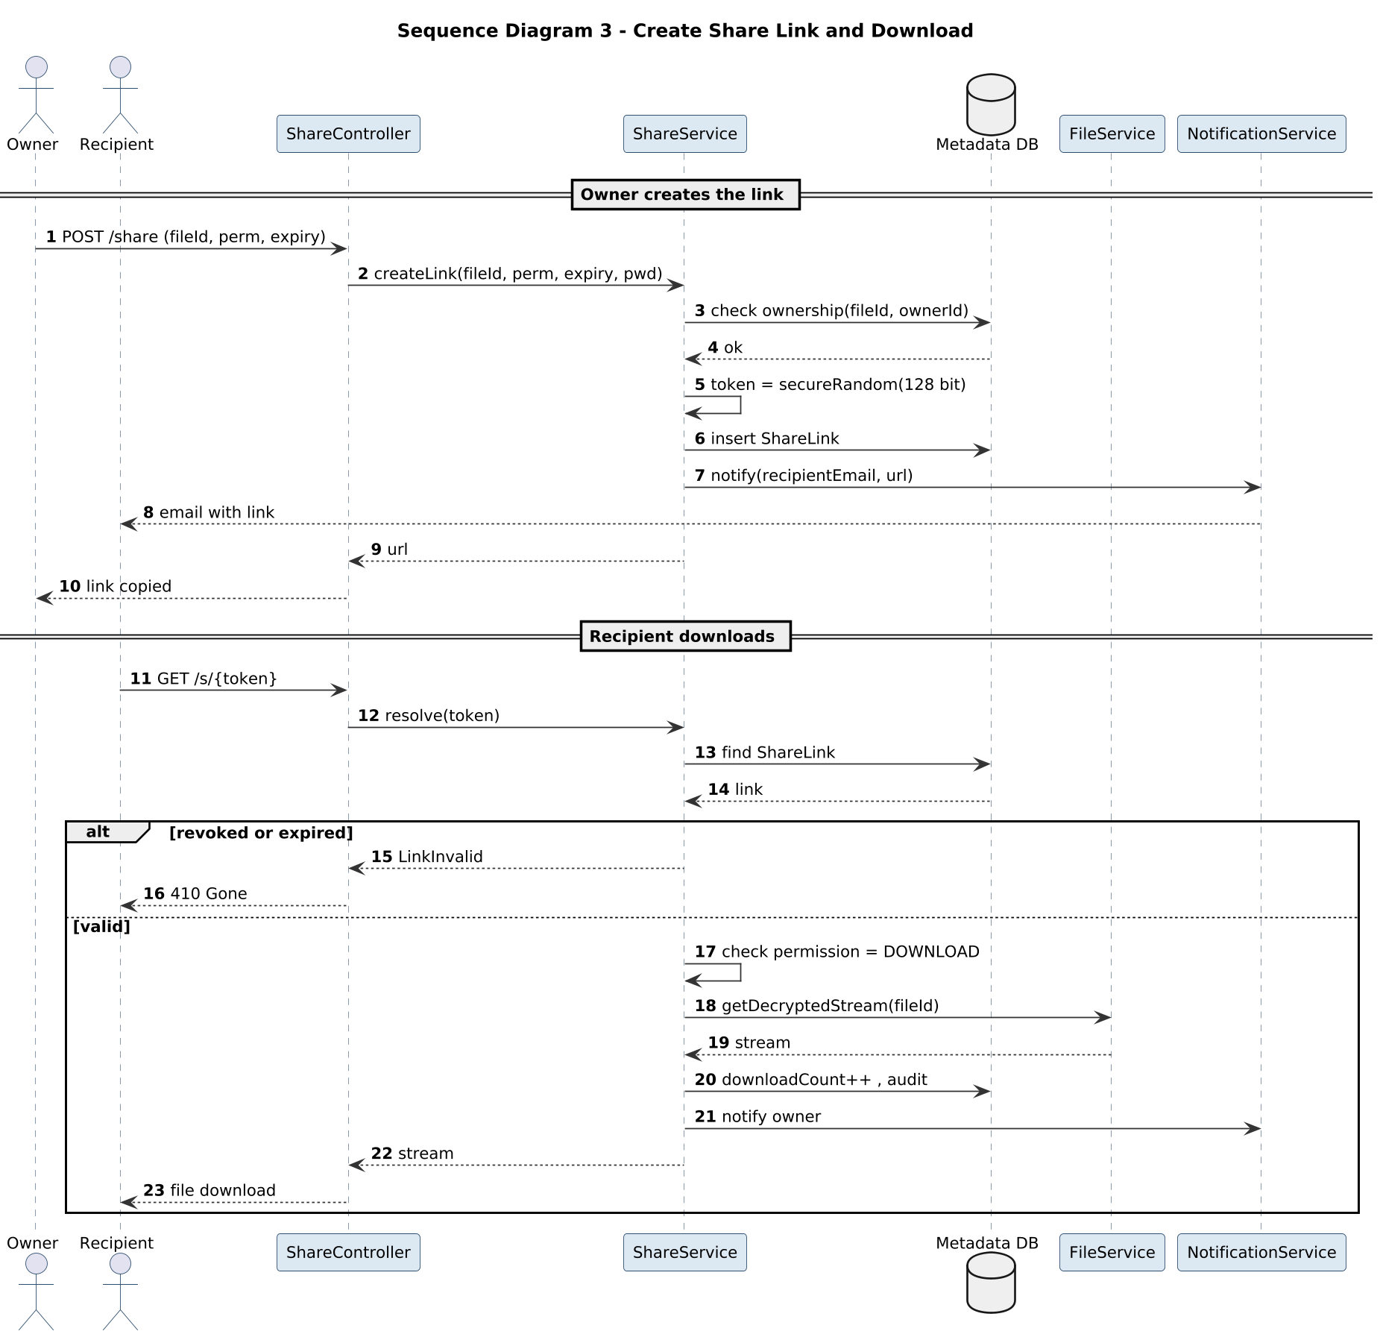
Figure 10: Sequence diagram for creating a share link and downloading the file

8.4 Revoke Access
The token is evicted from the Redis cache immediately so a link that has been revoked cannot be used even for a few seconds.
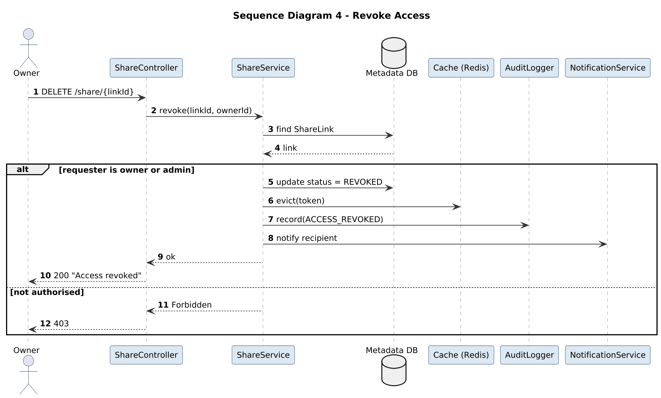
Figure 11: Sequence diagram for revoking access

9. Observations
- Writing the failure paths took more time than the happy paths, but that is where most of the security logic actually lives.
- The fork/join in the upload flow showed that the scan and the checksum do not depend on each other, so they can run in parallel to save time.
- The sequence diagrams pointed out a few things missing from the class diagram, like controllers, a cache and a KMS. These are implementation level objects so we did not add them back to the domain class diagram.
- The message numbers made it easy to discuss specific steps in the group ("step 13 should also check the download limit").
- Swimlanes made the responsibility of each actor very clear. The user only ever does a few actions while the system does most of the checking.

10. Result and Conclusion
The major scenarios of the Secure File Sharing System, namely registration and login with MFA, encrypted upload, link sharing, download and revoking access, were modelled using five activity diagrams and four sequence diagrams in PlantUML.
The activity diagrams helped us capture the complete workflow with all decisions and error cases, and the sequence diagrams showed how the classes identified in Lab 3 work together at run time. Together they give a clear base for implementing and testing the system.

