Software Engineering Lab
LAB 5: UML Sequence Diagram Modeling
Project: Secure File Sharing System
Name | Anjil Tripathi
Roll No. | 202401100200053
Branch / Year | Computer Science Engineering / 3rd Year
Technology Stack | MERN (MongoDB, Express.js, React, Node.js)

1. Objective
To model the major scenarios of the Secure File Sharing System using UML Sequence Diagrams, showing the order of messages exchanged between the user, the React client, the Express API, the cryptography service, file storage, the database and external services.

2. System Overview
The Secure File Sharing System lets registered users upload files that are encrypted with AES-256-GCM before storage, download them, and share them with other users under controlled permissions and expiry times. Every sensitive operation is authenticated with JWT-based sessions (with an OTP second factor at login) and recorded in an audit log.

3. Participants (Lifelines)
Participant | Type | Responsibility
User / Owner / Recipient | Actor | Human users. Owner is a user who owns a file; Recipient is a user the file is shared with.
React Client | Boundary | Web UI: forms, file picker, share dialog; calls REST endpoints with the JWT.
Express API | Control | Routes, auth middleware, permission checks, orchestration of all other components.
Crypto Service | Control | Generates IV, encrypts and decrypts file data with AES-256-GCM and verifies integrity (auth tag).
File Storage | Entity | Stores only encrypted blobs (GridFS or S3-compatible storage).
MongoDB | Entity | Users, file metadata, shares and audit logs.
Email Service | External | Sends verification links, OTPs and share notifications.

4. Scenarios Modeled
The following six major scenarios are modeled in the next section. In every diagram, numbered solid arrows are requests, dashed arrows are responses, and the alt fragment shows alternative flows.
# | Scenario | Primary Actor | Trigger
1 | User Registration | New visitor | Submits registration form
2 | Login with MFA | Registered user | Submits credentials, then OTP
3 | Upload File | Authenticated user | Clicks Upload
4 | Download File | Owner / shared user | Clicks Download
5 | Share File | File owner | Submits share dialog
6 | Revoke Shared Access | File owner | Clicks Revoke

5. Sequence Diagrams

5.1 Scenario 1: User Registration
Primary actor: New visitor. Precondition: No existing account for the email. Postcondition: Account created with status PENDING; verification email sent.
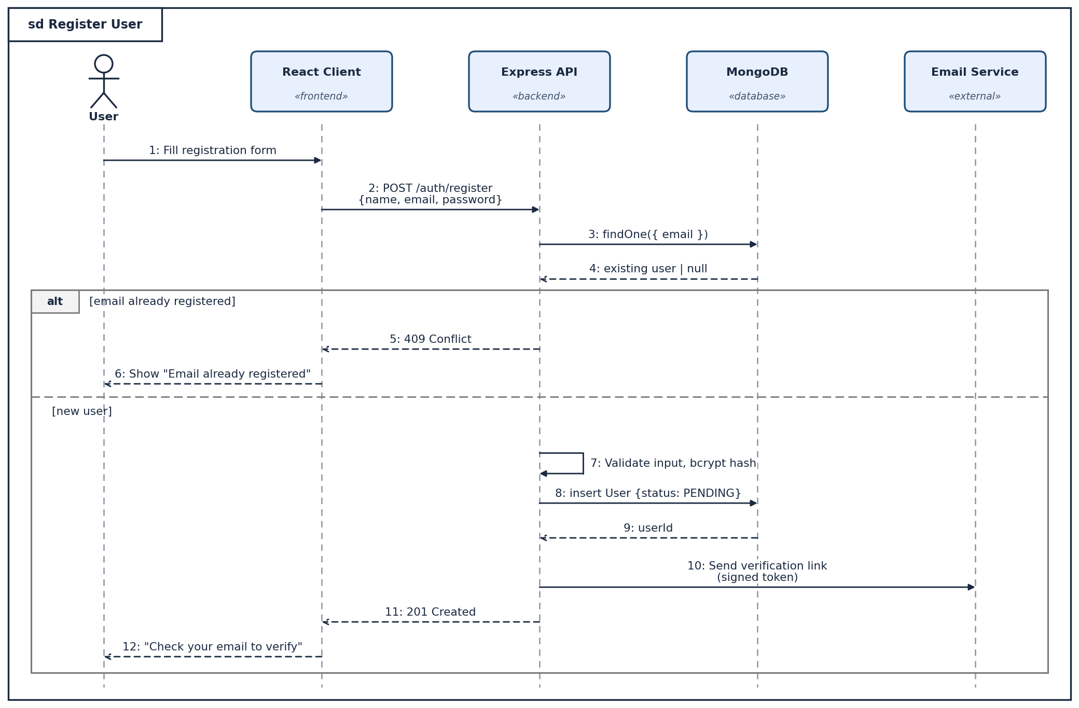

5.2 Scenario 2: Login with Multi-Factor Authentication
Primary actor: Registered user. Precondition: Account exists and is verified. Postcondition: User holds a valid JWT access token and refresh cookie.
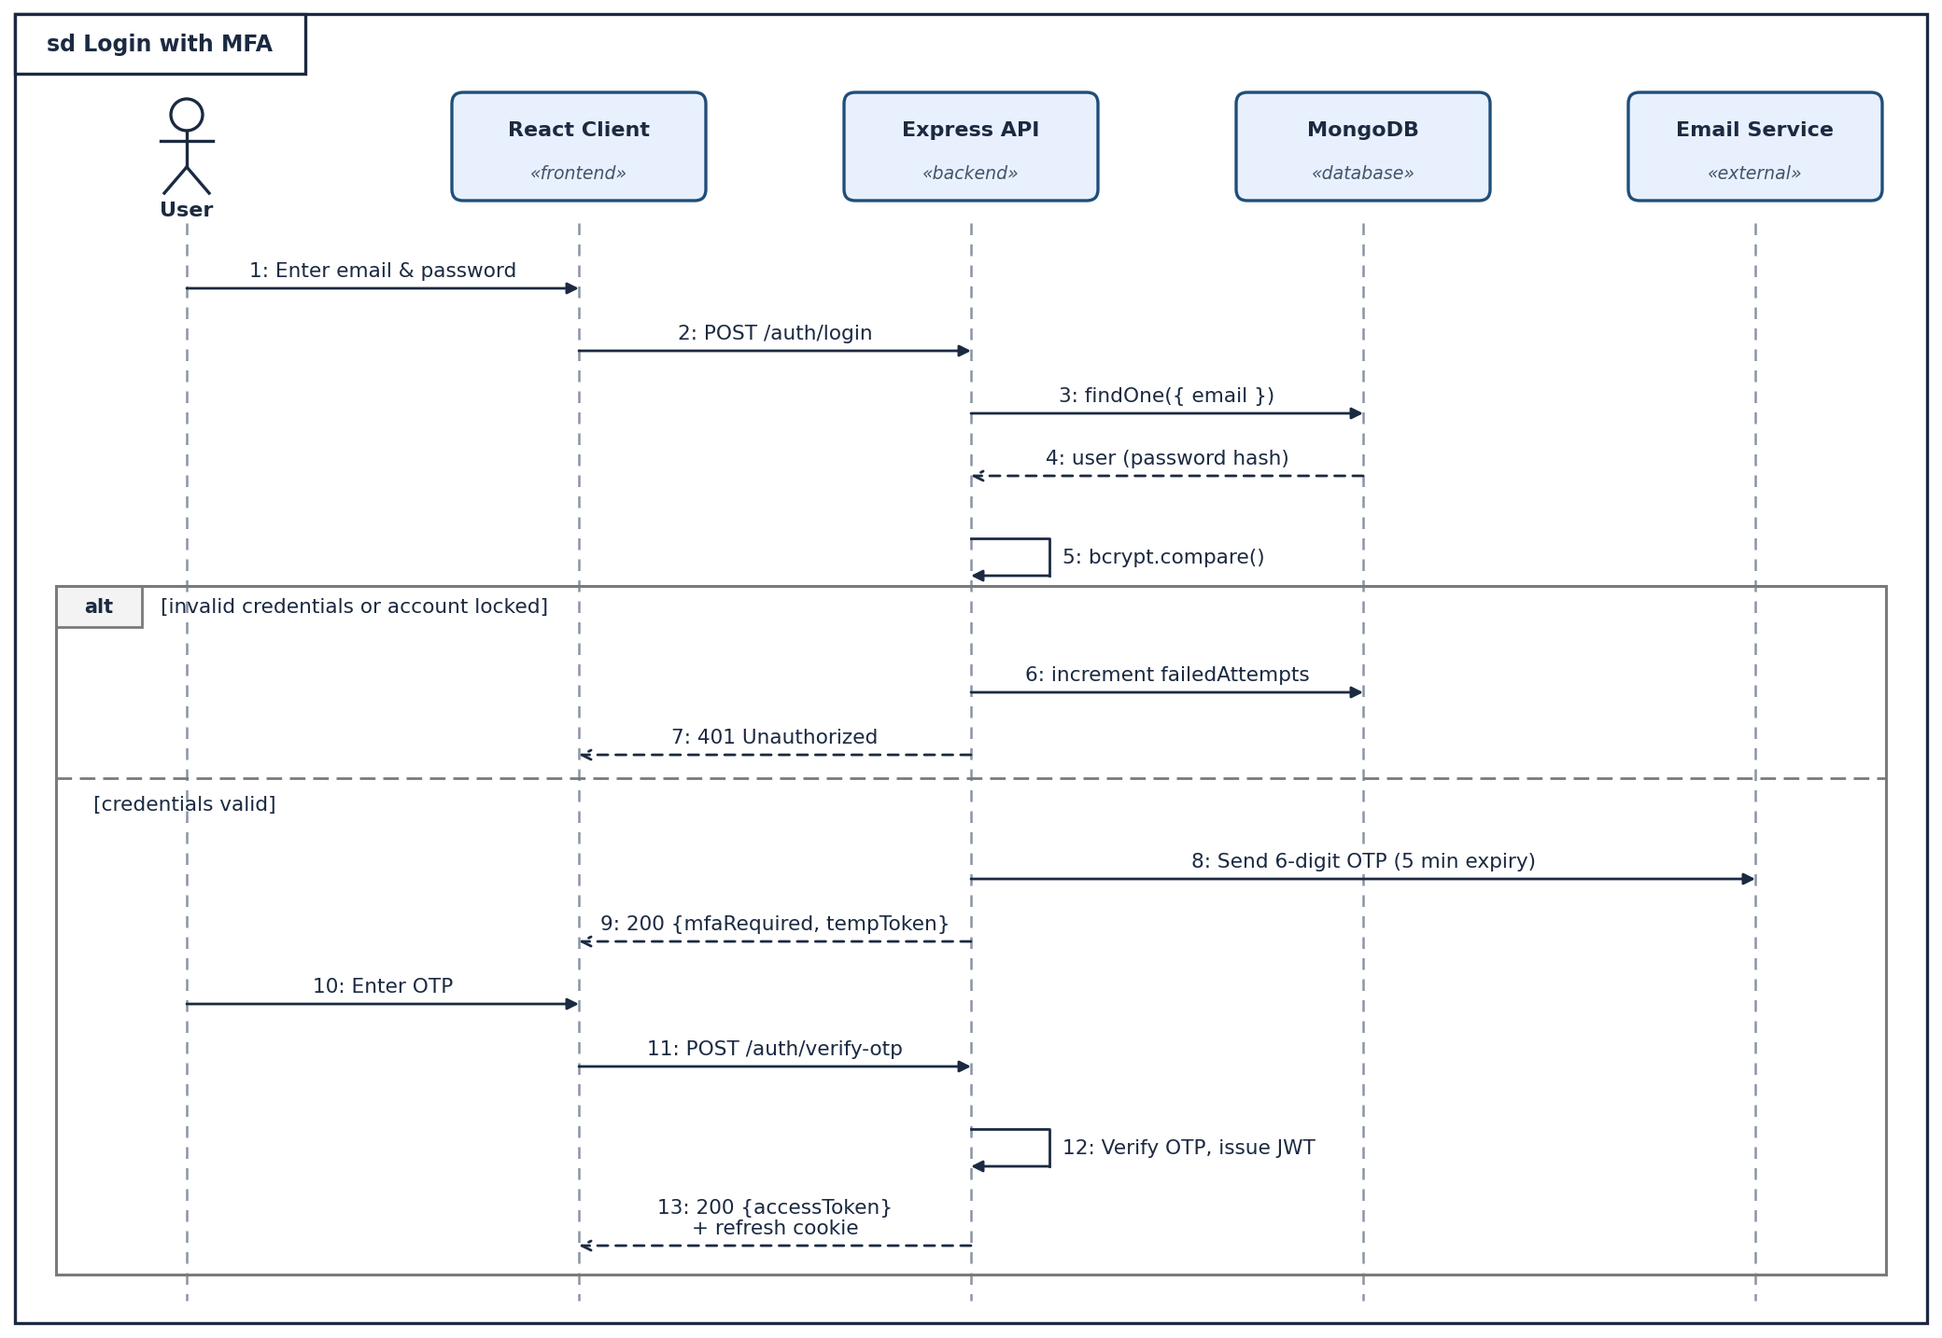

5.3 Scenario 3: Upload File (Encrypted at Rest)
Primary actor: Authenticated user. Precondition: User is logged in. Postcondition: Ciphertext stored; metadata and audit entry saved in MongoDB.
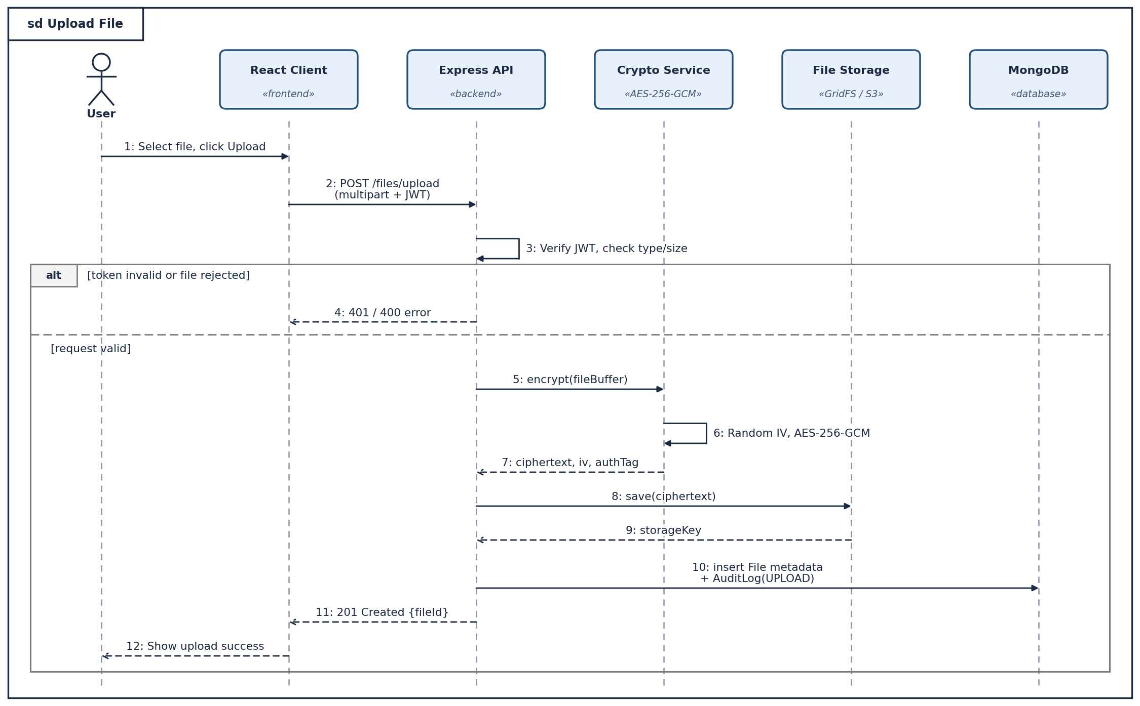

5.4 Scenario 4: Download File
Primary actor: Owner or shared user. Precondition: User is logged in and file exists. Postcondition: File decrypted and streamed; access logged (or denied and logged).
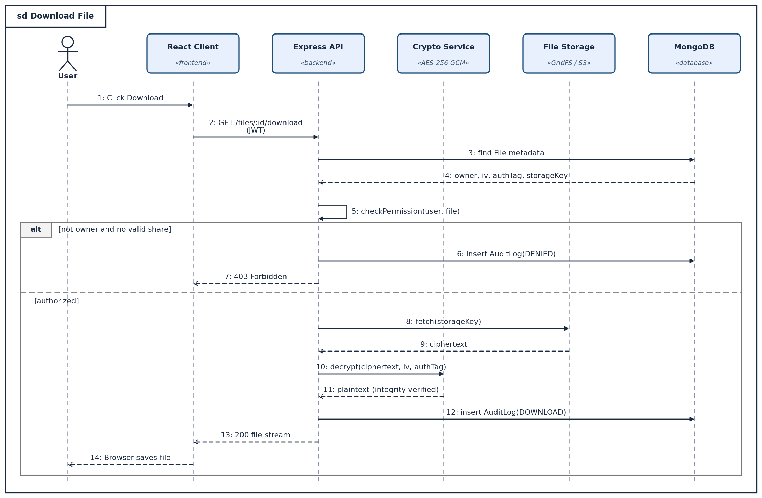

5.5 Scenario 5: Share File with Another User
Primary actor: File owner. Precondition: Owner is logged in and owns the file. Postcondition: Share record with permission and expiry created; recipient notified.
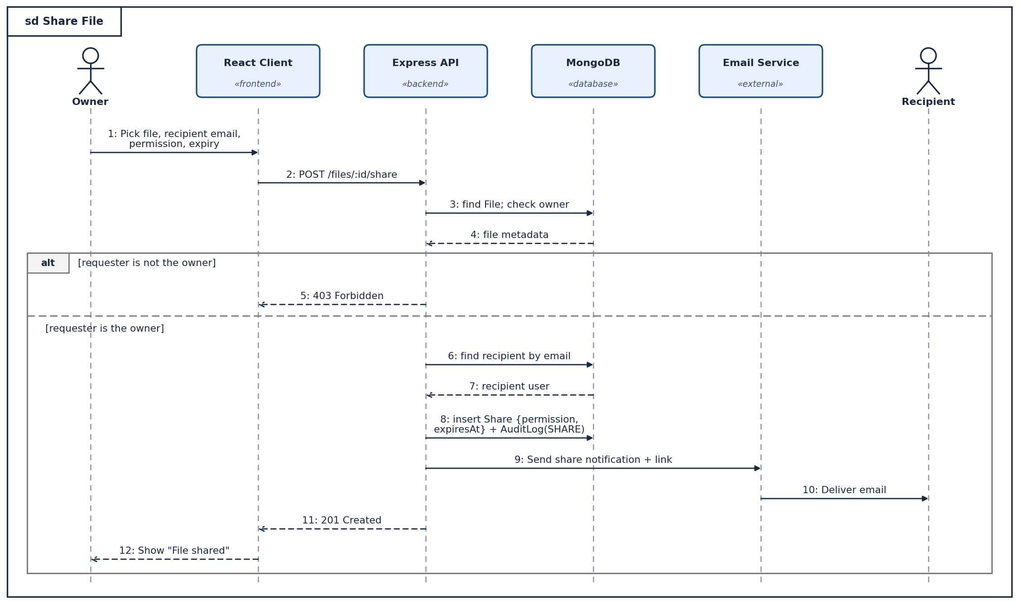

5.6 Scenario 6: Revoke Shared Access
Primary actor: File owner. Precondition: An active share exists. Postcondition: Share marked REVOKED; recipient can no longer access the file.
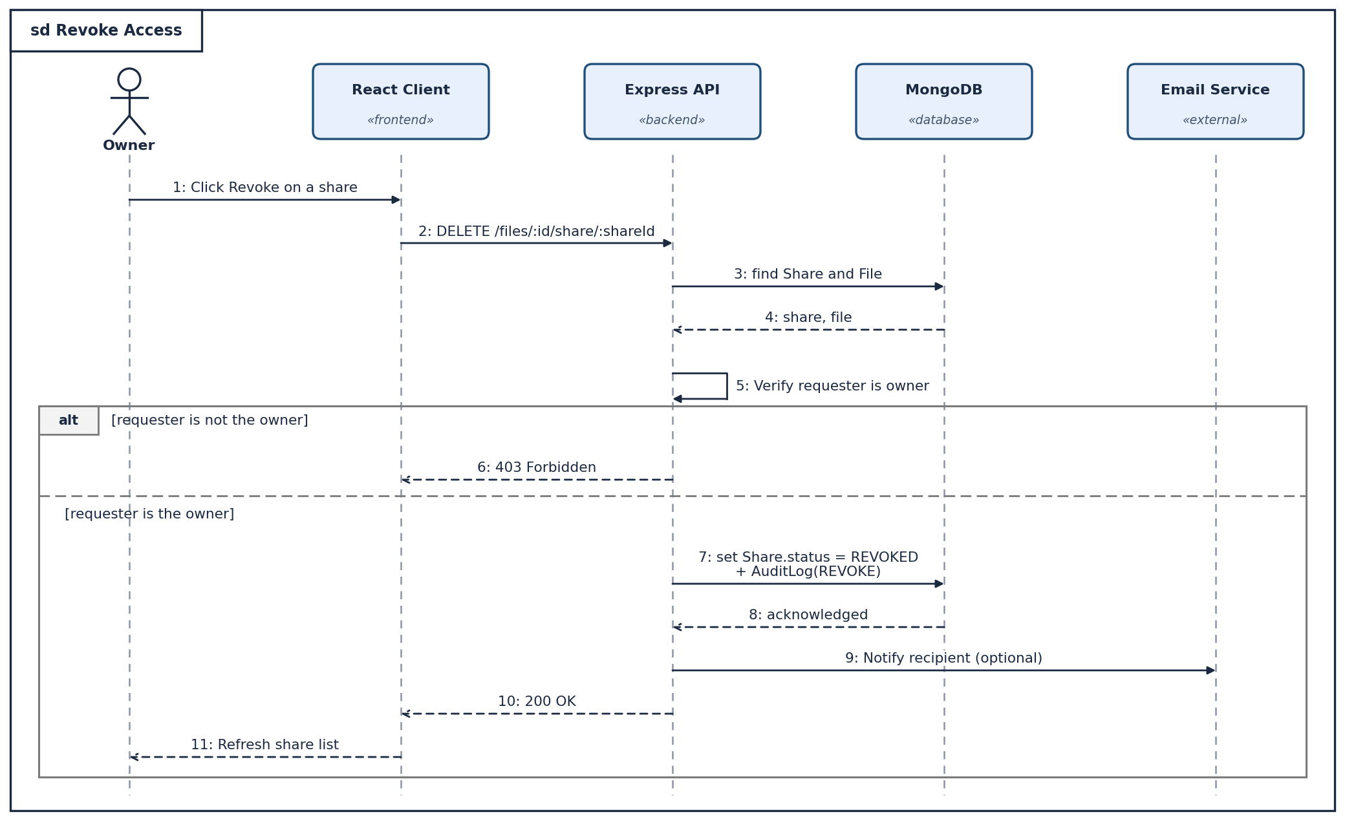

6. Notation Used
- Lifeline: dashed vertical line under each participant box; the stick figure denotes a human actor.
- Synchronous message: solid line with a filled arrowhead, labelled with a sequence number and the operation or HTTP call.
- Return message: dashed line with an open arrowhead (response, status code or returned data).
- Self message: arrow looping back to the same lifeline (internal processing such as hashing or permission checks).
- alt fragment: two alternative flows separated by a dashed line, each guarded by a condition in square brackets.
- sd frame: the outer rectangle names the interaction (for example, sd Upload File).

7. Conclusion
The sequence diagrams capture the message flow of the six core scenarios of the Secure File Sharing System, including error and access-denied paths. They show that security controls (password hashing, OTP-based MFA, JWT verification, permission checks, AES-256-GCM encryption and audit logging) are enforced centrally in the Express API, and they provide a clear basis for implementing the MERN components.

