Software Engineering Lab
LAB 7: System Architecture Diagram
Project: Secure File Sharing System
Name | Anjil Tripathi
Roll No. | 202401100200053
Section | A
Branch / Year | Computer Science Engineering / 3rd Year
Institution | KIET Group of Institutions, Ghaziabad
Technology Stack | MERN (MongoDB, Express.js, React, Node.js)
Based on: Software Requirements Specification v1.0 and Lab 6 Design Analysis Report

1. Introduction
This report presents the system architecture of the Secure File Sharing System. It turns the requirements of the Software Requirements Specification (SRS v1.0) and the design decisions of the Lab 6 Design Analysis Report into architecture diagrams: a layered logical view, a deployment view and a runtime data-flow view. Each diagram is followed by a short explanation so that the structure, the responsibilities of each part and the way the parts interact can be understood and verified.

1.1 Purpose and scope
The architecture covers the complete web application at system level: the React client, the Express API, the service layer, data access, the database, encrypted file storage, the mail provider and the secret store. It describes what each element does, how elements communicate and where the security controls sit. Detailed class and sequence models belong to the earlier labs and are not repeated here.

1.2 How to read this report
- Section 2 lists the SRS requirements that shape the architecture.
- Section 3 gives the layered system architecture diagram (Figure 1) and describes every layer.
- Section 4 describes each component and its interfaces.
- Sections 5 and 6 show the deployment view (Figure 2) and the runtime flows (Figure 3).
- Sections 7 to 9 cover the data architecture, security architecture and technology stack.

2. Architectural Drivers
The architecture is driven mainly by the security and quality requirements of the SRS. The table shows how the main requirements influence the structure.
SRS reference | Requirement (summary) | Architectural response
SFS-REQ-04, 05 | Passwords hashed; users authenticated before protected operations | AuthService with bcrypt; JWT verification in the middleware chain before any controller runs.
SFS-REQ-08, 09 | No access to files without login; user identity kept per request | Stateless JWT; identity attached to the request context by middleware.
Section 4.3 | Only owners manage sharing; active permission needed; revoke takes effect immediately | Share model with permission, expiry and status; central AuthorizationService checked on every request.
Section 4.4 | Audit of upload, share, revoke, download and delete | AuditService writing to a single AuditLog collection.
Section 2.5, 5.3 | HTTPS in production; secrets not in source code; validated file names and limits | TLS at the reverse proxy; secrets from environment or secrets manager; validation middleware.
TBD-04 | Encryption at rest at application layer or storage provider | Application-layer AES-256-GCM in CryptoService, so protection does not depend on the storage vendor.
Section 2.5 | Minimise dependence on one storage provider | StorageProvider interface with GridFS and S3 implementations.
Section 5.1, 5.4 | Metadata operations within about 2 s; scalability and reliability | Stateless API instances behind a load balancer; MongoDB replica set; streamed file transfer.

3. System Architecture Diagram
The system uses a layered client-server architecture. Each layer talks only to the layer directly below it. The red dashed line marks the trust boundary: everything above it runs on the user's device and is untrusted, so every security decision is enforced again on the server side.
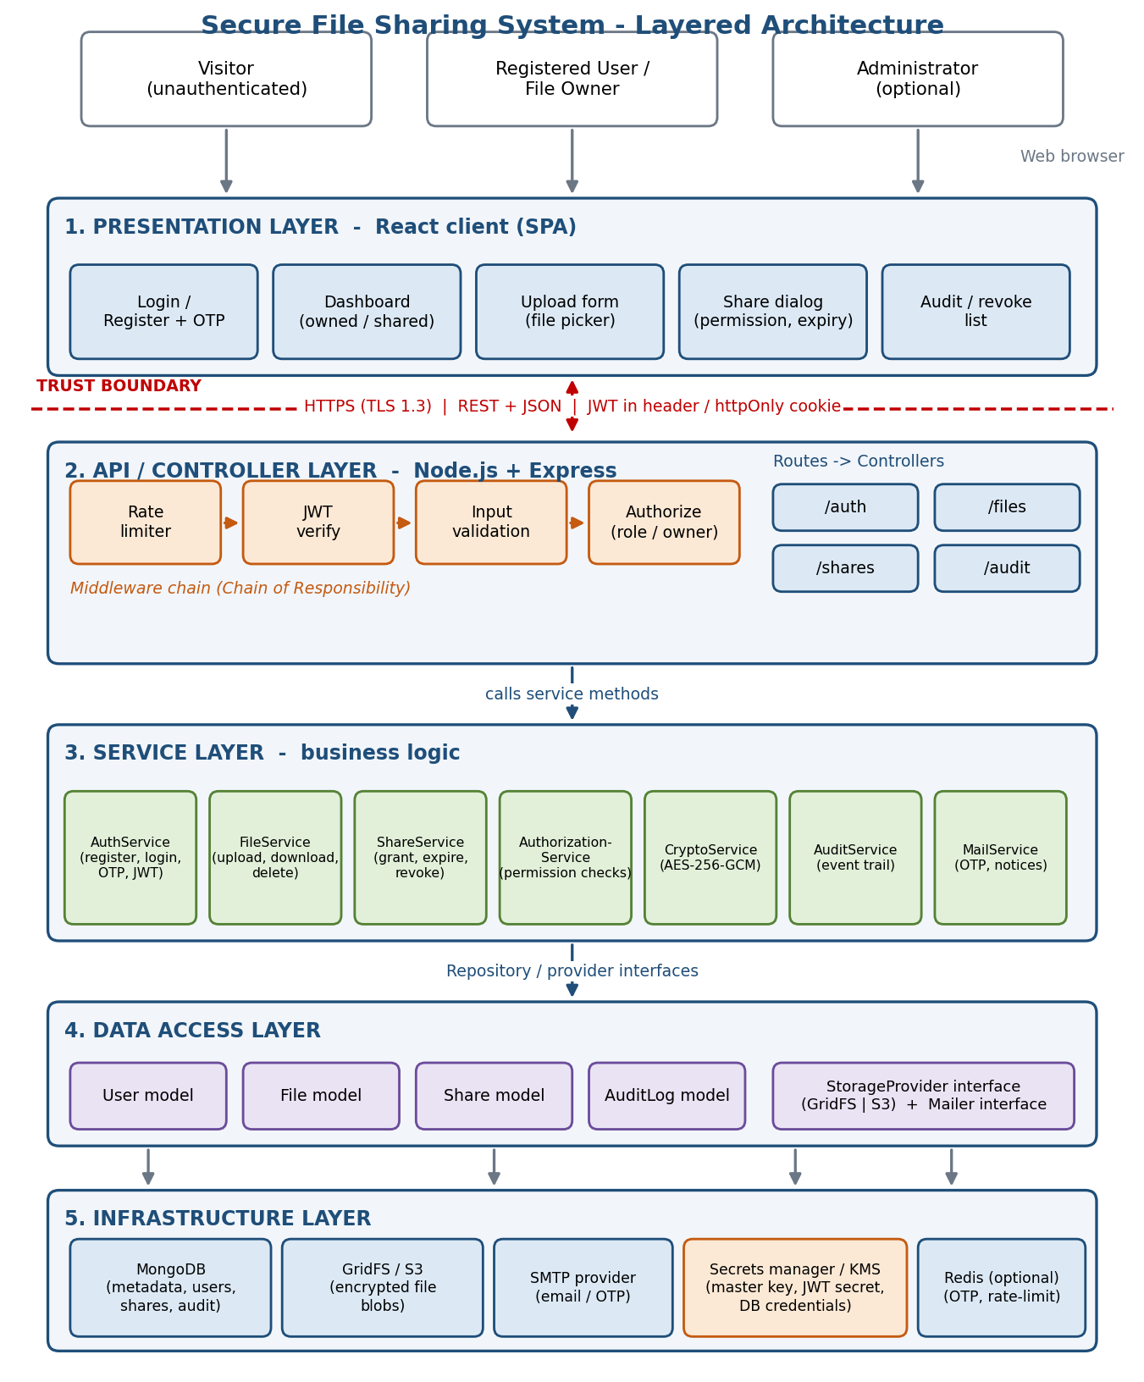
Figure 1: Layered system architecture of the Secure File Sharing System

3.1 Layer descriptions
Layer | Elements | Responsibility
1. Presentation | React SPA: login/register with OTP, dashboard, upload form, share dialog, audit and revoke list | Renders the interface, validates input for usability, calls the REST API and attaches the JWT. It makes no security decisions.
2. API / Controller | Express routes (/auth, /files, /shares, /audit); middleware: rate limiter, JWT verify, input validation, authorization | Receives HTTP requests, runs the middleware chain, and delegates to services. Controllers stay thin.
3. Service | AuthService, FileService, ShareService, AuthorizationService, CryptoService, AuditService, MailService | Implements business rules: hashing, OTP, encryption, permission checks, share expiry, audit writing, email.
4. Data access | Mongoose models: User, File, Share, AuditLog; StorageProvider and Mailer interfaces | Persists and queries metadata; hides storage and mail back-ends behind interfaces.
5. Infrastructure | MongoDB, GridFS or S3, SMTP provider, secrets manager / KMS, optional Redis | Stores data and provides external capabilities.

4. Component Description
Component | Main operations | Depends on
AuthService | register, login, verify OTP, issue and refresh JWT, logout | User model, MailService, AuditService
FileService | upload, list, download, delete (owner only) | CryptoService, StorageProvider, AuthorizationService, File model
ShareService | grant access with permission and expiry, revoke, list shares | Share model, AuthorizationService, MailService
AuthorizationService | decide whether a user may view, download, share or delete a file | File model, Share model
CryptoService | encrypt and decrypt with AES-256-GCM; manage IV and auth tag | Key from secrets manager / KMS
AuditService | record UPLOAD, DOWNLOAD, SHARE, REVOKE, DELETE and DENIED events | AuditLog model
MailService | send OTP and share notification emails | Mailer interface (SMTP)
StorageProvider | save, fetch and delete encrypted blobs (GridFS or S3 implementation) | Object storage

5. Deployment View
Figure 2 shows how the elements are placed on infrastructure in production. HTTPS ends at the reverse proxy, which balances traffic across two or more stateless API instances. The database runs as a replica set, encrypted blobs live in object storage, and keys are fetched from a secrets manager when the servers start.
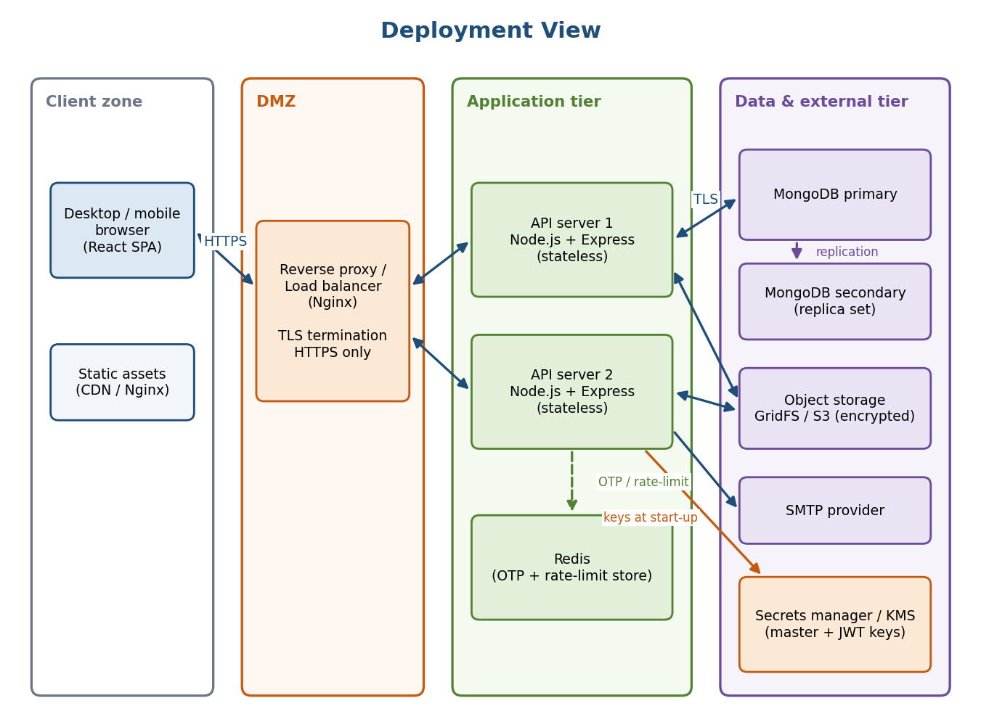
Figure 2: Deployment view with network zones
Zone | Elements | Protection
Client zone | Browser running the React SPA; static assets from CDN or Nginx | Untrusted; no secrets stored; JWT kept in httpOnly cookie or memory.
DMZ | Nginx reverse proxy and load balancer | TLS termination, HTTPS-only, request size and timeout limits.
Application tier | Two or more Node.js/Express instances, Redis | Stateless instances; Redis holds OTP and rate-limit counters shared between instances.
Data and external tier | MongoDB replica set, GridFS/S3, SMTP, secrets manager / KMS | Private network access only; files encrypted before storage; keys never stored with the data.

6. Runtime Data Flow
Figure 3 follows the two most security-sensitive operations through the layers. In both, the request passes the middleware chain first, so unauthenticated or invalid requests never reach the services.
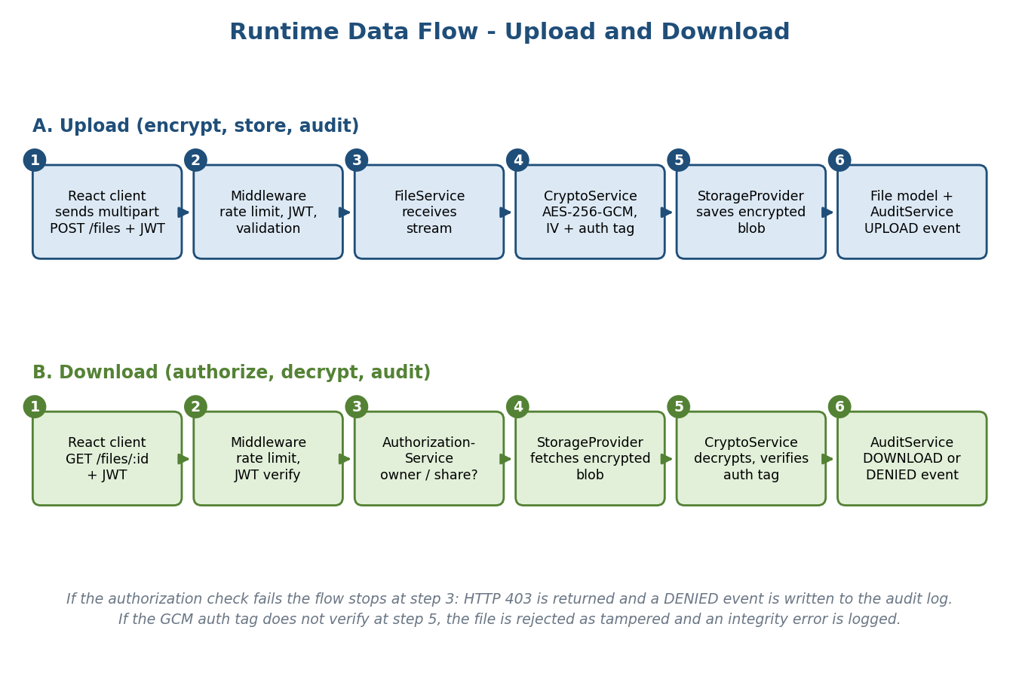
Figure 3: Upload and download data flow

6.1 Upload
The client sends a multipart request with the JWT. The middleware checks rate limit, token and file name, size and type. FileService streams the file to CryptoService, which encrypts it with AES-256-GCM using a fresh IV. StorageProvider stores the encrypted blob, the File record is saved with the owner and metadata, and AuditService records the UPLOAD event.

6.2 Download
After the middleware checks, AuthorizationService confirms that the user is the owner or holds an active, unexpired share. If not, the request ends with HTTP 403 and a DENIED event is logged. Otherwise StorageProvider fetches the encrypted blob, CryptoService decrypts it and verifies the GCM auth tag, and AuditService records the DOWNLOAD event before the file is returned.

7. Data Architecture
Small, queryable metadata is kept in MongoDB, while large encrypted file content is kept in object storage. This avoids the 16 MB document limit and keeps queries fast.
Entity | Key attributes | Relationships
User | id, email (unique), passwordHash, role, OTP state, createdAt | Owns many files; receives many shares.
File | id, originalName, storageRef, size, ownerId, iv, authTag, status, createdAt | Belongs to one User; has many Shares.
Share | id, fileId, recipientId, permission (view or download), expiresAt, status (Active or Revoked), timestamps | Links one File to one recipient User.
AuditLog | id, userId, action, fileId, outcome, timestamp, source IP | References User and File; passwords and file content are never logged.

8. Security Architecture
Control point | Where in the architecture | Threat addressed
TLS 1.3 / HTTPS | Reverse proxy and client-server link | Eavesdropping and tampering in transit
bcrypt hashing + OTP | AuthService | Stolen or guessed passwords
JWT verification | API middleware | Spoofing; access without login
Rate limiting and lockout | API middleware with Redis | Brute force and denial of service
Input validation, size and type limits | API middleware | Injection, path traversal, oversized uploads
Per-request authorization | AuthorizationService | Unauthorized direct object access; privilege escalation
AES-256-GCM encryption at rest | CryptoService | Storage or database leak; file tampering
Secrets manager / KMS | Infrastructure layer | Key exposure through source code or configuration
Audit logging | AuditService | Repudiation; detection of misuse

9. Technology Stack
Tier | Technology | Reason
Client | React, HTML/CSS, Fetch/Axios | Component-based UI; responsive on desktop and mobile.
Server | Node.js, Express.js | Lightweight REST API with a rich middleware ecosystem.
Database | MongoDB with Mongoose | Flexible document model for metadata, shares and audit records.
File storage | GridFS or Amazon S3 | Large encrypted blobs, replaceable through StorageProvider.
Security libraries | bcrypt, jsonwebtoken, Node crypto (AES-256-GCM), helmet, express-rate-limit | Proven libraries for hashing, tokens, encryption and hardening.
Infrastructure | Nginx, Redis, SMTP provider, secrets manager / KMS | TLS termination, shared counters, email delivery and key protection.

10. Conclusion
The Secure File Sharing System is organised as five layers with a clear trust boundary between the browser and the server. Security checks sit in the middleware chain and the AuthorizationService, files are encrypted before they reach storage, and every sensitive action is audited. Stateless API instances, a replicated database and interface-based storage and mail providers support scalability, availability and maintainability. The diagrams in this report give a consistent basis for implementation and for the testing of the SRS requirements.

