Software Engineering Lab
LAB 8: Software Metrics & Complexity Analysis
Project: Secure File Sharing System
Name | Anjil Tripathi
Roll No. | 202401100200053
Section | A
Branch / Year | Computer Science Engineering / 3rd Year
Institution | KIET Group of Institutions, Ghaziabad
Technology Stack | MERN (MongoDB, Express.js, React, Node.js)
Based on: SRS v1.0, Lab 6 Design Analysis Report and Lab 7 System Architecture Diagram

1. Introduction
This report applies software metrics to the Secure File Sharing System. It measures the expected size, complexity, design quality and maintainability of the system using the requirements in the SRS v1.0, the design analysed in Lab 6 and the architecture drawn in Lab 7. The results show where the design is simple and well balanced, where risk is concentrated, and how much testing and effort the project is likely to need.

1.1 Scope
The analysis covers the server-side services of the layered architecture (AuthService, FileService, ShareService, AuthorizationService, CryptoService, AuditService, MailService and the JWT middleware) and the size of the whole application. The React client is included only in the size estimate.

1.2 Method and assumptions
The system is at the design stage, so the figures are design-based measurements, not readings from a finished code base. They were obtained as follows:
- Function points are counted from the SRS features, using standard IFPUG weights.
- Cyclomatic complexity is counted from the decision points of each designed method. The control flow graph for the download use case is drawn in Section 4.2.
- Halstead metrics and the maintainability index are computed by a script from the reference implementation of downloadFile given in Appendix A.
- Class-level (Chidamber-Kemerer) metrics are derived from the service design of Lab 7.
These values should be measured again with tools such as ESLint, Plato or SonarQube once the code is written (see Section 8).

2. Metrics Selected
Category | Metric | What it tells us | Guideline used
Size | Function points (FP) | Functional size of the system from the user's view | Used for estimation, no pass/fail limit
Size / effort | LOC and basic COCOMO | Approximate code size, effort, schedule and team size | Planning estimate
Complexity | Cyclomatic complexity V(G) | Number of independent paths; minimum tests per method | V(G) 1-10 simple, 11-20 moderate, 21-50 complex, over 50 untestable
Complexity | Halstead measures | Volume, difficulty, effort and estimated bugs of a unit | Lower is better; compared between units
Design | WMC, CBO, NOM, DIT | Class complexity, coupling and size | WMC up to 20, CBO up to 5 per class
Maintainability | Maintainability Index (MI) | Combined ease of maintaining a unit | 20-100 good, 10-19 moderate, 0-9 low

3. Size Metrics

3.1 Function point analysis
Function points measure what the system does for its users, independent of the programming language. Items from the SRS were classified as low, average or high complexity and given the standard weights (ILF 7/10/15, EI 3/4/6, EO 4/5/7, EQ 3/4/6). The number in brackets is the weight assigned to each item.
Component | Items counted | Count | Function points
Internal logical files (ILF) | User (10), File (10), Share (10), AuditLog (7) | 4 | 37
External interface files (EIF) | None: mail and storage are accessed through provider interfaces, not read as files owned by another application | 0 | 0
External inputs (EI) | Register (4), Login + verify OTP (4), Logout (3), Upload file (6), Share file (4), Revoke access (3), Delete file (3) | 7 | 27
External outputs (EO) | Send OTP email (4), Share notification email (4), Download file (decrypted) (5) | 3 | 13
External inquiries (EQ) | List owned / shared files (4), View file details (3), List shares of a file (3), View audit log (4) | 4 | 14
Unadjusted function points (UFP) |  |  | 91

The 14 general system characteristics were rated from the SRS requirements (security, online use, complex encryption processing, ease of change). They give a total degree of influence TDI = 44.
General system characteristic | Rating (0-5) | General system characteristic | Rating (0-5)
Data communications | 5 | Online update | 4
Distributed data processing | 3 | Complex processing | 4
Performance | 3 | Reusability | 3
Heavily used configuration | 2 | Installation ease | 2
Transaction rate | 3 | Operational ease | 3
Online data entry | 4 | Multiple sites | 1
End-user efficiency | 4 | Facilitate change | 3

Value adjustment factor: VAF = 0.65 + 0.01 x TDI = 0.65 + 0.01 x 44 = 1.09
Adjusted function points: AFP = UFP x VAF = 91 x 1.09 = 99.2 FP
An application of about 99 FP is a small-to-medium system, which is consistent with a four-feature academic project that has a strong security focus.

3.2 Size and effort estimate (basic COCOMO)
Using an assumed 55 lines of JavaScript per function point (a planning assumption, not a measured value), the expected size is 99.2 x 55 = 5,455 LOC, or about 5.5 KLOC. Basic COCOMO gives the following estimates.
Mode | Effort (person-months) | Schedule (months) | Average team size
Organic (E = 2.4 x KLOC^1.05) | 14.3 | 6.9 | 2.1
Semi-detached (E = 3.0 x KLOC^1.12) | 20.1 | 7.1 | 2.8

The semi-detached figures are the safer plan because the security requirements (encryption, OTP, audit) are more demanding than in a routine business application. The estimate fits a team of two to three students working for about seven months, or a shorter schedule with a larger team.
Layer (Lab 7) | Share of code | Estimated LOC
Presentation (React client) | 40% | 2,182
API / controller layer | 15% | 818
Service layer | 28% | 1,528
Data access layer | 9% | 491
Configuration and infrastructure scripts | 8% | 436
Total | 100% | 5,455
The layer split is a planning assumption used to show where the effort is expected to go.

4. Complexity Metrics

4.1 Cyclomatic complexity of the designed methods
For a method with D decision points (each if, loop, catch, and each && or || condition), the cyclomatic complexity is V(G) = D + 1. It equals the number of independent paths and is the minimum number of unit tests needed to cover every branch.
Method | Decision points | D | V(G) | Risk
AuthService.register | field validation, duplicate e-mail, password strength | 3 | 4 | Simple
AuthService.login | user found, account locked, password match, attempts over limit | 4 | 5 | Simple
AuthService.verifyOtp | OTP exists, OTP expired, OTP matches, attempts over limit | 4 | 5 | Simple
AuthService.refreshToken | token in store, token expired | 2 | 3 | Simple
AuthService.logout | token in store | 1 | 2 | Simple
FileService.uploadFile | file present, size limit, type allowed, storage save ok, quota left | 5 | 6 | Simple
FileService.downloadFile | file exists, access allowed, integrity check | 3 | 4 | Simple
FileService.listFiles | shared-with-me filter, pagination | 2 | 3 | Simple
FileService.deleteFile | file exists, access allowed, storage delete ok | 3 | 4 | Simple
ShareService.shareFile | caller allowed, recipient exists, permission valid, expiry in future, duplicate active share | 5 | 6 | Simple
ShareService.revokeShare | share exists, caller allowed, already revoked | 3 | 4 | Simple
ShareService.listShares | caller allowed | 1 | 2 | Simple
AuthorizationService.canDownload | owner, share exists, not expired, permission ok | 4 | 5 | Simple
AuthorizationService.canShare | file exists, owner | 2 | 3 | Simple
AuthorizationService.canDelete | owner | 1 | 2 | Simple
CryptoService.encrypt | key available | 1 | 2 | Simple
CryptoService.decrypt | key available, auth tag valid | 2 | 3 | Simple
AuditService.log | write ok | 1 | 2 | Simple
AuditService.query | user filter, date-range filter | 2 | 3 | Simple
MailService.sendOtp | send ok | 1 | 2 | Simple
MailService.sendShareNotice | send ok | 1 | 2 | Simple
Middleware.verifyJwt | header present, token valid, not expired | 3 | 4 | Simple

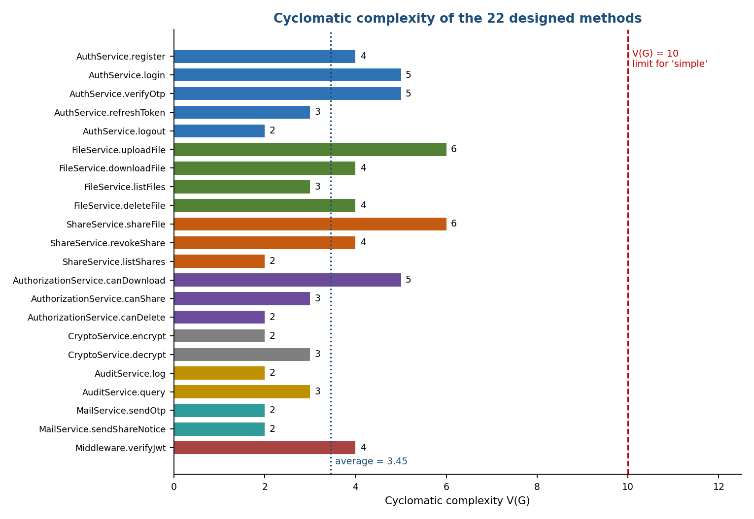
Figure 1: Cyclomatic complexity of each designed method
Result: the 22 methods have a total V(G) of 76, an average of 3.45 and a maximum of 6 (uploadFile and shareFile). Every method is in the "simple" band, so no method is a testing risk. The total of 76 is also the minimum number of unit test cases for full branch coverage.

4.2 Control flow graph and basis paths: download use case
The download use case crosses two services: FileService.downloadFile and AuthorizationService.canDownload. Taken together they form one flow with six decision points. Figure 2 shows its control flow graph.
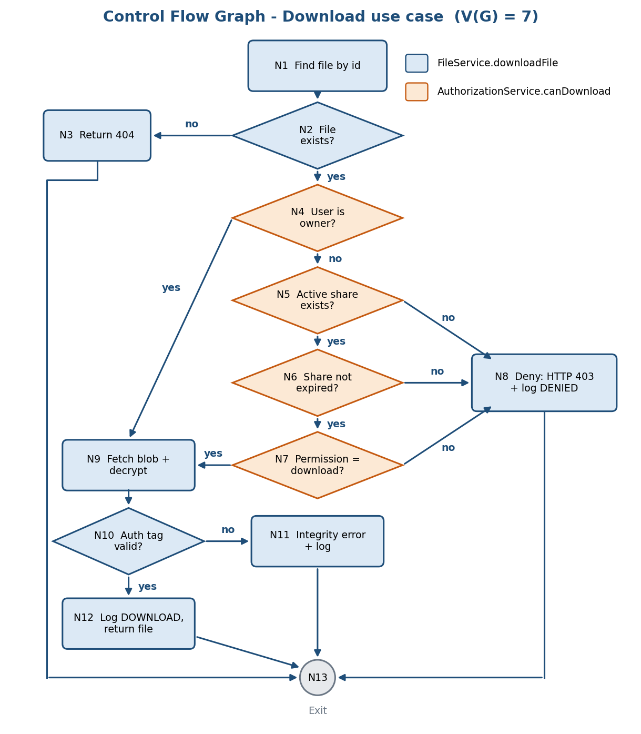
Figure 2: Control flow graph of the download use case
V(G) from the graph: edges E = 18, nodes N = 13, connected components P = 1, so V(G) = E - N + 2P = 18 - 13 + 2 = 7. This agrees with the decision-point count (6 + 1 = 7). Each method alone is simpler (downloadFile has V(G) = 4, canDownload has V(G) = 5), but the use case as a whole needs seven test scenarios.
Path | Nodes visited | Scenario to test | Expected result
P1 | N1-N2-N3-N13 | File id does not exist | HTTP 404
P2 | N1-N2-N4-N9-N10-N12-N13 | Owner downloads own file | File returned, DOWNLOAD logged
P3 | N1-N2-N4-N5-N8-N13 | Not owner, no active share | HTTP 403, DENIED logged
P4 | N1-N2-N4-N5-N6-N8-N13 | Share has expired | HTTP 403, DENIED logged
P5 | N1-N2-N4-N5-N6-N7-N8-N13 | Share allows view only | HTTP 403, DENIED logged
P6 | N1-N2-N4-N5-N6-N7-N9-N10-N12-N13 | Recipient with active download share | File returned, DOWNLOAD logged
P7 | N1-N2-N4-N9-N10-N11-N13 | Stored ciphertext was modified | HTTP 422, integrity failure logged

4.3 Halstead metrics
Halstead measures treat a program as a sequence of operators and operands. They were computed by a script for the downloadFile implementation in Appendix A (18 non-blank lines). Keywords, member access, assignment, comparison and logical symbols, separators and bracket pairs were counted as operators; identifiers, string literals and numbers as operands.
Measure | Symbol / formula | Value
Distinct operators | n1 | 18
Distinct operands | n2 | 30
Total operators | N1 | 80
Total operands | N2 | 52
Vocabulary | n = n1 + n2 | 48
Length | N = N1 + N2 | 132
Estimated length | n1 log2 n1 + n2 log2 n2 | 222.3
Volume | V = N log2 n | 737.2
Difficulty | D = (n1 / 2) x (N2 / n2) | 15.6
Effort | E = D x V | 11,501
Time to program | T = E / 18 seconds | 639 s (about 10.6 minutes)
Estimated delivered bugs | B = V / 3000 | 0.25

A volume of about 737 and difficulty of 15.6 describe a small, readable function. The estimated bug count of 0.25 is well below one, so the unit is low risk, but it is the right place to concentrate tests because it combines authorization, decryption and auditing.

5. Design (Object-Oriented) Metrics
The Chidamber-Kemerer metrics were derived from the service design. NOM is the number of methods in a class, WMC is the sum of the cyclomatic complexities of its methods, and CBO counts the other classes or models a class depends on. DIT and NOC are 0 for every service because the design uses composition and injected interfaces instead of inheritance, which keeps the hierarchy flat and easy to test.
Class | NOM | WMC | CBO | Coupled to
AuthService | 5 | 19 | 3 | User model, MailService, AuditService
FileService | 4 | 17 | 5 | File model, CryptoService, StorageProvider, AuthorizationService, AuditService
ShareService | 3 | 12 | 4 | Share model, AuthorizationService, MailService, AuditService
AuthorizationService | 3 | 10 | 2 | File model, Share model
CryptoService | 2 | 5 | 1 | Key provider (secrets)
AuditService | 2 | 5 | 1 | AuditLog model
MailService | 2 | 4 | 1 | Mailer interface
Total / average | 21 | 72 (avg 10.3) | avg 2.43

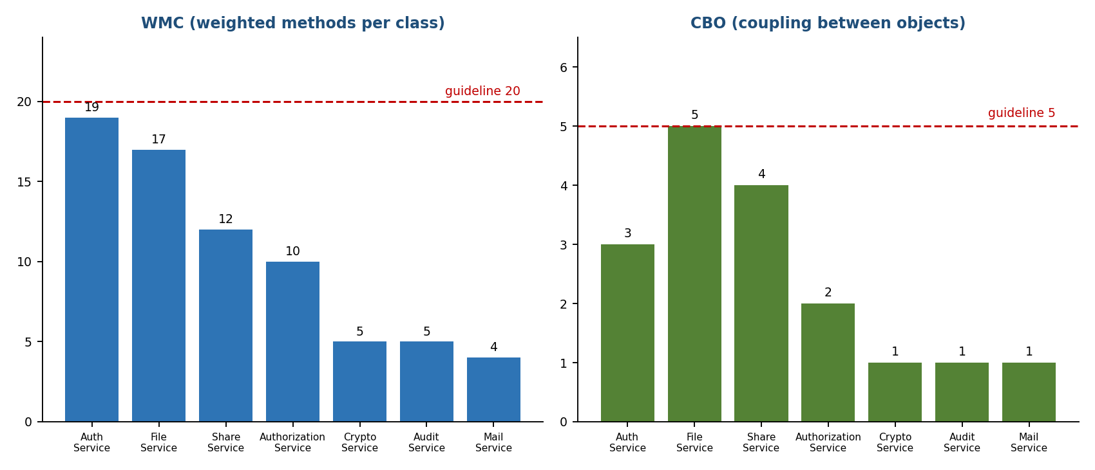
Figure 3: WMC and CBO per service class
Findings. All classes are within the guideline limits (WMC up to 20, CBO up to 5), but two are close to them. AuthService has the highest WMC (19) because it handles registration, login, OTP and token refresh together. FileService has the highest coupling (CBO = 5) because it coordinates storage, encryption, authorization and auditing. This confirms the Lab 6 watch point that FileService can grow into a catch-all, and it shows why permission checks were moved into AuthorizationService (WMC 10, CBO 2): without that class the permission logic would add roughly 10 more complexity points to FileService and ShareService.
Cohesion is high because every class groups methods around one concern, and coupling is low because services depend on interfaces (StorageProvider, Mailer) rather than concrete SDKs, as described in Lab 6.

6. Maintainability Index
The maintainability index combines Halstead volume, cyclomatic complexity and size: MI = 171 - 5.2 ln(V) - 0.23 G - 16.2 ln(LOC), rescaled to 0-100 as MI x 100 / 171. It was calculated for FileService.downloadFile using the values measured above.
Input | Value
Halstead volume V | 737.2
Cyclomatic complexity G | 4
Lines of code (LOC) | 18
MI (original scale) | 88.9
MI (normalised, 0-100) | 52.0

With a normalised index of 52.0, the unit is well inside the "good" band (20-100). It is the most complex part of the download flow, so the other, simpler methods are expected to score at least as well. The index will fall as the method grows, which is why the guidelines in Section 8 recommend keeping new logic in separate services.

7. Summary of Results
Metric | Result | Guideline | Verdict
Adjusted function points | 99.2 FP | No limit | Small-to-medium system
Estimated size | 5.5 KLOC | No limit | Realistic for a student team
Effort (semi-detached COCOMO) | 20.1 person-months | No limit | About 7 months for 2-3 people
Average V(G) per method | 3.45 | 10 or less | Good
Maximum V(G) per method | 6 | 10 or less | Good
Download use case V(G) | 7 | 10 or less | Good; 7 scenario tests needed
Minimum unit test cases (sum of V(G)) | 76 | - | Test plan baseline
Average WMC per class | 10.3 | 20 or less | Good
Highest WMC (AuthService) | 19 | 20 or less | Near the limit, monitor
Average CBO per class | 2.43 | 5 or less | Good
Highest CBO (FileService) | 5 | 5 or less | At the limit, monitor
Maintainability index (downloadFile) | 52.0 | 20 or more | Good
Estimated bugs (downloadFile) | 0.25 | Below 1 | Low risk

8. Risks and Recommendations
- Keep FileService from growing. It is already at the CBO limit. New concerns such as virus scanning or thumbnails should go into their own services behind interfaces.
- Watch AuthService. WMC is 19. If password reset or email verification (SRS TBD-03) is added, move OTP handling into a separate OtpService before the limit of 20 is crossed.
- Test by basis paths. Write at least one test for every independent path: 76 unit tests in total and the 7 scenarios in Section 4.2 for the download use case.
- Set quality gates in the build. Use the ESLint complexity rule with a limit of 10, and fail the build when a new method exceeds it.
- Aim for test coverage targets. Statement coverage of at least 80% and branch coverage of at least 70% on the service layer, measured with Jest.
- Re-measure after coding. Run Plato or SonarQube on the finished code and compare the results with this report, then update the COCOMO assumptions (LOC per FP) with the real values.

9. Conclusion
The metrics show that the Secure File Sharing System is a small-to-medium application of about 99.2 function points that can be built by a small team in roughly seven months. Method complexity is low (average V(G) 3.45, maximum 6), class coupling is low, and the one multi-service flow with the highest complexity, the download use case, has a clear set of seven test scenarios. AuthService and FileService are close to the guideline limits and should be watched as features are added. Applying the recommendations in Section 8 and re-measuring after implementation will keep the system maintainable and testable.

Appendix A: Reference Code Used for the Measurements
The following outline of FileService.downloadFile and AuthorizationService.canDownload was used for the Halstead and maintainability calculations and for the control flow graph in Figure 2.
FileService.downloadFile
async function downloadFile(userId, fileId) {
const file = await File.findById(fileId);
if (!file) throw new HttpError(404, "File not found");
if (!(await authz.canDownload(userId, file))) {
await audit.log("DENIED", userId, fileId);
throw new HttpError(403, "Access denied");
}
const blob = await storage.fetch(file.storageRef);
let data;
try {
data = crypto.decrypt(blob, file.iv, file.authTag);
} catch (e) {
await audit.log("INTEGRITY_FAIL", userId, fileId);
throw new HttpError(422, "File integrity check failed");
}
await audit.log("DOWNLOAD", userId, fileId);
return data;
}

AuthorizationService.canDownload
async function canDownload(userId, file) {
if (file.ownerId === userId) return true;
const share = await Share.findActive(file._id, userId);
if (!share || share.expiresAt <= Date.now() || share.permission !== "download") return false;
return true;
}

