Project Title
Automation Testing Framework for E-commerce Website using Python
Website Used: Demo Web Shop (https://demowebshop.tricentis.com)
1. Project Overview
This project automates core functionalities of the Demo Web Shop e-commerce website using Selenium WebDriver with Python and PyTest, following the Page Object Model (POM) design pattern.
The automation framework validates critical user workflows such as:
- User Registration
- User Login & Logout
- Product Search
- Add to Cart
- Wishlist Management
- Checkout Process
- Newsletter Subscription
- Navigation & UI Validation
The framework also handles dynamic web elements, synchronization issues, and UI interactions to ensure stable and maintainable automation execution.
2. Objectives
- Automate major functionalities of the e-commerce website
- Implement automation using PyTest with POM architecture Handle dynamic web elements and page synchronization
- Perform user interaction testing with Selenium
- Generate detailed testing documentation and reports
- Perform Lighthouse UI & performance analysis
- Create scalable and reusable automation scripts
- Prepare a professional QA automation project submission
3. Tools & Technologies Used

Tools | Details
Programming Language | Python
Automation Tool | Selenium
Test Framework | PyTest
Browser | Chrome
Driver Manager | webdriver-manager
Performance Testing Tool | Apache JMeter
Design Pattern | Page Object Model (POM)
Lighthouse | UI & Performance Audit
IDE | VS Code
Reporting Tool | pytest-html
4. Test Scenarios & Descriptions
4.1 User Registration

Objective
Validate user registration process and ensure new users can create accounts successfully.

Type
Functional Testing, UI Testing and Negative Testing

Actions Covered
- Enter First Name
- Enter Last Name
- Enter Email Address
- Enter Password
- Confirm Password
- Select Gender (optional)
- Submit Registration Form
- Validate required field messages

Expected Result
- New account should be created successfully with valid details
- Validation messages should appear for invalid or empty fields

Status
✅ Pass
Test Case:
Test Cases
4.2 Login Functionality

Objective
Verify successful login using valid credentials and ensure appropriate error handling for invalid login attempts.

Type
Functional Testing

Actions Covered
- Enter valid username and password
- Enter invalid username/password
- Click Login button
- Validate successful redirection
- Verify error message display
- Validate password masking

Expected Result
- User should successfully login with valid credentials
- Invalid credentials should display appropriate error message
- Password field should remain masked

Status
✅ Pass
Test Case:
Test Cases

4.3 Product Page Functionality

Objective
Ensure users can search products successfully using valid and invalid search keywords.

Type
Functional + UI Testing

Actions Covered
- Open Search Bar
- Enter Product Keyword
- Click Search Button
- Validate Search Results
- Add products to cart
- Removing added products directly from product page

Dynamic Handling
- Explicit waits for result loading
- Scroll handling for dynamically loaded products

Expected Result
- Relevant products should appear for valid searches
- “No products found” message should display for invalid searches

Status
❌ Fail
Test Case:
Test Cases

4.4 Cart Functionality

Objective
Verify users can add products to the shopping cart successfully.

Type
Functional + UI Testing

Actions Covered
- Select Product
- Open Product Details
- Click Add to Cart
- Validate Cart Quantity Update
- Verify Product Details in Cart

Expected Result
Selected product should be added to the shopping cart correctly.

Status
✅ Pass
Test Case:
Test Cases

4.5 Wishlist Functionality

Objective
Ensure users can add and manage products in the wishlist.

Type
Functional Testing

Actions Covered
- Select Product
- Add Product to Wishlist
- Verify Wishlist Update
- Remove Product from Wishlist

Expected Result
Products should be added and removed from wishlist successfully.

Status
❌ Fail
Test Case:
Test Cases

4.6 Checkout Process

Objective
Validate end-to-end checkout and order placement process.

Type
Functional + UI Testing

Actions Covered
- Add Product to Cart
- Proceed to Checkout
- Fill Billing Information
- Select Shipping Method
- Confirm Order
- Validate Order Confirmation

Expected Result
Order should be placed successfully and confirmation message displayed.

Status
✅ Pass
Test Case:
Test Cases

4.7 Newsletter Subscription Functionality

Objective
Validate newsletter subscription using valid and invalid email addresses.

Type
Functional Testing

Actions Covered
- Enter Email Address
- Click Subscribe Button
- Validate Success/Error Message

Expected Result
- Valid email should subscribe successfully
- Invalid email should display validation error

Status
✅ Pass
Test Case:
Test Cases

4.8 Responsive UI Testing

Objective
Validate website responsiveness across multiple screen sizes and devices.

Type
Responsive UI Testing

Actions Covered
- Resize browser window
- Test mobile/tablet layout
- Validate responsive menu behavior
- Verify text and image alignment

Expected Result
Website should adjust correctly across different resolutions without overlapping elements.

Status
✅ Pass

4.9 Lighthouse UI & Performance Testing

Objective
Analyze website quality using Google Lighthouse audit.

Type
Performance + UI Testing

Areas Validated
- Performance
- Accessibility
- Best Practices
- SEO
- Responsive UI

Lighthouse Scores
- Performance: 78
- Accessibility: 74
- Best Practices: 100
- SEO: 42
Performance Metrics
- First Contentful Paint (FCP): 1.1 s
- Largest Contentful Paint (LCP): 2.1 s
- Total Blocking Time (TBT): 0 ms
- Speed Index: 1.9 s
- Cumulative Layout Shift (CLS): 0.157

Test Observations
- The website loads quickly on desktop browsers.
- User interaction is responsive with no blocking delay.
- Layout shifting is slightly noticeable during banner loading.
- Accessibility standards are partially implemented.
- SEO optimization requires major improvements.
- Best practices implementation is excellent.

Recommendations

i) Performance Recommendations
- Compress and optimize large images.
- Enable lazy loading for media files.
- Reduce unused JavaScript and CSS.
- Improve server-side caching.
- Use CDN for faster asset delivery.

ii) Accessibility Recommendations
- Add ARIA labels where necessary.
- Improve keyboard accessibility.
- Ensure readable font sizes and contrast.
- Add descriptive alt text.

iii) SEO Recommendations
- Add metadata for all pages.
- Improve page titles and descriptions.
- Use semantic HTML tags.
- Improve mobile optimization.
Screenshot
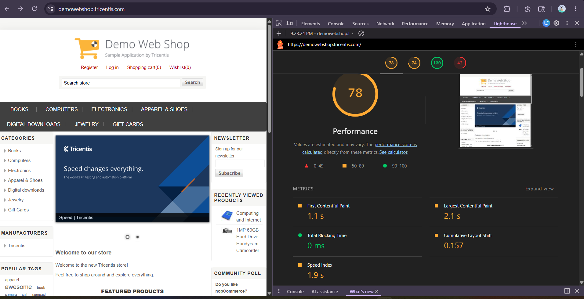

4.10 Performance Testing using JMeter (Login Page)

Objective
Validate website stability and performance under multiple concurrent users.

Type
Performance/ Load Testing

Test Configuration
Parameter | Value
Users | 50
Loop Count | 5
Total Requests | 250
Ramp-Up Time | 10 sec

Areas Validated
- Response Time
- Throughput
- Error Rate
- Server Stability

Aggregate Report

Metric | Result
Average Response Time | 1785 ms
Median | 1414 ms
Minimum | 299 ms
Maximum | 8082 ms
Error % | 0.00%
Throughput | 21.0/sec

Summary Report
Metric | Result
Total Samples | 250
Average | 1785 ms
Standard Deviation | 1375.50
Throughput | 21.0/sec
Received KB/sec | 468.40
Sent KB/sec | 6.36

Expected Result
The login page should handle multiple users successfully without errors.

Actual Result
- Login requests were processed successfully.
- No errors occurred during testing.
- Application remained stable under load.

Observations
- System handled concurrent users properly.
- Response time was acceptable.
- No request failures observed.
- Few requests took longer during peak load.

Recommendations
- Optimize server response time.
- Improve database performance.
- Perform stress testing with more users.
- Monitor system resources during heavy traffic.

Automation Report
Github link: https://github.com/AnjilaBohora/Demo_webapp_automation.git
Project Structure:
DEMOWEBAPP/
│
├── login.py
├── product.py
├── cart.py
├── checkout.py
├── logout.py
│
├── test_webapp.py
│
├── conftest.py
│
├── requirements.txt
│
├── reports/
└── report.html
Descriptions:

login.py
Responsible for:
- Open Website
- Click Login Link
- Enter Email
- Enter Password
- Click Login Button

product.py
Responsible for:
- Open Books Category
- Sort Price Low to High
- Open Product in New Tab
- Add Product to Cart
- Open Cart

cart.py
Responsible for:
- Update Quantity
- Remove Product
- Accept Terms
- Proceed Checkout

checkout.py
Responsible for:
- Billing Address
- Shipping Address
- Shipping Method
- Payment Method
- Confirm Order

logout.py
Responsible for:
- Click Logout
- Verify Logout

conftest.py: Contains WebDriver setup.

test_webapp.py
Complete End-to-End Flow:
Login
↓
Sort Product
↓
Open Product in New Tab
↓
Add To Cart
↓
Update Product Quantity
↓
Remove Product
↓
Update Cart
↓
Checkout
↓
Back to parent tab
↓
Logout

Web Elements Used
- Text Box (Email, Password, Search)
- Button (Login, Add to Cart, Checkout)
- Link (Shopping Cart, Logout)
- Checkbox (Terms of Service)
- Browser Tabs/Windows

Selenium Concepts Used
- Page Object Model (POM)
- Pytest Fixture
- Assertions
- Explicit Waits
- Window/Tab Handling
- End-to-End Automation Flow
- Dynamic Content Handling

