Table of Contents

1. Pricing Methodology 2

1.1. Method Overview 2

1.2. Method Justification 2

1.3. Black Scholes 3

1.4. Black Scholes with Dividend 4

1.5. Black Scholes with Single Normal Jump 4

1.6. Black Scholes with Double Normal Jump 5

1.7. Validation 5

2. Optimisation Methodology 6

2.1. Method Overview 6

2.2. Method Justification 6

2.3. Method Details 6

2.4. Validation 7

3. Exercises 8

3.1. Pricing Exercise 1 8

3.2. Optimisation Exercise 1 8

3.3. Optimisation Exercise 2 9

4. References 11

# Pricing Methodology

## Method Overview

In this repository I have implemented pricing functions for equity European and American options under four different variants of the classical Black Scholes model, which I refer to as:

1. Black Scholes,
2. Black Scholes with Dividend,
3. Black Scholes with Single Normal Jump,
4. Black Scholes with Double Normal Jump.

The last two models can be considered as simplifications of the Merton Jump Diffusion model, as proposed by Merton (1976), and the Kou Jump Diffusion model, as proposed by Kou (2002), respectively. In the former, the Poisson process with Normal jumps has been replaced with a single Normal jump at a deterministic time; and in the latter, the Poisson process with Double Exponential jumps has been replaced with a single deterministic Double Normal jump.

I implemented Monte Carlo methods to price European options. These implementations are rather trivial under each model, and so not discussed in depth.

I implemented tree methods to price American options under each of the above four models. For the Black Scholes diffusion part of the models, I implemented 2-state jumps, with probabilities under the Cox, Ross and Rubinstein (1979) and Tian (1993) models. For each Normal jump is used a 5-state moment matching scheme.

As the discrete deterministic dividend have no impact on the diffusion or jump processes, I first constructed the tree of underlying prices under the diffusion and jump parts, and then deducted the value of the dividend from each node after the dividend payment date. I also enforced a floor of 0 on the underlying price, and made it an absorbing state.

## Method Justification

I priced American options using trees because these methods can cope with path dependent options, as they run in backward time, and can achieve very fast pricing. Although Least Squares Monte Carlo methods, such as Longstaff Swartz, can also price path dependent options, they have a slower speed of pricing than trees.

An issue with tree methods is that they belong to the explicit family of finite difference schemes, and thus are not unconditionally stable. In other words, it is not guaranteed that the method converges to a price. However, these instances do not occur frequently. Moreover, unconditionally stable schemes such as ADI, or even Crank-Nicholson, are significantly more complex, and thus require greater code development time.

Since the option value is not differentiable at the Strike price, tree methods can at times yield an unstable price. Stability can be increased by ensuring that the Strike price always falls exactly on a node, or in the middle of a node. This was not implemented because doing so is not trivial in the presence of jumps.

## Black Scholes

The Black Scholes dynamics for the price of the stock at time $t$, $S_{t}$, is given by:

$$S_{t}=S_{0}e^{\left(r-q-\frac{σ^{2}}{2}\right)t+σW_{t}},$$

where $r$ is the risk-free rate, $q$ is the borrow rate, $σ$ is a constant, and $W_{t}$ is a Brownian motion.

It is assumed that we can continuously delta hedge with no transaction costs, and that there are 365 business days in a year.

Joshi (2007) and Chan et al. (2009) conclude that the classical Binomial tree method can be extended to have similar performance as the Trinomial tree method. These extensions form the basis of my implementation for the Black Scholes model, which in turn is used across the other three models as well.

I implemented the following extensions:

* Up and down state probabilities from Cox, Ross and Rubinstein (1979), and Tian (1993).
* Richardson Extrapolation: take the average of the option prices given by $n$ and $2n$ time steps. This averages out the oscillatory behaviour of tree prices.
* Smoothing: at the last discrete time before expiry, an American option is simply a European option. Hence, the American option value at all tree nodes at this time point can be set to the greater of the intrinsic value and the closed form solution for the price of a European option under Black Scholes.

In the BlackScholesTest.h test harness file I compared the performance of the different extensions by pricing a selection of European options. I found the inclusion of Richardson Extrapolation and Smoothing significantly improved the rate of convergence of the Binomial tree, especially compared to Monte Carlo. I found the use of the state probabilities from Tian (1993) to offer insignificant performance gains over those from Cox, Ross and Rubinstein (1979). Hence, for all my results I simply used the latter.

I selected the classical up and down jumps of $\exp\left(±σ\sqrt{δt}\right)$, with the up state probability of

$$0.5 * (1.0 +\sqrt{δt}*(r-q-0.5*σ^{2})$$

and chose the down state probability such that the two probabilities summed up to 1.

In the above equation $δt$ is the time step size for the tree, with the other parameters as per usual. I kept the time step size constant, which results in the jump sizes and probabilities being invariant with time. The time step size can be selected at run-time such that the option price converges, and that any discrete events such as dividend payments or price jumps occur in between discretisation times.

After constructing the tree, the value of the American option is determined in backward time. The option value at each node is equal to the greater of the intrinsic value at that node, and the discounted average of the option value from the two forward nodes. This process continues up until the single node at time 0 is hit.

## Black Scholes with Dividend

Suppose a cash dividend of amount $\$d$ is payed out at time $t_{div}$. Then, under the Black Scholes framework the dynamics are given by:

$$S_{t}=S_{0}e^{\left(r-q-\frac{σ^{2}}{2}\right)t+σW_{t}}-d.1\left\{t≥t_{div}\right\},$$

where

$$1\left\{t≥t_{div}\right\}=\left\{\begin{aligned}0 if t<t_{div} \\ 1 otherwise\end{aligned}.\right.$$

Note that the drop in the share price due to the dividend does not impact the diffusion process. Thus, I first constructed the tree all the way up to option maturity based on the diffusion process, and then deducted the dividend amount from all nodes after the dividend payment time.

## Black Scholes with Single Normal Jump

Suppose now an earnings event is scheduled at time $t_{ea}$. Then, the dynamics are given by:

$$S_{t}=S_{0}e^{\left(r-q-\frac{σ^{2}}{2}\right)t+J.1\left\{t≥t_{ea}\right\}+σW_{t}}-d.1\left\{t≥t_{div}\right\},$$

where $J\sim N\left(μ,σ_{ea}\right)$.

My method for implementing the Single Normal jump was inspired by that from Hilliard and Schwartz (2005). I discretised the Normal jump into 5 states via moment matching the first four non-central normal distribution moments and requiring the probabilities to sum to 1.

The 5 jump states I selected were $μ+2σ_{ea}$, $μ+σ_{ea}$, $μ$, $μ-σ_{ea}$, $μ-2σ_{ea}$. As the normal distribution is symmetric, the moment matching procedure yielded probabilities of 1/12, 1/6, 1/2, 1/6 and 1/12 respectively.

I constructed a recombining Binomial tree up until the discrete time immediately before the jump. Then, I applied ten jump diffusion nodes to each node at this time. Each jump diffusion node involves a diffusion up or down state, and one of the 5 jump states. From each of these jump diffusion nodes, I then constructed a new non-recombining Binomial tree up until option maturity.

Although I also implemented a recombining version, I found it to produce unstable results, thus requiring further investigation. The deprecated implementation is nonetheless available in the code.

The dividend was handled in the same way as the previous model.

## Black Scholes with Double Normal Jump

The Double Normal Jump model is given by the following dynamics:

$$S_{t}=S_{0}e^{\left(r-q-\frac{σ^{2}}{2}\right)t+J.1\left\{t≥t_{ea}\right\}+σW_{t}}-d.1\left\{t≥t_{div}\right\},$$

where $J=αJ_{+}+\left(1-α\right)J_{-}$ for $J_{±} \sim N(μ±k,σ_{ea })$, and $α$ a Bernoulli variable with probability $p$. That is, the jump is Double Normal.

The Double Normal jump in this model will result in a bimodal jump, depending on the distance between the mean of the two Normals. However, as the two Normal are independent, the 5-state moment matching can be performed independently for each Normal. This yields 10 jump states for the Double Normal. The probability for one of the 10 Double Normal jump states is then the Bernoulli probability of hitting the corresponding Normal, multiplied by the probability of hitting the corresponding state of that Normal. This results in a total of 20 jump diffusion states.

All else was done in the same way as the previous model.

## Validation

To validate my tree construction, I implemented European option Monte Carlo pricers for each of the four models, as well the analytic European option pricing formula for the Black Scholes model. I constructed a variety of tests, using predominantly European options, to check event timing and the validity of the distributions implied by the trees. The whole suite of tests is included in my C++ implementation.

# Optimisation Methodology

## Method Overview

I implemented a Differential Evolution optimiser to solve for the model parameters. I selected Differential evolution because:

1. it returns the global minimum;
2. it optimises in multidimensional real space, and so it can optimise for multiple parameters of interest;
3. and, it does not rely on gradients (i.e. the Greeks in our case).

## Method Justification

I considered Levenberg-Marquardt as an alternative to Differential Evolution, but decided against using that algorithm because it finds local minimum (although with some tweaks its chance of finding the global minimum can be improved) and will be dependent on the Greeks. Given that the implementation of the Greeks in the tree pricers would require further study (particularly for stability on the tree), I felt that Differential Evolution was the more appropriate choice.

## Method Details

The aim of a Differential Evolution algorithm is to find the global minimum of a function which maps a $D$ dimensional real space into a $1$ dimensional real space. That is, the algorithm finds the values of the $D$ parameters which minimise the function.

The main idea is to begin with a random selection within the space, and then iteratively adjust the random selection until the minimum is found. In particular, the algorithm is composed of 5 stages:

1. Initialisation : make a random selection (within upper and lower bounds) of $N$ points in the $D$ dimentional space. These $N$ points are referred to as the *target* *vectors*, and can be denoted as $x_{i}=[x_{i,1},…,x_{i,D}]$ for $i$ in $1,…,N$*.*
2. Mutation : For each one of the target vectors $x_{i}$, randomly select three other target vectors $x_{r1}$, $x_{r2}$ and $x_{r3}$ for $r1≠r2≠r3≠i$. Compute the $i^{th}$*donor vector $v_{i}=x_{r1}+F(x_{r2}-x_{r3})$* , where the *mutation factor $F$* is a constant selected between 0 and 2, inclusive.
3. Recombination : construct the $i^{th}$*trial vector $u_{i}$* as a random mixture of the $i^{th}$ target and donor vectors. In particular

$$u_{i,j}=\left\{\begin{aligned}v_{i,j} , {rand}_{i,j}≤CR or j=I_{rand} \\ x_{i,j} , & {rand}_{i,j}>CR and j≠I_{rand}\end{aligned}\right.$$

where ${rand}_{i,j}$ is a standard uniform random variable, $I{}_{rand}$ is a random integer form $1,…,D$; and $CR$ is the *selection criterion.*

1. Selection : Value the function at the $i^{th}$*trial* and *target* vectors, and select the one which has a lower value. The selected vector is then the $i^{th}$ target vector for the next iteration of the algorithm.
2. Repeat the above four steps until the global minimum is found within the desired tolerance.

An issue with the Differential Evolution algorithm is premature convergence, whereby the algorithm converges to a local rather than global minimum. This can be overcome by increasing the population size of the target vectors, at the expense of speed, or by making a better selection of the initial target vectors. One way to achieve the latter is by using quasi-random points, from say a Sobol sequence, rather than psuedo random points. For the present implementation, pseudo random points were used.

## Validation

I validated my Differential Evolution implementation by minimising the Ackley function, which is a multi-dimensional function that has a large number of local minimums, but only one global minimum.

# Exercises

## Pricing Exercise 1

**Exercise:** PricingDataset1 lists 78 different options – identified by exercise-style/strike/expiry/kind – and 6 different models – specified by the set of parameters $\left(r,q,σ,σ_{ea},d,t_{div},t_{ea}\right)$. Price the options defined in the dataset using the Double Normal Jump model with $S_{0}=\$170$.

**Solution:** Results can be found in PricingAnswer1.json These results were generated with 7 time steps in the jump diffusion tree (i.e. the price is an average from 14 and 7 time steps), with a total run time of only a few seconds. Prices were observed to converge reasonably well with even 4 time steps, with the whole set of options being priced in less than a second.

## Optimisation Exercise 1

**Exercise:** The prices in OptimisationDataset1 are computed for American options according to the Single Jump Model with $S_{0}=\$170, r=2\%, q=0.4\%,t_{div}=\frac{14}{365},d=\$0.5, t_{ea}=\frac{7}{365}$, and $k=0$. Estimate the $σ$ and $σ_{ea}$ used to generate the prices.

**Solution:** I completed this in two stages. First, I set the number of time steps in the jump diffusion tree to 5 for each of the options, along with $F=0.5, CR=0.1$, $N=10$, and a lower bound of 0.01% and an upper bound of $50\%$ for both of the two volatilities. I minimised the mean squared error across the option prices to get values of approximately $σ=15.40\%$ and $σ_{ea}=5.49\%$.

I then restarted the algorithm with 4 times steps in the jump diffusion tree, $F=0.5,CR=0.1,N=200$, and bound $σ$ between $10\%$ and 20%, and bound $σ_{ea}$ between 1% and 10%. The results after 7 iterations of the algorithm were as below.

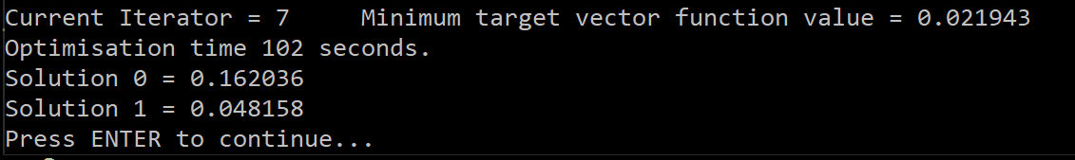

That is, $σ=16.20\%$ and $σ_{ea}=4.8\%$, with a mean square error of 0.021943 across the prices of the provided options.

## Optimisation Exercise 2

**Exercise:** Using OptimisationDataset2.json, repeat the previous exercise for $r,q,d,σ$ and $σ_{ea}$ given $S_{0}=\$170,t_{div}=\frac{14}{365}, t_{ea}=\frac{7}{365},$ and $k=0$.

**Solution:** I first chose 4 times steps in the jump diffusion tree, $F=0.5,CR=0.1,N=10$, and boundaries of $1\%<q<10\%, 1\%<r<10\%, 1\%<σ<50\%, \$0.20<d<\$0.70 and 1\%<σ_{ea}<30\%.$ The results after 9 iterations of the algorithm were as below.

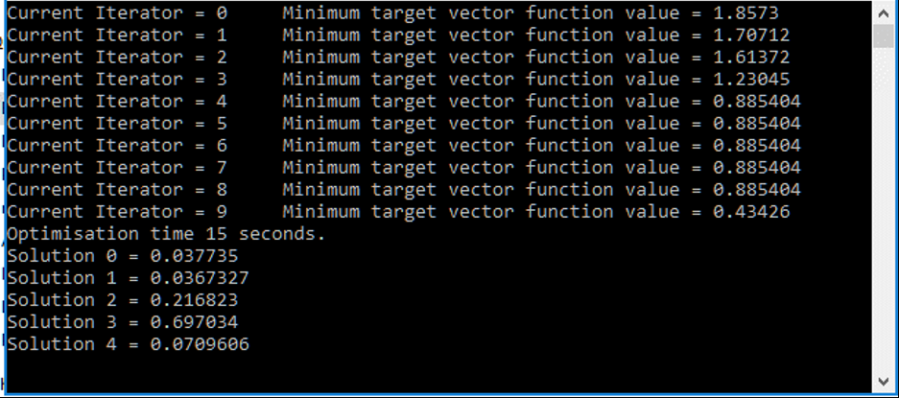

I then restarted the algorithm with 4 times steps in the jump diffusion tree, $F=0.5,CR=0.1,N=200$, and boundaries of $1\%<q<10\%, 1\%<r<10\%, 1\%<σ<30\%, \$0.10<d<\$1.50 and 1\%<σ_{ea}<20\%.$ The results after 46 iterations of the algorithm were $q=5.92\%, r=6.89\%, σ=21.24\%, d=\$1.49$ and $σ_{ea}=8.60\%$, with a mean squared error of 0.033.

Observing that the dividend amount was close to its upper bound of $\$1.49$, I restarted the algorithm one final time with the same parameters as above, except with $N=5^{5}$, and $\$0.10<d<\$10.00$. The results after 45 iterations (an overnight run) of the algorithm were $q=1.75\%, r=2.78\%, σ=20.14\%, d=\$1.59$ and $σ_{ea}=9.07\%$, with a mean squared error of $0.019$, as per below.

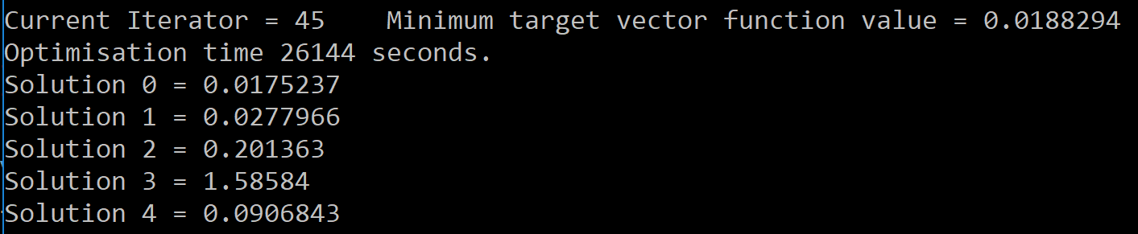

Running the algorithms for a longer period of time would result in further reduction of the mean squared error.

# References

Chan, J. H., Joshi, M., Tang, R. and Yang, C. (2009), Trinomial or binomial: Accelerating American put option price on trees. J. Fut. Mark., 29: 826–839. doi:10.1002/fut.20389

Cox, J. C.; Ross, S. A.; Rubinstein, M. (1979). "Option pricing: A simplified approach". Journal of Financial Economics. 7 (3): 229. doi:10.1016/0304-405X(79)90015-1.

Hilliard, Jimmy E., and Adam Schwartz. “Pricing European and American Derivatives under a Jump-Diffusion Process: A Bivariate Tree Approach.” The Journal of Financial and Quantitative Analysis, vol. 40, no. 3, 2005, pp. 671–691. JSTOR, JSTOR, www.jstor.org/stable/27647216.

Kou, S. G. (2002). A jump diffusion model for option pricing. Management Science 48, 1086-1101.

Joshi, Mark S., The Convergence of Binomial Trees for Pricing the American Put (November 14, 2007). Available at SSRN: https://ssrn.com/abstract=1030143 or <http://dx.doi.org/10.2139/ssrn.1030143>

Merton, R. C., 1976, “Option Pricing When Underlying Stock Returns Are Continuous,” Journal of Financial Economics, 3, 125-144.

Tian, Y. (1993), A modified lattice approach to option pricing. J. Fut. Mark., 13: 563–577. doi:10.1002/fut.3990130509