Computer Science 221

HW 2

Learning objectives:
- Use classes, branches, simple while loops, arithmetic, output.

Collaboration: NONE. This assignment is an individual effort, code developed by you, not found on the internet or provided by any other human or robot! It is cheating to google solutions to this problem or ask others for solutions to this problem. It is cheating to provide solutions or partial solutions to other students.
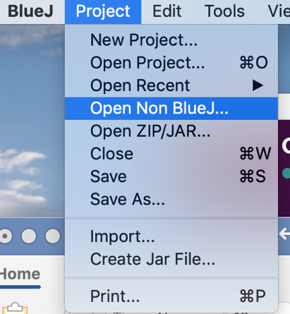
How to start:
You are provided with starter code in a folder called HW2 –
- Download HW2.zip from the OAKS HW dropbox folder. Store this zipped file in your CSCI 221 directory.
- Unzip to reveal folder name HW2.
- In BlueJ, under Project, choose Open non-BlueJ project (see picture at right).
- Navigate to you CSCI 221 directory and select the HW2 folder (that you just unzipped). And click Open on bottom right. (See below, left.)
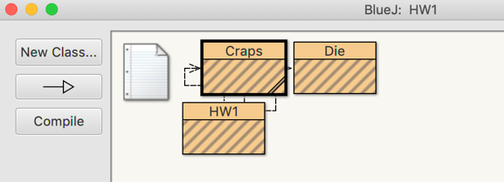
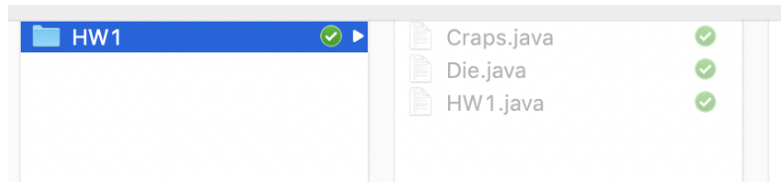
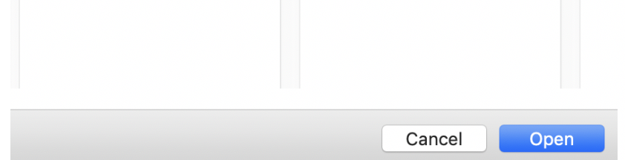

- After you click Open, you will see the three classes/files that make-up the starter code in BlueJ as shown above (on right). Click on any class to see its contents. Don't change anything until you read the assignment on the next page.

Actual Assignment:
Complete the code provided so that it plays 10000 games of craps. In the game of craps, two six-sided dice are rolled. A roll of 7 or 11 automatically wins, and a roll of 2, 3, or 12 automatically loses. If any other number is rolled, that number becomes the point. The player keeps rolling the dice until either 7 or the point is rolled. If the point is rolled, the player wins, but if 7 is rolled, the player loses.

- Complete the playCraps method which is found in the Java class called Craps (in a file named Craps.java), which is provided for you. playCraps is to simulate a game of craps using the rules above. The method playCraps returns an integer value: a 1 if the player wins; a 0 otherwise. Notice that your Craps class has two instance variables for the two dice required to play the game. The Die class is provided for you – do not edit it. The roll() method simulates a roll of a single die. NOTE: add your name to the Craps class. Never submit code that does not include your name.

Hint to help you judge if your solution is working: while you are completing the playCraps method, add output statements to show you what the die rolls are, so you can verify that your method works properly. You can run playCraps from the BlueJ workbench or from the main method included in the HW2.java file.

Once you are sure that your craps game works for a single game, remove any extra print statements you added to the playCraps method.

- Modify the main method in HW2 to
- play 10000 games,
- count how many times the player wins and loses.
- output the wins and losses and the probability of winning (wins / (wins + losses)).
- Label and format the output neatly, showing the probability as a percentage

- Add the required comments to the program as shown in the Project Policies document.

- Submit to OAKS following guidance provided here.
- Create a folder with your name and HW2. (i.e. StalveyRHW2)
- Put the two Java files you edited (Craps.java and HW2.java) in the folder. There must be no subdirectories or other files in this folder.
- Zip your folder and upload to OAKS by the deadline.

Required comments at the start of each file you submit:
Please review the Programming Project Policies document before submitting. This includes information about the needed header and other expectations for the course.

