CS2206
Cache Performance Analysis and Branch Prediction

Task 1: (30 points)

The task is to examine the accuracy of various branch predictors for the following repeating patterns (e.g., in a loop) of branch outcomes. Accuracy is defined as the percentage of guesses that are correct.
Consider C codes below and write MIPS assembly code for the same
(a)
Int i;
Int b[100];
Int a[100];
for(i=0; i< 100; i++) {
b[i] = a[a[i]];
}

(b)

for(j = 0; j < 100; j++)
for(i = 0; i < 100; i++)
A[i] = i;

MARS->tools-> Branch History Table Simulator
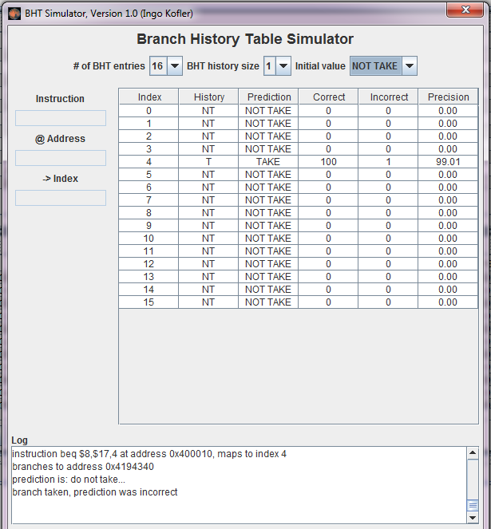

Task 2: (25 points)

Complete the MARS tutorial Part 2.

Your Analysis Here:

Task 2: (7- points)

Create one algorithm which demonstrate efficient use of data cache ( for example Matrix multiplication, ). Conduct performance analysis on different parameters such as block size, cache replacement algorithms.

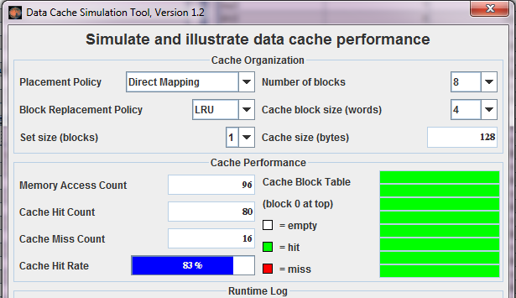

Your Analysis Here:

Submission:

Demonstrate to TAs your results and

Submit code and Report through

https://u.pcloud.com/#/puplink?code=kXnXZsoF5BAKXKD4HpveyQRLdsFGo8X70

