F-03 | Architecture, Data Flows & Asset Scope
MAPLEBRIDGE FINANCIAL TECHNOLOGY INC. • SIMULATED CASE STUDY • v1.0 • 05 Nov 2026
Baseline inherited without changes: F-01 charter/assumptions and F-02 governance/calendar. Non-bank Ontario PSP; 85 employees; 120 Canadian B2B customers; BridgeAPI, MatchLedger and OpsConsole; GCP Toronto primary and Montréal recovery. All diagrams, assets and flows are hypothetical, not observed infrastructure.

1. Architecture and trust boundaries
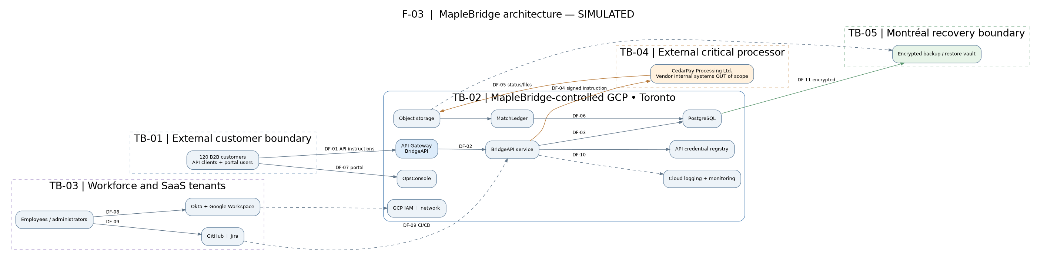
Legend: TB-01 customer-facing boundary; TB-02 company-managed GCP workloads; TB-03 workforce SaaS tenants; TB-04 CedarPay critical vendor; TB-05 Montréal recovery. Arrows are logical data/control flows, not an implementation-level network topology. SaaS tenant configurations and vendor interfaces are assessable; providers’ internal environments are not.

2. Principal end-to-end data flows
Instruction: Customer → BridgeAPI gateway → BridgeAPI service → CedarPay. MapleBridge validates, records and transmits instructions; CedarPay/partner banks execute and settle.
Reconciliation: CedarPay status/settlement files → GCP object storage → MatchLedger → PostgreSQL → OpsConsole reporting.
Workforce and change: Employees → Okta/Google Workspace; engineering approvals in GitHub/Jira → GCP deployment pipeline.
Security and recovery: Application/GCP events → monitoring; PostgreSQL and object storage → encrypted Montréal backup vault.

3. Data categories and classification
Restricted: payment metadata, processor status/reconciliation files, customer API credential metadata, security telemetry and backups. Confidential: customer contacts, employee identity records, source code and change evidence. All sample data is synthetic. No raw card PAN, customer banking credentials, actual secrets, or real personal records are included.

4. Systems and assessment boundaries
The companion workbook is the authoritative F-03 system-of-record: 15 assets (AST-01–AST-15), 14 in-scope systems (SYS-01–SYS-14), 11 flows (DF-01–DF-11), five trust boundaries (TB-01–TB-05) and seven data categories (DC-01–DC-07). Each asset includes an F-02 owner, criticality and scope linkage. Criticality is a preliminary scenario assumption, not a completed business impact analysis.

5. Explicit exclusions and limitations
Excluded: customer infrastructure, CedarPay production internals, partner-bank networks, funds custody and settlement, lending/FX/remittances, live penetration tests, formal audit attestation/certification and real regulatory determination. Provider-managed infrastructure is outside direct technical testing. The GCP managed database, CI/CD integration, encryption, retention and mTLS choices are architectural assumptions to be tested against simulated evidence later—not verified facts.

6. F-03 completion gate
- Architecture includes payment API, GCP, PostgreSQL, Okta, Workspace, GitHub/Jira, backups, monitoring and CedarPay — PASS
- Customer/vendor/workforce/recovery trust boundaries and directional data flows documented — PASS
- 15 assets/services have accountable F-02 owners and criticality — PASS
- Systems-in-scope register defines assessment depth and exclusions — PASS
- F-01 business/legal baseline and F-02 snapshot dates unchanged — PASS
- All content labelled simulated; no independent assurance or live access claimed — PASS
Handoff to F-04: preserve all IDs and system/owner mappings; introduce risk/control/evidence IDs without renumbering F-03 assets. Any change requires a documented version decision.

