

Tawsiah

Recommendation as a service for tourism

Student ID | Student name
444006280 | ايوان حسن مليبارى
445000593 | راوي حسن القرشي
445004747 | مشاري انس الغامدى
445007489 | عبدالكريم جابر القرني
44510047 | نواف عبدالله الغالب
44510471 | محمد عبدالله اكبر

Supervised By
Dr.Abdulhadi M.Aleidaroos

Table of Contents
Chapter 1: Introduction 2
1.1 Project Idea: 3
1.2 Problem statement: 3
1.3 Project Objectives: 3
1.4 Project Scope: 3
1.5 Project Significance: 3
Chapter 2: Background 4
2.1 Related Work: 5
2.2 Used Technologies: 6
2.2.1 Frontend Layer 6
2.2.2 Backend Layer (Business logic API) 6
2.2.3 Backend Layer (AI API) 7
2.2.4 Version Control 7
2.2.5 Testing 8
2.2.6 Database Layer 9
2.2.7 Deployment 10
2.3 Challenges in the domain: 13
2.4 How is our program different? 15
2.5 Research Analysis 16
2.6 Ethical & Engineering Risks Table 17
Chapter 3: Requirement Modeling & Specification 18
3.1 Functional Requirements 19
3.2 Non-Functional Requirements 22
3.3 Requirements Diagrams 23
3.3.1 Class Diagrams 23
3.3.2 Use Case Diagrams 28
3.3.3 Sequence Diagrams. 36
3.3.4 Activity Diagrams 45
3.3.5 State Diagrams 56
3.4 User Stories for AI-Powered Tourism Recommendation System 65
3.5 API Designs 67
References 84

Chapter 1: Introduction

1.1 Project Idea:
Recommendation as a service for tourism

1.2 Problem statement:
- Unclear Tourism services
- Tourists suffer from information overload
- Limited availability of reusable APIs and software

1.3 Project Objectives:

Our primary objective is to develop an AI-powered recommendation engine API that delivers personalized tourism suggestions—including places, activities, and events—for visitors to Saudi Arabia. It will specifically cater to travelers seeking major experiential events, such as WWE WrestleMania 43 and the FIFA World Cup 2034

1.4 Project Scope:

In-Scope:
- Geographic Focus: The initial implementation will cover one major Saudi city (e.g., Riyadh or Jeddah) as a Proof of Concept.
- Core Functionality: User profiling, AI-based recommendation generation, and a web interface for interaction.
- Data: Focus on key tourist attractions, entertainment venues, and major shopping centers.
Out-of-Scope
- Direct booking and payment processing.
- Social features like friend-based recommendations.

1.5 Project Significance:

- For Saudi Arabia: It helps with the big plan, Vision 2030, to bring more tourists to the country by giving them a great digital tool. This will let the tourists have satisfied experiences in big events such as FIFA World Cup 2034
- For Business: It will attract commercial companies to advertise themselves in the website, this with the recommendation service will help tourists find more things to do, so they might stay longer and spend more money.

Chapter 2: Background

2.1 Related Work:
System | Methods | Dataset | Outcomes | Limitations
Layla AI | LLMs (Large Language Models) | APIs (flights/hotels) | Full travel plans via chat | Lacks cultural context
WonderPlan | AI planner + budget model | Price/interest data | Cost-based itineraries | Ignores real-time context
GuideGeek | Conversational LLM (Large Language Models) | Global travel DB (Data Base) | Instant Q&A, digital guide | Low personalization
Context-aware POI Recommendation System | Context-aware ML (Machine Learning) | GPS, time, weather | Adapts to user situation | Needs sensor data
Personalized Recommender System | ML (collab. filtering) | User reviews | Personalized suggestions | Cold-start issue
Group POI Recommender System | Optimization model | Group preference data | Collective POI list | High computation cost

While existing systems like Layla AI, WonderPlan, and GuideGeek provide strong automated travel planning and recommendations, they each face limitations such as lack of deep cultural understanding, weak personalization, or limited adaptability to real-time context.
Our proposed system addresses these issues by integrating context-aware LLM reasoning with localized cultural data, enabling more relevant, adaptive, and culturally sensitive travel recommendations.

2.2 Used Technologies:

2.2.1 Frontend Layer
HTML, CSS(Bootstrap), JavaScript(React.js)
Role: the frontend layer serves as the user interface and presentation layer, handling all user
interactions and visual element of the application.

Purpose:
- React.js: builds dynamic User Interfaces efficiently
- JavaScript: provides responsive components for faster development.
- HTML & CSS (Bootstrap): Allows rapid development while maintaining a modern professional look.

Advantages:
- Responsive Design: Bootstrap ensures the application works seamlessly across different screen sizes (mobile, tablet, desktop).
- Component Re-usability: React's component-based structure allows to re-use code across different parts of the application.

2.2.2 Backend Layer (Business logic API)
Java with SpringBoot:
Role: Business logic, authentication and main API endpoints.
Purpose:
- SpringBoot: JVM delivers excellent performance for handling concurrent requests, Spring provides enterprise-grade security and features with minimal configurations.

Advantages:
- High performance under heavy traffic which plays a huge role on our side.
- Built-in security (authentications, authorization).

Limitations:
- Higher memory consumption than lightweight alternatives
- More complex architecture

2.2.3 Backend Layer (AI API)
Python with FastAPI:
Role: AI recommendations engine running independently which is the core point of the application.
Purpose:
- Python: Dominates AI\ML development with libraries
- FastAPI: delivers recommendations generated by AI with asynchronous support
Advantages:
- Best AI/ML library ecosystem available
- Auto-generated API documentation
- Decomposition - AI service doesn't affect main back end

Limitations:
- Running two backends requires more infrastructure
- Network calls between Java and Python add latency
- Managing two codebases in different languages

2.2.4 Version Control
GitHub:
Role: Code collaboration and version tracking
Purpose:
- GitHub: Industry standard with excellent collaboration features

Advantages:
- Complete change history with rollback capability
- Pull requests enable code review before merging
- CI/CD integration for automated testing

Limitations:
- Git learning curve (merge conflicts, branching)

2.2.5 Testing
JUnit, Pytest, Postman, Jest, React Testing Library,
Playwright:
Role: Quality assurance across all application layers

Purpose:
Each tool tests a specific layer:
Unit Testing:
- JUnit
- Pytest
- Jest

API tests:
- Postman

Component tests:
- React library test

end-to-end tests:
- Playwright

Advantages:
- Catches bugs early before production
- Automated tests prevent regressions when code changes
- Tests document how code should behave
- Confidence to refactor safely

Limitations:
- Writing tests doubles development time initially
- Test maintenance - tests break when features change
- Large test suites slow down development feedback

2.2.6 Database Layer
PostgreSQL & Qdrant:
Role: Data persistence and vector storage for the application

Purpose:

PostgreSQL:
• Main relational database for application data
• Stores user information, authentication data, and business records
• ACID ensures data integrity

Qdrant:
• Vector DB specialized for AI/ML workloads
• Stores embeddings and enables semantic search
• Powers the recommendation engine with similarity matching

Advantages:

PostgreSQL:
• Rich feature set (JSON support, full-text search, advanced indexing)
• Excellent performance for complex queries
• Strong community support and extensive documentation
• Free and open-source

Qdrant:
• Built specifically for vector similarity search
• Scales efficiently with large embedding datasets
• RESTful API integrates seamlessly with FastAPI
• Supports real-time updates and filtering

Limitations:

PostgreSQL:
• Not optimized for vector operations compared to specialized databases
• Higher resource consumption for write-heavy workloads
Qdrant:
• Additional infrastructure component to manage
• Requires separate backup and monitoring strategies
• Memory-intensive for large vector collections

2.2.7 Deployment
Docker:
Role: Containerization for consistent deployment

Purpose:
- Docker: Packaging app with all dependencies
Advantages:
- Identical behavior across developers, staging, production
- Microservices support - run Java and Python services separately
- Lightweight compared to virtual machines
Limitations:
- Images consume significant disk space
- Container networking can be tricky to configure
- Debugging inside containers is difficult

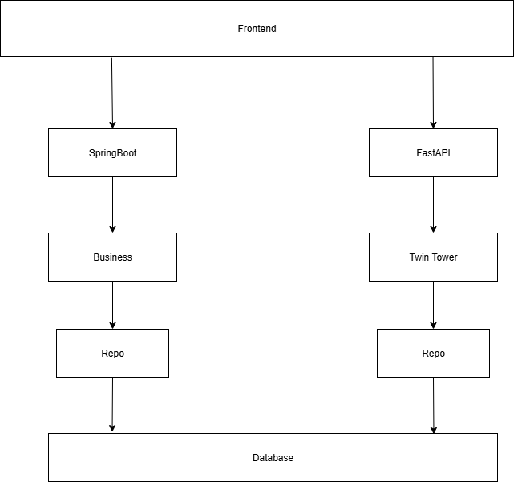
Architecture 1.0: high-level layered architecture for system

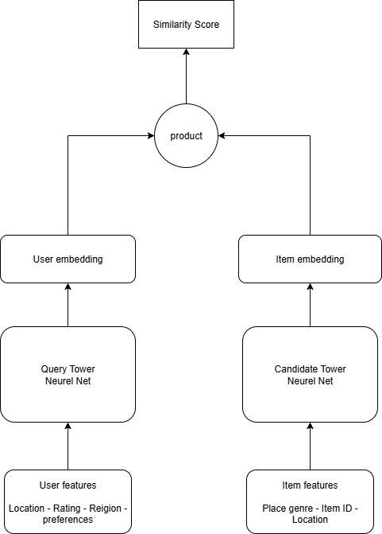
1.2 Twin Tower Architecture

2.3 Challenges in the domain:
- Tourists risk receiving inaccurate, outdated, or culturally inappropriate recommendations, leading to reduced satisfaction and trust in the recommendation system.
- A 2025 OECD tourism report highlights that inaccurate digital data is among the top causes of negative tourist feedback, reducing overall visitor satisfaction scores by up to 18%.
- Inconsistent recommendation accuracy (below 85%) reduces conversion rates between digital searches and actual visits.
- Absence of multilingual and culturally adaptive recommendation features results in mismatched expectations, particularly among international visitors.
- Inadequate real-time updates about availability, pricing, or location changes cause wasted time and poor travel experiences.
- Service providers (local attractions, restaurants, and businesses) may lose potential customers due to poor visibility, misinformation, or limited integration with digital platforms.
- Small and medium-sized tourism businesses remain underrepresented in digital listings, with visibility rates below 50% in some regions (OECD, 2024).
- Lack of standardized data entry and verification mechanisms leads to high error rates (10–15%) in tourism databases.
- Key KPIs impacted include Provider Visibility Index (PVI), Booking Conversion Rate (BCR), and Customer Retention Ratio (CRR).
- Inadequate feedback loops between tourists, providers, and authorities prevent early identification of systemic issues.

- KPI analysis indicates that every 5% drop in visitor satisfaction can correlate with a 3% decline in repeat visitation rate.
- Absence of unified performance monitoring tools limits the Ministry’s ability to track real-time performance indicators such as Average Spend per Tourist (AST), Visitor Satisfaction Index (VSI), and Net Promoter Score (NPS).
Conclusion:
In summary, the tourism recommendation domain faces multidimensional challenges technological, organizational, and experiential. The evidence highlights measurable inefficiencies across tourists, service providers, and government stakeholders. Strengthening KPI monitoring (accuracy, visibility, satisfaction, retention, and spend metrics) and improving data integration are essential to align the sector’s performance with Vision 2030 targets and ensure consistent, high-quality visitor experiences across Saudi Arabia.

2.4 How is our program different?
Our AI recommendation engine is different from general global planners like Layla AI or GuideGeek Those tools often have lack real-time updates and don't understand local culture
We provide a better solution by focusing on a "specialized, API-first approach" made just for the Saudi market Our engine is designed for Saudi Arabia, so we give more personal and accurate recommendations using our "cultural filters"

Feature | Benefit | Metric
Cultural Sensitivity Filters | Prevents culturally inappropriate recommendations, and enhances visitor trust | Target: 5/5  user satisfaction score on the cultural relevance of recommendations.
Real-Time Event Updates | Our information is new and correct for big events Tourists won't get outdated information | Target: 4.5/5  user rating on the accuracy and timeliness of event information
Targeted AI Personalization | Directly solves the tourist's problem of information overload by providing relevant suggestions instead of generic lists | Target: 4.5/5  user rating on the helpfulness and personalization of recommendations
Specialized, API-first Approach | Solves the problem of limited availability of reusable APIs | Target: 5/5  satisfaction rating from the frontend development team on the API's ease of integration and documentation clarity

2.5 Research Analysis

A comparative analysis of existing work in Tourism Recommendation Systems (TRS) reveals a critical dichotomy between academic and commercial approaches. Academic research primarily emphasizes algorithmic precision and theoretical problem-solving, often resulting in sophisticated solutions with limited real-world scalability and user experience (UX) considerations. For example, some scholarly works like MPDI and Mahasarakham University, prioritize accuracy derived from expert-provided data, thereby neglecting the implicit preferences and dynamic interests of typical users. This constrained methodological focus often limits a system's external validity, a limitation demonstrated by systems confined to small geographical scopes and lacking adequate scalability for national or global application. Similarly, a review of key articles across diverse domains (Electronics, Computation, and Mathematics) reveals a high concentration on theoretical optimization, subsequently overlooking critical practical implementation challenges and potential user friction points. Conversely, commercial systems like Layla AI and WonderPlan, despite their established global operational reach, function as generalist solutions. This generalist approach inherently leads to a lack of deep cultural adaptation—failing to account for specific regional nuances and regulatory compliance (e.g., Saudi PDPL 2023)—and a reliance on static knowledge bases incapable of supporting dynamic, pop-up events or real-time changes. Moreover, the multitude of general recommendations often results in high cognitive overload for the tourist. Therefore, our system is designed to bridge this crucial methodological and market gap. While adopting a Hybrid AI methodology with Twin tower architecture, informed by advanced academic rigor to ensure high recommendation accuracy, we combine this with a strong commercial focus on practical, user-centric outputs. The core differentiation of our project lies in its fundamental integration of explicit cultural filters and the provision of real-time event updates, positioning our solution as both academically robust and commercially viable for the unique Saudi market.

2.6 Ethical & Engineering Risks Table
 | Type | Risk | Impact | Mitigation
1 | Engineering | Providing outdated recommendations (expired events or stale data) | Loss of trust and perceived unreliability of the system | Automated data refresh + real-time APIs + data freshness validation
2 | Engineering | System downtime during peak load (e.g., big match time) | Loss of service at a critical time | Load balancing + auto-scaling + CDN
3 | Ethical | Favoring large brands over small local businesses | Unfair competition and economic inequality | Balanced algorithmic weighting for SMEs
4 | Ethical | Recommending visits to protected or restricted areas | Environmental harm + legal violations | Use only officially permitted locations list
5 | Ethical | Promoting events or places not family-appropriate to family users | Ethical violation and negative user experience | Enable Family-Friendly filtering and link recommendations to user type

Chapter 3: Requirement Modeling & Specification

3.1 Functional Requirements

FR-1: The system shall allow a new user to create an account using a unique email
address and a password.

FR-2: The system shall present a one-time interest selection questionnaire to the user immediately after their first successful login to identify their initial interests .

FR-3: The system shall generate and display a list of at least 6 personalized tourist
recommendations on the user's home page based on their interests.

FR-4: The system shall provide a search function allowing users to find places by
name.

FR-5: The system shall provide a filtering mechanism to refine recommendation results based on category (historical, entertainment, Nature, Dining, Cultural, and Shopping.).

FR-6: The system shall provide a feature for authenticated users to save a
recommended place to a personal "My List".

FR-7: The system shall allow the user to view and remove items from their "My List".

FR-8: The system shall display a detailed information page when a user selects a
recommendation This page must include a description, opening hours, user ratings,
and photos of the place.

FR-9: The system shall allow users to provide a rating (e.g., 1 to 5 stars) for any tourist place they have visited to refine future recommendation.

FR-10: The system shall send a password reset link to a user's registered email upon request.

FR-11: The system shall clearly indicate if a place is currently open or closed based on current time and opening hours data.

FR-12: The password policy shall require a minimum length of 8 characters, including uppercase, lowercase, numbers, and symbols.

FR-13: The core services shall utilize Spring's Dependency Injection container for managing all internal component relationships.

FR-14: The database interaction layer shall utilize Spring Data JPA repositories for standardized and simplified data access operations.

FR-15: The system shall display upcoming major events (e.g., FIFA World Cup 2034, WWE matches) on a dedicated events section with automatic recommendations for nearby attractions and accommodations.

FR-16: The system shall allow users to filter recommendations based on proximity to selected events with distance radius options (1km, 5km, 10km).

FR-17: The system shall display real-time operational status for each recommended place showing event-influenced modifications (e.g., "Closed for prayer - reopens at 1:30 PM", "Extended hours tonight until 2 AM due to World Cup match", "Temporarily closed during WWE event traffic"), and automatically update these statuses based on overlapping events, prayer times, and special occasions.

FR-18: The system shall display real-time crowd density indicators for major event venues and suggest optimal arrival times to avoid peak congestion periods

FR-19: The system shall automatically detect and alert users when recommended activities or events have scheduling conflicts (including prayer times, overlapping event times, or insufficient travel time between locations) and suggest alternative timings or nearby substitutes.

FR-20: The system shall implement a cultural compliance scoring system that rates each recommended venue on family-friendliness, gender-segregation availability, halal certification status, and prayer facility access, displaying these scores prominently with user-adjustable threshold filters.

FR-21: The system shall allow users to create and manage multiple custom trip lists where they can add, remove, and reorder recommended places, assign custom names and descriptions to each list, and toggle list visibility between private and public, with public lists being discoverable and cloneable by other users.

FR-22: The system shall provide predictive crowd density analytics for recommended venues during major events, displaying expected wait times, peak hours, and alternative time slots with lower congestion based on historical event data and current reservation patterns.

FR-23: The system shall enable users to set granular dietary and activity preferences (halal-only, vegetarian, vegan, accessibility requirements, budget range) that automatically filter all recommendations and update the AI model's personalization weights for future suggestions.

FR-24: The System shall ask permission from user through a pop up message, to get live location from their device.

FR-25: The System shall utilize the user's device live location to recommend places.

FR-26: The system shall allow users to share their favorite events or trip lists directly via social media platforms (e.g., Twitter, Snapchat, WhatsApp).

FR-27: The system shall notify users about newly added events or nearby activities that match their saved interests.

FR-28: The system shall display a weather forecast section for each event location to help users plan their visits accordingly.

FR-29: The system shall allow users to report incorrect information (e.g., wrong timings or closed venues) through a feedback button.

FR-30: The system shall display a “Recommended Time to Visit” indicator for each location, based on crowd data and event schedules.

3.2 Non-Functional Requirements

NFR-1: The Personalized content will be visible 5 seconds after the user logs in

NFR-2: The system shall have at least 100 concurrent active sessions

NFR-3: User interface shall follow usability standards/principles

NFR-4: The system interface shall be optimized for both Arabic and English languages with culturally appropriate design.

NFR-5: The system shall display search results within 3 seconds after the user submits a query

NFR-6: The recommendation algorithm shall support continuous learning from user behavior

NFR-7: All services must include comprehensive unit tests achieving 85% code coverage (using JUnit, Pytest, Jest).

NFR-8: The deployment process shall be automated using Docker to ensure consistent environments.

3.3 Requirements Diagrams

3.3.1 Class Diagrams

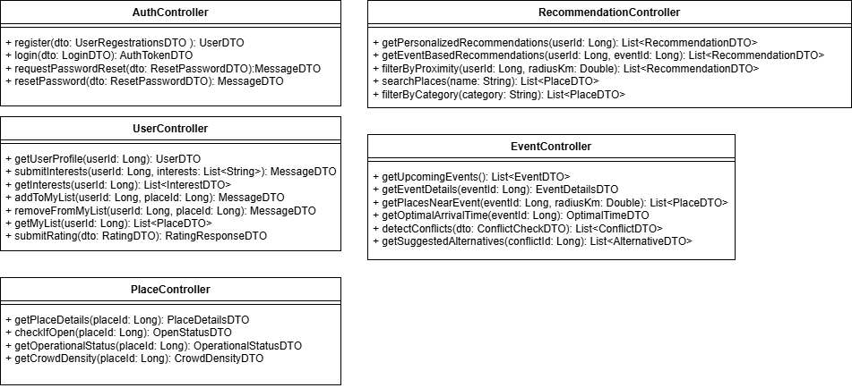
Controller Layer figure 1
Service Interface Layer figure 2

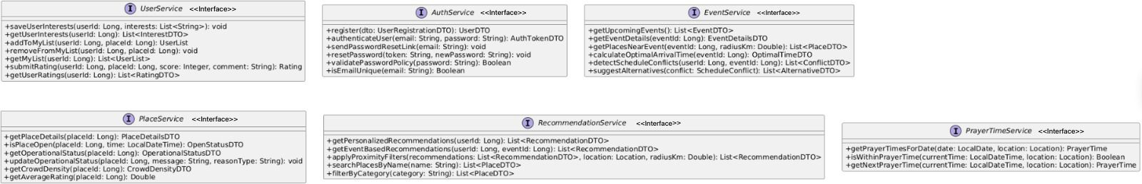

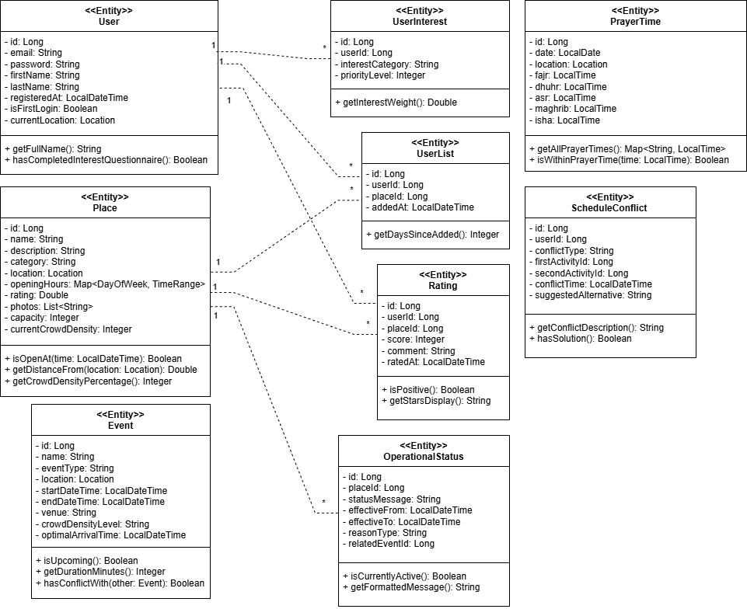

Entity Layer figure 3
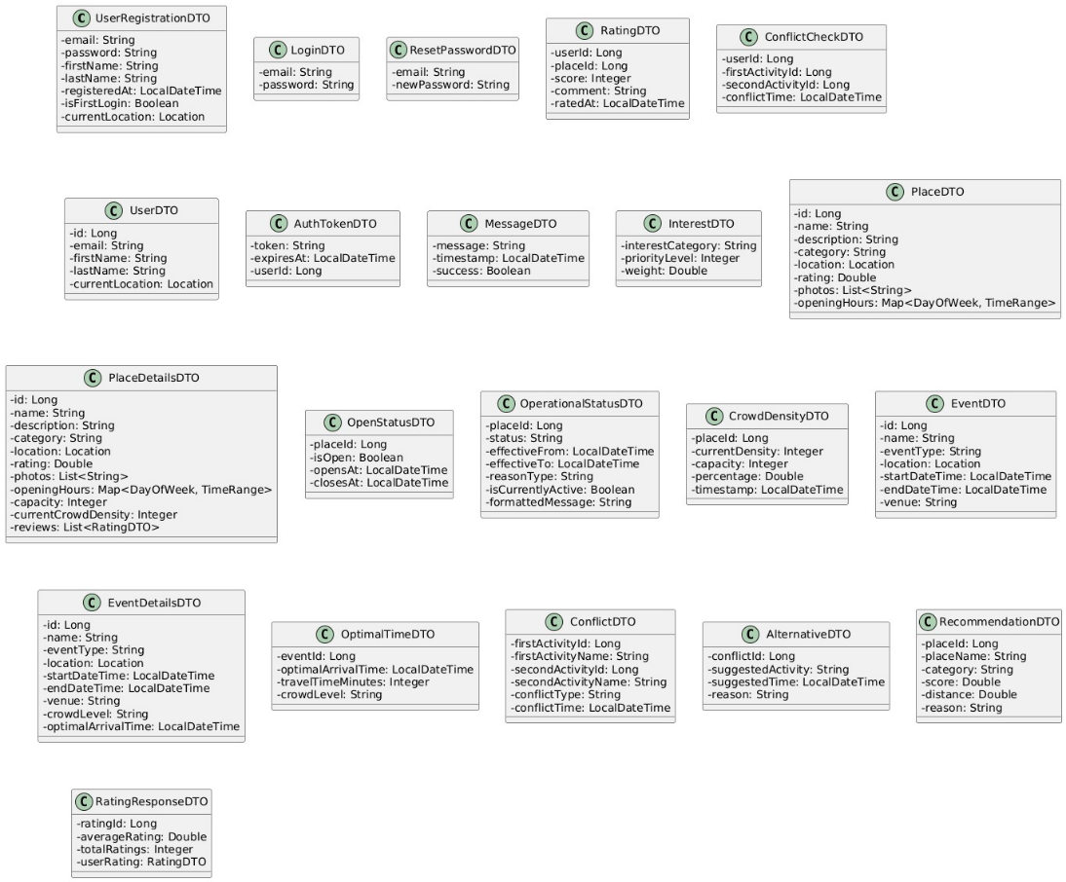

DTO Layer figure 4

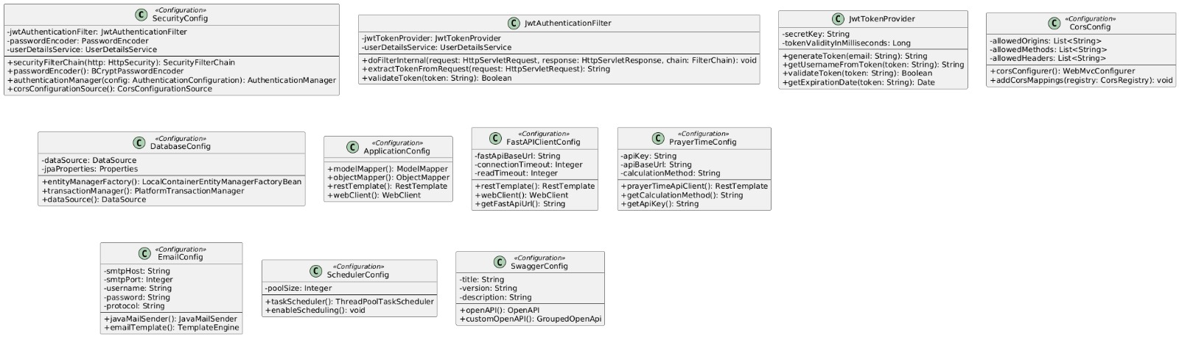

Config Layer figure 5

Repo Layer figure 6

Service Layer figure 7
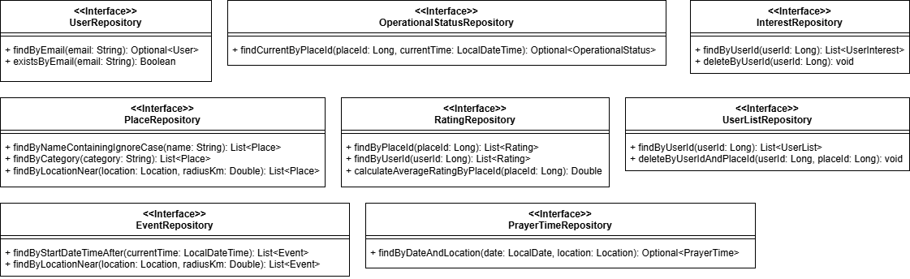
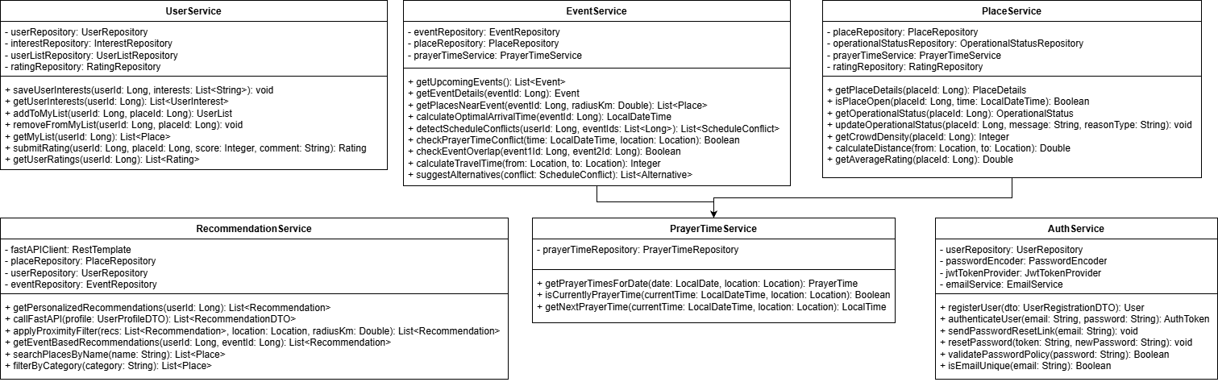

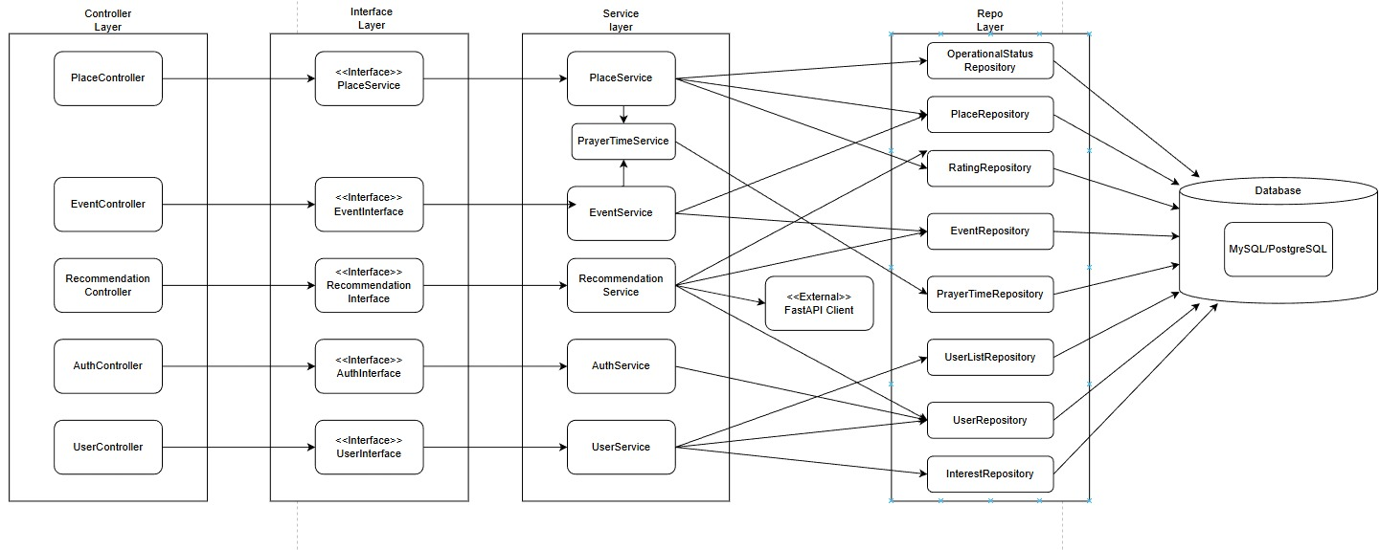
Architecture Layer figure 8

FastAPI class diagram figure 9

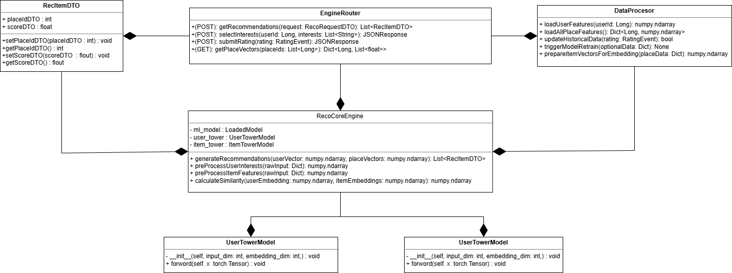

3.3.2 Use Case Diagrams

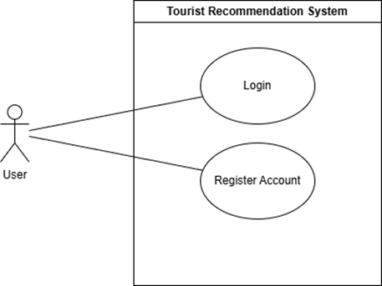
FR-1 Use Case Diagram

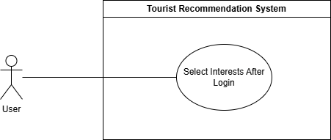
FR-2-Use Case Diagram

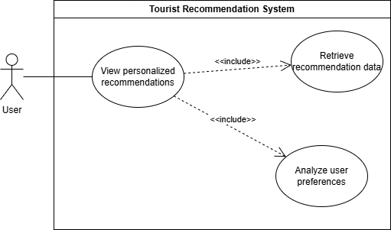
FR-3 Use Case Diagram

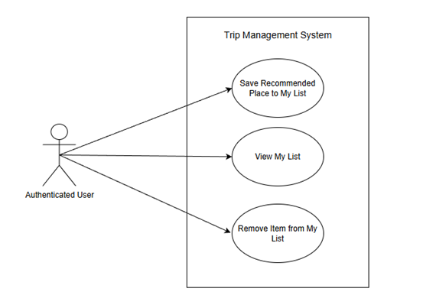
FR-6,7 Use Case Diagram

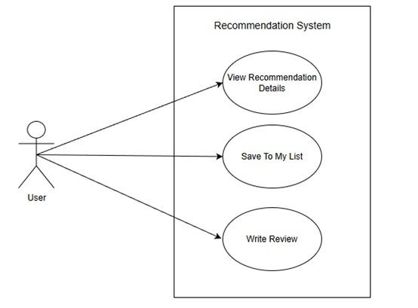
FR-8 Use Case Diagram

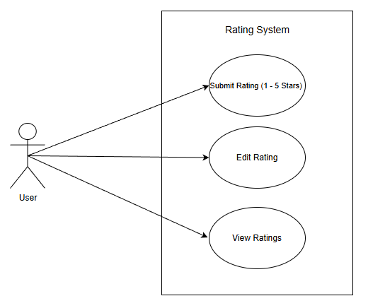
FR-9 Use Case Diagram

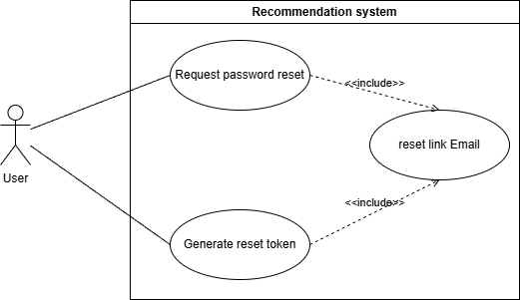
FR-10 Use Case Diagram

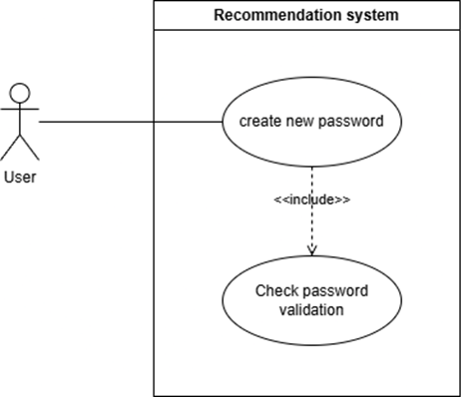
FR-12 Use Case Diagram

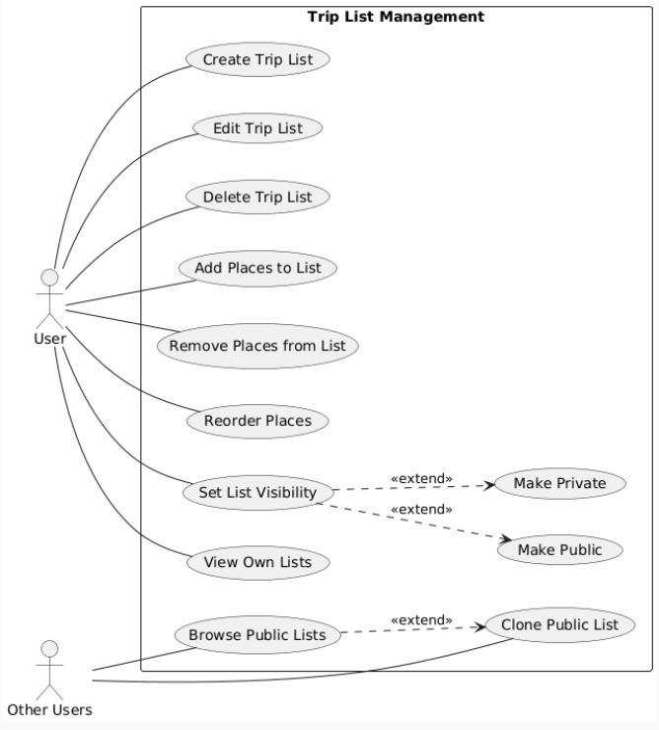
FR-21 Use Case Diagram
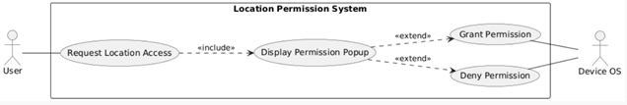
FR-24 Use Case Diagram

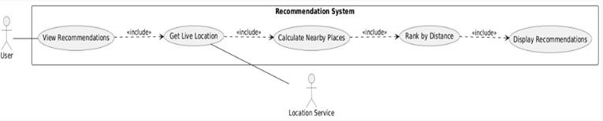
FR-25 Use Case Diagram

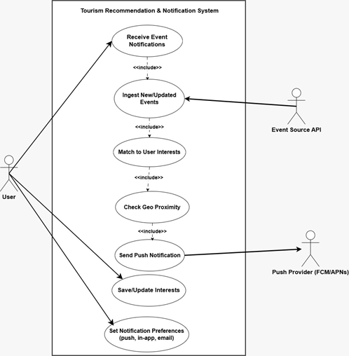
FR-27 Use Case Diagram

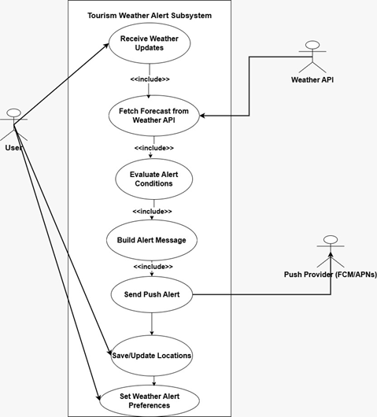
FR-28 Use Case Diagram

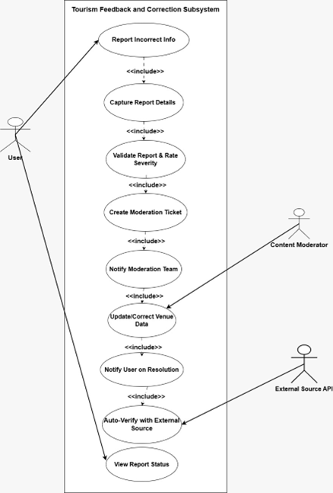
FR-29 Use Case Diagram

3.3.3 Sequence Diagrams.

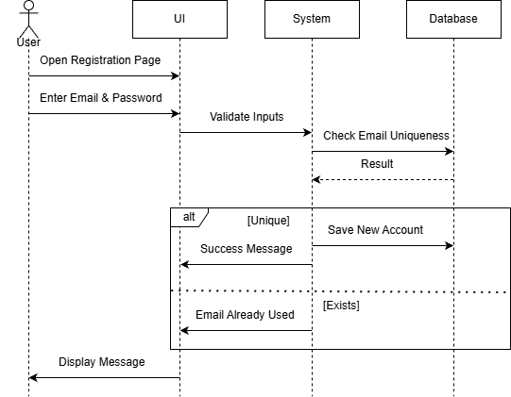
FR-1 Sequence Diagram.

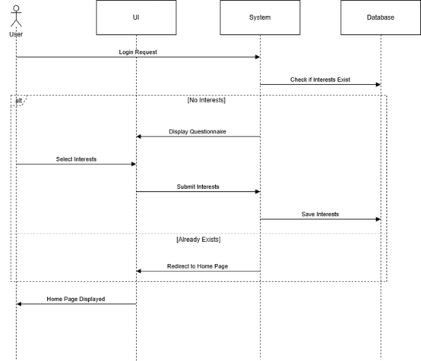
FR-2 Sequence Diagram

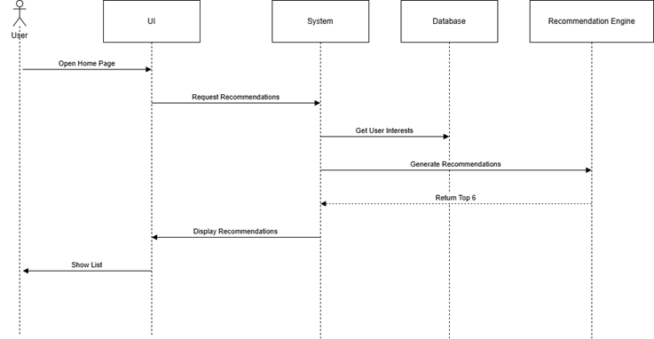
FR-3 Sequence Diagram

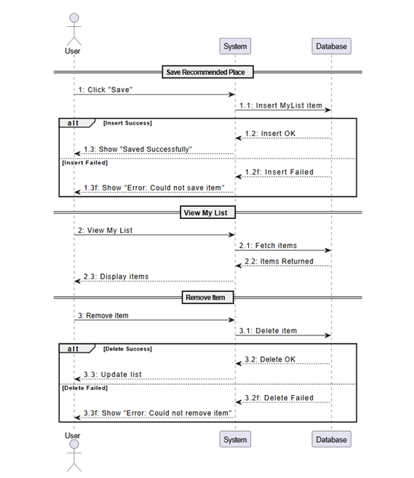
FR-6,7 Sequnce Diagram

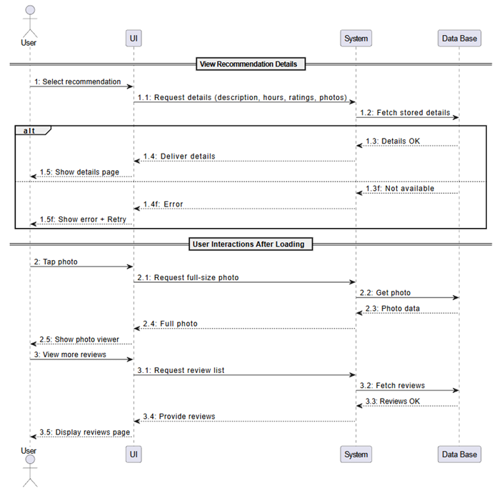
FR-8 Sequence Diagram

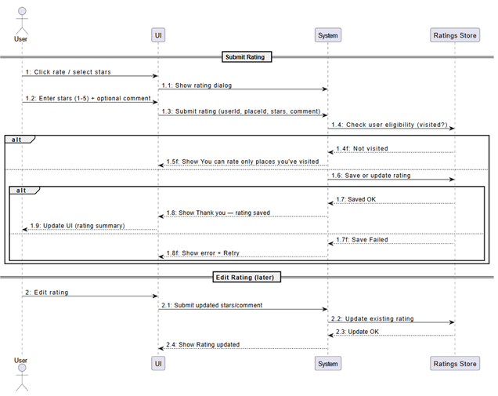
FR-9 Sequecne Diagram

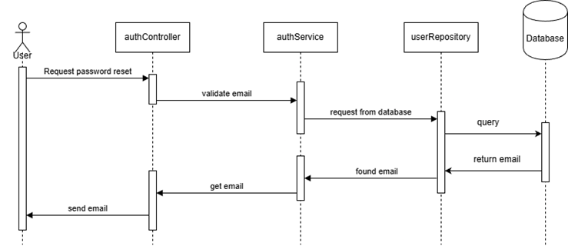
FR-10 Sequance Diagram

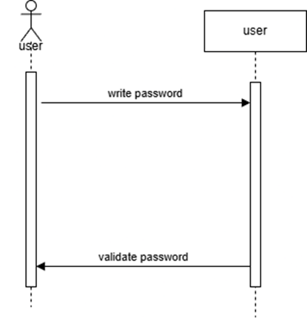
FR-12 Sequence Diagram

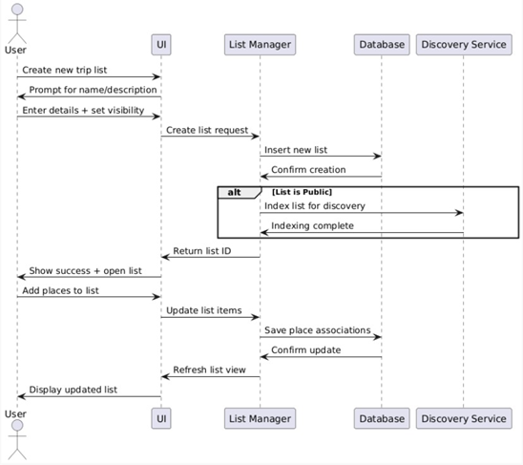
FR-21 Sequence Diagram

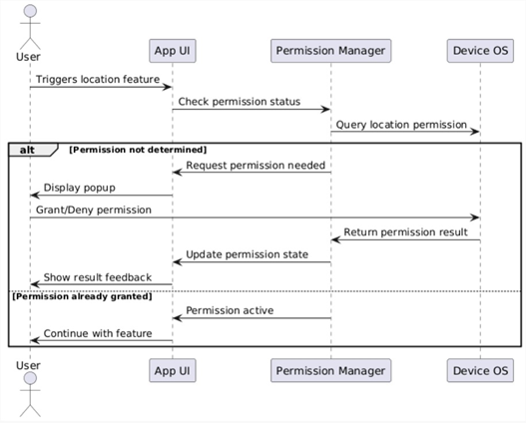
FR-24 Sequence Diagram

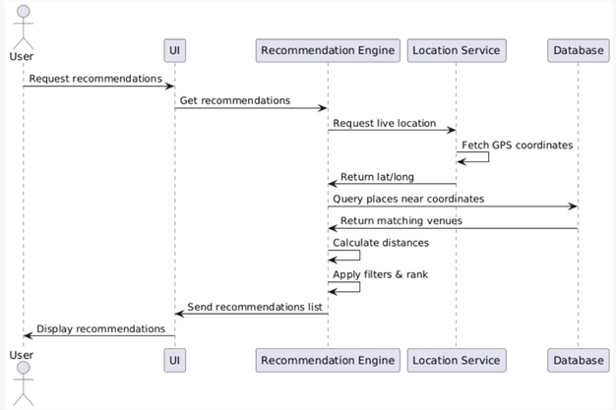
FR-25 Sequence Diagram

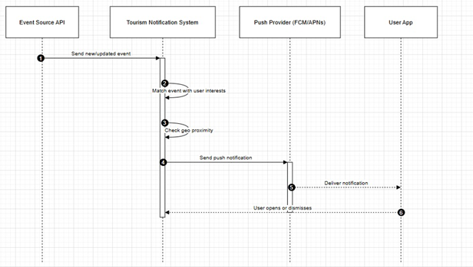
FR-27 Sequence Diagram

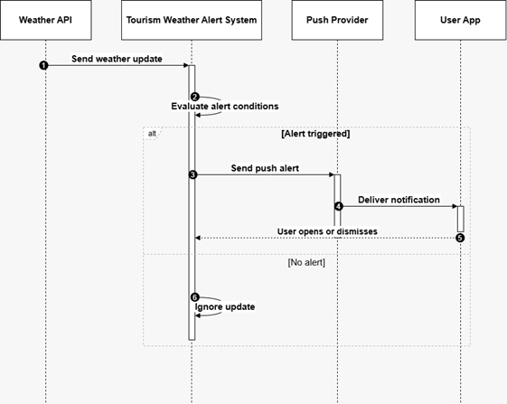
FR-28 Sequence Diagram

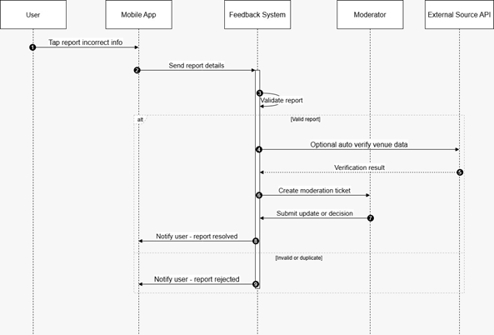
FR-29 Sequence Diagram

3.3.4 Activity Diagrams

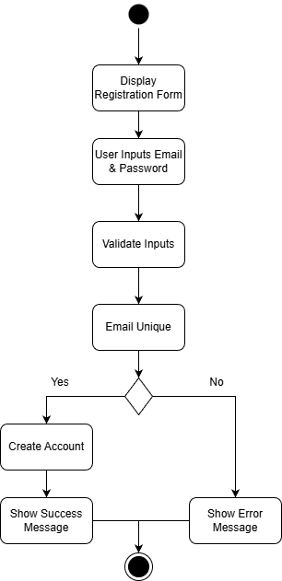
FR-1 Activity Diagram

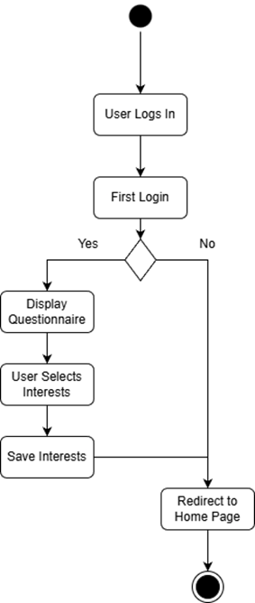
FR-2 Activity Diagram


FR-3 Activity Diagram

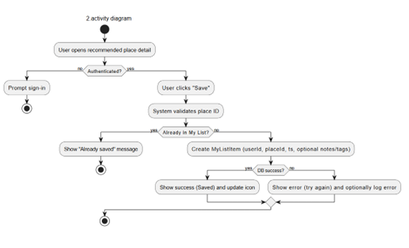
FR-6,7 Activity Diagram

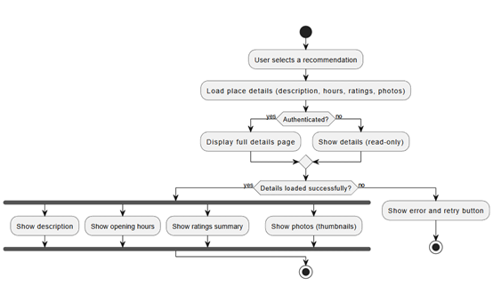
FR-8 Activity Diagram

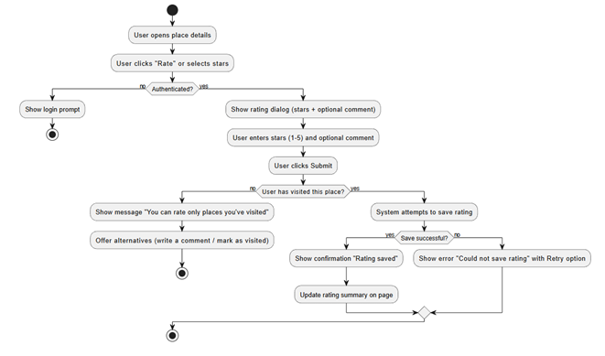
FR-9 Activity Diagram

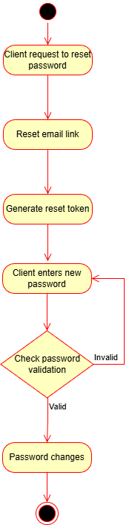
FR-10 Activity Diagram

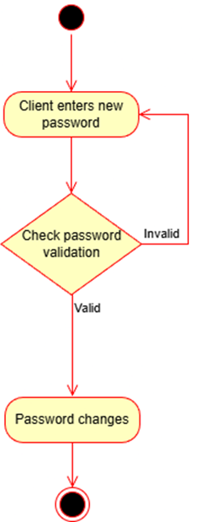
FR-12 Activity Diagram

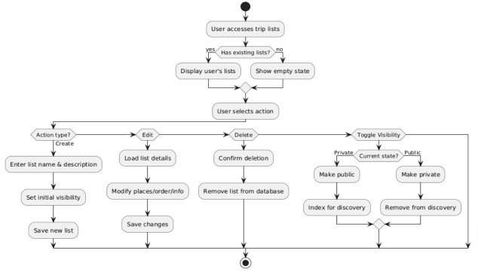
FR-21 Activity Diagram

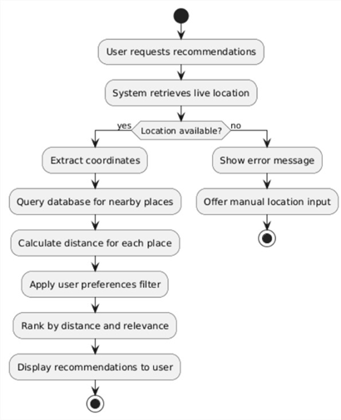
FR-25 Activity Diagram

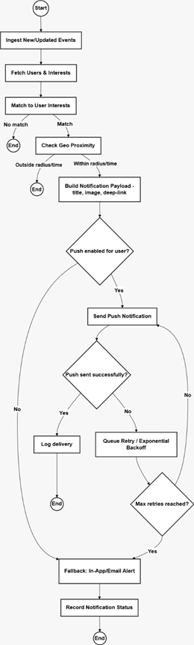
FR-27 Activity Diagram

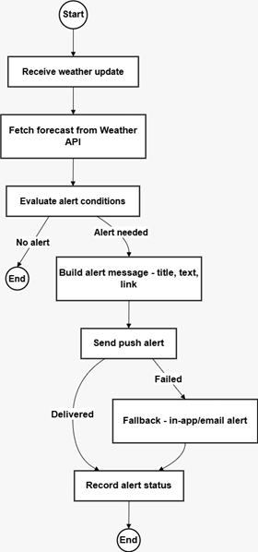
FR-28 Activity Diagram

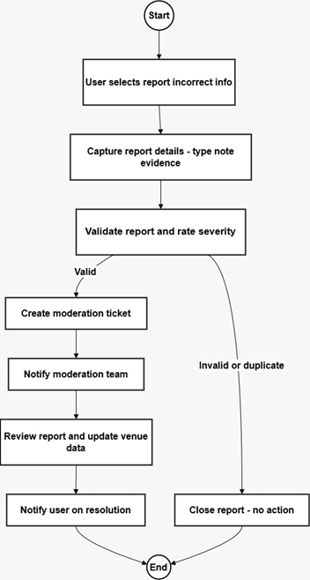
FR-29 Activity Diagram

3.3.5 State Diagrams

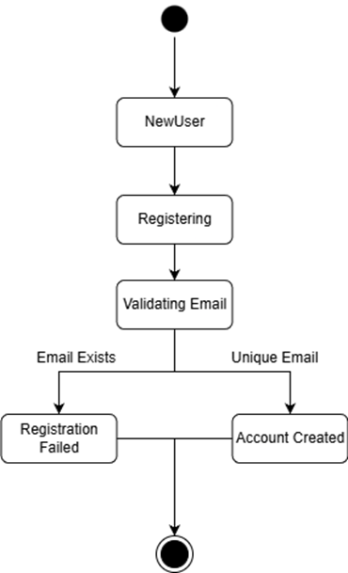
FR-1 State Diagram

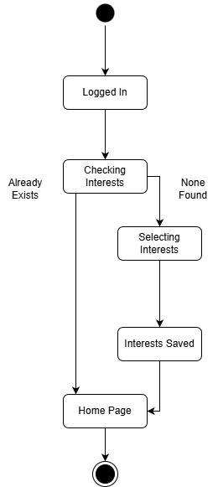
FR-2-State Diagram.

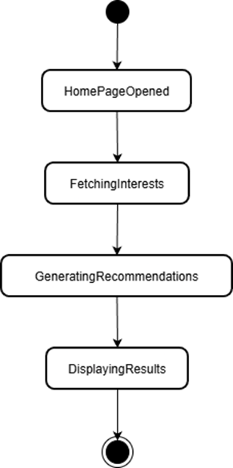
FR-3 State Diagram

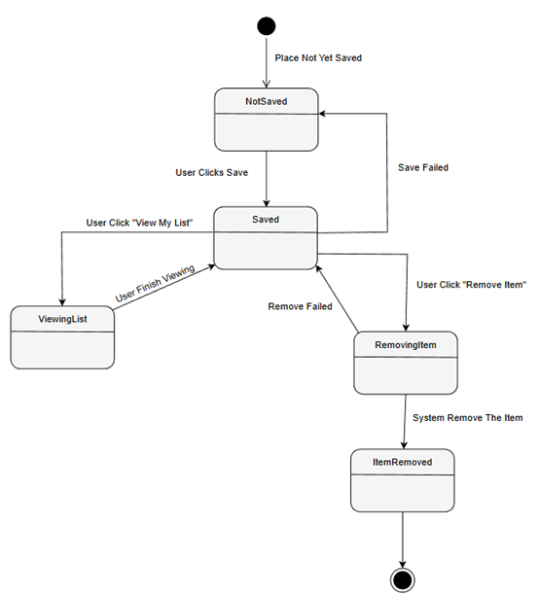
FR-6,7 State Diagram

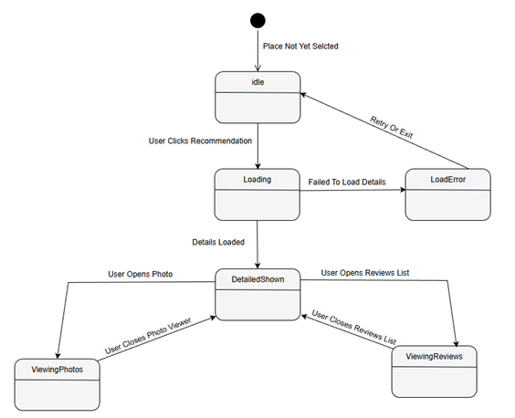
FR-8 State Diagram

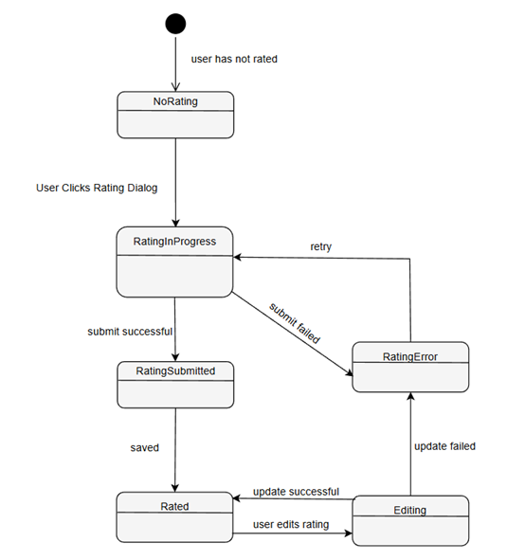
FR-9 State Diagram

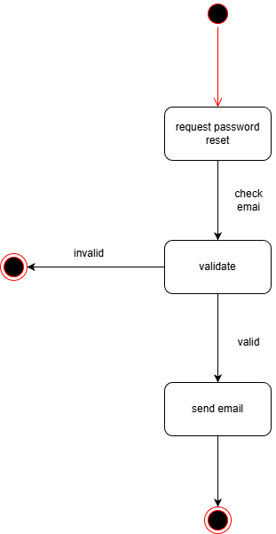
FR-10 State Diagram

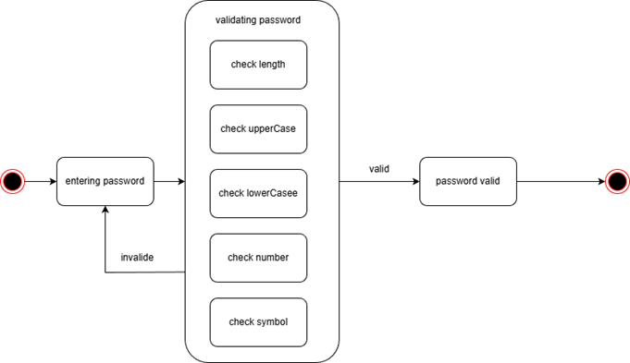
FR-12 State Diagram

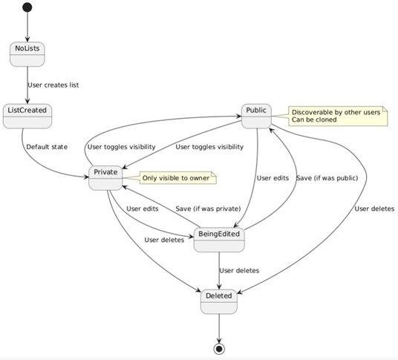
FR-21 State Diagram

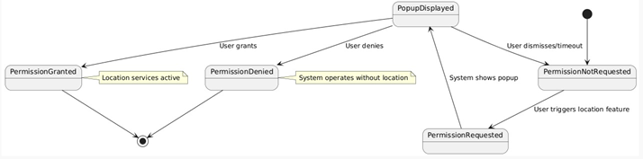
FR-24 State Diagram

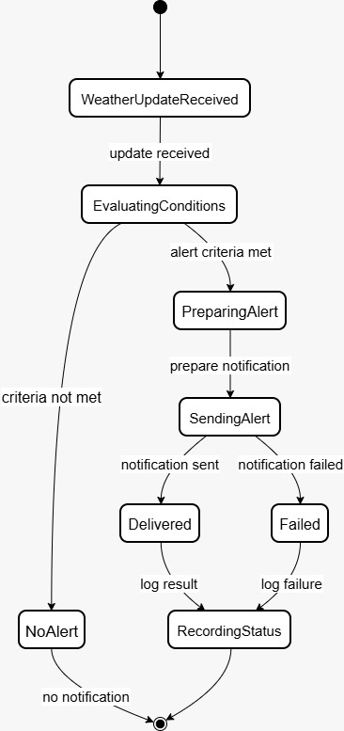
FR-28 State Diagram

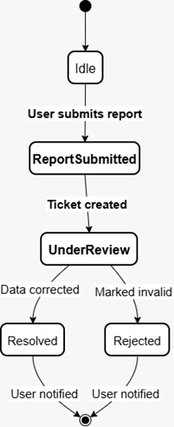
FR-29 State Diagram

3.4 User Stories for AI-Powered Tourism Recommendation System
Authentication & User Management
US-1: Account Creation As a new tourist, I want to create an account with my email and password so that I can access personalized recommendations for my Saudi Arabia trip.
US-2: Initial Interest Survey As a first-time user, I want to complete a one-time questionnaire about my interests immediately after logging in so that the system understands my preferences from the start.
US-3: Password Recovery As a registered user, I want to receive a password reset link via email when I forget my password so that I can regain access to my account quickly.
Personalization & Recommendations
US-4: Personalized Home Feed As a logged-in user, I want to see at least 6 personalized tourist recommendations on my home page within 5 seconds so that I can quickly discover places that match my interests.
US-5: Search Functionality As a tourist, I want to search for specific places by name so that I can quickly find information about destinations I've heard about.
US-6: Category Filtering As a user browsing recommendations, I want to filter results by category (historical, entertainment, shopping) so that I can focus on the type of experiences I'm most interested in.
US-7: Rating-Based Learning As a returning user, I want to rate places I've visited (1-5 stars) so that future recommendations become more accurate and aligned with my actual preferences.
US-8: Dietary & Activity Preferences As a user with specific needs, I want to set granular preferences (vegetarian, accessibility requirements ) so that all recommendations automatically match my requirements.
Trip Planning & Lists
US-9: Save to My List As a user exploring recommendations, I want to save interesting places to my personal "My List" so that I can easily find them later when planning my itinerary.
US-10: Manage My List As a user with saved places, I want to view and remove items from "My List" so that I can keep my collection organized and up to date.

Location-Based Features
US-11: Nearby Recommendations As a tourist currently in Saudi Arabia, I want recommendations based on my real-time location so that I can discover interesting places near me right now.
US-12: Event Proximity Filtering As a visitor attending a major event (FIFA World Cup 34), I want to filter recommendations by distance from the event venue (1km, 5km, 10km) so that I can find convenient activities before or after the event.

Event & Real-Time Information
US-13: Major Event Discovery As a tourist planning my visit, I want to see upcoming major events (FIFA World Cup 2034) on a dedicated section so that I can plan my trip around these experiences.
US-14: Real-Time Operational Status As a user viewing a recommendation, I want to see real-time status updates (e.g., "Closed for prayer - reopens at 1:30 PM," "Extended hours due to World Cup match") so that I don't waste time traveling to closed venues.
US-15: Crowd Density Indicators As a tourist attending popular events, I want to see real-time crowd density indicators and optimal arrival times so that I can avoid peak congestion and have a better experience.
US-16: Schedule Conflict Detection As a user building my itinerary, I want the system to automatically detect scheduling conflicts (prayer times, overlapping events, insufficient travel time) and suggest alternatives so that my plans are realistic and respectful of local customs.
US-17: Weather Forecasts As a tourist planning outdoor activities, I want to see weather forecasts for each event location so that I can dress appropriately and adjust my plans if needed.
Cultural Compliance & Safety
US-18: Cultural Compliance Scores As an international visitor, I want to see cultural compliance ratings (family-friendliness, gender-segregation availability, prayer facilities) for each venue so that I can choose places that align with my values and local customs.
US-19: Family-Friendly Filtering As a parent traveling with children, I want recommendations filtered for family-appropriateness so that I'm never suggested venues unsuitable for my family.

Information & Details
US-20: Detailed Place Information As a user considering a recommendation, I want to view a detailed page with description, opening hours, ratings, and photos so that I can make an informed decision about visiting.
US-21: Opening Status Indicator As a tourist ready to visit a place, I want to clearly see if it's currently open or closed based on current time so that I don't arrive at an inconvenient moment.
US-22: Recommended Visit Times As a planner, I want to see a "Recommended Time to Visit" indicator based on crowd data and event schedules so that I can experience each location at its best.
Engagement & Feedback
US-23: Interest-Based Notifications As a user with saved interests, I want to receive notifications about newly added events or activities that match my preferences so that I never miss relevant experiences during my trip.
US-24: Report Incorrect Information As a user who encounters outdated details, I want to report incorrect information (wrong timings, closed venues) through a feedback button so that the system maintains accuracy and helps other tourists.
US-25: Multilingual Interface As an Arabic or English speaker, I want the interface optimized in my language with culturally appropriate design so that I can navigate comfortably and feel the system respects my cultural context.

3.5 API Designs

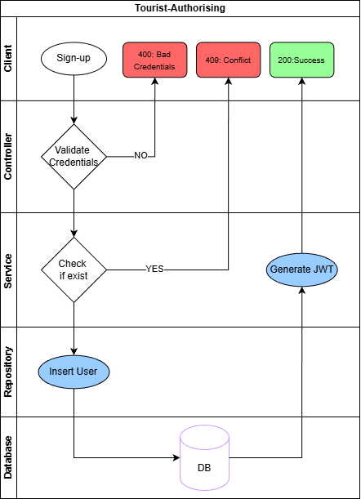
Tourist signup Design

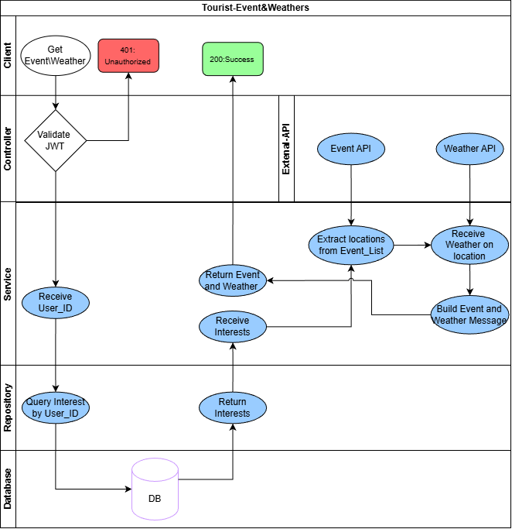
Tourist-Event&Weathers Design

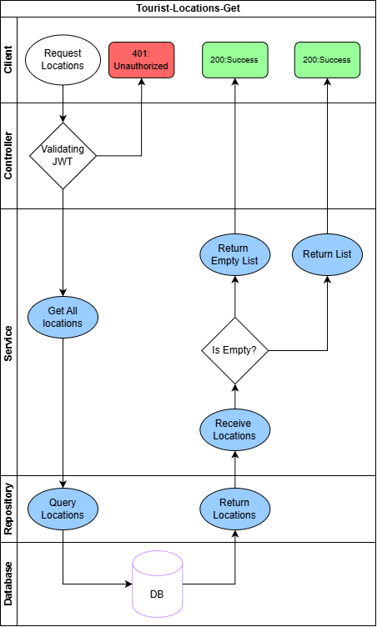
Tourist-Locations-get Design

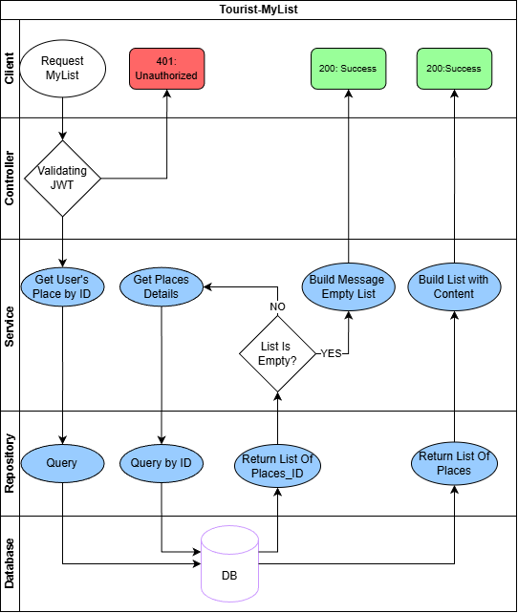
Tourist-Mylist Design

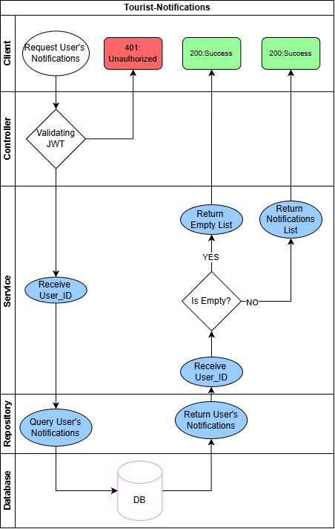
Tourist-Notifications Design

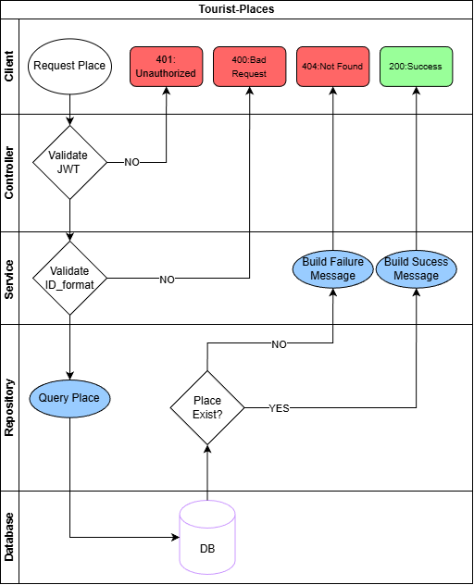
Tourist-Places Design

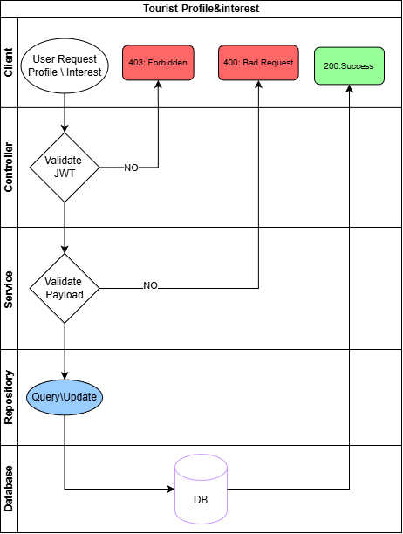
Tourist-Profile&Interest Design

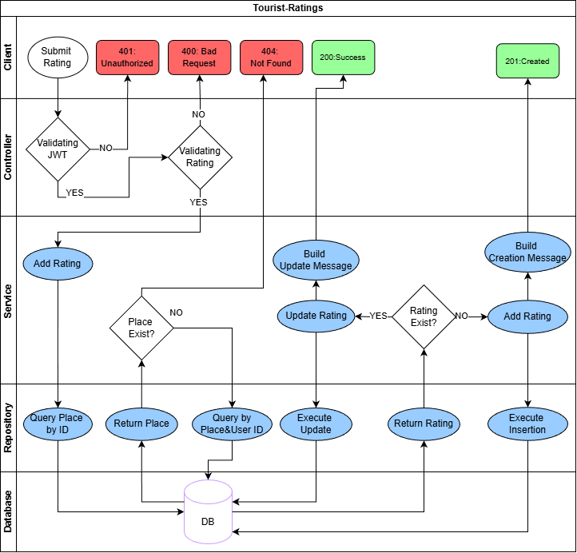
Tourist-Ratings Design

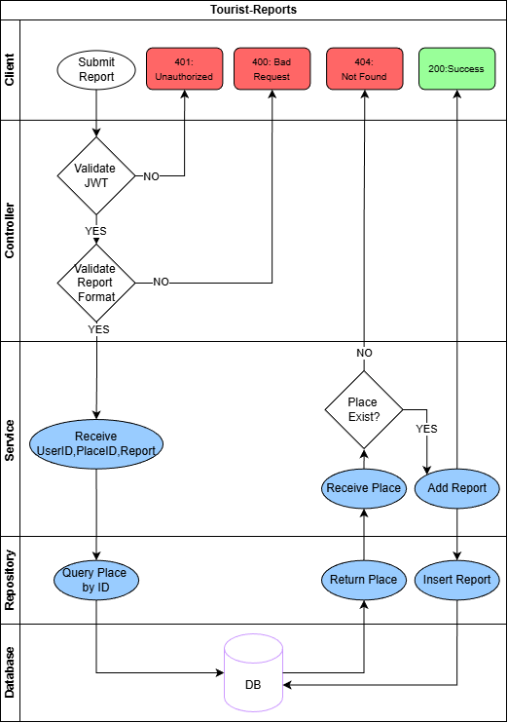
Tourist-Reports Design

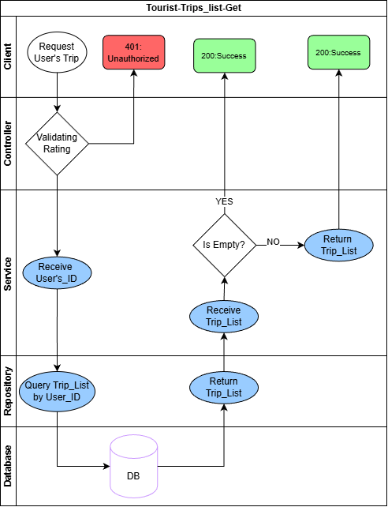
Tourist-Trips-list-Get Design

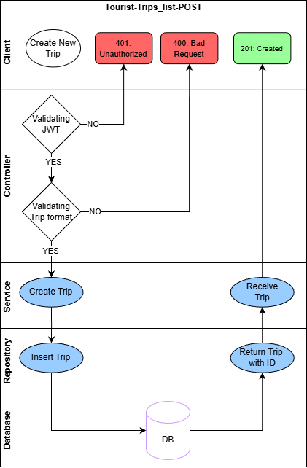
Tourist-Trips-List-POST Design

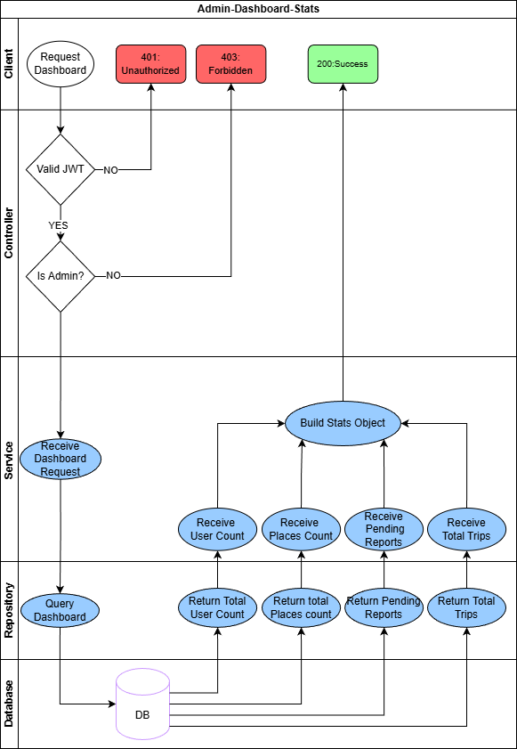
Admin-Dashboard-Stats Design

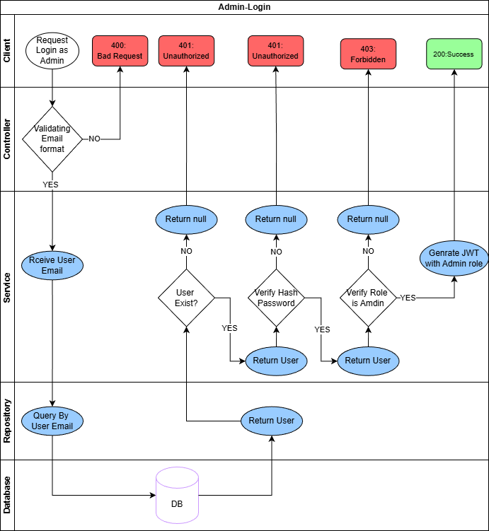
Admin-Login Design

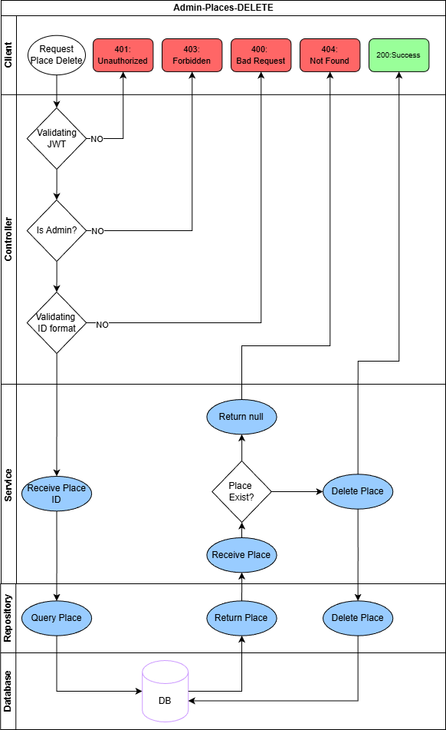
Admin-Places-DELETE Design

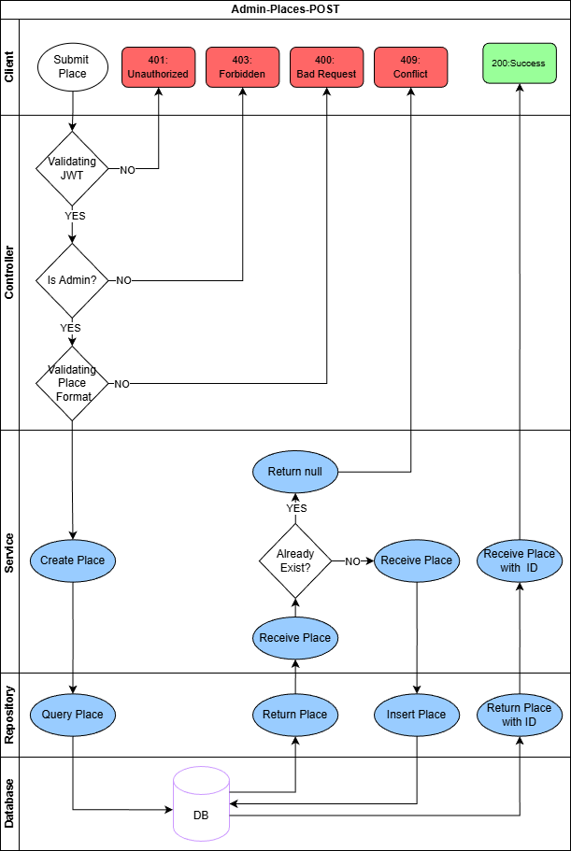
Admin-Places-POST Design

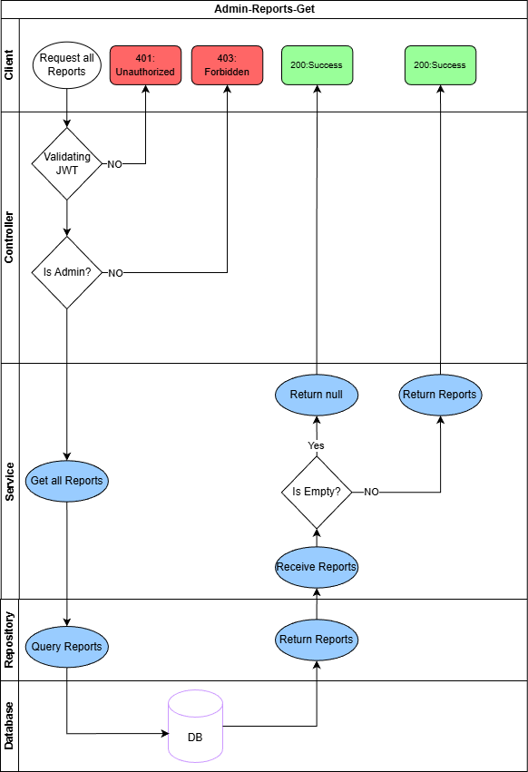
Admin-Reports-Get Design

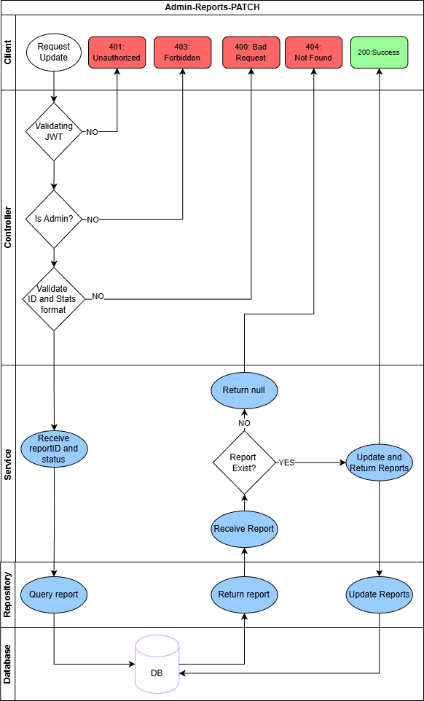
Admin-Reports-PATCH Design

References

Point of Interest recommendations based on immediate user preferences and contextual influences. Electronics, 12(20), 4199. (2023). Retrieved from
https://doi.org/10.3390/electronics12204199
Personalized tourist recommender system: A data-driven and machine-learning approach. Computation, 12(3), 59. (2024). Retrieved from
https://doi.org/10.3390/computation12030059
A Point of Interest Recommender System for Tourist Groups Based on Cooperative Location Set Cover Problem. Mathematics, 11(17), 3646. (2023). Retrieved from
https://doi.org/10.3390/math11173646
Wanderlog. (2025, September 17). Wanderlog: free travel itinerary & road

trip planner app. Wanderlog.

https://wanderlog.com
Layla.ai. (2025, May 24). Layla: AI travel assistant for personalized trip planning.

Layla.
https://www.layla.ai
Viavii. (n.d.). Viavii: Personalized travel experiences & activities.

Viavii.

https://www.viavii.com

https://gtg.webhost.uoradea.ro/PDF/GTG-1-2025/gtg.58120-1405.pdf

