Digital Capacities Index - Quantitative Findings

4 April 2016

Table of Contents

## Digital Capacities Index - Quantitative Findings

The *Digital Capacities Index* is a pilot survey instrument developed by researchers at Western Sydney University and Google Australia. The survey was administered by [Pure Profile](https://www.pureprofile.com/us/) in Febuary 2016.

### Introduction

We included a total of 158 items measuring (a) frequency of various online behaviour, (b) levels of agreement with statements about digital capacities, (c) perceived importance of online activities and (d) ease of use of digital technologies.

We further distinguished questions into the following key thematic areas, or what we have termed, following James (2014), 'critical issues'. These issues are:

* **Competencies** (42 indicators).
* **Interests** (44 indicators).
* **Resilience** (24 indicators).
* **Social Connectedness** (48 indicators).

These four issues were distilled from a list of nine issues that also included *Engagement*, *Inclusion*, *Policy Environment*, *Infrastructure* and *Consequences*.

Against these four issues, we selected items and scales from existing sources in the literature where possible. In particular we drew from 'Kids Online' (Livingstone et al. 2010), Helsper's (2012) 'Corresponding fields model', a study by Humphry (2014) of mobile use among homeless populations, and indicators compiled by the [Young and Well CRC](http://www.youngandwellcrc.org.au/). Other indicators were developed by the *Digital Capacities Index* team.

A large number of candidate scales were distilled down to the current list after two day-long workshops, and testing of the survey.

### Demographics

The survey included a total of 2,157 participants. We requested the survey provider provide a panel in terms of age groups, gender and geographic regions. As the panel provider recruited participants online, our pilot sample is expected to be skewed towards Australian citizens and families with comparatively high digital capacities. This caveat is signficant to the interpretation of our results below.

#### Age

Participant ages ranged from 12 to 91, with a median value of 42.

*Figure 1* provides more detailed age demographics:

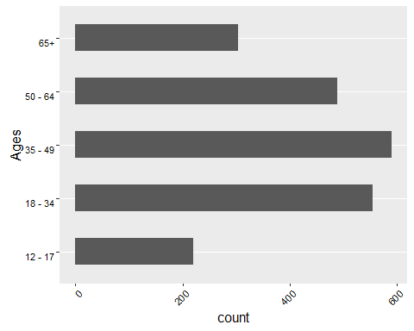

**Figure 1: Age Frequency**

These show participants' ages correspond approximately to Australia's adult demographic. 89.8% of participants were aged 35-54.

#### Gender

Participant gender is roughly evenly distributed. The survey included 1,105 (51%) women; 1,048 (49%) men; and 4 (0.19%) identifying as 'Other'.

Gender demographics are distributed, as show in Figure 2:

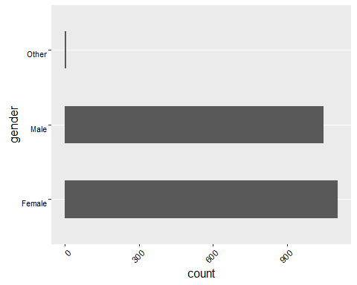

**Figure 2: Gender Frequency**

#### Combined Age and Gender

Combined age and gender demographics are distributed as per *Figure 3:

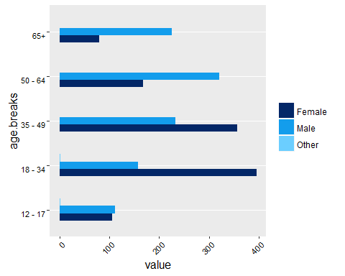

**Figure 3: Age & Gender Frequency**

These figures approximate to Australia's adult age distribution, as reported by the ABS in 2014 in **Figure 4** below, though with a considerably higher skew towards younger women and older men.

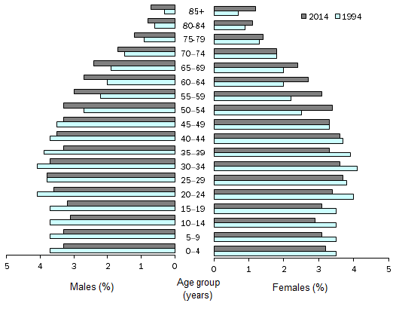

**Figure 4: Australia's Age & Gender Frequency (ABS 2014)**

#### State and Location

Survey distribution by state broadly follows Australia's demographic distribution.

The split of participants between urban and regional/rural is as follows:

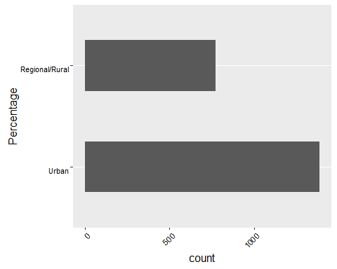

The percentage of reported urban residents here is 64.3 - considerably less than [World Bank figures of 89%](http://data.worldbank.org/indicator/SP.URB.TOTL.IN.ZS).

## Results by Critical Issue - Aggregated

### Competencies

Our survey asked participants to respond to two questions about competencies:

* Frequency of online activity
* Perceived ease of conducting online activity

#### General Results

##### Frequency of online activity

*Frequency of online activity* measures frequency of 15 different activities, ranging from highly common activities such as sending email through to less common activities (in 2016), such as writing blogs.

The graph below shows the relative frequencies of each activity. Using the Internet generally (for work, study, and for personal use), sending email and social networking are the most common activities. Streaming music, playing games with others, sharing media and writing blogs or diaries are comparatively uncommon activities.

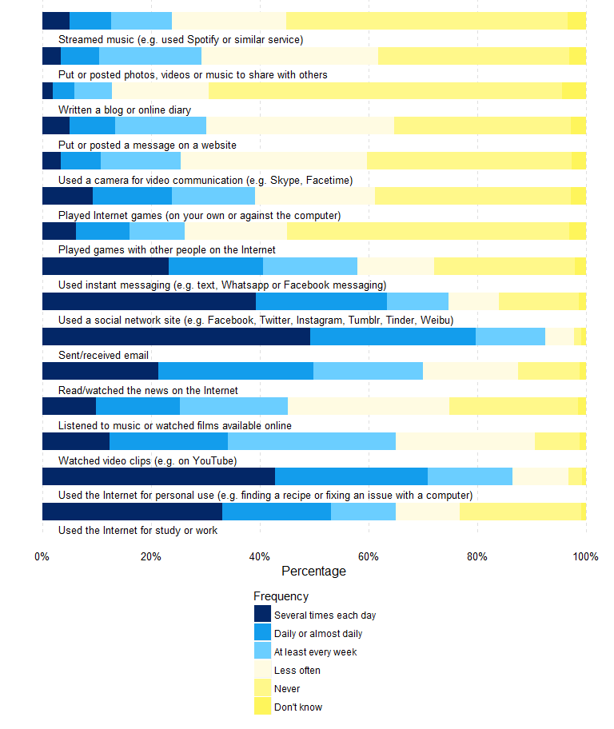

##### Perceived ease of conducting online activity

[Introductory Text]

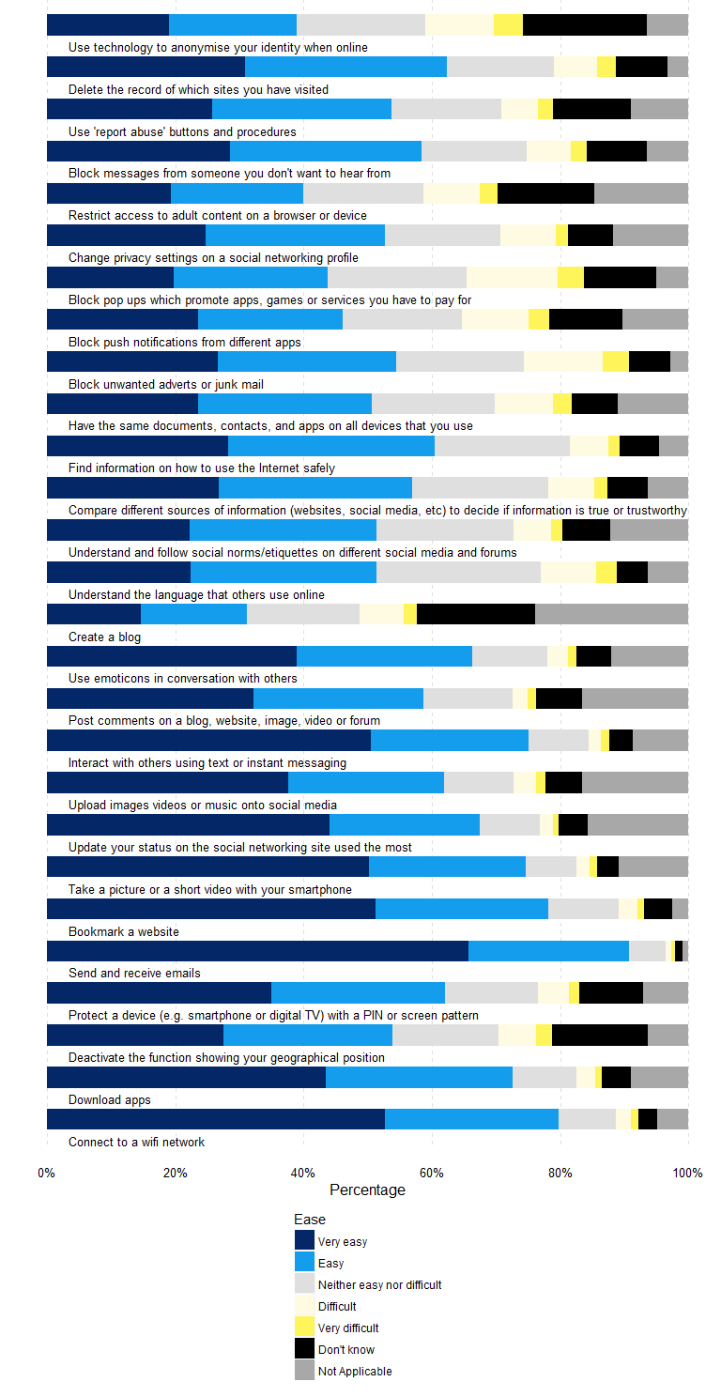

#### Results by Age

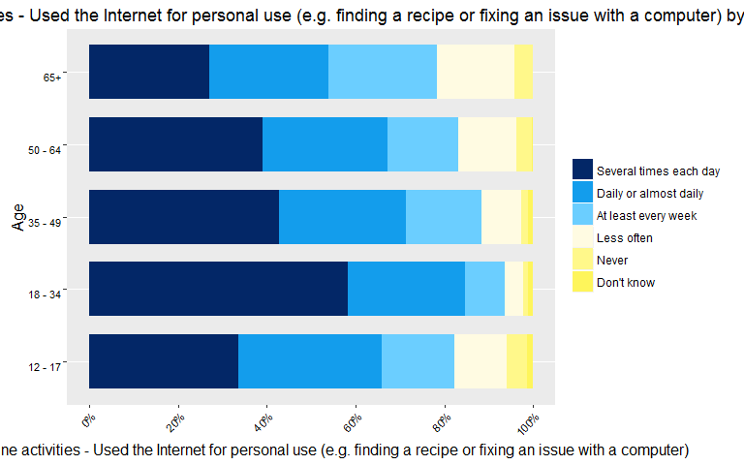

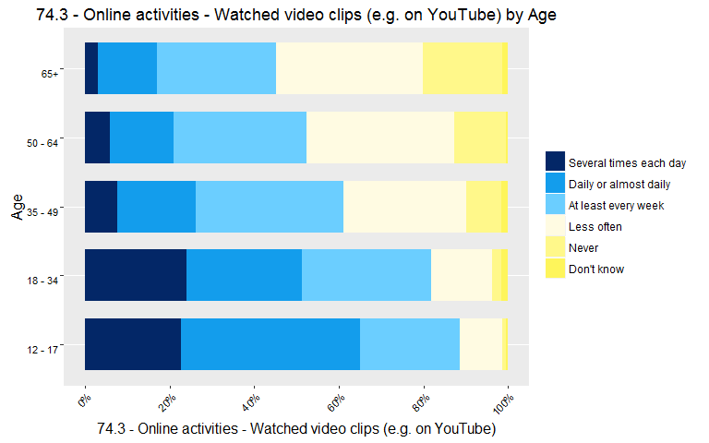

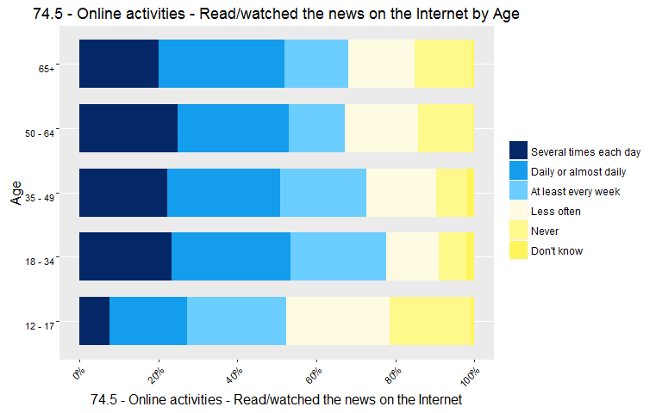

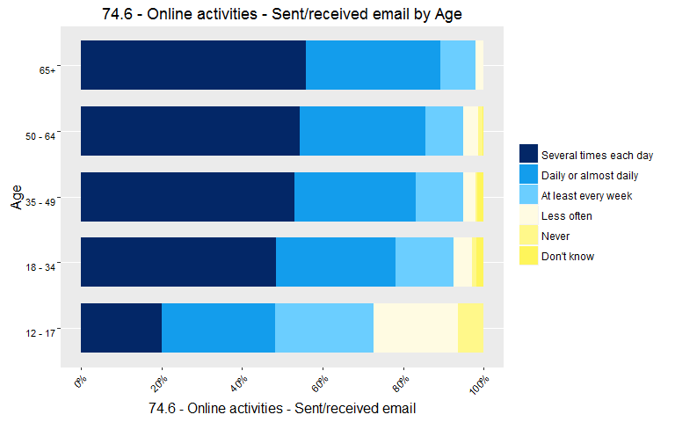

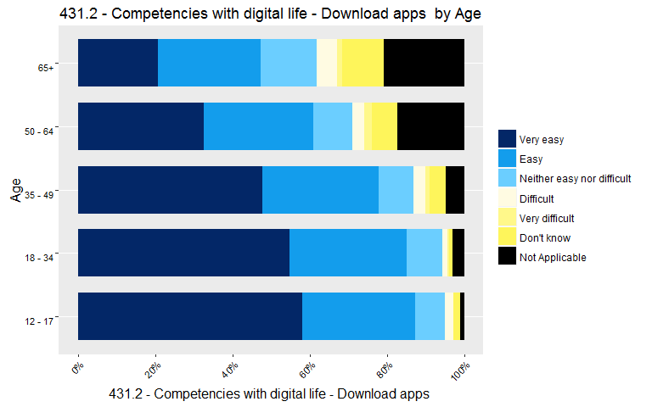

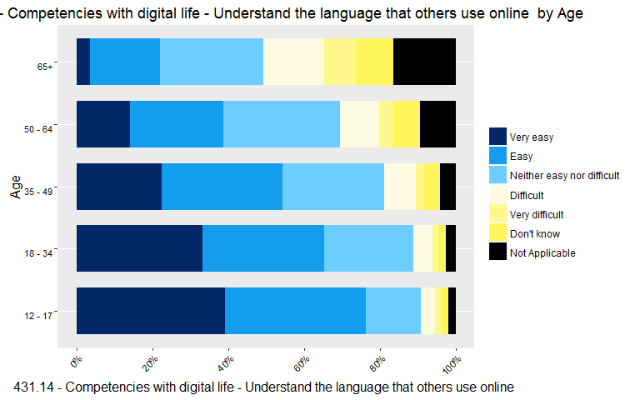

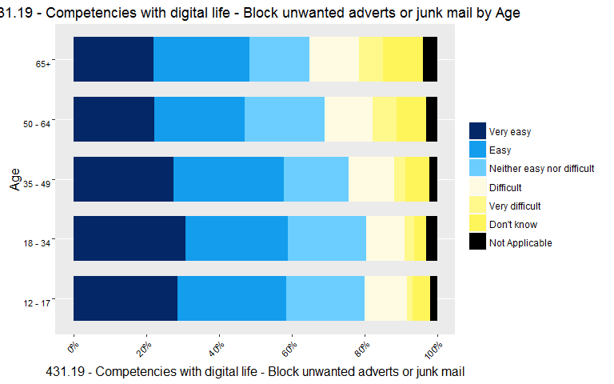

### Interests

[Overview of Critical Issue]

#### General Results

##### General Interests

[Introductory Text]

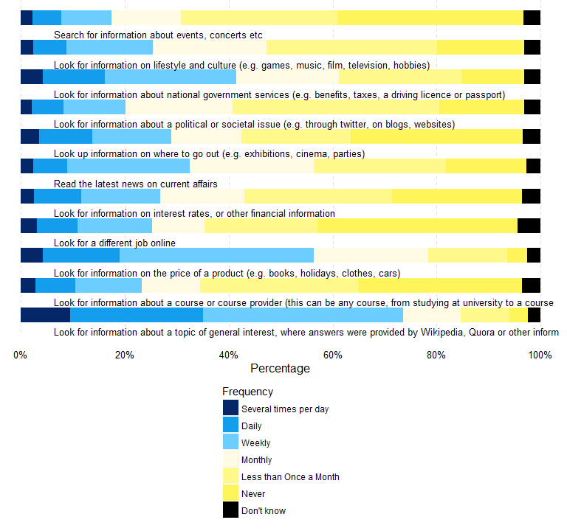

##### Interest in seeking difference

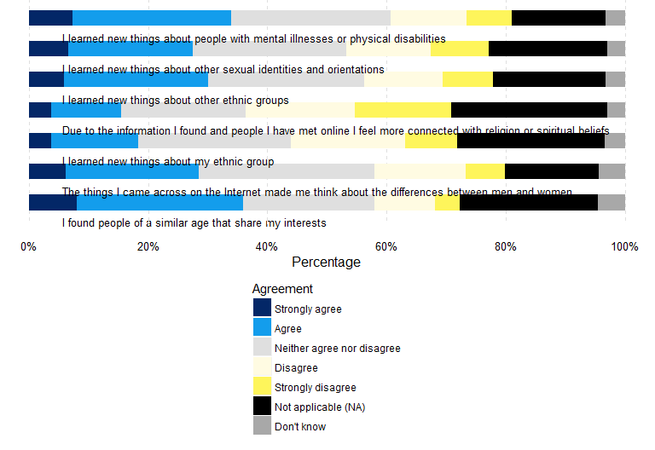

##### Interest in fitness and health improvement

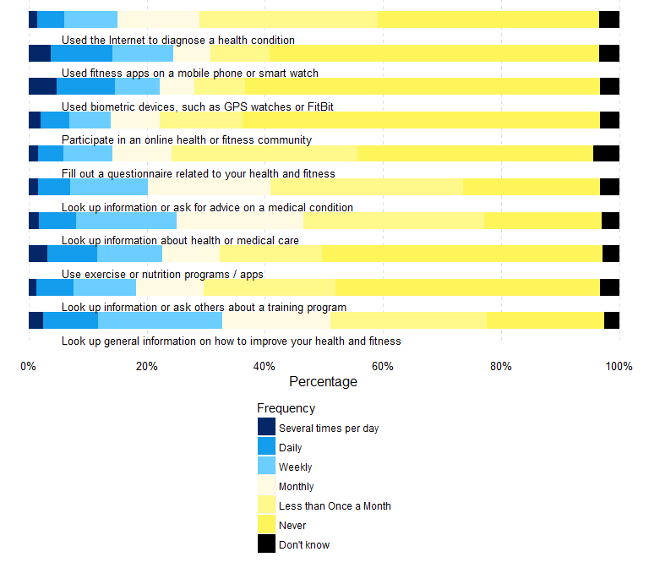

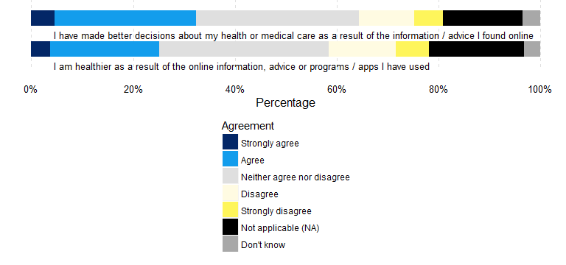

##### Interest in keeping in touch

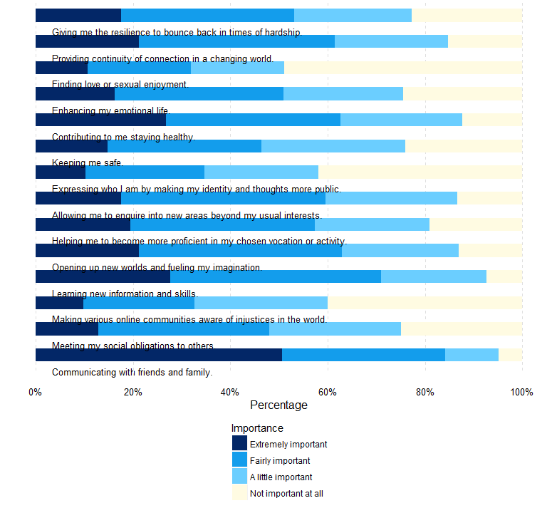

#### Results by Age

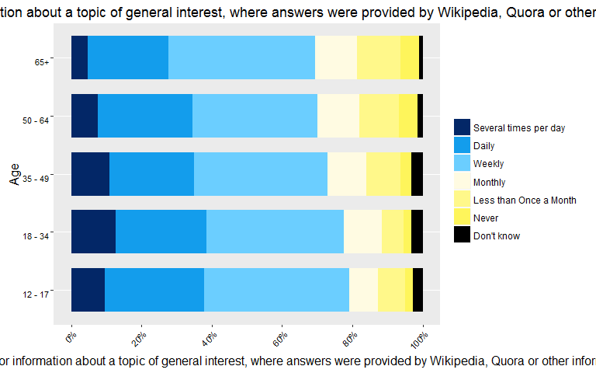 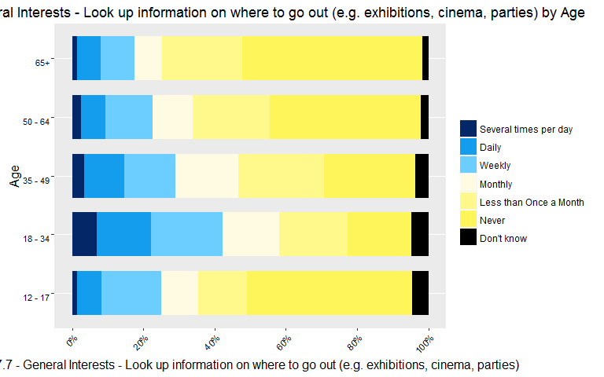 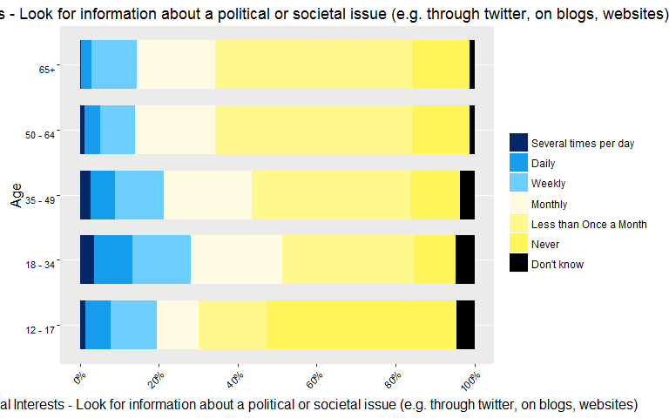 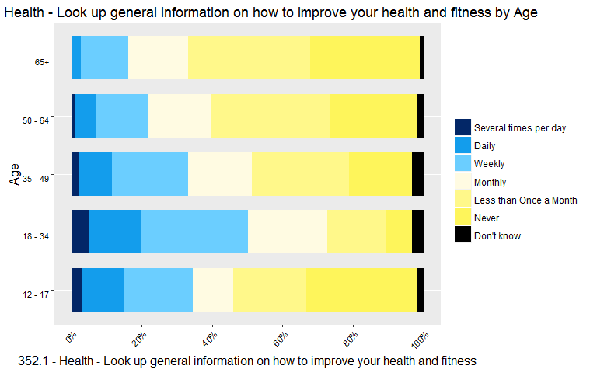

### Resilience

Our survey asked participants to respond to three questions about potential risks and harms of online activity, and how they prepare themselves for dealing with them.

* Experience of potential risks and harms of online activity in the last 12 months
* Level of agreement with statements about potential risks and harms
* Level of agreement with statements about engaging with others online

#### General Results

##### Frequency of harmful events

*Frequency of harmful events* measures frequency of 11 risks of online activity. These include getting a virus on one's device or seeing upsetting content online, or actions taken as a protection measure against those risks, such as reporting an issue online, deleting data or blocking further contacts from an individual.

**The graph below shows the relative frequencies of experiencing a risk, or taking a specific action in response to a risk, in the last 12 months.**

A large proportion of respondents (Enter value here) reported having never experienced these risks or potentially harmful events. The event that was most commonly experienced was 'Seeing or experiencing something on the internet that had bothered them in some way' with Enter value here 50+% [exact %?] of respondents experiencing this at least once in the last 12 months and Enter value here reporting experiencing this on a weekly basis or more often.

Half of respondents reported taking protective measures, such as blocking further contacts from an individual or deleting data in response to security and privacy concerns, at least once in the last 12 months.

Although respondents reported experiencing potentially harmful events online, the frequency of such events remains generally low. The most frequently reported action in response to online risks is to use extra security measures to protect privacy.

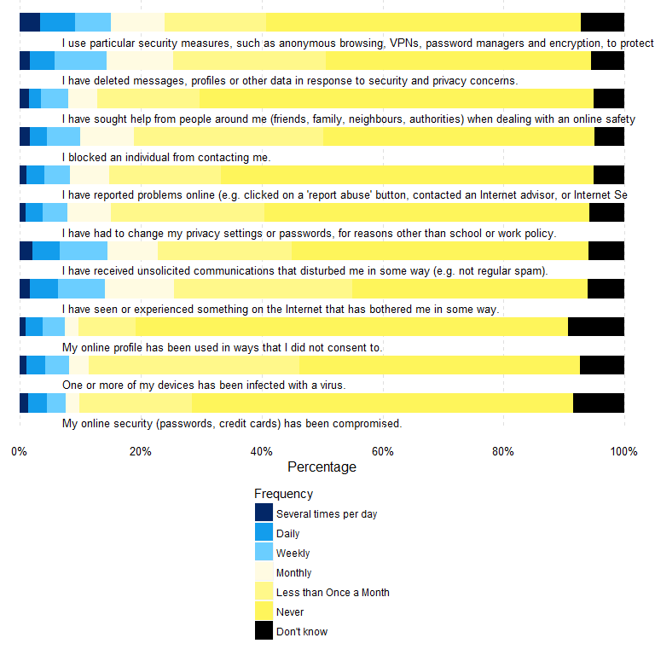

##### Responses to statements about online harms

The graph below shows the level of agreement with a number of statements relating to online harms.

Despite reporting having experienced some potentially harmful events in the last 12 months, the level of agreement with statements about online harms of a more general nature show an overall positive attitude towards those risks. The majority of respondents agree or strongly agree that the opportunities of online activities outweigh its risks and that some level of online risk is inevitable but also provides an important learning opportunity.

Online security and safety remains a pressing concern for just over a third of respondents but there appears to be both an increased level of acceptance and the development of coping mechanisms to better manage the risks.

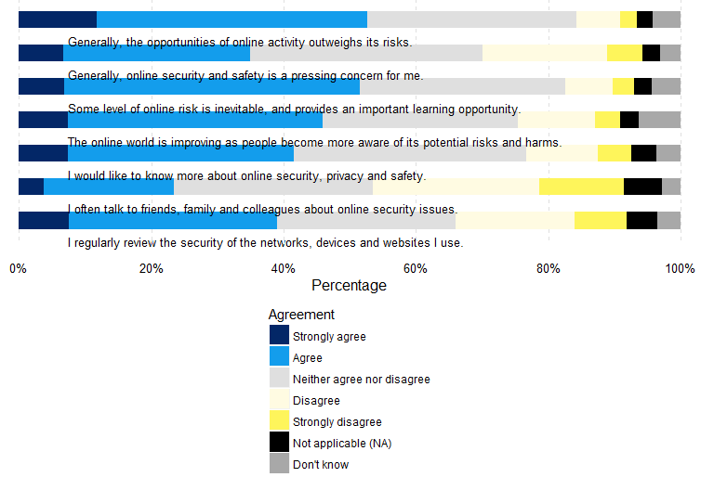

##### Willingness to engage with others

Thinking about how they feel when they engage with others online, respondents were asked to what extent they agree with several statements relating to their willingness to engage with others.

For each statements, a large proportion of respondents neither agree nor disagree. People tend to disagree that it is easier to be oneself online than face to face or that they talk about private things online that they do not share face to face. Similar proportions agree or disagree that going online make them feel better when they are going through a difficult time.

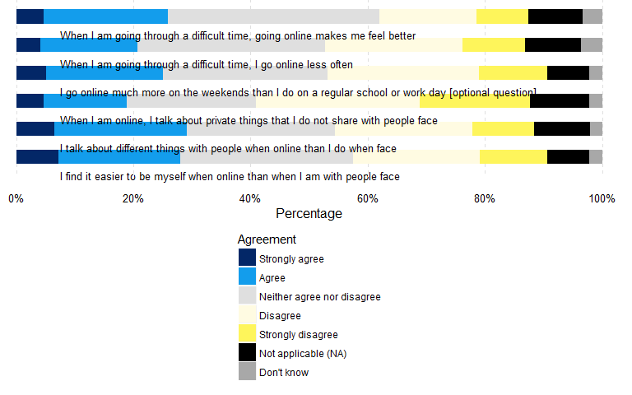

#### Results by Age

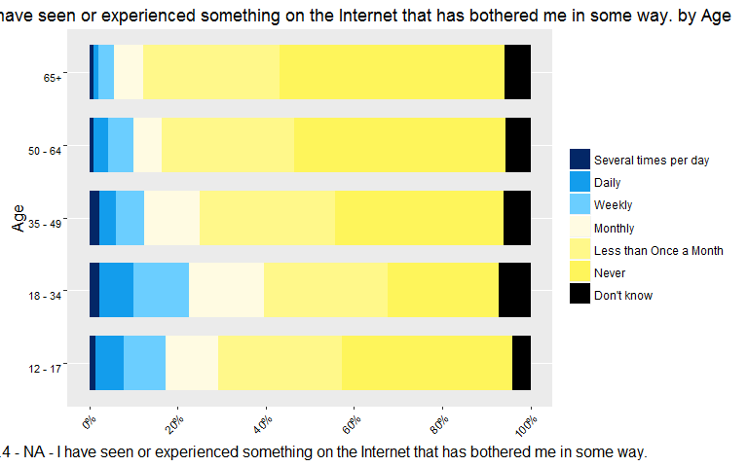

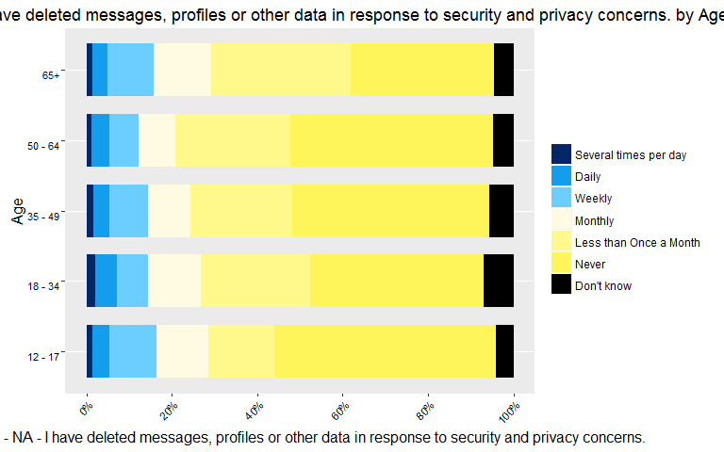

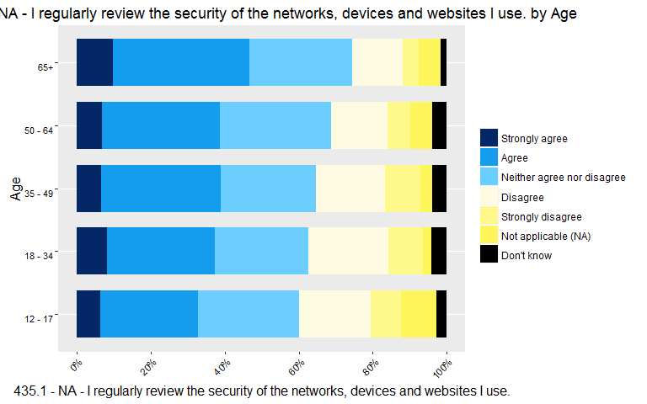

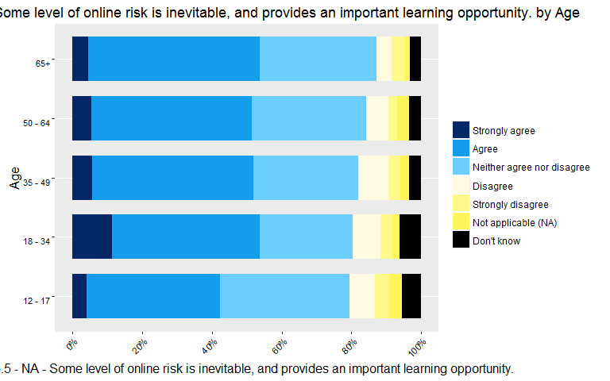

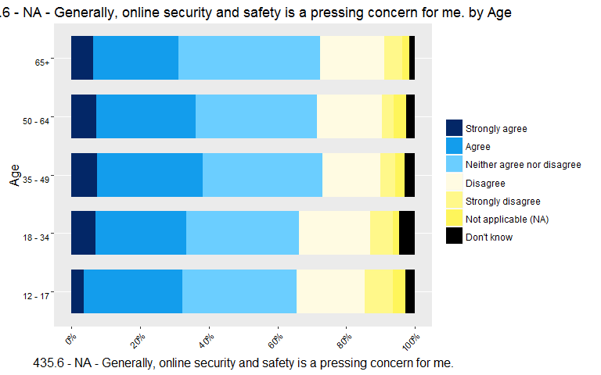

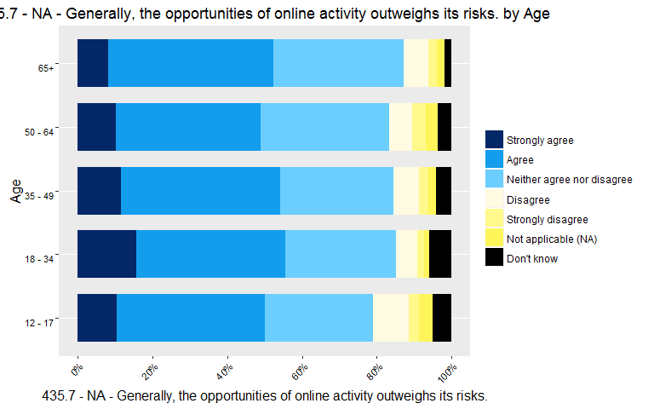

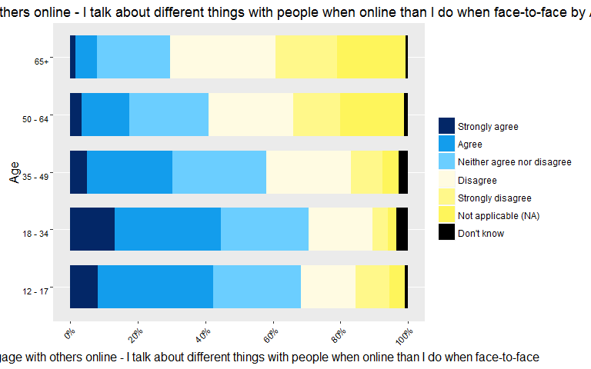

### Social Connectedness

Our survey asked participants to respond to questions about social connectedness and the role technology plays in their interactions with other people.

* Frequency of online activity to maintain connections
* Importance of online life to maintaining relationships
* Level of agreement with statements about broader issues concerning technology

##### General Results

##### Maintaining connections

This question measures frequency of 8 different online activities whose main purpose, or direct consequence, is to interact with others and/or to maintain connections.

The graph below shows the relative frequencies of each activity. Reading updates from friends or family via email or social media is the most frequent and most commonly reported activity, followed by making comments on those updates. Making new friends, meeting people or looking at websites that help meet new people are less common. This suggests that online activity is primarily used to strengthen connection with offline networks rather than as a distinct circle of connections.

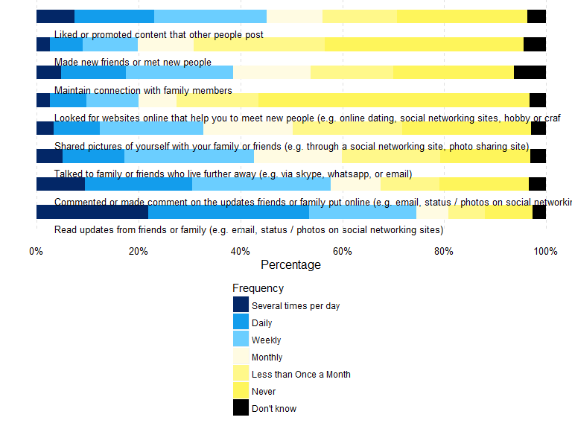

##### Importance of online life in maintaining relationships

When asked how important online life is in maintaining relationships with various groups within a broader social network, friends and family were the two groups with the highest level of importance. Online is also considered important in maintaining relationships with other networks of interest and work or school peers, but comparatively not as important to maintain relationships with neighbours.

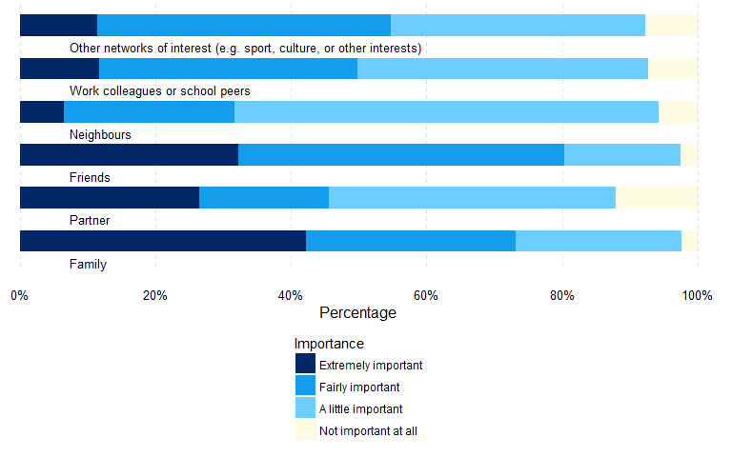

##### Attitudes towards Technology

The survey asked respondents to what extent they agree or disagree with a number of statements with regards to attitudes towards broader issues concerning technology.

Similar to our findings on the more general statements about online risks and harms, the attitudes of respondents towards technology is especially positive with over 60% reporting being optimistic about the future of technology. Three quarters r agree or strongly agree that technology is part of everyday life and half r believe that technology can not only strengthen familial relationships but also foster social inclusion.

The positive attitude is nevertheless counterbalanced with concerns about the use of online information by governments or companies, the impact on the environment or the growing divide between technology experts and the rest of society.

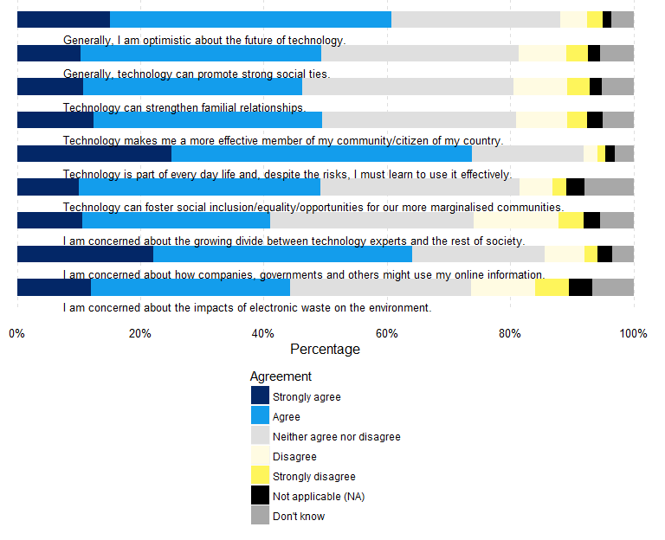

#### Results by Age

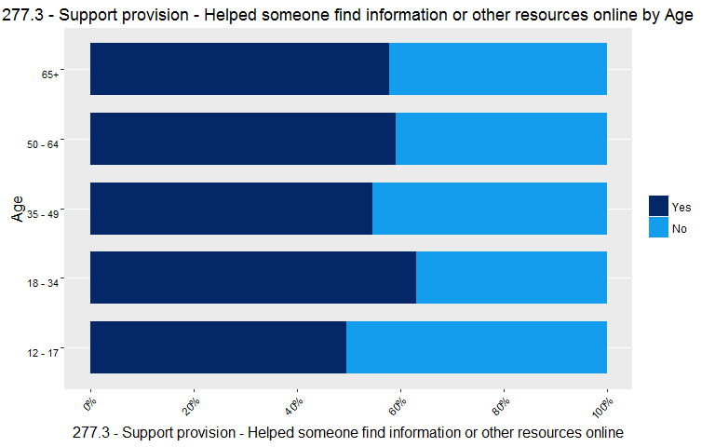

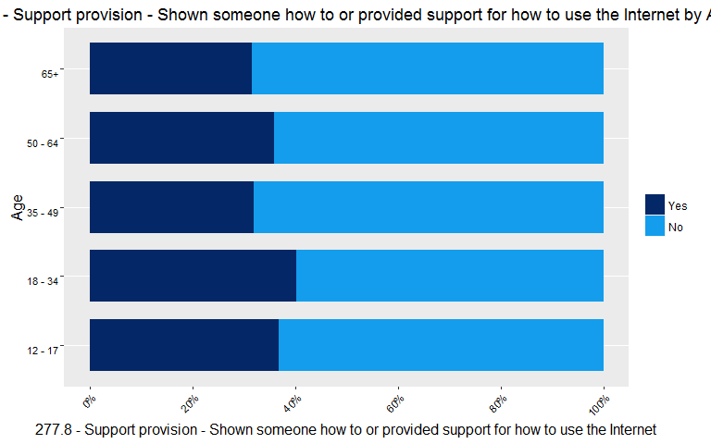

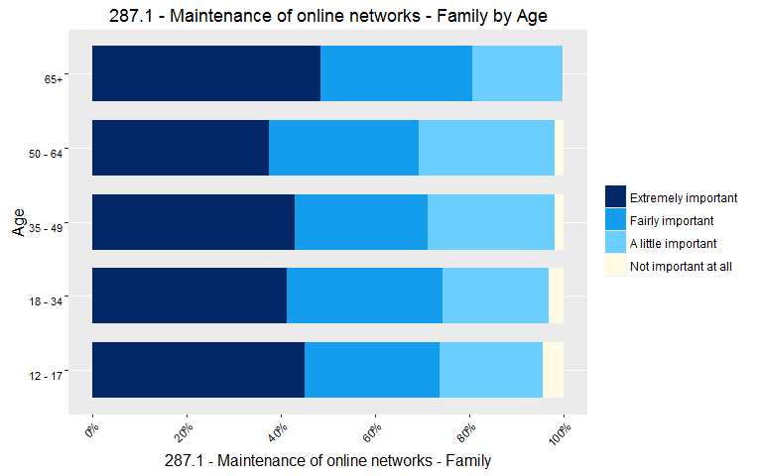

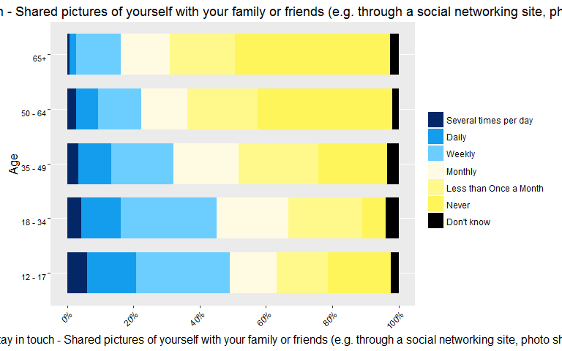

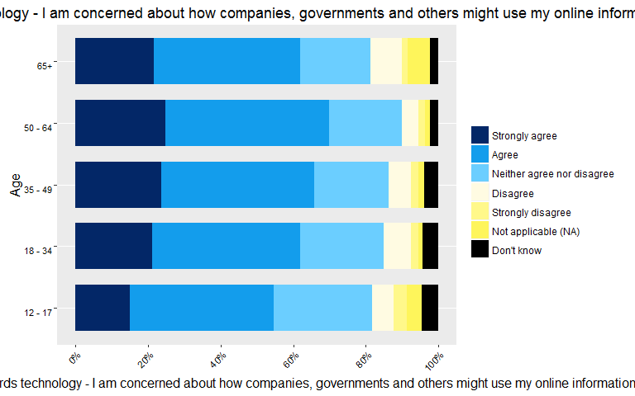

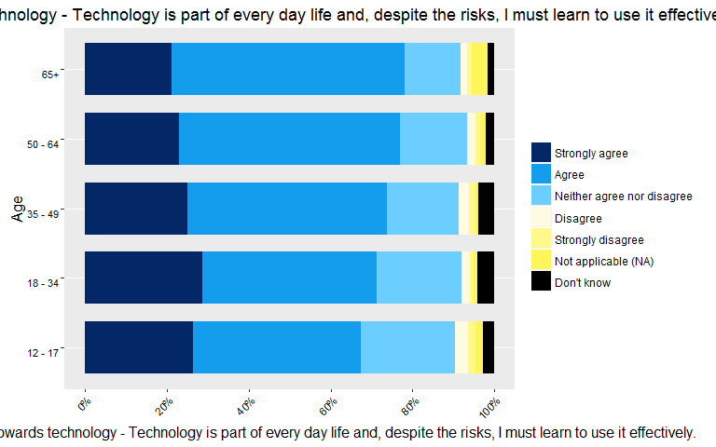

## Overall results

### Aggregates by Critical Issue

To gain an overall picture of our results, we generated Figure 5: Aggregated Results by Critical Issue, which aggregates responses to each critical issue (*Competencies*, *Interests*, *Resilience* and *Competencies*).

These results are indicative only, and have several evident limitations we discuss further below. The procedure to generate scores for each of the issues is as follows:

1. Interpret each question as having either a *positive* or *negative* influence of the score of the critical issue. For example, "Frequency of harmful events" has a *negative influence* on the issue of Resilience (and indeed, on overall "Digital Capacities").
2. Determine the *direction* of the scale coding. For example, in all of our "Agreement" questions, "Strongly Agree" was coded **5**.
3. For each question, calculate a question score based on both its interpretation and direction, by summing responses to individual items.
4. For each respondent, add each of their question scores to produce a respondent critical issue score. This value is converted to a percentile, wher '100%' would indicate maximum responses to each item for each question in that critical issue.
5. An combined score is taken by averaging the four critical issue scores.

Figure 5: Aggregated Results by Critical Issue then displays the relative frequencies of these scores, similar to the preceding individual question graphs. Because values are continuous (anywhere on a scale between 0 and 100 per cent), the graphs show a spectrum from blue (indicating a low score) to bright yellow (indicating a high score).

The *Resilience* score is calculated in the same way as the other issue scores, with the exception that only the first two items under *Question 428*, "Willingness to engage with others", are included in the scoring procedure. We have intepreted these items ("When I am going through a difficult time, I go online less often"; "When I am going through a difficult time, going online makes me feel better") as having some influence (the first negative, the second positive) on *Resilience*.

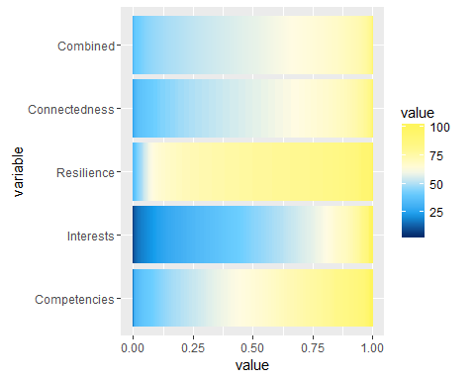

#### Limitations

The above procedure has several limitations.

First, it is questionable whether complex concepts such as digital resilience and social connectedness, in particular, are reducible to a quantitative value, regardless of the procedure used to derive it. At the very least, we recommend comparing these scores with our qualitative findings, which illustrate the more nuanced and sometimes contradictory character of these qualities in Australian families.

Second, the procedure treats, at the moment, each of the scales as numerically regular. For example, on the *Agreement* scale it assumes *Strongly agree* warrants 1 more score point than *Agree*, which in turn warrants 1 more point than *Neither Agree nor Disagree*. In other words, ordinal scales are treated as *ratio* variables, with regular intervals.

Third, the procedure assumes all questions and individual items have equal influence on the critical issue they have been aligned to.

[Note for reviewers: The latter two of these issues can be addresses by a more sophisticated scaling and weighting approach. We are considering holding a workshop for this purpose in preparation of the complete draft meeting in May 2016.]

## References

Helsper, Ellen. 2012. “A Corresponding Fields Model for the Links Between Social and Digital Exclusion.” *Communication Theory* 22 (4). Wiley Online Library: 403–26.

Humphry, Justine. 2014. “The Importance of Circumstance: Digital Access and Affordability for People Experiencing Homelessness.” *Australian Journal of Telecommunications and the Digital Economy* 2 (3). Telecommunications Association: 55.

James, Paul. 2014. *Urban Sustainability in Theory and Practice: Circles of Sustainability*. Routledge.

Livingstone, Sonia, Leslie Haddon, Anke Görzig, and Kjartan Ólafsson. 2010. “Risks and Safety on the Internet: The Perspective of European Children: Key Findings from the EU Kids Online Survey of 9-16 Year Olds and Their Parents in 25 Countries.” EU Kids Online.