Digital Capacities Index - Quantitative Findings

4 April 2016

Table of Contents

Digital Capacities Index - Quantitative Findings 2

Introduction 2

Demographics 2

Age 2

Gender 3

Combined Age and Gender 4

State and Location 6

Results by Critical Issue - Aggregated 7

Competencies 7

General Results 7

Results by Age 11

Interests 13

General Results 13

Results by Age 18

Resilience 19

General Results 19

Results by Age 22

Social Connectedness 23

General Results 24

Results by Age 26

Overall results 27

Aggregates by Critical Issue 27

Limitations 28

Observations 29

References 29

## Digital Capacities Index - Quantitative Findings

The *Digital Capacities Index* is a pilot survey instrument developed by researchers at Western Sydney University and Google Australia. The survey was administered by [Pure Profile](https://www.pureprofile.com/us/) in February 2016.

### Introduction

We included a total of 158 items measuring (a) frequency of various online behaviour, (b) levels of agreement with statements about digital capacities, (c) perceived importance of online activities and (d) ease of use of digital technologies.

We further distinguished questions into the following key thematic areas, or what we have termed, following James (2014), 'critical issues'. These issues are:

* **Competencies** (42 indicators).
* **Interests** (44 indicators).
* **Resilience** (24 indicators).
* **Social Connectedness** (48 indicators).

These four issues were distilled from a list of nine issues that also included *Engagement*, *Inclusion*, *Policy Environment*, *Infrastructure* and *Consequences*.

Against these four issues, we selected items and scales from existing sources in the literature where possible. In particular we drew from 'Kids Online' (Livingstone et al. 2010), Helsper's (2012) 'Corresponding fields model', a study by Humphry (2014) of mobile use among homeless populations, and indicators compiled by the [Young and Well CRC](http://www.youngandwellcrc.org.au/) (2013). Other indicators were developed by the *Digital Capacities Index* team.

A large number of candidate scales were distilled down to the current list after two day-long workshops, and testing of the survey.

### Demographics

The survey included a total of 2,157 participants. We requested the survey provider provide a panel in terms of age groups, gender and geographic regions. As the panel provider recruited participants online, our pilot sample is expected to be skewed towards Australian citizens and families with comparatively high digital capacities. This caveat is signficant to the interpretation of our results below.

#### Age

Participant ages ranged from 12 to 91, with a median value of 42.

*Figure 1* provides more detailed age demographics:

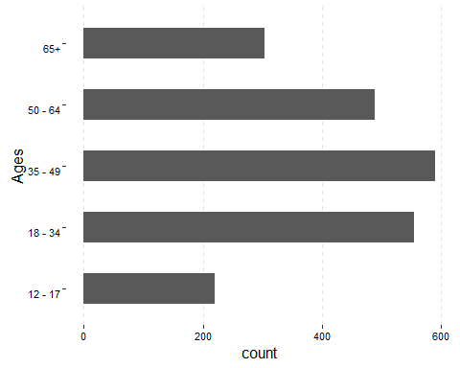

**Figure 1: Age Frequency**

These show participants' ages correspond approximately to Australia's adult demographic. 89.8% of participants were aged 35-54.

#### Gender

Participant gender is roughly evenly distributed. The survey included 1,105 (51%) women; 1,048 (49%) men; and 4 (0.19%) identifying as 'Other'.

Gender demographics are distributed, as shown in Figure 2:

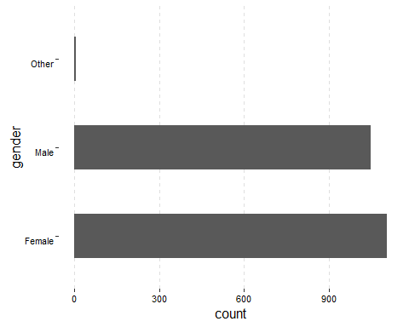

**Figure 2: Gender Frequency**

#### Combined Age and Gender

Combined age and gender demographics are distributed as shown in *Figure 3*:

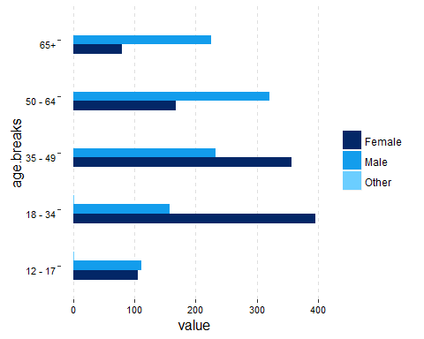

**Figure 3: Age & Gender Frequency**

These figures approximate to Australia's adult age distribution, as reported by the ABS in 2014 in **Figure 4** below, though with a considerably higher skew towards younger women and older men.

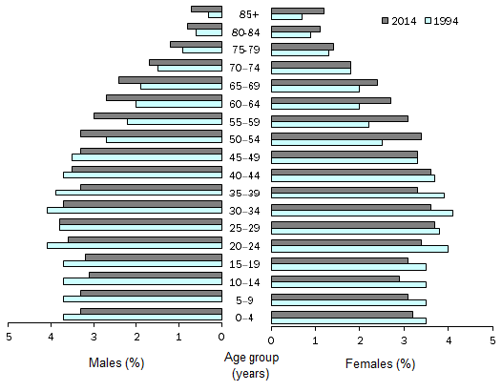

**Figure 4: Australia's Age & Gender Frequency (ABS 2014)**

#### State and Location

Survey distribution by state broadly follows Australia's demographic distribution.

The split of participants between urban and regional/rural is as follows:

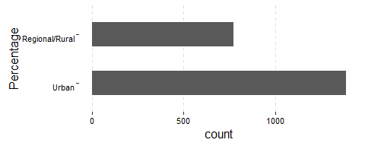 **Figure 5: Location Frequency**

The percentage of reported urban residents here is 64.3 - considerably less than [World Bank figures of 89%](http://data.worldbank.org/indicator/SP.URB.TOTL.IN.ZS).

## Results by Critical Issue - Aggregated

### Competencies

Our survey asked participants to respond to two questions about competencies:

* Frequency of online activity
* Perceived ease of conducting online activity

#### General Results

##### Frequency of online activity

*Frequency of online activity* measures frequency of 15 different activities, ranging from highly common activities such as sending email through to less common activities (in 2016), such as writing blogs.

Figure 6 below shows the relative frequencies of each activity. Using the Internet generally (for work, study, and for personal use), sending email and social networking are the most common activities. Streaming music, playing games with others, sharing media and writing blogs or diaries are comparatively uncommon activities.

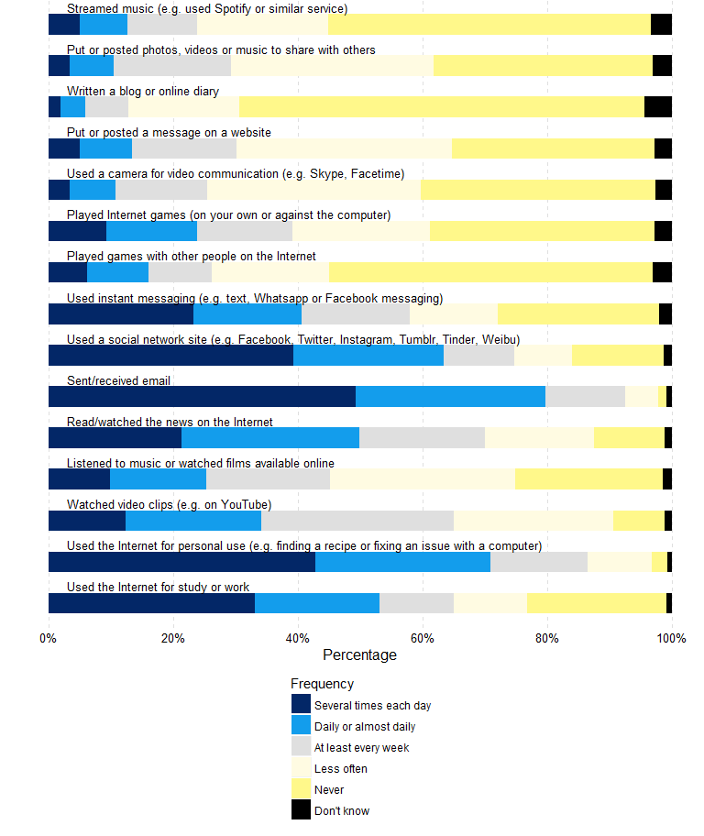

**Figure 6: Frequency of online activity**

##### Perceived ease of conducting online activity

Respondents were asked to rate the ease or difficulty of 27 online activities. Overall respondents report a high level of competency across all activities with bookmarking a website and connecting to a wifi network scoring the highest. Understanding the language that others use online and creating a blog were reported as more difficult activities. Despite the high level of competence reported by respondents in each of the 27 activities there were a small percentage of respondents who reported each of these activities as difficult or very difficult. Analysing the results according to age ranges provides a more illustrative breakdown of the results.

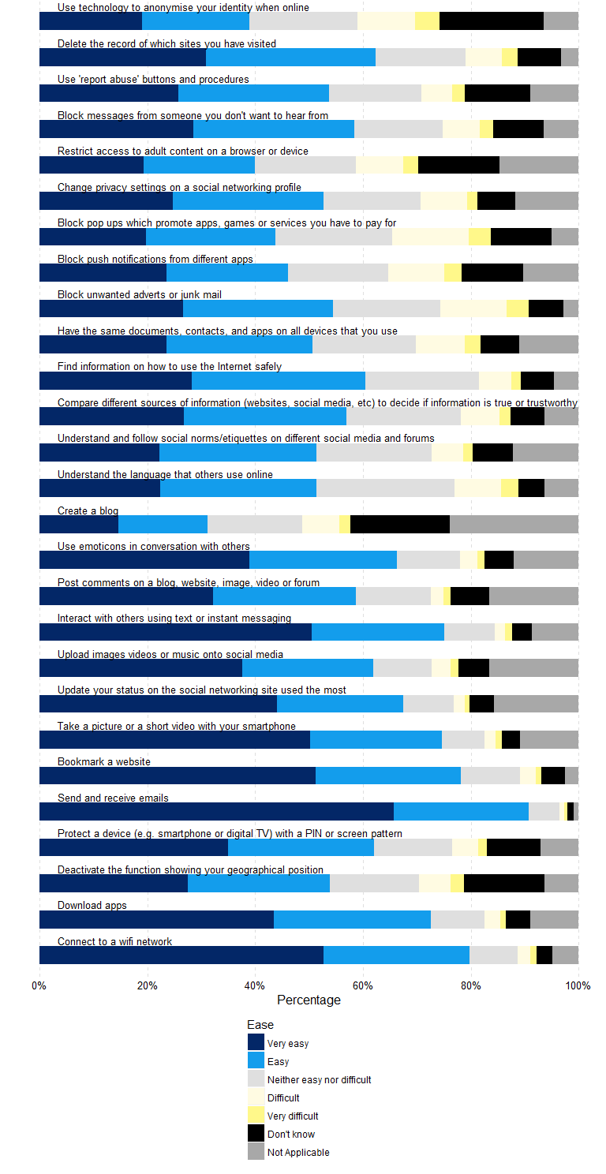

**Figure 7: Perceived ease of conducting online activity**

#### Results by Age

##### Used the Internet for personal use (e.g. finding a recipe or fixing an issue with a computer)

Across all age groups, a large majority of respondents reported using the internet for personal use almost daily or more often. The 18-34 age group are the heaviest users, with 58% using the internet for personal use several times a day.

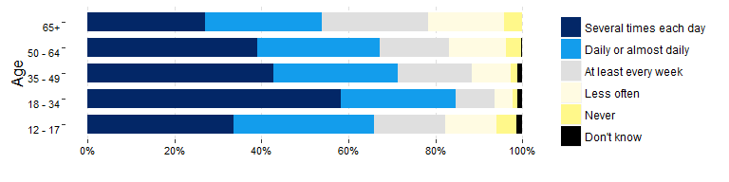

**Figure 8: Used the Internet for personal use (e.g. finding a recipe or fixing an issue with a computer)**

##### Watched video clips (e.g. on YouTube)

Differences by age groups are more visible depending on specific uses of the internet. Watching video clips for example is an activity where there is a clear demarcation between the under 35s, who are more likely to do this on a daily basis or more often, and those aged 35 or over, who are more likely to do this on a weekly basis or less often.

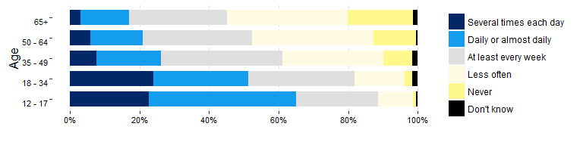

**Figure 9: Watched video clips (e.g. on YouTube)**

##### Sent/received email

In contrast, respondents over 18 overwhelmingly reported using email as a means of communication several times a day, compared to only a fifth of those aged 12 to 17.

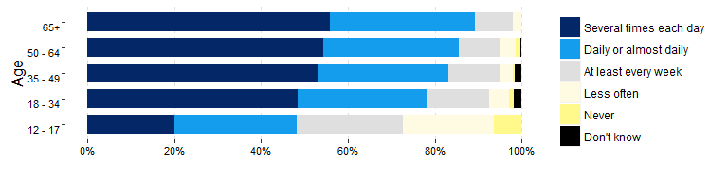

**Figure 10: Sent/received email**

##### Create a blog

Although respondents in the older age groups were less likely than younger people to report specific digital tasks to be easy or very easy, it is worth noting that they did not necessarily report those to be especially difficult. Rather, much higher proportions of respondents in the older age groups answered "Don't know" or "Not applicable" to those specific tasks such as creating a blog, pointing to a difference in levels of need and interest more so than actual competencies.

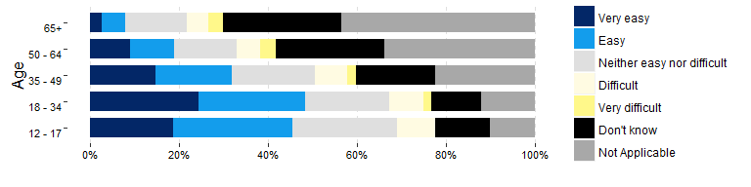

**Figure 11: Create a blog**

##### Understand the language that others use online

When asked about more 'general' or overarching skills such as understanding the language that others use online, the age correlation by which the perceived ease of conducting specific tasks decreases as the age of respondents increases becomes more apparent.

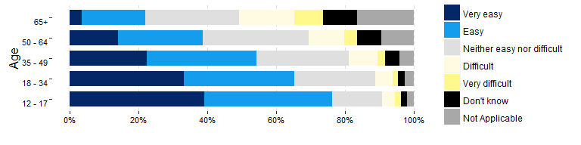

**Figure 12: Understand the language that others use online**

##### Block unwanted adverts or junk mail

There is, however, greater consistency across age groups for competencies such as blocking unwanted adverts or junk mail.

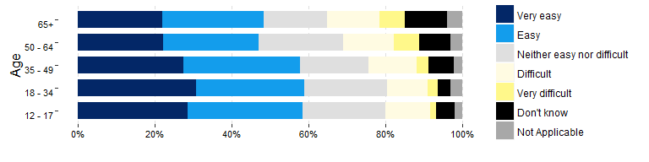

**Figure 13: Block unwanted adverts or junk mail**

### Interests

#### General Results

##### General Interests

*Frequency of online activity* measures frequency of 11 different activities related to information seeking, ranging from highly common activities, such as looking for information about general interests on platforms such as Wikipedia, through to more specific activities (in 2016), such as national government services.

*Figure 14* below shows the relative frequencies of each activity. Looking for information about a topic of general interest where answers were provided by Wikipedia, Quora or other informational sites, and searching for prices are the most common activities. Looking for information about concerts and events, and political or societal issues are comparatively uncommon activities.

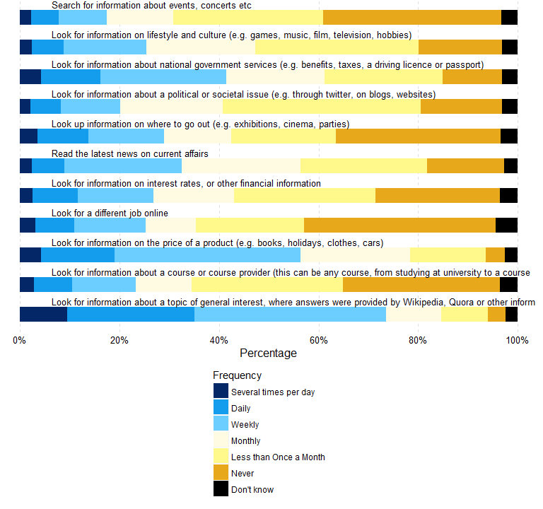

**Figure 14: General Interests**

##### Interest in seeking difference

This question measures frequency of 7 different online activities whose main purpose is to determine to what extent online information seeking helps people to find others who share their interests and to learn about or understand social and cultural difference.

*Figure 15* below shows the relative frequencies of each activity. Finding people of a similar age who share my interests is the most frequent and most commonly reported activity, followed by learning new things about people with mental illnesses or physical disabilities and learning new things about other ethnic groups. Learning things about participant's own ethnic group and feeling more connected to spiritual or religious beliefs are less common. This suggests that for Australians, online information seeking is more directed towards questions of interest, gender and health, rather than ethnicity and religion.

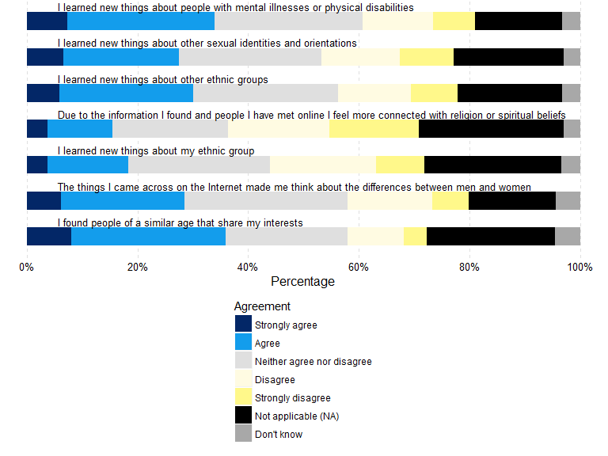

**Figure 15: Interest in seeking difference**

##### Interest in fitness and health improvement

This question measures frequency of 10 different online activities whose main purpose is to determine to what extent online technologies assist people to manage their health and fitness.

*Figure 16* below shows the relative frequencies of each activity. Looking up information or asking others about a training program is the most frequent and commonly reported activity, followed by looking up information or asking advice on a medical condition. The least common activities reported are participating in an online health or fitness community and filling out questionnaires about fitness. There are not large differences reported between any of the activities, and less than 40% of participants reported engaging in any of the activities on more than a monthly basis.

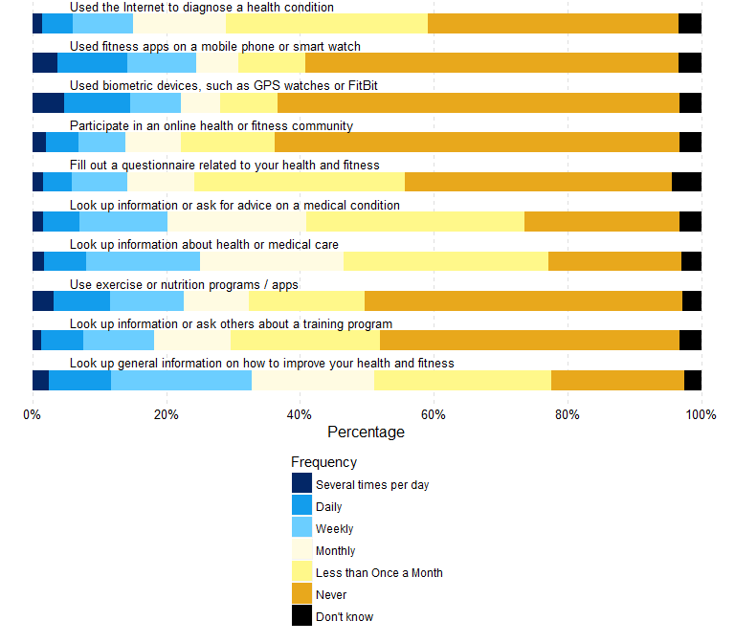

**Figure 16: Interest in fitness and health improvement**

We asked a series of subsidiary statements about use of digital capacities to improve health. More participants agreed than disagreed (32% to 17%) with the statement they made better decisions as a result of online advice. In terms of outcomes, responses were more evenly split: 25% agreed their health had improved, while 20% disagreed.

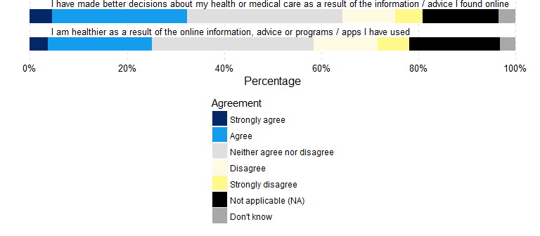

**Figure 17: Health Impacts**

##### Interest in keeping in touch

The survey asked respondents to rate the importance of their motivations for using the internet for maintaining their general interests, along with their connections with others. Respondents were asked to rate 14 statements which ranged between extremely important and not important at all. All the statements were rated with a degree of importance in over 50% of all responses. "Communicating with friends and family" was rated the highest, with over 90% of respondents rating this on the scale of importance. Opening up new worlds and fueling my imagination also scored highly. Less common in the scale was providing continuity of connection in a changing world. This suggests that the reasons that motivate people to use the internet are contingent upon their connections with others and their sense of self.

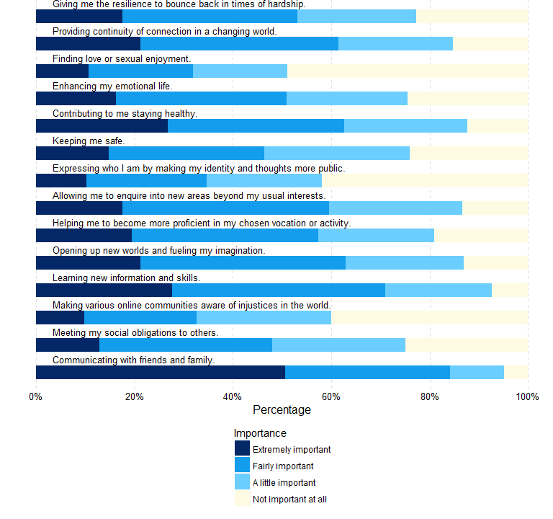

**Figure 18: Interest in keeping in touch**

#### Results by Age

##### Look for information about a topic of general interest, where answers were provided by Wikipedia, Quora or other informational sites

As previously mentioned, differences by age are more or less noticeable depending on the various uses of the internet, which directly relates to motivations, interests and the reasons why respondents go online. A commonly reported use such as going online to look for information about a topic of general interest (where answers are provided by informational sites like Wikipedia or Quora) is typically one where the relative frequency is consistent across all age groups.

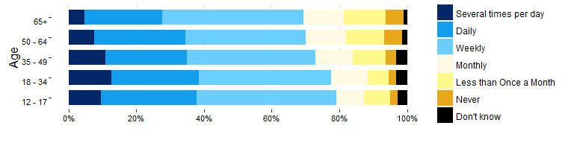

**Figure 19: Look for information about a topic of general interest, where answers were provided by Wikipedia, Quora or other informational sites**

##### Look for information about national government services (e.g. benefits, taxes, a driving licence or passport)

Comparatively, much lower relative frequencies were reported for going online to look for information about a political or societal issue.

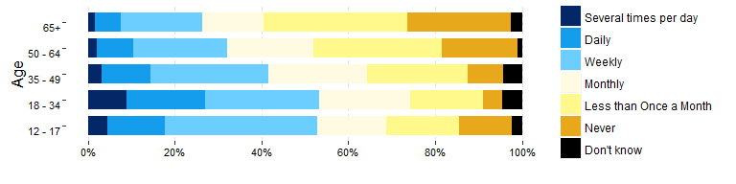

**Figure 20: Look for information about national government services (e.g. benefits, taxes, a driving licence or passport)**

##### Look up information about health or medical care

Nearly half (46%) of younger respondents (under 18) reported not looking up information about health or medical care in the last 12 months. The proportion of those who did so at least once in the last 12 months increase with age, although the relative frequencies remain low.

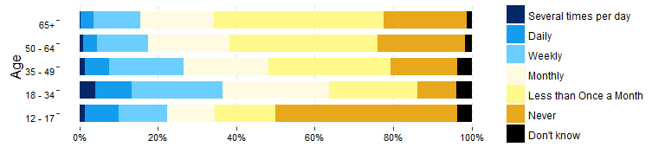

**Figure 21: Look up information about health or medical care**

### Resilience

Our survey asked participants to respond to three questions about potential risks and harms of online activity, and how they prepare themselves for dealing with them.

* Experience of potential risks and harms of online activity in the last 12 months
* Level of agreement with statements about potential risks and harms
* Level of agreement with statements about engaging with others online

#### General Results

##### Frequency of harmful events

*Frequency of harmful events* measures frequency of 11 risks of online activity. These include getting a virus on one's device or seeing upsetting content online, or actions taken as a protection measure against those risks, such as reporting an issue online, deleting data or blocking further contacts from an individual.

***Figure 22* below shows the relative frequencies of experiencing a risk, or taking a specific action in response to a risk, in the last 12 months.**

On average, more than half of respondents (51%) reported having never experienced these risks or potentially harmful events. The event that was most commonly experienced was 'Seeing or experiencing something on the internet that had bothered them in some way' with 55% of respondents experiencing this at least once in the last 12 months, and 14% reporting experiencing this on a weekly basis or more often.

Half of respondents reported taking protective measures, such as blocking further contacts from an individual or deleting data in response to security and privacy concerns, at least once in the last 12 months.

Although respondents reported experiencing potentially harmful events online, the frequency of such events remains generally low. The most frequently reported action in response to online risks is to use extra security measures to protect privacy.

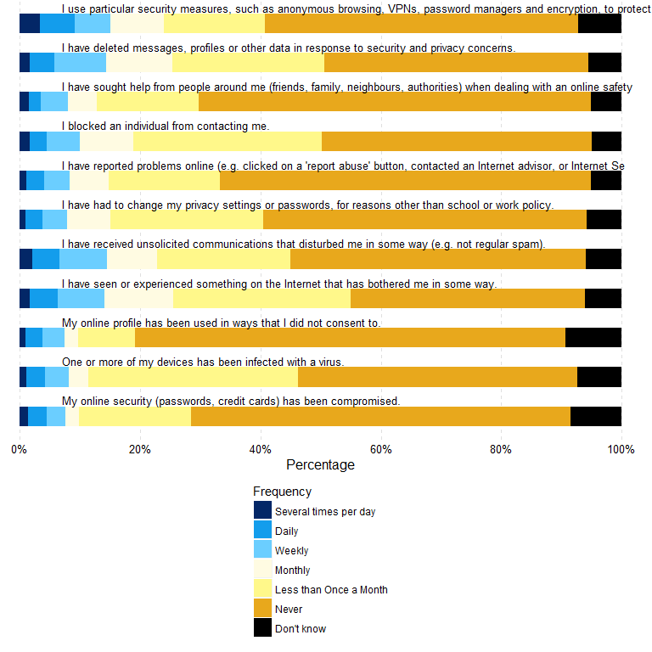

**Figure 22: Frequency of harmful events**

##### Responses to statements about online harms

*Figure 23* below shows the level of agreement with a number of statements relating to online harms.

Despite reporting having experienced some potentially harmful events in the last 12 months, the level of agreement with statements about online harms of a more general nature show an overall positive attitude towards those risks. The majority of respondents agree or strongly agree that the opportunities of online activities outweigh its risks and that some level of online risk is inevitable but also provides an important learning opportunity.

Online security and safety remains a pressing concern for just over a third of respondents but there appears to be both an increased level of acceptance and the development of coping mechanisms to better manage the risks.

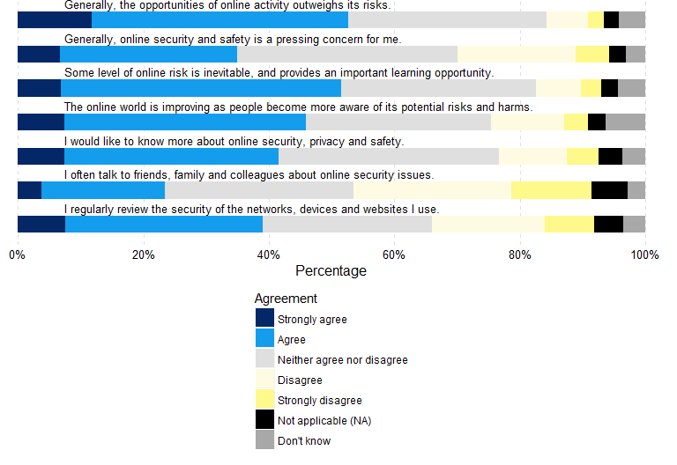

**Figure 23: Responses to statements about online harms**

##### Willingness to engage with others

Thinking about how they feel when they engage with others online, respondents were asked to what extent they agree with several statements relating to their willingness to engage with others.

For each of these statements, a large proportion of respondents neither agree nor disagree. People tend to disagree that it is easier to be oneself online than face to face or that they talk about private things online that they do not share face to face. Similar proportions agree or disagree that going online makes them feel better when they are going through a difficult time.

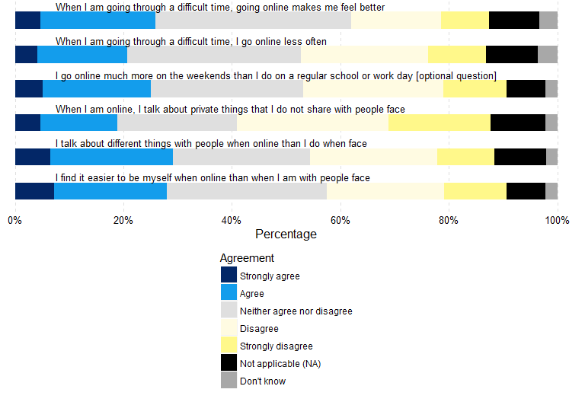

**Figure 24: Willingness to engage with others**

#### Results by Age

##### I have seen or experienced something on the Internet that has bothered me in some way.

Respondents under the age of 35 were more likely to report higher frequency of seeing something on the internet that had bothered them in some way.

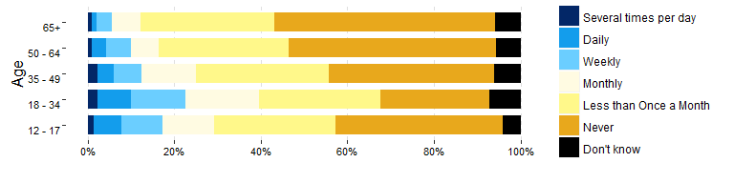

**Figure 25: I have seen or experienced something on the Internet that has bothered me in some way.**

##### I have deleted messages, profiles or other data in response to security and privacy concerns.

There are no differences by age in the reported frequency of deleting data in response to privacy concerns.

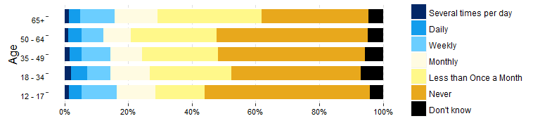

**Figure 26: I have deleted messages, profiles or other data in response to security and privacy concerns.**

##### Generally, online security and safety is a pressing concern for me.

Over a third (35%) of respondents agree or strongly agree that online security and safety is generally a pressing concern. Interestingly, there were no noticeable differences by age groups.

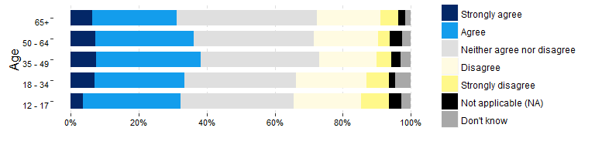

**Figure 27: Generally, online security and safety is a pressing concern for me.**

##### Generally, the opportunities of online activity outweighs its risks.

Having said that, respondents also overwhelmingly agree that the opportunities of online activity outweigh its risks, with half agreeing or strongly agreeing with that statement. Again, there are no noticeable differences by age groups.

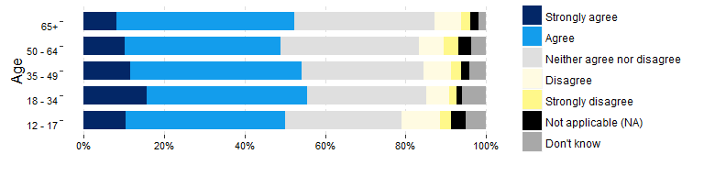

**Figure 28: Generally, the opportunities of online activity outweighs its risks.**

### Social Connectedness

Our survey asked participants to respond to questions about social connectedness and the role technology plays in their interactions with other people. Key topics include:

* Frequency of online activity to maintain connections
* Importance of online life to maintaining relationships
* Level of agreement with statements about broader issues concerning technology

#### General Results

##### Maintaining connections

This question measures frequency of 8 different online activities whose main purpose, or direct consequence, is to interact with others and/or to maintain connections.

*Figure 29* below shows the relative frequencies of each activity. Reading updates from friends or family via email or social media is the most frequent and most commonly reported activity, followed by making comments on those updates. Making new friends, meeting people or looking at websites that help meet new people are less common. This suggests that online activity is primarily used to strengthen connection with offline networks rather than as a distinct circle of connections.

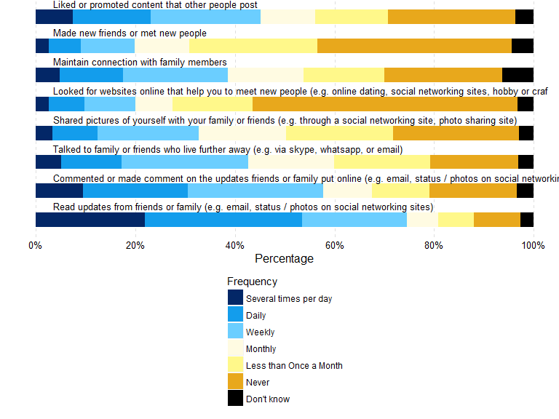

**Figure 29: Maintaining connections**

##### Importance of online life in maintaining relationships

When asked how important online life is in maintaining relationships with various groups within a broader social network, friends and family were the two groups with the highest level of importance. Online is also considered important in maintaining relationships with other networks of interest and work or school peers, but comparatively not as important to the maintenance of relationships with neighbours.

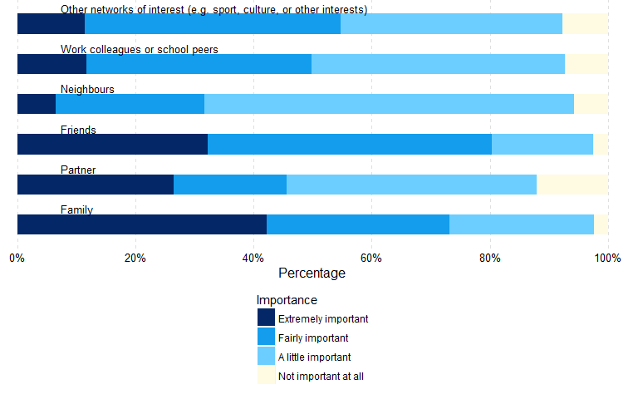

**Figure 30: Importance of online life in maintaining relationships**

##### Attitudes towards Technology

The survey asked respondents to what extent they agree or disagree with a number of statements with regards to attitudes towards broader issues concerning technology.

Similar to our findings on the more general statements about online risks and harms, the attitudes of respondents towards technology is especially positive with over 60% reporting being optimistic about the future of technology. Nearly three quarters (74%) agree or strongly agree that technology is part of everyday life. Nearly half (49%) believe that technology can not only make participants more effective members of their community or nation, but can also foster social inclusion.

The positive attitude is nevertheless counterbalanced with concerns about the use of online information by governments or companies, the impact on the environment or the growing divide between technology experts and the rest of society.

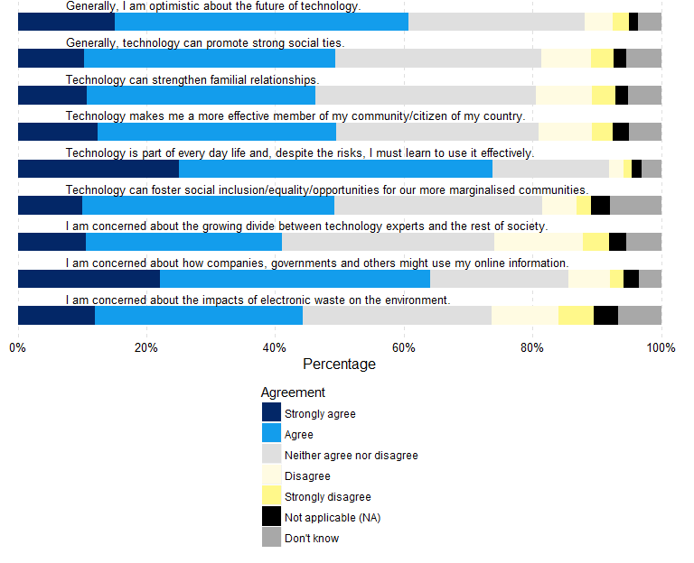

**Figure 31: Attitudes towards Technology**

#### Results by Age

##### Family

Across all age groups, a large proportion of respondents reported that their online life was extremely important in maintaining relationships with family members.

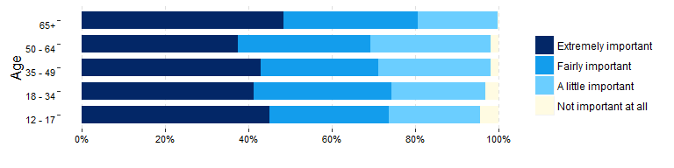

**Figure 32: Family**

##### Shared pictures of yourself with your family or friends (e.g. through a social networking site, photo sharing site)

The ways in which people maintain connections with others online, however, differ depending on the people's age. The likelihood of sharing pictures of oneself with family or friends decreases with age, with half of 12-17 year olds doing so weekly or more often compared to less than a fifth of those aged 65 or over.

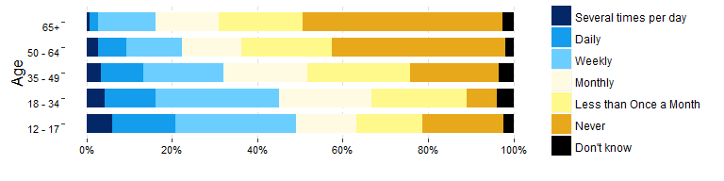

**Figure 33: Shared pictures of yourself with your family or friends (e.g. through a social networking site, photo sharing site)**

##### I am concerned about how companies, governments and others might use my online information.

Overall, respondents largely agreed to being concerned about how companies, governments or others might use their online information, and results are consistent across all age groups.

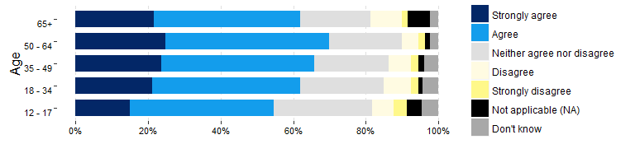

**Figure 34: I am concerned about how companies, governments and others might use my online information.**

## Overall results

### Aggregates by Critical Issue

To gain an overall picture of our results, we generated a series of stacked graphs in *Figure 35: Aggregated Results by Critical Issue*. These aggregate responses to each critical issue (*Competencies*, *Interests*, *Resilience* and *Competencies*), and the combined total.

These results are indicative only, and have several evident limitations we discuss further below. The procedure to generate scores for each of the issues is as follows:

1. Interpret each question as having either a *positive* or *negative* influence of the score of the critical issue. For example, "Frequency of harmful events" has a *negative influence* on the issue of Resilience (and indeed, on overall "Digital Capacities").
2. Determine the *direction* of the scale coding. For example, in all of our "Agreement" questions, "Strongly Agree" was coded **1**.
3. For each question, calculate a question score based on both its interpretation and direction, by adding responses to individual items.
4. For each respondent, add each of their question scores to produce a respondent critical issue score. This value is converted to a percentile, where '100%' would indicate maximum responses to each item for each question in that critical issue.
5. A combined score is taken by averaging the four critical issue scores.

Figure 35 then displays the relative frequencies of these scores, similar to the preceding individual question graphs. Because values are continuous (anywhere on a scale between 0 and 100 per cent), the graphs show a spectrum from blue (indicating a low score) to bright yellow (indicating a high score).

The *Resilience* score is calculated in the same way as the other issue scores, with the exception that only the first two items under *Question 428*, "Willingness to engage with others", are included in the scoring procedure. We have intepreted these items ("When I am going through a difficult time, I go online less often"; "When I am going through a difficult time, going online makes me feel better") as having some influence (the first negative, the second positive) on *Resilience*.

#### Limitations

The above procedure has several limitations.

First, it is questionable whether complex concepts such as digital resilience and social connectedness, in particular, are reducible to a quantitative value, regardless of the procedure used to derive it. Further, for reasons of space, our characterisation of Digital Capacities includes a total of nine critical issues, only four of which are included in the survey. We recommend comparing these scores with our qualitative findings, which illustrate the more nuanced and sometimes contradictory character of these qualities in Australian families.

Second, the procedure treats, at the moment, each of the scales as numerically regular. For example, on the *Agreement* scale it assumes *Strongly agree* warrants 1 more score point than *Agree*, which in turn warrants 1 more point than *Neither Agree nor Disagree*. In other words, ordinal scales are treated as *ratio* variables, with regular intervals.

Third, the procedure assumes all questions and individual items have equal influence on the critical issue they have been aligned to.

**[REVIEW NOTE: The latter two of these issues can be addressed partially by a more sophisticated scaling and weighting approach. We are considering holding a workshop for this purpose in preparation of the complete draft meeting in May 2016.]**

### Observations

Bearing in mind the method of deriving these aggregate scores, we make only minimal observations at this stage. *Figure 35* shows that results for *Compentencies* and *Connectedness* are evenly distributed, with respondents' scores spread across the 100-point scale. These are also similar to the spread of *Combined* scores. *Resilience* scores tend high, with most respondents reporting little exposure to harms, and familiarity with methods for responding to those harms.

On the other hand, *Interest* scores tend low. This may be explained by our limiting interests to areas of social difference, fitness, health and family, which will not effectively poll the range or extent of participants' interests.

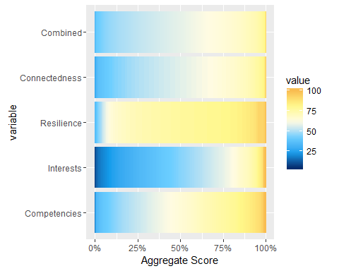

*Figure 35: Aggregated Results by Critical Issue*

## References

Helsper, Ellen. 2012. “A Corresponding Fields Model for the Links Between Social and Digital Exclusion.” *Communication Theory* 22 (4). Wiley Online Library: 403–26.

Humphry, Justine. 2014. “The Importance of Circumstance: Digital Access and Affordability for People Experiencing Homelessness.” *Australian Journal of Telecommunications and the Digital Economy* 2 (3). Telecommunications Association: 55.

James, Paul. 2014. *Urban Sustainability in Theory and Practice: Circles of Sustainability*. Routledge.

Livingstone, Sonia, Leslie Haddon, Anke Görzig, and Kjartan Ólafsson. 2010. “Risks and Safety on the Internet: The Perspective of European Children: Key Findings from the EU Kids Online Survey of 9-16 Year Olds and Their Parents in 25 Countries.” EU Kids Online.

Young and Well Cooperative Research Centre. 2013. “CRC Standard Measures.”