Digital Capacities Index - Quantitative Findings

4 April 2016

Table of Contents

## Digital Capacities Index - Quantitative Findings

The *Digital Capacities Index* is a pilot survey instrument developed by researchers at Western Sydney University and Google Australia. The survey was administered by [Pure Profile](https://www.pureprofile.com/us/) in Febuary 2016.

### Introduction

We included a total of 158 items measuring (a) frequency of various online behaviour, (b) levels of agreement with statements about digital capacities, (c) perceived importance of online activities and (d) ease of use of digital technologies.

We further distinguished questions into the following key thematic areas, or what we have termed, following James (2014), 'critical issues'. These issues are:

* **Competencies** (42 indicators).
* **Interests** (44 indicators).
* **Resilience** (24 indicators).
* **Social Connectedness** (48 indicators).

These four issues were distilled from a list of nine issues that also included *Engagement*, *Inclusion*, *Policy Environment*, *Infrastructure* and *Consequences*.

Against these four issues, we selected items and scales from existing sources in the literature where possible. In particular we drew from 'Kids Online' (Livingstone et al. 2010), Helsper's (2012) 'Corresponding fields model', a study by Humphry (2014) of mobile use among homeless populations, and indicators compiled by the [Young and Well CRC](http://www.youngandwellcrc.org.au/). Other indicators were developed by the *Digital Capacities Index* team.

A large number of candidate scales were distilled down to the current list after two day-long workshops, and testing of the survey.

### Demographics

The survey included a total of 2,157 participants. We requested the survey provider provide a panel in terms of age groups, gender and geographic regions. As the panel provider recruited participants online, our pilot sample is expected to be skewed towards Australian citizens and families with comparatively high digital capacities. This caveat is signficant to the interpretation of our results below.

#### Age

Participant ages ranged from 18 to 91, with a median value of 45.

*Figure 1* provides more detailed age demographics:

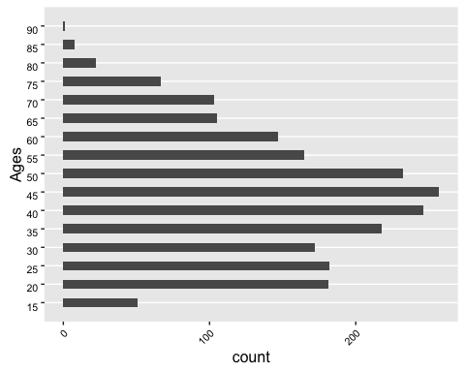

**Figure 1: Age Frequency**

These show participants' ages correspond approximately to Australia's adult demographic. 44.2% of participants were aged 35-54.

#### Gender

Participant gender is roughly evenly distributed. The survey included 1,105 (51%) women; 1,048 (49%) men; and 4 (0.19%) identifying as 'Other'.

Gender demographics are distributed, as show in Figure 2:

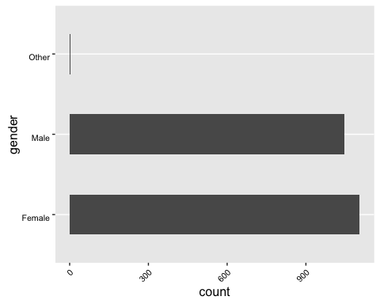

**Figure 2: Gender Frequency**

#### Combined Age and Gender

Combined age and gender demographics are distributed as per *Figure 3:

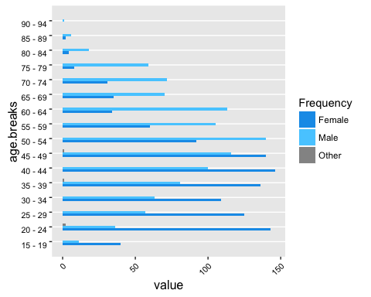

**Figure 3: Age & Gender Frequency**

These figures approximate to Australia's adult age distribution, as reported by the ABS in 2014 in **cf("age.gender.freq.abs")** below, though with a considerably higher skew towards younger women and older men.

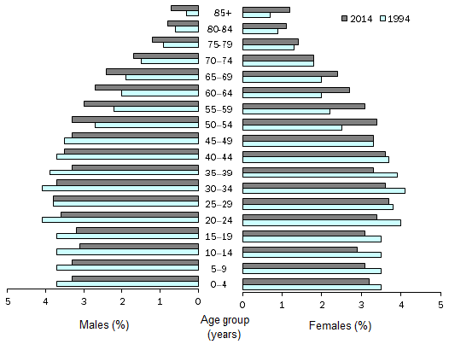

**fig_nums("age.gender.freq.abs")**

#### State and Location

Participants are distributed by state as follows:

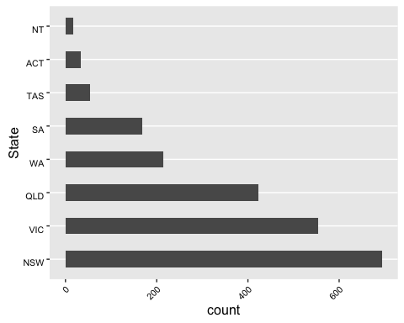

The split of participants between urban and regional/rural is as follows:

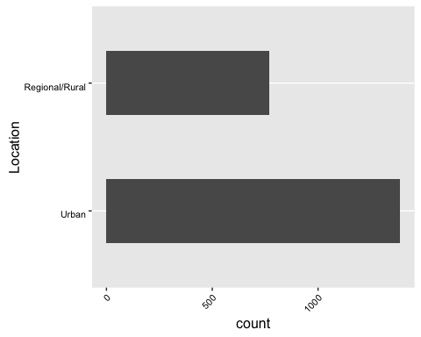

## Results by Critical Issue - Aggregated

### Competencies

Our survey asked participants to respond to two questions about competencies:

* Frequency of online activity
* Perceived ease of conducting online activity

#### Frequency of online activity

*Frequency of online activity* measures frequency of 15 different activities, ranging from highly common activities such as sending email through to less common activities (in 2016), such as writing blogs.

##### By activity

The graph below shows the relative frequencies of each activity. Using the Internet generally (for work, study, and for personal use), sending email and social networking are the most common activities. Streaming music, playing games with others, sharing media and writing blogs or diaries are comparatively uncommon activities.

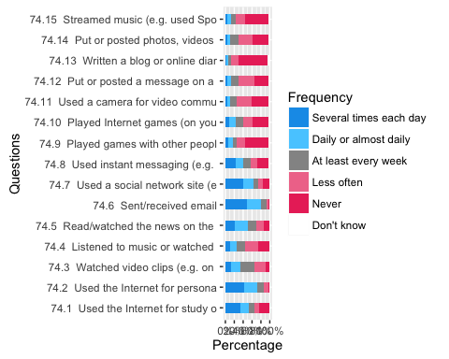

##### Aggregated online activity

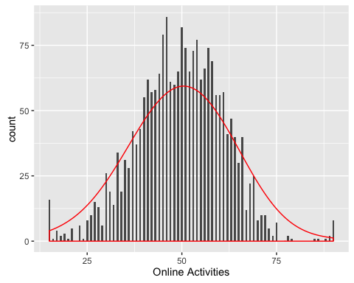

#### Perceived ease of conducting online activity

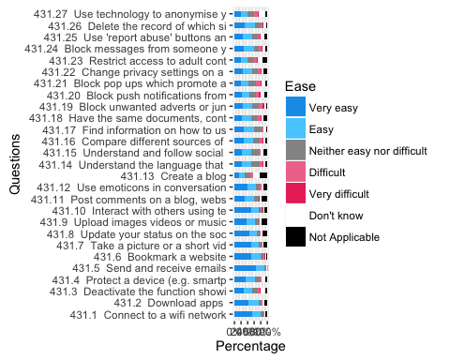

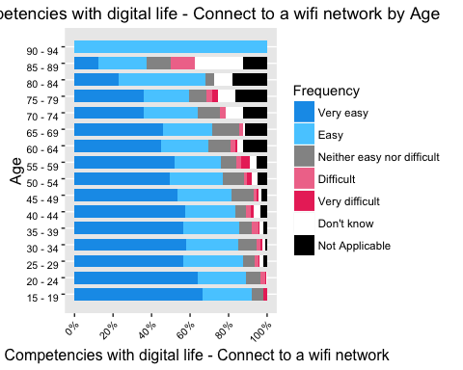

### Interests

#### General Interests

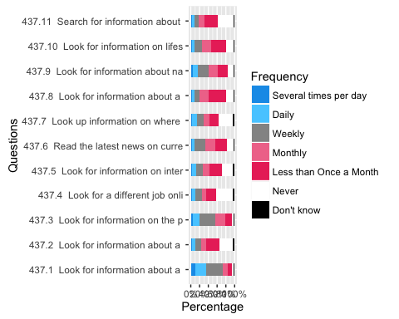

#### Interest in seeking difference

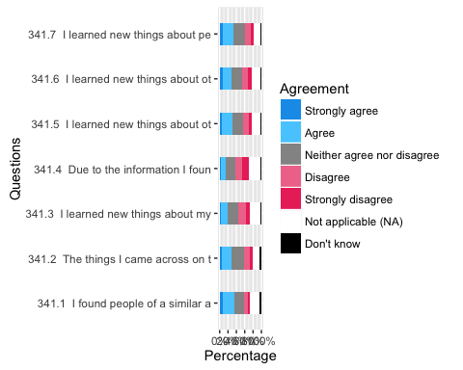

#### Interest in fitness and health improvement

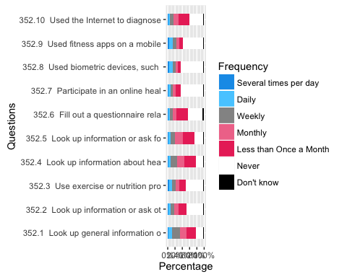

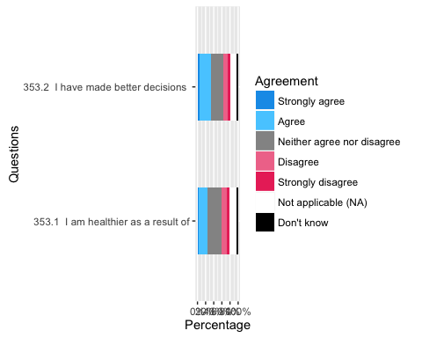

#### Interest in keeping in touch

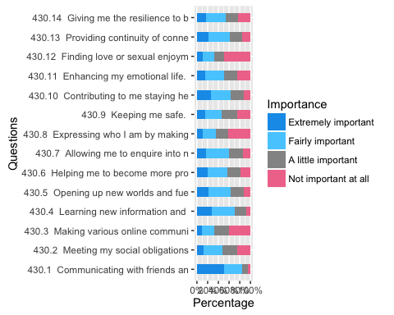

### Resilience

#### Frequency of harmful events

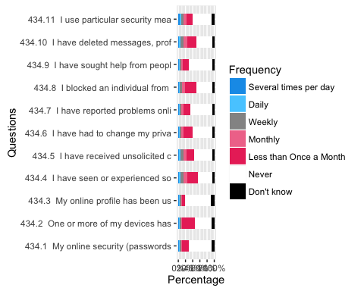

#### Responses to statements about online harms

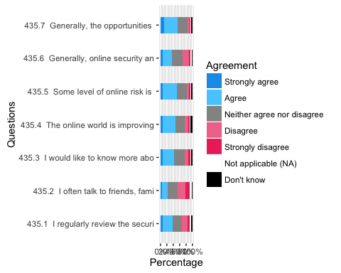

#### Willingness to engage with others

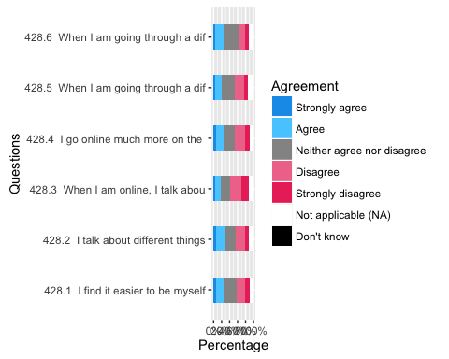

### Social Connectedness

#### Maintaining connections

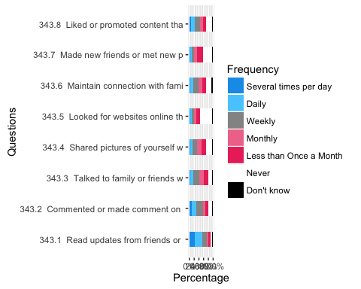

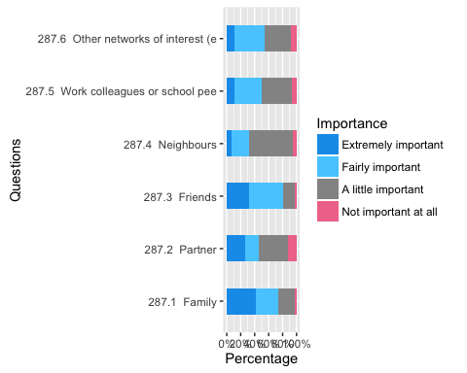

#### Attitudes towards Technology

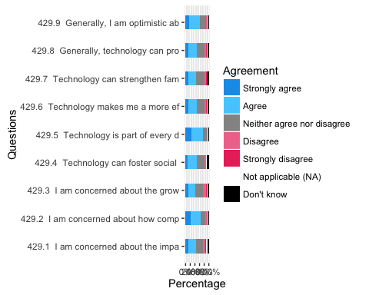

## Overall results

### Index scores

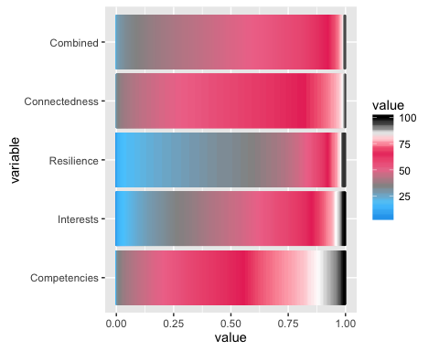

### Aggregated by age

#### Aggregated by age

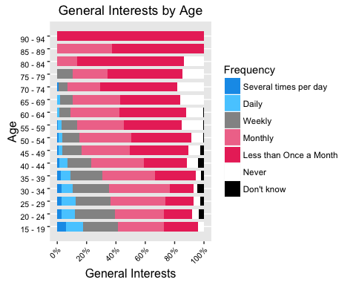

## All Questions

## Appendex 1 - Results by Critical Issue - Individualised

### Competencies

#### Frequency of online activity

##### 74.1 - Online activities - Used the Internet for study or work

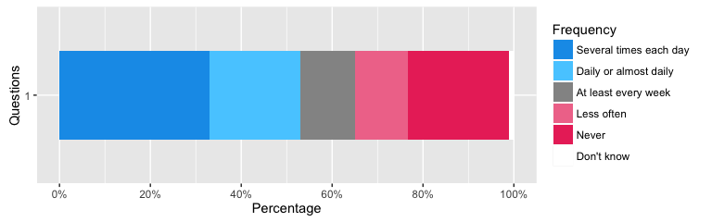

##### 74.2 - Online activities - Used the Internet for personal use (e.g. finding a recipe or fixing an issue with a computer)

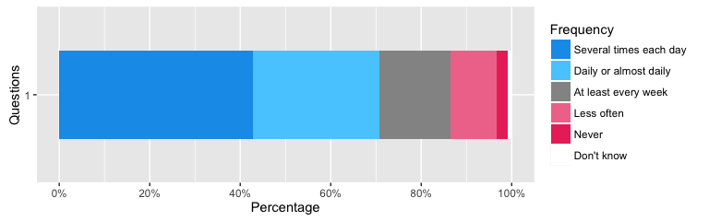

##### 74.3 - Online activities - Watched video clips (e.g. on YouTube)

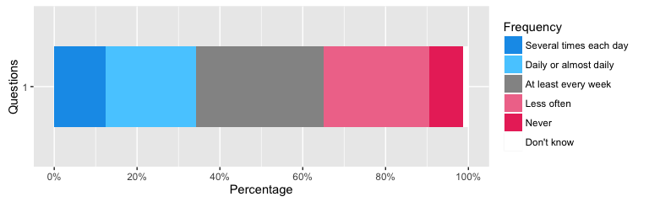

##### 74.4 - Online activities - Listened to music or watched films available online

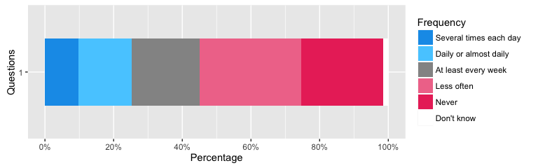

##### 74.5 - Online activities - Read/watched the news on the Internet

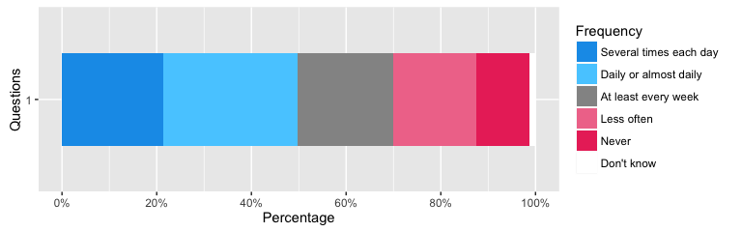

##### 74.6 - Online activities - Sent/received email

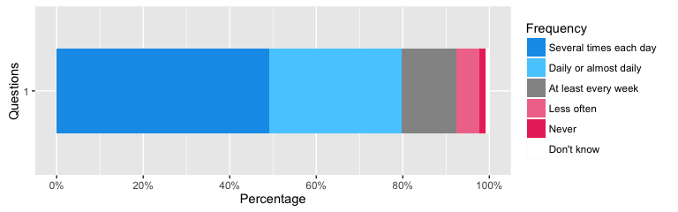

##### 74.7 - Online activities - Used a social network site (e.g. Facebook, Twitter, Instagram, Tumblr, Tinder, Weibu)

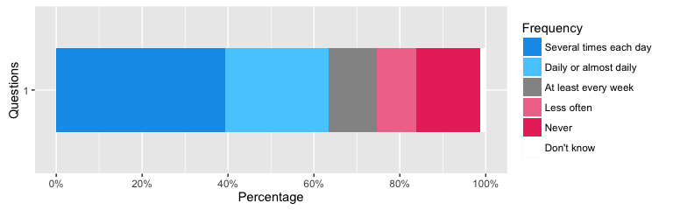

##### 74.8 - Online activities - Used instant messaging (e.g. text, Whatsapp or Facebook messaging)

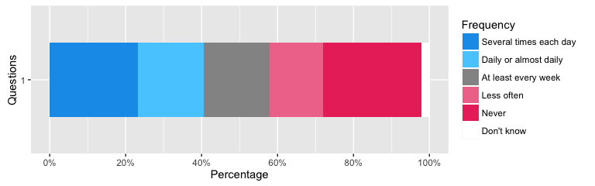

##### 74.9 - Online activities - Played games with other people on the Internet

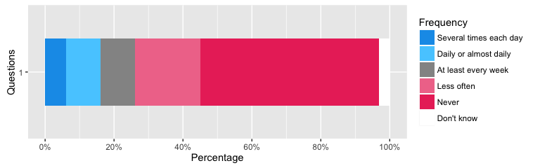

##### 74.10 - Online activities - Played Internet games (on your own or against the computer)

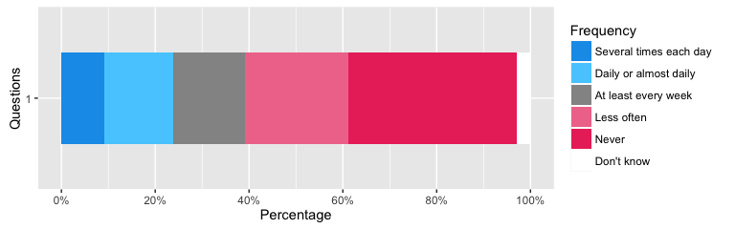

##### 74.11 - Online activities - Used a camera for video communication (e.g. Skype, Facetime)

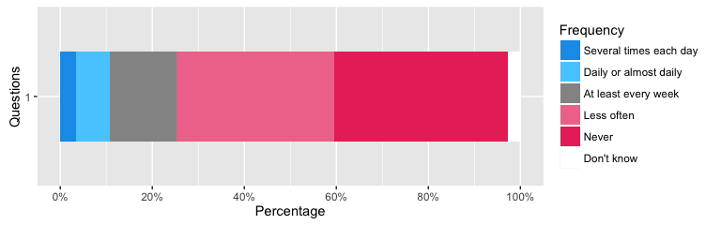

##### 74.12 - Online activities - Put or posted a message on a website

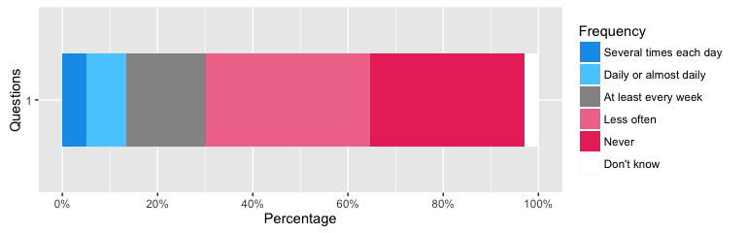

##### 74.13 - Online activities - Written a blog or online diary

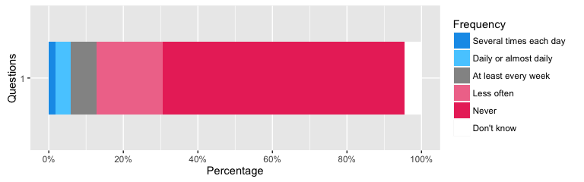

##### 74.14 - Online activities - Put or posted photos, videos or music to share with others

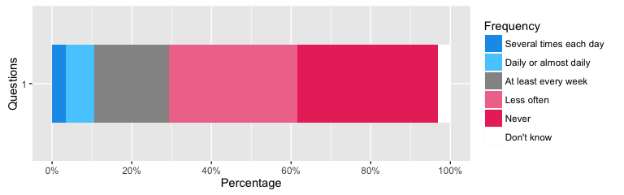

##### 74.15 - Online activities - Streamed music (e.g. used Spotify or similar service)

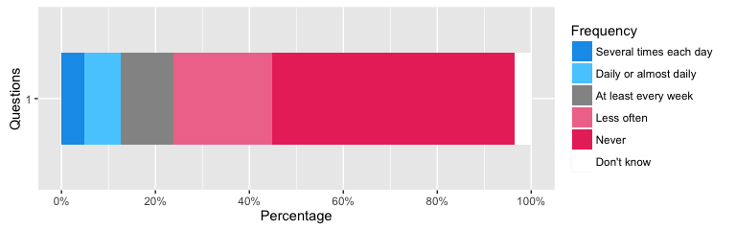 NULL

#### Perceived ease of conducting online activity

##### 431.1 - Competencies with digital life - Connect to a wifi network

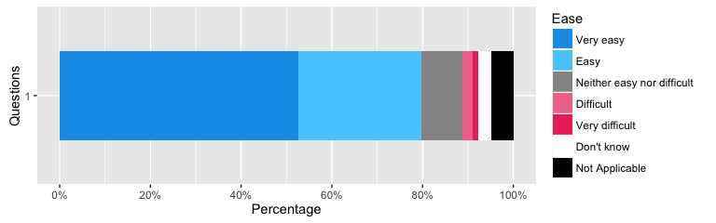

##### 431.2 - Competencies with digital life - Download apps

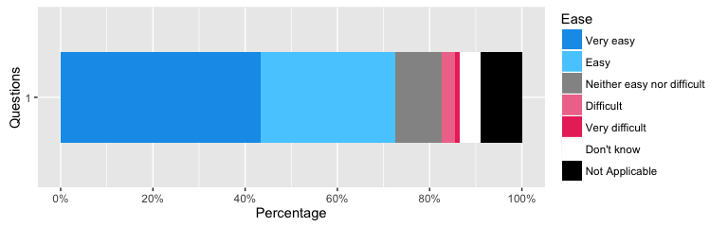

##### 431.3 - Competencies with digital life - Deactivate the function showing your geographical position

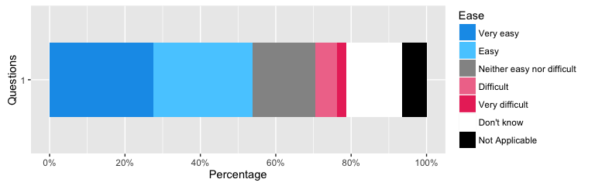

##### 431.4 - Competencies with digital life - Protect a device (e.g. smartphone or digital TV) with a PIN or screen pattern

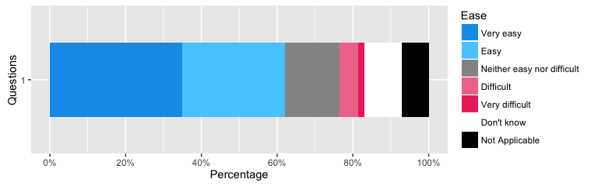

##### 431.5 - Competencies with digital life - Send and receive emails

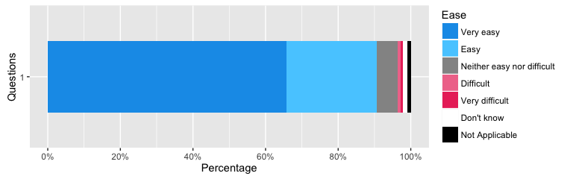

##### 431.6 - Competencies with digital life - Bookmark a website

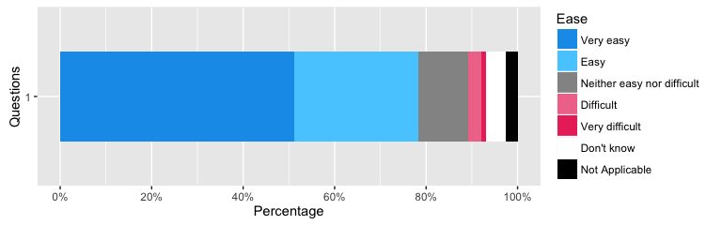

##### 431.7 - Competencies with digital life - Take a picture or a short video with your smartphone

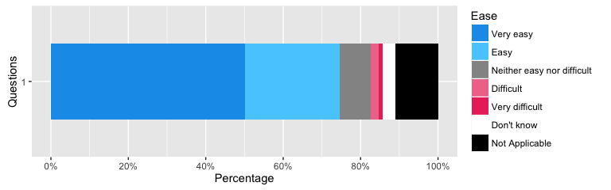

##### 431.8 - Competencies with digital life - Update your status on the social networking site used the most

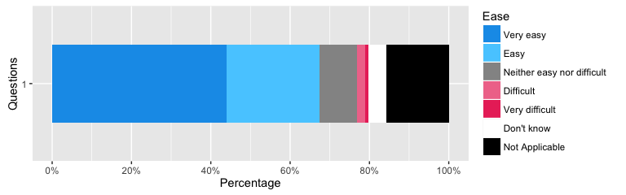

##### 431.9 - Competencies with digital life - Upload images videos or music onto social media

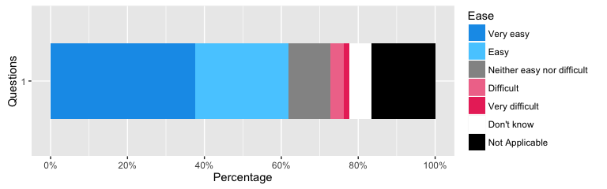

##### 431.10 - Competencies with digital life - Interact with others using text or instant messaging

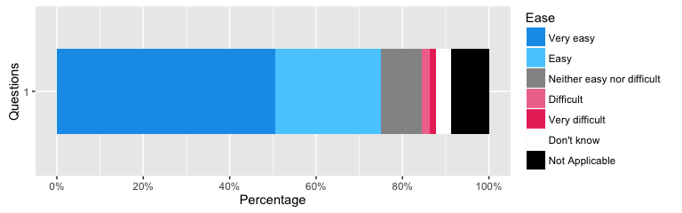

##### 431.11 - Competencies with digital life - Post comments on a blog, website, image, video or forum

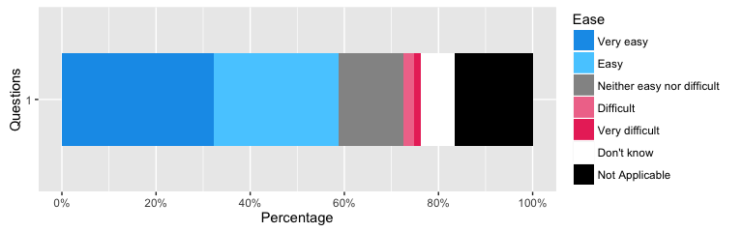

##### 431.12 - Competencies with digital life - Use emoticons in conversation with others

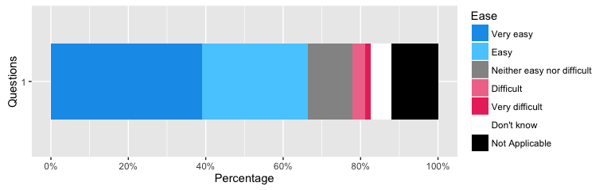

##### 431.13 - Competencies with digital life - Create a blog

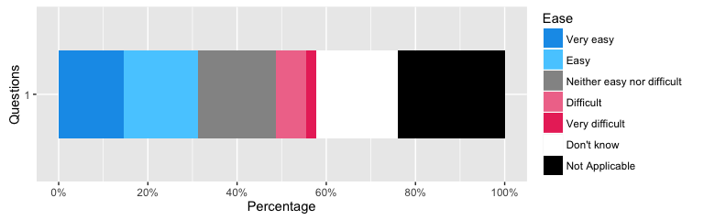

##### 431.14 - Competencies with digital life - Understand the language that others use online

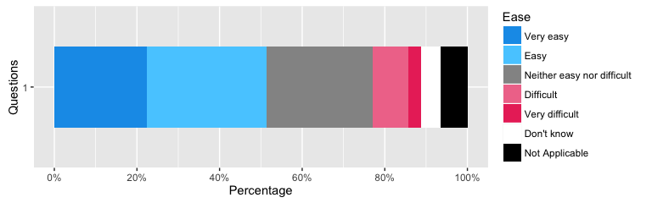

##### 431.15 - Competencies with digital life - Understand and follow social norms/etiquettes on different social media and forums

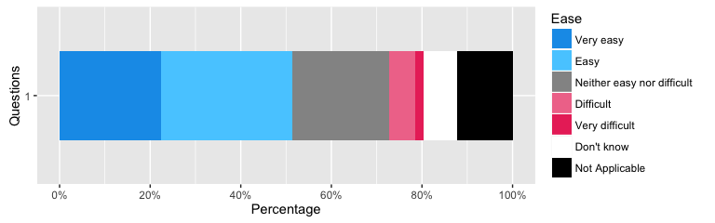

##### 431.16 - Competencies with digital life - Compare different sources of information (websites, social media, etc) to decide if information is true or trustworthy

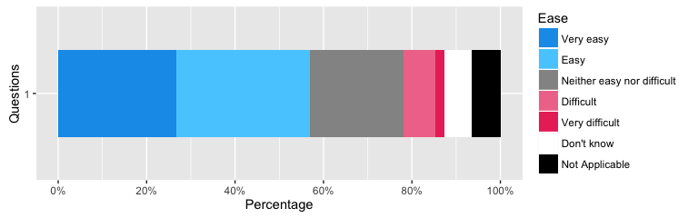

##### 431.17 - Competencies with digital life - Find information on how to use the Internet safely

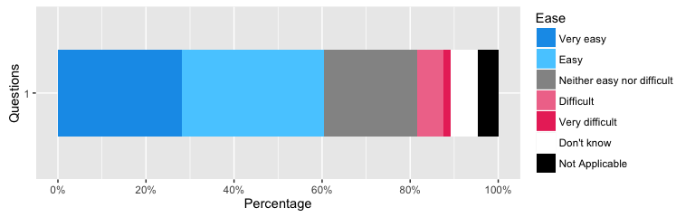

##### 431.18 - Competencies with digital life - Have the same documents, contacts, and apps on all devices that you use

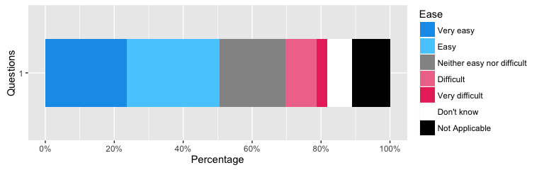

##### 431.19 - Competencies with digital life - Block unwanted adverts or junk mail

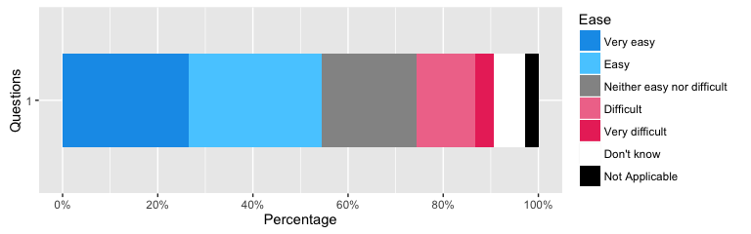

##### 431.20 - Competencies with digital life - Block push notifications from different apps

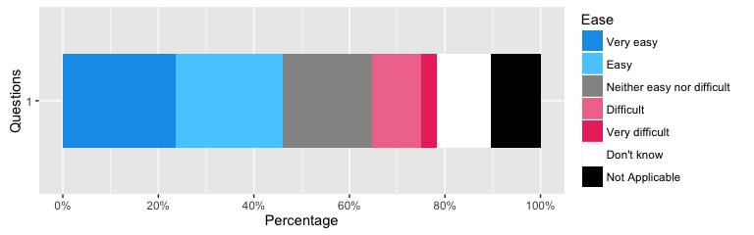

##### 431.21 - Competencies with digital life - Block pop ups which promote apps, games or services you have to pay for

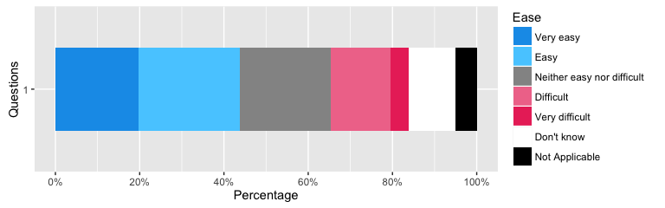

##### 431.22 - Competencies with digital life - Change privacy settings on a social networking profile

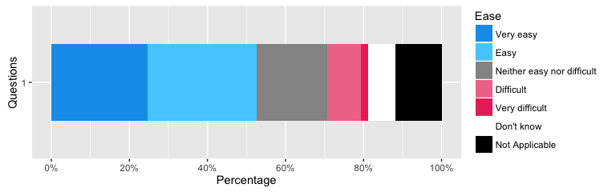

##### 431.23 - Competencies with digital life - Restrict access to adult content on a browser or device

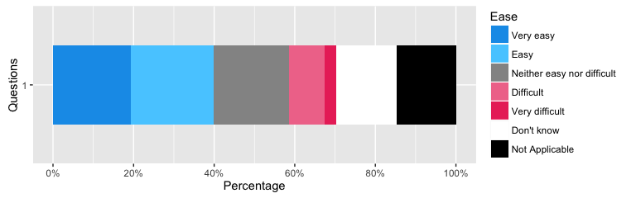

##### 431.24 - Competencies with digital life - Block messages from someone you don't want to hear from

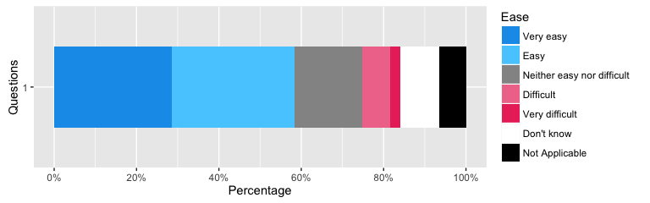

##### 431.25 - Competencies with digital life - Use 'report abuse' buttons and procedures

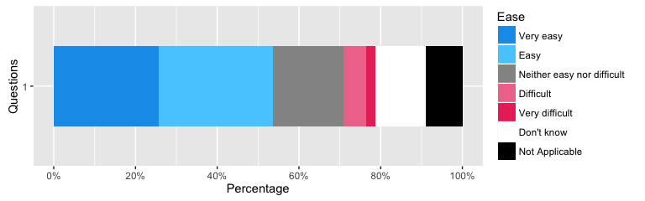

##### 431.26 - Competencies with digital life - Delete the record of which sites you have visited

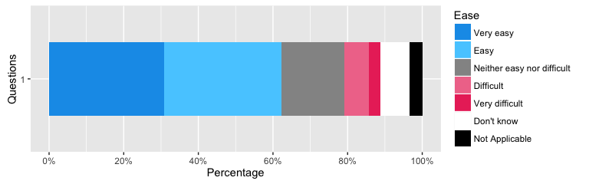

##### 431.27 - Competencies with digital life - Use technology to anonymise your identity when online

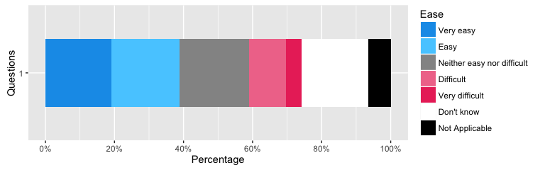 NULL

### Interests

#### General Interests

##### 437.1 - General Interests - Look for information about a topic of general interest, where answers were provided by Wikipedia, Quora or other informational sites

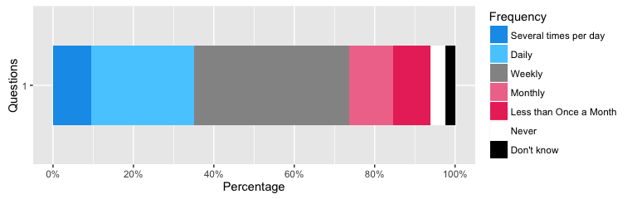

##### 437.2 - General Interests - Look for information about a course or course provider (this can be any course, from studying at university to a course for personal interests like pottery or photography)

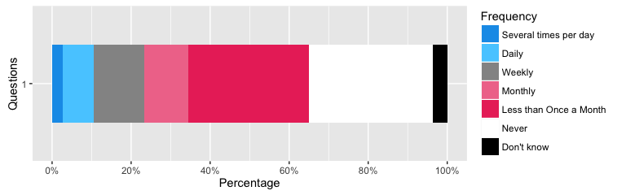

##### 437.3 - General Interests - Look for information on the price of a product (e.g. books, holidays, clothes, cars)

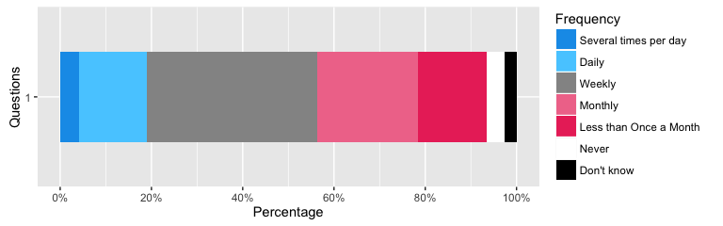

##### 437.4 - General Interests - Look for a different job online

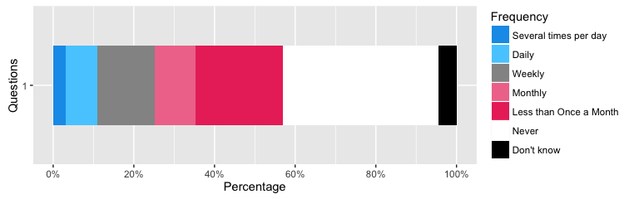

##### 437.5 - General Interests - Look for information on interest rates, or other financial information

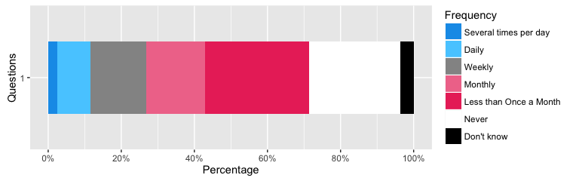

##### 437.6 - General Interests - Read the latest news on current affairs

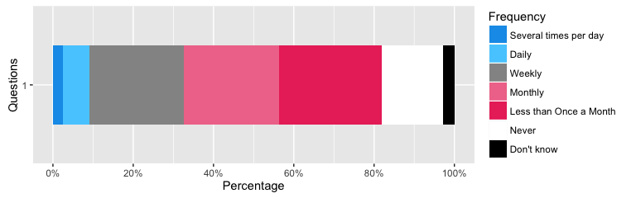

##### 437.7 - General Interests - Look up information on where to go out (e.g. exhibitions, cinema, parties)

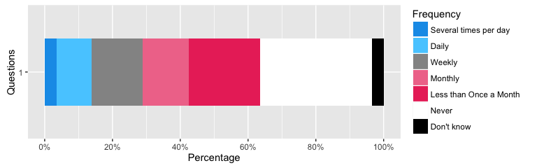

##### 437.8 - General Interests - Look for information about a political or societal issue (e.g. through twitter, on blogs, websites)

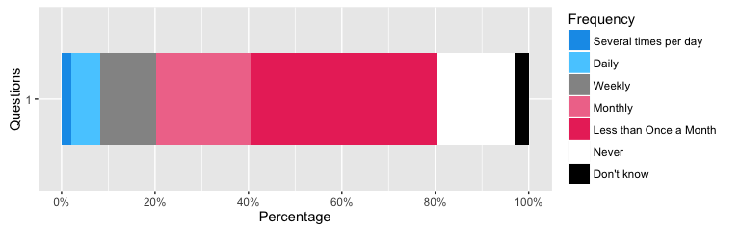

##### 437.9 - General Interests - Look for information about national government services (e.g. benefits, taxes, a driving licence or passport)

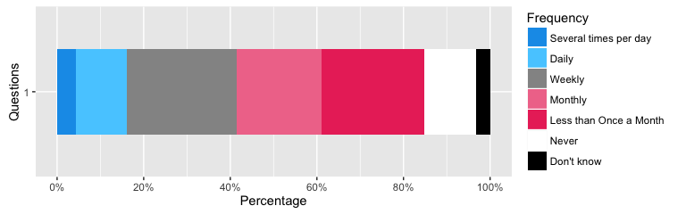

##### 437.10 - General Interests - Look for information on lifestyle and culture (e.g. games, music, film, television, hobbies)

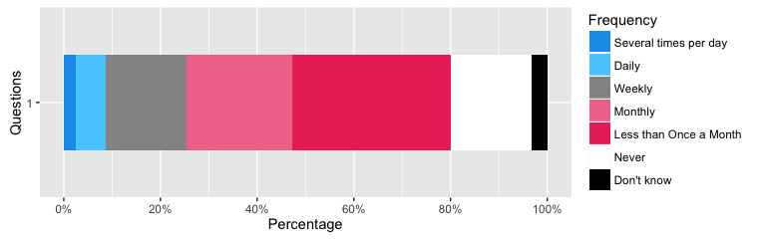

##### 437.11 - General Interests - Search for information about events, concerts etc

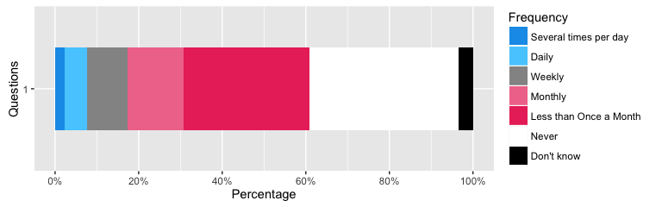

#### Interest in seeking difference

##### 341.1 - Difference seeking - I found people of a similar age that share my interests

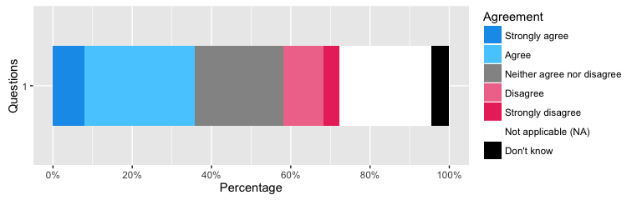

##### 341.2 - Difference seeking - The things I came across on the Internet made me think about the differences between men and women

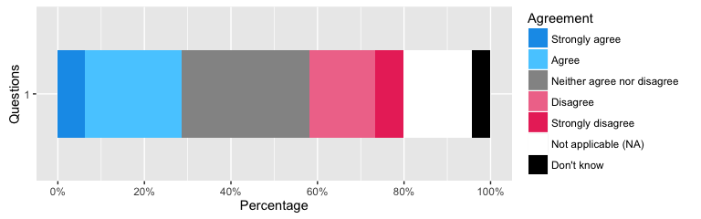

##### 341.3 - Difference seeking - I learned new things about my ethnic group

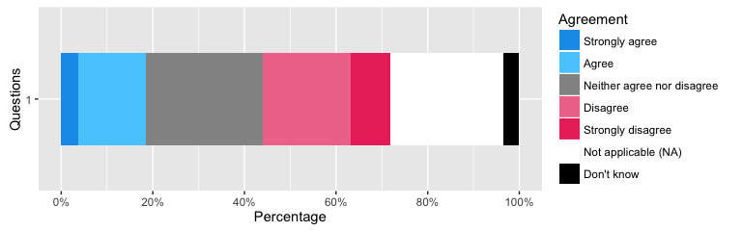

##### 341.4 - Difference seeking - Due to the information I found and people I have met online I feel more connected with religion or spiritual beliefs

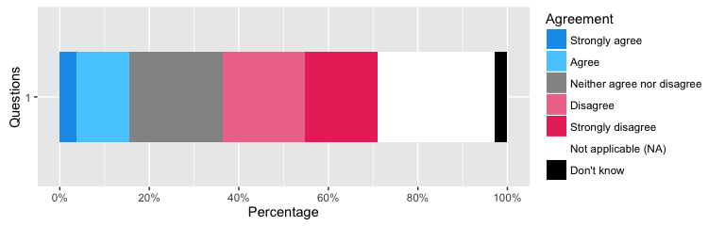

##### 341.5 - Difference seeking - I learned new things about other ethnic groups

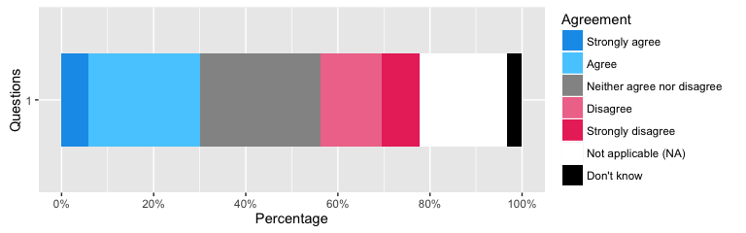

##### 341.6 - Difference seeking - I learned new things about other sexual identities and orientations

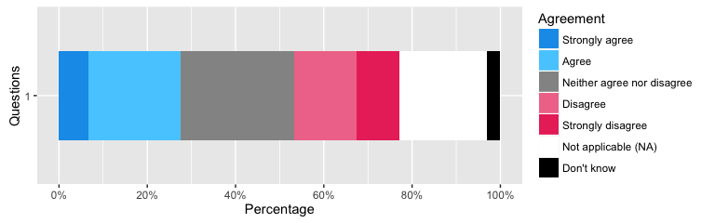

##### 341.7 - Difference seeking - I learned new things about people with mental illnesses or physical disabilities

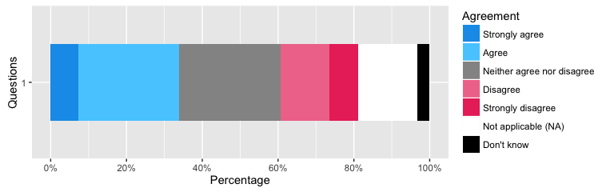

#### Interest in fitness and health improvement

##### 352.1 - Health - Look up general information on how to improve your health and fitness

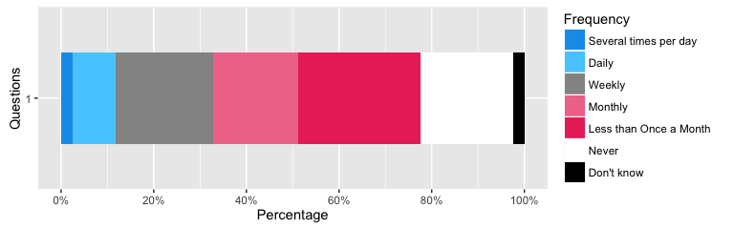

##### 352.2 - Health - Look up information or ask others about a training program

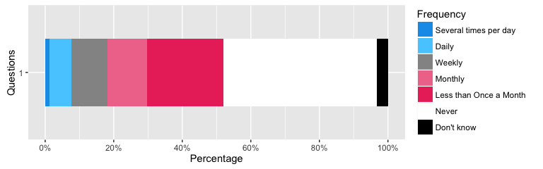

##### 352.3 - Health - Use exercise or nutrition programs / apps

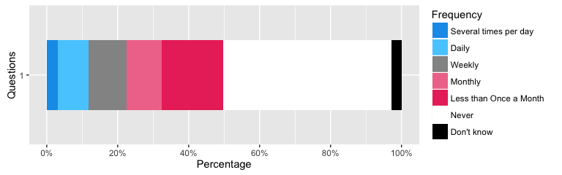

##### 352.4 - Health - Look up information about health or medical care

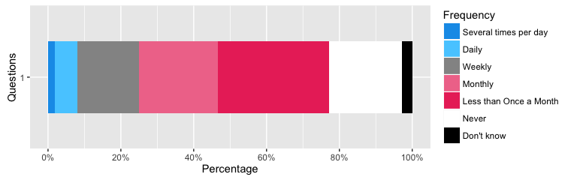

##### 352.5 - Health - Look up information or ask for advice on a medical condition

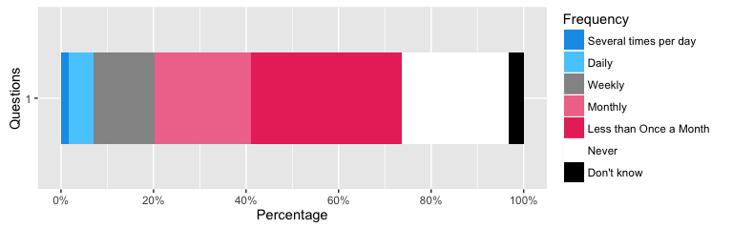

##### 352.6 - Health - Fill out a questionnaire related to your health and fitness

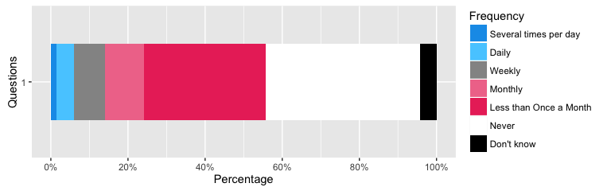

##### 352.7 - Health - Participate in an online health or fitness community

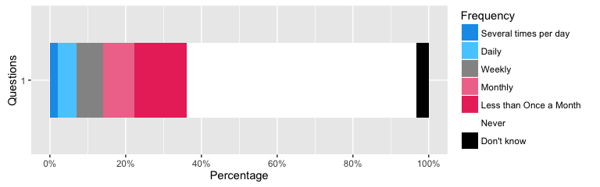

##### 352.8 - Health - Used biometric devices, such as GPS watches or FitBit

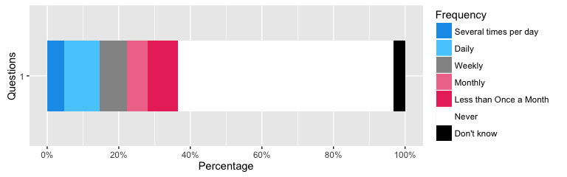

##### 352.9 - Health - Used fitness apps on a mobile phone or smart watch

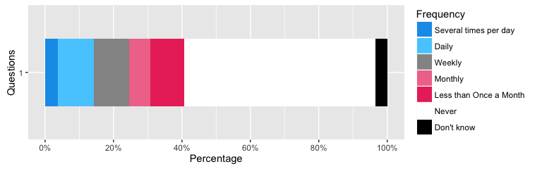

##### 352.10 - Health - Used the Internet to diagnose a health condition

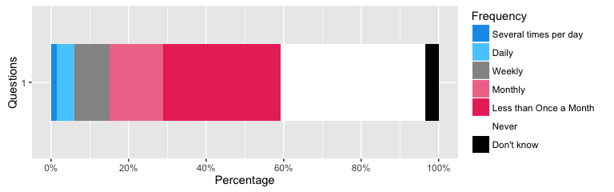

##### 353.1 - Health improvement - I am healthier as a result of the online information, advice or programs / apps I have used

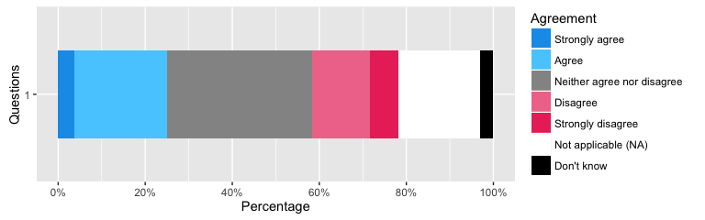

##### 353.2 - Health improvement - I have made better decisions about my health or medical care as a result of the information / advice I found online

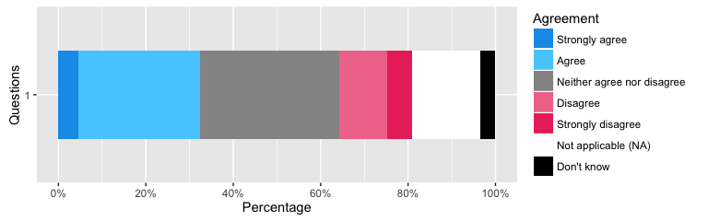

#### Interest in keeping in touch

##### 430.1 - Keeping in touch - Communicating with friends and family.

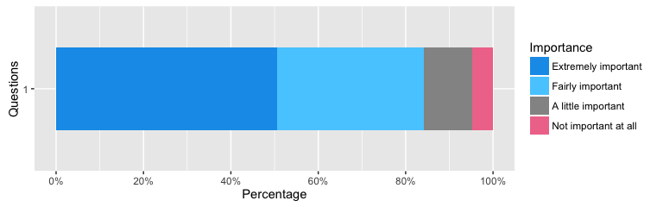

##### 430.2 - Keeping in touch - Meeting my social obligations to others.

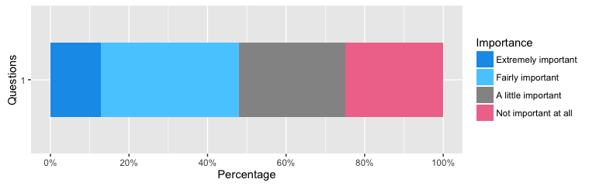

##### 430.3 - Keeping in touch - Making various online communities aware of injustices in the world.

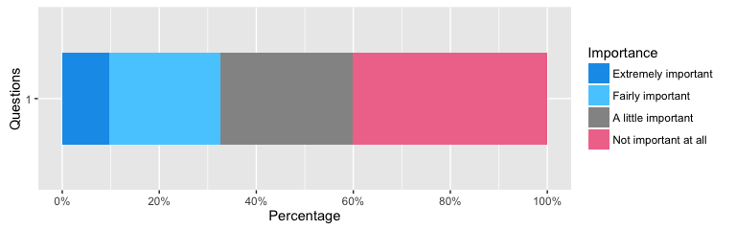

##### 430.4 - Keeping in touch - Learning new information and skills.

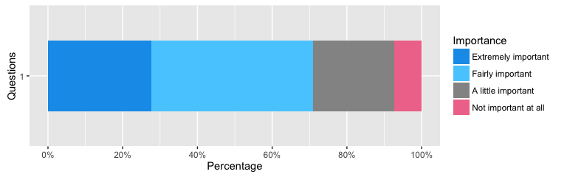

##### 430.5 - Keeping in touch - Opening up new worlds and fueling my imagination.

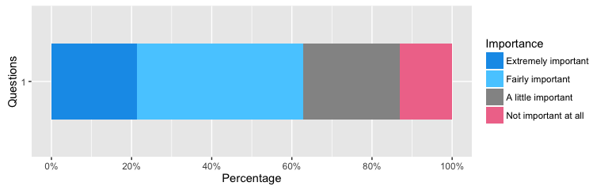

##### 430.6 - Keeping in touch - Helping me to become more proficient in my chosen vocation or activity.

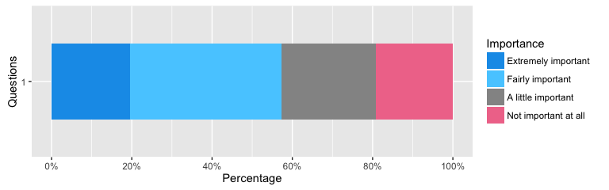

##### 430.7 - Keeping in touch - Allowing me to enquire into new areas beyond my usual interests.

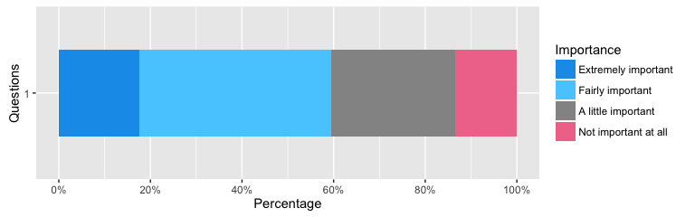

##### 430.8 - Keeping in touch - Expressing who I am by making my identity and thoughts more public.

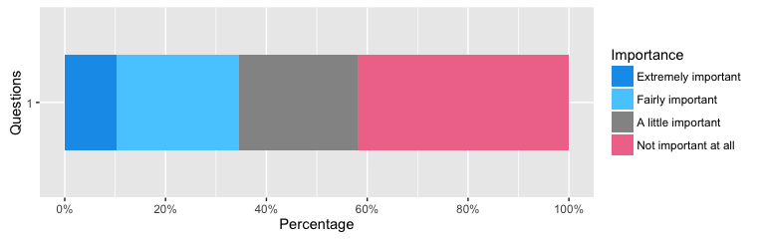

##### 430.9 - Keeping in touch - Keeping me safe.

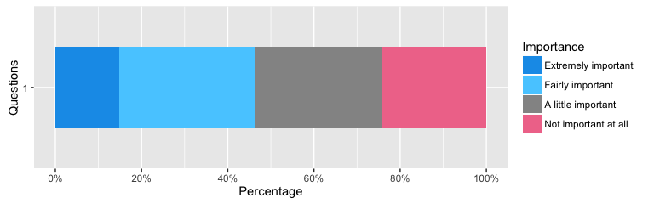

##### 430.10 - Keeping in touch - Contributing to me staying healthy.

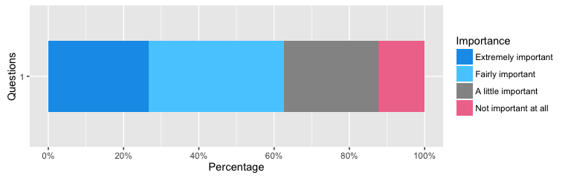

##### 430.11 - Keeping in touch - Enhancing my emotional life.

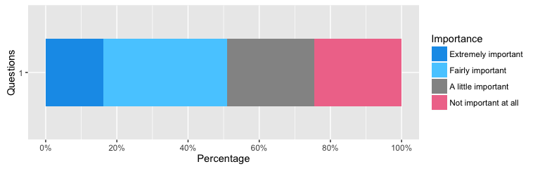

##### 430.12 - Keeping in touch - Finding love or sexual enjoyment.

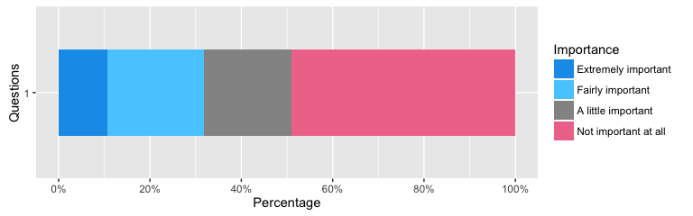

##### 430.13 - Keeping in touch - Providing continuity of connection in a changing world.

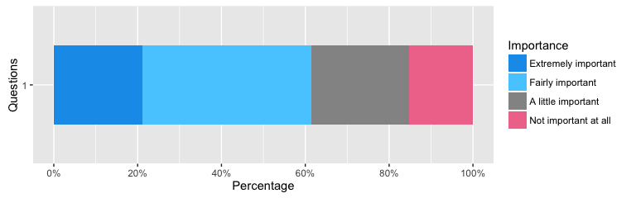

##### 430.14 - Keeping in touch - Giving me the resilience to bounce back in times of hardship.

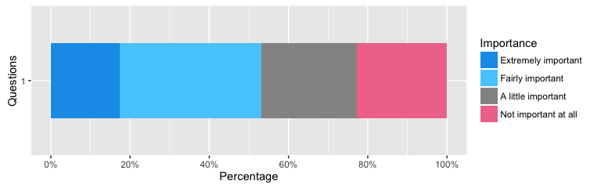

### Resilience

#### Frequency of harmful events

##### 434.1 - NA - My online security (passwords, credit cards) has been compromised.

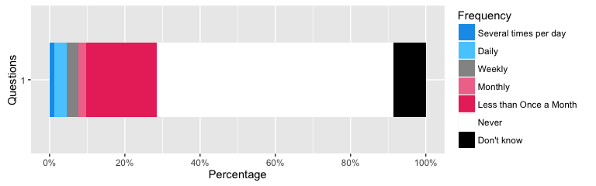

##### 434.2 - NA - One or more of my devices has been infected with a virus.

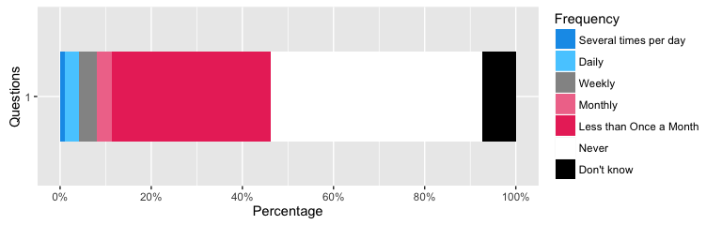

##### 434.3 - NA - My online profile has been used in ways that I did not consent to.

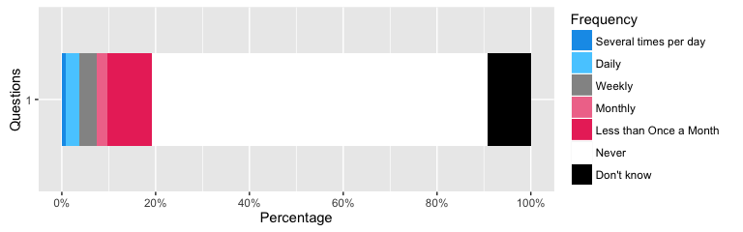

##### 434.4 - NA - I have seen or experienced something on the Internet that has bothered me in some way.

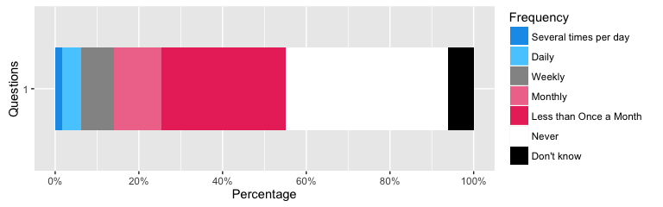

##### 434.5 - NA - I have received unsolicited communications that disturbed me in some way (e.g. not regular spam).

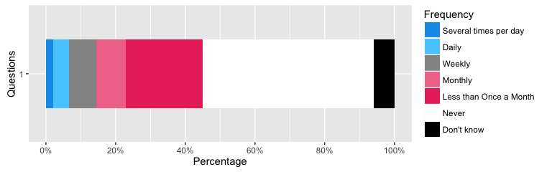

##### 434.6 - NA - I have had to change my privacy settings or passwords, for reasons other than school or work policy.

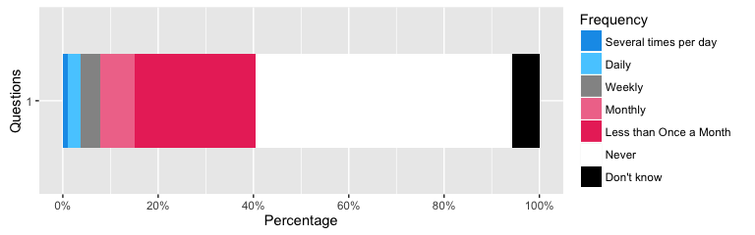

##### 434.7 - NA - I have reported problems online (e.g. clicked on a 'report abuse' button, contacted an Internet advisor, or Internet Service Provider (ISP)).

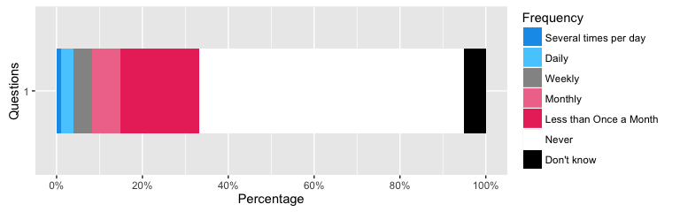

##### 434.8 - NA - I blocked an individual from contacting me.

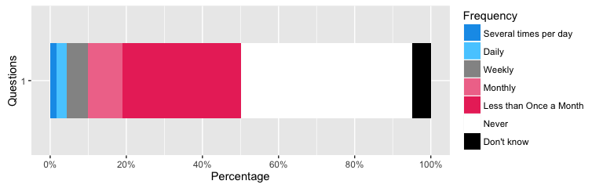

##### 434.9 - NA - I have sought help from people around me (friends, family, neighbours, authorities) when dealing with an online safety issue.

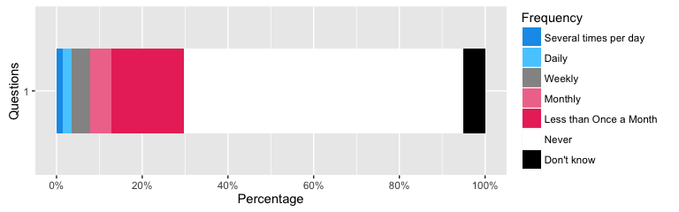

##### 434.10 - NA - I have deleted messages, profiles or other data in response to security and privacy concerns.

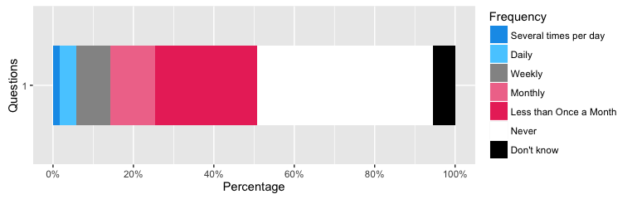

##### 434.11 - NA - I use particular security measures, such as anonymous browsing, VPNs, password managers and encryption, to protect my privacy.

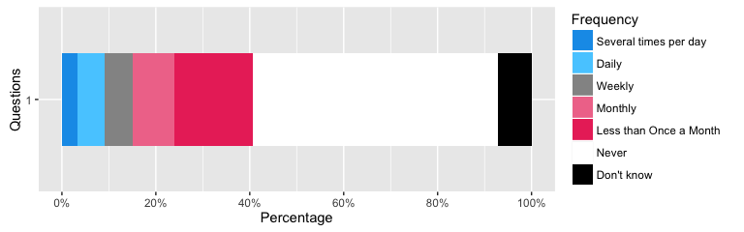

#### Responses to statements about online harms

##### 435.1 - NA - I regularly review the security of the networks, devices and websites I use.

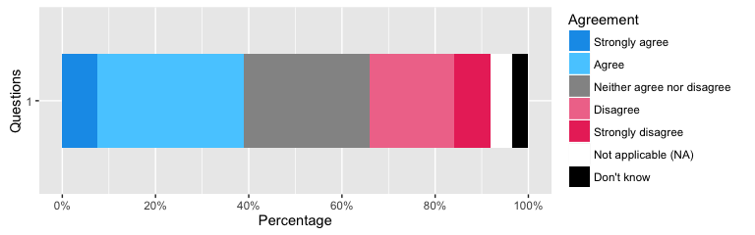

##### 435.2 - NA - I often talk to friends, family and colleagues about online security issues.

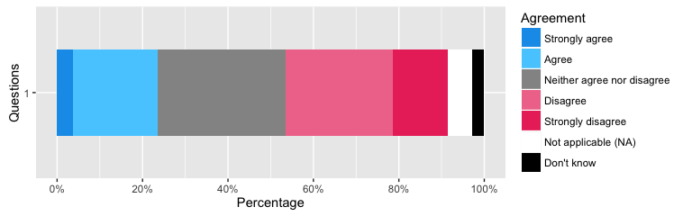

##### 435.3 - NA - I would like to know more about online security, privacy and safety.

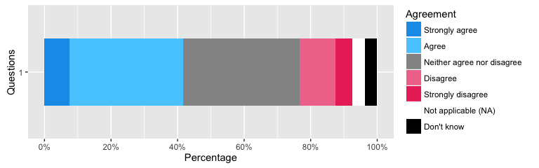

##### 435.4 - NA - The online world is improving as people become more aware of its potential risks and harms.

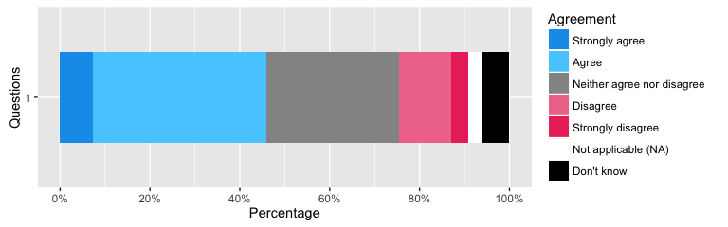

##### 435.5 - NA - Some level of online risk is inevitable, and provides an important learning opportunity.

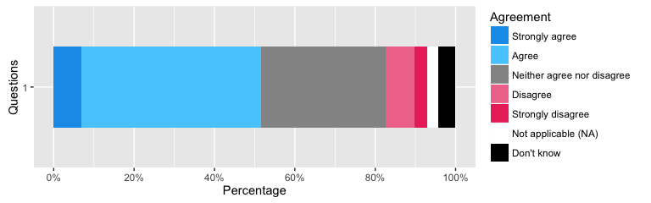

##### 435.6 - NA - Generally, online security and safety is a pressing concern for me.

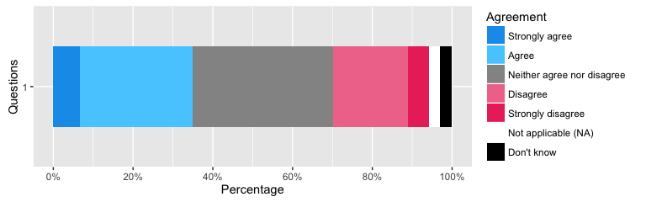

##### 435.7 - NA - Generally, the opportunities of online activity outweighs its risks.

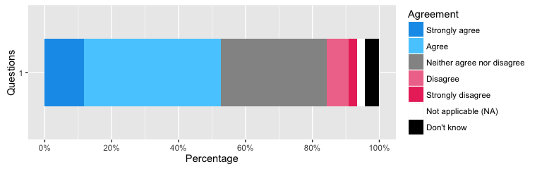

#### Willingness to engage with others

##### 428.1 - Engage with others online - I find it easier to be myself when online than when I am with people face-to-face

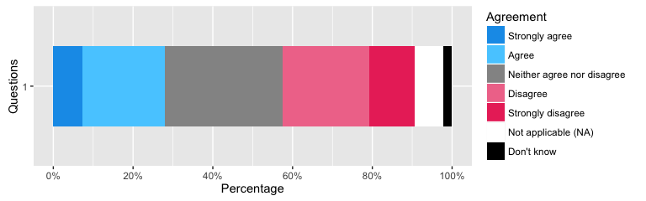

##### 428.2 - Engage with others online - I talk about different things with people when online than I do when face-to-face

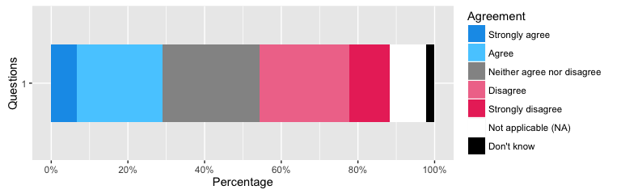

##### 428.3 - Engage with others online - When I am online, I talk about private things that I do not share with people face-to-face

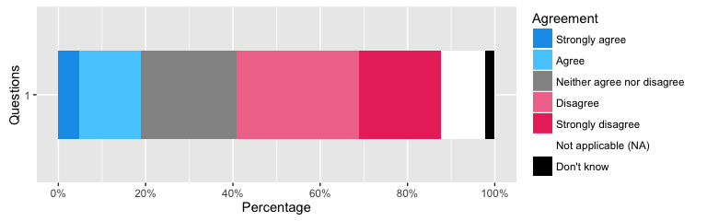

##### 428.4 - Engage with others online - I go online much more on the weekends than I do on a regular school or work day [optional question]

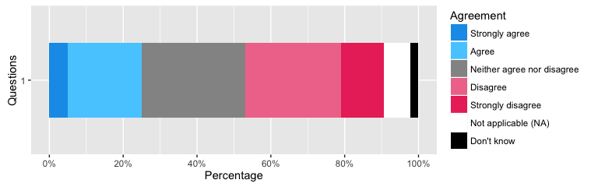

##### 428.5 - Engage with others online - When I am going through a difficult time, I go online less often

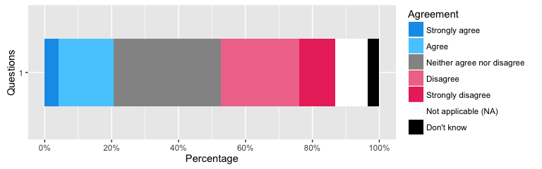

##### 428.6 - Engage with others online - When I am going through a difficult time, going online makes me feel better

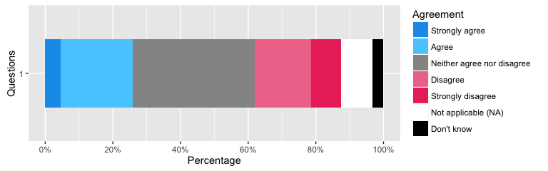

### Social Connectedness

#### Maintaining connections

##### 343.1 - Using the Internet to stay in touch - Read updates from friends or family (e.g. email, status / photos on social networking sites)

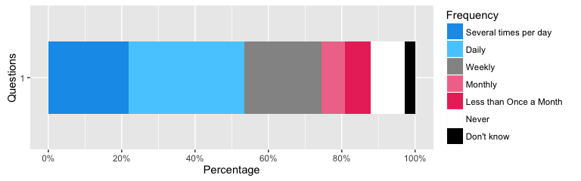

##### 343.2 - Using the Internet to stay in touch - Commented or made comment on the updates friends or family put online (e.g. email, status / photos on social networking sites)

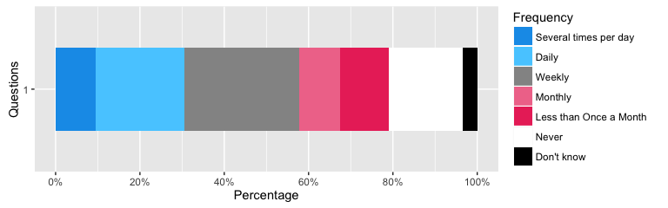

##### 343.3 - Using the Internet to stay in touch - Talked to family or friends who live further away (e.g. via skype, whatsapp, or email)

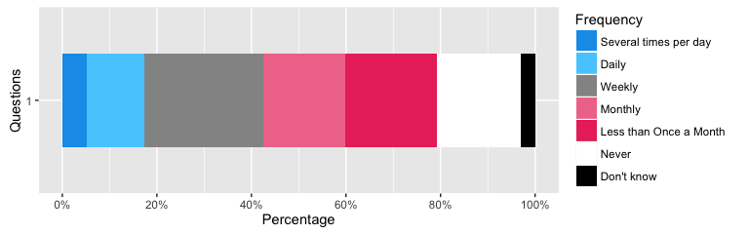

##### 343.4 - Using the Internet to stay in touch - Shared pictures of yourself with your family or friends (e.g. through a social networking site, photo sharing site)

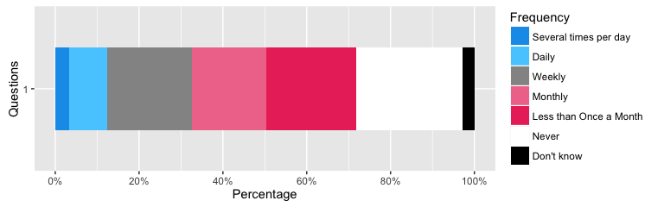

##### 343.5 - Using the Internet to stay in touch - Looked for websites online that help you to meet new people (e.g. online dating, social networking sites, hobby or crafts clubs)

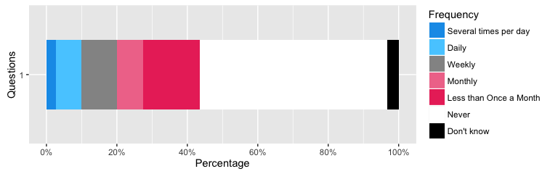

##### 343.6 - Using the Internet to stay in touch - Maintain connection with family members

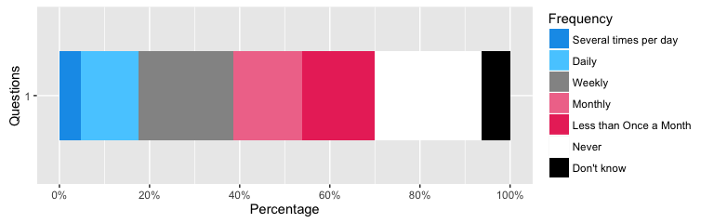

##### 343.7 - Using the Internet to stay in touch - Made new friends or met new people

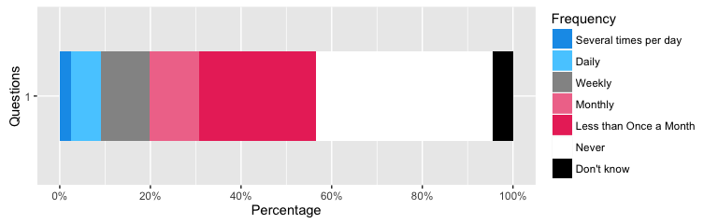

##### 343.8 - Using the Internet to stay in touch - Liked or promoted content that other people post

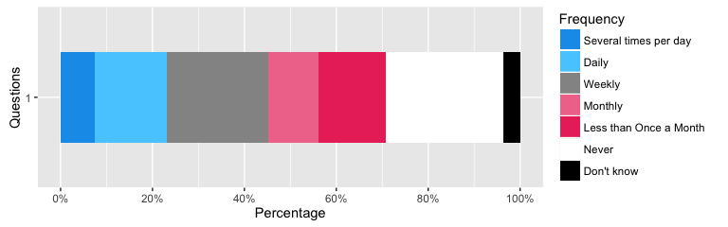

##### 287.1 - Maintenance of online networks - Family

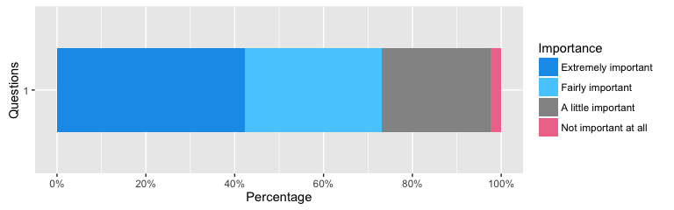

##### 287.2 - Maintenance of online networks - Partner

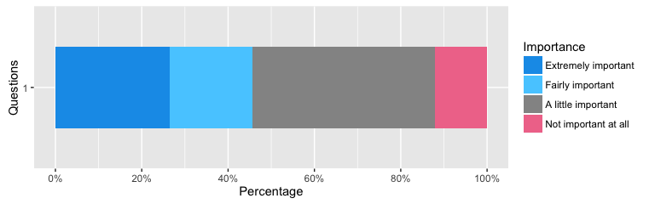

##### 287.3 - Maintenance of online networks - Friends

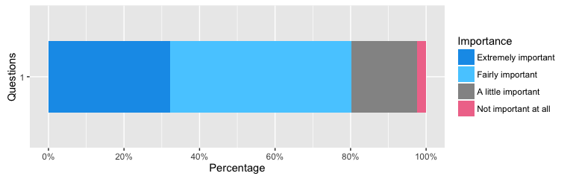

##### 287.4 - Maintenance of online networks - Neighbours

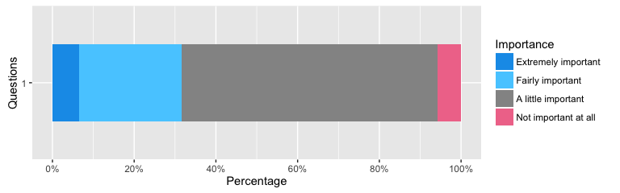

##### 287.5 - Maintenance of online networks - Work colleagues or school peers

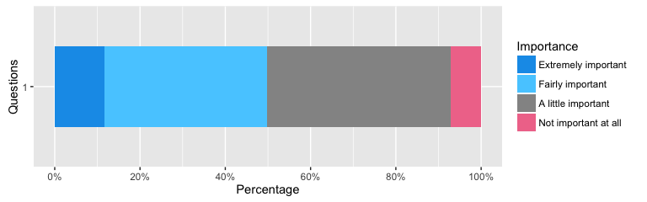

##### 287.6 - Maintenance of online networks - Other networks of interest (e.g. sport, culture, or other interests)

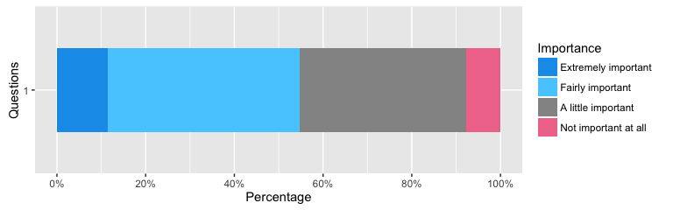

#### Attitudes towards Technology

##### 429.1 - Attitudes towards technology - I am concerned about the impacts of electronic waste on the environment.

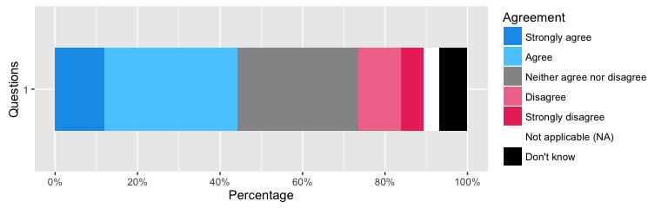

##### 429.2 - Attitudes towards technology - I am concerned about how companies, governments and others might use my online information.

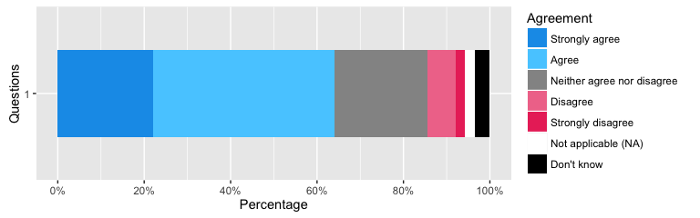

##### 429.3 - Attitudes towards technology - I am concerned about the growing divide between technology experts and the rest of society.

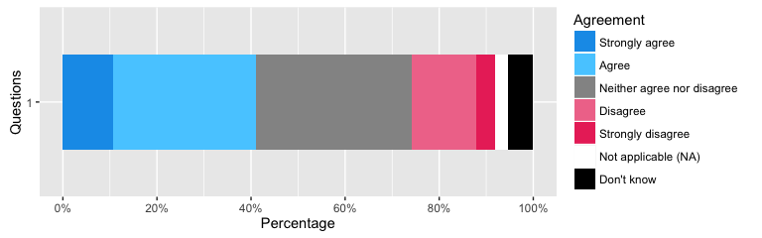

##### 429.4 - Attitudes towards technology - Technology can foster social inclusion/equality/opportunities for our more marginalised communities.

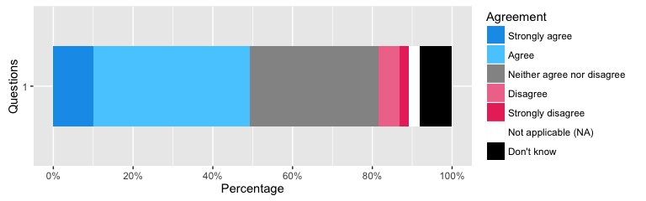

##### 429.5 - Attitudes towards technology - Technology is part of every day life and, despite the risks, I must learn to use it effectively.

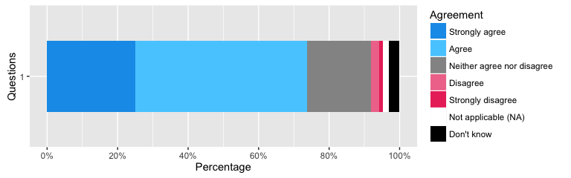

##### 429.6 - Attitudes towards technology - Technology makes me a more effective member of my community/citizen of my country.

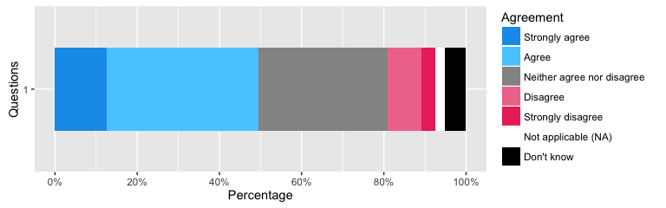

##### 429.7 - Attitudes towards technology - Technology can strengthen familial relationships.

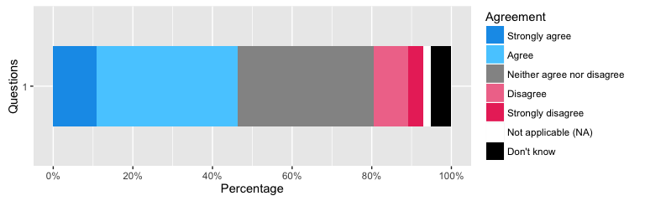

##### 429.8 - Attitudes towards technology - Generally, technology can promote strong social ties.

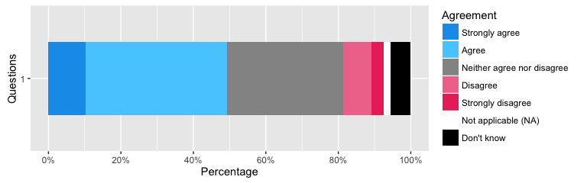

##### 429.9 - Attitudes towards technology - Generally, I am optimistic about the future of technology.

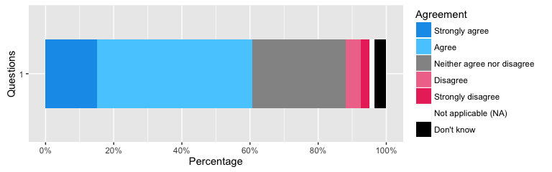

## Appendex 2 - To Be Completed

* Fix age axes - DONE
* More detailed demographics
* Fix References
* Name all chunks
* Name all figures

## References

Helsper, Ellen. 2012. “A Corresponding Fields Model for the Links Between Social and Digital Exclusion.” *Communication Theory* 22 (4). Wiley Online Library: 403–26.

Humphry, Justine. 2014. “The Importance of Circumstance: Digital Access and Affordability for People Experiencing Homelessness.” *Australian Journal of Telecommunications and the Digital Economy* 2 (3). Telecommunications Association: 55.

James, Paul. 2014. *Urban Sustainability in Theory and Practice: Circles of Sustainability*. Routledge.

Livingstone, Sonia, Leslie Haddon, Anke Görzig, and Kjartan Ólafsson. 2010. “Risks and Safety on the Internet: The Perspective of European Children: Key Findings from the EU Kids Online Survey of 9-16 Year Olds and Their Parents in 25 Countries.” EU Kids Online.